break

break

Maim and pollard

Amazing they survive

And brandish

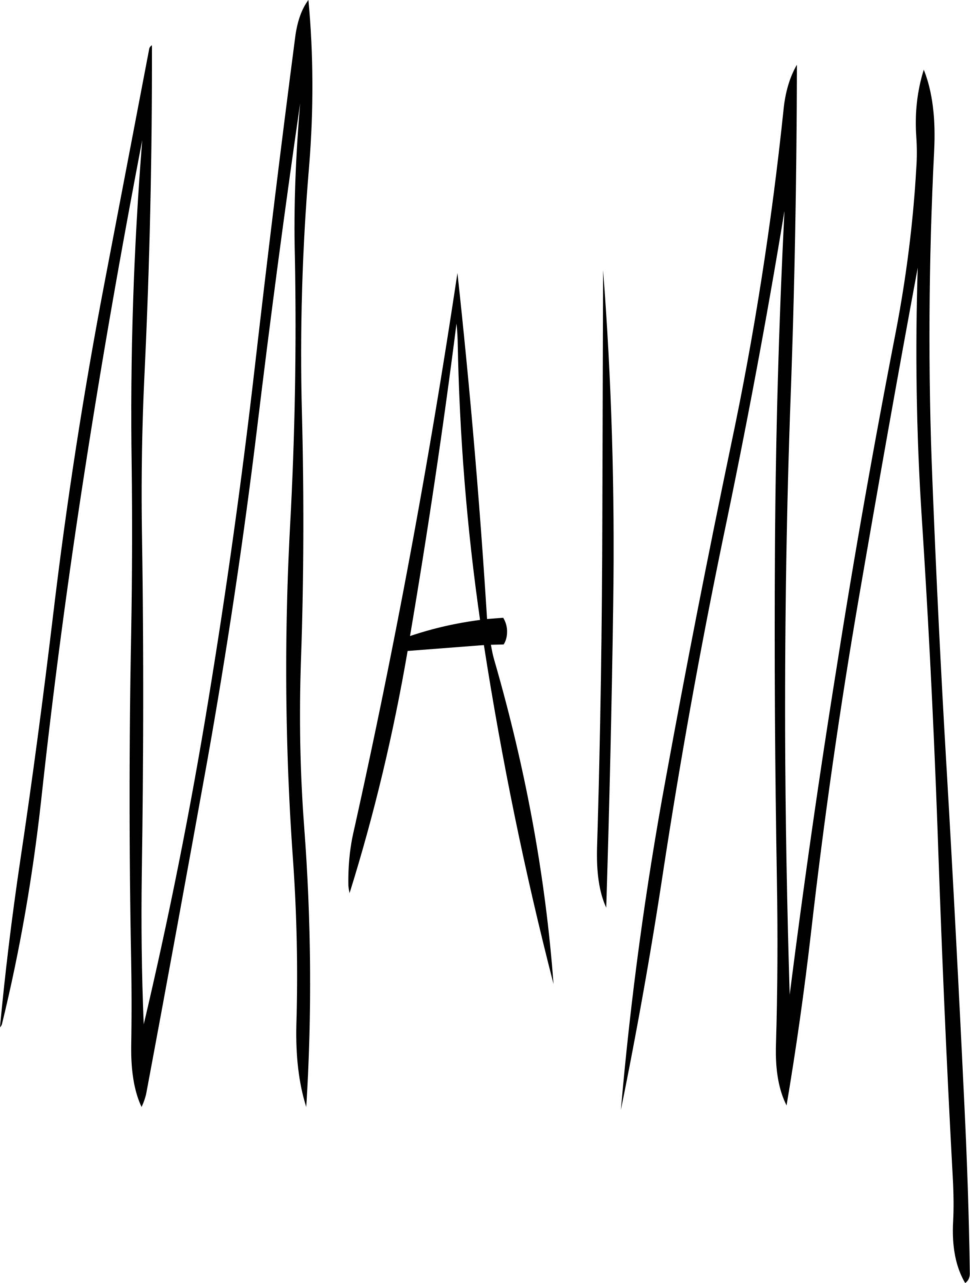

**Kickshaws in mem. John Crombie**

break

