**Kickshaws in mem. John Crombie**

break

The moustache said 'I'm grumpy' (which he was)

Though the grey eyes couldn't hide dismay, amusement or delight.

He set up shop in Charité, among funereal florists,

His printed books - the petals on a lead chrysanthemum;

Slept in the back shop - something out of Whitmarsh - God knows how.

Retreated to his pill-box flat in noisy Montparnasse.

Last time he ventured out on his own, just him and his stick,

A plastic bag for a bottle of J&B,

A beggar at the bottle shop harassed a man on crutches;

John tried to intervene; the codgers landed in a heap,

More Metamorphosis than his old pal Sam. Which made him laugh.

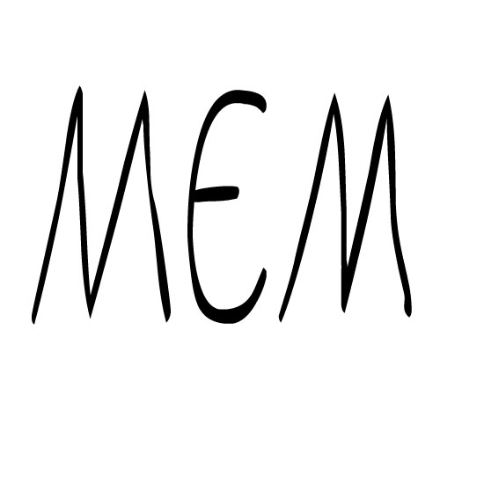

break

break

Maim and pollard

Amazing they survive

And brandish

