Simon Mclaren & Liam Robertson

At low timesteps (dt~0.1) both algorithms simulate reality for any number of steps. At larger time steps (dt~1) the time step is too large for the symplectic euler algorithm, causing the particle to leave the zone of influence of the force so it continues on in a straight trajectory. At this time step the velocity verlet algorithm still simulates reality to an extent but the trajectory varies for each orbit. At larger time steps (dt~10) both algorithms fail to simulate reality. Therefore the velocity verlet algorithm performs better than the symplectic euler algorithm for larger time steps but both fail at very high time steps. This is displayed in the figures on page 2, and can also be seen in the lower energy fluctuations of the velocity verlet algorithm in comparison to the symplectic euler algorithm.

The characteristic time is 2*pi. For the velocity verlet algorithm the time step of 2*pi is too big so it will not produce an accurate simulation. This algorithm has an inherit level of accuracy which means that it will never perfectly match reality. This means that the particle will arrive to a slightly different point than it would in reality. In figure 7 we see that the first time step was so large that the particle escaped the zone of influence of the force causing it to continue on in a straight trajectory.

By testing many different time steps we found (to an accuracy of 3 significant figures) that the maximum timestep to simulate the system with an energy fluctuation less than 10^-6 is:

velocity-verlet: dt=0.588
symplectic-euler: dt=0.141

Velocity-verlet algorithm with dt=2*Pi
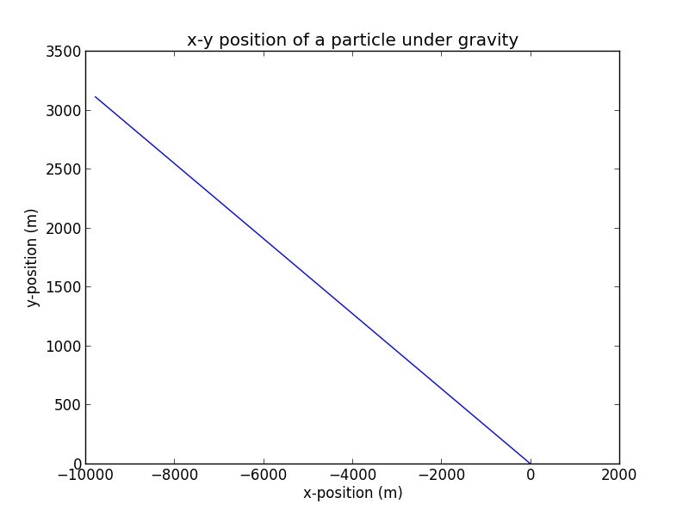

Symplectic-euler algorithm with dt=0.1
Velocity-verlet algorithm with dt=0.1

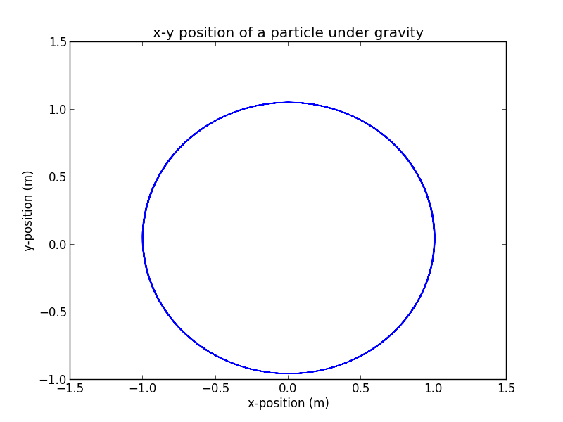
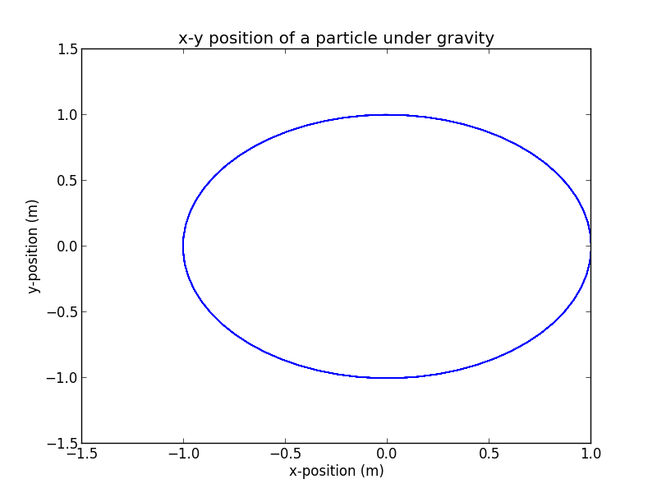

Symplectic-euler algorithm with dt=1
Velocity-verlet algorithm with dt=1

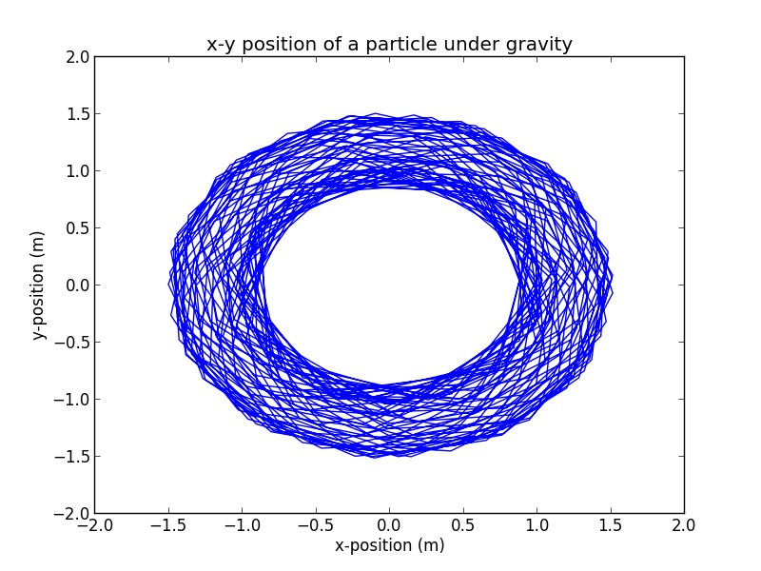
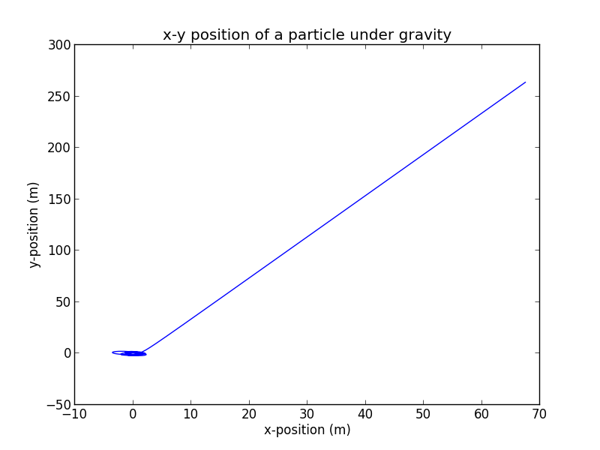

Velocity-verlet algorithm with dt=10
Symplectic-euler algorithm with dt=10

