CS Education Day: Experienced with BYOB

Welcome to Cal! You’re going to work with BYOB (Build Your Own Blocks), our advanced version of Scratch, a programming language for kids developed at MIT. The activities in this document are for people who have used Scratch and BYOB before. If that’s not you, try

http://bit.ly/cs-ed-1 if you have not used Scratch before.
http://bit.ly/cs-ed-2 if you have used Scratch before, but have not used BYOB.

Mission #1: Draw a squiral using a for loop
BYOB comes packaged with many useful blocks. To use these blocks, click on the “Choose New Sprite From File” button just below the stage. Select the sprite called ToolSprite from the list of sprites that pops up:

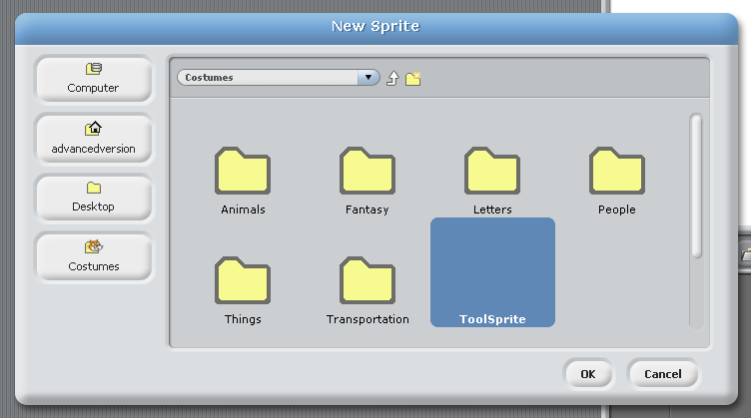

You should see a bunch of new blocks on the stage, and a new sprite called ToolSprite in the list of sprites being used. We don’t actually need the new sprite; we only need the blocks that it brings. Right-click on the sprite and click “delete.” Once you’re done, you can move from tab to tab in BYOB, and explore the new blocks that are now available for you to use. For example, these are the ones available in the Control tab:
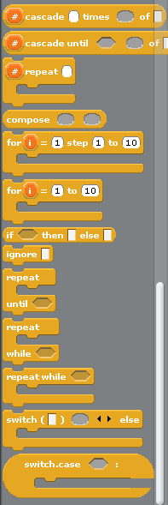
Let’s use one of the new blocks to create a squiral, which is a delightful cross between a square and a spiral:
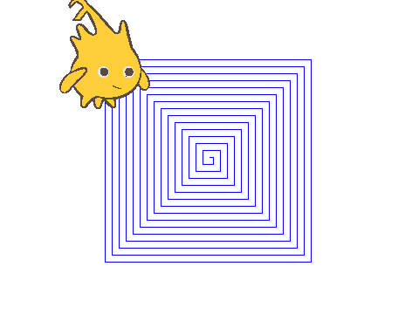
In particular, we will use the for loop:
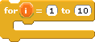
The for loop is similar to the other looping blocks in the Control tab, such as the repeat loop: in fact, just like the repeat loop, it runs the script placed inside it a specific number of times. In this case, it runs the script 10 times, one for each of the numbers between 1 and 10. The main advantage of the for loop over the repeat loop, however, is the variable near the top, whose value changes from 1 and 10 as the loop runs.

Enough talk: let’s try it out! Create the following script on the stage and run it:
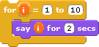
Can you use the for loop, the move and turn blocks from the Motion tab, and the pen down block from the Pen tab to create the squiral shown above?

Mission #2: Create the for loop yourself!
As you might imagine, the for loop comes in handy in a lot of different situations. In the previous exercise, you used a for loop that was provided to you. But you could have drawn the squiral without using for, by using “Make a variable” to create the variable i and then using change ____ by 1 to increase the step size.

Wait... you mean you could everything that a for loop can do before you even had a for loop? That means that you should be able to build your own for loop using the same techniques that you have used in BYOB before! How could we make a for loop as a custom block?

There are a couple of clever block-related tricks in BYOB that you may not have used before, such as making C-shaped input slots and using a special type of input slot called an upvar.

First, use “Make a block” to make a new Control block called for loop with one input called action. The first thing we need to do is convert the block from the standard command block form into a C-shaped block form. Click on the action input and edit its properties. Select the C-shape type. After clicking OK, you should see a [ character besides the action input that you were just adjusting. If you look at your newly created block, you will notice that it is C-shaped!
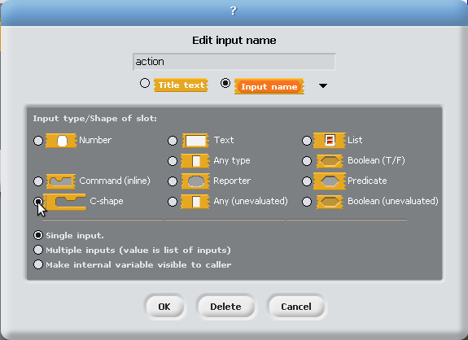

We are off to a strong start so far. The next part to set up an upvar. The parameter in the for block you used for Mission 1 was an example of an upvar: it simply allows the script in the C-shaped slot to use the value of that variable while the block is running. Let us create a new parameter called i and turn it into an upvar. Add two numeric input slots also:

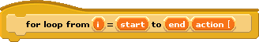
To convert an input into an upvar, open the properties of the input i and select “Make internal variable visible to caller.” After clicking OK, you should notice a small arrow pointing upwards beside the input’s name. This is how BYOB identifies upvars.

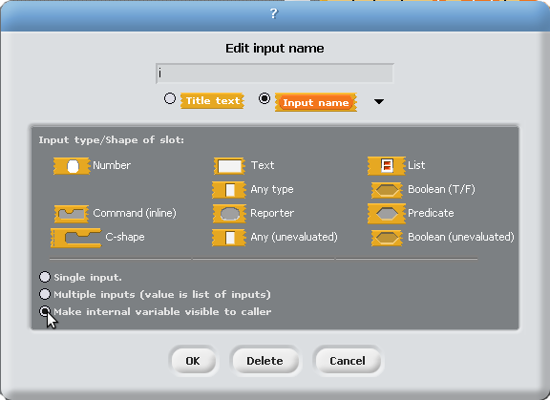

Check out your loop! Now, it has all of the correct tools in place, except for the script of the for loop block itself. How do you make the for loop block actually run the script placed in its body?
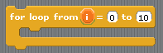

This is where the run block, located in the Control tab, proves useful:
The run block, as the name implies, runs the script that is passed into it. Since the action parameter refers to the script placed in the body of the for loop, we can run this script with a simple

Now, it is up to you to complete the main mission: how would you run the script stored in action as many times as the user specifies? Also, how would you change the value of the variable ?

Once you are done constructing your for loop, see if you can use it instead of the one we provided for Mission 1. If so, then you have succeeded in your mission!

Extra for Experts: Add extra features to the for loop block
We have all had the sinking feeling that our homemade for loop does not do everything that it could. If you are looking to push the limits a bit, try implementing these two features:
- Stepping - Sometimes you don’t want your loop to run for every number in the specified range. Let us say, for example, that you wanted to run a for loop with only even numbers. By allowing users to specify a step size, you essentially give them the power to progress through the number range in a pattern of their choosing. For example, a for loop from 1 to 10 with a step of 3 would run with getting the values 1, 4, 7, 10.
- Decrementing - In an ideal world, users would be able to specify either increasing or decreasing ranges into a for loop. Your loop currently only supports increasing ranges. How could you modify it to support both increasing and decreasing ranges?

-----------------------------------
Scratch (http://scratch.mit.edu/) and BYOB (http://byob.berkeley.edu/) are freely available online.

