UE4 - UX Improvements Project Liam Kelly

Team

Liam Kelly

# Sources

[Matt Aspland – Youtube - (Collect 'X' Items To Win / Open A Door | Collectable System - Unreal Engine 4 Tutorial)](https://www.youtube.com/watch?v=r5Cx180UFEQ&t=691s)

This tutorial helped me to enable and disable input within player range of an object, along with the formatting of stored variables to text.

[CodeLikeMe – Youtube – (Unreal Objective Markers with Distance)](https://www.youtube.com/watch?v=QybsOfCNLn8&t=364s)

This tutorial helped me to calculate and display the distance from player character and actor placed in world.

# UX Improvements

My main focus was to create a more engageable level to give the user some sort of task, rather than just killing the AI and winning. I added the following UX improvements to the game world provided:

1. Splash screen - Rather than the game world starting instantly, on start it brings the user to a main menu where they have option when they want the game to start, along with a “controls” menu with information regarding user input. This can be experienced by launching the map ‘Menu’ and clicking the start button which starts the game level through the following screen.
2. Marked various objects in world that user can interact with. These can be experienced by the user seeing icons in the game world with a distance from that object. This indicates to the user that something of use may be in the area and gives reason for the user to engage with it.
3. Ability to pick up objects with user input– This can be experienced by walking up towards the marked object and hitting an input in order to pick up (or destroy) the object.
4. Mission objective placed on HUD: This can be experienced in the top right of the HUD, giving the user an objective in the game world. Having an objective adds to the game flow, by having progression tasks to achieve. ie, kill enemies and collect statues, rather than the character just staying in the game world
5. Add health measure on HUD to show player how much health remains. This can be experienced by the progress bar above the zombies head which depletes when player hits it.
6. Restart level once player dies – this can be experienced by running into the enemies and making health reach 0. The level will reset to its original state.
7. Textures: various textures were placed in the game world to give realism the environment.

# UX Justification

Having an objective system significantly improves the game flow of a particular game. Originally being spawned with zombies running at you was not a very rewarding objective. A mission objective gives emotion to the player by gaining a sense of achievement from the feedback on each collected item or enemy killed.

Having marked collectable objects in the game world gives the user some motivation and desire to explore the game world or seek out something that is purposely drawing attention from them.

Like marked objects, health of enemies you are attacking is also useful information to have within a game world. Perhaps under different implementation, there would be limited ammo, and other things you would have to worry about. Where knowing the enemy’s health would be extremely helpful in regard to what you should do next. This gives valuable feedback to the player.

The ability to pick up objects also give the player the feeling of achievement. Perhaps a future implementation could be similar to a roguelike game, where you gain experience/skill points, or get to pick a certain item whether it be fixed or random.

Overall, I feel my UX improvements has made the game much more engageable and motivates the player much more than in assignment 2. I mainly focused on engage ability, and signs and feedback from Hodents UX design. The mission objective gives purpose to the level and is a direct goal for the player to complete and gives feedback to the player on how they are doing within the game world. The marker gives a sign to the player that it is an object of importance to them.

# UX Testing

My level was tested by my non-gamer girlfriend who has limited knowledge in computer games. While starting the game, she clicked outside of the button area while trying to select a button and said she couldn’t select a menu item, something I had not noticed prior. She discovered a flaw which I was not aware of – the game running behind my start screen.

While playing the game, she understood the purpose of the game from the objective text in the upper right of the HUD and was able to successfully kill all the zombies and collect three statues but died by collision on the stairs while trying to collect the fourth statue - which was behind the glass wall. I explained that hitting walls and other things will lower her health. (Something I would change not under time constraints) She tried a second time after knowing that walking into walls does damage to the player, and successfully killed the zombies, collected the four statues, and ran to the portal, and then asked why anything isn’t happening. I then explained that it wasn’t implemented yet, and ideally, she would run into the portal since all mission objective conditions have been satisfied, and it would start a new level with new objective, and new enemies to kill.

Overall, I believe it was useful in having someone else test the game, since I was not aware that clicking in the black area of my start game widget would interact with the original map level.

# Other Notes

Ideally, while not under time constraints I would have liked the portal to start a new level once the required conditions have been met. I originally planned on having the markers compass style like a game such as Skyrim, but I ran into trouble with creating and sizing the compass bar and lining it up with the direction of the game word, so I settled for in game markers with distance from player. I planned to make an inventory but felt it didn’t add anything to what I was currently making so I scrapped the idea due to time.

Included in the project folder is a video on how the game is played.

Code Appendix (‘->’ indicates blueprint ref)

1. Splash Screen -> (FirstPersonBP/Maps/Menu)

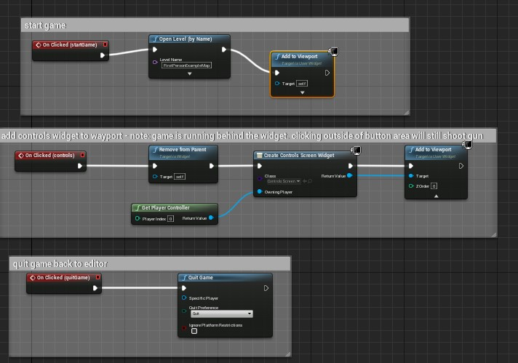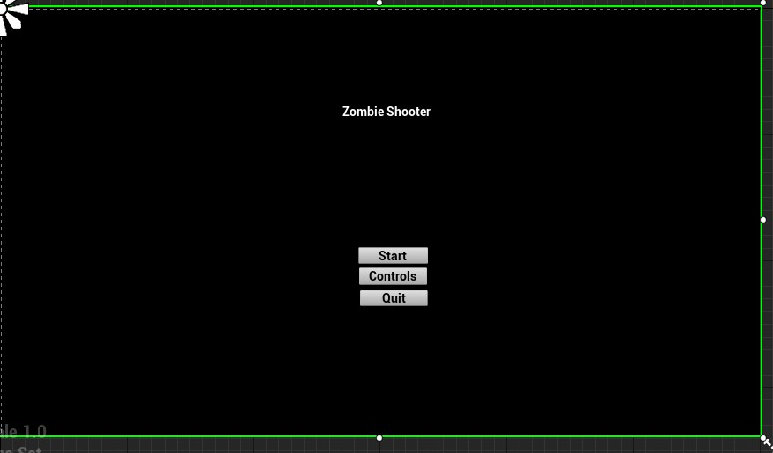

Controls Screen after button onClick “Controls”

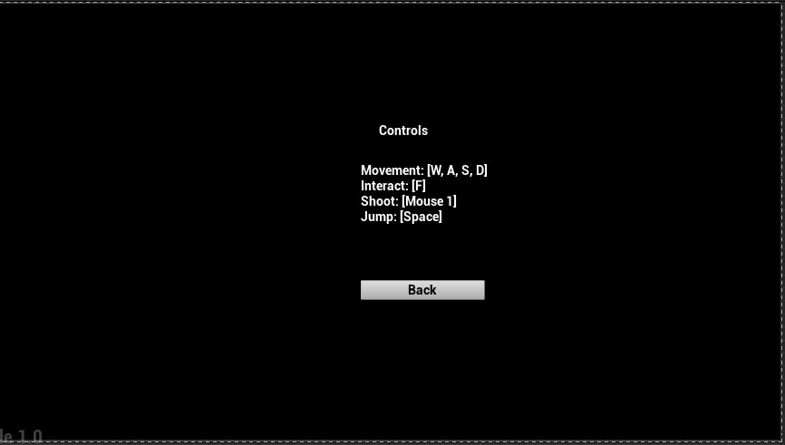

1. Object Markers relative distance text -> (FirstPersonBP/BP_Marker)

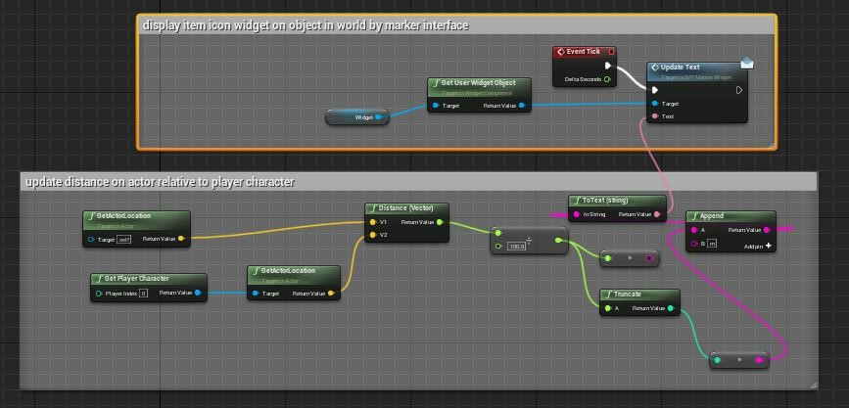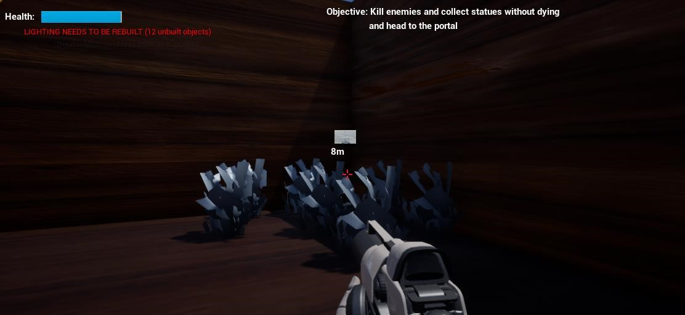

Marker Widget with text -> (FirstPersonBP / MarkerWidget)

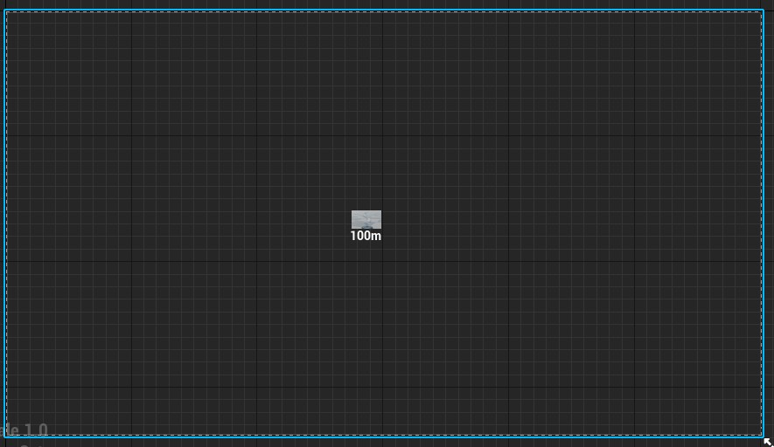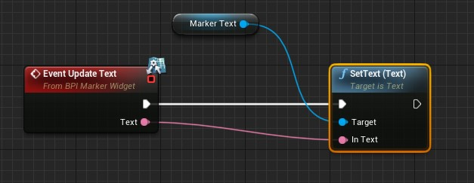

1. Ability to pick up statue objects on key press -> (FirstPersonBP/BP_Marker)

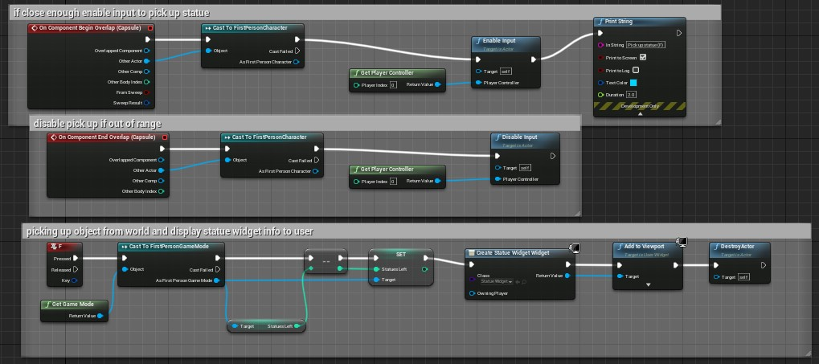

1. Determining and displaying the number of statues on HUD ->

(FirstPersonBP/Blueprints/FirstPersonGameMode), (FirstPersonBP/StatueWidget)

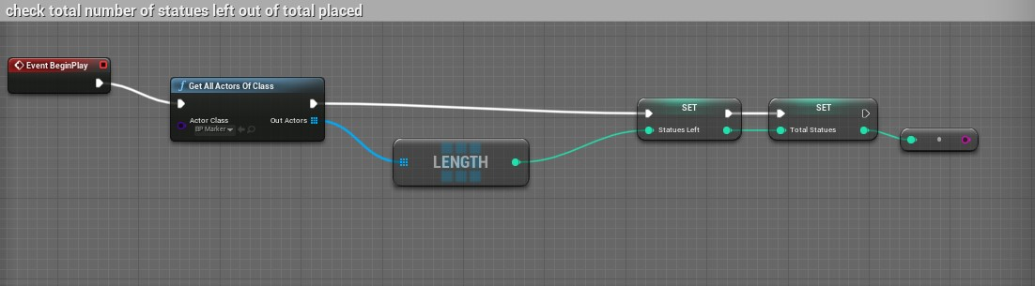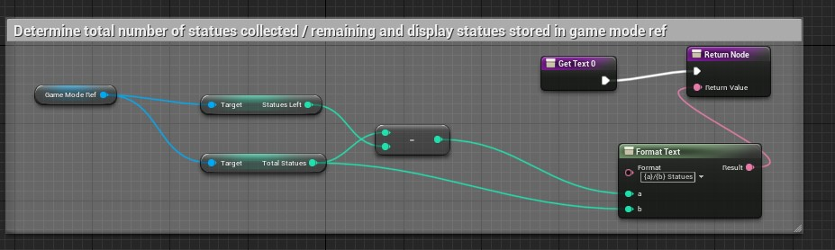

Make ‘success: all enemies killed’ visible if all ZombieCharacters are destroyed, rather than having WIN in middle of screen/reset game like in assignment 2 -> (FirstPersonBP/SurvivalHUD)

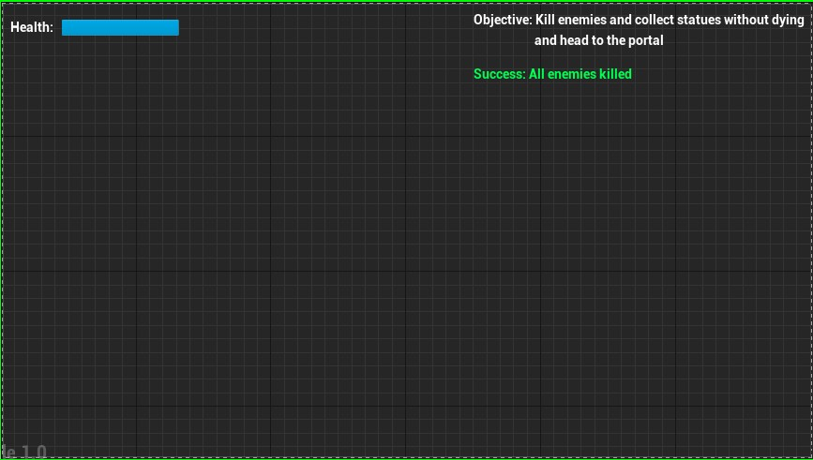

1. Enemy Health Bars displayed to user -> (FirstPersonBP/ZombieAI/Zombie Character), (HealthBar)

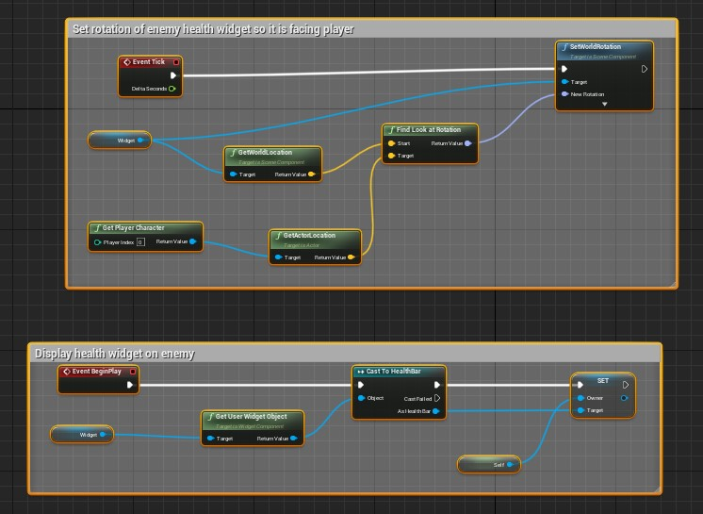

1. Reset game on player death -> FirstPersonExampleMap

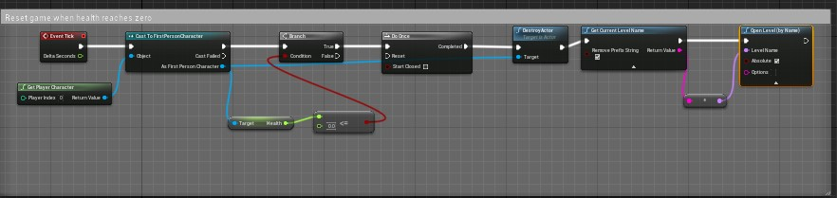

1. Textures –> inside world placed static meshes