Group 18 Report

We are very happy with our final program believe we worked well as a team despite the challenging circumstances.

The work was divided between our three group members, Liam Junkermann, Liam O’Lionaird and April Sheeran. Liam J did a lot of work on importing and processing the data. He worked on displaying the data in graphs, text panels and ensuring the program ran smoothly. Liam OL implemented the scrollbar and the slider. He also added colour to many aspects of the program and made sure the filtering by date on the graph using the slider worked efficiently. April worked on the screen class and implemented the widgets to change screen. She also worked on the biggest changes in stock and displayed them filtered by sector or by year.

Our design idea was to create a clear, visual, and accessible program to display and interact with the stock data. Liam O’Lionaird created a mock-up of the original design idea, shown below.

Our final product was slightly different from that original mock-up but contains all the required functionality. After the loading screen, the homepage is displayed. On the right a list of the 20 largest overall changes in stock price. They are coloured coded in red and green to clearly display if the stock decreased, red, or increased, green.

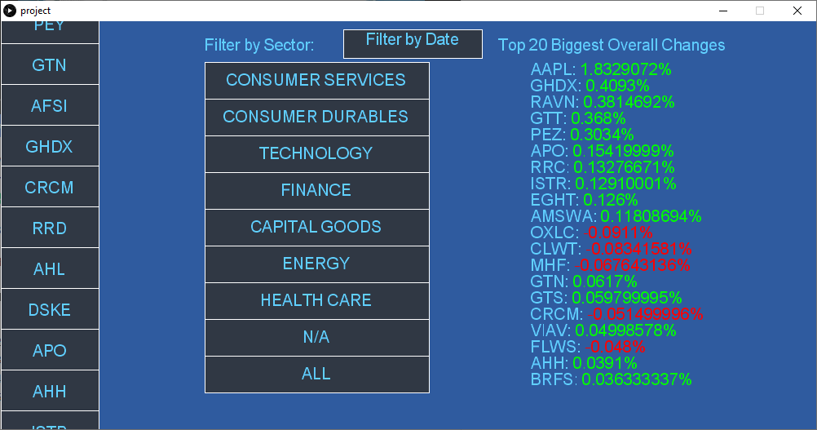

Next to this list there is a set of widgets to allow the user to filter this list by sector.

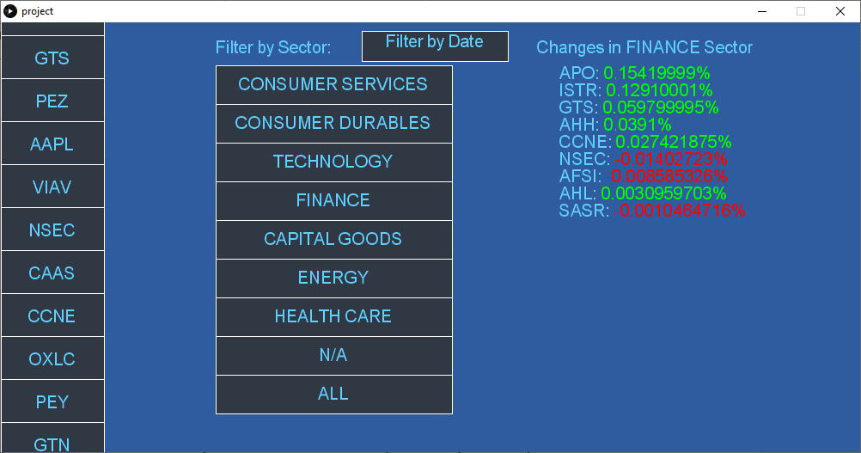

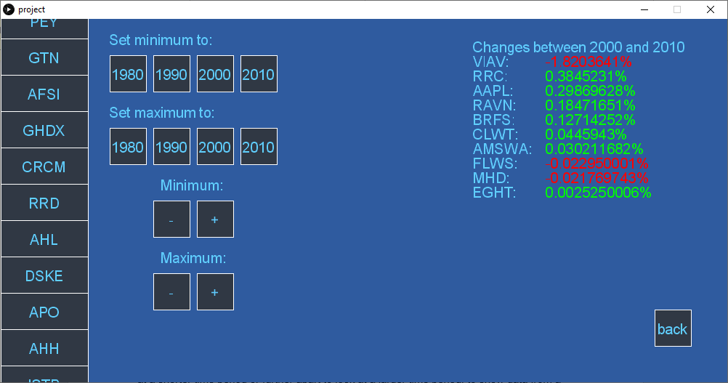 There is also a widget labelled “filter by date” which, when clicked, brings the user to a new screen. This screen displays the biggest changes in the stocks within a given time period of years. There are multiple widgets to allow the user to set, increase or decrease the maximum and minimum of the range of years. This list is also colour coded for clarity.

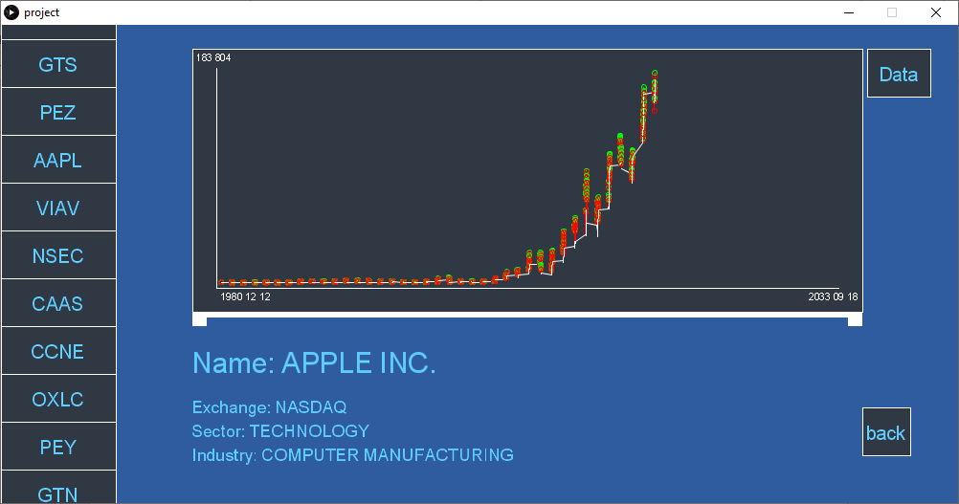On the left-hand side of the screen, a scrollbar containing all the stocks as widgets. The user can easily scroll up and down the list with the mouse and select a stock to view. When a widget is pressed, the user is brought to a new screen displaying data about the stock. It displays the name, sector, and industry of the stock in text below the graph. The graph displays the change in price of the stock over time. The red and green points indicate the closing and opening stock prices.

There is also a slider implemented below the graph. This allows the user to adjust the graph, by moving the ends of the slider closer together to look at a shorter time period or further apart to look at a larger time period, to show data from a specific time range. The dates are displayed on the graph.

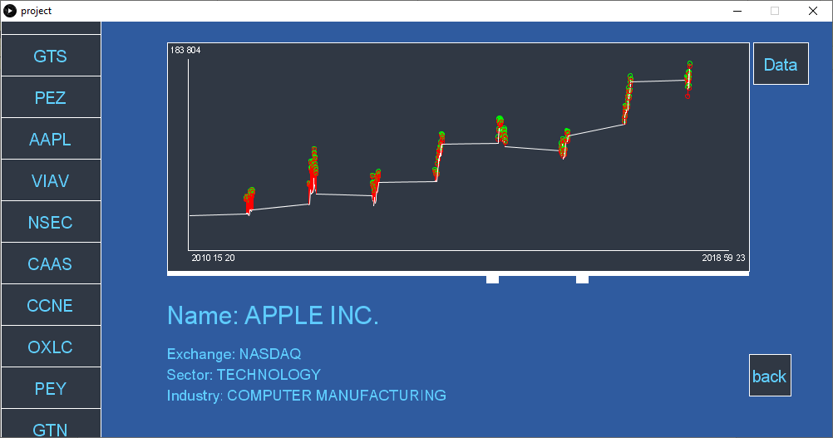

A large problem we encountered was trying to filter the stock data by date. Trying to filter the largest changes by exact date was difficult as not all the stocks had recorded data on those dates. It was then decided to filter this list instead by year to give a more general overview of the changes. A similar issue was encountered when trying to implement the slider to adjust the date range of the graph. It was tricky to align the movement in the slider with the adjustment in the graph range. This problem was resolved, and the sliders and graphs work well together.