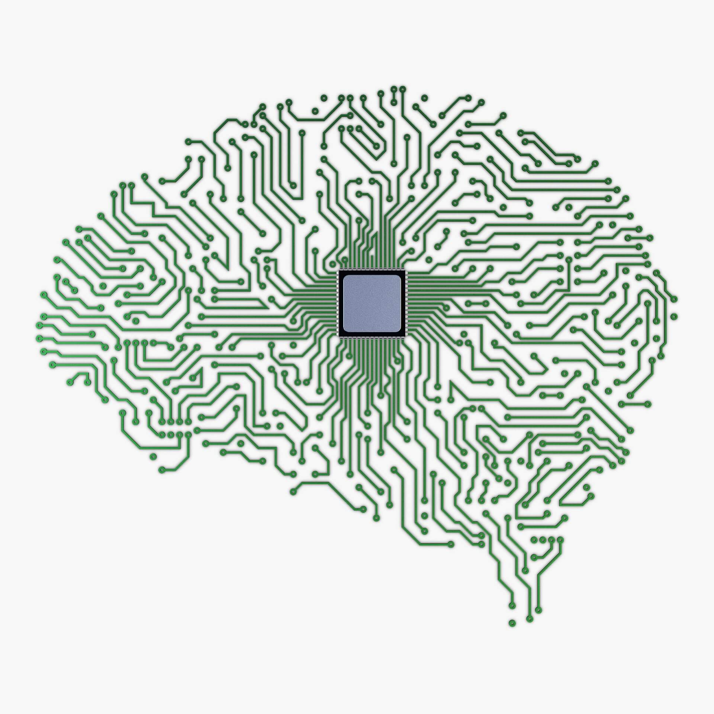 **Liam Barstad**

**Machine Learning – Data Engineering – MLOps**

|  |  |  |  |  |  |  |
| --- | --- | --- | --- | --- | --- | --- |
| |  | | --- | | **Contact**  **Phone:** 720-224-5041  **Resume:** [resume.liambarstad.com](https://resume.liambarstad.com/)  **Consulting:** business.liambarstad.com  **LinkedIn:** [linkedin.com/in/liam-barstad](https://www.linkedin.com/in/liam-barstad)  **Github:** [github.com/liambarstad](https://github.com/liambarstad) | | **Summary**  Multi-talented Software Engineer with 5 years of industry experience working with big data and predictive analytics.  Creative, diligent, agile, and business-oriented, well-versed in enabling Machine Learning teams and automating large scale operations | | **Technical Skills**  **Languages: Python – Javascript – SQL – Ruby**  **Libraries: Pytorch – Spark – Airflow – Flask – React – Redis – Neo4j**  **DevOps: Linux – Docker – MLFlow – Kubernetes – Kubeflow – AWS – GCP**  **Machine Learning: Reinforcement Learning – Time Series Analysis – Gradient Boosting – Regression – Classification – Unsupervised Learning – Text to Speech** | | |  | | --- | | **Experience**  **Operations Specialist – AT&T – 2 years**   * Real-time Anomaly Detection for systems monitoring * Internal tooling for operations monitoring, using Flask/React/Airflow/SQL tech stack * LSTMs, predictive analytics and graph-based algorithms for customer journey analysis   **Machine Learning Consultant – Align Tech and Finance – 2 months**   * Profitable Deep Reinforcement Learning solutions for trading and arbitrage * Deployed to AWS SageMaker pipeline   **Research Support Engineer – Quantum Metric – 1.5 years**   * Custom analyses, including a kernel two-sample test in SQL, for enterprise clients * Back-end pipelines in Airflow, Kubernetes, and GCP for custom reports * Feature extraction and ETL processes for the research team   **Senior Web Developer – Zober – 1 year**   * Lead a team of 4 developers, using agile and SCRUM methodologies * Created the first iteration for a production ecommerce platform in Ruby on Rails and React | | **Education**  **UCSD Machine Learning Certification - 2023**  **Turing School of Software and Design - 2017**  **Front Range Community College - 2016** | |

**Projects**

**Pee Wee Text to Speech** – peewee-tts.liambarstad.com - github.com/liambarstad/peewee-tts

This project is a combination of 3 deep neural networks that work in tandem to generate speech that sounds like the beloved character Pee Wee Herman. An LSTM encoder generates an embedding that differentiates the speaker. A Tacotron 2 Deep Neural Network with attention synthesizes the mel spectrogram, and a WaveNet vocoder translates the spectrogram into speech