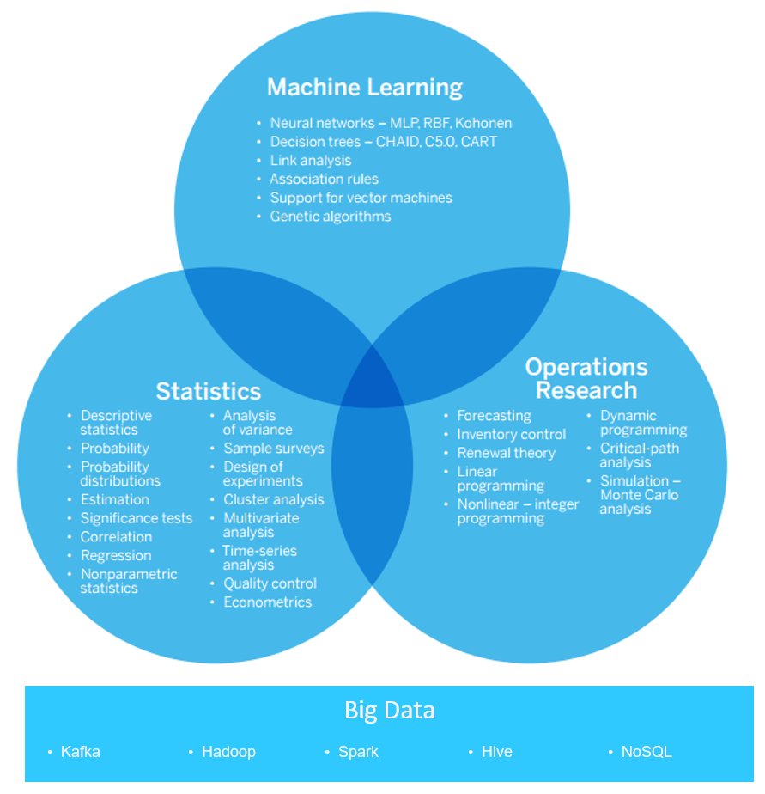

**Big Data**

• Ingestion • Storage • Analysis • Querying • Visualization