# Problem Analysis

This program calculates the total revenue made by selling seats at four different levels to a football game. The four levels are: Box at $250 a seat, Sideline at $100 per seat, Premium at $50 per seat, and General Admission at $25 per seat. This data is loaded into C++ by opening and reading a file. The output produced is the total revenue and the total number of seats sold. The total number of seats sold should be in integer form, and the total revenue should be to two decimal places. This output is then exported to a text document in the working directory (unless otherwise specified).

# Algorithm

1. Assign each variable a data type: price, sold (which is the number sold at each price), box, sideline, premium, GA, rev (total revenue), seats1, seats2, seats3, seats4, and seats (total number of seats sold).
2. Open the appropriate input file, in our case this is **football.txt**.
3. Open appropriate output file/create output file: **ticketsSold.txt.**
4. Tell the user that the system is processing and where to find the output document.
5. Define the precision for the output.
6. Store price and seats sold for each level.
7. Calculate total seats sold by adding each level’s seats, and total revenue by adding each level’s revenue.
8. Print these in the output file.
9. Close the input and output files.
10. Terminate program.

# User Documentation

In order to run this program, open **Visual Studio**, and navigate to the **File 🡪 Open 🡪 Project/Solution** and select the **FlannaganPA3** file in the appropriate file location.

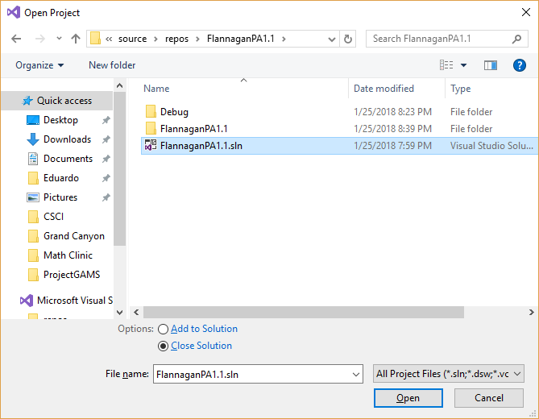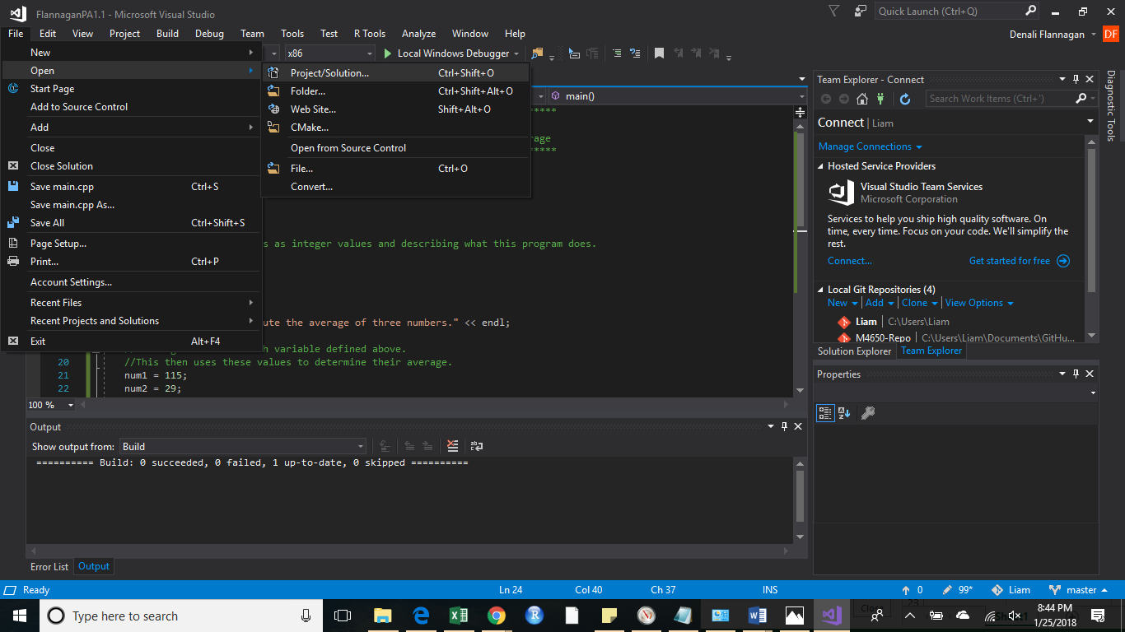

Next, ensure that the required file containing each level’s prices and seats sold is in the appropriate directory. Visual studio will assume that the file is in the current working directory, where the project is stored, unless otherwise specified.

There are many ways to find the file location, but here is one. On the right hand side under **Search Solution Explorer**, right click on **Solution FlannaganPA3**, and select open Folder in File explorer.

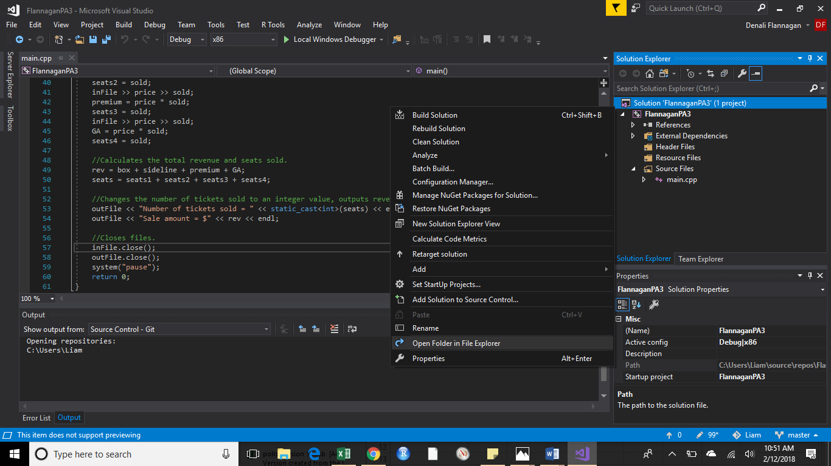

You will need to go into the **FlannaganPA3** folder, since this first folder only contains the solution. You should see **football.txt**; if you do not, just save a text file, with that name in this directory. The other option is to save this document in any location on your computer, you will just need to specify that location when telling Visual Studio to open this. You do this by entering a path like “C:/Users/Liam/Documents” if **football.txt** is in the Documents folder. Note that copying a path produces forward slashes “/” but because C++ uses thes as comments, you will need to replace the forward slash with a back slash “\”.

This program also assumes that the first line of the document contains text to determine what information each column represents.

Once you have done this, select the **Local Windows Debugger**. This will open a new window.

You will see a screen informing you that the program is processing, and then what file to open in the working directory to see the results.

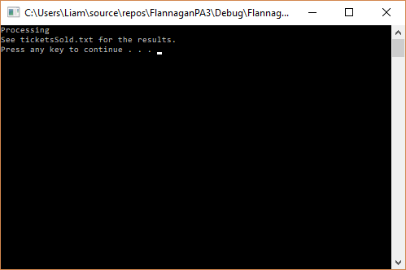

Press any key to exit this new window.

Navigate to your working directory and you will see the new document. Open this document, and you will see the results.

