# Problem Analysis

This program seeks to calculate and output the possible distance a user can drive based on his input values of his vehicle’s tank capacity and miles per gallon. The capacity and MPG are our program’s data, and it is determined by user input. The output we wish to see is the estimated distance this user can drive. This output should take the form of an integer. Specifically, it should return the next lowest integer (round down).

# Algorithm

1. Create the number variables: capacity as an integer, mpg as a float, and distance as an integer.
2. Prompt the user for his vehicle’s capacity.
3. Prompt the user for his vehicle’s miles per gallon.
4. Set the variable *distance* to the formula *(capacity*mpg)*.
5. Output the user’s input, as well as the distance the vehicle can run.
6. Terminate program.

# User Documentation

In order to run this program, open **Visual Studio**, and navigate to the **File 🡪 Open 🡪 Project/Solution** and select the **FlannaganPA2** file in the appropriate file location.

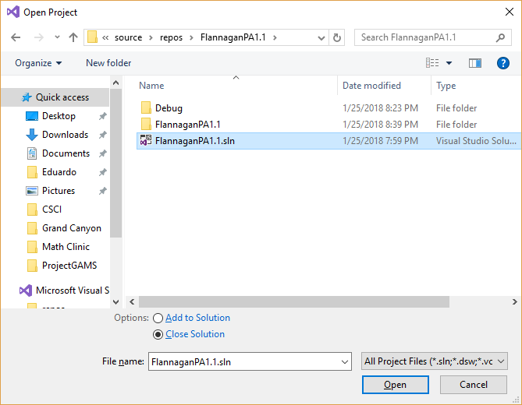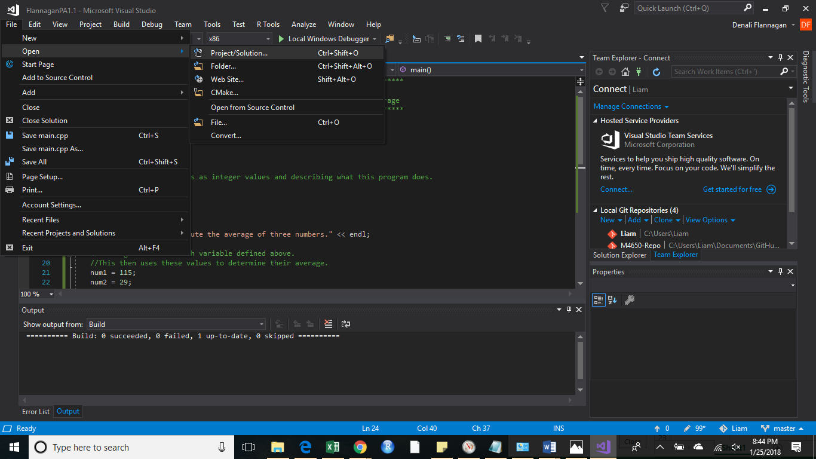

Once you have done this, select the **Local Windows Debugger**. This will open a new window, that looks very similar to command line. Here you will see the output from this program.

You will be prompted to enter your vehicle’s tank size in gallons.

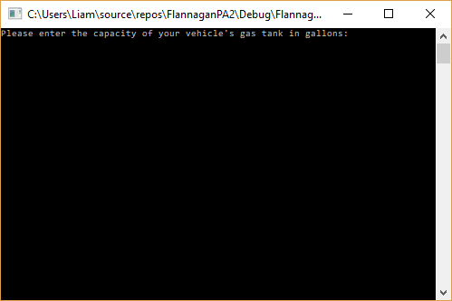

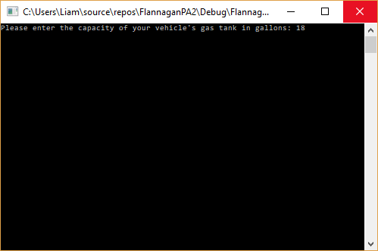

My vehicle’s tank holds 18 gallons of gas, so that is the value I have used. Once you have entered your tank size, hit enter to move to the next prompt.

Now you will be prompted to enter the vehicle’s miles per gallon. You may enter a decimal value here.

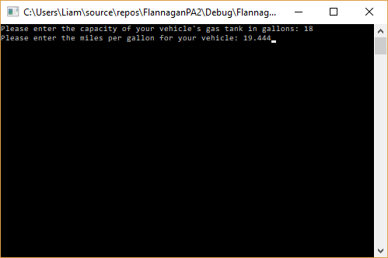

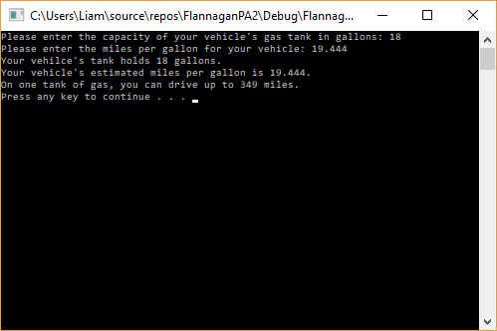

Press enter to see the total number of miles your vehicle may drive without refueling.

Press any key to exit this new window.