# Problem Analysis

This program calculates the total number of boxes and containers needed to store a user specified number of cookies. This data is based on fixed numbers: a box can hold 24 cookies, and a container can hold 75 boxes. This program also relies on user inputted values, specifically the number of cookies. The output produced appears on screen. This program outputs: the number of boxes needed to store the cookies, if any; the number of left over cookies, if any; the number of containers needed to store the boxes, if any; and finally the number of extra boxes, if any.

# Algorithm

1. Assign each variable a data type: box, container, cookies, leftoversbox, and leftoverscont are set to integer. Set box and container equal to 24 and 75, respectively.
2. Ask the user for the number of cookies.
3. Determine if there are enough cookies for a box.
   1. If so, determine how many boxes are possible, and the number of extra cookies, if there are any.
      1. Calculate the number of boxes by taking (number of cookies/24), return last whole number.
      2. Calculate the number of extra cookies by taking cookies mod 24, and return this value. If cookies mod 24 is 0, then do nothing.
   2. If there are not enough cookies for a box, tell the user of this.
4. Determine if there are enough boxes for a container.
   1. If so, determine how many containers are possible, and the number of extra boxes, if there are any.
      1. Calculate the number of container by taking (number of boxes/75), return last whole number.
      2. Calculate the number of extra boxes by taking boxes mod 75, and return this value. If boxes mod 75 is 0, then do nothing.
   2. If there are not enough boxes for a container, tell the user this.
5. Terminate program.

# User Documentation

In order to run this program, open **Visual Studio**, and navigate to the **File 🡪 Open 🡪 Project/Solution** and select the **FlannaganPA3** file in the appropriate file location.

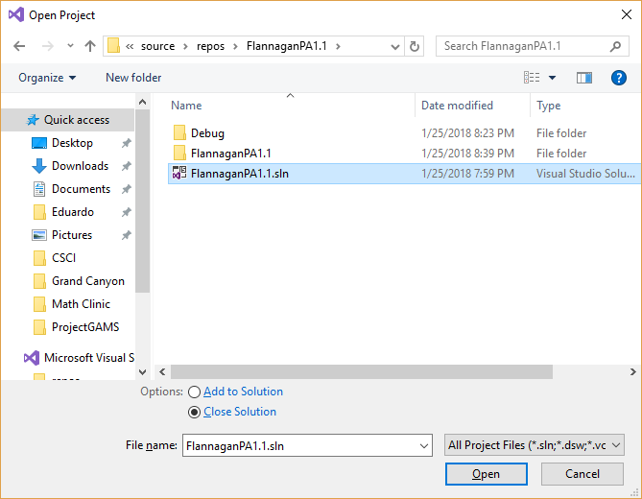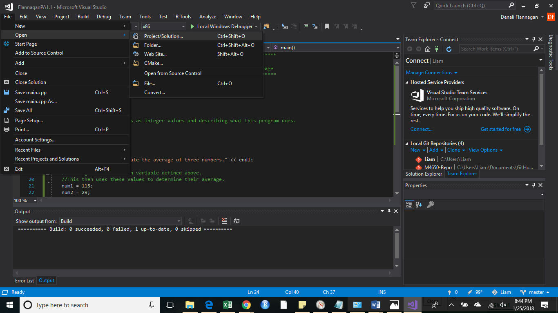

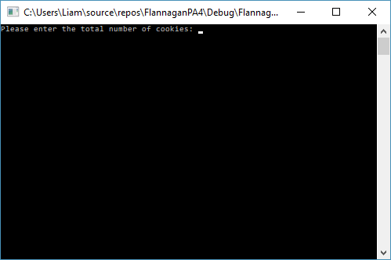Select the **Local Windows Debugger**. This will open a new window.

Enter the number of cookies as prompted, then press enter.

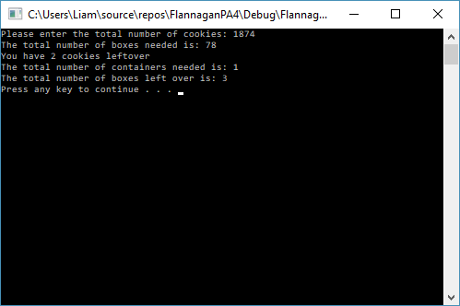

Press any key to terminate the program.