# First Number = 87, Second Number = 125

To test data from the problem description, enter 87 and 125 on each line as prompted.

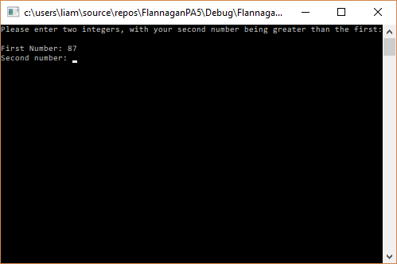

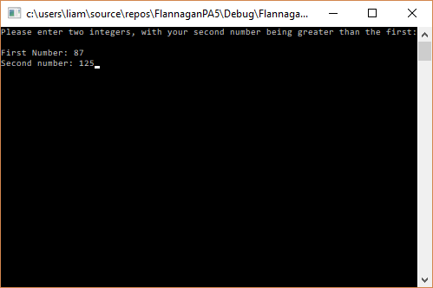

Once we press enter, we see the same results from the problem description:

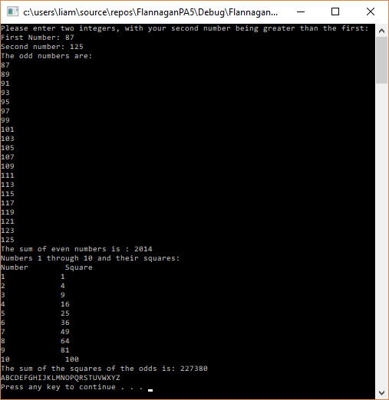

# First Number = 10, Second Number = 25

Enter the first number and second number as prompted, and then press enter.

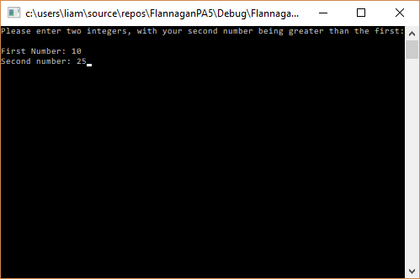

We see that it prints out the information correctly:

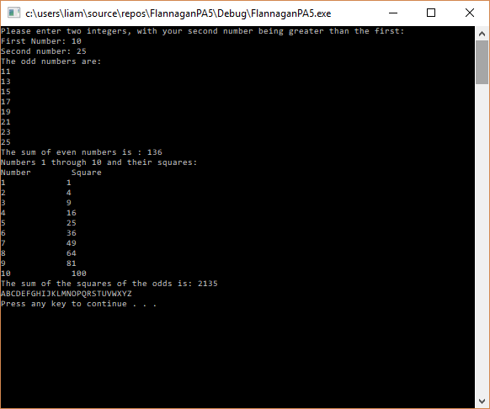

# First Number = 90, Second Number = 10

Entering 90, and 10 for the first and second numbers yields the following results:

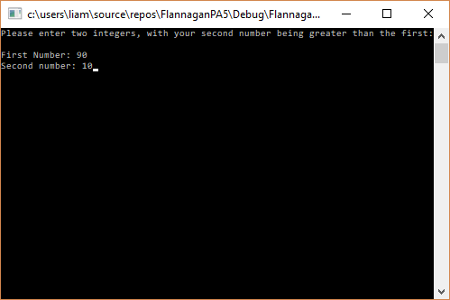

Since there are no odd numbers between 90 and 10, by our algorithm, the program leaves that entry blank. It also calculates the sum of the evens, and sum of the odds squared to zero, for the same reason. The program does, however, continue to output number 1 through 10 and their squares, as well as the capital letters from A to Z.

