# Temperature = 11F, Wind speed = 88mph

To test data from the problem description, we enter 11 for the temperature, and 88 for the wind speed.

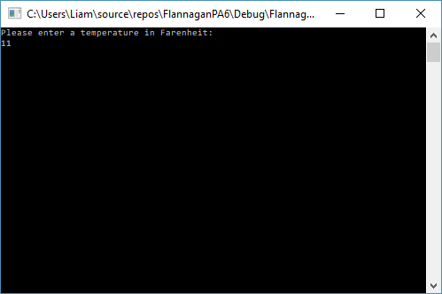

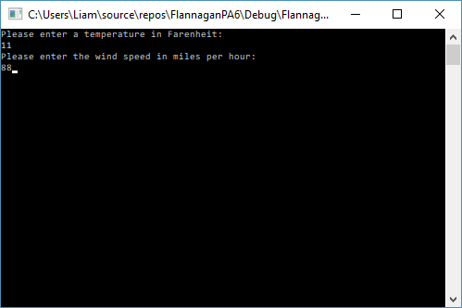

Once we press enter, we see the same results from the problem description:

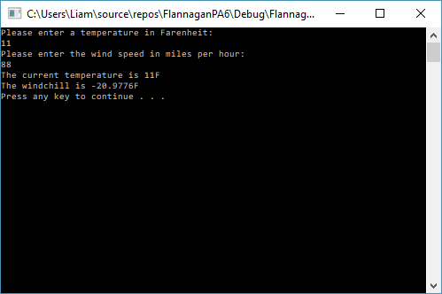

# Temperature = 32F, Wind speed = 15mph

Enter 32 for the temperature and 15 for the wind speed. We yield the following results:

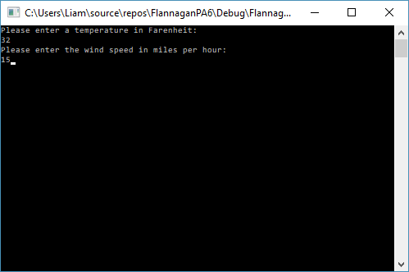

We see that it prints out the information correctly:

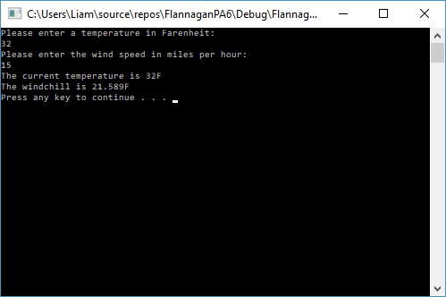

# Max and Min Ranges

## Min Range for Wind speed:

This program has a loop built in to prevent the user from entering a negative speed, so the lower limit on wind speed is 0.

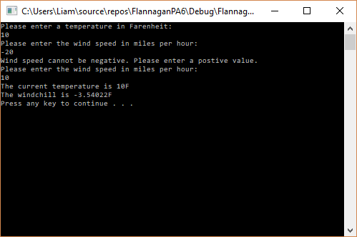

## Max ranges for Wind Speed, Min Range for Temperature:

Since these variables are of data type *double* they have a maximum and minimum ranges of   
-1.7*10^308 and 1.7*10^308 respectively. If we take the literal max and mins of each, the highest temperature ever recorded was 134F in Death Valley in 1913[1], and the lowest temperature ever recorded was -128.6F in Antarctica in 1983[2]. So we could set a limit from -200 F to 200 F. We could also adjust the minimum for the temperature to be absolute zero, or -459.67F. The fastest wind ever recorded was in Australia in 1996 and registered 253 mph, so we could also set a limit to about 300 on wind speed.[3]

1. [World: Highest Temperature](http://wmo.asu.edu/content/world-highest-temperature) [Archived](https://web.archive.org/web/20170714144146/https:/wmo.asu.edu/content/world-highest-temperature) 2017-07-14 at the [Wayback Machine](https://en.wikipedia.org/wiki/Wayback_Machine). [World Meteorological Organization](https://en.wikipedia.org/wiki/World_Meteorological_Organization) 
2. Turner, J.; Anderson, P.; Lachlan-Cope, T.; Colwell, S.; Phillips, T.; Kirchgaessner, A. L.; Marshall, G. J.; King, J. C.; Bracegirdle, T.; Vaughan, D. G.; Lagun, V.; Orr, A. (2009). ["Record low surface air temperature at Vostok station, Antarctica"](http://nora.nerc.ac.uk/9656/1/jgrd15635.pdf) (PDF). *Journal of Geophysical Research*. **114**: D24102
3. https://weather.com/storms/severe/news/most-extreme-winds-earth