# Problem Analysis

This program reads a line from user input that has a student's first and last name, their social security number, user ID, and password. It then outputs these lines with the student's name, x's over the student's social security number, their student ID, and then x's over their password.

# Algorithm

1) Ask the user for their name, Social Security number, user ID (including S), and password.

2) Find the first number of the social security number, subtract one from that index, and then output the name from 0 to that point.

3) Find the beginning of the "S" number, perform similar calculation as the name to find the length of the social security number. If the number has 9 digits, then we know the user did not input dashes. If the number has 11 digits then we know it did have dashes. We reduce the 11 digits to 9, then “mask” the social by outputting the x’s.

4) Find the end of the S number, and output the characters from the end of the social security number number to the end of the S number (student ID).

5) Take the string length and subtract all of the characters calculated to this point, output x's reflecting the number of characters in the password string.

6) Terminate program.

# User Documentation

In order to run this program, open **Visual Studio**, and navigate to the **File 🡪 Open 🡪 Project/Solution** and select the **FlannaganPA3** file in the appropriate file location.

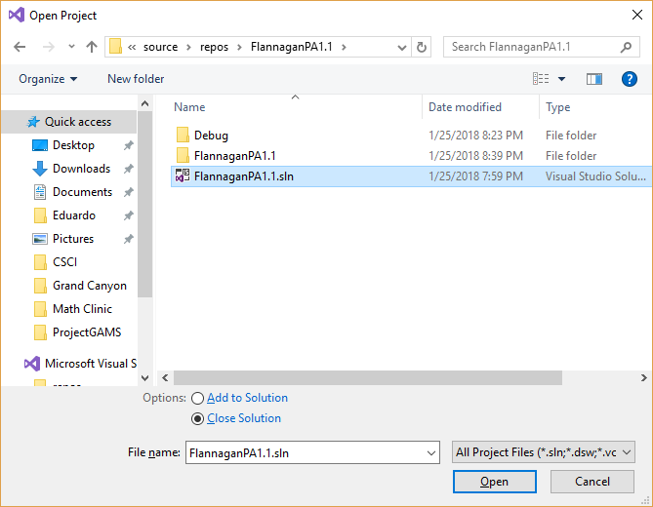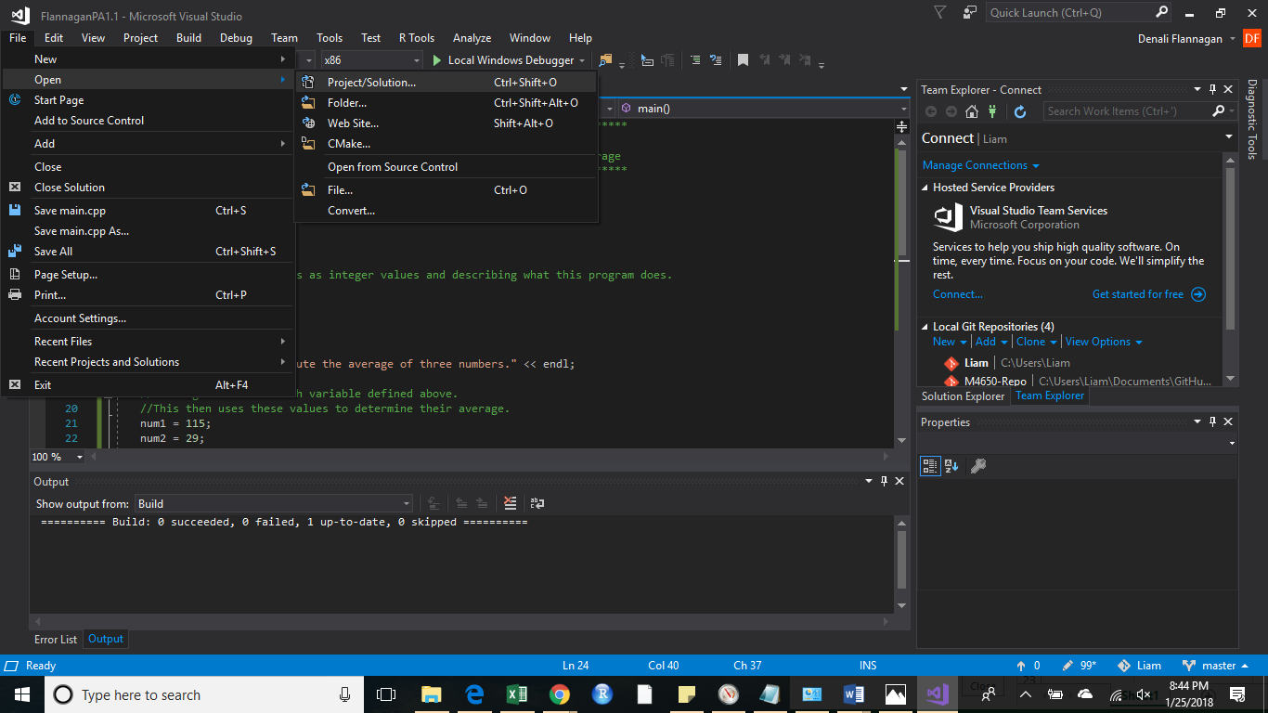

Select the **Local Windows Debugger**. This will open a new window.

Enter a student's name, social security number, user ID (including the 'S' of the S number), and password on one line.

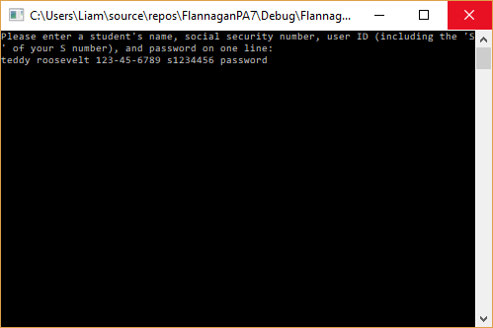

Press *enter* and the output will display below.

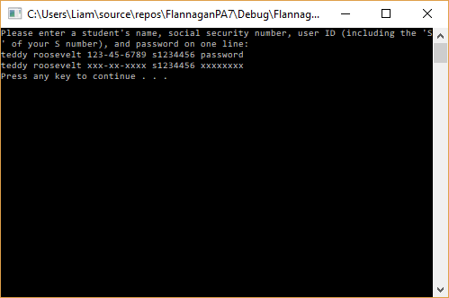

Press any key to terminate the program.