# Nominal Test 1

To test the data, we went enter the following string of text: Jane Smith 222-33-4444 S12345 password

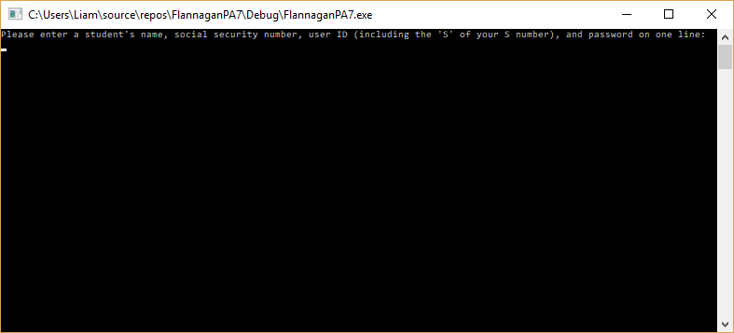

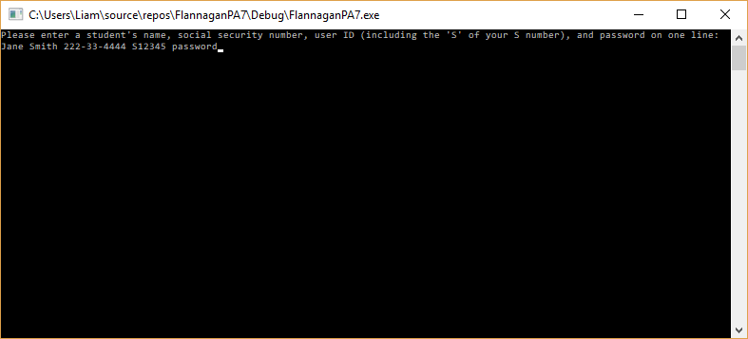

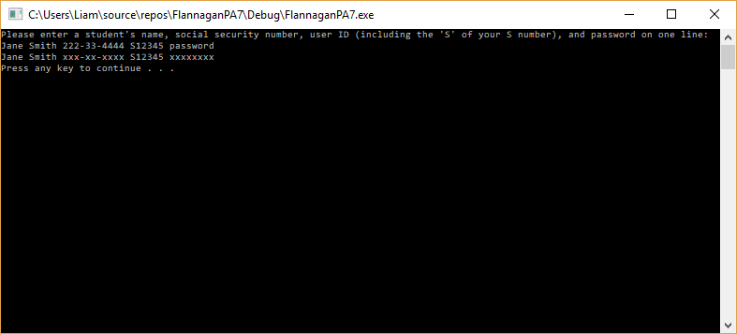

We see that the program outputs the same information as in the problem statement.

# Nominal Test 2

To test the data, we enter the following string of text: John Paul II 123456789 s1345676543 d0ntstopb3L!eving

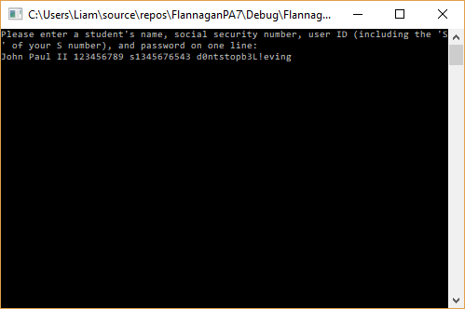

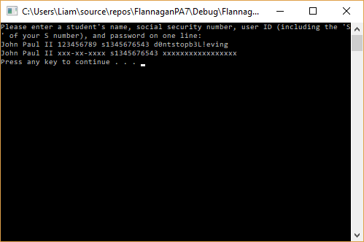

We see that the program accepts user input for the social security number without dashes, as well as with dashes (the previous example). It also accepts input for a variety of student ID numbers, provided they start with either an “s” or and “S.” It also outputs the correct number of characters for the password, regardless of the characters within the passwords (i.e. digits vs letters vs symbols).

# Max and Min Ranges

This program will output the string of any length for the names, student number, and password. If the user were to enter a number in the name, say John Paul 2 instead of John Paul II, the output would not be correct. This is because the program finds the first instance of a digit, so it would fail to output the user’s full name. There is no control structure in place to prevent this.

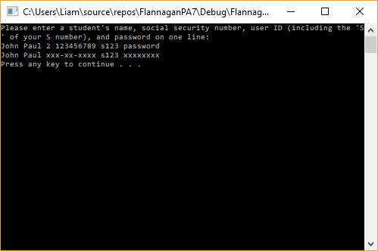

This program also does not handle social security numbers that are fewer than 9 digits or more than 11.

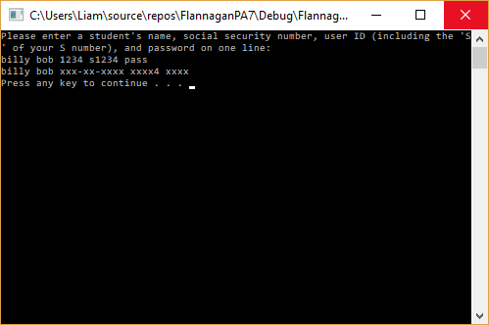

The program will accept any characters in the student ID number and the password, with the exception of spaces.

