# Problem Analysis

This program asks the user to enter the last names of five candidates in an election, and the number of votes received by each candidate. It then outputs the number of votes received, and the percentage of the total votes received by the candidate. It outputs the winner of the election. Data is from user input, and the output is a combination of strings and numbers in table format.

# Algorithm

# 1) Ask the user for the last names of the candidates and the number of votes they received.

# 2) Indexing over the 5 names, store the names and the values.

# 3) Indexing over the 5 numbers of votes, sum the votes.

# 4) Indexing over the 5 entries, output the names, number of votes, and % of the vote.

# 5) Indexing over the 5 votes, find the largest:

# a) If the vote is greater than the largest vote, then store vote in largest

# b) Move to next vote total.

# 6) Output the results. 7) Terminate the program.

# User Documentation

In order to run this program, open **Visual Studio**, and navigate to the **File 🡪 Open 🡪 Project/Solution** and select the **FlannaganPA3** file in the appropriate file location.

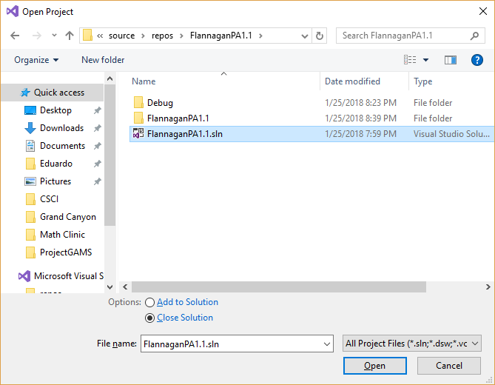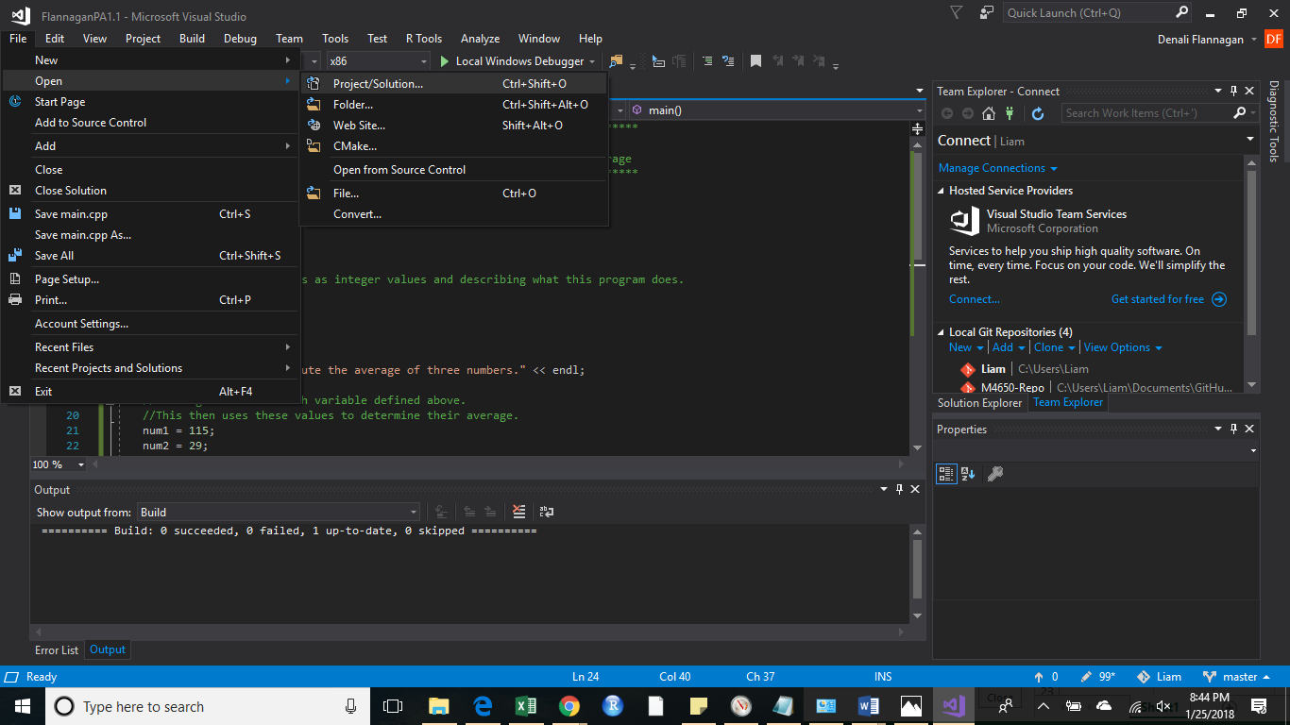

Select the **Local Windows Debugger**. This will open a new window.

Enter the candidates names and total vote tallies.

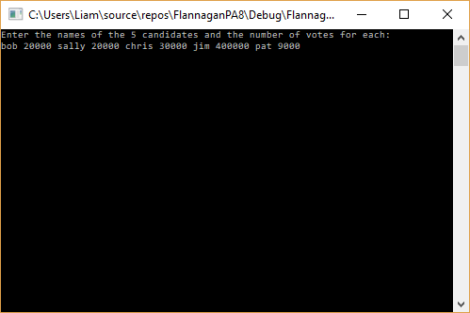

Press *enter* and the output will display below.

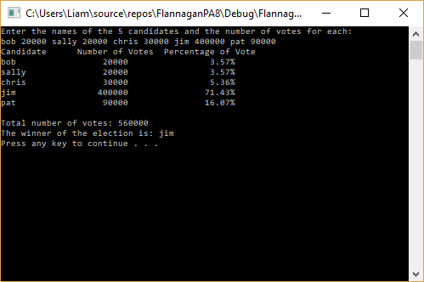

Press any key to terminate the program.