# Nominal Test 1

To test the data, we went enter the following:

Smith 12345 Jones 4567 Adams 555 Washington 888888 Jefferson 456789

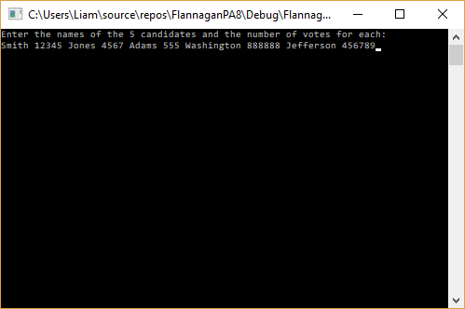

We see that the program outputs the same information as in the problem statement.

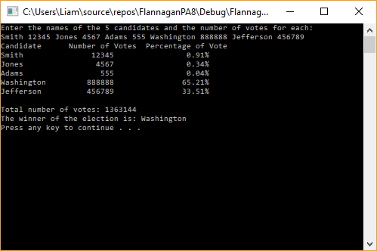

# Nominal Test 2

To test the data, we went enter the following:

Roosevelt 999999 Taft 888888 Wilson 923456 Harding 123431 Coolidge 987634

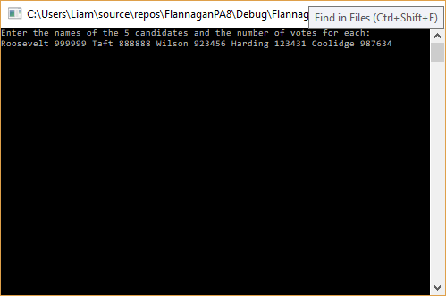

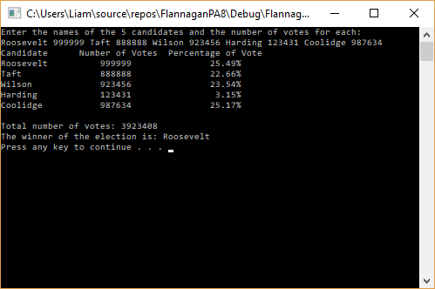

We see that the program correctly outputs the winner, and each candidates’ respective percentage of the total vote.

# Max and Min Ranges

This program will accept names of any length, provided that it is only one name. We can have a name with 25 characters, but we cannot have two names with 12 characters each next to one another.

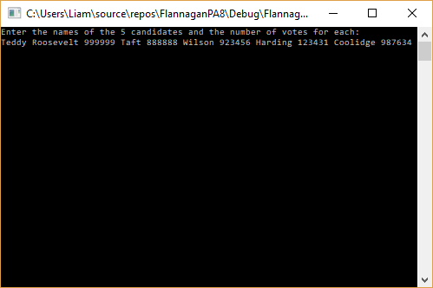

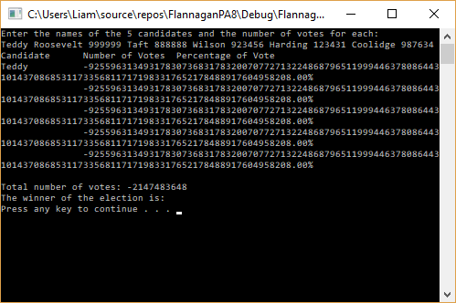

The program also accepts user input on multiple lines:

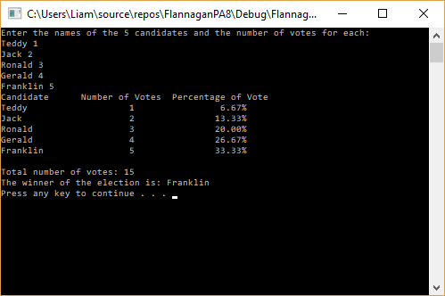

If a user enters more than 5 names on one line, the program does not accept the 6th entry.

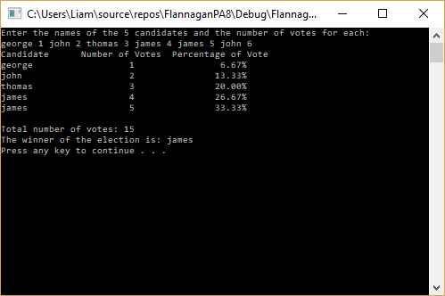

The limits on all the numbers are the typical memory limits imposed by C++ data types, or the number of voting age adults in the United States. None of these values can technically be less than 0, no one can receive negative votes, but I did not build this control structure into this program.