# Problem Analysis

# This program reads a file of students’ names followed by their test scores. Then it outputs the name followed by grade. It also finds the highest test scores, and prints the scores and the student's name.

# Algorithm

# 1) Declare the structure of name, testscore, and grade under studentType

# 2) Set up functions to call for loading the students, printing the students and their letter grades, and determining the highest scores

# 3) Call the functions in the appropriate order in the main function

# 4) Open the file and store the names in the appropriate variables

# 5) Determine the grades based on a standard scoring system (10 points)

# 6) Open the output file, print the students' names, scores, and letter grades.

# 7) Calculate the highest grade

# 8) Print the names of the students with the highest grades

# 9) Terminate the program.

# User Documentation

In order to run this program, open **Visual Studio**, and navigate to the **File 🡪 Open 🡪 Project/Solution** and select the **FlannaganPA9** file in the appropriate file location.

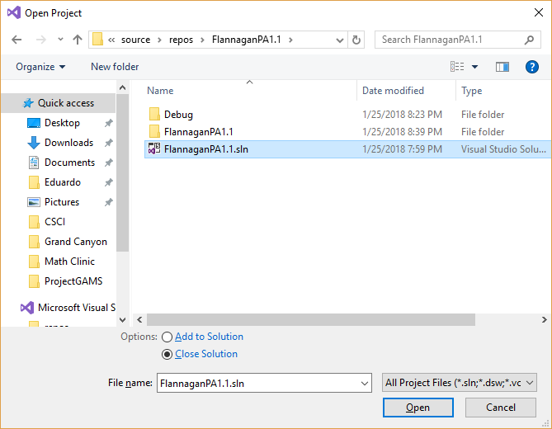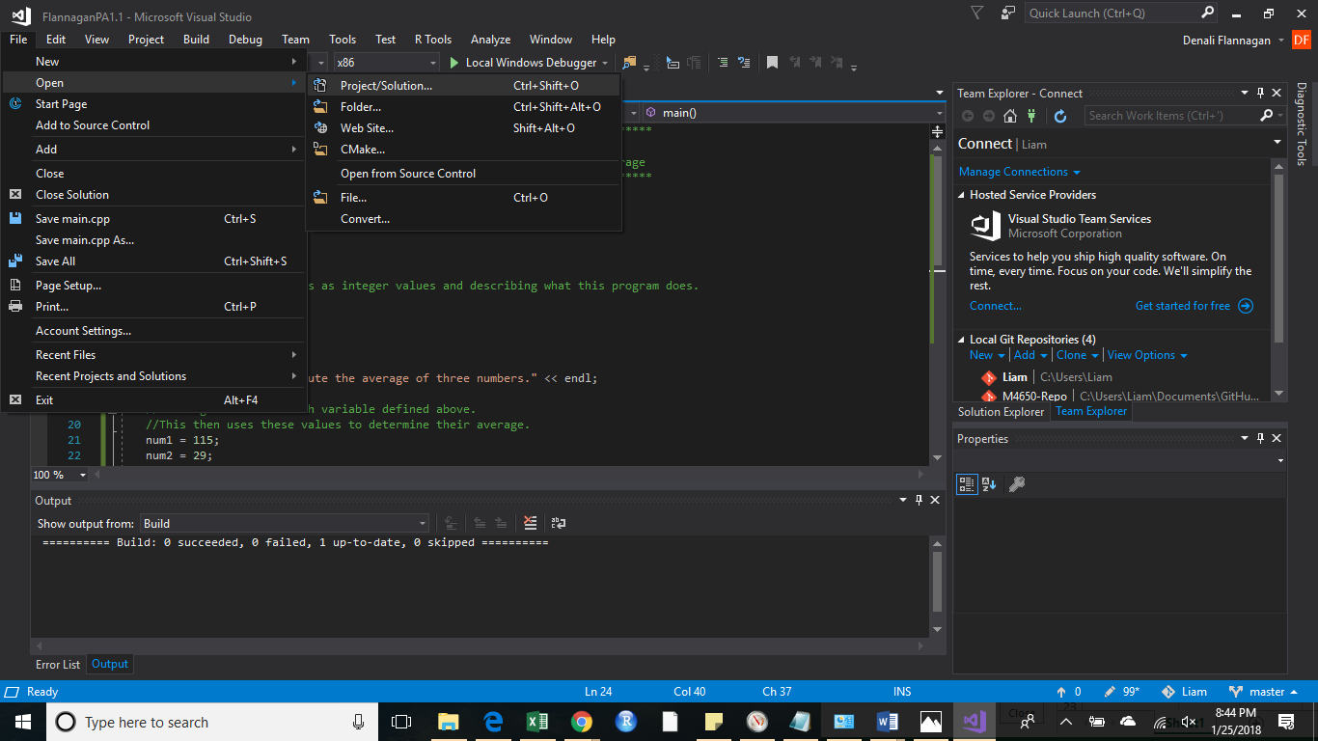

Next, ensure that the required file containing each level’s prices and seats sold is in the appropriate directory. Visual studio will assume that the file is in the current working directory, where the project is stored, unless otherwise specified.

There are many ways to find the file location, but here is one. On the right hand side under **Search Solution Explorer**, right click on **Solution FlannaganPA9**, and select open Folder in File explorer.

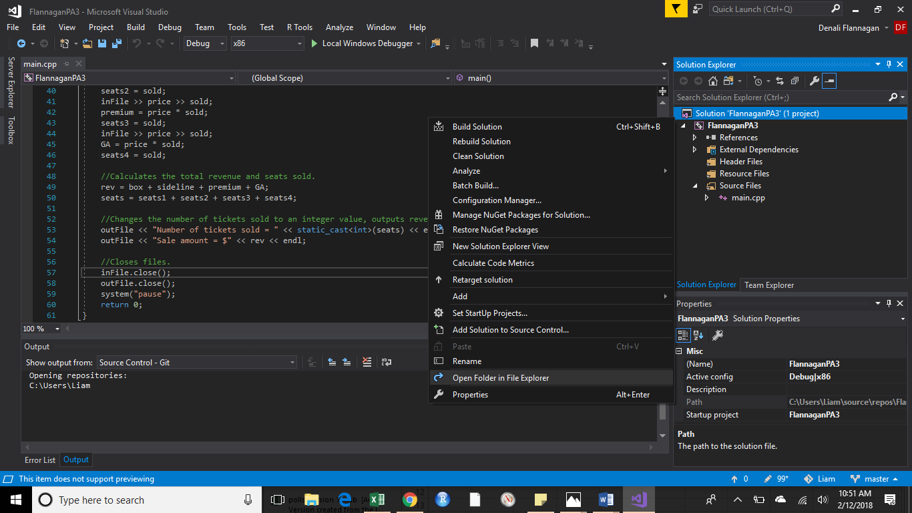

You will need to go into the **FlannaganPA9** folder, since this first folder only contains the solution. You should see **students.txt**; if you do not, just save a text file, with that name in this directory. The other option is to save this document in any location on your computer, you will just need to specify that location when telling Visual Studio to open this. You do this by entering a path like “C:/Users/Liam/Documents” if **students.txt** is in the Documents folder. Note that copying a path produces forward slashes “/” but because C++ uses thes as comments, you will need to replace the forward slash with a back slash “\”.

This program also assumes that the first line of the document contains text to determine what information each column represents.

Once you have done this, select the **Local Windows Debugger**. This will open a new window. 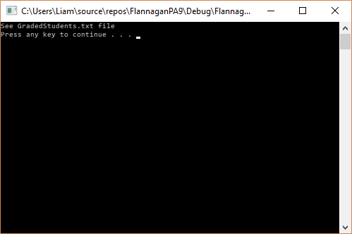

You will see a screen informing you that the program is processing, and then what file to open in the working directory to see the results.

Press any key to exit this new window.

Navigate to your working directory and you will see the new document. Open this document, and you will see the results.

