# Nominal Test

To test the data, we went enter the following:

Duckey Donald 85

Goof Goofy 89

Brave Balto 93

Snow Smitn 93

Alice Wonderful 89

Samina Akthar 85

Simba Green 95

Donald Egger 90

Brown Deer 86

Johny Jackson 95

Greg Gupta 75

Samuel Happy 80

Danny Arora 80

Sleepy June 70

Amy Cheng 83

Shelly Malik 95

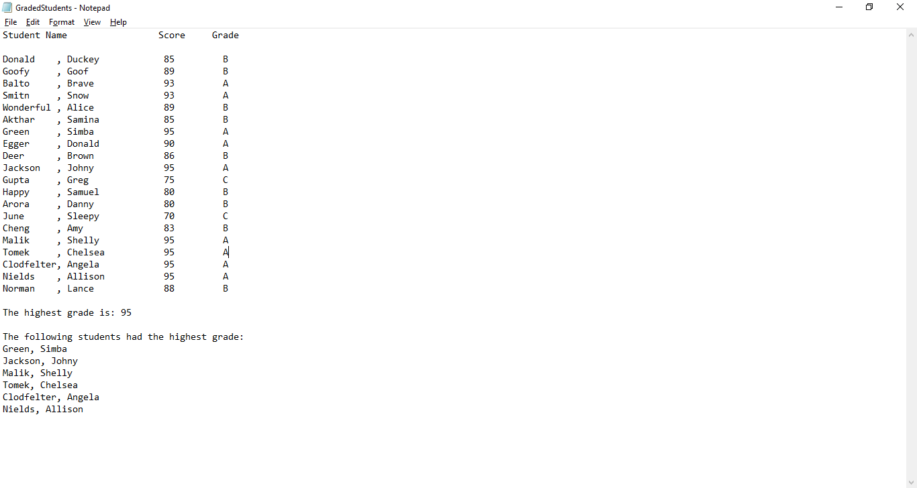Chelsea Tomek 95

Angela Clodfelter 95

Allison Nields 95

Lance Norman 88

We run the program and see that it outputs the correct information.

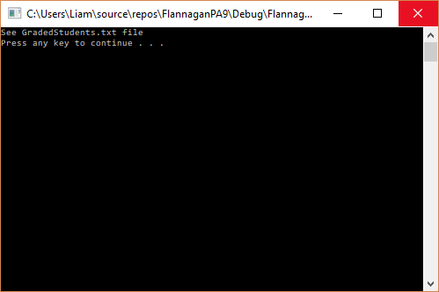

# Abnormal Data

To test the data, we went enter the following:

Scooby dooby Doo 85

Goof Goofy 89

Brave Balto 93

Snow Smitn 93



Running the program we see that the output is incorrect because of the three names in Scooby Doo.

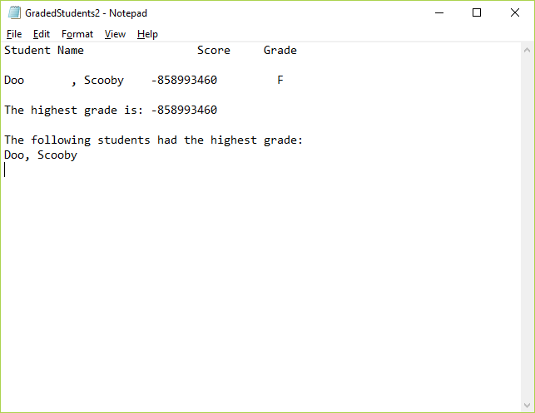

We enter the following information and run the program (extra space at the bottom):

Scooby dooby -85

Goof Goofy 89

Brave Balto 93

Snow Smitn 93

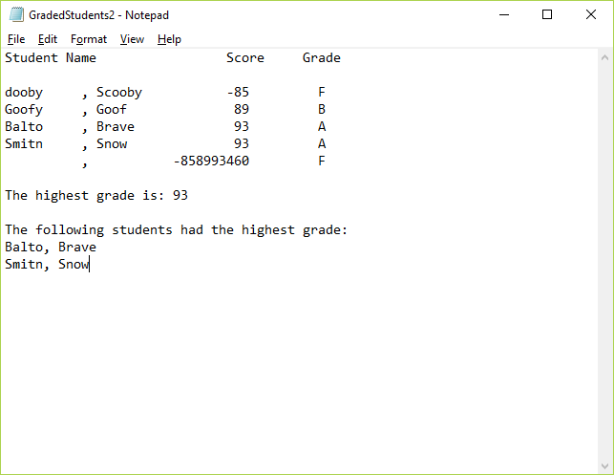

We see that the program correctly outputs Scooby Dooby’s score, but does not have a control structure in place for negative values. The program also throws an error on the blank line left at the bottom of the document.