**Computer Networks Homework 1**

$Homework 1$ ID: 2017320229 Name: Gyuhyeon Sim

1. **(Bandwidth):** How long does it take to transmit *x* kB over a *y*-Mbps link? Give your answer in *x* and *y*.

**Answer: Transmission delay is $\frac{a unit size}{bandwidth}$. So, answer is $\frac{8×x×{10}^{3}bit}{y×{10}^{6}bps}=\frac{8x}{y}ms$.**

1. **(Circuit switching):** Using modems to exchange information can be inefficient. Suppose you use a 9.6 Kbps modem to do an on-line chatting from your home computer to a friend’s computer. During this transmission, a telephone connection is established. Suppose you are trying to send a long message to your friend. Assume that you are a fast typist, you can type 400 characters per minute where the data size of 1 character is 1 byte. Show that you are using less than 0*.*6% of the bandwidth capacity of the modem connection. (This example reveals a problem of the dedicated resource assignment in circuit-switching networks.)

**Answer: Users are communicating with my friend using a circuit switching method and using only $\frac{400×8}{60}bps$. It is about $0.00555555556$ percent of the bandwidth capacity of the modem. Thus, Users are using lass than 0.6% of the bandwidth capacity of the modem connection.**

1. **(Bandwidth-delay product):** Calculate the bandwidth- delay product for the following links. Use one-way delay, and the only delay is speed-of-light (3x108 m/s) propagation delay.
   1. 2 Gbps Ethernet with a delay of 12 *µ*s.

**Answer: Bandwidth-delay product is a value of bandwidth capacity multiple of delay(latency). Thus, the bandwidth-delay product is**

* 1. 1.5-Mbps T1 link, with a delay of 6 ms.

**Answer: The bandwidth-delay is**

* 1. 10 Mbps link through a satellite in geosynchronous orbit, 35,900 km high.

**Answer: Propagation Delay is $\frac{Distance}{c}$. In the problem, the propagation delay is $\frac{\left(35900×{10}^{3}\right)m}{3×{10}^{8}m/s}=\frac{359}{3}ms$. Consequently, the answer is $\left(\frac{359}{3}×{10}^{-3}\right)s×{10}^{7}bps=\frac{3590}{3}kb$**

1. Calculate the latency (from first bit sent to last bit received) for the following:
   1. 10-Mbps Ethernet with a single store-and-forward switch in the path, and a packet size of 5000 bits. Assume that each link introduces a propagation delay of 10*µs* and that the switch begins retransmitting immediately after it has finished receiving the packet.

**Answer: In the problem, there is no queuing delay. The total latency(delay)is two times propagation delay plus two times transmit delay. Thus, the answer is $1ms+20μ=1.02ms$**

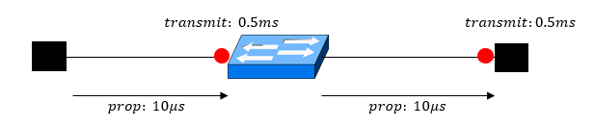

Figure 1. solution for 4.(a)

* 1. Same as (a) but with three switches.

**Answer: In the problem, any queuing delay is not exist. The total latency(delay)is four times propagation delay plus four times transmit delay. Thus, the answer is $2ms+40μ=2.04ms$**

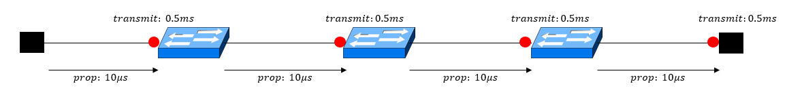

Figure 2. solution for 4.(b)

* 1. Same as (a) but assume the switch implements cut-through switching: It is able to begin retransmitting the packet after the first 200 bits have been received.

**Answer: Cut-through switching is a method for packet switching systems, wherein the switch starts forwarding a packet before the whole packet has been received(ref. https://en.wikipedia.org/wiki/Cut-through_switching). So, this method replace the second transmit delay with $\frac{200bit}{{10}^{7}bps}=20μs$. The total latency(delay) is two times propagation delay plus two different transmit delay. Thus, the answer is $0.5ms+40μ=0.54ms$**

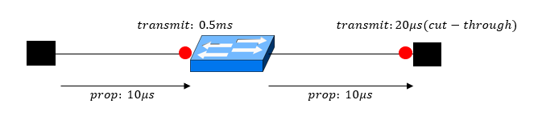

Figure 3. solution for 4.(c)

1. **(Delay):** A network is composed of a 100 Mbps Ethernet link directly between two nodes A and B. They are connected by an Ethernet cable which is 30 meters long. What is the total transfer latency (from the first bit sent to the last bit received) for a 200 bit packet? Assume the light propagates at 3 *×* 108 meters per second along the cable and there is no queuing delay.

**Answer: In the problem, the propagation delay is $0.1μs\left(\frac{30m}{3×{10}^{8}m}\right)$ and the transmission delay is $2μs\left(\frac{200bit}{{10}^{8}bps}\right).$ The total latency is the propagation delay plus the transmission delay. Thus, the answer is $0.1μs+2μs=2.1μs$.**

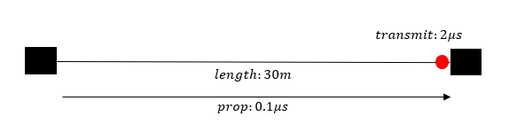

Figure 4. solution for 5

1. **(Circuit vs Packet switching).** Suppose there exists a switch whose link supports up to *C* bps. A number of users try to share the switch where the bandwidth requirement for each user is *c* bps.
   1. If the switch uses circuit switching method, what is the maximum number of users the switch can accomodate?

**Answer: In circuit switching method, Users try to share a circuit. So, the answer is .**

* 1. Suppose the switch adopts packet switching method. We would like the probability of overflow to be less than

*q*. The probability that each user is active is given by *p*. Express the maximum number of users the switch can accommodate in terms of *p*, *q*, *c* and *C*.

**Answer: If we supposed M is the number of users , the probability of overflow is defined as $\sum_{k=\frac{C}{c}}^{M}{{\text{C}}_{\text{k}}^{\text{M}}}{\left(p\right)}^{k}×{\left(1-p\right)}^{M-k}$. When the statement $\sum_{k=\frac{C}{c}}^{M}{{\text{C}}_{\text{k}}^{\text{M}}}{\left(p\right)}^{k}×{\left(1-p\right)}^{M} =q$ was satisfied, the number of user become the maximum number plus 1. Thus the answer is M-1 that satisfies the statement $\sum_{k=\frac{C}{c}}^{M}{{\text{C}}_{\text{k}}^{\text{M}}}{\left(p\right)}^{k}×{\left(1-p\right)}^{M} =q$.**