Computer Networks Homework 2

Seung Jun Baek

1. **(Encapsulation and Layering)** Suppose you transmit packets on a 10 Mbps Ethernet link. You have created packets that belong to application/presentation/session layers, and their size is 1000 bytes. The packets undergo encapsula- tion by the following layers and their protocols: transport layer protocol is UDP, network layer protocol is IP, link layer protocol is Ethernet. The header sizes of UDP, IP and Ethernet are 8, 20 and 22 bytes respectively. Calculate the maximum number of packets per second that can be transmitted on the Ethernet link (Note: 1*.* The answer may not be necessarily an integer. 2*.* Ignore CSMA/CD or any details of the real Ethernet for now! In this problem, you can think of Ethernet as a link providing a pure bandwidth of 10 Mbps.).

**Answer: The total packet is like Figure 1. Thus, the maximum number of packets per second is $\frac{{10}^{6}}{8400}≈119$ packets .**

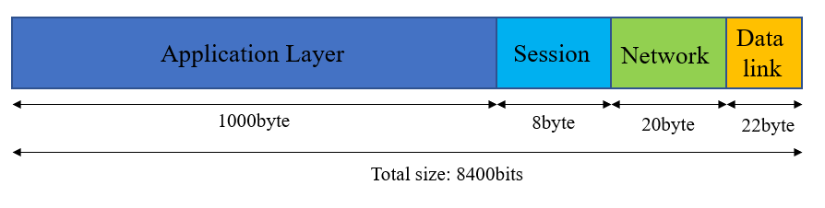

Figure . packet

1. **(Poisson random variables):**
   1. Let *X* and *Y* be *independent* random variables which take values from {0*,* 1*,* 2*, . . .* }. Let *Z* = *X* + *Y* . Let us define P(*X* = *k*) := *pX* (*k*), P(*Y* = *k*) := *pY* (*k*) and P(*Z* = *k*) := *pZ* (*k*) for *k* = 0*,* 1*,* 2*, . . .* . Prove that *pZ* (*k*) = *pX* (*k*) ∗ *pY* (*k*) holds where ∗ denotes the *convolution* operation: in other words,

*k*

*pZ* (*k*) = γ *pX* (*l*)*pY* (*k* − *l*)

*l*=0

Answer(Proof):

* 1. Let *X*1 and *X*2 be independent Poisson random variables with parameter *λ*1 and *λ*2 respectively. Let *Y* =

*X*1 + *X*2. Prove that, *Y* is a Poisson random variable with parameter *λ*1 + *λ*2.

* 1. We can further generalize the result from (b), namely let *Xi* be independent Poisson random variables with

parameter *λi*, *i* = 1*, . . . , n*. Then *Y* = 5*n*

*i*=1

*Xi* is also a Poisson random variable with parameter 5*n*

*λi*.

Suppose there are *n* users in a slotted ALOHA network. The packet arrival per unit time for *each* user is distributed as an independent Poisson random variable with parameter *λ* = 0*.*01. Find the number of users *n* which maximizes the throughput.

*i*=1

1. **(Slotted ALOHA):** Suppose there are *N* nodes in a slotted ALOHA network. Every node is trying to transmit a packet at every time slot with probability *p*, independently of each other. It takes one time slot to transmit a packet.
   1. Express the offered load (the average number of packets per time slot that are arriving to the network) in terms of *N* and *p*.
   2. Show the throughput (the average number of successfully transmitted packets per time slot) is equal to *Np*(1 −

*p*)*N−*1.

* 1. Suppose the nodes can somehow change the probability of transmission *p* in their favor. Find value of *p* that maximizes the throughput.
  2. Let us denote the maximum throughput by *T* (*N* ), using the value of *p* from part (c). We call *T* (*N* ) as capacity of the network. Calculate the capacity if there are infinite number of nodes, in other words, find lim*N→∞ T* (*N* ). (I hope the answer looks familiar to you!)

1. **(CSMA/CD:)** Consider building a CSMA/CD network running at 1 Gbps over a 1 km cable with no repeaters. The signal speed in the cable is 2 × 105 km/sec. What is the minimum frame size?
2. **(Partitioning Collision Domains on Ethernet Networks):** Figure 1 shows how network managers can partition an Ethernet network to accommodate more nodes. The figure assumes that each node transmits *R* bps, on average, during a representative period of time. There are *N* nodes to be connected. If the total transmission rate *N* × *R* is larger that the rate that can be handled by one Ethernet, then the network manager can try to partition the network.

For instance, if the efficiency of one Ethernet connecting the *N* nodes is 80% and if *N* × *R >* 8 Mbps, then one Ethernet cannot handle all the nodes. Let us assume that the *N* nodes can be divided into two groups that do not exchange messages frequently. For simplicity, say that each group sends a fraction *p* of its messages to the other

group. let us connect the computers in each group with a dedicated Ethernet, as shown in the figure. The two Ethernets are connected by a *bridge*.

* 1. Find an expression for the traffic on each Ethernet.
  2. The arrangement can handle the *N* nodes if this rate is less than the efficiency of each Ethernet times 10 Mbps. Of course, the bridge must be able to handle the throughput. Assuming an efficiency of 80%, *R* = 1 Mbps and *p* = 20% compute how many stations can be supported.
  3. Under the same efficiency and load assumptions compare the number of hosts that could be supported with a single collision domain versus that with the two collision domains computed above.
  4. If *p* were smaller, i.e., the traffic exhibits more *locality*, would the advantages of partitioning the network increase or decrease?

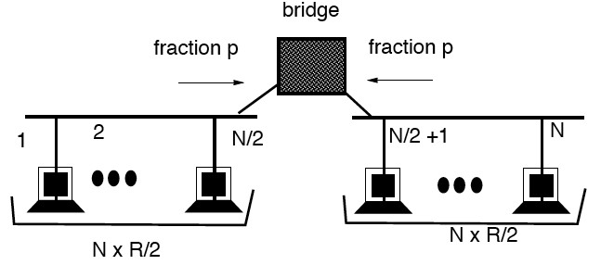

Figure 1: Ethernet load and design.

1. **(CSMA/CD in wireless?)** Compared to wired networks, state two reasons why CSMA/CD is not appropriate in the context of wireless networks.
2. **(Problems with solving exposed node problem)** Consider the wireless network in Figure 1. Node A performs CSMA/CA procedure proposed by MACAW, in other words RTS-CTS-DATA-ACK sequence for transmission. Sup- pose node B has just received RTS from node A and found out that A tries to transmit to node C, but did not hear CTS from node C. Node B concluded that he became an exposed node and decides to transmit data to node D.
   1. Node B initiates RTS-CTS-DATA-ACK sequence with node D, at the same moment as A starts to transmit data packet. What is the potential problem with node Bs attempt? (Hint: Suppose node A is transmitting a large packet.)

Figure 2: B is an exposed node.

* 1. Instead of MACAW procedure, node B starts DATA-ACK sequence (CSMA-CA in weaker sense) for trans- mission to node D, at the same moment as A finishes transmitting data packet. What is the potential problem with node Bs attempt? (Hint: Suppose node B is transmitting a large packet.)

1. **(Capacity of wireless networks and transmission range)**: Consider a wireless network with six nodes and their physical distances as in Figure 2 (All the angles in the geometry in Figure 2 are 90 degrees.). The transmission range of a node is modelled by a circle of radius *R*, in other words, if two nodes are within distance *R* of each other, one can successfully transmit data to the other. Suppose every node can transmit packets at a rate up to *P* packets/sec. A node is allowed to transmit to another node as long as its intended receiver is not interfered by other transmissions. For a given *R*, we define the capacity of the network as the maximum of the sum of successfully transmitted packets per second in the network. Assume that the nodes cannot transmit and receive at the same time (half-duplex). Figure 2: A wireless network.
   1. Suppose you can control the value of *R* (for example, by adjusting radio transmission power). Obviously, the choice of a large *R* will be poor: consider *R* to be 200 meters for example, then at any instant, only one node will be able to transmit to another node, in which case the capacity will be only *P* packets/sec. You can achieve higher capacity by appropriate setting the value of *R*, but *R* has to be greater than some minimum radius *R*min. Find the maximum capacity of this network and find the value of *R*min. (Hint: Think in terms of the number of concurrent transmissions that are allowed in the network.)
   2. If we increase the value of R starting from *R*min, you will see that we cannot achieve the maximum capacity derived in part (a) if *R* reaches some value *R*max. Find *R*max.

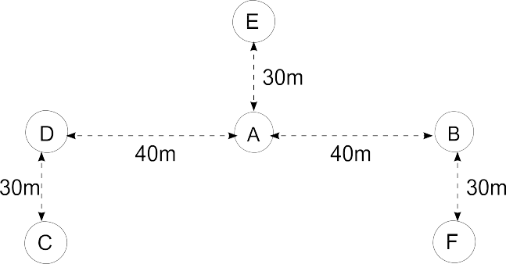

Figure 3: A Wireless Network.