The Closure of the Strait of Hormuz:
Consequences for International Trade, Inflation, and Economic Growth
International Economics | Final Research Paper
October 2026

Introduction
The Strait of Hormuz is one of the most consequential maritime chokepoints in international commerce. It connects the Persian Gulf with the Gulf of Oman and the wider Indian Ocean, allowing petroleum and liquefied natural gas (LNG) exports to reach overseas customers. According to the U.S. Energy Information Administration (EIA, 2024), oil flows through the strait averaged about 20.9 million barrels per day in 2023, equivalent to roughly one-fifth of global petroleum liquids consumption. Dependence on one narrow passage exposes countries and businesses far beyond the Middle East to geopolitical risk. A prolonged interruption would affect not only crude oil markets but also manufacturing costs, household purchasing power, shipping reliability, and patterns of international specialization.
This paper asks: How would a sustained closure of the Strait of Hormuz affect international trade, inflation, and economic growth across major world regions? Its central argument is that an interruption would transmit a negative energy-supply shock through international price systems and logistics networks, creating cost-push inflation, reducing real output, and weakening trade flows. The severity would depend on the closure’s duration, the volume actually prevented from moving, available inventories, and the ability of producers and carriers to use alternatives. The discussion therefore analyzes a closure scenario rather than assuming that every threatened disruption automatically becomes a complete or permanent blockade.

Strategic Importance and Exposure
Saudi Arabia, Iraq, Kuwait, Qatar, and the United Arab Emirates rely on Persian Gulf export infrastructure, while Iran borders the strait’s northern shore. Geography makes maritime passage highly concentrated, although control of the strait is not the same as exclusive legal ownership of the international waterway. The EIA (2024) estimates that most crude oil and condensate moving through Hormuz is destined for Asian markets. China, India, Japan, and South Korea therefore face particularly direct exposure. Qatar’s LNG shipments also underscore that a closure is a natural-gas as well as an oil problem.
Some Gulf oil can bypass Hormuz through existing pipelines, including Saudi and Emirati routes, but bypass capacity is limited relative to normal maritime flows (EIA, 2024). Importers can draw on reserves or buy from other producers, yet those measures cannot instantaneously replace every stranded cargo. A distinction is also necessary between oil not produced, oil produced but unable to leave the Gulf, and oil temporarily delayed: each affects global availability differently. Markets react to expected scarcity as well as current physical shortages, so prices may rise before an extended loss of deliveries becomes visible.

Oil and Energy Shock: Why Prices Rise
A closure would reduce the quantity of readily deliverable oil in world markets. In a standard supply-and-demand framework, the available supply curve shifts left while demand remains relatively unresponsive in the short run. Households cannot immediately replace gasoline-powered vehicles, airlines cannot quickly switch fuels, and many factories depend on equipment built around particular energy sources. Hamilton (2009) describes the macroeconomic importance of oil shocks and the challenges of adjusting consumption rapidly. Consequently, even a moderate reduction in supply can produce a substantial price response. Figure 1 illustrates the mechanism without claiming a specific forecast for actual oil prices.
Energy markets are interconnected. Refiners bid for substitute crude grades; importers compete for cargoes from alternative suppliers; and higher freight and risk costs can raise delivered prices. Natural gas prices may also rise when LNG flows are interrupted, particularly in markets dependent on seaborne imports. Oil-exporting countries outside the Gulf might receive higher prices, but that does not imply a net gain for the world economy: expensive energy imposes costs on consumers and energy-intensive producers, while volatility discourages investment. Strategic reserves and spare production capacity could cushion the shock, but their effectiveness depends on available volumes, refinery compatibility, and the duration of disruption (IEA, 2024).
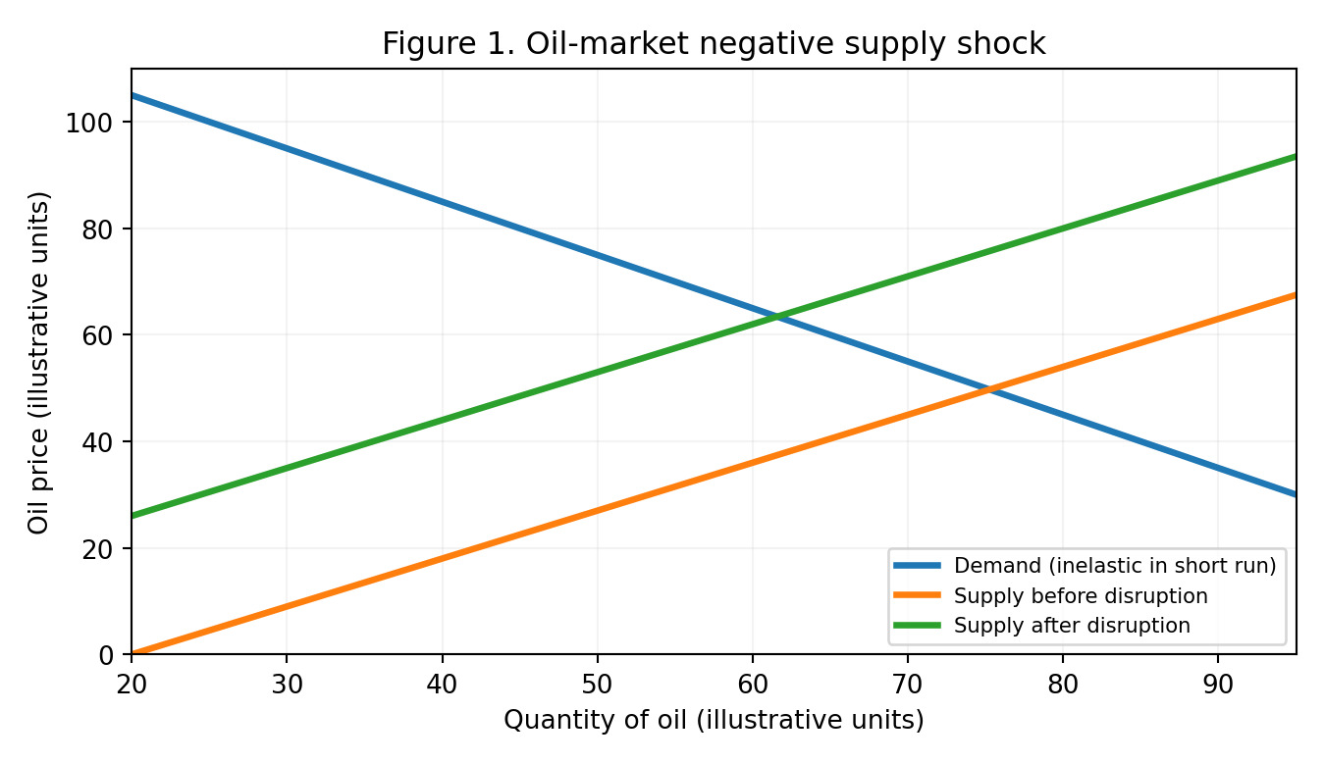
Note. Stylized theoretical curves; axes are illustrative, not observed price or quantity data.

How the Energy Shock Produces Inflation
The first inflation channel is direct. Higher crude oil prices raise the price of gasoline, diesel, jet fuel, and other refined products. These purchases enter consumer price measures, so the initial effect appears quickly in household energy spending. A second, broader channel is cost-push inflation. Diesel-powered trucks distribute groceries, cargo vessels transport intermediate inputs, and factories use fuel and electricity to operate machinery. When energy becomes more expensive, firms must either accept lower margins, reduce production, or pass some additional costs to buyers. As these adjustments occur across industries, prices can rise for food, manufactured goods, and services even when demand has not increased.
Agriculture illustrates the chain particularly well. Fuel powers tractors and transport; natural gas is an important feedstock for ammonia-based fertilizer; and packaging often relies on petrochemicals. Higher costs at several stages can compound before food reaches retail shelves. Similarly, petrochemical feedstocks influence plastics and many industrial materials. The amount ultimately passed through depends on competition, contracts, inventories, exchange rates, and consumer demand. It is therefore inaccurate to assume that a 20% oil-price increase automatically produces 20% overall inflation. The relevant economic question is how much energy enters the production basket and how much of the added cost businesses can pass along.
At the macroeconomic level, rising input costs shift short-run aggregate supply (SRAS) left. Figure 2 shows that, with aggregate demand initially unchanged, the equilibrium price level increases while real GDP falls. This combination creates stagflationary pressure: inflation coincides with weaker output and potentially weaker employment. Blanchard (2021) explains the difficulties of stabilization when adverse supply shocks push inflation and activity in opposite directions. Central banks can raise interest rates to contain demand and inflation expectations, but tighter credit may worsen the slowdown. Conversely, aggressive stimulus could sustain spending while amplifying price pressures.
An important distinction separates a one-time rise in the price level from persistently high inflation. A temporary energy shock may cause a burst of measured inflation that fades when prices stabilize. Inflation becomes more persistent if employees negotiate higher wages to recover purchasing power, firms repeatedly reset prices, or expectations of future inflation become entrenched. Imported inflation can intensify in economies whose currencies depreciate as energy import bills grow. Research by Kilian (2009) further shows that the macroeconomic consequences of oil-price changes depend on the underlying source of the shock, making it essential to distinguish supply disruptions from demand-driven price increases. Figure 3 summarizes the main transmission chain.
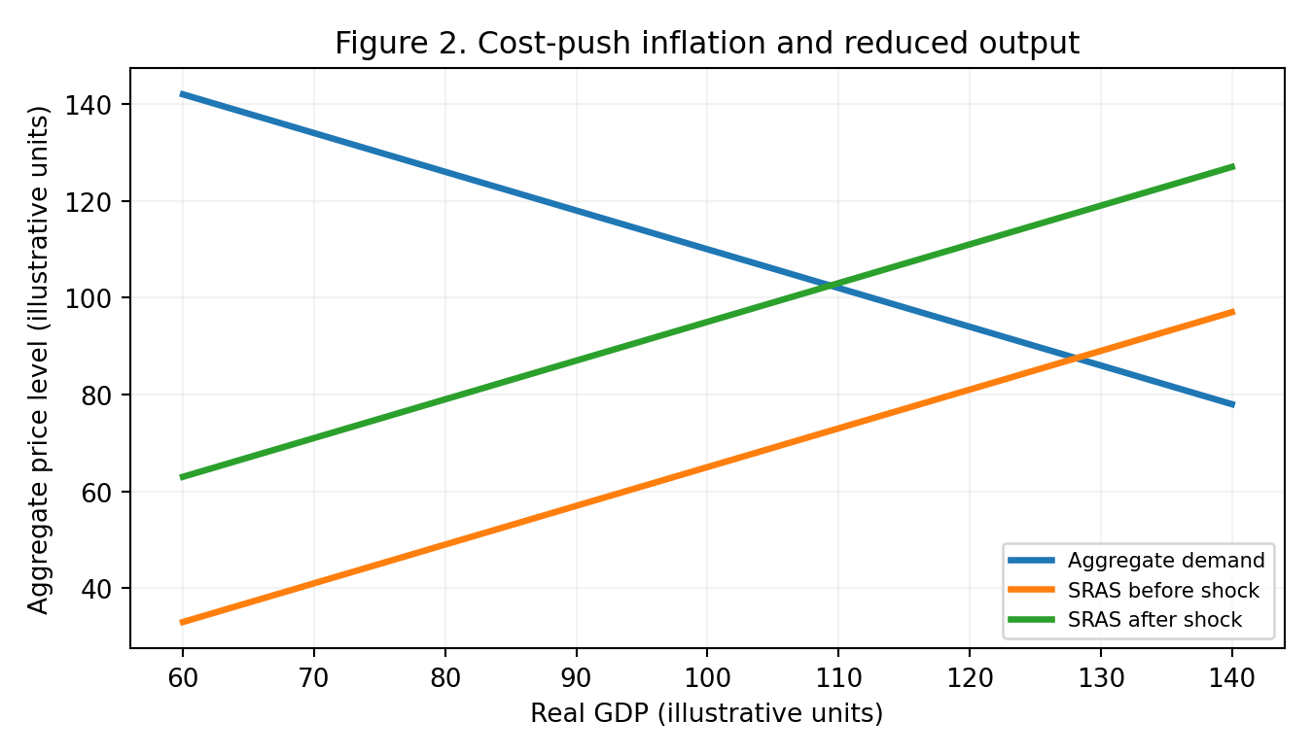
Note. Stylized AD–AS relationships, not estimated macroeconomic outcomes.
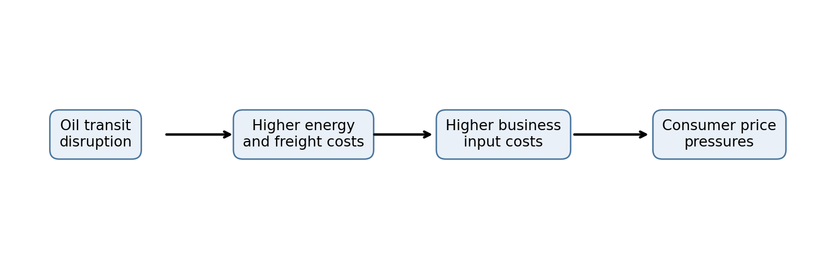
Figure 3. Main channels through which energy disruptions can affect consumer prices.

Shipping Costs and International Trade
A closure would interrupt vessel access to Gulf ports and exports, but rerouting must be described precisely. A tanker loading inside the Persian Gulf cannot simply sail around Africa to bypass the strait; it must first exit through Hormuz or obtain oil from a pipeline outlet outside the Gulf. Once oil is sourced from alternative ports, voyages may be longer, including routes around the Cape of Good Hope when other shipping corridors are constrained. War-risk insurance, security measures, financing costs, and vessel availability would raise the delivered cost of trade. Freight markets might tighten as ships wait, reposition, or operate on longer voyages.
These developments connect to the gravity model of trade. In its simplest form, trade rises with the economic size of trading partners and falls with bilateral trade frictions. Anderson and van Wincoop (2003) emphasize the central role of trade costs in explaining observed trade patterns. A Hormuz closure would increase effective trade costs even where geographic distance does not change: uncertainty, insurance, transit time, and supply reliability are all relevant frictions. Importers could reduce purchases, seek closer suppliers, or pay more to maintain existing relationships. The result would likely be lower trade volumes in affected routes and costly trade diversion rather than a uniform collapse in all world commerce.

Supply Chains and Industry-Level Consequences
Modern production systems depend on predictable deliveries of fuel, raw materials, components, and finished goods. When transport reliability declines, companies may hold more safety stock, source from multiple regions, and renegotiate supplier contracts. Those changes increase resilience but can raise working-capital and procurement costs. Baldwin and Freeman (2022) explain how interconnected production networks transmit disruptions across countries and industries. An energy shock can therefore travel beyond the immediate oil-importing firm to downstream customers and suppliers.
Chemicals, plastics, fertilizers, airlines, shipping, and energy-intensive manufacturing would face especially acute cost pressure. Pharmaceutical production may also be affected through energy, packaging, and transport expenses, although its vulnerability varies by product and supply network. Firms with long-term fixed-price contracts may initially absorb losses, while businesses able to adjust prices may transfer more of the burden to customers. These differences matter because the impact is not identical across all sectors. A prolonged closure could encourage nearshoring and supplier diversification, but such restructuring takes capital and time; it cannot restore trade flows overnight.

Regional Effects and Comparative Advantage
Asian importers are especially exposed because a large share of Hormuz energy exports normally heads east. Japan and South Korea have limited domestic hydrocarbon resources, while China and India are large consumers with diversified but substantial import needs. Higher import costs can weaken trade balances and compress real household incomes. Europe would face global benchmark price increases and potential LNG competition even where direct Gulf exposure is smaller. The United States has substantial domestic production, but its households and firms still respond to internationally linked oil prices.
Gulf exporters face a different problem: higher market prices do not guarantee higher export earnings if physical shipments cannot reach customers. Government budgets, foreign-exchange receipts, and investment plans may suffer. Importing economies with domestic energy resources or stronger fiscal buffers may weather the shock more effectively. These uneven outcomes reshape comparative advantage. As Krugman, Obstfeld, and Melitz (2018) explain, relative production costs help determine specialization and trade. A lasting increase in imported energy costs can undermine the competitiveness of energy-intensive exports, while favoring locations with reliable power and diversified energy supplies. These adjustments are economically rational but can be expensive during the transition.

Policy Responses and Long-Term Adaptation
Governments can reduce immediate damage by coordinating emergency reserves, facilitating alternative supply arrangements, and limiting unnecessary restrictions on energy trade. Targeted support for vulnerable households may be more sustainable than broad price controls that suppress incentives to conserve scarce fuel. Central banks must monitor whether temporary energy-price increases spread into wages and broader inflation expectations. Companies can map supplier dependencies, develop contingency inventories for critical inputs, and test transport alternatives before a crisis occurs.
Over the longer term, investment in pipeline capacity, grid resilience, renewable electricity, efficiency, and supplier diversification can reduce dependence on a single chokepoint. However, infrastructure takes years to build, and diversification involves trade-offs between resilience and low-cost specialization. The optimal response is not complete self-sufficiency but a more balanced international trade system that prices geopolitical risk into sourcing and logistics decisions.

Conclusion
A sustained closure of the Strait of Hormuz would be more than a regional shipping problem. By restricting the delivery of oil and gas, it would raise global energy prices, increase transport and production costs, and transmit inflationary pressure into a broad range of consumer goods. The negative supply shock would also weaken real output, complicate monetary policy, and create uneven regional burdens. Higher insurance costs and unreliable delivery schedules would increase effective trade distance, while firms would adapt their supply chains and production locations. The magnitude of these effects would depend on the length and completeness of the disruption and on the availability of alternative supplies. Ultimately, Hormuz demonstrates how concentrated energy infrastructure can turn a geopolitical crisis into a worldwide trade and macroeconomic challenge.

References
Anderson, J. E., & van Wincoop, E. (2003). Gravity with gravitas: A solution to the border puzzle. American Economic Review, 93(1), 170–192. https://doi.org/10.1257/000282803321455214
Baldwin, R., & Freeman, R. (2022). Risks and global supply chains: What we know and what we need to know. Annual Review of Economics, 14, 153–180. https://doi.org/10.1146/annurev-economics-051420-113737
Blanchard, O. (2021). Macroeconomics (8th ed.). Pearson.
Hamilton, J. D. (2009). Causes and consequences of the oil shock of 2007–08. Brookings Papers on Economic Activity, 2009(1), 215–261. https://doi.org/10.1353/eca.0.0047
International Energy Agency. (2024). Oil 2024: Analysis and forecast to 2030. https://www.iea.org/reports/oil-2024
Kilian, L. (2009). Not all oil price shocks are alike: Disentangling demand and supply shocks in the crude oil market. American Economic Review, 99(3), 1053–1069. https://doi.org/10.1257/aer.99.3.1053
Krugman, P. R., Obstfeld, M., & Melitz, M. J. (2018). International economics: Theory and policy (11th ed.). Pearson.
U.S. Energy Information Administration. (2024). The Strait of Hormuz is the world’s most important oil transit chokepoint. https://www.eia.gov/todayinenergy/detail.php?id=61002

