**lidR: (A workshop for) Airborne Lidar Data Manipulation and Visualization for Environmental Applications**

***Quick Setup Guide***

**Workshop:** [**https://liamirwin.github.io/LPS_lidRtutorial/**](https://liamirwin.github.io/LPS_lidRtutorial/)

1. **Install Required Software**
   * Download and install:
     + Recent version of R: 4.x
     + RStudio: not mandatory but highly recommended
2. **Download Data and Scripts**
   * Go to **https://liamirwin.github.io/LPS_lidRtutorial/#download-workshop-materials** (part way down) and download the three zip folders
   * Extract the zip folders to a folder for this workshop
   * 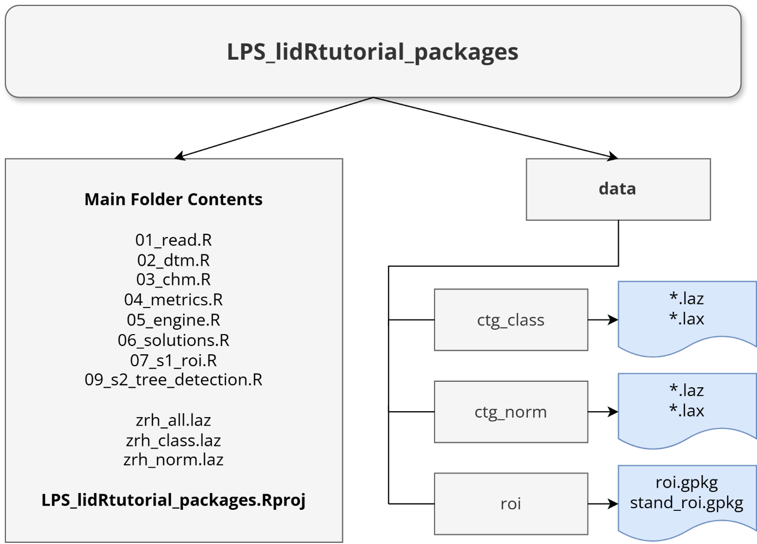For the easiest experience set your folder up as follows:

**SETUP CONTINUES ON REVERSE**

1. Open the **LPS_lidRtutorial_packages.Rproj** with RStudio
2. Open 01_read.R
3. **Install Required R Packages (start of 01_read.R or on workshop site)**
   * Within RStudio (or your IDE of choice) run:

install.packages(“lidR”)

libs <- c(“terra”, “viridis”, “future”, “sf”, “mapview”)

install.packages(libs)

if (!requireNamespace(“devtools”, quietly = TRUE)) {

install.packages(“devtools”)}

devtools::install_github(“ptompalski/lidRmetrics”)

1. Now follow along each step using the navigation bar at the top of the website (1-6)

Workshop developed and presented by the IRSS based at the University of British Columbia, Canada

irsslab.forestry.ubc.ca

lidR is an open-source package still maintained by the original developer (Jean Romain Roussel) through his company: r-lidar

r-lidar.com