Liam Kolber

Paul Constantine

CSCI 3236

11 October 2017

Midterm 1 Take Home

1. No question but verified my vandermonde function and got the desired output.
2. 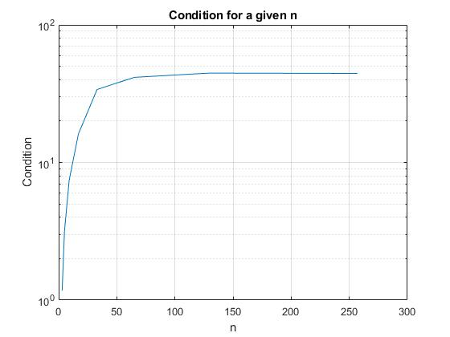As we increase the values for n, the condition number increases dramatically but begins to converge. This vandermonde matrices are – as expected – very ill-conditioned meaning that INSERT MEANING HERE
3. 