1. Run ‘QtPhases.py’
2. Open the mesh generator (“Mesh > Generate Mesh”) and head to the rectangle tab.
3. Create the mesh by adding rectangles:
   * Define dx and dy this will be the size of each of the elements in the mesh. (Note: the way this has been programmed the smallest size possible is 10^-8. If it needs to be smaller it would only require a few changes)
   * Define the width and height of the leftmost rectangle, click add
   * Define the width and height of the next rectangle. Clicking will add a rectangle to the right of the previous rectangle. Many rectangles can be added to the mesh to create slightly more complex meshes.

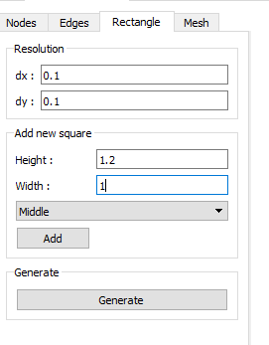

1. Click generate to generate the mesh. This process is complete when the “Parameters” tab opens at the left of the window.
2. Go to “Mesh> Edit Mesh Conditions”. This will show the generated mesh. Initial Conditions and Boundary Conditions will need to be defined using this editor.
3. With the selections in the toolbar shown box select can be used to select multiple elements then Right Click -> “Edit ICs” will display a dialog where initial conditions can be edited for each element. The size of elements can also be made smaller with Right Click “Subdivide Elements” , which will divide each of the elements in to four smaller ones.



1. Edit boundary conditions with toolbar settings shown. Right Click -> “Edit Boundary Conditions” will open a dialog to edit boundary conditions of the form aT’+bT+c. 
2. Define all simulation parameters in the panel on the left.

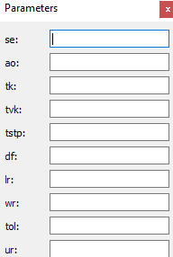

1. To save the mesh hit “File > Save Mesh To File”. Pass in a directory, this requires the full directory folder path, then give the project a name.
2. Mesh Created!