**Name:** Raboy, Liam Paul S.

1. Display all columns from tbl_employees.
2. Display only the firstname and lastname of all employees.
3. Show firstname, lastname, and salary of all employees.
4. Find all employees whose firstname starts with **'S'**.
5. Find all employees whose lastname ends with **'off'**.
6. Find employees with firstname containing **'an'**.
7. Find employees whose firstname second letter is **'e'**.
8. Find employees whose lastname starts with **'R'**.
9. Show distinct position_id values.
10. Show distinct gender values from the table.
11. Display all employees with a salary greater than **60,000**.

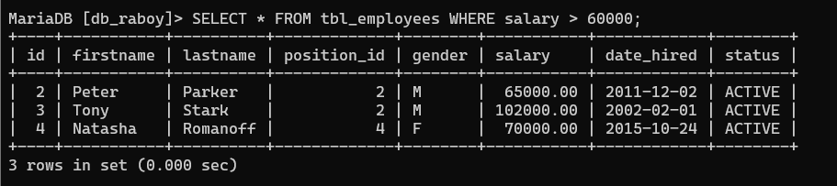

1. Display all employees who were hired before **2015-01-01**.

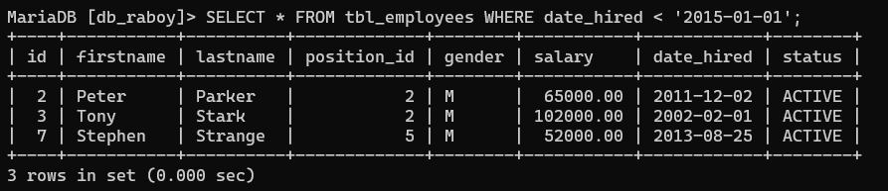

1. Display employees with gender = 'F'.

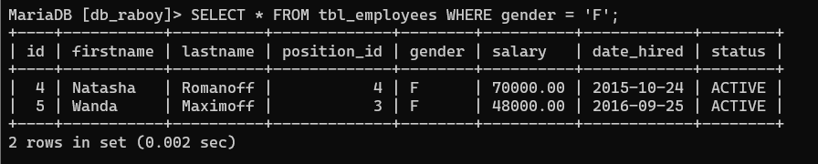

1. Show employees whose status is ACTIVE.

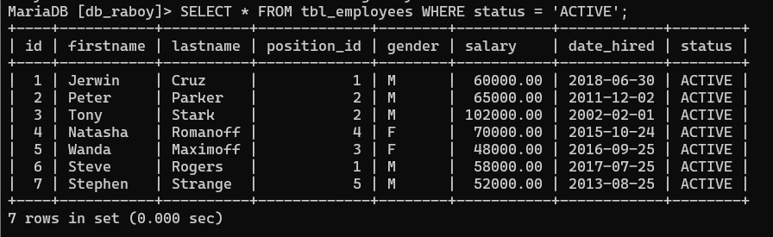

1. Display employees whose salary is between **50,000** and **70,000**.

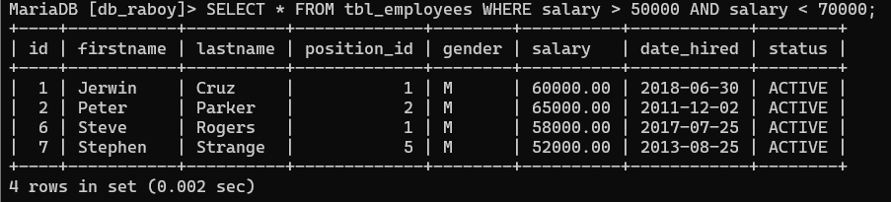

1. Display employees sorted by firstname in ascending order.
2. Display employees sorted by salary in descending order.
3. Show employees sorted by date_hired (oldest first).
4. Count how many employees are in each position_id.
5. Count how many employees are grouped by gender.
6. Find the total salary per position_id.
7. Show position_id groups having more than **1 employee**.
8. Show gender groups where the average salary is above **60,000**.
9. Show only the **first 3 employees** from the table.
10. Show **3 employees starting from the 3rd record** in the table.