**Name: Salazar, Catherine Joy P.**

1. Display all columns from tbl_employees.
2. Display only the firstname and lastname of all employees.
3. Show firstname, lastname, and salary of all employees.
4. Find all employees whose firstname starts with **'S'**.
5. Find all employees whose lastname ends with **'off'**.
6. Find employees with firstname containing **'an'**.
7. Find employees whose firstname second letter is **'e'**.
8. Find employees whose lastname starts with **'R'**.
9. Show distinct position_id values.
10. Show distinct gender values from the table.
11. Display all employees with a salary greater than **60,000**.
12. Display all employees who were hired before **2015-01-01**.
13. Display employees with gender = 'F'.
14. Show employees whose status is ACTIVE.
15. Display employees whose salary is between **50,000** and **70,000**.
16. Display employees sorted by firstname in ascending order.

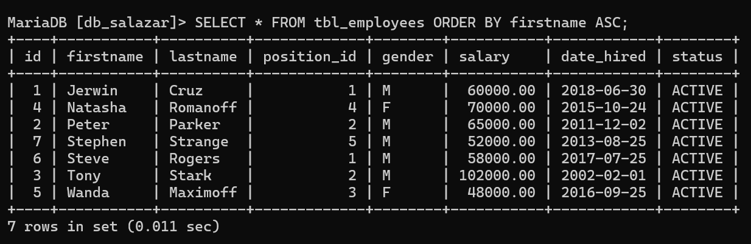

1. Display employees sorted by salary in descending order.

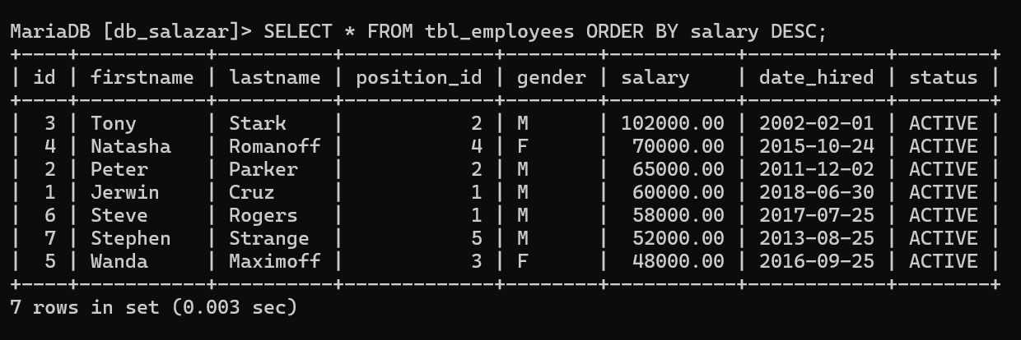

1. Show employees sorted by date_hired (oldest first).

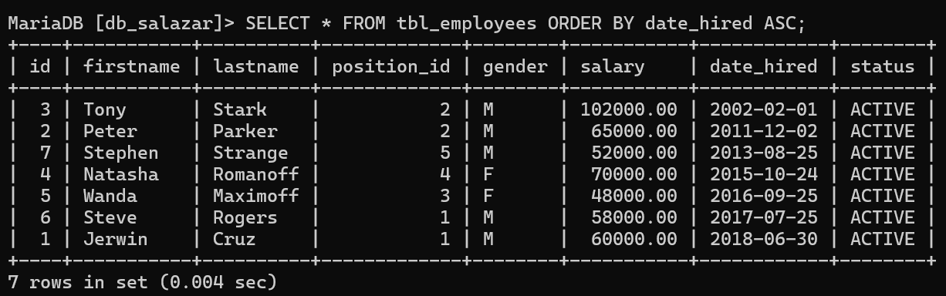

1. Count how many employees are in each position_id.

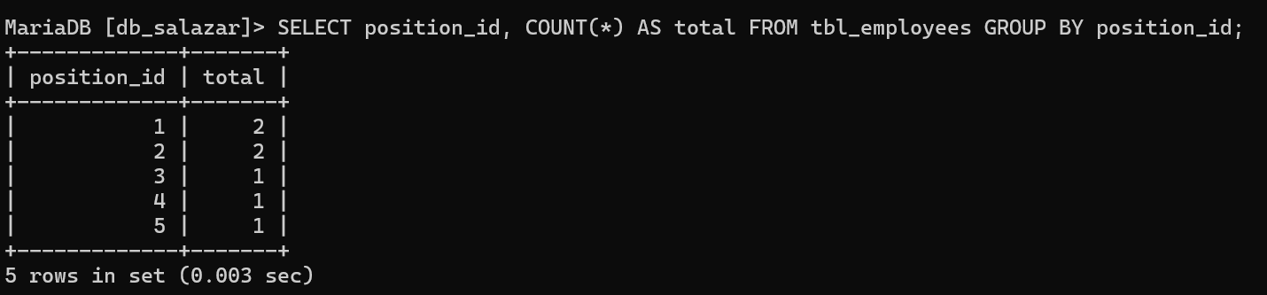

1. Count how many employees are grouped by gender.

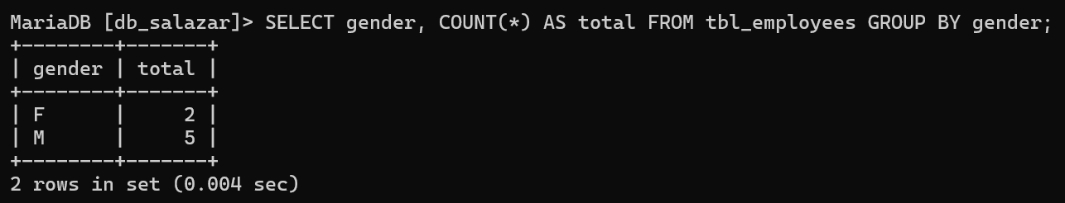

1. Find the total salary per position_id.
2. Show position_id groups having more than **1 employee**.
3. Show gender groups where the average salary is above **60,000**.
4. Show only the **first 3 employees** from the table.
5. Show **3 employees starting from the 3rd record** in the table.