St. Ippolito Commemorative Coin Order Form

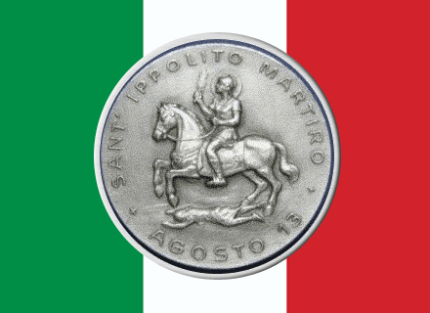

Each coin is made of high quality Zinc Alloy 1-1/2 in diameter and imaged on both sides.
$12.50 each includes shipping within the United States
Each coin comes with a plastic protective sleeve
Name | Shipping Address | # of Coins | Total Amount

Please print and mail this form with check made out to:
St. Ippolito Society
1118 Centennial Way
Lansing, MI 48917
Supplies are limited
Please allow 7-10 days for delivery

