# Rationale u3158183 – Liam Varjavandi

When designing my website using CSS, I kept some of the main web conventions in mind (Dutcher, 2017) such as navigation and logo placement to ensure ease of use. As well as designing to the established conventions I researched a few websites for design inspiration, such as the styling of the logo of the website for the National Archive of Australia. I chose the NAA due to the similarities in content being displayed.

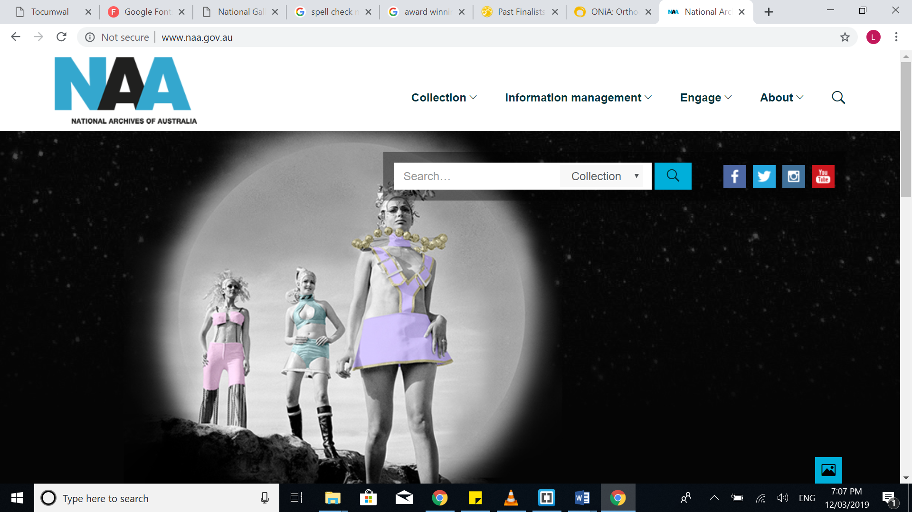 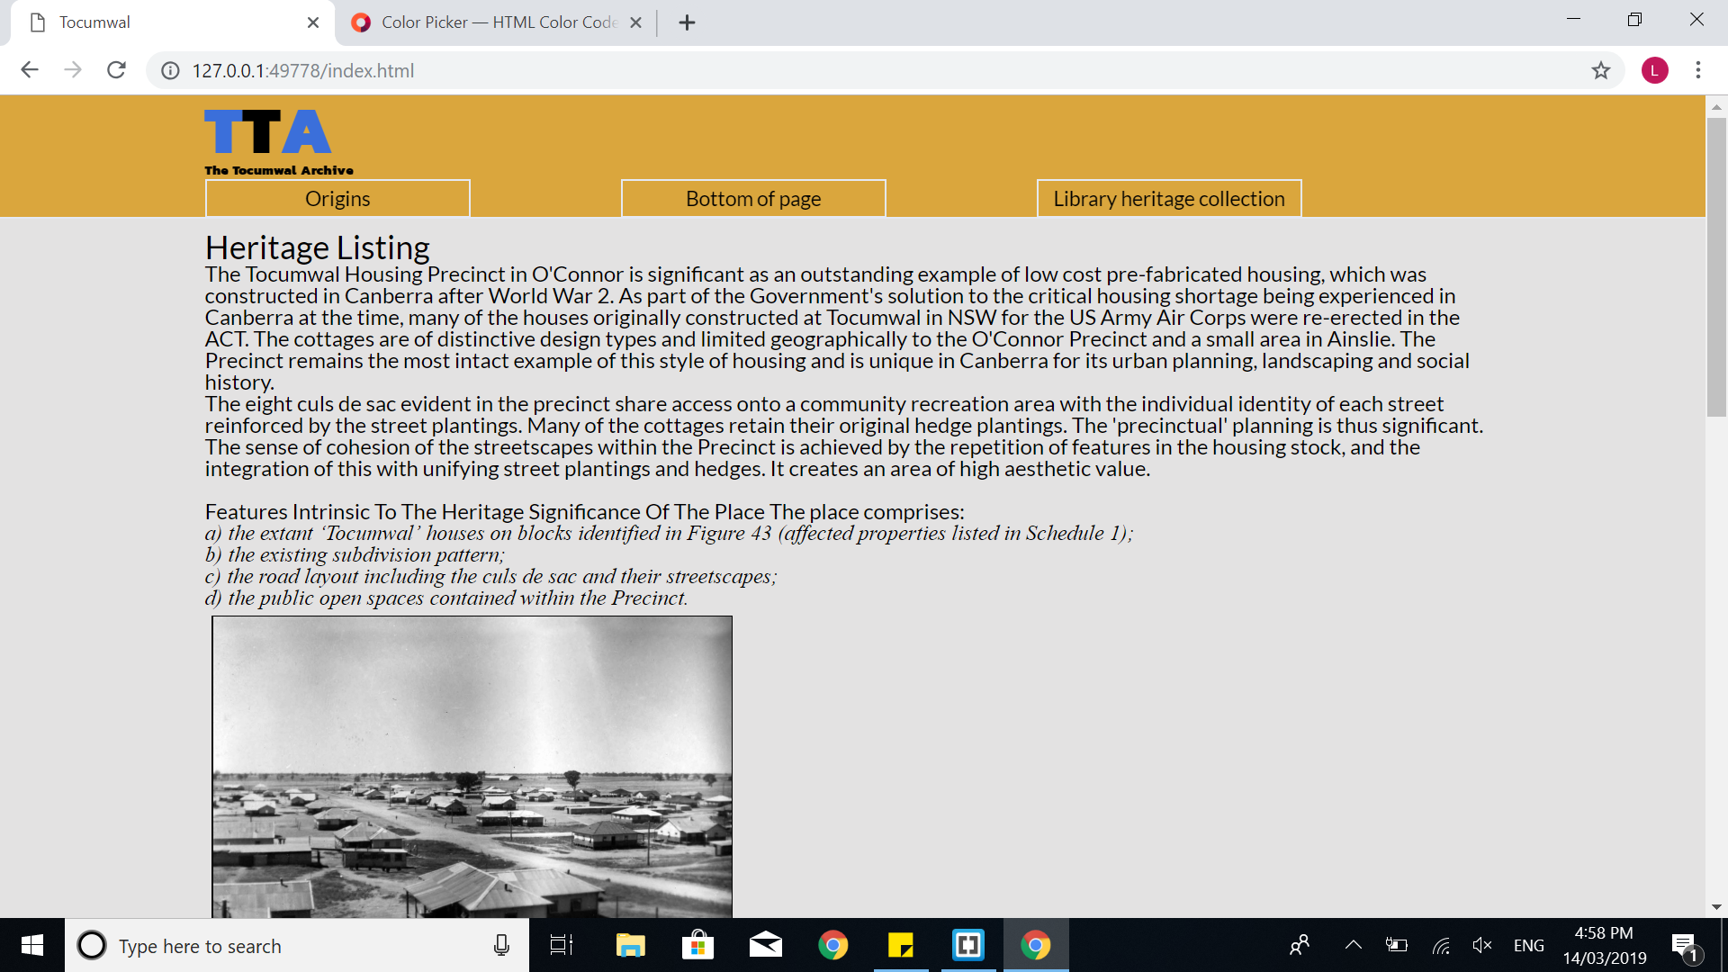

The logo was created using the imported google font ‘Kanit’ for the acronym, as well as a small styled sub heading to expand on the acronym.

For the colours I used **#DAA63B** which is deep mustard tone for most of the site, which is counter pointed by **#3B6FDA** which is its direct complementary colour on the colour wheel. I chose the mustard colour as it is not a colour you see often on website and I wanted to try and add a sense of individuality to the website.

Another stylistic choice influenced by my research was the decision to implement a sticky header, as found on several websites. An example of a sticky header can be found on the ONiA website, which was the winner of the commercial category of the Australian Web Awards (Webawards.com.au, 2019). The sticky header was created by setting the elements position to fixed and top:0, as seen on line 76 of the CSS.

The header contains the page navigation elements held within the <nav> tag. The nav elements are styled into buttons. To show that the buttons can be clicked on they change colour when hovered over, this provides tactile feedback for the user when interacting with the site. This was achieved by adding the ‘hover’ pseudo-class to the button and changing to a lighter background colour and changing the text to white when hovered over.

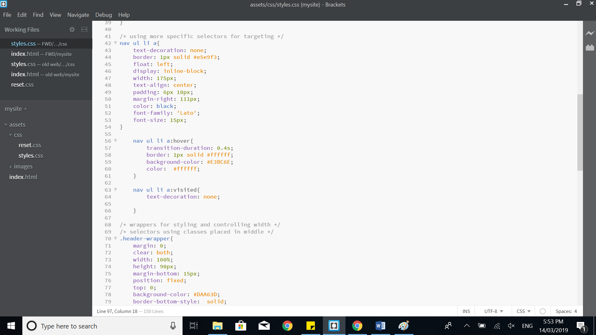

One button leads to an external site for further reading on the topic. The other two buttons lead to different positions on the page for internal navigation. As well as this there is a link that returns the user to the top of the page in the footer. While the buttons use hash addressing to move to the position the footer link reloads the whole page, while this is slower it is much more effective at resetting the position with the sticky header being fixed at the top of the page.

When deciding on the placement of the elements on my page I decided to keep the F-shaped pattern, which has been found to be the most natural way people scan a webpage (Cao, 2019). 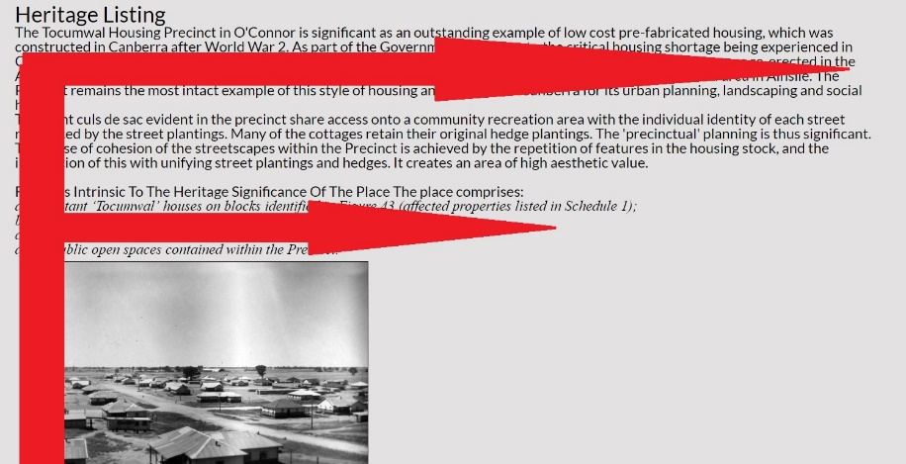

The layout of the website was achieved using two types of wrappers, one wrapper to style the website and one wrapper to hold the content. The content wrapper is 960px wide and no elements spill over these content lines.

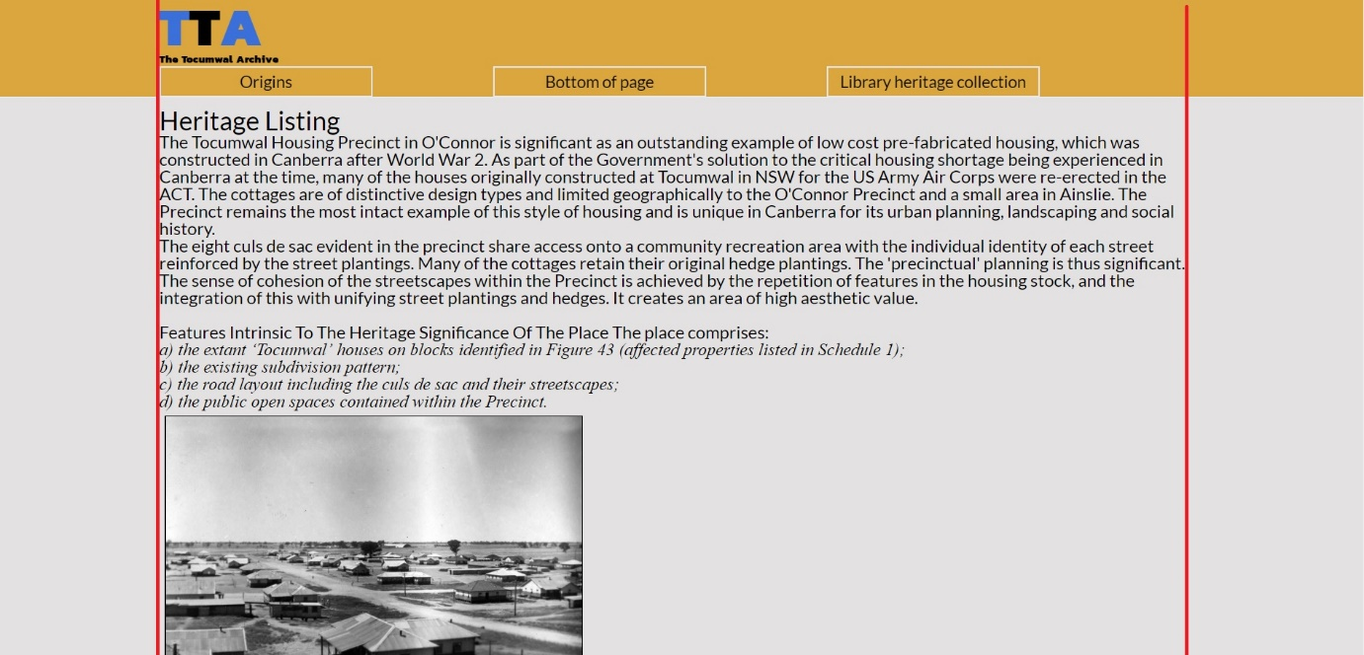

For the font of the main content I decided to use the sans serif font “Lato”. I chose this font as sans serif fonts are considered easiest to read on the web (Best Website Builder Reviews for 2019, 2019), which I thought would be most suitable due to the large amount of text present on the site.

# Bibliography

Best Website Builder Reviews for 2019. (2019). *How To Pick The Best Font For Your Website (feb 2019)*. [online] Available at: https://www.websitebuilderexpert.com/designing-websites/pick-best-font-style-for-website/ [Accessed 14 Mar. 2019].

Cao, J. (2019). *How To Design Websites That Mirror How Our Eyes Work*. [online] The Next Web. Available at: https://thenextweb.com/dd/2015/04/10/how-to-design-websites-that-mirror-how-our-eyes-work/ [Accessed 12 Mar. 2019].

Dutcher, K. (2017). *7 Website Conventions to Follow When Designing Your Website*. [online] Web Ascender. Available at: https://www.webascender.com/blog/7-website-conventions-to-follow-when-designing-your-website/ [Accessed 12 Mar. 2019].

National Archives of Australia. (2019). *National Archives of Australia*. [online] Available at: http://www.naa.gov.au/ [Accessed 14 Mar. 2019].

NiA. (2019). *ONiA: Orthodontic Network in Adelaide*. [online] Available at: https://www.onia.com.au/ [Accessed 14 Mar. 2019].

Webawards.com.au. (2019). *Past Finalists & Winners 2017 | Australian Web Awards 2019*. [online] Available at: https://www.webawards.com.au/finalists/2017#commercial [Accessed 12 Mar. 2019].