**Generation Tool V1**

**Liam Watson**

**Introduction** -

The Generation tool has been designed to and can generate doodads (trees, rocks and items) randomly in a world on startup of the script.

Getting Started -

**Inspector** -

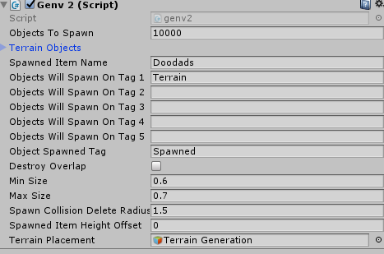

**Objects to spawn** = how many objects the script will try and spawn.

**Terrain Objects** = Array of game objects that the script will try and spawn, these are chosen randomly.

**Spawned Item Name** = When the objects are spawned they will be named

**Objects will spawn On Tag** = any objects that are tagged with any of these will potentially have spawned objects on them.

**Object Spawned Tag** = what are the instantiated objects tagged with NOTE(this tag must exist, hence create it)

**Min & Max Size** = a factor of scale, eg, 0.5 - 1.5 will spawn items randomly between 50% - 150% original size.

**Destroy Overlap** = if true will enable the generator to stop overlapping spawned entities but can reduce the number of total objects spawned.

**Spawn Collision Delete Radius** = how large a sphere will scale out to detect other objects when the object is instantiated (if the object detects other instantiated objects it will delete itself stopping overlaps).

**Spawned Item height offset** = how far under the surface the object will spawn, this is useful for slanted hills etc to stop the roots or edges spawning.

**Terrain Placement** = the object that the script attaches to, you must drag that into here as it uses the scale of the object to set where it will spawn objects

**Setup -**

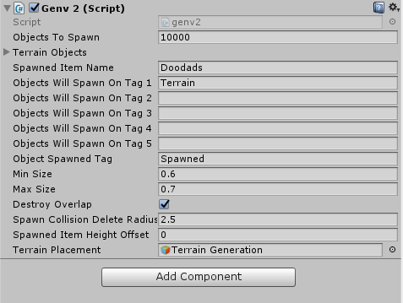

1. Import the script into unity
2. Create a 3D cube and attach the script to the cube
3. Rename the cube to whatever you want (something you will remember to keep the hierarchy clean)
4. Click the cube in the cube in the hierarchy and then drag the cube onto the Terrain Placement field on the inspector (drag itself onto itself)
5. Set how many objects you want to spawn
6. Create your tags eg (terrain, water, notwalkable etc)
7. Add your prefabs (gameobjects into the array on the inspector(terrain objects))
8. Type in the tags you want the generator to spawn on “objects will spawn on tag 1-5
9. Create and tag objects and landscapes with the tags you want eg (terrain, cliff)
10. If needed set a spawned tag and name
11. Set min and max sizes
12. Toggle destroy object and its parameters to suit what you want (higher spawn deletion radius results in less overall objects)
13. Setup offset if you have cliffs (higher means object gets spawned lower)
14. Press play