**Software Requirements Specification**

*Version 1.0*

June 17, 2020

**Management of a transport company**

*Hany Salloum*

*Lian Aljundi*

*Basma Dekar*

*Zolfakkar Aldaher*

*Submitted in partial fulfillment of the requirements of Software Engineering 2*

**1.Introduction**

1.1. Purpose

The purpose of this document is to present a detailed description of YourRoad applications and transportation system.

It will explain the purpose and features of the applications, the interfaces

of the applications and what the system will do. This document is intended for the passengers, the drivers and the developers of the system.

1.2. Scope of Project

This software system will be an online booking for local journeys. This system will be designed to improve booking quality and customer comfort by easily choosing preferred time and destination and many others features.

1.3. Glossary

|  |  |
| --- | --- |
| Term | Definition |
| Booking | the interface where a passenger can book his journey online and choose whatever characteristics he needs for this journey |
| Tickets | the interface where a passenger can check his tickets |
| Last Trips | the interface of which the user can check out his previous journeys and trips |
| My Trip | the interface of which the user can check the live status of his current journey |

1.4. References

IEEE. IEEE Std 830-1998 IEEE Recommended Practice for Software Requirements Specifications. IEEE Computer Society, 1998.

1.5. Overview of Document

The next chapter, the Overall Description section, of this document gives an overview of the functionality of the applications

**2.0. Overall Description**

2.1 System Environment

The YourRoad System has three active actors and one cooperating system.

The Passenger, the driver accesses the interfaces via internet. Through apps. The manager

accesses the entire system directly.

2.2 Functional Requirements Specification

This section outlines the use cases for each of the active actors separately.

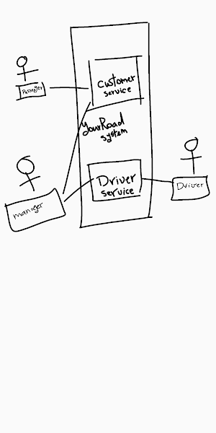

2.2.1 Passenger Use Case

Use case: Book your journey

Brief Description:

The passenger accesses the booking tab, chooses which time and destination he'd like to travel to.

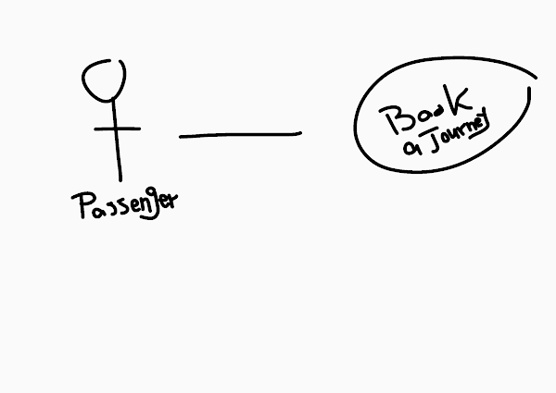

Use case: Tickets

Brief Description:

The passenger accesses the tickets tab, checking the tickets he has.

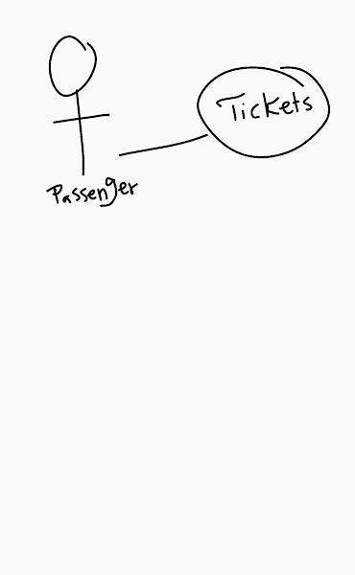

Use case: last trips

Brief Description:

The passenger accesses the last Trips tab, views last Trips he had.

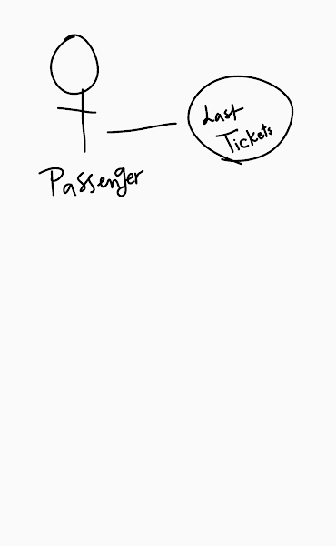

Use case: my trip

Brief Description:

The passenger accesses the my trip tab, checking for the details of the current trip he's on.

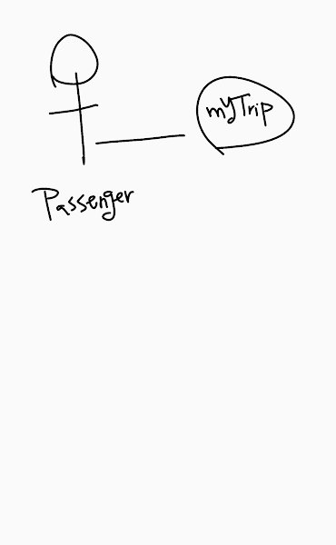

2.2.2 Driver Use Case

Use case: supplying departing time

Brief Description:

The driver presses a button and sends current time of departure.

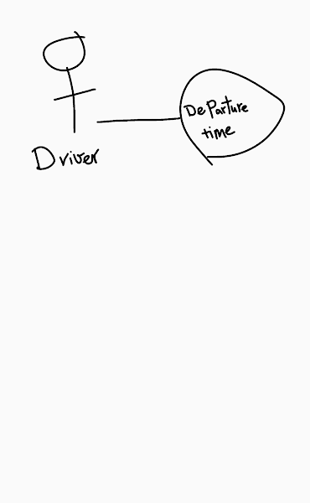

Use case: supplying arriving time

Brief Description:

The driver presses a button and sends current time of arriving.

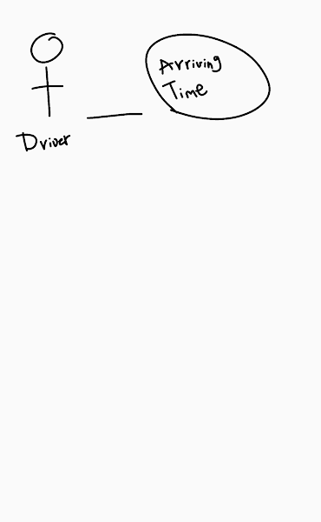

Use case: supplying live location

Brief Description:

The driver presses a button and sends his live location.

