**武汉纺织大学**

**《Direct3D图形编程》上机实验报告**

**题目:** **模板（2）**

**成 绩：**

**学 号： 1604240705**

**姓 名： 胡 莲**

**班 级： 计算机11603**

**指导教师： 李 敏**

**报告日期：2019 年4月26日**

1. **实验1**
2. 题目

绘制一个正方形，用ice.bmp对正方形做纹理映射；在正方形前绘制一个黄色茶壶并绘制茶壶在正方形中的镜像；通过模板缓存控制茶壶镜像只出现在镜子区域内；通过VK_LEFT，VK_RIGHT，VK_UP和VK_DOWN按键来调整茶壶在X轴和Y轴的位置，具体如下：

[1] VK_LEFT：x轴上的值减少；

[2] VK_RIGHT：x轴上的值增加；

[3] VK_UP：y轴上的值增加；

[4] VK_DOWN：y轴上的值减少。

1. 实现代码

在d3dInit程序框架上修改代码：

1. 全局变量：

IDirect3DDevice9* Device = 0;

IDirect3DVertexBuffer9 * VB=0;

IDirect3DTexture9 * Tex=0;

D3DMATERIAL9 mtrl;

ID3DXMesh* Teapot=0;

D3DMATERIAL9 TeapotMtrl;

D3DXVECTOR3 TeapotPos(0.0f, 0.0f, -5.0f);

1. 定义灵活顶点格式：

struct Vertex

{

Vertex(){}

Vertex(float x, float y, float z, float nx, float ny, float nz, float u, float v)

{

_x = x; _y = y; _z = z; _nx = nx; _ny = ny; _nz = nz; _u = u; _v = v;

}

float _x, _y, _z;

float _nx, _ny, _nz;

float _u,_v;

static const DWORD FVF;

};

const DWORD Vertex::FVF = D3DFVF_XYZ | D3DFVF_NORMAL | D3DFVF_TEX1;

1. Setup()函数：

Device->CreateVertexBuffer(

6 * sizeof(Vertex),

D3DUSAGE_WRITEONLY,

Vertex::FVF,

D3DPOOL_MANAGED,

&VB,

0);

Vertex* v;

VB->Lock(0,0,(void**)&v,0);

v[0] = Vertex(-10.0f,-10.0f,0.0f,0.0f,0.0f,-1.0f,0.0f,1.0f);

v[1] = Vertex(-10.0f,10.0f,0.0f,0.0f,0.0f,-1.0f,0.0f,0.0f);

v[2] = Vertex(10.0f,10.0f,0.0f,0.0f,0.0f,-1.0f,1.0f,0.0f);

v[3] = Vertex(-10.0f,-10.0f,0.0f,0.0f,0.0f,-1.0f,0.0f,1.0f);

v[4] = Vertex(10.0f,10.0f,0.0f,0.0f,0.0f,-1.0f,1.0f,0.0f);

v[5] = Vertex(10.0f,-10.0f,0.0f,0.0f,0.0f,-1.0f,1.0f,1.0f);

VB->Unlock();

mtrl = d3d::WHITE_MTRL;

TeapotMtrl = d3d::YELLOW_MTRL;

D3DXCreateTeapot(Device,&Teapot,0);

D3DLIGHT9 dir;

::ZeroMemory(&dir, sizeof(dir));

dir.Type = D3DLIGHT_DIRECTIONAL;

dir.Diffuse = d3d::WHITE;

dir.Specular = d3d::WHITE * 0.2f;

dir.Ambient = d3d::WHITE * 0.6f;

dir.Direction = D3DXVECTOR3(0.707f, 0.0f, 0.707f);

Device->SetLight(0, &dir);

Device->LightEnable(0, true);

Device->SetRenderState(D3DRS_NORMALIZENORMALS, true);

D3DXCreateTextureFromFile(

Device,

"ice.bmp",

&Tex);

Device->SetSamplerState(0,D3DSAMP_MAGFILTER,D3DTEXF_LINEAR);

Device->SetSamplerState(0,D3DSAMP_MINFILTER,D3DTEXF_LINEAR);

Device->SetSamplerState(0,D3DSAMP_MIPFILTER,D3DTEXF_POINT);

D3DXMATRIX proj;

D3DXMatrixPerspectiveFovLH(

&proj,

D3DX_PI * 0.5f,

(float)Width / (float)Height,

1.0f,

1000.0f);

Device -> SetTransform(D3DTS_PROJECTION, &proj);

return true;

1. Cleanup()函数：

d3d::Release<IDirect3DVertexBuffer9*>(VB);

d3d::Release<IDirect3DTexture9*>(Tex);

d3d::Release<ID3DXMesh*>(Teapot);

1. Display()函数：

Device->Clear(0, 0, D3DCLEAR_TARGET | D3DCLEAR_ZBUFFER|D3DCLEAR_STENCIL, 0xffffffff, 1.0f, 0);

Device->BeginScene();

Device->SetRenderState(D3DRS_STENCILENABLE,true);

Device->SetRenderState(D3DRS_STENCILFUNC,D3DCMP_ALWAYS);

Device->SetRenderState(D3DRS_STENCILREF,0x1);

Device->SetRenderState(D3DRS_STENCILZFAIL,D3DSTENCILOP_KEEP);

Device->SetRenderState(D3DRS_STENCILFAIL,D3DSTENCILOP_KEEP);

Device->SetRenderState(D3DRS_STENCILPASS,D3DSTENCILOP_REPLACE);

D3DXMATRIX W;

D3DXMatrixTranslation(&W,0.0f,0.0f,0.0f);

Device->SetTransform(D3DTS_WORLD,&W);

Device->SetStreamSource(0,VB,0,sizeof(Vertex));

Device->SetFVF(Vertex::FVF);

Device->SetMaterial(&mtrl);

Device->SetTexture(0, tex);

Device->DrawPrimitive(D3DPT_TRIANGLELIST,0,2);

Device->SetRenderState(D3DRS_STENCILFUNC,D3DCMP_EQUAL);

Device->SetRenderState(D3DRS_STENCILPASS,D3DSTENCILOP_KEEP);

D3DXMatrixTranslation(&W,TeapotPos.x,TeapotPos.y,TeapotPos.z);

D3DXMATRIX R,p;

D3DXPLANE plane(0.0f,0.0f,1.0f,0.0f);

D3DXMatrixReflect(&R,&plane);

p = W * R;

Device->SetTransform(D3DTS_WORLD,&p);

Device->SetMaterial(&TeapotMtrl);

Device->SetTexture(0, 0);

Device->Clear(0,0,D3DCLEAR_ZBUFFER,0,1.0f,0);

Device->SetRenderState(D3DRS_ALPHABLENDENABLE,true);

Device->SetRenderState(D3DRS_SRCBLEND,D3DBLEND_DESTCOLOR);

Device->SetRenderState(D3DRS_DESTBLEND,D3DBLEND_ZERO);

Device->SetRenderState(D3DRS_CULLMODE,D3DCULL_CW);

Teapot->DrawSubset(0);

Device->SetRenderState(D3DRS_ALPHABLENDENABLE,false);

Device->SetRenderState(D3DRS_STENCILENABLE,false);

Device->SetRenderState(D3DRS_CULLMODE,D3DCULL_CCW);

D3DXMatrixTranslation(&W,TeapotPos.x,TeapotPos.y,TeapotPos.z);

Device->SetTransform(D3DTS_WORLD,&W);

Device->SetMaterial(&TeapotMtrl);

Device->SetTexture(0, 0);

Teapot->DrawSubset(0);

Device->EndScene();

Device->Present(0, 0, 0, 0);

1. WndProc()函数：

case WM_KEYDOWN:

if( wParam == VK_ESCAPE )

::DestroyWindow(hwnd);

if ( wParam == VK_LEFT )

TeapotPos.x -= 0.1f;

if ( wParam == VK_RIGHT )

TeapotPos.x += 0.1f;

if( wParam == VK_UP )

TeapotPos.y += 0.1f;

if( wParam == VK_DOWN )

TeapotPos.y -= 0.1f;

break;

1. 程序运行结果
   1. 初始画面

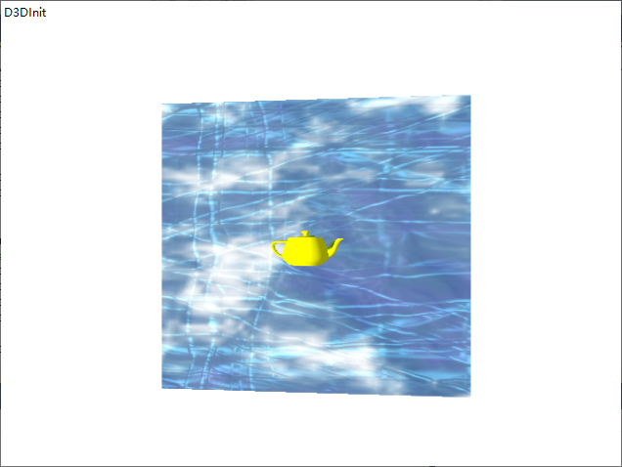

* 1. 按下VK_LEFT后的画面

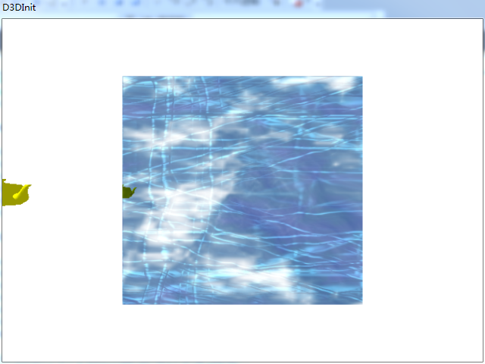

* 1. 按下VK_RIGHT后的画面

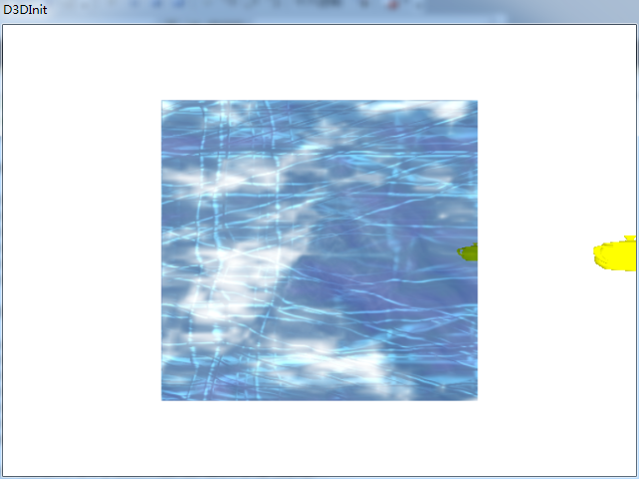

* 1. 按下VK_UP后的画面

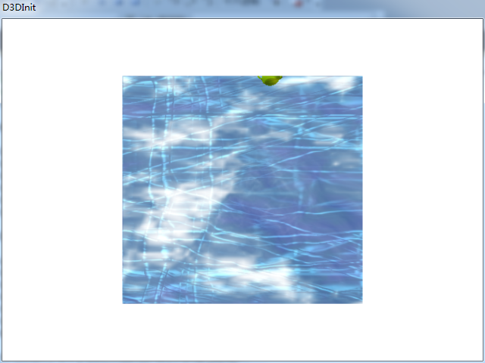

* 1. 按下VK_DOWN后的画面

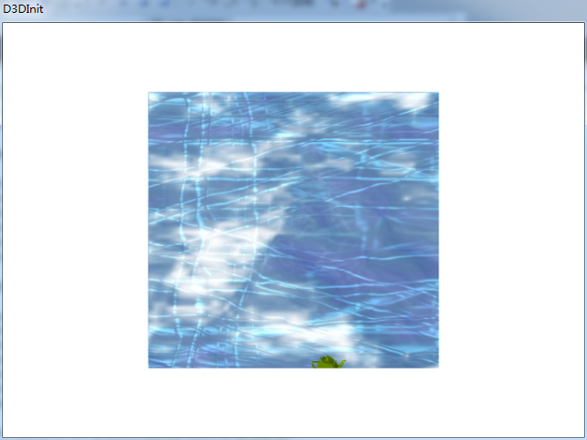

1. **总结**
2. 问题：看不到茶壶镜像。

解决方法：开启模板的代码要放在绘制镜子前，且模板的比较代码要放在绘制镜子后、绘制镜像前。

1. **实验2**
2. 题目

绘制一个正方体，用red.jpg，green.jpg和blue.jpg三个纹理文件对正方体的6个面做纹理映射，具体为：前面/后面（red）, 左面/右面（green）, 上面/下面（blue）;并且使得正方体绕Y轴连续旋转。

1. 实现代码

在d3dInit程序框架上修改代码：

1. 全局变量：

IDirect3DDevice9* Device = 0;

IDirect3DVertexBuffer9* VB = 0;

IDirect3DTexture9* tex1 = 0;

IDirect3DTexture9* tex2 = 0;

IDirect3DTexture9* tex3 = 0;

1. 定义灵活顶点格式：

struct Vertex

{

Vertex(){}

Vertex(float x, float y, float z, float nx, float ny, float nz, float u, float v)

{

_x = x; _y = y; _z = z; _nx = nx; _ny = ny; _nz = nz; _u = u; _v = v;

}

float _x, _y, _z;

float _nx, _ny, _nz;

float _u,_v;

static const DWORD FVF;

};

const DWORD Vertex::FVF = D3DFVF_XYZ | D3DFVF_NORMAL | D3DFVF_TEX1;

1. Setup()函数：

Device->CreateVertexBuffer(

36 * sizeof(Vertex),

D3DUSAGE_WRITEONLY,

Vertex::FVF,

D3DPOOL_MANAGED,

&VB,

0);

Vertex* v;

VB->Lock(0,0,(void**)&v,0);

//V0(-1,0,-1) V1(-1,0,1) V2(1,0,1) V3(1,0,-1)

//V4(-1,1,-1) V5(-1,1,1) V6(1,1,1) V7(1,1,-1)

v[0] = Vertex(-1.0f,0.0f,-1.0f,0.0f,0.0f,-1.0f,0.0f,1.0f);//前面 V0 V4 V7

v[1] = Vertex(-1.0f,2.0f,-1.0f,0.0f,0.0f,-1.0f,0.0f,0.0f);

v[2] = Vertex(1.0f, 2.0f, -1.0f,0.0f,0.0f,-1.0f,1.0f,0.0f);

v[3] = Vertex(-1.0f,0.0f,-1.0f,0.0f,0.0f,-1.0f,0.0f,1.0f);//V0 V7 V3

v[4] = Vertex(1.0f, 2.0f, -1.0f,0.0f,0.0f,-1.0f,1.0f,0.0f);

v[5] = Vertex(1.0f,0.0f,-1.0f,0.0f,0.0f,-1.0f,1.0f,1.0f);

v[6] = Vertex(-1.0f,0.0f,1.0f,0.0f,0.0f,1.0f,0.0f,1.0f);//背面 V1 V6 V5

v[7] = Vertex(1.0f,2.0f,1.0f,0.0f,0.0f,1.0f,1.0f,0.0f);

v[8] = Vertex(-1.0f,2.0f,1.0f,0.0f,0.0f,1.0f,0.0f,0.0f);

v[9] = Vertex(-1.0f,0.0f,1.0f,0.0f,0.0f,1.0f,0.0f,1.0f);//V1 V2 V6

v[10] = Vertex(1.0f,0.0f,1.0f,0.0f,0.0f,1.0f,1.0f,1.0f);

v[11] = Vertex(1.0f,2.0f,1.0f,0.0f,0.0f,1.0f,1.0f,0.0f);

v[12] = Vertex(1.0f,0.0f,-1.0f,1.0f,0.0f,0.0f,0.0f,1.0f);//右面 V3 V7 V6

v[13] = Vertex(1.0f,2.0f, -1.0f,1.0f,0.0f,0.0f,0.0f,0.0f);

v[14] = Vertex(1.0f,2.0f,1.0f,1.0f,0.0f,0.0f,1.0f,0.0f);

v[15] = Vertex(1.0f,0.0f,-1.0f,1.0f,0.0f,0.0f,0.0f,1.0f);//V3 V6 V2

v[16] = Vertex(1.0f,2.0f,1.0f,1.0f,0.0f,0.0f,1.0f,0.0f);

v[17] = Vertex(1.0f,0.0f,1.0f,1.0f,0.0f,0.0f,1.0f,1.0f);

v[18] = Vertex(-1.0f,0.0f,-1.0f,-1.0f,0.0f,0.0f,0.0f,1.0f);//左面 V0 V5 V4

v[19] = Vertex(-1.0f,2.0f,1.0f,-1.0f,0.0f,0.0f,1.0f,0.0f);

v[20] = Vertex(-1.0f,2.0f,-1.0f,-1.0f,0.0f,0.0f,0.0f,0.0f);

v[21] = Vertex(-1.0f,0.0f,-1.0f,-1.0f,0.0f,0.0f,0.0f,1.0f);//V0 V1 V5

v[22] = Vertex(-1.0f,0.0f,1.0f,-1.0f,0.0f,0.0f,1.0f,1.0f);

v[23] = Vertex(-1.0f,2.0f,1.0f,-1.0f,0.0f,0.0f,1.0f,0.0f);

v[24] = Vertex(-1.0f,2.0f,-1.0f,0.0f,1.0f,0.0f,0.0f,1.0f);//顶面V4 V5 V6

v[25] = Vertex(-1.0f,2.0f,1.0f,0.0f,1.0f,0.0f,0.0f,0.0f);

v[26] = Vertex(1.0f,2.0f,1.0f,0.0f,1.0f,0.0f,1.0f,0.0f);

v[27] = Vertex(-1.0f,2.0f,-1.0f,0.0f,1.0f,0.0f,0.0f,1.0f);//V4 V6 V7

v[28] = Vertex(1.0f,2.0f,1.0f,0.0f,1.0f,0.0f,1.0f,0.0f);

v[29] = Vertex(1.0f,2.0f, -1.0f,0.0f,1.0f,0.0f,1.0f,1.0f);

v[30] = Vertex(-1.0f,0.0f,-1.0f,0.0f,-1.0f,0.0f,0.0f,1.0f);//底面 V0 V2 V1

v[31] = Vertex(1.0f,0.0f,1.0f,0.0f,-1.0f,0.0f,1.0f,0.0f);

v[32] = Vertex(-1.0f,0.0f,1.0f,0.0f,-1.0f,0.0f,0.0f,0.0f);

v[33] = Vertex(-1.0f,0.0f,-1.0f,0.0f,-1.0f,0.0f,0.0f,1.0f);//V0 V3 V2

v[34] = Vertex(1.0f,0.0f,-1.0f,0.0f,-1.0f,0.0f,1.0f,1.0f);

v[35] = Vertex(1.0f,0.0f,1.0f,0.0f,-1.0f,0.0f,1.0f,0.0f);

VB->Unlock();

Device->SetRenderState(D3DRS_NORMALIZENORMALS, true);

Device->SetRenderState(D3DRS_SPECULARENABLE, false);

D3DXCreateTextureFromFile(

Device,

"red.jpg",

&tex1);

D3DXCreateTextureFromFile(

Device,

"green.jpg",

&tex2);

D3DXCreateTextureFromFile(

Device,

"blue.jpg",

&tex3);

Device->SetSamplerState(0, D3DSAMP_MAGFILTER, D3DTEXF_LINEAR);

Device->SetSamplerState(0, D3DSAMP_MINFILTER, D3DTEXF_LINEAR);

Device->SetSamplerState(0, D3DSAMP_MIPFILTER, D3DTEXF_LINEAR);

D3DXVECTOR3 position(0.0f, 0.0f, -5.0f);

D3DXVECTOR3 target(0.0f, 0.0f, 0.0f);

D3DXVECTOR3 up(0.0f, 1.0f, 0.0f);

D3DXMATRIX V;

D3DXMatrixLookAtLH(&V, &position, &target, &up);

Device -> SetTransform(D3DTS_VIEW, &V);

D3DXMATRIX proj;

D3DXMatrixPerspectiveFovLH(

&proj,

D3DX_PI * 0.5f,

(float)Width / (float)Height,

1.0f,

1000.0f);

Device -> SetTransform(D3DTS_PROJECTION, &proj);

Device->SetRenderState(D3DRS_LIGHTING,false);

return true;

1. Cleanup()函数：

d3d::Release<IDirect3DVertexBuffer9*>(VB);

d3d::Release<IDirect3DTexture9*>(tex1);

d3d::Release<IDirect3DTexture9*>(tex2);

d3d::Release<IDirect3DTexture9*>(tex3);

1. Display()函数：

Device->Clear(0, 0, D3DCLEAR_TARGET | D3DCLEAR_ZBUFFER, 0xffffffff, 1.0f, 0);

D3DXMATRIX Ry,Rx;

static float y = 0.0f;

D3DXMatrixRotationY(&Ry,y);

y+=timeDelta;

D3DXMatrixRotationX(&Rx,3.14f/4.0f);

D3DXMATRIX p = Rx * Ry;

Device->SetTransform(D3DTS_WORLD,&p);

Device->BeginScene();

Device->SetStreamSource(0,VB,0,sizeof(Vertex));

Device->SetFVF(Vertex::FVF);

Device->SetTexture(0, tex1);

Device->DrawPrimitive(D3DPT_TRIANGLELIST,0,4);

Device->SetTexture(0, tex2);

Device->DrawPrimitive(D3DPT_TRIANGLELIST,12,4);

Device->SetTexture(0, tex3);

Device->DrawPrimitive(D3DPT_TRIANGLELIST,24,4);

Device->EndScene();

Device->Present(0, 0, 0, 0);

1. 程序运行结果

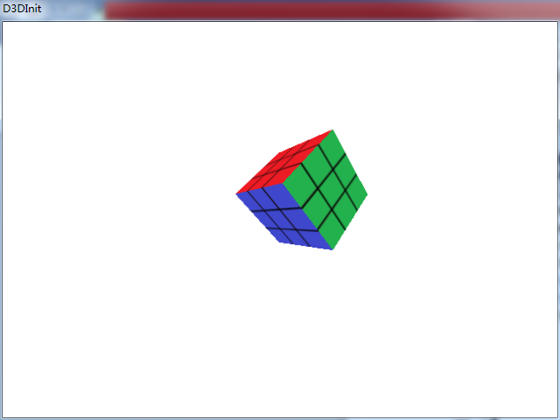

1. **总结**

纹理贴图的顺序要严格按照顶点缓存的顺序。