**武汉纺织大学**

**《Direct3D图形编程》上机实验报告**

**题目:** **综合程序设计(1)**

**成 绩：**

**学 号： 1604240705**

**姓 名： 胡 莲**

**班 级： 计算机11603**

**指导教师： 李 敏**

**报告日期：2019 年5月9 日**

1. **实验1（茶桌和茶壶）**
2. 题目

1)绘制一个茶桌(圆形桌面/正方形桌面+圆形或方形桌腿),桌面上面放置一把茶壶，要求通过键盘来控制茶壶在桌面上移动，且只能够在桌面区域内移动。为场景添加光照和纹理映射。

2)通过键盘控制摄像机以不同角度和位置观察场景。

3)将按键提示信息以文字的形式显示在视口区适当位置处。

1. 实现代码

在d3dInit框架的基础上添加代码：

1. 全局变量

IDirect3DDevice9* Device = 0;

ID3DXMesh* mesh[6] = {0,0,0,0,0,0};

IDirect3DTexture9* tex[2] = {0,0};

D3DMATERIAL9 mtrl[2];

D3DXMATRIX W[6];

D3DXVECTOR3 TeapotPos(0.0f,3.0f,0.0f);

float x = 0.0f;

float y = 0.0f;

float z = -5.0f;

ID3DXFont* Font = 0;

RECT rect = {0, 0, Width, Height};

1. Setup()函数

D3DXFONT_DESC df;

ZeroMemory(&df,sizeof(D3DXFONT_DESC));

df.Height = 15;

df.Width = 10;

df.Weight = 200;

df.MipLevels = D3DX_DEFAULT;

df.Italic = false;

df.CharSet = DEFAULT_CHARSET;

df.OutputPrecision = 0;

df.Quality = 0;

df.PitchAndFamily = 0;

strcpy(df.FaceName,"宋?体¬?");

D3DXCreateFontIndirect(Device,&df,&Font);

D3DXCreateCylinder(Device, 3.0f, 3.0f, 0.1f, 40, 40, &mesh[0], 0);

D3DXCreateCylinder(Device, 0.2f, 0.2f, 3.0f, 20, 20, &mesh[1], 0);

D3DXCreateCylinder(Device, 0.2f, 0.2f, 3.0f, 20, 20, &mesh[2], 0);

D3DXCreateCylinder(Device, 0.2f, 0.2f, 3.0f, 20, 20, &mesh[3], 0);

D3DXCreateCylinder(Device, 0.2f, 0.2f, 3.0f, 20, 20, &mesh[4], 0);

D3DXCreateTeapot(Device, &mesh[5], 0);

mtrl[0] = d3d::WHITE_MTRL;

mtrl[1] = d3d::YELLOW_MTRL;

D3DLIGHT9 dir;

::ZeroMemory(&dir, sizeof(dir));

dir.Type = D3DLIGHT_DIRECTIONAL;

dir.Diffuse = d3d::WHITE;

dir.Specular = d3d::WHITE * 0.2f;

dir.Ambient = d3d::WHITE * 0.6f;

dir.Direction = D3DXVECTOR3(0.707f, 0.0f, 0.707f);

Device->SetLight(0, &dir);

Device->LightEnable(0, true);

Device->SetRenderState(D3DRS_NORMALIZENORMALS, true);

Device->SetRenderState(D3DRS_SPECULARENABLE, false);

D3DXCreateTextureFromFile(Device,"black.jpg",&tex[0]);

D3DXCreateTextureFromFile(Device,"brown.jpg",&tex[1]);

Device->SetSamplerState(0, D3DSAMP_MAGFILTER, D3DTEXF_LINEAR);

Device->SetSamplerState(0, D3DSAMP_MINFILTER, D3DTEXF_LINEAR);

Device->SetSamplerState(0, D3DSAMP_MIPFILTER, D3DTEXF_LINEAR);

D3DXMATRIX proj;

D3DXMatrixPerspectiveFovLH(

&proj,

D3DX_PI * 0.5f,

(float)Width / (float)Height,

1.0f,

1000.0f);

Device -> SetTransform(D3DTS_PROJECTION, &proj);

Device->SetRenderState(D3DRS_LIGHTING,true);

return true;

1. Cleanup()函数

for(int i = 0; i < 6; i++)

d3d::Release<ID3DXMesh*>(mesh[i]);

for(int j = 0; j < 2; j++)

d3d::Release<IDirect3DTexture9*>(tex[j]);

d3d::Release<ID3DXFont*>(Font);

1. Display()函数

Device->Clear(0, 0, D3DCLEAR_TARGET | D3DCLEAR_ZBUFFER|D3DCLEAR_STENCIL, 0xffffffff, 1.0f, 0);

D3DXVECTOR3 position(x, y, z);

D3DXVECTOR3 target(0.0f, 0.0f, 0.0f);

D3DXVECTOR3 up(0.0f, 1.0f, 0.0f);

D3DXMATRIX V;

D3DXMatrixLookAtLH(&V, &position, &target, &up);

Device -> SetTransform(D3DTS_VIEW, &V);

Device->BeginScene();

/*提¬¨¢示º?信?息¡é*/

Font->DrawText(NULL,

"1、¡é'VK_LEFT'茶¨¨壶?左Á¨®移°?，ê?'VK_RIGHT'茶¨¨壶?右®¨°移°?、¡é\n 'VK_UP'茶¨¨壶?上¦?移°?，ê? 'VK_DOWN'茶¨¨壶?下?移°?\n\n2、¡é'W'视º¨®点Ì?y+、¡é'S'视º¨®点Ì?y-、¡é\n 'A'视º¨®点Ì?x-、¡é'D'视º¨®点Ì?x+、¡é\n 'Z'视º¨®点Ì?z+、¡é'X'视º¨®点Ì?z-",

-1,

&rect,

DT_TOP|DT_LEFT,

0xff000000);

/*绘?制?圆2盘¨¬*/

D3DXMATRIX Ry1;

D3DXMatrixRotationX(&Ry1,3.14f/4.0f);

D3DXMatrixTranslation(&W[0], 0.0f, 1.0f, -1.0f);

D3DXMATRIX p1 = W[0] * Ry1;

Device->SetMaterial(&mtrl[0]);

Device->SetTransform(D3DTS_WORLD, &p1);

Device->SetTexture(0, tex[0]);

mesh[0]->DrawSubset(0);

/*绘?制?四?条¬?腿ª¨¨*/

D3DXMATRIX Ry2;

D3DXMatrixRotationX(&Ry2,3.14f/4.0f);

D3DXMatrixTranslation(&W[1], -1.2f, -0.8f,0.5f);

D3DXMATRIX p2 = W[1] * Ry2;

Device->SetMaterial(&mtrl[0]);

Device->SetTransform(D3DTS_WORLD, &p2);

Device->SetTexture(0, tex[1]);

mesh[1]->DrawSubset(0);//右®¨°下?

D3DXMATRIX Ry3;

D3DXMatrixRotationX(&Ry3,3.14f/4.0f);

D3DXMatrixTranslation(&W[2], -1.2f, 2.2f, 0.5f);

D3DXMATRIX p3 = W[2] * Ry3;

Device->SetMaterial(&mtrl[0]);

Device->SetTransform(D3DTS_WORLD, &p3);

Device->SetTexture(0, tex[1]);

mesh[2]->DrawSubset(0);//左Á¨®上¦?

D3DXMATRIX Ry4;

D3DXMatrixRotationX(&Ry4,3.14f/4.0f);

D3DXMatrixTranslation(&W[3], 1.0f, -0.8f, 0.5f);

D3DXMATRIX p4 = W[3] * Ry4;

Device->SetMaterial(&mtrl[0]);

Device->SetTransform(D3DTS_WORLD, &p4);

Device->SetTexture(0, tex[1]);

mesh[3]->DrawSubset(0);//右®¨°下?

D3DXMATRIX Ry5;

D3DXMatrixRotationX(&Ry5,3.14f/4.0f);

D3DXMatrixTranslation(&W[4], 1.0f, 2.2f, 0.5f);

D3DXMATRIX p5 = W[4] * Ry5;

Device->SetMaterial(&mtrl[0]);

Device->SetTransform(D3DTS_WORLD, &p5);

Device->SetTexture(0, tex[1]);

mesh[4]->DrawSubset(0);//右®¨°上¦?

D3DXMATRIX Ry7,zoom1;

D3DXMatrixRotationX(&Ry7,-3.14f/4.0f);

D3DXMatrixTranslation(&W[5],TeapotPos.x,TeapotPos.y,TeapotPos.z+1.0f);

D3DXMatrixScaling(&zoom1,0.5,0.5,0.5);

D3DXMATRIX p7 = W[5] * Ry7 * zoom1;

Device->SetTransform(D3DTS_WORLD,&p7);

Device->SetMaterial(&mtrl[1]);

Device->SetTexture(0, 0);

mesh[5]->DrawSubset(0);

Device->EndScene();

Device->Present(0, 0, 0, 0);

1. WndProc()函数

case WM_KEYDOWN:

if( wParam == VK_ESCAPE )

::DestroyWindow(hwnd);

if ( wParam == VK_LEFT )

{

TeapotPos.x -= 0.1f;

if(TeapotPos.x < -3.5f)

TeapotPos.x = -3.5f;

}

if ( wParam == VK_RIGHT )

{

TeapotPos.x += 0.1f;

if(TeapotPos.x > 3.5f)

TeapotPos.x = 3.5f;

}

if( wParam == VK_UP )

{

TeapotPos.z += 0.1f;

if(TeapotPos.z > 5.0f)

TeapotPos.z = 5.0f;

}

if( wParam == VK_DOWN )

{

TeapotPos.z -= 0.1f;

if(TeapotPos.z < -3.5f)

TeapotPos.z = -3.5f;

}

if( ::GetAsyncKeyState('W'))

y += 2.0f;

if( ::GetAsyncKeyState('S'))

y -= 2.0f;

if( ::GetAsyncKeyState('A'))

x -= 2.0f;

if( ::GetAsyncKeyState('D'))

x += 2.0f;

if( ::GetAsyncKeyState('Z'))

z += 2.0f;

if( ::GetAsyncKeyState('X'))

z -= 2.0f;

break;

1. 程序运行结果
2. 原本

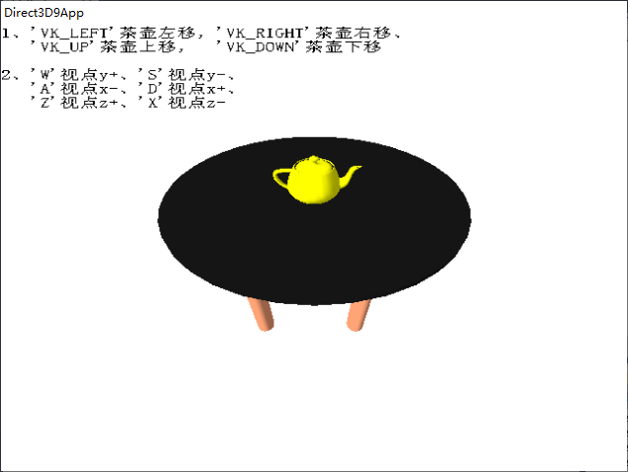

1. 按下VK_LEFT

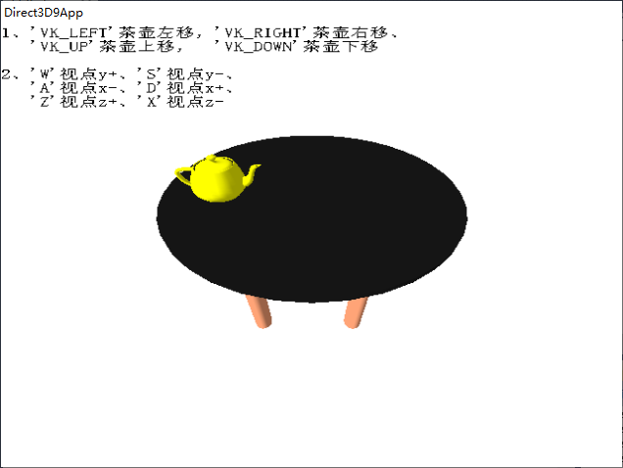

1. 按下VK_RIGHT

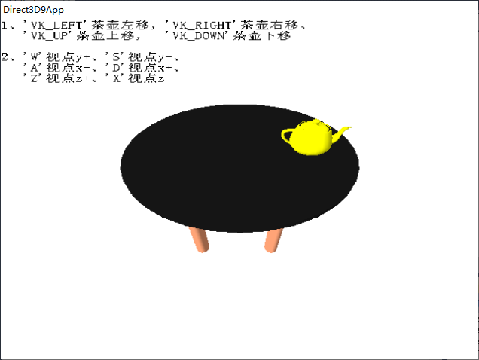

1. 按下VK_UP

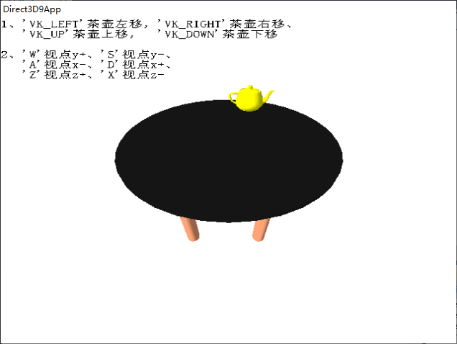

1. 按下VK_DOWN

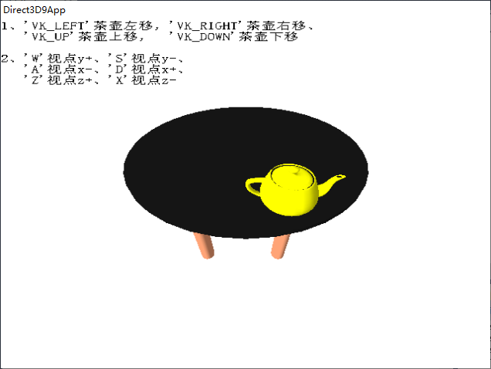

1. 按下W

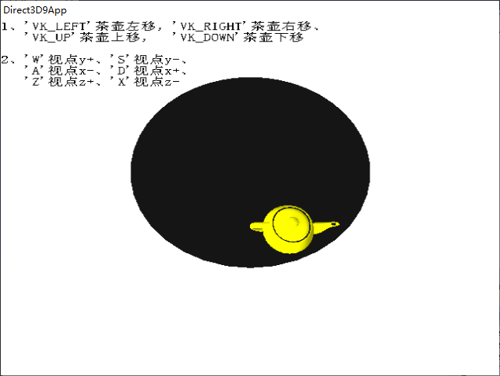

1. 按下S

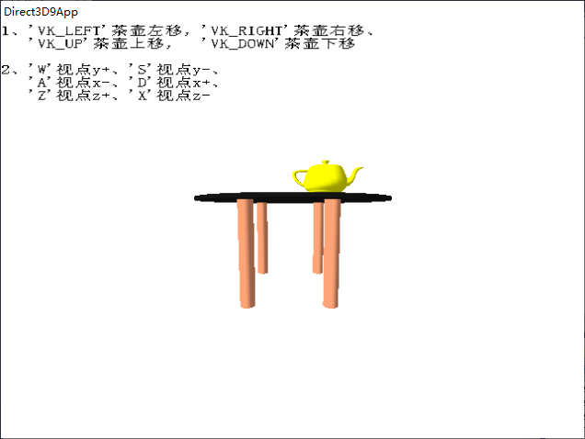

1. 按下A

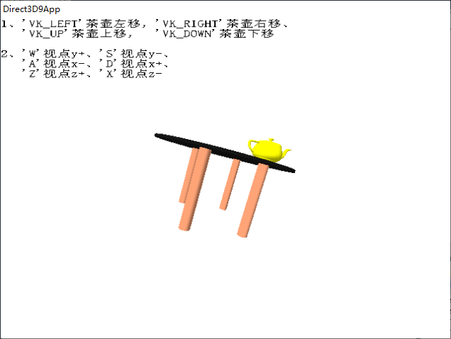

1. 按下D

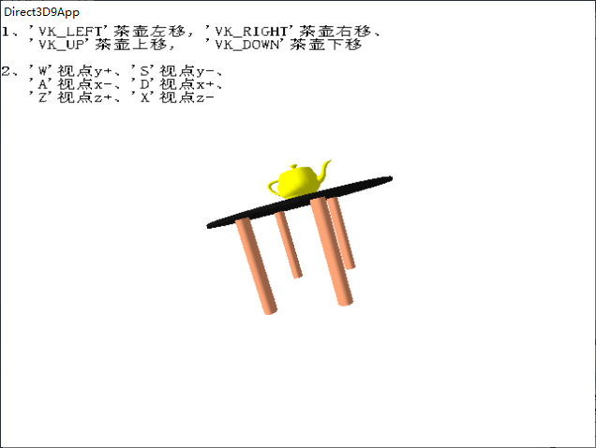

1. 按下Z

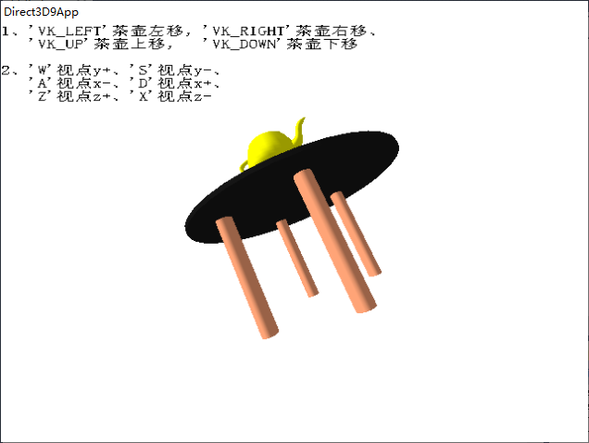

1. 按下X

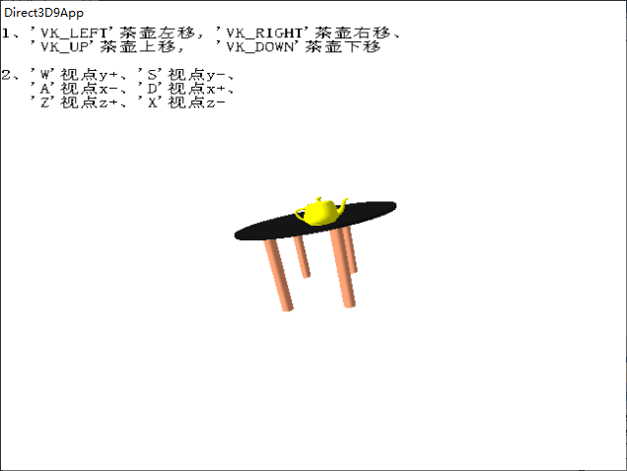

1. **总结**
2. 各个物体的位置需要一个个慢慢试出来，花费的时间比较长。
3. 画茶壶这里可以使用模板，也可不用。在使用模板时，从别的角度看，可以看到隐隐的茶壶镜像，没有很清楚，只有一抹黄。
4. 关于茶壶只能在桌面上移动，由于桌面是圆柱体通过变换来的，所以不能准确的知道桌面的边距，只能够设定一个大概值。
5. **实验2（三维动态球体）**
6. 题目

在屏幕上面绘制一个球体，要求能够通过键盘来控制球的状态，要求：

1)按下‘I’，球变大，按下‘O’变小（通过修改球的半径达到这一效果）；

2)按下‘pageup’、‘pagedown’、‘home’、‘end’，球能够上下左右移动；

3)按下‘C’，球能够旋转；

4)按下‘R’、‘G’、‘B’，可以有不同颜色的光照到球上；

5)按下‘P’、‘D’、‘S’，分别选择点光源，方向灯光源和聚光灯光源；

6)将按键提示信息以文字的形式显示在视口区适当位置处。

1. 实现代码

在d3dInit框架的基础上添加代码：

1. 全局变量

IDirect3DDevice9* Device = 0;

ID3DXMesh* sphere;

D3DXCOLOR c = d3d::RED;

D3DLIGHT9 light;

D3DXVECTOR3 dir(1.0f, 0.0f, 0.0f );

float zm = 1.0f;

D3DXVECTOR3 spherePos(0.0f,0.0f,0.0f);

float y = 0.0f;

ID3DXFont* Font1 = 0;

ID3DXFont* Font2 = 0;

RECT rect = {0, 0, Width, Height};

char* x = "您¨²还1没?有®D按ã¡ä下?任¨?何?键¨¹";

1. Setup()函数

D3DXFONT_DESC df;

ZeroMemory(&df,sizeof(D3DXFONT_DESC));

df.Height = 15;

df.Width = 10;

df.Weight = 200;

df.MipLevels = D3DX_DEFAULT;

df.Italic = false;

df.CharSet = DEFAULT_CHARSET;

df.OutputPrecision = 0;

df.Quality = 0;

df.PitchAndFamily = 0;

strcpy(df.FaceName,"宋?体¬?");

D3DXCreateFontIndirect(Device,&df,&Font1);

D3DXCreateFontIndirect(Device,&df,&Font2);

D3DXCreateSphere(Device,2.0f,20,20,&sphere,0);

D3DMATERIAL9 mtrl;

mtrl = d3d::WHITE_MTRL;

Device->SetMaterial(&mtrl);

light = d3d::InitDirectionalLight(&dir, &c);

Device->SetRenderState(D3DRS_NORMALIZENORMALS,true);

D3DXVECTOR3 position(0.0f, 0.0f, -6.0f);

D3DXVECTOR3 target(0.0f, 0.0f, 0.0f);

D3DXVECTOR3 up(0.0f, 1.0f, 0.0f);

D3DXMATRIX V;

D3DXMatrixLookAtLH(&V, &position, &target, &up);

Device -> SetTransform(D3DTS_VIEW, &V);

D3DXMATRIX proj;

D3DXMatrixPerspectiveFovLH(

&proj,

D3DX_PI * 0.5f,

(float)Width / (float)Height,

1.0f,

1000.0f);

Device -> SetTransform(D3DTS_PROJECTION, &proj);

Device -> SetRenderState(D3DRS_LIGHTING,true);

1. Cleanup()函数

d3d::Release<ID3DXMesh*>(sphere);

d3d::Release<ID3DXFont*>(Font1);

d3d::Release<ID3DXFont*>(Font2);

1. Display()函数

Device->BeginScene();

/*提¬¨¢示º?相¨¤应®|按ã¡ä键¨¹及¡ã功|能¨¹*/

Font1->DrawText(NULL,x,-1,&rect,DT_TOP|DT_CENTER,0xff000000);

/*所¨´有®D的Ì?按ã¡ä键¨¹提¬¨¢示º?，ê?不?会¨¢变À?*/

Font2->DrawText(NULL,

"\n\n\n1、¡é'I'键¨¹球¨°变À?大ä¨®，ê?'O'键¨¹球¨°变À?小?\n2、¡é'pageup'、¡é'pagedown'、¡é'home'、¡é'end'，ê?球¨°能¨¹够?上¦?下?左Á¨®右®¨°移°?动¡¥\n3、¡é'C'键¨¹球¨°能¨¹够?旋y转Áa\n4、¡é'R'、¡é'G'、¡é'B'，ê?可¨¦以°?有®D不?同ª?颜?色¦?的Ì?光a照?到Ì?球¨°上¦?；ê?\n5、¡é'P'、¡é'D'、¡é'S'，ê?分¤?别Àe选?择?点Ì?光a源¡ä，ê?方¤?向¨°灯Ì?光a源¡ä和¨ª聚?光a灯Ì?光a源¡ä。¡ê",

-1,

&rect,

DT_TOP|DT_LEFT,

0xff000000);

/*绘?制?球¨°体¬?*/

sphere->DrawSubset(0);

/*光a源¡ä*/

Device->SetLight(0,&light);

Device->LightEnable(0,true);

D3DXMATRIX Ts,Zoom,Ry;

D3DXMatrixTranslation(&Ts,spherePos.x,spherePos.y,spherePos.z);

D3DXMatrixScaling(&Zoom,zm,zm,zm);

D3DXMatrixRotationY(&Ry,y);

//y += timeDelta;

D3DXMATRIX p = Ts * Zoom * Ry;

Device->SetTransform(D3DTS_WORLD,&p);

Device->EndScene();

1. WndProc()函数

case WM_KEYDOWN:

if( wParam == VK_ESCAPE )

::DestroyWindow(hwnd);

if( ::GetAsyncKeyState('I') )

{

x = "您¨²按ã¡ä下?了¢?I键¨¹，ê?球¨°变À?大ä¨®";

zm += 0.1f;

}

if( ::GetAsyncKeyState('O') )

{

x = "您¨²按ã¡ä下?了¢?O键¨¹，ê?球¨°变À?小?";

zm -= 0.1f;

if(zm < 0.0f)

zm = 0.0f;

}

if( wParam == VK_UP )//pageup0x33

{

x = "您¨²按ã¡ä下?了¢?pageup键¨¹，ê?球¨°上¦?移°?";

spherePos.y += 0.1f;

}

if( wParam == VK_DOWN )//PageDown0x34

{

x = "您¨²按ã¡ä下?了¢?pagedown键¨¹，ê?球¨°下?移°?";

spherePos.y -= 0.1f;

}

if( wParam == VK_LEFT )//Home0x36

{

x = "您¨²按ã¡ä下?了¢?home键¨¹，ê?球¨°左Á¨®移°?";

spherePos.x -= 0.1f;

}

if( wParam == VK_RIGHT )//End0x35

{

x = "您¨²按ã¡ä下?了¢?end键¨¹，ê?球¨°右®¨°移°?";

spherePos.x += 0.1f;

}

if( ::GetAsyncKeyState('C') )

{

x = "您¨²按ã¡ä下?了¢?C键¨¹，ê?球¨°旋y转Áa";

y += 1.0f;

}

if( ::GetAsyncKeyState('R') )

{

x = "您¨²按ã¡ä下?了¢?R键¨¹，ê?球¨°为a红¨¬色¦?";

c = d3d::RED;

light = d3d::InitDirectionalLight(&dir, &c);

}

if( ::GetAsyncKeyState('G') )

{

x = "您¨²按ã¡ä下?了¢?G键¨¹，ê?球¨°为a绿¨¬色¦?";

c = d3d::GREEN;

light = d3d::InitDirectionalLight(&dir, &c);

}

if( ::GetAsyncKeyState('B') )

{

x = "您¨²按ã¡ä下?了¢?B键¨¹，ê?球¨°为a蓝¤?色¦?";

c = d3d::BLUE;

light = d3d::InitDirectionalLight(&dir, &c);

}

if( ::GetAsyncKeyState('P') )

{

x = "您¨²按ã¡ä下?了¢?P键¨¹，ê?点Ì?光a源¡ä";

D3DXVECTOR3 pos(10.0f,0.0f,0.0f);

light = d3d::InitPointLight(&pos, &c);

}

if( ::GetAsyncKeyState('D') )

{

x = "您¨²按ã¡ä下?了¢?D键¨¹，ê?方¤?向¨°光a";

D3DXVECTOR3 dir(1.0f, 0.0f,0.0f);

light = d3d::InitDirectionalLight(&dir, &c);

}

if( ::GetAsyncKeyState('S') )

{

x = "您¨²按ã¡ä下?了¢?S键¨¹，ê?聚?光a灯Ì?";

D3DXVECTOR3 pos(0.0f,0.0f,-15.0f);

D3DXVECTOR3 dir(0.0f,0.0f,1.0f);

light = d3d::InitSpotLight(&pos,&dir, &c);

}

break;

1. 程序运行结果
2. 原本

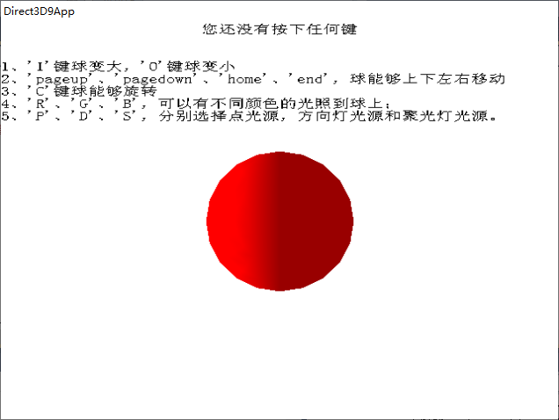

1. 按下I

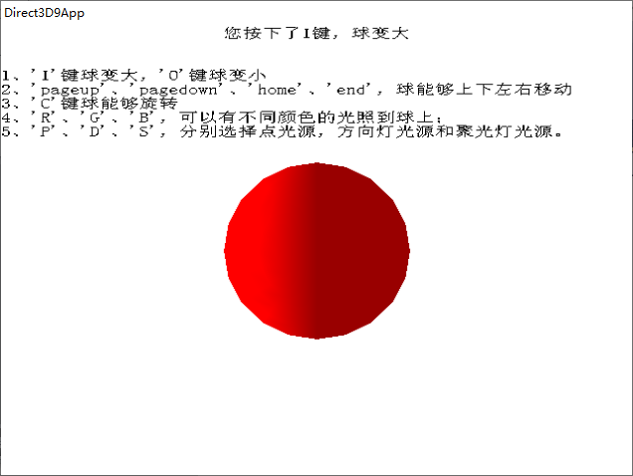

1. 按下O

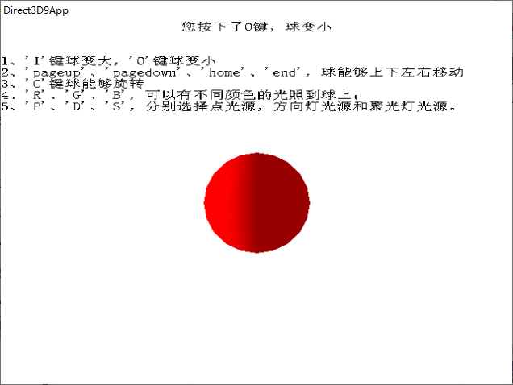

1. 按下VK_LEFT

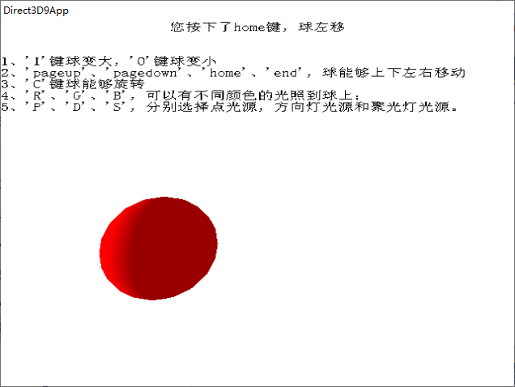

1. 按下VK_RIGHT

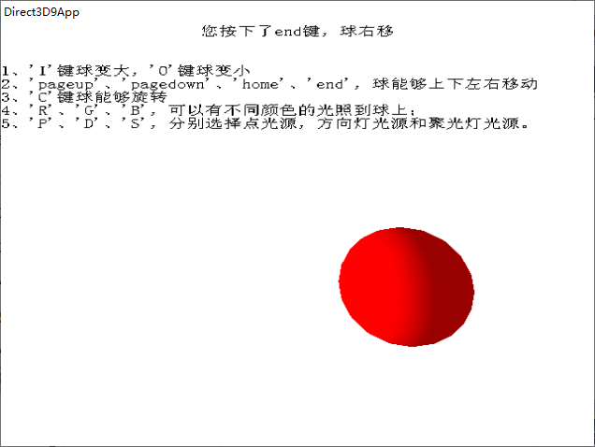

1. 按下VK_UP

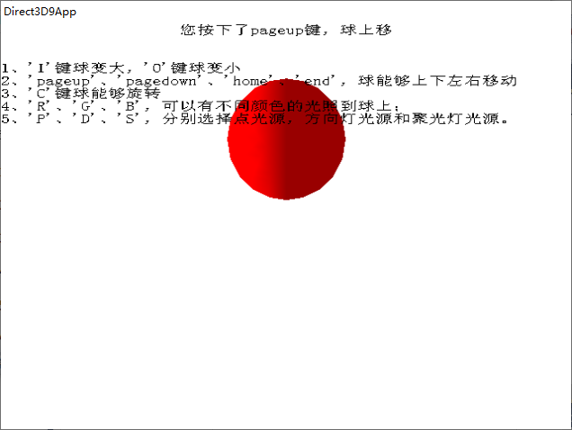

1. 按下VK_DOWN

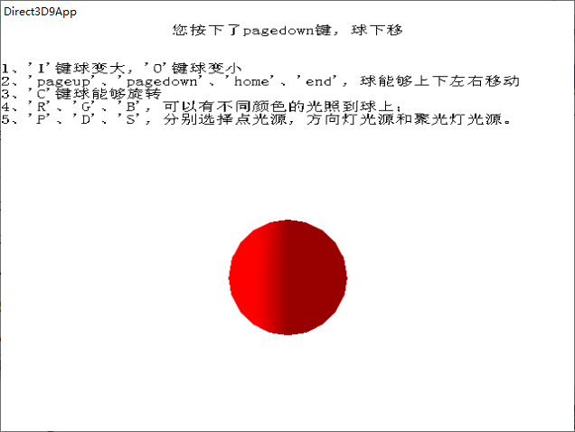

1. 按下R

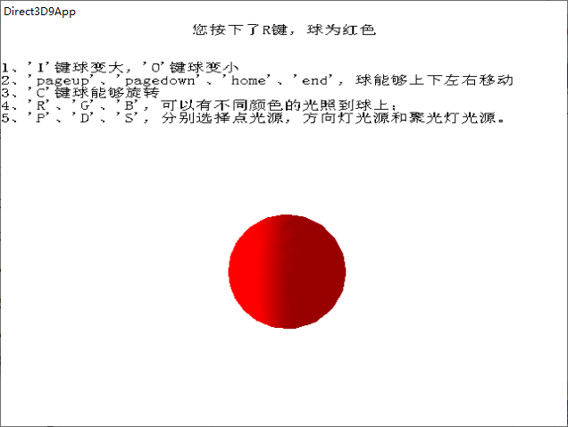

1. 按下G

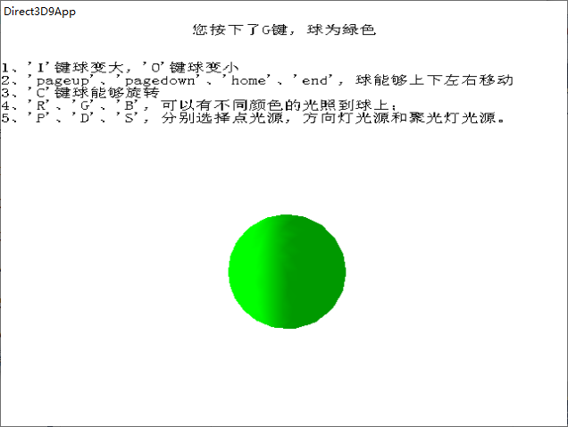

1. 按下B

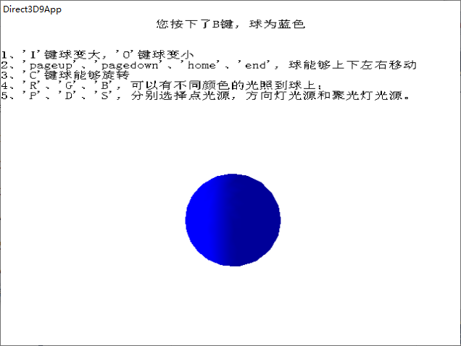

1. 按下P

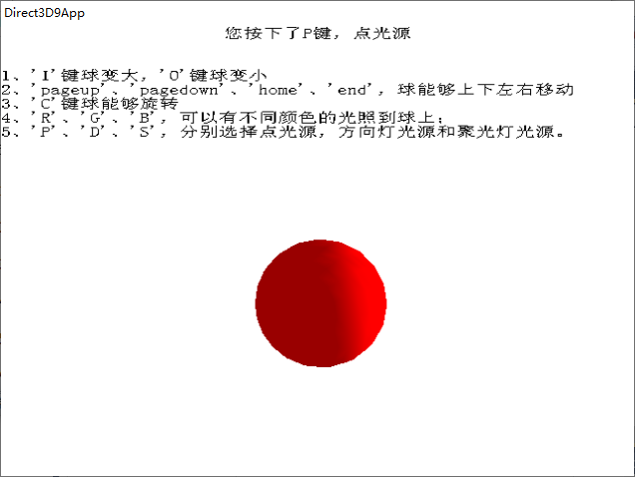

1. 按下D

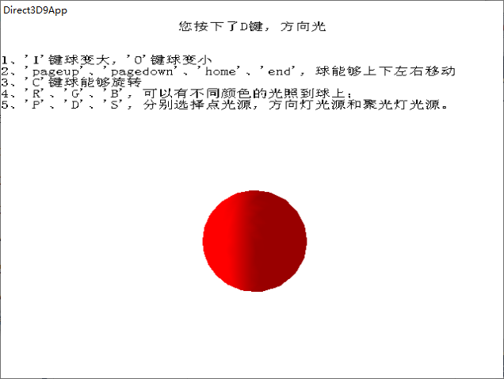

1. 按下S

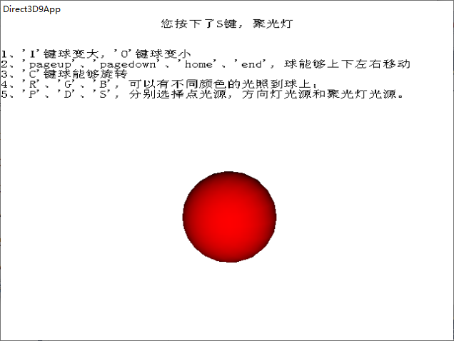

1. **总结**
2. Pageup、pagedown、home、end键，在机房电脑无法运行，在自己电脑上其与VK_UP等四键重合，故直接用了VK_UP等键。
3. 按C键球体旋转，在这里只实现了按一下旋转一下，没有实现连续旋转。
4. **实验3(三维动态柱体)**
5. 题目

在屏幕上面绘制一个柱体，要求能够通过键盘来控制其状态，

要求：

1)按下‘L’，变长，按下‘N’变短；按下‘F’变胖；按下‘T’变瘦；

2)按下‘pageup’、‘pagedown’、‘home’、‘end’，柱体能够上下左右移动；

3)按下‘C’，柱体够旋转；

4)按下‘R’、‘G’、‘B’、可以有不同颜色的光照到柱体上；

5)按下‘P’、‘D’、‘S’，分别选择点光源，方向灯光源和聚光灯光源；

6)将按键提示信息以文字的形式显示在视口区适当位置处。

1. 实现代码

在d3dInit框架的基础上添加代码：

1. 全局变量

IDirect3DDevice9* Device = 0;

ID3DXMesh* cylinder;

D3DXCOLOR c = d3d::RED;

D3DLIGHT9 light;

D3DXVECTOR3 dir(1.0f, 0.0f, 0.0f );

float zmx = 1.0f;

//float zmy = 1.0f;

float zmz = 1.0f;

D3DXVECTOR3 cylinderPos(0.0f,0.0f,0.0f);

D3DXMATRIX Ts,Zoom,Ry,Rx;

float y = 0.0f;

float rx = 0.0f;

ID3DXFont* Font1 = 0;

ID3DXFont* Font2 = 0;

RECT rect = {0, 0, Width, Height};

char* x = "您¨²还1没?有®D按ã¡ä下?任¨?何?键¨¹";

1. Setup()函数

D3DXFONT_DESC df;

ZeroMemory(&df,sizeof(D3DXFONT_DESC));

df.Height = 15;

df.Width = 10;

df.Weight = 200;

df.MipLevels = D3DX_DEFAULT;

df.Italic = false;

df.CharSet = DEFAULT_CHARSET;

df.OutputPrecision = 0;

df.Quality = 0;

df.PitchAndFamily = 0;

strcpy(df.FaceName,"宋?体¬?");

D3DXCreateFontIndirect(Device,&df,&Font1);

D3DXCreateFontIndirect(Device,&df,&Font2);

D3DXCreateCylinder(Device,1.0f,1.0f,3.0f,20,20,&cylinder,0);

D3DMATERIAL9 mtrl;

mtrl = d3d::WHITE_MTRL;

Device->SetMaterial(&mtrl);

light = d3d::InitDirectionalLight(&dir, &c);

Device->SetRenderState(D3DRS_NORMALIZENORMALS,true);

D3DXVECTOR3 position(1.0f, 0.0f, -5.0f);

D3DXVECTOR3 target(0.0f, 0.0f, 0.0f);

D3DXVECTOR3 up(0.0f, 1.0f, 0.0f);

D3DXMATRIX V;

D3DXMatrixLookAtLH(&V, &position, &target, &up);

Device -> SetTransform(D3DTS_VIEW, &V);

D3DXMATRIX proj;

D3DXMatrixPerspectiveFovLH(

&proj,

D3DX_PI * 0.5f,

(float)Width / (float)Height,

1.0f,

1000.0f);

Device -> SetTransform(D3DTS_PROJECTION, &proj);

Device -> SetRenderState(D3DRS_LIGHTING,true);

1. Cleanup()函数

d3d::Release<ID3DXMesh*>(cylinder);

d3d::Release<ID3DXFont*>(Font1);

d3d::Release<ID3DXFont*>(Font2);

1. Display()函数

Device->BeginScene();

/*提¬¨¢示º?相¨¤应®|按ã¡ä键¨¹及¡ã功|能¨¹*/

Font1->DrawText(NULL,x,-1,&rect,DT_TOP|DT_CENTER,0xff000000);

/*所¨´有®D的Ì?按ã¡ä键¨¹提¬¨¢示º?，ê?不?会¨¢变À?*/

Font2->DrawText(NULL,

"\n\n\n1、¡é'L'变À?长¡è，ê?'N'变À?短¨¬，ê?'F'变À?胖?，ê?'T'变À?瘦ºY\n2、¡é'pageup'、¡é'pagedown'、¡é'home'、¡é'end'，ê?柱¨´体¬?能¨¹够?上¦?下?左Á¨®右®¨°移°?动¡¥\n3、¡é'C'键¨¹柱¨´体¬?能¨¹够?旋y转Áa\n4、¡é'R'、¡é'G'、¡é'B'，ê?可¨¦以°?有®D不?同ª?颜?色¦?的Ì?光a照?到Ì?柱¨´体¬?上¦?；ê?\n5、¡é'P'、¡é'D'、¡é'S'，ê?分¤?别Àe选?择?点Ì?光a源¡ä，ê?方¤?向¨°灯Ì?光a源¡ä和¨ª聚?光a灯Ì?光a源¡ä。¡ê",

-1,

&rect,

DT_TOP|DT_LEFT,

0xff000000);

/*绘?制?球¨°体¬?*/

cylinder->DrawSubset(0);

/*光a源¡ä*/

Device->SetLight(0,&light);

Device->LightEnable(0,true);

D3DXMATRIX Rx2;

D3DXMatrixTranslation(&Ts,cylinderPos.x,cylinderPos.y,cylinderPos.z);

D3DXMatrixScaling(&Zoom,zmx,zmx,zmz);

D3DXMatrixRotationY(&Ry,y);

D3DXMatrixRotationY(&Rx,rx);

D3DXMatrixRotationY(&Rx2,3.14f/1.57f);

//y += timeDelta;

D3DXMATRIX p = Ts * Zoom * Ry * Rx *Rx2;

Device->SetTransform(D3DTS_WORLD,&p);

Device->EndScene();

1. WndProc()函数

case WM_KEYDOWN:

if( wParam == VK_ESCAPE )

::DestroyWindow(hwnd);

if( ::GetAsyncKeyState('L') )

{

x = "您¨²按ã¡ä下?了¢?L键¨¹，ê?柱¨´体¬?变À?长¡è";

zmz += 0.1f;

}

if( ::GetAsyncKeyState('N') )

{

x = "您¨²按ã¡ä下?了¢?N键¨¹，ê?柱¨´体¬?变À?短¨¬";

zmz -= 0.1f;

if(zmz < 0.0f)

zmz = 0.0f;

}

if( ::GetAsyncKeyState('F') )

{

x = "您¨²按ã¡ä下?了¢?F键¨¹，ê?柱¨´体¬?变À?胖?";

zmx += 0.1f;

}

if( ::GetAsyncKeyState('T') )

{

x = "您¨²按ã¡ä下?了¢?T键¨¹，ê?柱¨´体¬?变À?瘦ºY";

zmx -= 0.1f;

if(zmx < 0.0f)

zmx = 0.0f;

}

if( wParam == VK_UP )//pageup0x33

{

x = "您¨²按ã¡ä下?了¢?pageup键¨¹，ê?柱¨´体¬?上¦?移°?";

cylinderPos.y += 0.1f;

}

if( wParam == VK_DOWN )//PageDown0x34

{

x = "您¨²按ã¡ä下?了¢?pagedown键¨¹，ê?柱¨´体¬?下?移°?";

cylinderPos.y -= 0.1f;

}

if( wParam == VK_LEFT )//Home0x36

{

x = "您¨²按ã¡ä下?了¢?home键¨¹，ê?柱¨´体¬?左Á¨®移°?";

cylinderPos.x -= 0.1f;

}

if( wParam == VK_RIGHT )//End0x35

{

x = "您¨²按ã¡ä下?了¢?end键¨¹，ê?柱¨´体¬?右®¨°移°?";

cylinderPos.x += 0.1f;

}

if( ::GetAsyncKeyState('C') )

{

x = "您¨²按ã¡ä下?了¢?C键¨¹，ê?柱¨´体¬?旋y转Áa";

rx = 3.14f/4.0f;

y += 1.0f;

}

if( ::GetAsyncKeyState('R') )

{

x = "您¨²按ã¡ä下?了¢?R键¨¹，ê?柱¨´体¬?为a红¨¬色¦?";

c = d3d::RED;

light = d3d::InitDirectionalLight(&dir, &c);

}

if( ::GetAsyncKeyState('G') )

{

x = "您¨²按ã¡ä下?了¢?G键¨¹，ê?柱¨´体¬?为a绿¨¬色¦?";

c = d3d::GREEN;

light = d3d::InitDirectionalLight(&dir, &c);

}

if( ::GetAsyncKeyState('B') )

{

x = "您¨²按ã¡ä下?了¢?B键¨¹，ê?柱¨´体¬?为a蓝¤?色¦?";

c = d3d::BLUE;

light = d3d::InitDirectionalLight(&dir, &c);

}

if( ::GetAsyncKeyState('P') )

{

x = "您¨²按ã¡ä下?了¢?P键¨¹，ê?点Ì?光a源¡ä";

D3DXVECTOR3 pos(10.0f,0.0f,0.0f);

light = d3d::InitPointLight(&pos, &c);

}

if( ::GetAsyncKeyState('D') )

{

x = "您¨²按ã¡ä下?了¢?D键¨¹，ê?方¤?向¨°光a";

D3DXVECTOR3 dir(1.0f, 0.0f,0.0f);

light = d3d::InitDirectionalLight(&dir, &c);

}

if( ::GetAsyncKeyState('S') )

{

x = "您¨²按ã¡ä下?了¢?S键¨¹，ê?聚?光a灯Ì?";

D3DXVECTOR3 pos(0.0f,0.0f,-15.0f);

D3DXVECTOR3 dir(0.0f,0.0f,1.0f);

light = d3d::InitSpotLight(&pos,&dir, &c);

}

break;

1. 程序运行结果
2. 原本

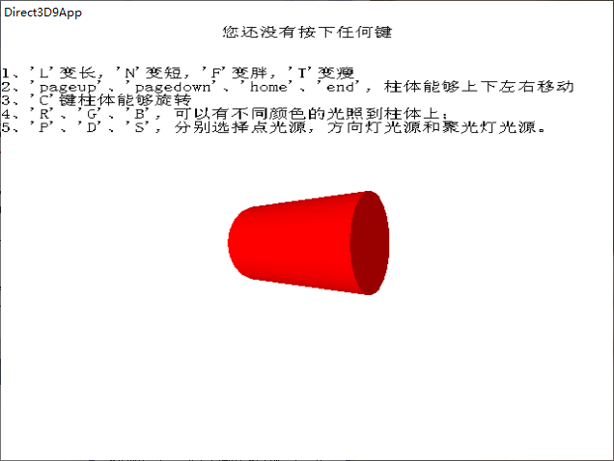

1. 按下L

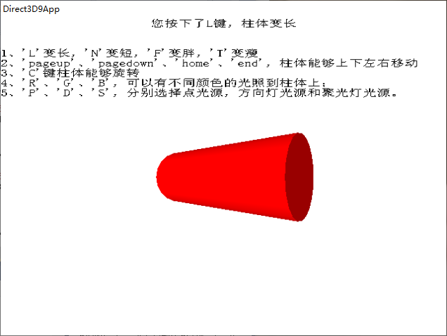

1. 按下N

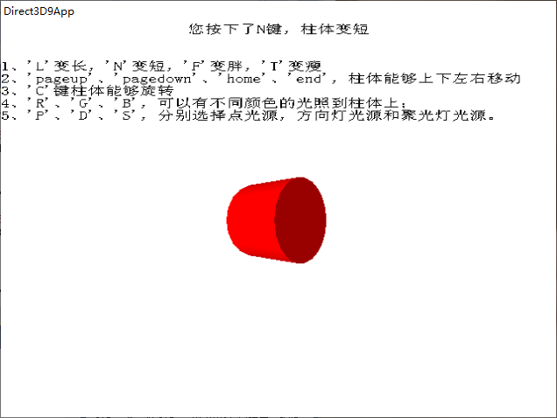

1. 按下F

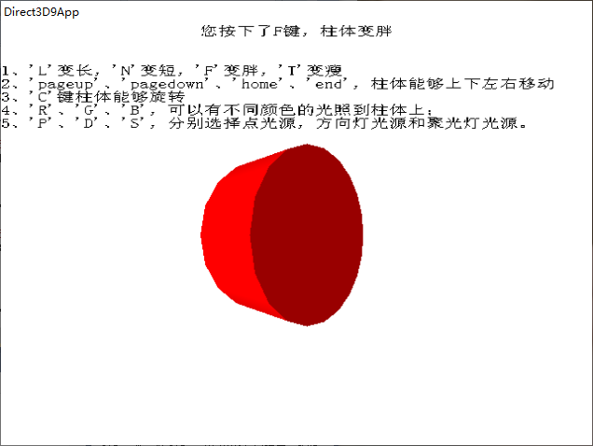

1. 按下T

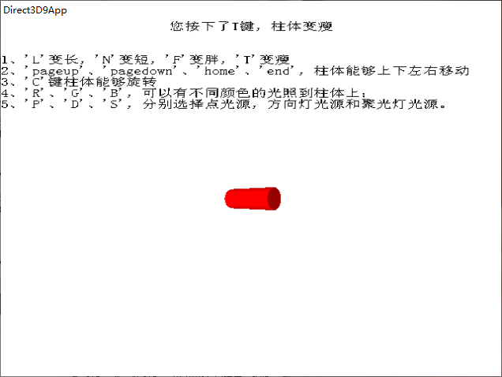

1. 按下VK_LEFT

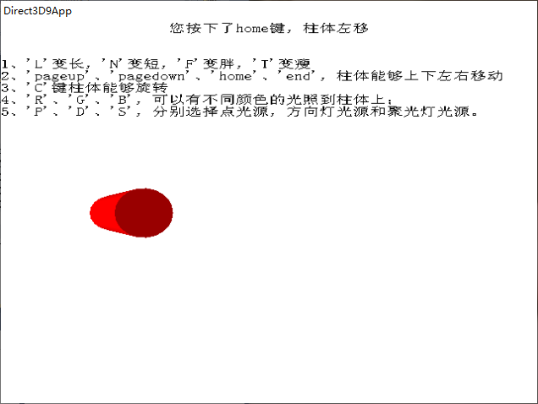

1. 按下VK_RIGHT

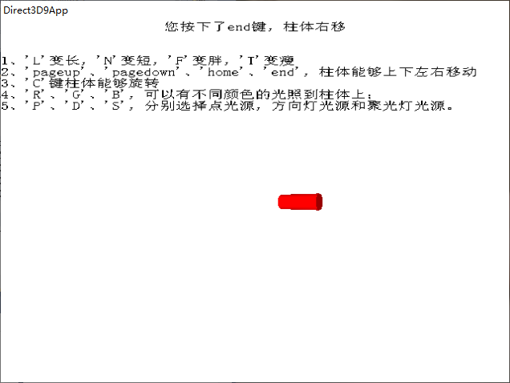

1. 按下VK_UP

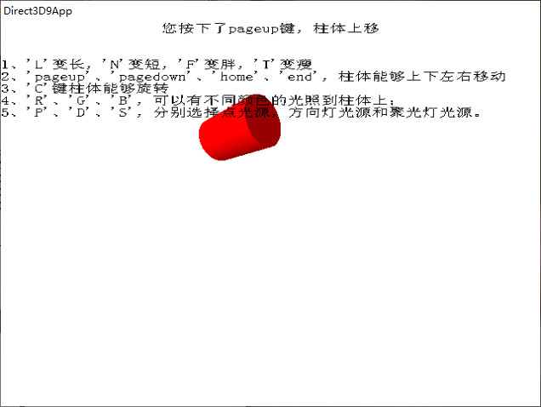

1. 按下VK_DOWN

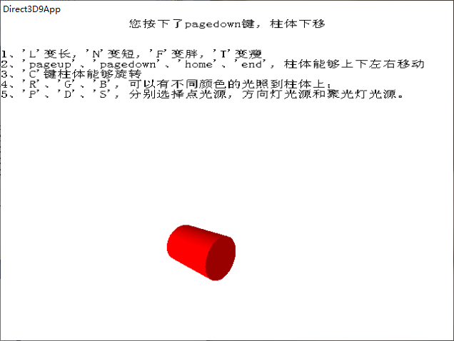

1. 按下R

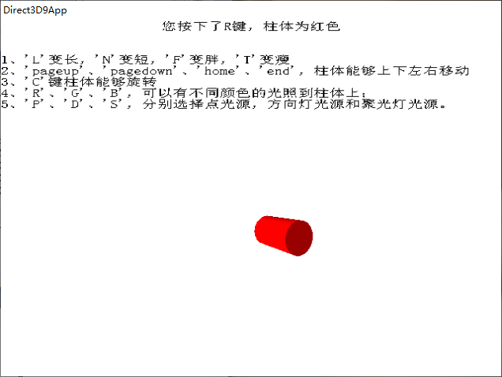

1. 按下G

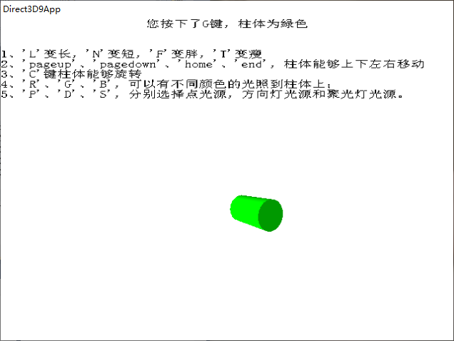

1. 按下B

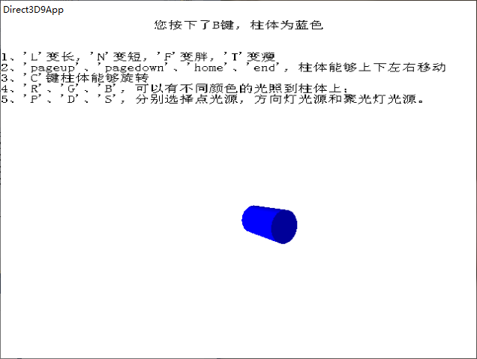

1. 按下P

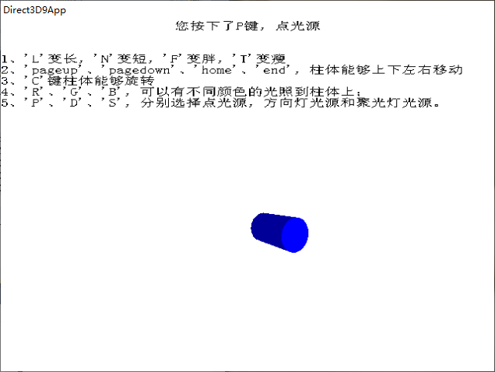

1. 按下D

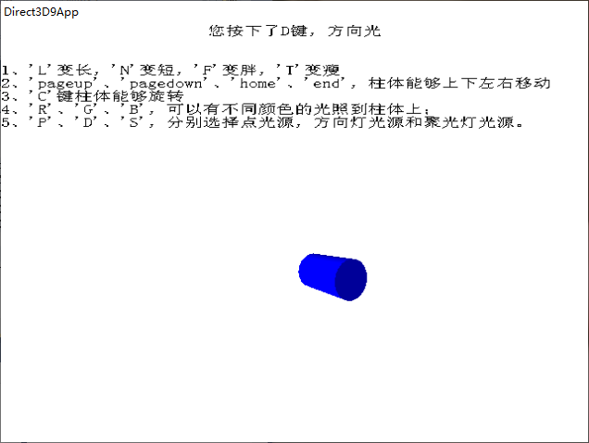

1. 按下S

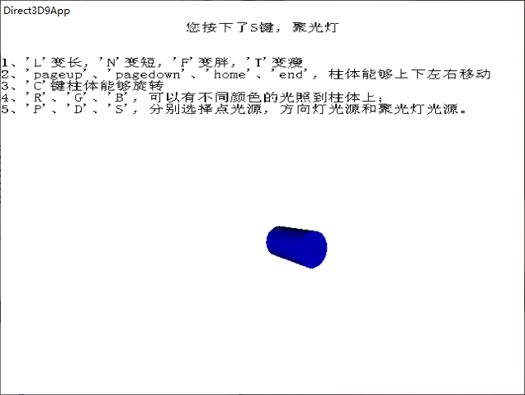

1. **总结**
2. 在柱体变胖变瘦时，xy要相同，因为底面是圆。