**武汉纺织大学**

**《Direct3D图形编程》上机实验报告**

**题目:** **三角形的绘制**

**成 绩：**

**学 号： 1604240705**

**姓 名： 胡 莲**

**班 级： 计算机11603**

**指导教师： 李 敏**

**报告日期：2019 年3月11日**

1. **实验1**
2. 题目

使用D3D设备绘制一个三角形。

1. 实现代码
2. 在D3DInit整合了的基础上，修改d3dInit.cpp

const int Width = 640;

const int Height = 480;

IDirect3DVertexBuffer9* Triangle = 0;

//定义一个顶点结构体

struct Vertex

{

Vertex(){}

Vertex(float x, float y, float z)

{

_x = x; _y = y; _z = z;

}

float _x, _y, _z;

static const DWORD FVF;

};

const DWORD Vertex::FVF = D3DFVF_XYZ;

1. 修改Setup()函数：

Device -> CreateVertexBuffer(

3 * sizeof(Vertex),

D3DUSAGE_WRITEONLY,

Vertex::FVF,

D3DPOOL_MANAGED,

&Triangle,

0);

Vertex* vertices;

Triangle -> Lock(0, 0, (void**)&vertices, 0);

vertices[0] = Vertex(-5.0f, 0.0f, 0.0f);

vertices[1] = Vertex(0.0f, 5.0f, 0.0f);

vertices[2] = Vertex(5.0f, 0.0f, 0.0f);

Triangle -> Unlock();

D3DXVECTOR3 position(0.0f, 0.0f, -15.0f);

D3DXVECTOR3 target(0.0f, 0.0f, 0.0f);

D3DXVECTOR3 up(0.0f, 1.0f, 0.0f);

D3DXMATRIX V;

D3DXMatrixLookAtLH(&V, &position, &target, &up);

Device -> SetTransform(D3DTS_VIEW, &V);

D3DXMATRIX proj;

D3DXMatrixPerspectiveFovLH(

&proj,

D3DX_PI * 0.5f,

(float)Width / (float)Height,

1.0f,

1000.0f);

Device -> SetTransform(D3DTS_PROJECTION, &proj);

Device -> SetRenderState(D3DRS_FILLMODE,D3DFILL_WIREFRAME);

D3DVIEWPORT9 vp = {0,0,640,480,0,1};

Device -> SetViewport(&vp);

1. 修改Cleanup()函数：

d3d::Release<IDirect3DVertexBuffer9*>(Triangle);

1. 修改Display()函数：

if( Device ) // Only use Device methods if we have a valid device.

{

// Instruct the device to set each pixel on the back buffer black -

// D3DCLEAR_TARGET: 0x00000000 (black) - and to set each pixel on

// the depth buffer to a value of 1.0 - D3DCLEAR_ZBUFFER: 1.0f.

Device->Clear(0, 0, D3DCLEAR_TARGET | D3DCLEAR_ZBUFFER, 0xffffffff, 1.0f, 0);

Device->BeginScene();

Device->SetStreamSource(0,Triangle,0,sizeof(Vertex));

Device->SetFVF(Vertex::FVF);

D3DXMATRIX matrix;

D3DXMatrixTranslation(&matrix,0,0,-8);

Device->SetTransform(D3DTS_WORLD,&matrix);

Device->DrawPrimitive(D3DPT_TRIANGLELIST,0,1);

Device->EndScene();

// Swap the back and front buffers.

Device->Present(0, 0, 0, 0);

}

1. 程序运行结果

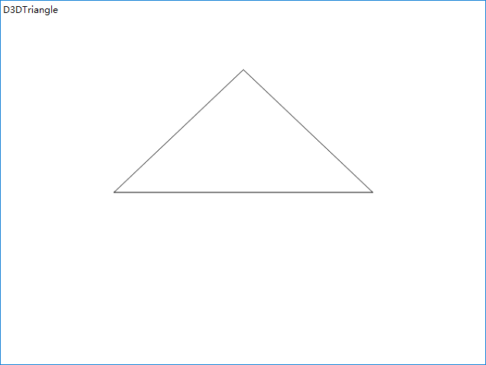

1. **总结**

先自定义好顶点格式，然后创建顶点缓存，初始化顶点，注意各种变换的写法。