**武汉纺织大学**

**《Direct3D图形编程》上机实验报告**

**题目:** **彩色三角椎体的绘制**

**成 绩：**

**学 号： 1604240705**

**姓 名： 胡 莲**

**班 级： 计算机11603**

**指导教师： 李 敏**

**报告日期：2019 年3月23日**

1. **实验1**
2. 题目

绘制一个底为三角形的锥体，用平面着色模式给三角锥的每一面设置不一样的颜色，并以一个点为支撑点绕Y轴旋转锥体。

1. 实现代码

在上次实验的基础上，修改代码：

1. 修改顶点格式：

struct ColorVertex

{

ColorVertex(){}

ColorVertex(float x, float y, float z,D3DCOLOR color)

{

_x = x; _y = y; _z = z; _color = color;

}

float _x, _y, _z;

D3DCOLOR _color;

static const DWORD FVF;

};

const DWORD ColorVertex::FVF = D3DFVF_XYZ | D3DFVF_DIFFUSE;

1. 在d3dUtility.h中的命名空间d3d中加入：

const D3DXCOLOR WHITE(D3DCOLOR_XRGB(255,255,255));

const D3DXCOLOR BLACK(D3DCOLOR_XRGB(0,0,0));

const D3DXCOLOR RED(D3DCOLOR_XRGB(255,0,0));

const D3DXCOLOR GREEN(D3DCOLOR_XRGB(0,255,0));

const D3DXCOLOR BLUE(D3DCOLOR_XRGB(0,0,255));

const D3DXCOLOR YELLOW(D3DCOLOR_XRGB(255,255,0));

const D3DXCOLOR CYAN(D3DCOLOR_XRGB(0,255,255));

const D3DXCOLOR MAGENTA(D3DCOLOR_XRGB(255,0,255));

1. Setup()函数：

Device -> CreateVertexBuffer(

12 * sizeof(ColorVertex),

D3DUSAGE_WRITEONLY,

ColorVertex::FVF,

D3DPOOL_MANAGED,

&VB,

0);

ColorVertex* v;

VB -> Lock(0, 0, (void**)&v, 0);

//V0(-1,0,-1)

//V1(0,0,1)

//V2(1,0,-1)

//V3(0,1,0)

v[0] = ColorVertex(-1.0f,0.0f,-1.0f,d3d::RED);//前¡ã面? V0 V3 V2

v[1] = ColorVertex(0.0f,1.0f,0.0f,d3d::GREEN);

v[2] = ColorVertex(1.0f, 0.0f, -1.0f,d3d::BLUE);

v[3] = ColorVertex(1.0f,0.0f,-1.0f,d3d::YELLOW);//右®¨°面? V2 V3 V1

v[4] = ColorVertex(0.0f, 1.0f, 0.0f,d3d::RED);

v[5] = ColorVertex(0.0f,0.0f,1.0f,d3d::GREEN);

v[6] = ColorVertex(-1.0f,0.0f,-1.0f,d3d::BLUE);//左Á¨®面? V0 V1 V3

v[7] = ColorVertex(0.0f, 0.0f, 1.0f,d3d::YELLOW);

v[8] = ColorVertex(0.0f, 1.0f, 0.0f,d3d::RED);

v[9] = ColorVertex(-1.0f, 0.0f, -1.0f,d3d::GREEN);//底Ì¡Á面? V0 V2 V1

v[10] = ColorVertex(1.0f,0.0f,-1.0f,d3d::BLUE);

v[11] = ColorVertex(0.0f, 0.0f, 1.0f,d3d::YELLOW);

VB -> Unlock();

取消线性绘图模式且关闭光照：

Device -> SetRenderState(D3DRS_LIGHTING,false);

1. Display()函数：

Device->BeginScene();

Device->SetStreamSource(0,VB,0,sizeof(ColorVertex));

Device->SetFVF(ColorVertex::FVF);

D3DXMATRIX Tz,Rx,Ry;

D3DXMatrixTranslation(&Tz,0.0f,0.0f,-1.0f);

D3DXMatrixRotationX(&Rx,3.14f/1.05f);

static float y = 0.0f;

D3DXMatrixRotationY(&Ry,y);

y+=timeDelta;

if(y>=6.28f)

y = 0.0f;

D3DXMATRIX p = Tz * Rx * Ry;

Device->SetTransform(D3DTS_WORLD,&p);

Device->SetRenderState(D3DRS_SHADEMODE,D3DSHADE_FLAT);

Device->DrawPrimitive(D3DPT_TRIANGLELIST,0,4);

Device->EndScene();

1. 程序运行结果

以V1为支撑点绕Y轴旋转效果图如下：

（图一的支撑点为最左边，图二的支撑点为最右边，图三的支撑点为蓝绿交点右交点）

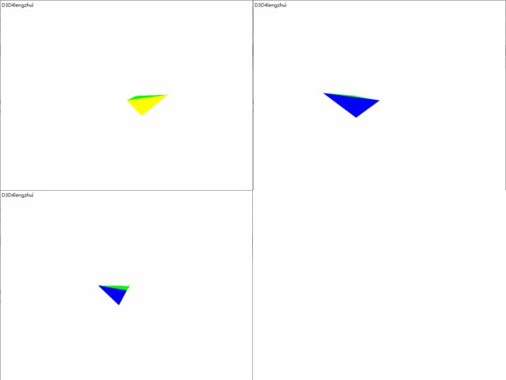

1. **总结**

设置顶点坐标及顺序的地方，经常会有一点错误，要仔细检查。