

DSO 522 Final Project Technical Report
Energy Load Time Series Forecasting

Instructor: Robertas Gabrys

Group Members
Nianzhe Li, Yiping Liu, Shuang Liang,
Jiaqi Zhu, Yuanyuan Wang, Xuerong Jia

December 2019

Table of Contents

I. Executive Summary 3
II. Description of Data & Data Cleaning 3
III. Model Building 4
Part I - Forecasting model and performance 4
Part II – Machine learning model 5
1. Model Assumption 5
2. Variable Creation 5
3. Model selection and add the second layer to deal with residual autocorrelation 6
4. Model Results 7
IV. Monetize forecasting error 12
VI. Conclusion and Further Improvement 14

I. Executive Summary
Our final forecasting system to predict hourly load for the next day is a two-layer model with the XGBoost model in the first layer and Arima model in the second layer. To achieve high accuracy, we put a lot of effort into variable creation. To capture the strong seasonality of the load data, we add lag variables, seasonality variables, and trigonometric function variables. Considering the strong effect of temperature, the high and low temperature of each region is another significant feature. And the best model performance successfully reaches 3.22% MAPE.

II. Description of Data & Data Cleaning
The data we used in this project were mainly from four data sources:
- Load data of "SCE" territory in hour intervals for every day starting from 2014.01.01 to 2019.09.01 from “20140101-20190901 SCE & CAISO Actual Load 9 27 2019.xlsx”,
- Daily temperature data of “SCE” territory from “SCETemps14-19.xlsx”,
- Hourly temperature data from an R package called “riem” (details shown in Fig 1),
- Price data from “Price_Data_2015_2019.csv”.
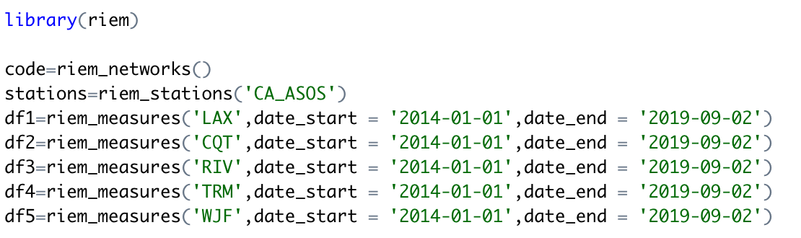
Chart 1
For hourly temperature data extracted from the R package “riem”, the missing values were replaced by the average temperature of two nearest data points before and after that time. Since within each hour there were several observed temperature values, the average hourly temperature was calculated to represent each hour. Based on hourly temperature data, an integrated data frame with records of all possible hours was created, but some of the records have no hourly temperature data. Thus, for those records with no temperature data at all, we use an average temperature of the same hour on an identical day in each year (if available) to fill in the blanks. For example, if 2016.03.28 8am’s temperature was missing, the average temperature of it at 2014.03.28 8 am, 2015.03.28 8 am, 2017.03.28 8 am, 2018.03.28 8 am, and 2019.03.28 8 am would be calculated to fill the NA. The Load dataset was joined to the integrated data frame after filling the NAs by applying the same methods, as well as the daily temperature data.
With all the datasets organized into one single data frame, some duplicate records of the same hour appeared. After some inspection and exploration, we ascribed this duplication phenomenon to the daylight saving time transformation. We treated all the time as UTC format to solve this chaos in time and a final data frame with all the information needed for time series model building is generated.

III. Model Building

Part I - Forecasting model and performance
Before building a forecasting model, a visualization of data was needed. To clearly visualize seasonality, we used the prophet package to generate plots shown as follows:
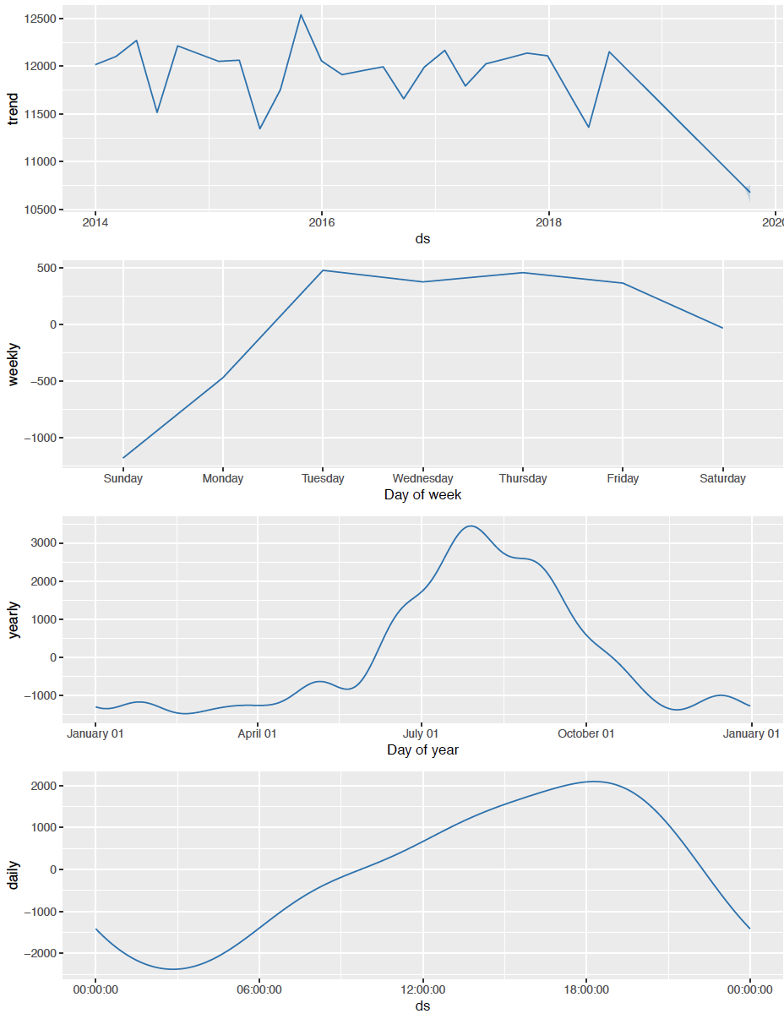
Chart 2

As we can see from chart 2, our load data has strong daily, weekly and yearly seasonality, which indicates we should adopt multiple seasonal models. We tried various traditional time series forecasting models: SNaive, ARIMA, ETS, SES, Decomposition (some of the results are shown below), yet all of them failed to reach an ideal result.
Model Name | Avg. MAPE 2017 | Avg. MAPE 2018 | Avg. MAPE 2019 | Average MAPE
ETS | 19.19% | 18.06% | 17.06% | 18.13%
SES | 14.27% | 13.74% | 13.12% | 13.72%
SNaive | 13.84% | 13.50% | 13.50% | 13.63%
Chart 3
Therefore, we turned to machine learning model building to see if any improvement could be made.

Part II – Machine learning model

1. Model Assumption
After trying different models, we found that temperature movement is very important in predicting future load. Since nowadays many organizations offer an accurate prediction of temperature, we recommend purchasing these data to help run the forecasting system. In our model, the next day’s highest and lowest temperatures for each region from the temperature dataset were used, since we assume that the predicted temperature from weather bureau would be very close to the real data.

2. Variable Creation
In addition to temperature and load, other variables including lags, seasonalities, and temperature extremums were created to improve the model accuracy. 117 variables were created in total and 90 variables were used in our final model after model selection. Among 90 variables 81 were significant.
(1). Lag variables
We created lag variables shown as follows since autocorrelation, weekly, and yearly pattern are very obvious.
- Day lag: load value of 2, 3, 4, 5 and 6 days before
- Week lag: load value of 1, 2 and 3 weeks before
- Month lag: load value of 1, 2, 3, 4, 5 and 6 months before
- Year lag: load value of 363, 364, 365, 366 days before
(2). Seasonality variables
To capture the effects generated by specific days, such as Sunday, Monday, holiday, and specific hours, seasonality variables were created.
Holiday: whether this day is a holiday.
Hour: the n^{th} hour in a day.
Day_week: the n^{th} day in a week.
W_day: whether this day is Tuesday, Wednesday, Thursday or Friday.
Month: the n^{th} month in a year.
Day_month: the n^{th} day in a month.
Day_year: the n^{th} day in a year.
Year: year 2014, 2015, 2016, 2017, 2018, 2019
Quarter: the n^{th} quarter in a year
Warm: treat May, June, July, August, September as warm periods
Cca: whether the date is after 2019-03-01.
(3). Trigonometric function variables
We used the following function to build trigonometric variables for each seasonality:
$$\sin\left(\frac{2πjt}{s}\right), \cos\left(\frac{2πjt}{s}\right) ( j=1,2,3,…\frac{s}{2}, s=how many points in one seasonal periods)$$
Daily seasonality: 6 pairs of $sin⁡(hour)$ and $cos⁡(hour)$
Weekly seasonality: 4 pairs of $sin⁡(day of the week)$ and $cos⁡(day of the week)$
Yearly seasonality: 6 pairs of $⁡sin(month)$ and $cos⁡(month)$;
5 pairs of $sin(day of the year)$ and $cos⁡(day of the year)$
(4). Temperature variables
We have the daily highest and lowest temperatures of 5 regions in Los Angeles, including LAX, RIV, CQT, TRM, and WJF. Additionally, we create a square and cube value of LAX’s highest temperature, LAX’s lowest temperature, RIV’s highest temperature, and RIV’s lowest temperature.

3. Model selection and add the second layer to deal with residual autocorrelation
With the variables created above, we tried linear regression, deep neural network, and XgBoost, among which the XgBoost method stood out. Yet with only the machine learning model, residual would still have autocorrelation shown below:
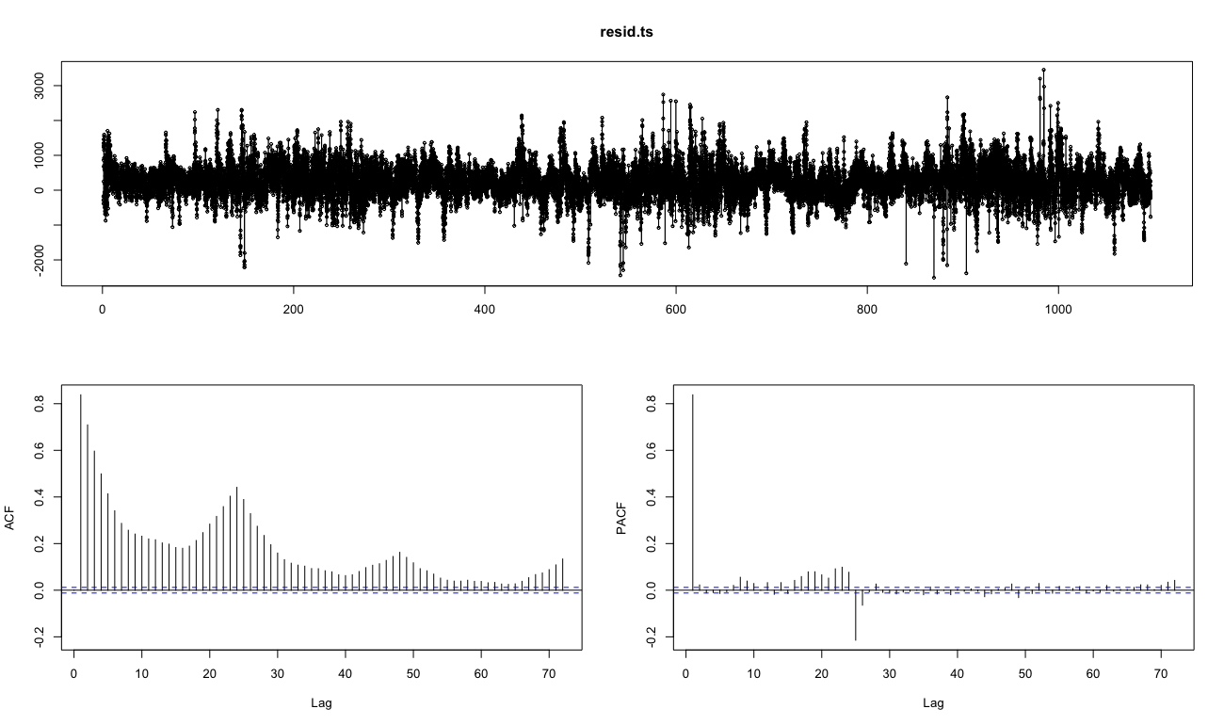
Chart 4
To solve this problem, we added the second layer, an ARIMA model (order = (1,0,1), seasonal = (1,0,0)), which indeed improved our model’s MAPE.

4. Model Results
(1). Feature importance:

Below are the top 10 most significant features in our model:
 | Feature | Gain | Cover | Frequency
1 | Square of two days lag | 0.2172 | 0.0728 | 0.0399
2 | One week lag | 0.2129 | 0.0994 | 0.0460
3 | Two weeks lag | 0.1331 | 0.0739 | 0.0405
4 | Two days lag | 0.1180 | 0.0217 | 0.0103
5 | Cube of two days lag | 0.1002 | 0.0043 | 0.0014
6 | Cube of RIV high temperature | 0.0571 | 0.0836 | 0.0825
7 | RIV high temperature | 0.0176 | 0.0158 | 0.0275
8 | Cube of RIV low temperature | 0.0154 | 0.0362 | 0.0399
9 | Three weeks lag | 0.0141 | 0.0312 | 0.0165
10 | Sin(hour*2* Pi/24) | 0.0132 | 0.0121 | 0.0282
Chart 5
(2). Accuracy Report:
Model Name | Avg. MAPE 2017 | Avg. MAPE 2018 | Avg. MAPE 2019 | Average MAPE
SES + LR | 9.65% | 9.68% | 9.29% | 9.49%
LR + NN | 5.96% | 5.12% | 5.42% | 5.51%
Xgboost | 3.59% | 3.58% | 3.83% | 3.64%
Xgboost + ARIMA | 3.21% | 3.12% | 3.39% | 3.22%
Chart 6

(3). Model Performance Visualization:

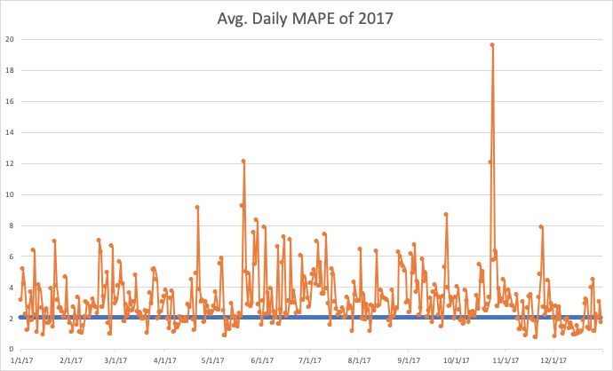
Chart 7
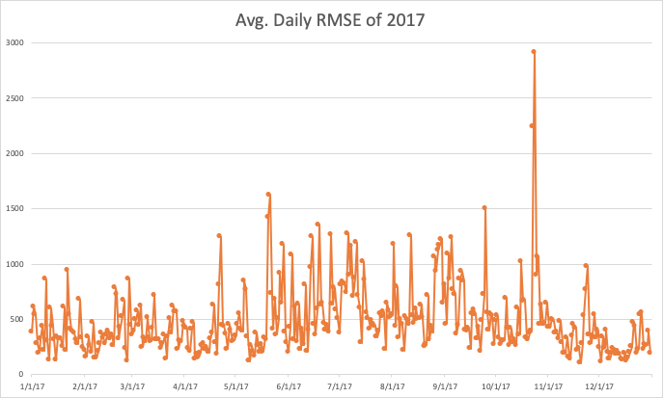
Chart 8

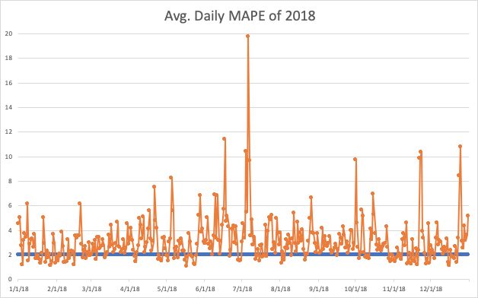
Chart 9

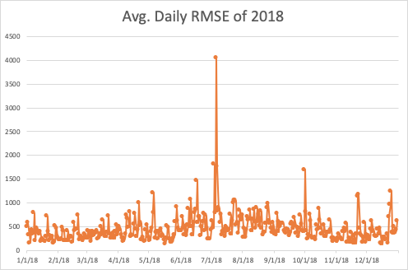
Chart 10

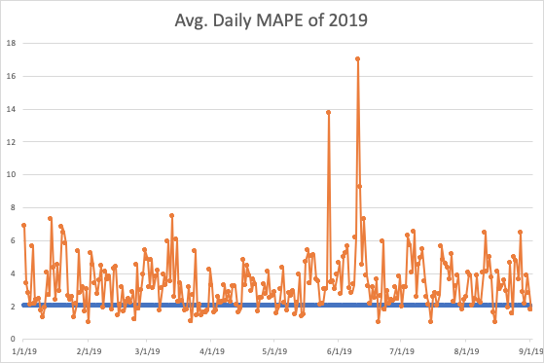
Chart 11

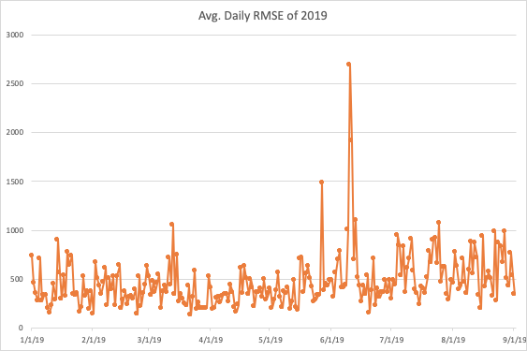
Chart 12

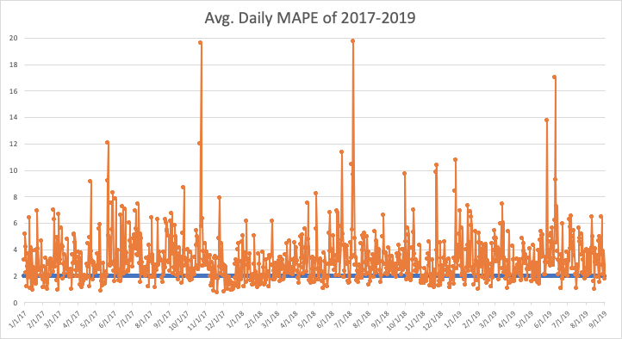
Chart 13

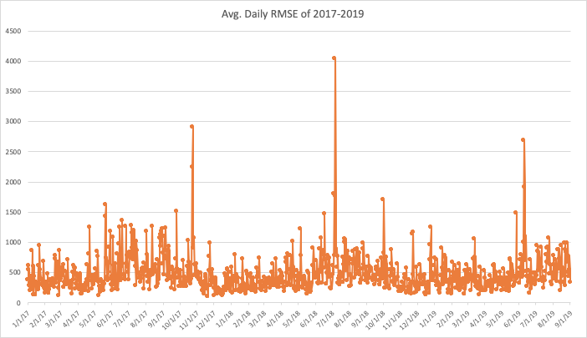
Chart 14

IV. Monetize forecasting error
1. Method of calculating error cost:
During the forecasting future load, we may overpredict or underpredict the actual one, leading to a loss. When we overpredict the load, we will buy an extra load causing unnecessary waste. Thus, we use 8:00 a.m. (time we buy load for the next day) load price to monetize this part. For the underpredicting day, we need to buy loads in real-time when we find the supply is not enough. And the cost will be a lack of load times real-time price.
2. Report on the average daily cost
Daily avg cost 2017 | Daily avg cost 2018 | Daily avg cost 2019 | Daily avg cost 17-19
$227,320.99  $ 0.23 M | $245,558.81  $ 0.25 M | $203,854.60  $ 0.20 M | $228,276.85  $ 0.23 M
Chart 15
3. Visualization of hourly cost and daily cost:
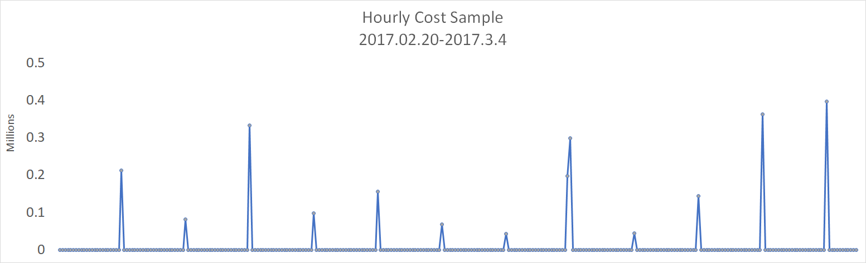
Chart 16

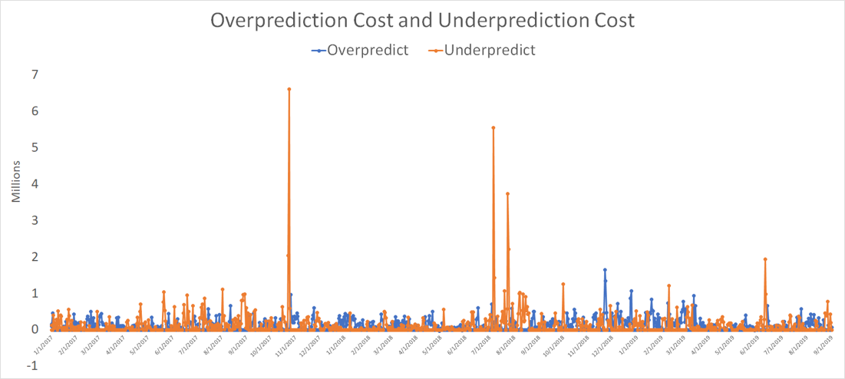
Chart 17

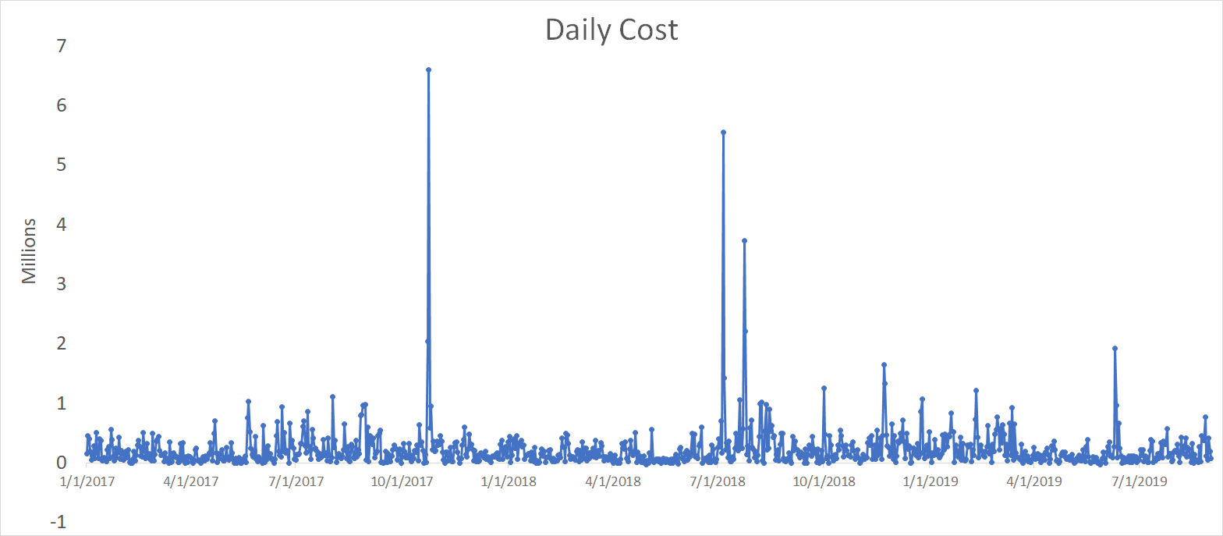
Chart 18
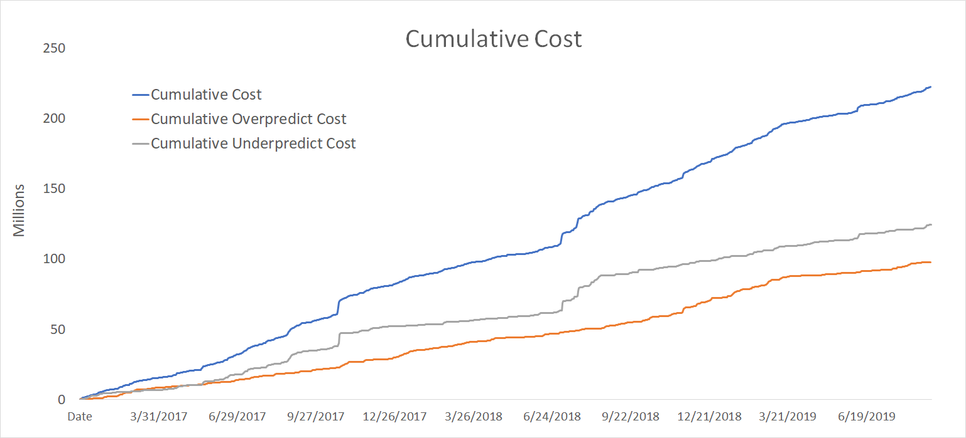
Chart 19

V. Peak Hour Forecasts
We used the final predicted load to estimate each day's peak hour with the highest load of the day and adopted two metrics to measure prediction accuracy. First one is “exactly correct”, and the second one is “Within One Hour”:
Year | Exactly Correct | Within One Hour
2017 | 59.45% | 90.41%
2018 | 55.61% | 91.78%
2019 | 65.16% | 95.08%
2017-2019 | 59.44% | 92.09%
Chart 20

VI. Conclusion and Further Improvement
The Two-Layer model (XGboost + Arima), with the lowest MAPE of 3.22%, captures most of the multiple-seasonality and temperature movement, thus performs the best among all the models we had tried.
If given more time and better datasets, we would keep adjusting our model and try more models such as Long Short-Term Memory, Recurrent Neural Network, to better capture the extreme values, improve the model performance and lower the MAPE.

