**Hello Team!** **Consider the below two tables**:

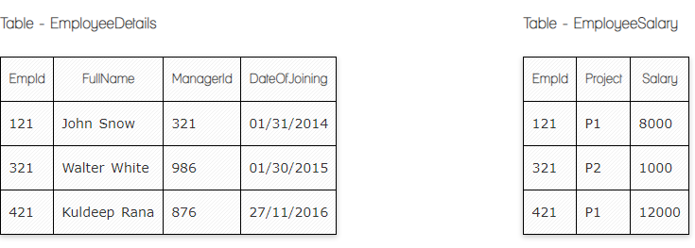

**Ques.1. Write a SQL query to fetch the count of employees working in project 'P1'.**

**Your Answer:**

**SELECT COUNT(*) FROM EmployeeSalary**

**WHERE Project=’P1’;**

**Ques.2. Write a SQL query to fetch employee names having salary greater than or equal to 5000 and less than or equal 10000.**

**Your Answer:**

**SELECT FullName FROM EmployeeDetails**

**WHERE EmpId IN ( SELECT EmpId FROM EmployeeSalary**

**WHERE Salary BETWEEN 5000 AND 10000);**

**Ques.3. Write a SQL query to fetch count of employees sorted by project's count in descending order.**

**Your Answer:**

**SELECT Project, count(EmpId) CountProject FROM EmployeeSalary**

**GROUP BY Project**

**ORDER BY CountProject DESC;**

**Ques.4. Write a query to fetch employee names and salary records. Return employee details even if the salary record is not present for the employee.**

**Your Answer:**

**SELECT E.FullName, S.Salary**

**FROM EmployeeDetails E LEFT JOIN EmployeeSalary S ON E.EmpId = S.EmpId;**

**Ques.5. Write a SQL query to create an empty table with ‘Test’ name.**

**Your Answer:**

**CREATE TABLE Test (**

**column1 datatype,**

**.**

**.**

**.**

**columnN datatype**

**);**

**Ques.6. Write a SQL query to delete an empty table with ‘Test’ name.**

**Your Answer:**

DROP TABLE Test;

**Ques.7. Write a SQL query to fetch all the Employees details from EmployeeDetails table who joined in Year 2016.**

**Your Answer:**

**SELECT * FROM EmployeeDetails**

**WHERE DateOfJoining BETWEEN “01.01.2016” AND “31.12.2016”;**

**Ques.8. Write a SQL query to insert new record to the EmployeeDetails table with any data.**

**Your Answer:**

**INSERT INTO EmployeeDetails (FullName,ManagerId, DateOfJoining)**

**VALUES ( “value1”, “value2”, “value3”);**

**Ques.9. Write a SQL query to update EmployeeSalery table with setting Salary to 2000 for Project P2.**

**Your Answer:**

**UPDATE EmployeeSalary**

**SET Salary = 2000**

**WHERE Project = “P2”;**

**Ques.10. Write a SQL query to right join both tables and draw the results.**

**Your Answer:**

**SELECT EmployeeSalary.EmpId, EmployeeSalary.Salary FROM EmployeeSalary**

**RIGHT JOIN EmployeeDetails ON EmployeeDetails.EmpId = EmployeeSalary.EmpId**

**EmpID Salary**

**121 8000**

**321 1000**

**421 12000**

**Now take these two tables:**

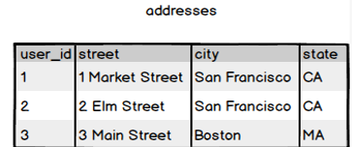

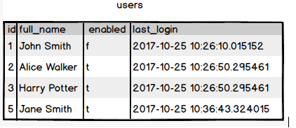

**Ques.11. Write a SQL query to fetch all users full_name from San Francisco.**

**Your Answer:**

**SELECT full_name FROM users**

**INNER JOIN addresses ON addresses.user_id =users.id WHERE city = “San Francisco”;**

**Ques.12. Write a SQL query to fetch all users full_name, last_login who are enabled.**

**Your Answer:**

**SELECT users.full_name,users.last_login FROM users WHERE enabled=”t”;**

**Ques.13. Write a SQL query to fetch all users full_name who are not from Main street**

**Your Answer:**

**SELECT full_name FROM users**

**INNER JOIN addresses ON addresses.user_id = users.id WHERE street NOT IN (“ 3 Main Street”);**

**Ques.14. Write a SQL query to fetch all users full_name who are from Main street or San Francisco**

**Your Answer:**

**SELECT full_name FROM users INNER JOIN addresses ON addresses.user_id = users.id**

**WHERE street IN (“3 Main Street”,”San Francisco”)**

**Ques.15. Write a SQL query to fetch user full_name who is equal to user_id from Boston (find user_id value in sub_query)**

**Your Answer:**

**SELECT full_name FROM users**

**WHERE id IN**

**(SELECT user_id from addresses WHERE city = “Boston”);**