- CV -

PERSONAL DETAILS
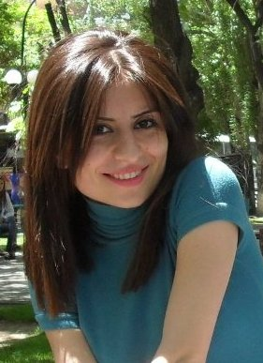

-picture -

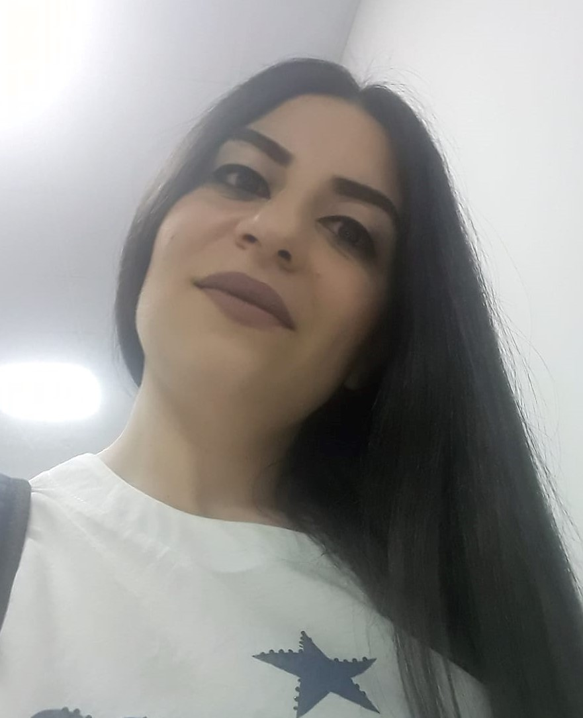
Surname Avagyan

Name Liana

Date of birth 05/11/1990

Place of birth Yerevan, Armenia

Nationality Armenian

Address Davtashen 4th block, 29/12

Telephone number (mobile) 091 46 16 63
077 79 00 27

Telephone number (other) 011 25 79 73

E-mail-address lianavagyan90@gmail.com

EDUCATION

School
September/1997 – May/2007 School №112 after Sh. Simonyan
Yerevan, Armenia

University
September/2007 – May/2011 Armenian State University of Economics
Yerevan, Armenia
Management Information Systems/ Bachelor

OTHER TRAININGS

February/2008 - March/2008 Training center
Microsoft Office

August/2010 Knowledge City
Adobe Photoshop, Corel Draw

February/2019 – July//2019 Motivesystem
HTML, CSS, Bootstrap, Javascript

August/2019 – till present Armenian Code Academy
Javascript, React.js

ADDITIONAL QUALIFICATIONS/ ACTIVITIES

Language skills Armenian (mother tongue)
Russian (advanced)
English (advanced)

IT-skills MS Office (Word, Excel, PowerPoint, Access, Project)
Visual FoxPro
Adobe Photoshop, Corel Draw
Git/Github
HTML, CSS, Bootstrap, Javascript, OOP, React.js

Hobbies/ activities/ interests Reading, writing, singing, watching films

