**Brand Name: League of Legends Championship Information System**

**Business Process/Transaction:**

1. To find the top 3 rounds that have the most viewers.
2. To find the top 3 champions with the highest win rate.
3. To find the player with the best performance (defined as (player kill + player assist) / player death) in a single round.
4. To find the player with the best average performance (defined as the average of the player’s performance in all the matches he attended) for each position (i.e. top, mid, jungle, adc, support)
5. To describe the average performance of players from different regions.
6. In each club, find the player who has served the club for the longest time.

**ER Schema:**

Entities, Attributes and Primary Keys:

Championship (**chpsId**, chpsName, -chpsSeason, -chpsRegion, -chpsYear)

Round(**rndId**, rndDate, rndLength, rndViewerCount)

Match(**matId**, matBestOfGames)

Team(**temId**, temName, temTriCode)

Club(**clbId**, clbName, clbRegion)

Player(**plyId**, plyNickname, plyName,-plyFirstName, -plyLastName, plyBirthDate, =plyAge, plyCitizenShip)

Champion(**chpId**, chpName, chpTitle)

Relationships, Attributes, Degrees, Participating Entities and Constraints:

Pertain:binary relationship

1 Team to 1 Club

1 Club to 0 or more Team

Serve (srvStartDate, srvEndDate): binary relationship

1 Team to 1 or more Player

1 Player to 0 or 1 Team

Participate: binary relationship

1 Team to 0 or more Round

1 Round to 1 or many Team

Perform(plyKill, plyDeath, plyAssist): ternary relationship

1 Player and 1 Round to 1 Champion

1 Player and 1 Champion to 1 or more Round

1 Round and 1 Champion to 1 or more Player

Include: binary relationship

1 Match to 1 Championship

1 Championship to 1 or more Match

Belong: binary relationship

1 Match to 1 or many Round

1 Round to 0 or 1 Match

Contract: binary relationship

1 Player to 1 Club

1 Club to 1 Player

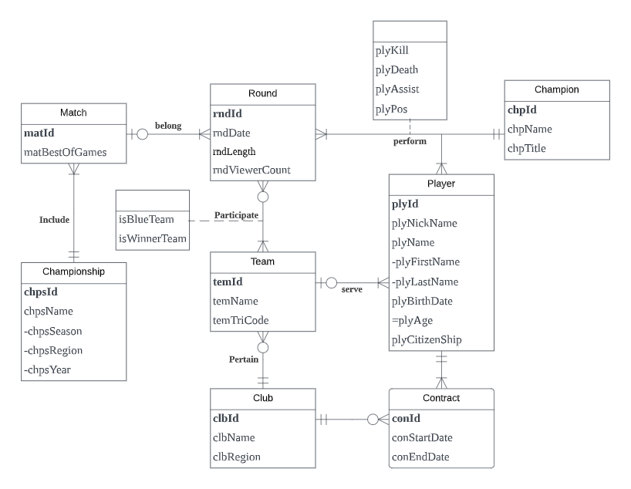

**Relations**:

Championship (**chpsId**, chpsSeason, chpsRegion, chpsYear)

Match(**matId**, matBestOfGames, *chpsID*)

Round(**rndId**, rndDate, rndLength, rndViewerCount*, matId*)

Club(**clbId**, clbName, clbRegion)

Team(**temId**, temName, temTriCode, *clbId*)

Player(**plyId**, plyFirstName, plyLastName, plyNickname, plyBirthDate, plyCitizenShip, *temId*)

Champion(**chpId**, chpName, chpTitle)

Contract(**conId**, conStartDate,conEndDate, *clbId, plyId*)

Participate(***temId***, ***rndId***, isBlueTeam, isWinnerTeam)

Perform(***rndId***, ***plyId***, plyKill, plyDeath, plyAssist, plyPos, *chpId*)

## Business rules:

[R1] When a championship is deleted from the database, the corresponding match information should also be deleted from the database.

[R2] When the information of a championship is changed, the corresponding match information should be changed accordingly.

[R3] When a team is deleted from the database, the corresponding team information of the players should be set to null.

[R4] When the information of a team is changed, the corresponding team information of the players in the team should be changed accordingly.

[R5]When a club is deleted from the database, the corresponding teams should also be deleted from the database.

[R6]When the club information changed, the team information should be changed accordingly.

[R7] When the club information is deleted from the database, the corresponding information in contracts should be set to null.

[R8] When the information of a player is deleted from the database, the corresponding contract information should be deleted.

[R9] When the information of the club is changed, the corresponding contract information should be changed.

[R10] When the information of a player is changed, the corresponding contract information should also be changed.

[R11]When a team is deleted from the database, the participation information should also be deleted.

[R12]When the information of a team is changed, the corresponding participation information should be changed accordingly.

[R13]When a round is deleted from the database, the participation information should also be deleted.

[R14]When the information of a round is changed, the corresponding participation information should be changed accordingly.

[R15]When the information of the round is changed, the corresponding performance information should be changed.

[R16] When the information of the round is deleted from the database, the corresponding performance information should be also deleted.

[R17] When a player has performed in a round, the player’s information cannot be deleted from the database.

[R18] When the information of a player is changed, the performance information should also be changed.

[R19] When a player has performed in a match using a champion, information of the champion cannot be deleted from the database.

[R20] When the information of a champion is changed, the corresponding performance information should also be changed.

[R21]When a match is deleted from the database, the corresponding rounds should also be deleted.

[R22]When the information of a match is changed, the information of corresponding rounds should be changed accordingly.

Referential Integrity:

| Relation | Foreign Key | Base Relation | Primary Key | Business Rule | Constraint:  ON DELETE | Business Rule | Constraint:  ON UPDATE |
| --- | --- | --- | --- | --- | --- | --- | --- |
| Match | chpsId | Championship | chpsId | R1 | CASCADE | R2 | CASCADE |
| Round | matId | Match | matId | R21 | CASCADE | R22 | CASCADE |
| Team | clbId | Pertain | clbId | R5 | CASCADE | R6 | CASCADE |
| Player | temId | Team | temId | R3 | SET NULL | R4 | CASCADE |
| Contract | clbId | Club | clbId | R7 | SET NULL | R9 | CASCADE |
| Contract | plyId | Player | plyId | R8 | CASCADE | R10 | NO ACTION |
| Participate | temId | Team | temId | R11 | CASCADE | R12 | CASCADE |
| Participate | rndId | Round | rndId | R13 | CASCADE | R14 | CASCADE |
| Perform | rndId | Round | rndId | R16 | CASCADE | R15 | CASCADE |
| Perform | plyId | Player | plyId | R17 | NO ACTION | R18 | CASCADE |
| Perform | chpId | Champion | chpId | R19 | NO ACTION | R20 | CASCADE |

Mission Statements:

* To provide professional clubs with records of past professional game events of *League of Legends* so as to help them find players of aptitude.
* To build insights on players and clubs that have the highest commercial value for advertisers, which is based on their performance in professional events.
* To analyze player preferences of champions for Riot games.

Mission Objectives:

* To find the top 3 rounds that have the most viewers.
* To find the top 3 champions with the highest win rate.
* To find the player with the best performance (defined as (player kill + player assist) / player death) in a single round.
* To find the player with the best average performance (defined as the average of the player’s performance in all the matches he attended) for each position (i.e. top, mid, jungle, adc, support)
* To describe the average performance of players from different regions.
* In each club, who is the player who has served the club for the longest time?

Sample data:

Championship (‘0001’, NULL,’World’, 2022)

Championship (‘0002’, ‘Summer’, ‘LPL’, 2022)

Match(‘M000001’, 5, ‘0001’)

Round(‘R00000001’, 2022-11-05, 31:10, 113884, ‘M000001’)

Team(‘T00001’, ‘T1’, ‘T1’, ‘CLB001’)

Team(‘T00002’, ‘DRX’, ‘DRX’, ‘CLB002’)

Club(‘CLB001’, ‘T1’, ‘LCK’)

Club(‘CLB002’, ‘DRX’, ‘LCK’)

Player(‘P00001’, ‘Woo-Je’, ‘Choi’, ‘Zeus’, 2004-01-31, ‘South Korea’, ‘T00001’ )

Player(‘P00002’, ‘Seong-hoon’, ‘Hwang’, ‘Kingen’, 2000-03-11, ‘South Korea’, ‘T00002’ )

Champion(‘C001’, ‘Yone’, ‘The Unforgotten’)

Champion(‘C002’, ‘Lin Sin’, ‘The Blind Monk’)

Contract(‘CT00001’, ‘2020-11-01’, 2023-11-20, ‘CLB001’, ‘P00001’)

Contract(‘CT00002’, ’2020-11-01 ’, 2022-11-21, ‘CLB002’, ‘P00002’)

Participate(‘T00001’, ‘R00000001’, 0, 1)

Participate(‘T00002’, ‘R00000001’, 1, 0)

Perform(‘R00000001’, ‘P00001’, 4, 1, 5, ‘TOP’, ‘C001’)

Perform(‘R00000001’, ‘P00002’, 3, 2, 1, ‘ JUG’, ‘C002’)