EXERCISE FOR
TESTING THE ASSUMPTIONS OF THE REGRESSION ERROR TERM
1. Gather data for three time series variables (make sure they are all economic variables). Let Y_{t} be one of the time series variables, while the remaining two variables can serve as independent variables X_{1t} and X_{2t}. Use appropriate variable names and define them with their correct units of measurement.
Variable Y_{t} = cons – Household final consumption expenditure of the Philippines (households and NPISHs), in billion pesos at constant prices
Variable X_{1t} = gdp – Gross domestic product of the Philippines (national income), in billion pesos at constant prices
Variable X_{2t} = lendrate – Average bank lending interest rate in the Philippines, in percent per year (%)
Sample size n = 40 (annual observations, 1980–2019)
Source of data: World Bank, World Development Indicators (data.worldbank.org), series NE.CON.PRVT.KN (households and NPISHs final consumption expenditure, constant LCU), NY.GDP.MKTP.KN (GDP, constant LCU) and FR.INR.LEND (lending interest rate, %). The peso values were divided by 1,000,000,000 to express them in billion pesos. The sample ends in 2019, the last year of the lending rate series. The full data set is in Annex A.
2. State your Regression Model
Answer:
cons_{t} = β₀ + β₁ gdp_{t} + β₂ lendrate_{t} + ε_{t}
This is the basic consumption function: household consumption depends on income (GDP) and on the cost of borrowing (the lending interest rate). The expected signs are β₁ > 0 (consumption rises with income; β₁ is the marginal propensity to consume) and β₂ < 0 (a higher interest rate discourages consumption).
3. Fit your regression model (i.e., Y_{t} = β₀ + β₁ X_{1t} + β₂ X_{2t} + ε_{t}) on the data set that you collected and fill-up the following table (round-off parameters to 2 decimal places) using the STATA command <reg Y X1 X2>
Answer:
Y(cons) | Coef | Std. Err. | t_{c} | P > |t| |  | No. of obs = 40
X₁(gdp) | 0.71 | 0.01 | 54.63 | 0.000 |  | R² = 0.9955
X₂(lendrate) | −26.84 | 9.00 | −2.98 | 0.005 |  | Adjusted R² = 0.9953
_cons | 539.63 | 217.55 | 2.48 | 0.018 |  | Root MSE = 219.40

Estimated equation: conŝ = 539.63 + 0.71 gdp − 26.84 lendrate (F(2, 37) = 4,136.60, Prob > F = 0.0000)
Both slopes have the expected signs and are statistically significant at α = 5% (p-values 0.000 and 0.005 < 0.05). A ₱1 billion increase in GDP raises household consumption by about ₱0.71 billion, holding the lending rate constant. A 1 percentage point increase in the lending rate lowers consumption by about ₱26.84 billion, holding GDP constant. The regressors explain 99.55% of the variation in consumption.
4. Generate the error term of your regression model using the command <predict error, residual>
Check assumption A.3, i.e., E(ε) = 0 by getting the mean of the error term that was generated by STATA. Is Assumption A.3 validated? Explain your answer.
Answer:
 | Mean | Std. error | 95% CI
error | 0.00 | 33.79 | −68.34 to 68.34

Assumption A.3 is validated. The mean of the error term is 0.00 (practically zero; STATA prints only a tiny rounding value). Its 95% confidence interval, −68.34 to 68.34, contains zero, so the mean of the error term is not significantly different from zero. The errors are sometimes positive and sometimes negative, with no systematic tendency in either direction. This is expected because the model has an intercept: as shown in Lesson 3, the constant β₀ absorbs any nonzero mean of the disturbance term, so the error term always averages to zero.
5. Check whether the error term normally distributed (Assumption A.6) is using the joint skewness- kurtosis test in STATA. The command is as follows <sktest error>.
Answer:
Skewness/Kurtosis tests for Normality
 | Skewness test | Kurtosis test | Joint Skewness and Kurtosis Test
Variable | Pr(Skewness) | Pr(Kurtosis) | Adj chi2(2) | Prob>chi2
error | 0.0296 | 0.4171 | 5.23 | 0.0732

The joint test gives Adj chi2(2) = 5.23 with Prob>chi2 = 0.0732. Taken separately, the skewness test is significant (Pr(Skewness) = 0.0296 < 0.05; the residuals are skewed to the left, skewness = −0.81), while the kurtosis test is not (Pr(Kurtosis) = 0.4171 > 0.05; kurtosis = 3.25, close to 3).
a. Set up the null and alternative hypotheses for the normality test for the error term of your regression model.
H₀: The error term of the consumption model is normally distributed, i.e., it is symmetric and bell-shaped, with a peakedness and tail thickness that give a kurtosis of 3.
H_{a}: The error term of the consumption model is not normally distributed.
b. What is the implication of your test results regarding the normality assumption of the error term. Is assumption A.6 validated or violated? Explain your answer
Assumption A.6 is validated. The p-value of the joint skewness-kurtosis test, Prob>chi2 = 0.0732, is greater than α = 0.05, so we fail to reject H₀: the error term can be considered normally distributed. The only departure is a mild negative skew (Pr(Skewness) = 0.0296), which comes from the large negative errors of 1980–1983. It is not strong enough for the joint test to reject normality. Because the errors are normal, the t-tests and F-test of the regression in Item 3 can be used.
6. Generate the histogram of the estimated error terms using the STATA command: <histogram error, normal>. Does this graph conforms with the result from #5?
Answer:
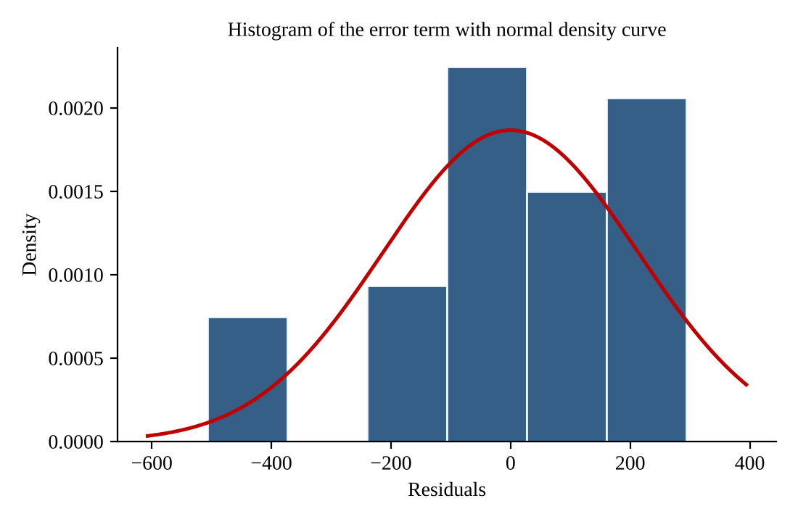
Figure 1. Histogram of the error term with the normal density curve (histogram error, normal)
Yes, the graph conforms with the result of #5. Most of the errors are grouped around zero and roughly follow the bell shape of the normal curve, which agrees with the joint test that did not reject normality. The histogram also shows the mild departure found in #5: a separate group of large negative errors around −500 (the years 1980–1983) makes the left tail longer than the right, which is the negative skewness picked up by the skewness test. The peak is not unusually sharp or flat, which agrees with the kurtosis being close to 3.
7. Check for the exogeneity of the independent variables X₁ and X₂ with respect to the error term ε (Assumption A.7), i.e., E[ε, X₁] = 0 and E[ε, X₂] = 0
To do this, get the correlation of the generated error term from the regression run with the independent variables X₁ and X₂, STATA command <pwcorr error X1 X2, sig>.
Answer:
 | ε | X₁(gdp) | X₂(lendrate)
ε | 1.0000
p-value
X₁(gdp) | 0.0000 | 1.0000
p-value | 1.0000
X₂(lendrate) | 0.0000 | −0.7794 | 1.0000
p-value | 1.0000 | 0.0000

What is the implication of your results. Is assumption A.7 validated or violated? Explain your answer.
Assumption A.7 is validated. The correlation of the error term with gdp is 0.0000 (p-value = 1.0000) and with lendrate is 0.0000 (p-value = 1.0000). Both p-values are far above α = 0.05, so there is no significant correlation between the error term and either regressor: E[ε, X₁] = 0 and E[ε, X₂] = 0. The regressors are exogenous with respect to the error term, so they can continue to be treated as non-stochastic (Assumption A.2 remains valid) and the problem of heteroscedasticity from this source does not arise. Note that a zero correlation is guaranteed for OLS residuals: the normal equations X′Xβ̂ = X′Y imply X′e = 0, so the residuals are always uncorrelated with the regressors in the sample.
8. Check assumption A.4 regarding the spherical distribution of the disturbance term, i.e., the error term is homoscedastic. To do this, plot the graph of your errorsquare (ε²) with respect to Yhat and check if there is a pattern in the fluctuations of the error square. STATA command to generate Yhat: <predict yhat>
Note: The errorsquare (ε²) is a good representation of the variance of the error term.
Answer:
STATA commands used: <predict yhat>, <generate errorsq = error^2> and <scatter errorsq yhat>.
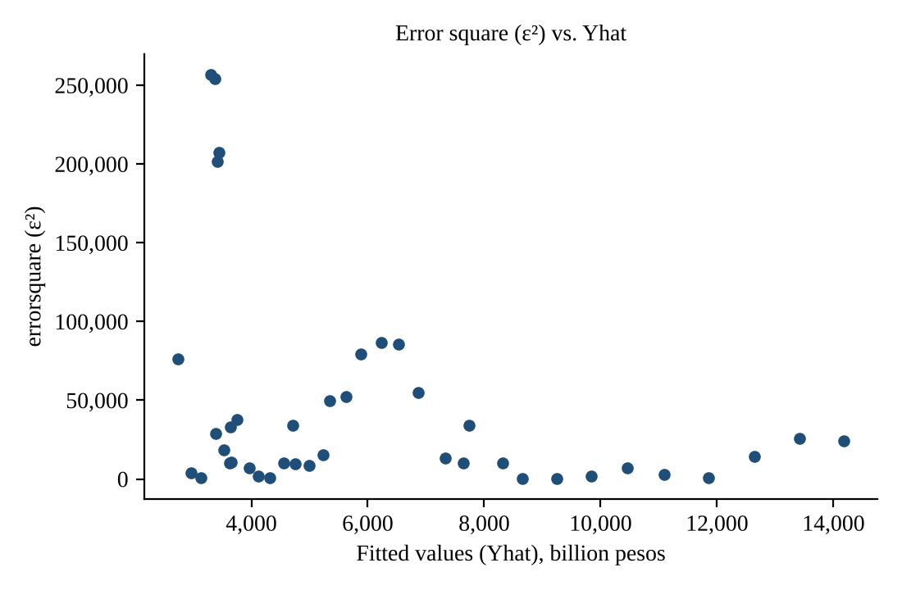
Figure 2. Error square (ε²) plotted against the fitted values (Yhat)
What is the implication of your results regarding the assumption A.4. Is it validated or violated in your regression run? Explain your answer.
Assumption A.4 is violated; the error term is heteroscedastic. The error square does not fluctuate within a constant band across the values of Yhat. It is largest at the lowest fitted values (about 200,000 to 257,000 for 1980–1983), rises again in a hump between Yhat of about 5,000 and 7,000 (2001–2006), and stays small at most of the higher fitted values. Since ε² represents the variance of the error term, the variance is not the same for all observations: the error is more erratic in some years than in others. This is the problem of heteroscedasticity, so the OLS standard errors (and therefore the t-tests) in Item 3 may not be reliable.
9. Check of the values of the error term are independent of each other, i.e., Assumption A.5 E(ε_{t}, ε_{t−1}) = 0. Before obtaining the correlation coefficient of ε_{t} and ε_{t−1}, generate the variable ε_{t−1} first.
Answer:
STATA commands used: <generate errorlag = error[_n-1]> and <pwcorr error errorlag, sig> (n = 39 pairs, since 1980 has no previous year).
 | ε_{t} | ε_{t−1}
ε_{t} | 1.0000
p-value
ε_{t−1} | 0.7753 | 1.0000
p-value | 0.0000

What is the implication of your results regarding the assumption A.5. Is it validated or violated? Explain your answer.
Assumption A.5 is violated; the error term is autocorrelated. The correlation between ε_{t} and ε_{t−1} is 0.7753, which is strong and positive, and its p-value (0.0000) is below α = 0.05, so it is statistically significant. E(ε_{t}, ε_{t−1}) ≠ 0: when the error is large and positive in one year, it tends to be large and positive in the next year too (for example, the errors are all negative in 1980–1983 and all positive in 2001–2006). This is the problem of autocorrelation, which, as noted in Lesson 3, is common in time series data like this.
10. Check for the exogeneity of the independent variables X₁ and X₂, i.e., Assumption A.8: E[X₁, X₂] = 0
To do this, run the correlation matrix for all your independent variables X₁ and X₂ using the command <pwcorr X1 X2, sig>.
Answer:
 | X₁(gdp) | X₂(lendrate)
X₁(gdp) | 1.0000
p-value
X₂(lendrate) | −0.7794 | 1.0000
p-value | 0.0000

What is the implication of your results regarding assumption A.8. Is it validated or violated? Explain your answer.
Assumption A.8 is violated. The correlation between gdp and lendrate is −0.7794, a strong negative correlation, and its p-value (0.0000) is below α = 0.05, so it is statistically significant. The two regressors are not independently distributed: E[X₁, X₂] ≠ 0. Over 1980–2019, GDP grew steadily while the lending rate trended downward. This indicates a problem of multicollinearity, which makes it harder to separate the individual effects of income and the interest rate on consumption. Even so, both coefficients in Item 3 remained individually significant.

Annex A. Data used (Philippines, 1980–2019)
cons and gdp in billion pesos at constant prices; lendrate in percent per year. Source: World Bank, World Development Indicators.
Year | cons | gdp | lendrate |  | Year | cons | gdp | lendrate
1980 | 2,789.43 | 4,389.22 | 14.00 |  | 2000 | 5,356.41 | 6,985.38 | 10.91
1981 | 2,863.51 | 4,539.43 | 15.34 |  | 2001 | 5,567.58 | 7,198.38 | 12.40
1982 | 2,963.77 | 4,707.32 | 18.12 |  | 2002 | 5,851.52 | 7,465.89 | 9.14
1983 | 2,991.23 | 4,796.61 | 19.24 |  | 2003 | 6,166.31 | 7,845.68 | 9.47
1984 | 3,028.22 | 4,458.96 | 28.20 |  | 2004 | 6,530.39 | 8,361.08 | 10.08
1985 | 3,011.68 | 4,153.15 | 28.61 |  | 2005 | 6,820.63 | 8,774.32 | 10.18
1986 | 3,105.26 | 4,298.95 | 17.53 |  | 2006 | 7,105.90 | 9,240.80 | 9.78
1987 | 3,212.78 | 4,486.46 | 13.34 |  | 2007 | 7,447.65 | 9,843.24 | 8.69
1988 | 3,392.56 | 4,786.92 | 15.92 |  | 2008 | 7,734.58 | 10,270.88 | 8.75
1989 | 3,547.04 | 5,082.94 | 19.27 |  | 2009 | 7,930.38 | 10,419.63 | 8.57
1990 | 3,732.22 | 5,239.63 | 24.12 |  | 2010 | 8,215.06 | 11,183.86 | 7.67
1991 | 3,825.48 | 5,216.76 | 23.07 |  | 2011 | 8,671.17 | 11,615.36 | 6.66
1992 | 3,949.31 | 5,238.55 | 19.48 |  | 2012 | 9,260.73 | 12,416.47 | 5.68
1993 | 4,049.14 | 5,352.85 | 14.68 |  | 2013 | 9,799.61 | 13,254.64 | 5.77
1994 | 4,167.18 | 5,586.97 | 15.06 |  | 2014 | 10,366.46 | 14,096.05 | 5.53
1995 | 4,291.59 | 5,845.38 | 14.68 |  | 2015 | 11,034.54 | 14,990.91 | 5.58
1996 | 4,455.55 | 6,187.93 | 14.84 |  | 2016 | 11,823.46 | 16,062.68 | 5.64
1997 | 4,648.60 | 6,508.87 | 16.28 |  | 2017 | 12,527.83 | 17,175.98 | 5.63
1998 | 4,894.62 | 6,475.41 | 16.78 |  | 2018 | 13,250.08 | 18,265.19 | 6.12
1999 | 5,091.79 | 6,692.10 | 11.78 |  | 2019 | 14,027.46 | 19,382.75 | 7.10

Annex B. STATA commands
* Exercise 2 - Testing the assumptions of the regression error term
* Data: Philippines, 1980-2019 (World Bank, World Development Indicators)
* cons = household final consumption expenditure, billion pesos (constant prices)
* gdp = gross domestic product, billion pesos (constant prices)
* lendrate = bank lending interest rate, percent per year
import delimited "exercise2_data.csv", clear
tsset year

* Item 3: fit the regression model
reg cons gdp lendrate

* Item 4: generate the error term and check A.3, E(e)=0
predict error, residual
mean error

* Item 5: normality of the error term (A.6)
sktest error

* Item 6: histogram of the error term with normal curve
histogram error, normal

* Item 7: exogeneity of X1 and X2 with respect to the error term (A.7)
pwcorr error gdp lendrate, sig

* Item 8: homoscedasticity (A.4): plot error square against yhat
predict yhat
generate errorsq = error^2
scatter errorsq yhat

* Item 9: independence of the error terms (A.5)
generate errorlag = error[_n-1]
pwcorr error errorlag, sig

* Item 10: independence of the regressors (A.8)
pwcorr gdp lendrate, sig

