Analysis and Results Report
  - Who Pays for Oil Shocks? — every analysis and every estimate
Generated by scripts/10_analysis_report.py from output/tables
Table of Contents

1. How to read this report
This report lists every analysis carried out in the study and every estimate it produced, in the order the analyses were run. It is generated from the output tables, so its numbers always match the current run of ./run_all.sh.
Units and conventions.
- All changes are 100 × Δln, so a coefficient is the change in percentage points (pp) per 1% change in the fuel index.
- Per-horizon responses (β_h) are effects on the one-month change at horizon h. Cumulative responses are effects on the price level after h months.
- Gap = ln(CPI all income / CPI bottom 30%). A negative response means the bottom 30% face larger price increases (regressive); a positive response means the average household does (progressive).
- Standard errors in parentheses. *, **, ***: significant at 10%, 5%, 1% (two-sided, normal critical values). Bands in figures are 90%.
- National models: Newey–West standard errors with h + 1 lags. Regional panel: region fixed effects, Driscoll–Kraay standard errors. EU validation: country fixed effects, clustered (or robust) standard errors.
- “nobs_h0” is the number of observations in the h = 0 regression; “units” is 1 for national models and the number of regions or countries for panels.
Status of each analysis. Pre-registered: specified in the decision log before any estimate was produced (replication gate; RQ1–RQ4 and robustness). Supplementary: specified after the first results (RQ3b, sub-period splits, 2026 episode E1–E4). Descriptive: no model (Objective 1 statistics; 2026 decomposition E5).
Analysis index.
# | Analysis | Script | Status | Section
A0 | Simulation test of the estimator | tests/test_lp.py | Validation | 2.1
A1 | Replication gate on EU data (G1–G3) | scripts/04_replicate.py | Pre-registered | 2.2
A2 | Descriptive statistics and trends (Objective 1) | scripts/09_descriptive.py | Descriptive | 3
A3 | RQ1 pass-through, national | scripts/05_estimate.py | Pre-registered | 4.1
A4 | RQ2 distributional gap, national | scripts/05_estimate.py | Pre-registered | 4.2
A5 | RQ3 CPI divisions and weight decomposition | scripts/05_estimate.py | Pre-registered | 4.3
A6 | RQ3b bottom-30% vs all-income components; sub-period splits | scripts/05_estimate.py | Supplementary | 4.4
A7 | RQ4 regional panel and group interactions | scripts/05_estimate.py | Pre-registered | 4.5
A8 | Robustness (a)–(l), including leave-one-region-out | scripts/05_estimate.py | Pre-registered | 4.6
A9 | E1 out-of-sample test of the 2026 shock | scripts/07_episode_2026.py | Supplementary | 5.1
A10 | E2–E3 regional burden and peso cost, 2026 | scripts/07_episode_2026.py | Supplementary | 5.2
A11 | E4 mechanism: household fuels, fares, cereals | scripts/07_episode_2026.py | Supplementary | 5.3
A12 | E5 decomposition of the 2026 gap | scripts/07_episode_2026.py | Descriptive | 5.4

2. Validation

2.1 Simulation test (A0)
Data are simulated from y_t = 0.4·y_{t−1} + 0.04·x_t + 0.02·x_{t−1} + 0.01·x_{t−2} + e_t (x ~ N(0, 3²), e ~ N(0, 0.2²)), whose impulse response is known exactly (0.040, 0.036, 0.0244, …). The tests in tests/test_lp.py require the estimator to recover it within 0.006 at h = 0..6 for (i) a single long series with Newey–West errors, (ii) a 20-unit panel with clustered errors and (iii) the same with Driscoll–Kraay errors; to recover the cumulative response within 0.01; and to estimate a known group difference of 0.03 within 0.005. All five tests pass in every run of ./run_all.sh. ## 2.2 Replication gate (A1)
Pre-registered criteria are in the decision log (CLAUDE.md). Result:
test | pass
G1 | True
G2 | True
G3 | True
Per-horizon responses (EU: country fixed effects; PH: Newey–West):
spec | h=0 | h=1 | h=2 | h=3 | h=4 | h=5 | h=6 | nobs | units
G1 after tax [cluster] | 0.0568*** (0.0036) | 0.0260*** (0.0027) | −0.0019 (0.0021) | −0.0002 (0.0022) | 0.0028 (0.0031) | 0.0003 (0.0025) | 0.0060*** (0.0017) | 4334 | 28
G1 after tax [robust] | 0.0568*** (0.0024) | 0.0260*** (0.0025) | −0.0019 (0.0027) | −0.0002 (0.0025) | 0.0028 (0.0025) | 0.0003 (0.0026) | 0.0060** (0.0026) | 4334 | 28
G2 Brent in euro [cluster] | 0.0140*** (0.0011) | 0.0148*** (0.0013) | 0.0008 (0.0006) | 0.0000 (0.0008) | 0.0026*** (0.0009) | 0.0008 (0.0007) | −0.0002 (0.0007) | 4536 | 28
G2 Brent in euro [robust] | 0.0140*** (0.0008) | 0.0148*** (0.0008) | 0.0008 (0.0008) | 0.0000 (0.0008) | 0.0026*** (0.0008) | 0.0008 (0.0008) | −0.0002 (0.0008) | 4536 | 28
G2 before tax + tax control [cluster] | 0.0241*** (0.0019) | 0.0117*** (0.0013) | −0.0005 (0.0012) | 0.0026 (0.0019) | 0.0024** (0.0012) | 0.0003 (0.0015) | 0.0049*** (0.0014) | 4334 | 28
G2 before tax + tax control [robust] | 0.0241*** (0.0014) | 0.0117*** (0.0015) | −0.0005 (0.0016) | 0.0026* (0.0015) | 0.0024* (0.0014) | 0.0003 (0.0015) | 0.0049*** (0.0015) | 4334 | 28
G3 HICP fuels CP0722 [cluster] | 0.0652*** (0.0033) | 0.0258*** (0.0026) | −0.0011 (0.0021) | −0.0032 (0.0022) | 0.0053*** (0.0020) | 0.0025 (0.0017) | 0.0037* (0.0022) | 6192 | 28
G3 HICP fuels CP0722 [robust] | 0.0652*** (0.0019) | 0.0258*** (0.0022) | −0.0011 (0.0023) | −0.0032 (0.0022) | 0.0053** (0.0022) | 0.0025 (0.0022) | 0.0037 (0.0023) | 6192 | 28
PH alone, fuel index [newey_west] | 0.0633*** (0.0139) | 0.0327*** (0.0081) | −0.0087 (0.0070) | 0.0108* (0.0063) | 0.0004 (0.0057) | 0.0052 (0.0068) | 0.0085* (0.0051) | 234 | 1
Reference values transcribed from Kpodar and Liu (2021), Annex Tables 1–2 and Figures 7 and 10:
source | sample | outcome | shock | h | beta | se | signif | obs | n_units | adj_r2
annex_table_1 | advanced | d_ln_cpi | d_ln_gasoline | 0 | 0.044 | 0.002 | *** | 8368.000 | 48.000 | 0.430
annex_table_1 | advanced | d_ln_cpi | d_ln_gasoline | 1 | 0.018 | 0.003 | *** | 8320.000 | 48.000 | 0.340
annex_table_1 | advanced | d_ln_cpi | d_ln_gasoline | 2 | 0.000 | 0.002 |  | 8272.000 | 48.000 | 0.340
annex_table_1 | advanced | d_ln_cpi | d_ln_gasoline | 3 | −0.001 | 0.001 |  | 8224.000 | 48.000 | 0.350
annex_table_1 | advanced | d_ln_cpi | d_ln_gasoline | 4 | 0.003 | 0.002 |  | 8176.000 | 48.000 | 0.350
annex_table_1 | advanced | d_ln_cpi | d_ln_gasoline | 5 | −0.004 | 0.003 |  | 8128.000 | 48.000 | 0.350
annex_table_1 | advanced | d_ln_cpi | d_ln_gasoline | 6 | 0.000 | 0.002 |  | 8080.000 | 48.000 | 0.350
annex_table_2 | developing | d_ln_cpi | d_ln_gasoline | 0 | 0.018 | 0.007 | ** | 9147.000 | 74.000 | 0.230
annex_table_2 | developing | d_ln_cpi | d_ln_gasoline | 1 | 0.016 | 0.004 | *** | 9085.000 | 74.000 | 0.130
annex_table_2 | developing | d_ln_cpi | d_ln_gasoline | 2 | 0.016 | 0.003 | *** | 9007.000 | 74.000 | 0.120
annex_table_2 | developing | d_ln_cpi | d_ln_gasoline | 3 | 0.015 | 0.006 | ** | 8929.000 | 74.000 | 0.120
annex_table_2 | developing | d_ln_cpi | d_ln_gasoline | 4 | 0.017 | 0.005 | *** | 8851.000 | 74.000 | 0.150
annex_table_2 | developing | d_ln_cpi | d_ln_gasoline | 5 | 0.004 | 0.002 | * | 8773.000 | 74.000 | 0.150
annex_table_2 | developing | d_ln_cpi | d_ln_gasoline | 6 | 0.005 | 0.003 |  | 8695.000 | 74.000 | 0.150
figure_7_read_off | eu | d_ln_cpi | d_ln_gasoline_after_tax | 0 | 0.055
figure_7_read_off | eu | d_ln_cpi | d_ln_gasoline_before_tax | 0 | 0.020
figure_7_read_off | eu | d_ln_cpi | d_ln_crude | 0 | 0.015
figure_10_read_off | developing | d_ln_cpi_q1_poorest | d_ln_gasoline | peak | 0.030
figure_10_read_off | developing | d_ln_cpi_q2 | d_ln_gasoline | peak | 0.031
figure_10_read_off | developing | d_ln_cpi_q3 | d_ln_gasoline | peak | 0.035
figure_10_read_off | developing | d_ln_cpi_q4 | d_ln_gasoline | peak | 0.038
figure_10_read_off | developing | d_ln_cpi_q5_richest | d_ln_gasoline | peak | 0.046

3. Descriptive statistics and trend analysis (A2, Objective 1)

3.1 Summary statistics of monthly changes (100 × Δln), national
period | variable | n | mean | sd | min | max | annualised_mean
2001–2026 (full) | Fuel index (07.2.2) | 308 | 0.449 | 4.367 | −18.096 | 31.793 | 5.386
2001–2026 (full) | CPI, all income | 308 | 0.314 | 0.386 | −0.590 | 2.598 | 3.770
2001–2026 (full) | CPI, bottom 30% | 308 | 0.361 | 0.565 | −0.881 | 3.889 | 4.332
2001–2026 (full) | Gap: ln(CPI all/CPI b30) | 308 | −0.047 | 0.303 | −2.275 | 0.706 | −0.563
2001–2012 | Fuel index (07.2.2) | 144 | 0.604 | 2.862 | −12.487 | 8.663 | 7.249
2001–2012 | CPI, all income | 144 | 0.352 | 0.350 | −0.441 | 1.614 | 4.221
2001–2012 | CPI, bottom 30% | 144 | 0.422 | 0.617 | −0.881 | 3.889 | 5.070
2001–2012 | Gap: ln(CPI all/CPI b30) | 144 | −0.071 | 0.379 | −2.275 | 0.706 | −0.848
2013–2019 | Fuel index (07.2.2) | 84 | −0.028 | 3.716 | −12.588 | 6.475 | −0.337
2013–2019 | CPI, all income | 84 | 0.224 | 0.279 | −0.590 | 0.984 | 2.684
2013–2019 | CPI, bottom 30% | 84 | 0.238 | 0.354 | −0.784 | 1.567 | 2.861
2013–2019 | Gap: ln(CPI all/CPI b30) | 84 | −0.015 | 0.171 | −0.583 | 0.295 | −0.177
2020–2025 | Fuel index (07.2.2) | 72 | 0.293 | 4.699 | −18.096 | 12.002 | 3.519
2020–2025 | CPI, all income | 72 | 0.313 | 0.432 | −0.392 | 1.661 | 3.751
2020–2025 | CPI, bottom 30% | 72 | 0.338 | 0.546 | −0.850 | 1.967 | 4.059
2020–2025 | Gap: ln(CPI all/CPI b30) | 72 | −0.026 | 0.245 | −0.761 | 0.554 | −0.307
2026 (Jan–Aug) | Fuel index (07.2.2) | 8 | 4.062 | 16.215 | −17.708 | 31.793 | 48.745
2026 (Jan–Aug) | CPI, all income | 8 | 0.601 | 0.999 | −0.514 | 2.598 | 7.209
2026 (Jan–Aug) | CPI, bottom 30% | 8 | 0.748 | 1.129 | −0.431 | 3.126 | 8.973
2026 (Jan–Aug) | Gap: ln(CPI all/CPI b30) | 8 | −0.147 | 0.300 | −0.529 | 0.229 | −1.764

3.2 Annual inflation (average of monthly year-on-year rates)
year | yoy_cpi_all | yoy_cpi_b30 | yoy_gap | yoy_fuel
2001.000 | 5.412 | 5.393 | −0.019 | 11.840
2002.000 | 2.727 | 2.978 | 0.251 | 0.114
2003.000 | 2.248 | 2.403 | 0.154 | 10.932
2004.000 | 4.801 | 5.929 | 1.129 | 15.801
2005.000 | 6.608 | 7.905 | 1.298 | 23.363
2006.000 | 5.480 | 6.617 | 1.137 | 19.041
2007.000 | 2.942 | 3.260 | 0.318 | 1.386
2008.000 | 8.171 | 13.908 | 5.736 | 20.888
2009.000 | 4.259 | 5.379 | 1.119 | −15.905
2010.000 | 3.785 | 3.613 | −0.172 | 12.852
2011.000 | 4.718 | 5.133 | 0.415 | 11.896
2012.000 | 3.172 | 2.815 | −0.357 | 2.142
2013.000 | 2.583 | 3.048 | 0.465 | −1.412
2014.000 | 3.602 | 4.679 | 1.078 | −0.421
2015.000 | 0.679 | 1.315 | 0.636 | −24.346
2016.000 | 1.253 | 1.113 | −0.140 | −7.273
2017.000 | 2.853 | 2.300 | −0.554 | 14.007
2018.000 | 5.226 | 5.985 | 0.760 | 23.198
2019.000 | 2.412 | 1.909 | −0.503 | −0.970
2020.000 | 2.392 | 2.591 | 0.200 | −11.229
2021.000 | 3.930 | 4.221 | 0.291 | 20.789
2022.000 | 5.811 | 6.561 | 0.750 | 39.696
2023.000 | 6.010 | 6.771 | 0.761 | −9.064
2024.000 | 3.219 | 4.184 | 0.966 | −2.950
2025.000 | 1.660 | 0.288 | −1.372 | −4.322
2026.000 | 5.160 | 6.204 | 1.044 | 33.835

3.3 Fuel-shock episodes (≥ 3 months with fuel ≥ +15% y/y)
start | end | months | peak_fuel_yoy | mean_infl_all | mean_infl_b30 | mean_gap_b30_minus_all
2001-01 | 2001-03 | 3 | 22.791 | 5.833 | 5.903 | 0.070
2004-06 | 2006-09 | 28 | 28.284 | 6.209 | 7.534 | 1.325
2008-02 | 2008-10 | 9 | 40.313 | 8.501 | 14.676 | 6.174
2010-01 | 2010-05 | 5 | 23.491 | 3.918 | 3.882 | −0.036
2017-01 | 2017-03 | 3 | 24.638 | 2.885 | 2.124 | −0.761
2017-09 | 2017-11 | 3 | 15.893 | 3.057 | 2.613 | −0.445
2018-02 | 2018-11 | 10 | 33.479 | 5.417 | 6.225 | 0.807
2021-04 | 2022-12 | 21 | 62.695 | 4.990 | 5.522 | 0.532
2026-03 | 2026-08 | 6 | 76.347 | 6.139 | 7.582 | 1.443

3.4 Cross-correlations: fuel change at t with price change at t + k
lag | CPI, all income | CPI, bottom 30% | Gap: ln(CPI all/CPI b30)
0.000 | 0.536 | 0.428 | −0.114
1.000 | 0.295 | 0.271 | −0.129
2.000 | −0.028 | 0.012 | −0.057
3.000 | −0.058 | −0.023 | −0.030
4.000 | 0.060 | 0.036 | 0.010
5.000 | 0.168 | 0.092 | 0.042
6.000 | 0.166 | 0.139 | −0.048
7.000 | 0.128 | 0.127 | −0.075
8.000 | 0.069 | 0.093 | −0.085
9.000 | 0.024 | 0.026 | −0.019
10.000 | 0.061 | 0.066 | −0.046
11.000 | 0.015 | 0.009 | 0.002
12.000 | −0.016 | −0.025 | 0.026

3.5 Regional summary
region | infl_all_2001_2025 | infl_b30_2001_2025 | cum_gap_2001_2025 | fuel_sd_monthly | infl_b30_aug2026_yoy | infl_all_aug2026_yoy | poverty_2018 | food_share_2018
NCR | 3.570 | 4.155 | −12.285 | 4.965 | 4.328 | 4.130 | 2.200 | 29.495
CAR | 3.719 | 4.080 | −6.920 | 4.409 | 8.320 | 6.750 | 12.000 | 35.759
R01 | 3.619 | 4.131 | −11.129 | 4.468 | 4.692 | 4.642 | 9.900 | 38.430
R02 | 3.808 | 4.272 | −10.868 | 4.459 | 7.132 | 6.776 | 16.300 | 43.853
R03 | 3.827 | 4.344 | −11.527 | 4.508 | 6.894 | 5.807 | 7.000 | 36.503
R04A | 3.770 | 4.161 | −7.344 | 4.645 | 5.968 | 5.551 | 7.100 | 33.017
R04B | 4.085 | 4.307 | −4.169 | 3.828 | 6.810 | 5.403 | 15.100 | 46.366
R05 | 4.089 | 4.340 | −5.839 | 4.244 | 9.304 | 7.744 | 27.000 | 45.555
R06 | 3.914 | 4.315 | −9.127 | 4.388 | 10.415 | 8.423 | 14.200 | 42.570
R07 | 3.928 | 4.576 | −16.049 | 4.245 | 9.706 | 7.899 | 16.100 | 37.857
R08 | 3.933 | 4.567 | −14.214 | 4.152 | 9.911 | 8.353 | 30.700 | 47.418
R09 | 4.013 | 4.243 | −4.447 | 4.308 | 10.008 | 7.556 | 32.700 | 49.612
R10 | 4.317 | 4.700 | −8.603 | 4.305 | 7.169 | 6.505 | 23.100 | 43.097
R11 | 4.143 | 4.529 | −8.877 | 4.275 | 12.066 | 8.872 | 19.100 | 42.980
R12 | 4.079 | 4.421 | −8.097 | 4.023 | 8.630 | 7.609 | 27.300 | 45.669
R13 | 4.296 | 4.535 | −4.740 | 4.120 | 10.402 | 8.898 | 30.500 | 46.732
BARMM | 4.442 | 4.872 | −9.303 | 3.924 | 8.974 | 8.583 | 60.400 | 59.383
PH | 3.838 | 4.412 | −13.263 | 4.367 | 8.223 | 6.148 | 16.700 | 37.745

3.6 Augmented Dickey–Fuller tests
series | form | adf_stat | p_value | lags | nobs
ln fuel index | level | −2.218 | 0.480 | 2 | 305
ln fuel index | first difference | −13.467 | 0.000 | 1 | 305
ln CPI all | level | −1.616 | 0.786 | 1 | 306
ln CPI all | first difference | −12.121 | 0.000 | 0 | 306
ln CPI b30 | level | −1.911 | 0.649 | 1 | 306
ln CPI b30 | first difference | −9.587 | 0.000 | 0 | 306
ln(CPI all/CPI b30) | level | −1.656 | 0.770 | 4 | 303
ln(CPI all/CPI b30) | first difference | −9.078 | 0.000 | 3 | 303
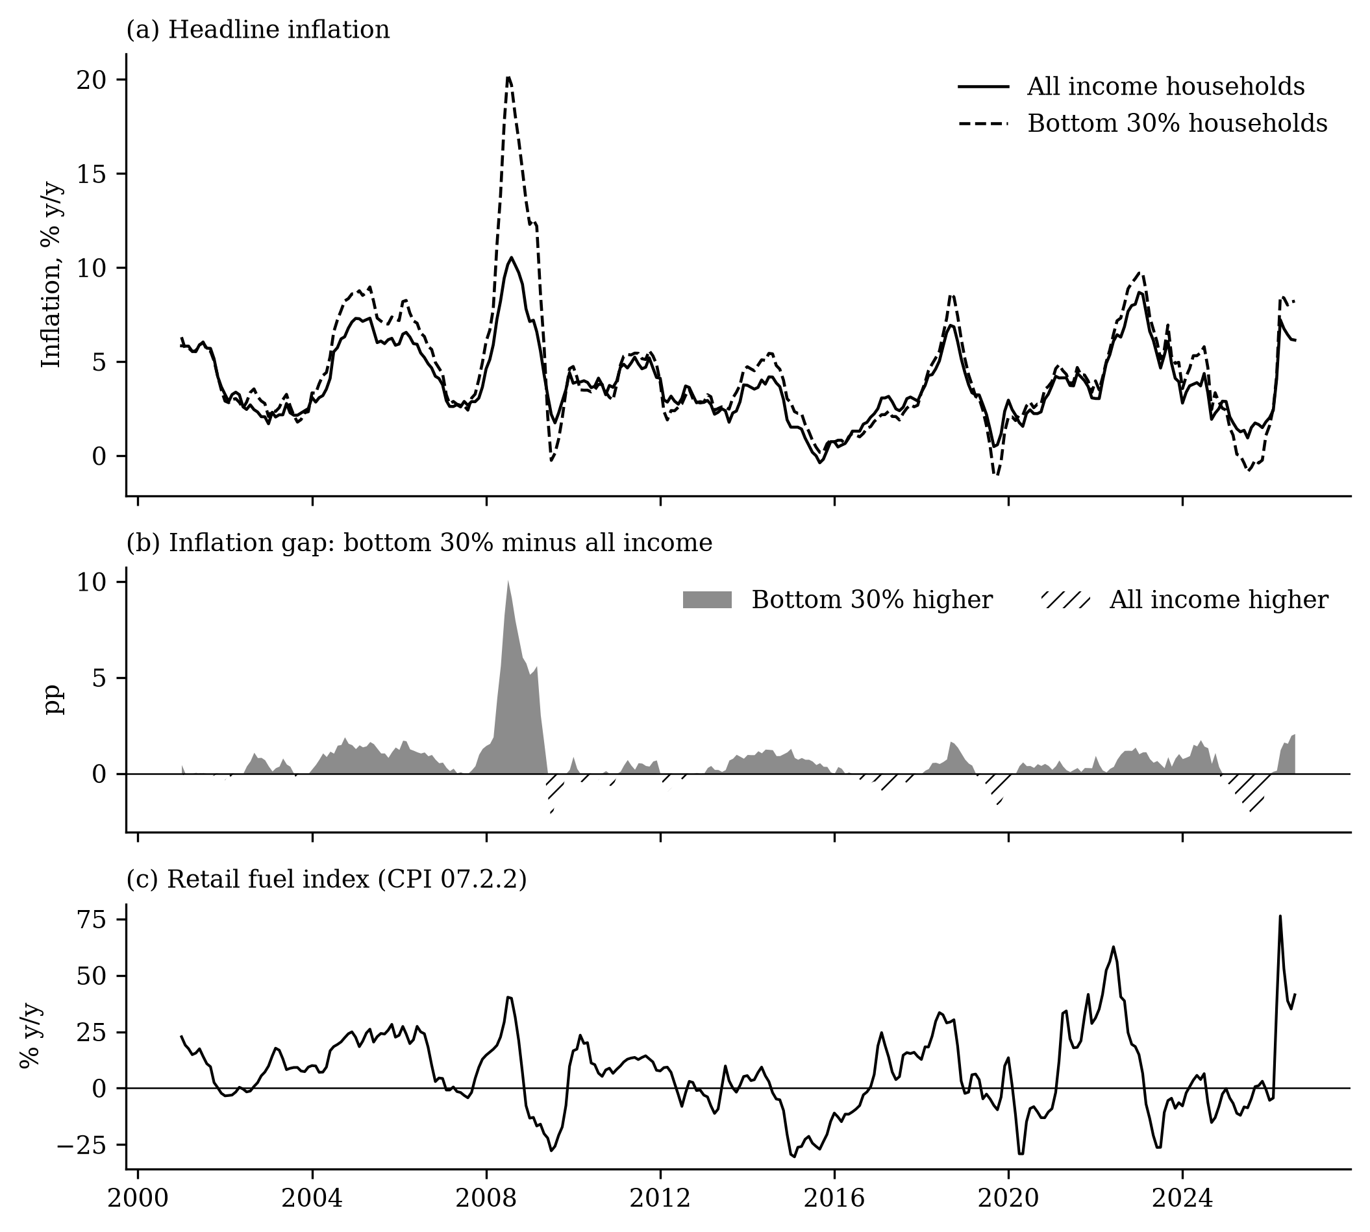
Trends: inflation by group, gap and fuel index
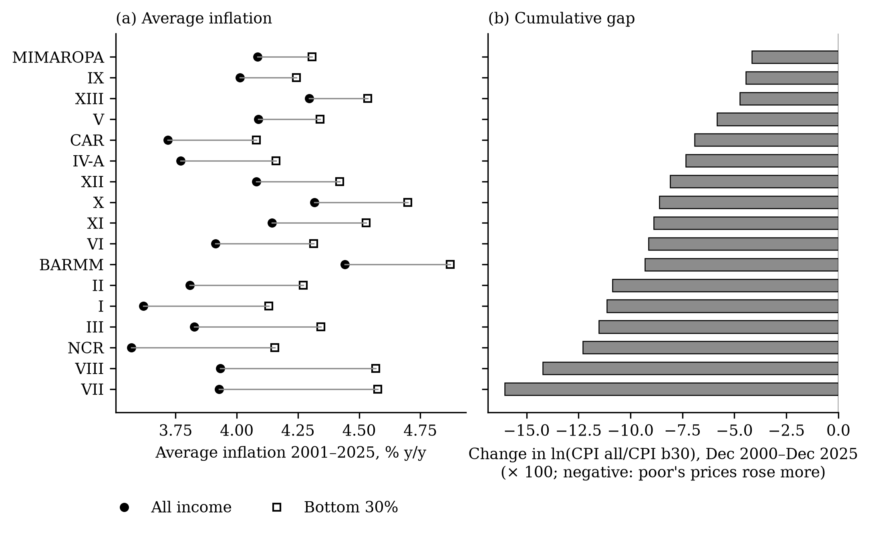
Regional averages and cumulative gap

4. Local projection estimates (Objective 2)
Each table: one row per specification; cells are β (s.e.) at each horizon.

4.1 RQ1: pass-through to all-income and bottom-30% prices (A3)
Cumulative responses
spec | outcome | shock | h=0 | h=1 | h=2 | h=3 | h=4 | h=5 | h=6 | h=7 | h=8 | h=9 | h=10 | h=11 | h=12 | nobs_h0 | units
baseline | d_cpi_all | d_fuel | 0.0440*** (0.0059) | 0.0836*** (0.0121) | 0.0443*** (0.0103) | 0.0772*** (0.0153) | 0.0632*** (0.0090) | 0.0758*** (0.0116) | 0.0870*** (0.0150) | 0.0885*** (0.0140) | 0.0995*** (0.0153) | 0.0928*** (0.0182) | 0.1013*** (0.0185) | 0.0947*** (0.0172) | 0.1016*** (0.0174) | 308 | 1
baseline | d_cpi_b30 | d_fuel | 0.0439*** (0.0093) | 0.0884*** (0.0188) | 0.0467** (0.0204) | 0.0967*** (0.0263) | 0.0734*** (0.0150) | 0.0860*** (0.0177) | 0.0950*** (0.0231) | 0.1006*** (0.0210) | 0.1168*** (0.0240) | 0.1029*** (0.0259) | 0.1152*** (0.0276) | 0.1020*** (0.0247) | 0.1016*** (0.0262) | 307 | 1
Per-horizon responses
spec | outcome | shock | h=0 | h=1 | h=2 | h=3 | h=4 | h=5 | h=6 | h=7 | h=8 | h=9 | h=10 | h=11 | h=12 | nobs_h0 | units
baseline | d_cpi_all | d_fuel | 0.0440*** (0.0059) | 0.0396*** (0.0099) | −0.0190* (0.0101) | 0.0127* (0.0073) | −0.0025 (0.0081) | 0.0128* (0.0072) | 0.0127** (0.0060) | 0.0023 (0.0059) | 0.0109 (0.0067) | −0.0058 (0.0074) | 0.0098 (0.0066) | −0.0056 (0.0067) | 0.0059 (0.0071) | 308 | 1
baseline | d_cpi_b30 | d_fuel | 0.0439*** (0.0093) | 0.0446*** (0.0136) | −0.0184* (0.0109) | 0.0178** (0.0083) | 0.0016 (0.0097) | 0.0127 (0.0081) | 0.0149* (0.0089) | 0.0074 (0.0072) | 0.0163** (0.0071) | −0.0122 (0.0086) | 0.0151 (0.0101) | −0.0126 (0.0079) | 0.0034 (0.0084) | 307 | 1

4.2 RQ2: distributional gap, national (A4)
Cumulative responses
spec | outcome | shock | h=0 | h=1 | h=2 | h=3 | h=4 | h=5 | h=6 | h=7 | h=8 | h=9 | h=10 | h=11 | h=12 | nobs_h0 | units
baseline | d_ratio | d_fuel | −0.0000 (0.0040) | −0.0077 (0.0073) | −0.0016 (0.0078) | −0.0185* (0.0110) | −0.0175** (0.0086) | −0.0130 (0.0097) | −0.0155 (0.0103) | −0.0161* (0.0094) | −0.0209** (0.0102) | −0.0137 (0.0101) | −0.0179 (0.0114) | −0.0161 (0.0111) | −0.0097 (0.0113) | 307 | 1
Per-horizon responses
spec | outcome | shock | h=0 | h=1 | h=2 | h=3 | h=4 | h=5 | h=6 | h=7 | h=8 | h=9 | h=10 | h=11 | h=12 | nobs_h0 | units
baseline | d_ratio | d_fuel | −0.0000 (0.0040) | −0.0076 (0.0052) | 0.0003 (0.0038) | −0.0064 (0.0041) | −0.0039 (0.0038) | 0.0026 (0.0036) | −0.0052 (0.0047) | −0.0002 (0.0035) | −0.0049 (0.0043) | 0.0075 (0.0055) | −0.0061 (0.0058) | 0.0040 (0.0050) | 0.0014 (0.0044) | 307 | 1

4.3 RQ3: CPI divisions, all income (A5)
Cumulative responses
spec | outcome | shock | h=0 | h=1 | h=2 | h=3 | h=4 | h=5 | h=6 | h=7 | h=8 | h=9 | h=10 | h=11 | h=12 | nobs_h0 | units
baseline | d_c01 | d_fuel | 0.0285** (0.0117) | 0.0578*** (0.0192) | 0.0226 (0.0165) | 0.0687*** (0.0223) | 0.0435** (0.0185) | 0.0651*** (0.0192) | 0.0990*** (0.0264) | 0.0854*** (0.0248) | 0.1069*** (0.0270) | 0.0785** (0.0335) | 0.0878*** (0.0332) | 0.0792*** (0.0301) | 0.0723** (0.0327) | 308 | 1
baseline | d_c02 | d_fuel | 0.0139** (0.0058) | 0.0240** (0.0115) | 0.0036 (0.0153) | 0.0037 (0.0259) | −0.0125 (0.0286) | 0.0169 (0.0337) | 0.0520 (0.0394) | 0.0058 (0.0420) | 0.0009 (0.0490) | −0.0038 (0.0521) | 0.0027 (0.0530) | −0.0042 (0.0529) | 0.0177 (0.0549) | 308 | 1
baseline | d_c03 | d_fuel | 0.0020 (0.0015) | 0.0041* (0.0022) | 0.0103*** (0.0031) | 0.0088** (0.0042) | 0.0113** (0.0048) | 0.0135** (0.0057) | 0.0224*** (0.0076) | 0.0261*** (0.0075) | 0.0263*** (0.0078) | 0.0319*** (0.0085) | 0.0291*** (0.0090) | 0.0309*** (0.0093) | 0.0316*** (0.0093) | 308 | 1
baseline | d_c04 | d_fuel | 0.0403*** (0.0071) | 0.0886*** (0.0184) | 0.0547*** (0.0127) | 0.0830*** (0.0201) | 0.0848*** (0.0141) | 0.1003*** (0.0159) | 0.0891*** (0.0145) | 0.1101*** (0.0135) | 0.1204*** (0.0135) | 0.1244*** (0.0128) | 0.1417*** (0.0142) | 0.1370*** (0.0135) | 0.1576*** (0.0148) | 308 | 1
baseline | d_c05 | d_fuel | −0.0037** (0.0017) | −0.0007 (0.0027) | 0.0025 (0.0047) | 0.0013 (0.0043) | 0.0063 (0.0049) | 0.0124** (0.0061) | 0.0125 (0.0078) | 0.0232*** (0.0081) | 0.0244*** (0.0079) | 0.0268*** (0.0088) | 0.0283*** (0.0093) | 0.0352*** (0.0094) | 0.0314*** (0.0097) | 308 | 1
baseline | d_c06 | d_fuel | 0.0041* (0.0024) | 0.0071* (0.0042) | 0.0107** (0.0047) | 0.0132* (0.0068) | 0.0195** (0.0084) | 0.0211** (0.0087) | 0.0116 (0.0101) | 0.0256*** (0.0098) | 0.0243** (0.0103) | 0.0292*** (0.0113) | 0.0259** (0.0115) | 0.0260** (0.0115) | 0.0272** (0.0134) | 308 | 1
baseline | d_c07 | d_fuel | 0.2929*** (0.0113) | 0.4768*** (0.0300) | 0.2293*** (0.0430) | 0.3520*** (0.0426) | 0.3168*** (0.0337) | 0.3489*** (0.0375) | 0.3084*** (0.0406) | 0.3526*** (0.0412) | 0.3264*** (0.0463) | 0.3486*** (0.0496) | 0.3554*** (0.0536) | 0.3241*** (0.0449) | 0.3702*** (0.0444) | 308 | 1
baseline | d_c08 | d_fuel | 0.0014 (0.0023) | 0.0069* (0.0039) | 0.0082** (0.0037) | 0.0109** (0.0046) | 0.0121*** (0.0044) | 0.0153*** (0.0059) | 0.0102* (0.0060) | 0.0106** (0.0052) | 0.0087 (0.0066) | 0.0086 (0.0061) | 0.0109* (0.0058) | 0.0126** (0.0057) | 0.0191*** (0.0066) | 308 | 1
baseline | d_c09 | d_fuel | 0.0037 (0.0057) | 0.0019 (0.0069) | −0.0171 (0.0121) | −0.0025 (0.0105) | 0.0081 (0.0113) | 0.0002 (0.0140) | 0.0153 (0.0173) | 0.0259 (0.0185) | 0.0194 (0.0207) | 0.0207 (0.0197) | 0.0495** (0.0243) | 0.0217 (0.0215) | 0.0238 (0.0253) | 308 | 1
baseline | d_c10 | d_fuel | −0.0098 (0.0090) | −0.0225* (0.0119) | −0.0068 (0.0135) | −0.0050 (0.0130) | −0.0137 (0.0143) | −0.0034 (0.0145) | 0.0081 (0.0173) | 0.0143 (0.0177) | 0.0047 (0.0165) | 0.0082 (0.0175) | 0.0109 (0.0184) | 0.0217 (0.0167) | −0.0087 (0.0220) | 308 | 1
baseline | d_c11 | d_fuel | 0.0051 (0.0042) | 0.0099 (0.0090) | 0.0087 (0.0092) | 0.0184 (0.0139) | 0.0188 (0.0132) | 0.0189 (0.0166) | 0.0207 (0.0180) | 0.0481*** (0.0183) | 0.0414** (0.0165) | 0.0471** (0.0184) | 0.0489*** (0.0179) | 0.0517*** (0.0181) | 0.0628*** (0.0175) | 308 | 1
baseline | d_c12 | d_fuel | −0.0571 (0.0547) | −0.0323 (0.0505) | −0.0064 (0.0640) | −0.0002 (0.0636) | 0.0864 (0.1417) | 0.1240 (0.1223) | 0.1461 (0.1577) | 0.3026 (0.2127) | 0.2178 (0.2038) | 0.3914* (0.2097) | 0.7382** (0.3041) | 0.8094** (0.3897) | 0.3579** (0.1579) | 91 | 1
baseline | d_c13 | d_fuel | 0.0001 (0.0015) | 0.0015 (0.0028) | 0.0032 (0.0030) | 0.0044 (0.0046) | 0.0066 (0.0047) | 0.0090 (0.0055) | 0.0096 (0.0066) | 0.0181** (0.0073) | 0.0156** (0.0074) | 0.0221*** (0.0077) | 0.0224** (0.0087) | 0.0237*** (0.0086) | 0.0249*** (0.0091) | 308 | 1
Per-horizon responses
spec | outcome | shock | h=0 | h=1 | h=2 | h=3 | h=4 | h=5 | h=6 | h=7 | h=8 | h=9 | h=10 | h=11 | h=12 | nobs_h0 | units
baseline | d_c01 | d_fuel | 0.0285** (0.0117) | 0.0292** (0.0115) | −0.0170 (0.0110) | 0.0209** (0.0082) | −0.0004 (0.0124) | 0.0146 (0.0104) | 0.0239** (0.0115) | −0.0029 (0.0127) | 0.0203** (0.0090) | −0.0278* (0.0167) | 0.0095 (0.0112) | −0.0075 (0.0096) | −0.0047 (0.0100) | 308 | 1
baseline | d_c02 | d_fuel | 0.0139** (0.0058) | 0.0091 (0.0073) | 0.0005 (0.0077) | −0.0060 (0.0132) | −0.0077 (0.0123) | 0.0303 (0.0204) | 0.0264* (0.0146) | −0.0359 (0.0244) | −0.0061 (0.0160) | −0.0050 (0.0105) | 0.0023 (0.0102) | −0.0050 (0.0096) | 0.0242** (0.0117) | 308 | 1
baseline | d_c03 | d_fuel | 0.0020 (0.0015) | 0.0021 (0.0018) | 0.0036** (0.0018) | 0.0002 (0.0025) | 0.0036* (0.0019) | 0.0009 (0.0024) | 0.0062** (0.0030) | 0.0033 (0.0028) | 0.0009 (0.0027) | 0.0057*** (0.0021) | 0.0001 (0.0026) | 0.0002 (0.0027) | 0.0063** (0.0028) | 308 | 1
baseline | d_c04 | d_fuel | 0.0403*** (0.0071) | 0.0480*** (0.0162) | −0.0174 (0.0130) | 0.0136 (0.0104) | 0.0028 (0.0106) | 0.0218** (0.0108) | 0.0006 (0.0080) | 0.0106 (0.0096) | 0.0156 (0.0097) | 0.0044 (0.0108) | 0.0179* (0.0099) | −0.0035 (0.0134) | 0.0162* (0.0094) | 308 | 1
baseline | d_c05 | d_fuel | −0.0037** (0.0017) | 0.0030 (0.0023) | 0.0019 (0.0020) | −0.0031 (0.0024) | 0.0062*** (0.0020) | 0.0051* (0.0027) | −0.0004 (0.0031) | 0.0078** (0.0032) | 0.0026 (0.0030) | 0.0023 (0.0031) | 0.0036 (0.0032) | 0.0060** (0.0029) | 0.0001 (0.0032) | 308 | 1
baseline | d_c06 | d_fuel | 0.0041* (0.0024) | 0.0031 (0.0030) | 0.0050** (0.0023) | 0.0024 (0.0030) | 0.0009 (0.0025) | 0.0071** (0.0031) | 0.0002 (0.0037) | 0.0067* (0.0038) | 0.0016 (0.0031) | 0.0052* (0.0031) | −0.0004 (0.0031) | −0.0023 (0.0026) | 0.0038 (0.0038) | 308 | 1
baseline | d_c07 | d_fuel | 0.2929*** (0.0113) | 0.1841*** (0.0300) | −0.1057** (0.0480) | 0.0238 (0.0350) | −0.0121 (0.0294) | 0.0250 (0.0279) | −0.0203 (0.0235) | 0.0235 (0.0188) | −0.0128 (0.0329) | 0.0215 (0.0360) | 0.0070 (0.0271) | −0.0214 (0.0217) | 0.0258 (0.0282) | 308 | 1
baseline | d_c08 | d_fuel | 0.0014 (0.0023) | 0.0054** (0.0027) | 0.0028 (0.0024) | 0.0018 (0.0024) | 0.0012 (0.0025) | 0.0034 (0.0025) | −0.0044 (0.0040) | −0.0000 (0.0033) | −0.0016 (0.0042) | 0.0000 (0.0031) | 0.0020 (0.0029) | 0.0022 (0.0023) | 0.0061* (0.0036) | 308 | 1
baseline | d_c09 | d_fuel | 0.0037 (0.0057) | −0.0020 (0.0043) | −0.0059 (0.0082) | 0.0034 (0.0050) | 0.0102 (0.0084) | −0.0063 (0.0079) | 0.0149 (0.0099) | 0.0010 (0.0087) | −0.0033 (0.0068) | 0.0014 (0.0066) | 0.0310 (0.0251) | −0.0291 (0.0265) | 0.0046 (0.0072) | 308 | 1
baseline | d_c10 | d_fuel | −0.0098 (0.0090) | −0.0129* (0.0077) | 0.0082 (0.0107) | 0.0047 (0.0081) | −0.0011 (0.0102) | 0.0067 (0.0098) | 0.0072 (0.0091) | 0.0084 (0.0100) | −0.0121 (0.0138) | 0.0027 (0.0119) | 0.0046 (0.0101) | 0.0087 (0.0133) | −0.0262 (0.0162) | 308 | 1
baseline | d_c11 | d_fuel | 0.0051 (0.0042) | 0.0047 (0.0066) | 0.0008 (0.0043) | 0.0017 (0.0032) | 0.0034 (0.0049) | 0.0017 (0.0037) | 0.0100 (0.0067) | 0.0190*** (0.0060) | −0.0017 (0.0053) | 0.0061 (0.0052) | 0.0062 (0.0044) | 0.0004 (0.0050) | 0.0118** (0.0048) | 308 | 1
baseline | d_c12 | d_fuel | −0.0571 (0.0547) | 0.0245 (0.0406) | 0.0200 (0.0399) | −0.0422 (0.0557) | 0.1357 (0.1180) | −0.0733 (0.0768) | 0.0166 (0.0670) | 0.1008 (0.1078) | −0.0909 (0.0657) | 0.0159 (0.0565) | 0.2795* (0.1613) | 0.0805 (0.0965) | −0.5506 (0.3442) | 91 | 1
baseline | d_c13 | d_fuel | 0.0001 (0.0015) | 0.0014 (0.0021) | 0.0016 (0.0016) | −0.0000 (0.0023) | 0.0031 (0.0022) | 0.0031 (0.0024) | 0.0029 (0.0022) | 0.0058** (0.0025) | −0.0010 (0.0026) | 0.0068*** (0.0023) | 0.0016 (0.0030) | −0.0003 (0.0026) | 0.0043 (0.0029) | 308 | 1
Weight decomposition (cumulative response at h = 12 × weight difference)
coicop | w_all | w_b30 | beta | se | division | contrib_all | contrib_b30 | contrib_gap
01 | 37.7451 | 54.9304 | 0.0723 | 0.0327 | Food and non-alcoholic beverages | 0.0273 | 0.0397 | −0.0124
02 | 2.1624 | 2.6278 | 0.0177 | 0.0549 | Alcoholic beverages and tobacco | 0.0004 | 0.0005 | −0.0001
03 | 3.1358 | 2.5325 | 0.0316 | 0.0093 | Clothing and footwear | 0.0010 | 0.0008 | 0.0002
04 | 21.3791 | 15.5160 | 0.1576 | 0.0148 | Housing, water, electricity, gas | 0.0337 | 0.0244 | 0.0092
05 | 3.2187 | 2.3508 | 0.0314 | 0.0097 | Furnishings and household equipment | 0.0010 | 0.0007 | 0.0003
06 | 2.8859 | 1.4372 | 0.0272 | 0.0134 | Health | 0.0008 | 0.0004 | 0.0004
07 | 9.0322 | 6.1225 | 0.3702 | 0.0444 | Transport | 0.0334 | 0.0227 | 0.0108
08 | 3.4109 | 1.0450 | 0.0191 | 0.0066 | Information and communication | 0.0007 | 0.0002 | 0.0005
09 | 0.9614 | 0.7440 | 0.0238 | 0.0253 | Recreation, sport and culture | 0.0002 | 0.0002 | 0.0001
10 | 1.9580 | 0.3657 | −0.0087 | 0.0220 | Education services | −0.0002 | −0.0000 | −0.0001
11 | 9.6173 | 7.4839 | 0.0628 | 0.0175 | Restaurants and accommodation | 0.0060 | 0.0047 | 0.0013
12 | 0.0339 | 0.0003 | 0.3579 | 0.1579 | Financial services | 0.0001 | 0.0000 | 0.0001
13 | 4.4592 | 4.8439 | 0.0249 | 0.0091 | Personal care and miscellaneous | 0.0011 | 0.0012 | −0.0001

4.4 RQ3b and sub-period splits (A6, supplementary)
Cumulative responses
spec | outcome | shock | h=0 | h=1 | h=2 | h=3 | h=4 | h=5 | h=6 | h=7 | h=8 | h=9 | h=10 | h=11 | h=12 | nobs_h0 | units
2013- all-income | d_c01 | d_fuel | 0.0220 (0.0141) | 0.0472** (0.0221) | 0.0217 (0.0166) | 0.0551** (0.0229) | 0.0354* (0.0212) | 0.0622** (0.0261) | 0.0945*** (0.0330) | 0.0873*** (0.0306) | 0.1123*** (0.0293) | 0.0681* (0.0389) | 0.0754** (0.0351) | 0.0669** (0.0316) | 0.0549* (0.0333) | 164 | 1
2013- all-income | d_c04 | d_fuel | 0.0333*** (0.0076) | 0.0833*** (0.0206) | 0.0497*** (0.0131) | 0.0644*** (0.0247) | 0.0654*** (0.0176) | 0.0774*** (0.0204) | 0.0623*** (0.0174) | 0.0904*** (0.0171) | 0.0953*** (0.0141) | 0.1065*** (0.0135) | 0.1230*** (0.0169) | 0.1313*** (0.0156) | 0.1419*** (0.0166) | 164 | 1
2013- all-income | d_c07 | d_fuel | 0.2795*** (0.0105) | 0.4387*** (0.0337) | 0.1903*** (0.0466) | 0.3195*** (0.0469) | 0.2630*** (0.0386) | 0.3088*** (0.0459) | 0.2548*** (0.0508) | 0.2877*** (0.0487) | 0.2900*** (0.0619) | 0.2759*** (0.0572) | 0.2864*** (0.0617) | 0.2434*** (0.0504) | 0.3000*** (0.0512) | 164 | 1
2013- all-income | d_c11 | d_fuel | −0.0006 (0.0035) | 0.0054 (0.0062) | 0.0042 (0.0071) | 0.0140 (0.0116) | 0.0096 (0.0129) | 0.0188 (0.0146) | 0.0258 (0.0164) | 0.0370** (0.0186) | 0.0286* (0.0168) | 0.0386** (0.0177) | 0.0306* (0.0163) | 0.0395** (0.0166) | 0.0435*** (0.0158) | 164 | 1
2013- bottom 30% | d_b30_c01 | d_fuel | 0.0303* (0.0163) | 0.0626** (0.0282) | 0.0271 (0.0231) | 0.0732** (0.0307) | 0.0469* (0.0252) | 0.0643** (0.0286) | 0.0819** (0.0379) | 0.0817** (0.0340) | 0.1159*** (0.0356) | 0.0736* (0.0419) | 0.0857** (0.0388) | 0.0803** (0.0353) | 0.0668* (0.0370) | 163 | 1
2013- bottom 30% | d_b30_c04 | d_fuel | 0.0360*** (0.0113) | 0.1024*** (0.0272) | 0.0663*** (0.0193) | 0.0953*** (0.0296) | 0.0862*** (0.0196) | 0.1059*** (0.0227) | 0.1128*** (0.0303) | 0.1322*** (0.0292) | 0.1487*** (0.0315) | 0.1523*** (0.0371) | 0.1838*** (0.0382) | 0.1742*** (0.0405) | 0.1818*** (0.0380) | 163 | 1
2013- bottom 30% | d_b30_c07 | d_fuel | 0.2296*** (0.0138) | 0.3874*** (0.0421) | 0.2068*** (0.0431) | 0.3086*** (0.0611) | 0.2569*** (0.0470) | 0.2556*** (0.0613) | 0.1778*** (0.0654) | 0.2158*** (0.0636) | 0.2088*** (0.0755) | 0.1808** (0.0742) | 0.2024** (0.0859) | 0.1791** (0.0773) | 0.1963** (0.0779) | 163 | 1
2013- bottom 30% | d_b30_c11 | d_fuel | 0.0006 (0.0030) | 0.0101* (0.0054) | 0.0120** (0.0059) | 0.0267** (0.0114) | 0.0177 (0.0110) | 0.0203 (0.0134) | 0.0355** (0.0164) | 0.0469*** (0.0181) | 0.0389** (0.0185) | 0.0459** (0.0183) | 0.0349* (0.0201) | 0.0367* (0.0190) | 0.0403* (0.0210) | 163 | 1
2013- ratio | d_ratio | d_fuel | 0.0031 (0.0033) | 0.0009 (0.0064) | 0.0005 (0.0055) | −0.0061 (0.0070) | −0.0024 (0.0066) | 0.0007 (0.0077) | −0.0046 (0.0095) | −0.0019 (0.0087) | −0.0146* (0.0087) | −0.0044 (0.0116) | −0.0067 (0.0097) | −0.0088 (0.0105) | 0.0031 (0.0092) | 164 | 1
national excl 2008 | d_ratio | d_fuel | 0.0034 (0.0033) | −0.0016 (0.0069) | −0.0029 (0.0062) | −0.0112* (0.0067) | −0.0126** (0.0063) | −0.0082 (0.0075) | −0.0131 (0.0088) | −0.0134 (0.0083) | −0.0167* (0.0093) | −0.0087 (0.0098) | −0.0133 (0.0114) | −0.0102 (0.0104) | −0.0079 (0.0115) | 295 | 1
regional 2001-2012 | d_ratio | d_fuel | −0.0238** (0.0117) | −0.0440** (0.0204) | −0.0278** (0.0142) | −0.0288** (0.0128) | −0.0456*** (0.0138) | −0.0409*** (0.0127) | −0.0541*** (0.0197) | −0.0495*** (0.0174) | −0.0525*** (0.0182) | −0.0493** (0.0195) | −0.0507*** (0.0159) | −0.0396** (0.0171) | −0.0369** (0.0147) | 2431 | 17
regional 2013- | d_ratio | d_fuel | 0.0053** (0.0022) | 0.0006 (0.0050) | −0.0024 (0.0045) | −0.0061 (0.0052) | −0.0040 (0.0046) | −0.0078 (0.0053) | −0.0091 (0.0064) | −0.0096 (0.0069) | −0.0139** (0.0069) | −0.0092 (0.0084) | −0.0095 (0.0072) | −0.0118 (0.0081) | −0.0063 (0.0075) | 2788 | 17
regional excl 2008 | d_ratio | d_fuel | 0.0045** (0.0021) | −0.0002 (0.0047) | −0.0038 (0.0045) | −0.0081* (0.0049) | −0.0110** (0.0046) | −0.0134*** (0.0052) | −0.0177** (0.0073) | −0.0171** (0.0072) | −0.0180** (0.0074) | −0.0119 (0.0082) | −0.0151* (0.0085) | −0.0146* (0.0085) | −0.0135 (0.0092) | 5015 | 17
Per-horizon responses
spec | outcome | shock | h=0 | h=1 | h=2 | h=3 | h=4 | h=5 | h=6 | h=7 | h=8 | h=9 | h=10 | h=11 | h=12 | nobs_h0 | units
2013- all-income | d_c01 | d_fuel | 0.0220 (0.0141) | 0.0252* (0.0142) | −0.0193 (0.0131) | 0.0207** (0.0102) | 0.0015 (0.0156) | 0.0193 (0.0119) | 0.0177 (0.0151) | 0.0027 (0.0171) | 0.0245** (0.0107) | −0.0461** (0.0210) | 0.0106 (0.0152) | −0.0075 (0.0125) | −0.0080 (0.0122) | 164 | 1
2013- all-income | d_c04 | d_fuel | 0.0333*** (0.0076) | 0.0499*** (0.0181) | −0.0234* (0.0138) | 0.0039 (0.0141) | −0.0051 (0.0145) | 0.0218* (0.0132) | 0.0056 (0.0107) | 0.0148 (0.0112) | 0.0127 (0.0099) | 0.0147 (0.0106) | 0.0168 (0.0133) | 0.0035 (0.0141) | 0.0098 (0.0103) | 164 | 1
2013- all-income | d_c07 | d_fuel | 0.2795*** (0.0105) | 0.1591*** (0.0335) | −0.1261** (0.0562) | 0.0216 (0.0394) | −0.0304 (0.0402) | 0.0317 (0.0350) | −0.0179 (0.0269) | 0.0121 (0.0212) | 0.0121 (0.0412) | 0.0124 (0.0432) | 0.0076 (0.0280) | −0.0368 (0.0287) | 0.0282 (0.0342) | 164 | 1
2013- all-income | d_c11 | d_fuel | −0.0006 (0.0035) | 0.0057 (0.0040) | 0.0005 (0.0046) | −0.0019 (0.0035) | 0.0019 (0.0045) | 0.0046 (0.0042) | 0.0052 (0.0044) | 0.0126** (0.0051) | −0.0050 (0.0056) | 0.0084 (0.0053) | −0.0017 (0.0040) | 0.0041 (0.0052) | 0.0098** (0.0050) | 164 | 1
2013- bottom 30% | d_b30_c01 | d_fuel | 0.0303* (0.0163) | 0.0323* (0.0179) | −0.0179 (0.0146) | 0.0190* (0.0116) | 0.0052 (0.0163) | 0.0111 (0.0134) | 0.0133 (0.0164) | 0.0061 (0.0147) | 0.0334*** (0.0111) | −0.0401** (0.0199) | 0.0155 (0.0182) | −0.0096 (0.0137) | −0.0056 (0.0138) | 163 | 1
2013- bottom 30% | d_b30_c04 | d_fuel | 0.0360*** (0.0113) | 0.0655*** (0.0211) | −0.0276* (0.0158) | 0.0190 (0.0145) | 0.0052 (0.0140) | 0.0274*** (0.0093) | 0.0232** (0.0113) | 0.0091 (0.0101) | 0.0244** (0.0106) | 0.0039 (0.0120) | 0.0379*** (0.0120) | −0.0193* (0.0110) | 0.0171** (0.0085) | 163 | 1
2013- bottom 30% | d_b30_c07 | d_fuel | 0.2296*** (0.0138) | 0.1574*** (0.0415) | −0.0949* (0.0510) | 0.0181 (0.0403) | −0.0402 (0.0376) | 0.0166 (0.0411) | −0.0100 (0.0253) | −0.0031 (0.0254) | 0.0076 (0.0394) | −0.0064 (0.0391) | 0.0282 (0.0298) | −0.0350 (0.0297) | 0.0001 (0.0348) | 163 | 1
2013- bottom 30% | d_b30_c11 | d_fuel | 0.0006 (0.0030) | 0.0089** (0.0042) | 0.0031 (0.0040) | 0.0038 (0.0042) | −0.0025 (0.0037) | 0.0014 (0.0045) | 0.0101** (0.0048) | 0.0120*** (0.0044) | −0.0034 (0.0057) | 0.0067** (0.0032) | −0.0043 (0.0050) | −0.0028 (0.0033) | 0.0106*** (0.0037) | 163 | 1
2013- ratio | d_ratio | d_fuel | 0.0031 (0.0033) | −0.0021 (0.0048) | −0.0011 (0.0042) | −0.0036 (0.0043) | −0.0031 (0.0037) | 0.0028 (0.0039) | −0.0040 (0.0052) | 0.0016 (0.0030) | −0.0117*** (0.0031) | 0.0108* (0.0062) | −0.0067 (0.0062) | 0.0035 (0.0049) | 0.0038 (0.0043) | 164 | 1
national excl 2008 | d_ratio | d_fuel | 0.0034 (0.0033) | −0.0050 (0.0053) | −0.0018 (0.0037) | −0.0054 (0.0040) | −0.0037 (0.0035) | 0.0027 (0.0034) | −0.0053 (0.0046) | 0.0004 (0.0036) | −0.0053 (0.0040) | 0.0064 (0.0057) | −0.0052 (0.0060) | 0.0030 (0.0049) | −0.0002 (0.0043) | 295 | 1
regional 2001-2012 | d_ratio | d_fuel | −0.0238** (0.0117) | −0.0202** (0.0083) | −0.0049 (0.0063) | 0.0001 (0.0086) | −0.0096* (0.0049) | 0.0049 (0.0037) | −0.0077 (0.0071) | 0.0029 (0.0053) | −0.0016 (0.0049) | 0.0062 (0.0047) | −0.0020 (0.0061) | 0.0091 (0.0068) | 0.0028 (0.0042) | 2431 | 17
regional 2013- | d_ratio | d_fuel | 0.0053** (0.0022) | −0.0046 (0.0034) | −0.0017 (0.0020) | −0.0035* (0.0019) | −0.0011 (0.0023) | −0.0038* (0.0021) | −0.0015 (0.0025) | −0.0005 (0.0027) | −0.0037** (0.0019) | 0.0049 (0.0037) | −0.0023 (0.0025) | −0.0009 (0.0023) | 0.0029** (0.0013) | 2788 | 17
regional excl 2008 | d_ratio | d_fuel | 0.0045** (0.0021) | −0.0046 (0.0033) | −0.0025 (0.0020) | −0.0037* (0.0022) | −0.0043* (0.0024) | −0.0028 (0.0019) | −0.0050* (0.0030) | 0.0012 (0.0027) | −0.0024 (0.0021) | 0.0049* (0.0030) | −0.0037 (0.0025) | 0.0003 (0.0024) | 0.0009 (0.0020) | 5015 | 17

4.5 RQ4: regional panel and group interactions (A7)
Cumulative responses
spec | outcome | shock | h=0 | h=1 | h=2 | h=3 | h=4 | h=5 | h=6 | h=7 | h=8 | h=9 | h=10 | h=11 | h=12 | nobs_h0 | units
pooled | d_ratio | d_fuel | −0.0006 (0.0032) | −0.0082 (0.0057) | −0.0065 (0.0046) | −0.0149** (0.0075) | −0.0180** (0.0071) | −0.0184*** (0.0070) | −0.0214** (0.0084) | −0.0213*** (0.0081) | −0.0242*** (0.0084) | −0.0187** (0.0086) | −0.0211** (0.0085) | −0.0205** (0.0089) | −0.0173** (0.0085) | 5219 | 17
x high_food | d_ratio | d_fuel | −0.0001 (0.0031) | −0.0091 (0.0059) | −0.0087* (0.0051) | −0.0184** (0.0079) | −0.0224*** (0.0078) | −0.0214*** (0.0076) | −0.0240*** (0.0085) | −0.0232*** (0.0082) | −0.0259*** (0.0088) | −0.0204** (0.0092) | −0.0239** (0.0093) | −0.0239** (0.0097) | −0.0216** (0.0094) | 5219 | 17
x high_poverty | d_ratio | d_fuel | 0.0003 (0.0032) | −0.0089 (0.0058) | −0.0090* (0.0053) | −0.0189** (0.0083) | −0.0234** (0.0092) | −0.0233** (0.0092) | −0.0271** (0.0108) | −0.0251** (0.0101) | −0.0257** (0.0102) | −0.0184* (0.0100) | −0.0192* (0.0099) | −0.0169* (0.0102) | −0.0131 (0.0100) | 5219 | 17
x island | d_ratio | d_fuel | 0.0003 (0.0032) | −0.0067 (0.0055) | −0.0049 (0.0044) | −0.0128* (0.0069) | −0.0162** (0.0064) | −0.0171*** (0.0064) | −0.0201*** (0.0078) | −0.0198*** (0.0074) | −0.0219*** (0.0078) | −0.0158** (0.0080) | −0.0183** (0.0077) | −0.0171** (0.0082) | −0.0147* (0.0079) | 5219 | 17
x mindanao | d_ratio | d_fuel | 0.0002 (0.0032) | −0.0083 (0.0058) | −0.0077 (0.0051) | −0.0174** (0.0082) | −0.0222** (0.0090) | −0.0222** (0.0092) | −0.0263** (0.0108) | −0.0246** (0.0102) | −0.0256** (0.0103) | −0.0184* (0.0100) | −0.0188* (0.0098) | −0.0163 (0.0099) | −0.0118 (0.0096) | 5219 | 17
Per-horizon responses
spec | outcome | shock | h=0 | h=1 | h=2 | h=3 | h=4 | h=5 | h=6 | h=7 | h=8 | h=9 | h=10 | h=11 | h=12 | nobs_h0 | units
pooled | d_ratio | d_fuel | −0.0006 (0.0032) | −0.0075** (0.0032) | −0.0021 (0.0021) | −0.0030 (0.0024) | −0.0038 (0.0023) | −0.0013 (0.0021) | −0.0042 (0.0028) | 0.0004 (0.0026) | −0.0027 (0.0019) | 0.0056* (0.0028) | −0.0030 (0.0023) | 0.0013 (0.0031) | 0.0017 (0.0014) | 5219 | 17
x high_food | d_ratio | d_fuel | −0.0001 (0.0031) | −0.0089** (0.0034) | −0.0033 (0.0023) | −0.0042 (0.0026) | −0.0042* (0.0024) | −0.0001 (0.0024) | −0.0039 (0.0029) | 0.0010 (0.0030) | −0.0024 (0.0022) | 0.0055** (0.0028) | −0.0041 (0.0029) | 0.0007 (0.0034) | 0.0009 (0.0017) | 5219 | 17
x high_poverty | d_ratio | d_fuel | 0.0003 (0.0032) | −0.0091*** (0.0033) | −0.0038 (0.0025) | −0.0045* (0.0025) | −0.0047* (0.0027) | −0.0004 (0.0023) | −0.0036 (0.0027) | 0.0023 (0.0032) | −0.0005 (0.0029) | 0.0072** (0.0031) | −0.0012 (0.0027) | 0.0029 (0.0035) | 0.0024 (0.0022) | 5219 | 17
x island | d_ratio | d_fuel | 0.0003 (0.0032) | −0.0070** (0.0030) | −0.0019 (0.0022) | −0.0026 (0.0025) | −0.0042* (0.0023) | −0.0017 (0.0022) | −0.0041 (0.0030) | 0.0006 (0.0028) | −0.0019 (0.0020) | 0.0060** (0.0028) | −0.0030 (0.0024) | 0.0019 (0.0033) | 0.0009 (0.0015) | 5219 | 17
x mindanao | d_ratio | d_fuel | 0.0002 (0.0032) | −0.0085*** (0.0032) | −0.0031 (0.0024) | −0.0043* (0.0025) | −0.0049* (0.0026) | −0.0005 (0.0023) | −0.0039 (0.0027) | 0.0019 (0.0030) | −0.0008 (0.0027) | 0.0071** (0.0031) | −0.0008 (0.0025) | 0.0031 (0.0034) | 0.0032 (0.0019) | 5219 | 17
Cumulative responses — coefficient on shock_x_high_food (additional effect in the group)
spec | outcome | shock | h=0 | h=1 | h=2 | h=3 | h=4 | h=5 | h=6 | h=7 | h=8 | h=9 | h=10 | h=11 | h=12 | nobs_h0 | units
x high_food | d_ratio | d_fuel | −0.0011 (0.0018) | 0.0021 (0.0024) | 0.0053* (0.0031) | 0.0083*** (0.0029) | 0.0104*** (0.0033) | 0.0072* (0.0039) | 0.0060 (0.0044) | 0.0045 (0.0045) | 0.0039 (0.0048) | 0.0040 (0.0044) | 0.0067 (0.0048) | 0.0080* (0.0047) | 0.0100* (0.0052) | 5219 | 17
Per-horizon responses — coefficient on shock_x_high_food (additional effect in the group)
spec | outcome | shock | h=0 | h=1 | h=2 | h=3 | h=4 | h=5 | h=6 | h=7 | h=8 | h=9 | h=10 | h=11 | h=12 | nobs_h0 | units
x high_food | d_ratio | d_fuel | −0.0011 (0.0018) | 0.0031* (0.0018) | 0.0028* (0.0016) | 0.0028** (0.0014) | 0.0010 (0.0015) | −0.0030* (0.0017) | −0.0009 (0.0022) | −0.0014 (0.0021) | −0.0006 (0.0018) | 0.0002 (0.0017) | 0.0028 (0.0025) | 0.0014 (0.0017) | 0.0018 (0.0017) | 5219 | 17
Cumulative responses — coefficient on shock_x_high_poverty (additional effect in the group)
spec | outcome | shock | h=0 | h=1 | h=2 | h=3 | h=4 | h=5 | h=6 | h=7 | h=8 | h=9 | h=10 | h=11 | h=12 | nobs_h0 | units
x high_poverty | d_ratio | d_fuel | −0.0020 (0.0027) | 0.0017 (0.0037) | 0.0058 (0.0057) | 0.0093 (0.0072) | 0.0124 (0.0090) | 0.0111 (0.0103) | 0.0128 (0.0119) | 0.0086 (0.0102) | 0.0033 (0.0081) | −0.0006 (0.0068) | −0.0042 (0.0066) | −0.0080 (0.0069) | −0.0095 (0.0078) | 5219 | 17
Per-horizon responses — coefficient on shock_x_high_poverty (additional effect in the group)
spec | outcome | shock | h=0 | h=1 | h=2 | h=3 | h=4 | h=5 | h=6 | h=7 | h=8 | h=9 | h=10 | h=11 | h=12 | nobs_h0 | units
x high_poverty | d_ratio | d_fuel | −0.0020 (0.0027) | 0.0037 (0.0026) | 0.0040 (0.0031) | 0.0034 (0.0024) | 0.0022 (0.0023) | −0.0021 (0.0017) | −0.0013 (0.0030) | −0.0042 (0.0032) | −0.0050 (0.0041) | −0.0038 (0.0031) | −0.0039 (0.0033) | −0.0036 (0.0027) | −0.0017 (0.0033) | 5219 | 17
Cumulative responses — coefficient on shock_x_island (additional effect in the group)
spec | outcome | shock | h=0 | h=1 | h=2 | h=3 | h=4 | h=5 | h=6 | h=7 | h=8 | h=9 | h=10 | h=11 | h=12 | nobs_h0 | units
x island | d_ratio | d_fuel | −0.0043 (0.0030) | −0.0070* (0.0041) | −0.0074 (0.0050) | −0.0097* (0.0056) | −0.0081 (0.0063) | −0.0060 (0.0076) | −0.0061 (0.0096) | −0.0070 (0.0095) | −0.0110 (0.0090) | −0.0135* (0.0082) | −0.0131* (0.0075) | −0.0158* (0.0081) | −0.0123 (0.0086) | 5219 | 17
Per-horizon responses — coefficient on shock_x_island (additional effect in the group)
spec | outcome | shock | h=0 | h=1 | h=2 | h=3 | h=4 | h=5 | h=6 | h=7 | h=8 | h=9 | h=10 | h=11 | h=12 | nobs_h0 | units
x island | d_ratio | d_fuel | −0.0043 (0.0030) | −0.0026 (0.0027) | −0.0007 (0.0022) | −0.0019 (0.0026) | 0.0023 (0.0018) | 0.0015 (0.0021) | −0.0008 (0.0023) | −0.0011 (0.0027) | −0.0038 (0.0023) | −0.0021 (0.0027) | −0.0001 (0.0022) | −0.0027 (0.0020) | 0.0035 (0.0029) | 5219 | 17
Cumulative responses — coefficient on shock_x_mindanao (additional effect in the group)
spec | outcome | shock | h=0 | h=1 | h=2 | h=3 | h=4 | h=5 | h=6 | h=7 | h=8 | h=9 | h=10 | h=11 | h=12 | nobs_h0 | units
x mindanao | d_ratio | d_fuel | −0.0025 (0.0037) | 0.0005 (0.0057) | 0.0039 (0.0075) | 0.0081 (0.0093) | 0.0128 (0.0112) | 0.0114 (0.0128) | 0.0146 (0.0151) | 0.0101 (0.0134) | 0.0042 (0.0103) | −0.0006 (0.0083) | −0.0069 (0.0074) | −0.0126 (0.0082) | −0.0166* (0.0092) | 5219 | 17
Per-horizon responses — coefficient on shock_x_mindanao (additional effect in the group)
spec | outcome | shock | h=0 | h=1 | h=2 | h=3 | h=4 | h=5 | h=6 | h=7 | h=8 | h=9 | h=10 | h=11 | h=12 | nobs_h0 | units
x mindanao | d_ratio | d_fuel | −0.0025 (0.0037) | 0.0030 (0.0036) | 0.0032 (0.0034) | 0.0040 (0.0029) | 0.0034 (0.0024) | −0.0024 (0.0020) | −0.0009 (0.0036) | −0.0045 (0.0033) | −0.0056 (0.0048) | −0.0045 (0.0042) | −0.0066 (0.0042) | −0.0056 (0.0035) | −0.0045 (0.0033) | 5219 | 17
Region groups used in the interactions
region | poverty_2018 | poverty_2023 | food_share_2018 | high_poverty | high_food | mindanao | island
NCR | 2.20 | 1.80 | 29.49 | 0.00 | 0.00 | 0.00 | 0.00
CAR | 12.00 | 7.00 | 35.76 | 0.00 | 0.00 | 0.00 | 0.00
R01 | 9.90 | 11.90 | 38.43 | 0.00 | 0.00 | 0.00 | 0.00
R02 | 16.30 | 10.40 | 43.85 | 0.00 | 1.00 | 0.00 | 0.00
R03 | 7.00 | 8.20 | 36.50 | 0.00 | 0.00 | 0.00 | 0.00
R04A | 7.10 | 7.90 | 33.02 | 0.00 | 0.00 | 0.00 | 0.00
R04B | 15.10 | 23.00 | 46.37 | 0.00 | 1.00 | 0.00 | 1.00
R05 | 27.00 | 27.50 | 45.55 | 1.00 | 1.00 | 0.00 | 0.00
R06 | 14.20 | 13.70 | 42.57 | 0.00 | 0.00 | 0.00 | 1.00
R07 | 16.10 | 17.30 | 37.86 | 0.00 | 0.00 | 0.00 | 1.00
R08 | 30.70 | 27.30 | 47.42 | 1.00 | 1.00 | 0.00 | 1.00
R09 | 32.70 | 31.70 | 49.61 | 1.00 | 1.00 | 1.00 | 0.00
R10 | 23.10 | 25.30 | 43.10 | 1.00 | 0.00 | 1.00 | 0.00
R11 | 19.10 | 16.00 | 42.98 | 1.00 | 0.00 | 1.00 | 0.00
R12 | 27.30 | 23.10 | 45.67 | 1.00 | 1.00 | 1.00 | 0.00
R13 | 30.50 | 20.80 | 46.73 | 1.00 | 1.00 | 1.00 | 0.00
BARMM | 60.40 | 32.40 | 59.38 | 1.00 | 1.00 | 1.00 | 0.00

4.6 Robustness (A8)
Cumulative responses
spec | outcome | shock | h=0 | h=1 | h=2 | h=3 | h=4 | h=5 | h=6 | h=7 | h=8 | h=9 | h=10 | h=11 | h=12 | nobs_h0 | units
a dubai crude php | d_cpi_all | d_dubai_php | 0.0099*** (0.0023) | 0.0243*** (0.0055) | 0.0196*** (0.0050) | 0.0194*** (0.0042) | 0.0261*** (0.0052) | 0.0292*** (0.0057) | 0.0299*** (0.0059) | 0.0348*** (0.0067) | 0.0367*** (0.0075) | 0.0376*** (0.0083) | 0.0399*** (0.0100) | 0.0405*** (0.0093) | 0.0410*** (0.0086) | 308 | 1
a dubai crude php | d_ratio | d_dubai_php | −0.0014 (0.0017) | −0.0025 (0.0034) | −0.0019 (0.0042) | −0.0051 (0.0044) | −0.0082 (0.0054) | −0.0098* (0.0058) | −0.0093 (0.0056) | −0.0101* (0.0054) | −0.0113* (0.0062) | −0.0093 (0.0058) | −0.0094 (0.0062) | −0.0092 (0.0067) | −0.0075 (0.0063) | 307 | 1
b macro controls | d_cpi_all | d_fuel | 0.0430*** (0.0066) | 0.0788*** (0.0139) | 0.0406*** (0.0113) | 0.0726*** (0.0157) | 0.0567*** (0.0109) | 0.0702*** (0.0133) | 0.0740*** (0.0152) | 0.0766*** (0.0149) | 0.0883*** (0.0160) | 0.0733*** (0.0154) | 0.0748*** (0.0177) | 0.0674*** (0.0181) | 0.0720*** (0.0199) | 308 | 1
b macro controls | d_ratio | d_fuel | 0.0028 (0.0032) | −0.0034 (0.0070) | 0.0038 (0.0098) | −0.0091 (0.0118) | −0.0066 (0.0127) | −0.0018 (0.0146) | −0.0046 (0.0156) | −0.0079 (0.0142) | −0.0076 (0.0146) | 0.0019 (0.0153) | −0.0017 (0.0161) | 0.0010 (0.0162) | 0.0086 (0.0160) | 307 | 1
c p=18 | d_cpi_all | d_fuel | 0.0450*** (0.0057) | 0.0872*** (0.0113) | 0.0504*** (0.0100) | 0.0809*** (0.0149) | 0.0677*** (0.0090) | 0.0790*** (0.0112) | 0.0933*** (0.0139) | 0.0920*** (0.0137) | 0.1032*** (0.0146) | 0.0990*** (0.0172) | 0.1093*** (0.0173) | 0.1009*** (0.0176) | 0.1086*** (0.0182) | 308 | 1
c p=18 | d_ratio | d_fuel | −0.0006 (0.0039) | −0.0101 (0.0067) | −0.0019 (0.0080) | −0.0183* (0.0109) | −0.0169** (0.0083) | −0.0156 (0.0096) | −0.0191* (0.0106) | −0.0181* (0.0097) | −0.0220** (0.0105) | −0.0148 (0.0098) | −0.0184 (0.0115) | −0.0153 (0.0114) | −0.0109 (0.0115) | 301 | 1
c p=6 | d_cpi_all | d_fuel | 0.0437*** (0.0059) | 0.0808*** (0.0120) | 0.0460*** (0.0100) | 0.0714*** (0.0157) | 0.0622*** (0.0092) | 0.0729*** (0.0136) | 0.0840*** (0.0158) | 0.0900*** (0.0153) | 0.1011*** (0.0168) | 0.0956*** (0.0190) | 0.1065*** (0.0201) | 0.1000*** (0.0193) | 0.1065*** (0.0198) | 308 | 1
c p=6 | d_ratio | d_fuel | 0.0002 (0.0040) | −0.0064 (0.0068) | −0.0013 (0.0076) | −0.0175 (0.0107) | −0.0181** (0.0082) | −0.0120 (0.0091) | −0.0160* (0.0093) | −0.0183** (0.0092) | −0.0233** (0.0098) | −0.0169* (0.0098) | −0.0224* (0.0116) | −0.0211* (0.0121) | −0.0157 (0.0121) | 308 | 1
d excl 2020 | d_cpi_all | d_fuel | 0.0471*** (0.0058) | 0.0882*** (0.0119) | 0.0499*** (0.0101) | 0.0823*** (0.0155) | 0.0665*** (0.0100) | 0.0768*** (0.0123) | 0.0859*** (0.0163) | 0.0901*** (0.0150) | 0.1052*** (0.0165) | 0.1038*** (0.0177) | 0.1155*** (0.0168) | 0.1049*** (0.0167) | 0.1109*** (0.0167) | 296 | 1
d excl 2020 | d_ratio | d_fuel | −0.0020 (0.0041) | −0.0131** (0.0066) | −0.0071 (0.0060) | −0.0242** (0.0113) | −0.0236*** (0.0089) | −0.0175* (0.0104) | −0.0186 (0.0121) | −0.0201* (0.0112) | −0.0243* (0.0124) | −0.0152 (0.0127) | −0.0218 (0.0134) | −0.0199 (0.0135) | −0.0142 (0.0129) | 295 | 1
d excl 2026 | d_cpi_all | d_fuel | 0.0396*** (0.0064) | 0.0676*** (0.0121) | 0.0332*** (0.0097) | 0.0538*** (0.0119) | 0.0643*** (0.0121) | 0.0722*** (0.0121) | 0.0872*** (0.0144) | 0.0889*** (0.0142) | 0.0995*** (0.0153) | 0.0928*** (0.0182) | 0.1013*** (0.0185) | 0.0947*** (0.0172) | 0.1016*** (0.0174) | 300 | 1
d excl 2026 | d_ratio | d_fuel | −0.0017 (0.0053) | −0.0032 (0.0089) | 0.0086 (0.0089) | −0.0060 (0.0085) | −0.0151 (0.0097) | −0.0117 (0.0102) | −0.0158 (0.0097) | −0.0162* (0.0096) | −0.0209** (0.0102) | −0.0137 (0.0101) | −0.0179 (0.0114) | −0.0161 (0.0111) | −0.0097 (0.0113) | 299 | 1
e splice dummies | d_cpi_all | d_fuel | 0.0434*** (0.0060) | 0.0831*** (0.0122) | 0.0441*** (0.0103) | 0.0773*** (0.0154) | 0.0634*** (0.0089) | 0.0757*** (0.0116) | 0.0861*** (0.0150) | 0.0865*** (0.0139) | 0.0983*** (0.0152) | 0.0919*** (0.0183) | 0.1015*** (0.0187) | 0.0951*** (0.0175) | 0.1017*** (0.0176) | 308 | 1
e splice dummies | d_ratio | d_fuel | −0.0000 (0.0040) | −0.0079 (0.0074) | −0.0020 (0.0079) | −0.0189* (0.0112) | −0.0177** (0.0087) | −0.0131 (0.0097) | −0.0155 (0.0102) | −0.0162* (0.0093) | −0.0210** (0.0102) | −0.0139 (0.0102) | −0.0181 (0.0114) | −0.0164 (0.0113) | −0.0100 (0.0114) | 307 | 1
f asymmetry | d_cpi_all | d_fuel | 0.0364*** (0.0096) | 0.0636*** (0.0142) | 0.0380** (0.0181) | 0.0613*** (0.0200) | 0.0581** (0.0237) | 0.0599** (0.0266) | 0.0700** (0.0294) | 0.0488* (0.0291) | 0.0565* (0.0334) | 0.0551 (0.0391) | 0.0606 (0.0384) | 0.0532 (0.0374) | 0.0663* (0.0386) | 308 | 1
f asymmetry | d_ratio | d_fuel | 0.0108* (0.0057) | 0.0111 (0.0110) | 0.0146 (0.0137) | −0.0057 (0.0165) | −0.0209 (0.0232) | −0.0272 (0.0273) | −0.0420 (0.0292) | −0.0448 (0.0276) | −0.0426 (0.0290) | −0.0371 (0.0329) | −0.0434 (0.0356) | −0.0438 (0.0378) | −0.0356 (0.0372) | 307 | 1
g to Jun 2019 | d_cpi_all | d_fuel | 0.0434*** (0.0068) | 0.0764*** (0.0123) | 0.0253* (0.0143) | 0.0633*** (0.0136) | 0.0680*** (0.0149) | 0.0741*** (0.0139) | 0.0877*** (0.0165) | 0.0831*** (0.0151) | 0.0985*** (0.0166) | 0.1005*** (0.0193) | 0.1039*** (0.0160) | 0.0909*** (0.0173) | 0.0934*** (0.0155) | 222 | 1
g to Jun 2019 | d_ratio | d_fuel | −0.0108 (0.0088) | −0.0255* (0.0144) | −0.0000 (0.0125) | −0.0216 (0.0158) | −0.0367** (0.0174) | −0.0304* (0.0168) | −0.0315 (0.0202) | −0.0324* (0.0179) | −0.0349* (0.0202) | −0.0331* (0.0200) | −0.0279 (0.0223) | −0.0314 (0.0213) | −0.0215 (0.0191) | 221 | 1
h gasoline 07.2.2.2 | d_cpi_all | d_gasoline | 0.0441*** (0.0094) | 0.0848*** (0.0216) | 0.0386*** (0.0135) | 0.0636*** (0.0192) | 0.0556*** (0.0144) | 0.0652*** (0.0166) | 0.0839*** (0.0237) | 0.0894*** (0.0223) | 0.0980*** (0.0271) | 0.0743** (0.0296) | 0.0912*** (0.0338) | 0.0847*** (0.0310) | 0.0959*** (0.0273) | 91 | 1
h gasoline 07.2.2.2 | d_ratio | d_gasoline | 0.0060 (0.0042) | 0.0053 (0.0064) | 0.0046 (0.0059) | −0.0022 (0.0066) | 0.0035 (0.0060) | 0.0053 (0.0066) | −0.0016 (0.0122) | −0.0069 (0.0115) | −0.0168 (0.0116) | −0.0087 (0.0160) | −0.0174 (0.0116) | −0.0167 (0.0114) | −0.0051 (0.0125) | 91 | 1
i WB pump price | d_cpi_all | d_wb_gasoline_php | 0.0229*** (0.0075) | 0.0279** (0.0124) | 0.0169 (0.0150) | 0.0296 (0.0181) | 0.0311 (0.0192) | 0.0524*** (0.0186) | 0.0717*** (0.0197) | 0.0792*** (0.0179) | 0.0914*** (0.0227) | 0.0784*** (0.0240) | 0.0847*** (0.0285) | 0.0631** (0.0251) | 0.0720*** (0.0191) | 86 | 1
i WB pump price | d_ratio | d_wb_gasoline_php | −0.0017 (0.0053) | 0.0026 (0.0087) | 0.0078 (0.0075) | 0.0033 (0.0085) | −0.0050 (0.0079) | −0.0007 (0.0090) | −0.0063 (0.0096) | −0.0155 (0.0100) | −0.0168** (0.0085) | −0.0140 (0.0088) | −0.0272*** (0.0072) | −0.0154** (0.0078) | −0.0005 (0.0054) | 86 | 1
j drop BARMM | d_ratio | d_fuel | −0.0004 (0.0031) | −0.0084 (0.0058) | −0.0064 (0.0047) | −0.0150** (0.0075) | −0.0183*** (0.0071) | −0.0180*** (0.0069) | −0.0213*** (0.0082) | −0.0210*** (0.0079) | −0.0239*** (0.0083) | −0.0186** (0.0086) | −0.0211** (0.0084) | −0.0199** (0.0088) | −0.0176** (0.0085) | 4912 | 16
j drop CAR | d_ratio | d_fuel | −0.0001 (0.0032) | −0.0074 (0.0056) | −0.0040 (0.0042) | −0.0141** (0.0072) | −0.0160** (0.0066) | −0.0170** (0.0067) | −0.0206** (0.0081) | −0.0204*** (0.0079) | −0.0239*** (0.0084) | −0.0189** (0.0086) | −0.0196** (0.0084) | −0.0206** (0.0091) | −0.0171* (0.0088) | 4912 | 16
j drop NCR | d_ratio | d_fuel | −0.0010 (0.0033) | −0.0089 (0.0061) | −0.0070 (0.0049) | −0.0155** (0.0079) | −0.0183** (0.0074) | −0.0189** (0.0074) | −0.0213** (0.0087) | −0.0222*** (0.0085) | −0.0250*** (0.0089) | −0.0198** (0.0092) | −0.0229** (0.0091) | −0.0222** (0.0095) | −0.0185** (0.0090) | 4912 | 16
j drop R01 | d_ratio | d_fuel | −0.0013 (0.0033) | −0.0092 (0.0060) | −0.0073 (0.0048) | −0.0160** (0.0078) | −0.0189*** (0.0071) | −0.0197*** (0.0070) | −0.0227*** (0.0085) | −0.0222*** (0.0081) | −0.0254*** (0.0086) | −0.0195** (0.0087) | −0.0221*** (0.0084) | −0.0217** (0.0090) | −0.0189** (0.0085) | 4912 | 16
j drop R02 | d_ratio | d_fuel | −0.0010 (0.0033) | −0.0087 (0.0058) | −0.0070 (0.0047) | −0.0151** (0.0077) | −0.0185** (0.0072) | −0.0182*** (0.0070) | −0.0209** (0.0084) | −0.0211*** (0.0081) | −0.0240*** (0.0084) | −0.0182** (0.0087) | −0.0214** (0.0086) | −0.0207** (0.0090) | −0.0176** (0.0087) | 4912 | 16
j drop R03 | d_ratio | d_fuel | −0.0008 (0.0033) | −0.0079 (0.0057) | −0.0063 (0.0046) | −0.0145** (0.0074) | −0.0173** (0.0069) | −0.0178*** (0.0067) | −0.0203** (0.0082) | −0.0206*** (0.0078) | −0.0238*** (0.0082) | −0.0185** (0.0084) | −0.0210** (0.0082) | −0.0206** (0.0087) | −0.0176** (0.0084) | 4912 | 16
j drop R04A | d_ratio | d_fuel | −0.0011 (0.0033) | −0.0085 (0.0058) | −0.0065 (0.0047) | −0.0149* (0.0076) | −0.0182*** (0.0071) | −0.0188*** (0.0070) | −0.0218** (0.0085) | −0.0217*** (0.0082) | −0.0251*** (0.0087) | −0.0193** (0.0090) | −0.0218** (0.0088) | −0.0212** (0.0092) | −0.0183** (0.0088) | 4912 | 16
j drop R04B | d_ratio | d_fuel | −0.0003 (0.0032) | −0.0076 (0.0057) | −0.0063 (0.0045) | −0.0146** (0.0074) | −0.0179** (0.0070) | −0.0183*** (0.0070) | −0.0220*** (0.0084) | −0.0217*** (0.0081) | −0.0247*** (0.0085) | −0.0188** (0.0087) | −0.0216** (0.0085) | −0.0208** (0.0090) | −0.0177** (0.0085) | 4912 | 16
j drop R05 | d_ratio | d_fuel | −0.0007 (0.0032) | −0.0082 (0.0058) | −0.0066 (0.0047) | −0.0150** (0.0076) | −0.0180** (0.0072) | −0.0183*** (0.0070) | −0.0214** (0.0084) | −0.0214*** (0.0082) | −0.0244*** (0.0085) | −0.0187** (0.0088) | −0.0214** (0.0086) | −0.0210** (0.0090) | −0.0181** (0.0087) | 4912 | 16
j drop R06 | d_ratio | d_fuel | −0.0008 (0.0032) | −0.0084 (0.0057) | −0.0065 (0.0047) | −0.0147** (0.0074) | −0.0176** (0.0070) | −0.0186*** (0.0069) | −0.0215*** (0.0083) | −0.0213*** (0.0080) | −0.0237*** (0.0083) | −0.0183** (0.0085) | −0.0203** (0.0083) | −0.0198** (0.0087) | −0.0168** (0.0084) | 4912 | 16
j drop R07 | d_ratio | d_fuel | −0.0001 (0.0033) | −0.0074 (0.0059) | −0.0064 (0.0046) | −0.0139* (0.0076) | −0.0181** (0.0074) | −0.0180** (0.0071) | −0.0208** (0.0086) | −0.0209** (0.0083) | −0.0234*** (0.0086) | −0.0176** (0.0087) | −0.0202** (0.0085) | −0.0184** (0.0089) | −0.0156* (0.0086) | 4912 | 16
j drop R08 | d_ratio | d_fuel | −0.0005 (0.0032) | −0.0083 (0.0058) | −0.0069 (0.0047) | −0.0154** (0.0074) | −0.0181*** (0.0069) | −0.0190*** (0.0068) | −0.0217*** (0.0082) | −0.0215*** (0.0079) | −0.0246*** (0.0083) | −0.0187** (0.0085) | −0.0214*** (0.0083) | −0.0205** (0.0087) | −0.0176** (0.0084) | 4912 | 16
j drop R09 | d_ratio | d_fuel | −0.0000 (0.0032) | −0.0075 (0.0056) | −0.0062 (0.0046) | −0.0143* (0.0074) | −0.0177** (0.0071) | −0.0183*** (0.0070) | −0.0216** (0.0084) | −0.0211** (0.0082) | −0.0244*** (0.0085) | −0.0184** (0.0086) | −0.0206** (0.0086) | −0.0206** (0.0089) | −0.0170** (0.0085) | 4912 | 16
j drop R10 | d_ratio | d_fuel | −0.0007 (0.0033) | −0.0083 (0.0057) | −0.0073 (0.0047) | −0.0154** (0.0077) | −0.0187** (0.0074) | −0.0190*** (0.0073) | −0.0222** (0.0086) | −0.0216*** (0.0083) | −0.0242*** (0.0085) | −0.0186** (0.0088) | −0.0208** (0.0086) | −0.0202** (0.0089) | −0.0161* (0.0085) | 4912 | 16
j drop R11 | d_ratio | d_fuel | −0.0003 (0.0032) | −0.0080 (0.0056) | −0.0063 (0.0043) | −0.0144* (0.0074) | −0.0173** (0.0071) | −0.0175** (0.0070) | −0.0211** (0.0085) | −0.0203** (0.0080) | −0.0229*** (0.0084) | −0.0170** (0.0085) | −0.0197** (0.0083) | −0.0187** (0.0088) | −0.0156* (0.0084) | 4912 | 16
j drop R12 | d_ratio | d_fuel | −0.0009 (0.0031) | −0.0087 (0.0057) | −0.0073 (0.0046) | −0.0159** (0.0076) | −0.0190*** (0.0072) | −0.0192*** (0.0071) | −0.0223*** (0.0085) | −0.0220*** (0.0081) | −0.0247*** (0.0085) | −0.0193** (0.0088) | −0.0214** (0.0085) | −0.0212** (0.0091) | −0.0180** (0.0086) | 4912 | 16
j drop R13 | d_ratio | d_fuel | −0.0002 (0.0031) | −0.0075 (0.0054) | −0.0059 (0.0044) | −0.0138** (0.0070) | −0.0173*** (0.0067) | −0.0178*** (0.0067) | −0.0208** (0.0082) | −0.0211*** (0.0078) | −0.0239*** (0.0083) | −0.0188** (0.0085) | −0.0206** (0.0083) | −0.0201** (0.0087) | −0.0168** (0.0084) | 4912 | 16
k drop flagged 2026 | d_ratio | d_fuel | −0.0009 (0.0034) | −0.0079 (0.0060) | −0.0059 (0.0047) | −0.0140* (0.0074) | −0.0180** (0.0072) | −0.0186*** (0.0071) | −0.0215*** (0.0083) | −0.0213*** (0.0081) | −0.0242*** (0.0084) | −0.0187** (0.0086) | −0.0211** (0.0085) | −0.0205** (0.0089) | −0.0173** (0.0085) | 5187 | 17
l national shock | d_ratio | d_fuel_nat | −0.0019 (0.0036) | −0.0110 (0.0067) | −0.0048 (0.0048) | −0.0181** (0.0090) | −0.0186** (0.0076) | −0.0198** (0.0083) | −0.0225** (0.0095) | −0.0225** (0.0090) | −0.0264*** (0.0096) | −0.0203** (0.0098) | −0.0221** (0.0096) | −0.0221** (0.0099) | −0.0188** (0.0095) | 5219 | 17
Per-horizon responses
spec | outcome | shock | h=0 | h=1 | h=2 | h=3 | h=4 | h=5 | h=6 | h=7 | h=8 | h=9 | h=10 | h=11 | h=12 | nobs_h0 | units
a dubai crude php | d_cpi_all | d_dubai_php | 0.0099*** (0.0023) | 0.0144*** (0.0040) | 0.0008 (0.0027) | −0.0010 (0.0019) | 0.0042** (0.0019) | 0.0030 (0.0021) | 0.0032* (0.0018) | 0.0039* (0.0021) | 0.0020 (0.0023) | 0.0004 (0.0028) | 0.0028 (0.0029) | 0.0001 (0.0025) | 0.0009 (0.0022) | 308 | 1
a dubai crude php | d_ratio | d_dubai_php | −0.0014 (0.0017) | −0.0011 (0.0023) | −0.0024 (0.0019) | −0.0027* (0.0016) | −0.0013 (0.0014) | −0.0016 (0.0018) | 0.0001 (0.0019) | −0.0009 (0.0019) | −0.0006 (0.0015) | 0.0016 (0.0020) | −0.0006 (0.0015) | 0.0009 (0.0014) | 0.0006 (0.0013) | 307 | 1
b macro controls | d_cpi_all | d_fuel | 0.0430*** (0.0066) | 0.0356*** (0.0108) | −0.0211** (0.0095) | 0.0096 (0.0071) | −0.0064 (0.0067) | 0.0128** (0.0062) | 0.0062 (0.0071) | 0.0010 (0.0062) | 0.0136* (0.0076) | −0.0108 (0.0076) | 0.0044 (0.0100) | −0.0084 (0.0078) | 0.0028 (0.0086) | 308 | 1
b macro controls | d_ratio | d_fuel | 0.0028 (0.0032) | −0.0064 (0.0053) | 0.0021 (0.0047) | −0.0026 (0.0046) | −0.0014 (0.0051) | 0.0015 (0.0050) | −0.0080 (0.0056) | −0.0010 (0.0053) | −0.0000 (0.0051) | 0.0095 (0.0063) | −0.0080 (0.0056) | 0.0070 (0.0056) | 0.0007 (0.0045) | 307 | 1
c p=18 | d_cpi_all | d_fuel | 0.0450*** (0.0057) | 0.0419*** (0.0092) | −0.0168 (0.0108) | 0.0122 (0.0079) | 0.0003 (0.0083) | 0.0102 (0.0071) | 0.0123** (0.0061) | −0.0002 (0.0054) | 0.0113* (0.0063) | −0.0038 (0.0070) | 0.0118* (0.0067) | −0.0064 (0.0072) | 0.0059 (0.0073) | 308 | 1
c p=18 | d_ratio | d_fuel | −0.0006 (0.0039) | −0.0095* (0.0050) | 0.0022 (0.0039) | −0.0066* (0.0040) | −0.0044 (0.0037) | 0.0000 (0.0034) | −0.0050 (0.0053) | 0.0009 (0.0036) | −0.0040 (0.0042) | 0.0074 (0.0052) | −0.0057 (0.0060) | 0.0046 (0.0051) | 0.0002 (0.0043) | 301 | 1
c p=6 | d_cpi_all | d_fuel | 0.0437*** (0.0059) | 0.0371*** (0.0101) | −0.0147 (0.0109) | 0.0069 (0.0085) | 0.0009 (0.0091) | 0.0109 (0.0086) | 0.0108* (0.0063) | 0.0066 (0.0069) | 0.0115* (0.0069) | −0.0055 (0.0073) | 0.0117* (0.0064) | −0.0048 (0.0057) | 0.0057 (0.0068) | 308 | 1
c p=6 | d_ratio | d_fuel | 0.0002 (0.0040) | −0.0067 (0.0050) | −0.0002 (0.0036) | −0.0060 (0.0039) | −0.0047 (0.0034) | 0.0032 (0.0034) | −0.0064 (0.0046) | −0.0014 (0.0037) | −0.0055 (0.0041) | 0.0062 (0.0057) | −0.0067 (0.0061) | 0.0031 (0.0050) | 0.0007 (0.0044) | 308 | 1
d excl 2020 | d_cpi_all | d_fuel | 0.0471*** (0.0058) | 0.0410*** (0.0105) | −0.0184* (0.0110) | 0.0136* (0.0081) | −0.0045 (0.0089) | 0.0129 (0.0082) | 0.0108 (0.0066) | 0.0036 (0.0059) | 0.0141** (0.0071) | 0.0004 (0.0064) | 0.0127* (0.0068) | −0.0096 (0.0077) | 0.0051 (0.0077) | 296 | 1
d excl 2020 | d_ratio | d_fuel | −0.0020 (0.0041) | −0.0111** (0.0046) | −0.0001 (0.0038) | −0.0059 (0.0042) | −0.0039 (0.0043) | 0.0034 (0.0040) | −0.0027 (0.0049) | −0.0014 (0.0038) | −0.0042 (0.0049) | 0.0095 (0.0059) | −0.0086 (0.0059) | 0.0047 (0.0054) | 0.0003 (0.0048) | 295 | 1
d excl 2026 | d_cpi_all | d_fuel | 0.0396*** (0.0064) | 0.0281*** (0.0079) | −0.0078 (0.0064) | 0.0092* (0.0056) | 0.0043 (0.0078) | 0.0098 (0.0071) | 0.0130** (0.0059) | 0.0024 (0.0059) | 0.0109 (0.0067) | −0.0058 (0.0074) | 0.0098 (0.0066) | −0.0056 (0.0067) | 0.0059 (0.0071) | 300 | 1
d excl 2026 | d_ratio | d_fuel | −0.0017 (0.0053) | −0.0015 (0.0055) | 0.0009 (0.0056) | −0.0077 (0.0049) | −0.0054 (0.0042) | 0.0019 (0.0037) | −0.0045 (0.0049) | −0.0003 (0.0035) | −0.0049 (0.0043) | 0.0075 (0.0055) | −0.0061 (0.0058) | 0.0040 (0.0050) | 0.0014 (0.0044) | 299 | 1
e splice dummies | d_cpi_all | d_fuel | 0.0434*** (0.0060) | 0.0396*** (0.0099) | −0.0190* (0.0101) | 0.0126* (0.0073) | −0.0022 (0.0082) | 0.0127* (0.0072) | 0.0123** (0.0061) | 0.0013 (0.0058) | 0.0113* (0.0066) | −0.0054 (0.0074) | 0.0109* (0.0065) | −0.0050 (0.0068) | 0.0056 (0.0072) | 308 | 1
e splice dummies | d_ratio | d_fuel | −0.0000 (0.0040) | −0.0079 (0.0052) | 0.0001 (0.0038) | −0.0064 (0.0041) | −0.0038 (0.0039) | 0.0026 (0.0036) | −0.0051 (0.0047) | −0.0003 (0.0035) | −0.0049 (0.0044) | 0.0074 (0.0055) | −0.0062 (0.0058) | 0.0040 (0.0049) | 0.0013 (0.0044) | 307 | 1
f asymmetry | d_cpi_all | d_fuel | 0.0364*** (0.0096) | 0.0271*** (0.0085) | −0.0035 (0.0095) | 0.0125 (0.0091) | 0.0108 (0.0102) | 0.0032 (0.0115) | 0.0101 (0.0087) | −0.0154* (0.0082) | 0.0070 (0.0089) | −0.0007 (0.0094) | 0.0091* (0.0050) | −0.0031 (0.0128) | 0.0118 (0.0093) | 308 | 1
f asymmetry | d_ratio | d_fuel | 0.0108* (0.0057) | 0.0003 (0.0073) | −0.0027 (0.0050) | −0.0133** (0.0062) | −0.0174*** (0.0059) | −0.0031 (0.0072) | −0.0098 (0.0068) | −0.0038 (0.0046) | 0.0025 (0.0078) | 0.0036 (0.0083) | −0.0062 (0.0073) | 0.0017 (0.0055) | 0.0025 (0.0046) | 307 | 1
g to Jun 2019 | d_cpi_all | d_fuel | 0.0434*** (0.0068) | 0.0330*** (0.0082) | −0.0094 (0.0085) | 0.0180*** (0.0066) | −0.0022 (0.0069) | 0.0076 (0.0079) | 0.0083 (0.0071) | 0.0043 (0.0068) | 0.0134* (0.0080) | −0.0005 (0.0078) | 0.0062 (0.0080) | −0.0078 (0.0082) | −0.0006 (0.0064) | 222 | 1
g to Jun 2019 | d_ratio | d_fuel | −0.0108 (0.0088) | −0.0147** (0.0073) | 0.0049 (0.0068) | −0.0083 (0.0068) | −0.0112* (0.0058) | 0.0033 (0.0060) | 0.0014 (0.0066) | −0.0024 (0.0060) | −0.0025 (0.0062) | 0.0006 (0.0054) | 0.0076 (0.0063) | 0.0001 (0.0059) | 0.0009 (0.0058) | 221 | 1
h gasoline 07.2.2.2 | d_cpi_all | d_gasoline | 0.0441*** (0.0094) | 0.0404** (0.0176) | −0.0330* (0.0170) | 0.0096 (0.0103) | −0.0000 (0.0111) | 0.0106 (0.0098) | 0.0236** (0.0094) | 0.0028 (0.0088) | 0.0099 (0.0128) | −0.0147 (0.0109) | 0.0080 (0.0110) | −0.0072 (0.0126) | 0.0134 (0.0165) | 91 | 1
h gasoline 07.2.2.2 | d_ratio | d_gasoline | 0.0060 (0.0042) | −0.0004 (0.0054) | −0.0011 (0.0053) | −0.0045 (0.0065) | 0.0001 (0.0047) | 0.0014 (0.0047) | −0.0067 (0.0074) | −0.0040 (0.0035) | −0.0101** (0.0045) | 0.0067 (0.0091) | −0.0131 (0.0084) | 0.0083 (0.0059) | 0.0046 (0.0045) | 91 | 1
i WB pump price | d_cpi_all | d_wb_gasoline_php | 0.0229*** (0.0075) | 0.0050 (0.0085) | −0.0060 (0.0079) | 0.0082 (0.0068) | 0.0001 (0.0072) | 0.0243*** (0.0065) | 0.0179*** (0.0066) | 0.0063 (0.0076) | 0.0201* (0.0116) | −0.0089 (0.0076) | 0.0039 (0.0078) | 0.0014 (0.0060) | −0.0004 (0.0058) | 86 | 1
i WB pump price | d_ratio | d_wb_gasoline_php | −0.0017 (0.0053) | 0.0043 (0.0060) | 0.0018 (0.0056) | −0.0038 (0.0042) | −0.0069* (0.0039) | 0.0018 (0.0050) | −0.0059 (0.0061) | −0.0067 (0.0047) | −0.0057 (0.0041) | −0.0007 (0.0045) | −0.0105** (0.0046) | 0.0062 (0.0040) | 0.0118*** (0.0042) | 86 | 1
j drop BARMM | d_ratio | d_fuel | −0.0004 (0.0031) | −0.0079** (0.0033) | −0.0016 (0.0022) | −0.0034 (0.0025) | −0.0039 (0.0024) | −0.0007 (0.0023) | −0.0046* (0.0026) | 0.0005 (0.0026) | −0.0026 (0.0020) | 0.0052* (0.0029) | −0.0031 (0.0023) | 0.0020 (0.0032) | 0.0009 (0.0015) | 4912 | 16
j drop CAR | d_ratio | d_fuel | −0.0001 (0.0032) | −0.0072** (0.0030) | −0.0008 (0.0020) | −0.0044** (0.0019) | −0.0026 (0.0021) | −0.0020 (0.0020) | −0.0046 (0.0029) | 0.0004 (0.0027) | −0.0033* (0.0018) | 0.0049* (0.0028) | −0.0013 (0.0021) | −0.0002 (0.0025) | 0.0020 (0.0015) | 4912 | 16
j drop NCR | d_ratio | d_fuel | −0.0010 (0.0033) | −0.0079** (0.0035) | −0.0019 (0.0023) | −0.0031 (0.0025) | −0.0035 (0.0024) | −0.0016 (0.0022) | −0.0041 (0.0029) | −0.0004 (0.0026) | −0.0026 (0.0020) | 0.0052* (0.0030) | −0.0037 (0.0024) | 0.0015 (0.0034) | 0.0021 (0.0015) | 4912 | 16
j drop R01 | d_ratio | d_fuel | −0.0013 (0.0033) | −0.0079** (0.0033) | −0.0022 (0.0022) | −0.0030 (0.0025) | −0.0037 (0.0024) | −0.0019 (0.0022) | −0.0043 (0.0029) | 0.0009 (0.0026) | −0.0031 (0.0019) | 0.0058** (0.0028) | −0.0031 (0.0024) | 0.0010 (0.0032) | 0.0015 (0.0014) | 4912 | 16
j drop R02 | d_ratio | d_fuel | −0.0010 (0.0033) | −0.0077** (0.0033) | −0.0024 (0.0022) | −0.0025 (0.0025) | −0.0037 (0.0024) | −0.0010 (0.0022) | −0.0041 (0.0029) | 0.0002 (0.0026) | −0.0028 (0.0018) | 0.0058** (0.0029) | −0.0038 (0.0025) | 0.0014 (0.0033) | 0.0017 (0.0014) | 4912 | 16
j drop R03 | d_ratio | d_fuel | −0.0008 (0.0033) | −0.0070** (0.0031) | −0.0022 (0.0021) | −0.0028 (0.0023) | −0.0033 (0.0024) | −0.0015 (0.0022) | −0.0037 (0.0028) | 0.0000 (0.0025) | −0.0031 (0.0019) | 0.0053* (0.0029) | −0.0031 (0.0023) | 0.0011 (0.0031) | 0.0015 (0.0015) | 4912 | 16
j drop R04A | d_ratio | d_fuel | −0.0011 (0.0033) | −0.0073** (0.0032) | −0.0022 (0.0022) | −0.0029 (0.0024) | −0.0038 (0.0024) | −0.0016 (0.0021) | −0.0045 (0.0029) | 0.0005 (0.0026) | −0.0032* (0.0019) | 0.0058* (0.0030) | −0.0030 (0.0024) | 0.0013 (0.0033) | 0.0015 (0.0015) | 4912 | 16
j drop R04B | d_ratio | d_fuel | −0.0003 (0.0032) | −0.0073** (0.0031) | −0.0021 (0.0022) | −0.0031 (0.0024) | −0.0040* (0.0024) | −0.0011 (0.0022) | −0.0046 (0.0029) | 0.0004 (0.0026) | −0.0027 (0.0019) | 0.0058** (0.0029) | −0.0033 (0.0024) | 0.0015 (0.0033) | 0.0017 (0.0015) | 4912 | 16
j drop R05 | d_ratio | d_fuel | −0.0007 (0.0032) | −0.0075** (0.0033) | −0.0022 (0.0022) | −0.0029 (0.0024) | −0.0037 (0.0024) | −0.0013 (0.0022) | −0.0043 (0.0029) | 0.0002 (0.0025) | −0.0027 (0.0020) | 0.0056* (0.0030) | −0.0033 (0.0024) | 0.0012 (0.0032) | 0.0013 (0.0016) | 4912 | 16
j drop R06 | d_ratio | d_fuel | −0.0008 (0.0032) | −0.0075** (0.0032) | −0.0021 (0.0022) | −0.0027 (0.0024) | −0.0038 (0.0025) | −0.0016 (0.0022) | −0.0039 (0.0029) | 0.0002 (0.0027) | −0.0022 (0.0020) | 0.0054* (0.0029) | −0.0024 (0.0024) | 0.0011 (0.0033) | 0.0017 (0.0015) | 4912 | 16
j drop R07 | d_ratio | d_fuel | −0.0001 (0.0033) | −0.0073** (0.0031) | −0.0025 (0.0021) | −0.0025 (0.0023) | −0.0046** (0.0023) | −0.0008 (0.0021) | −0.0041 (0.0028) | 0.0002 (0.0026) | −0.0022 (0.0017) | 0.0057** (0.0028) | −0.0031 (0.0023) | 0.0025 (0.0031) | 0.0014 (0.0014) | 4912 | 16
j drop R08 | d_ratio | d_fuel | −0.0005 (0.0032) | −0.0078** (0.0032) | −0.0023 (0.0022) | −0.0032 (0.0023) | −0.0035 (0.0024) | −0.0017 (0.0021) | −0.0041 (0.0029) | 0.0005 (0.0027) | −0.0028 (0.0019) | 0.0058** (0.0028) | −0.0032 (0.0024) | 0.0016 (0.0031) | 0.0015 (0.0015) | 4912 | 16
j drop R09 | d_ratio | d_fuel | −0.0000 (0.0032) | −0.0074** (0.0030) | −0.0020 (0.0022) | −0.0030 (0.0024) | −0.0042* (0.0023) | −0.0012 (0.0022) | −0.0043 (0.0029) | 0.0007 (0.0028) | −0.0030 (0.0020) | 0.0061** (0.0028) | −0.0027 (0.0023) | 0.0006 (0.0031) | 0.0021 (0.0015) | 4912 | 16
j drop R10 | d_ratio | d_fuel | −0.0007 (0.0033) | −0.0075** (0.0031) | −0.0026 (0.0022) | −0.0029 (0.0024) | −0.0041* (0.0024) | −0.0010 (0.0022) | −0.0040 (0.0028) | 0.0006 (0.0027) | −0.0022 (0.0020) | 0.0055** (0.0028) | −0.0028 (0.0023) | 0.0014 (0.0031) | 0.0025* (0.0015) | 4912 | 16
j drop R11 | d_ratio | d_fuel | −0.0003 (0.0032) | −0.0076** (0.0030) | −0.0024 (0.0021) | −0.0027 (0.0024) | −0.0037* (0.0022) | −0.0011 (0.0021) | −0.0041 (0.0027) | 0.0008 (0.0026) | −0.0023 (0.0020) | 0.0060** (0.0029) | −0.0033 (0.0022) | 0.0017 (0.0030) | 0.0016 (0.0015) | 4912 | 16
j drop R12 | d_ratio | d_fuel | −0.0009 (0.0031) | −0.0078** (0.0032) | −0.0023 (0.0022) | −0.0034 (0.0024) | −0.0037 (0.0024) | −0.0011 (0.0022) | −0.0043 (0.0028) | 0.0005 (0.0026) | −0.0024 (0.0020) | 0.0053* (0.0028) | −0.0026 (0.0024) | 0.0010 (0.0032) | 0.0017 (0.0014) | 4912 | 16
j drop R13 | d_ratio | d_fuel | −0.0002 (0.0031) | −0.0073** (0.0031) | −0.0017 (0.0022) | −0.0031 (0.0024) | −0.0040* (0.0024) | −0.0014 (0.0020) | −0.0043 (0.0028) | 0.0000 (0.0026) | −0.0025 (0.0020) | 0.0051* (0.0028) | −0.0025 (0.0024) | 0.0012 (0.0031) | 0.0019 (0.0015) | 4912 | 16
k drop flagged 2026 | d_ratio | d_fuel | −0.0009 (0.0034) | −0.0070** (0.0032) | −0.0020 (0.0023) | −0.0032 (0.0024) | −0.0040* (0.0024) | −0.0015 (0.0022) | −0.0041 (0.0028) | 0.0004 (0.0026) | −0.0027 (0.0019) | 0.0056* (0.0028) | −0.0030 (0.0023) | 0.0013 (0.0031) | 0.0017 (0.0014) | 5187 | 17
l national shock | d_ratio | d_fuel_nat | −0.0019 (0.0036) | −0.0091** (0.0037) | −0.0000 (0.0025) | −0.0052** (0.0026) | −0.0026 (0.0027) | −0.0021 (0.0024) | −0.0037 (0.0031) | 0.0000 (0.0029) | −0.0036 (0.0022) | 0.0062* (0.0034) | −0.0026 (0.0024) | 0.0010 (0.0028) | 0.0012 (0.0021) | 5219 | 17
Cumulative responses — coefficient on shock_x_pos (additional effect in the group)
spec | outcome | shock | h=0 | h=1 | h=2 | h=3 | h=4 | h=5 | h=6 | h=7 | h=8 | h=9 | h=10 | h=11 | h=12 | nobs_h0 | units
f asymmetry | d_cpi_all | d_fuel | 0.0140 (0.0127) | 0.0368** (0.0184) | 0.0114 (0.0223) | 0.0302 (0.0249) | 0.0088 (0.0331) | 0.0300 (0.0384) | 0.0381 (0.0562) | 0.0894 (0.0600) | 0.0966 (0.0678) | 0.0846 (0.0729) | 0.0915 (0.0754) | 0.0932 (0.0746) | 0.0794 (0.0793) | 308 | 1
f asymmetry | d_ratio | d_fuel | −0.0198* (0.0105) | −0.0342** (0.0166) | −0.0294 (0.0213) | −0.0239 (0.0235) | 0.0059 (0.0356) | 0.0265 (0.0420) | 0.0586 (0.0546) | 0.0638 (0.0534) | 0.0480 (0.0563) | 0.0520 (0.0652) | 0.0568 (0.0693) | 0.0618 (0.0724) | 0.0578 (0.0721) | 307 | 1
Per-horizon responses — coefficient on shock_x_pos (additional effect in the group)
spec | outcome | shock | h=0 | h=1 | h=2 | h=3 | h=4 | h=5 | h=6 | h=7 | h=8 | h=9 | h=10 | h=11 | h=12 | nobs_h0 | units
f asymmetry | d_cpi_all | d_fuel | 0.0140 (0.0127) | 0.0228 (0.0155) | −0.0282* (0.0148) | 0.0003 (0.0099) | −0.0230 (0.0147) | 0.0181 (0.0151) | 0.0058 (0.0186) | 0.0398** (0.0166) | 0.0088 (0.0152) | −0.0115 (0.0159) | 0.0016 (0.0125) | −0.0056 (0.0211) | −0.0132 (0.0138) | 308 | 1
f asymmetry | d_ratio | d_fuel | −0.0198* (0.0105) | −0.0143 (0.0097) | 0.0055 (0.0083) | 0.0129* (0.0078) | 0.0232** (0.0099) | 0.0106 (0.0093) | 0.0102 (0.0119) | 0.0080 (0.0098) | −0.0163 (0.0142) | 0.0086 (0.0140) | 0.0002 (0.0128) | 0.0052 (0.0078) | −0.0024 (0.0102) | 307 | 1
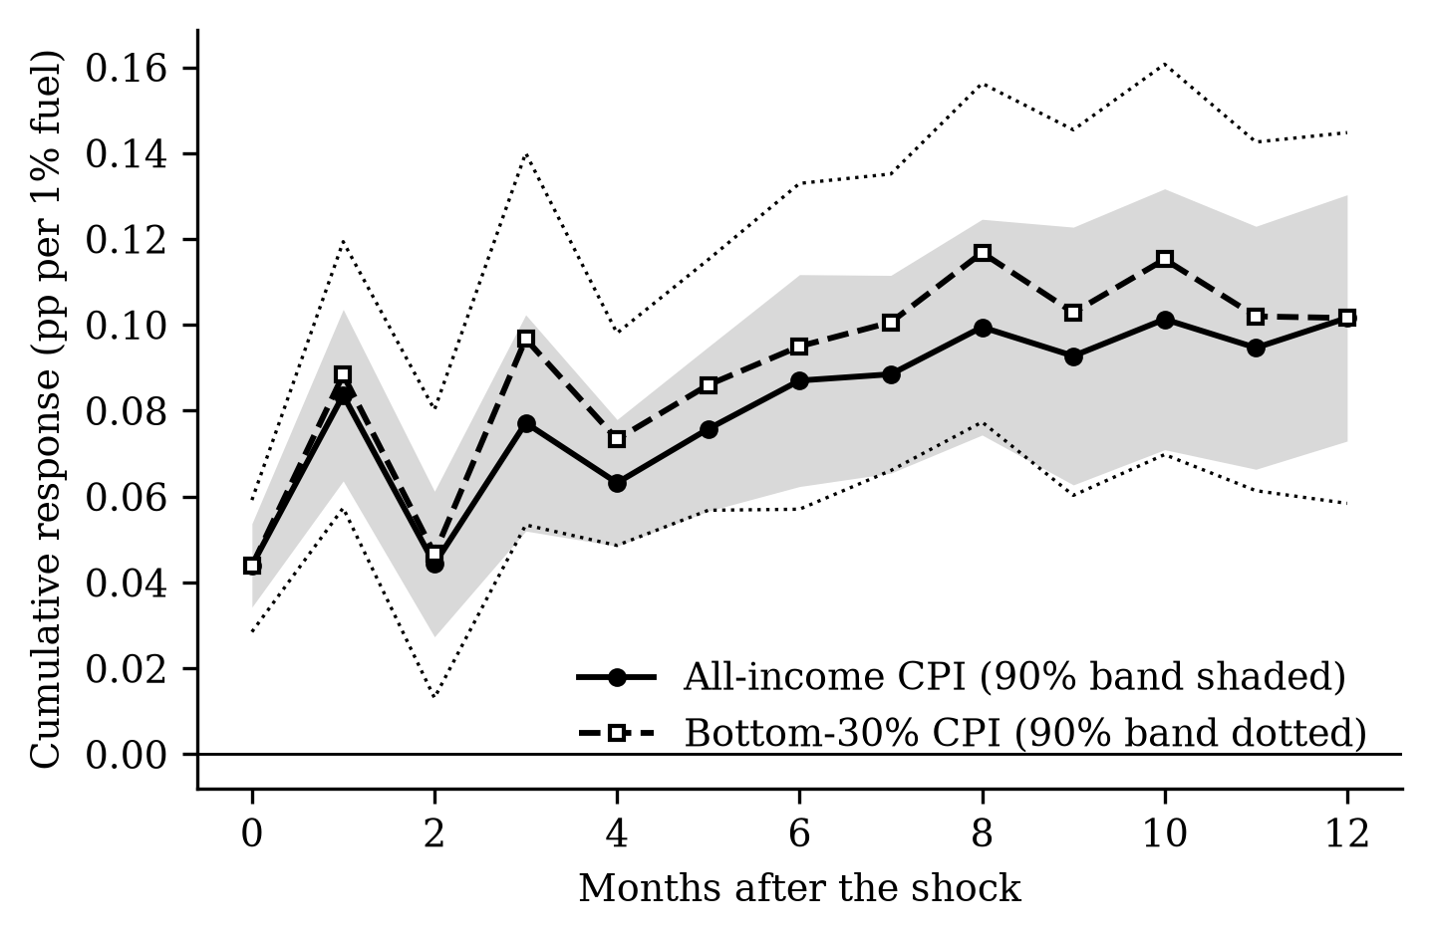
RQ1 cumulative pass-through
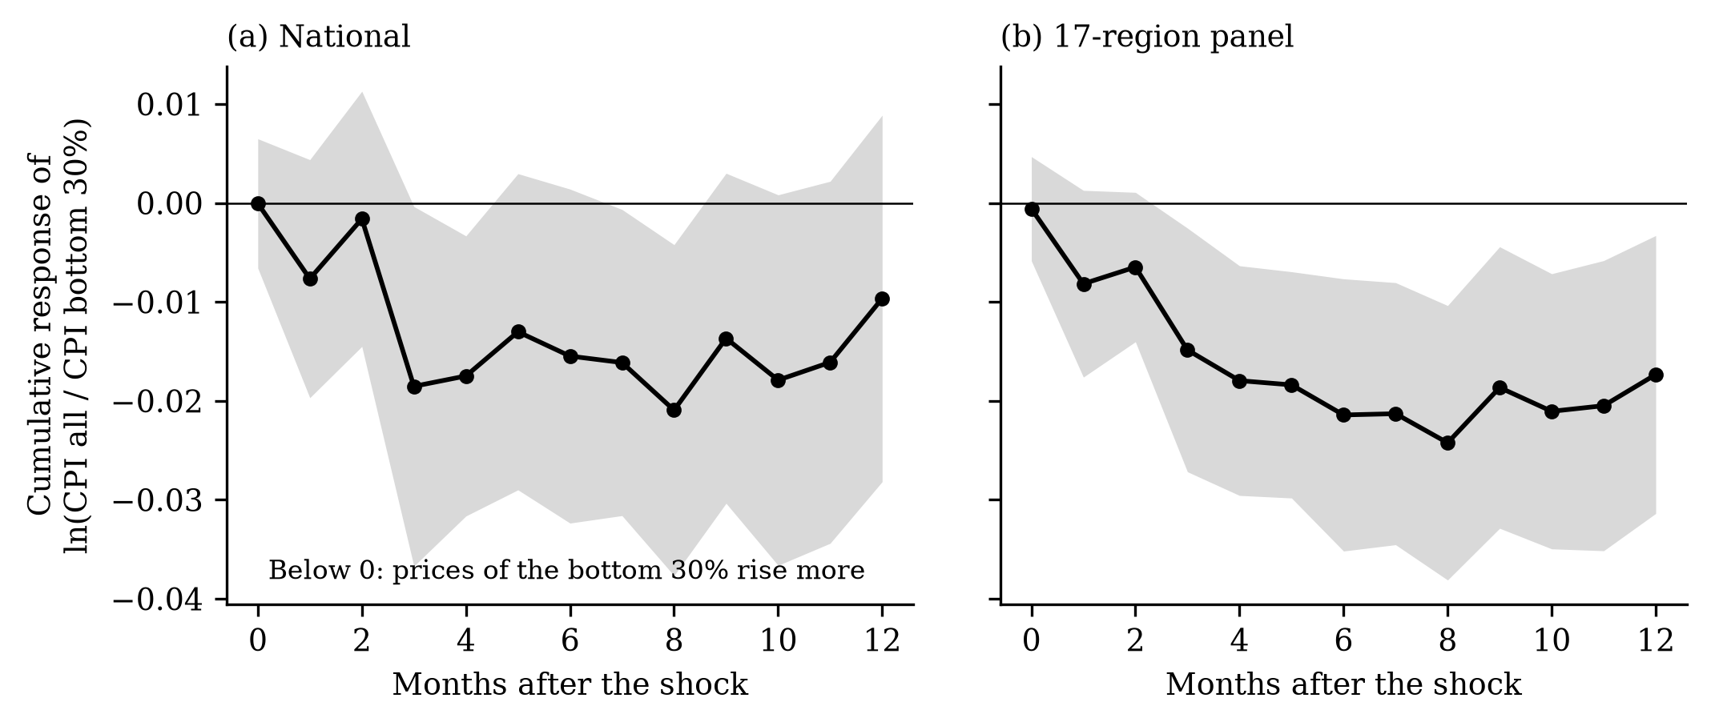
RQ2/RQ4 gap, national and panel
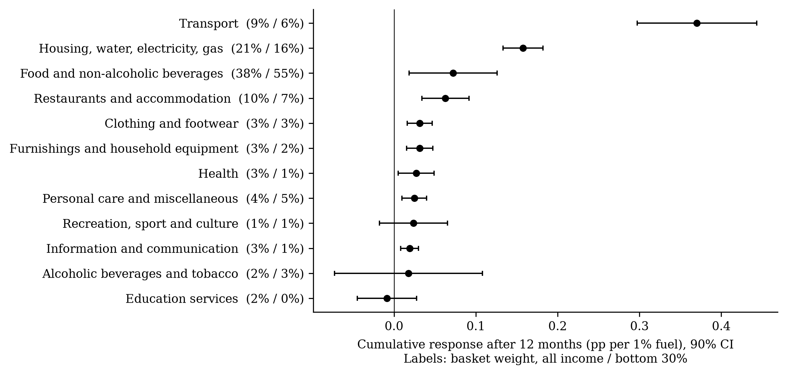
RQ3 divisions
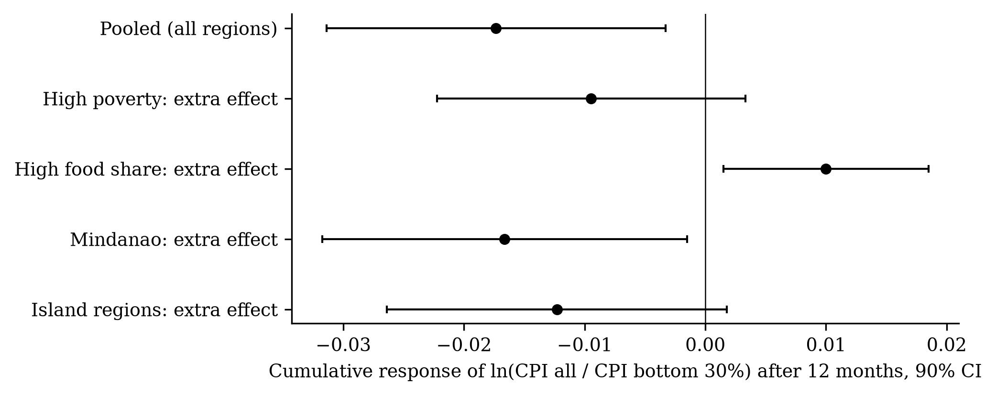
RQ4 group interactions
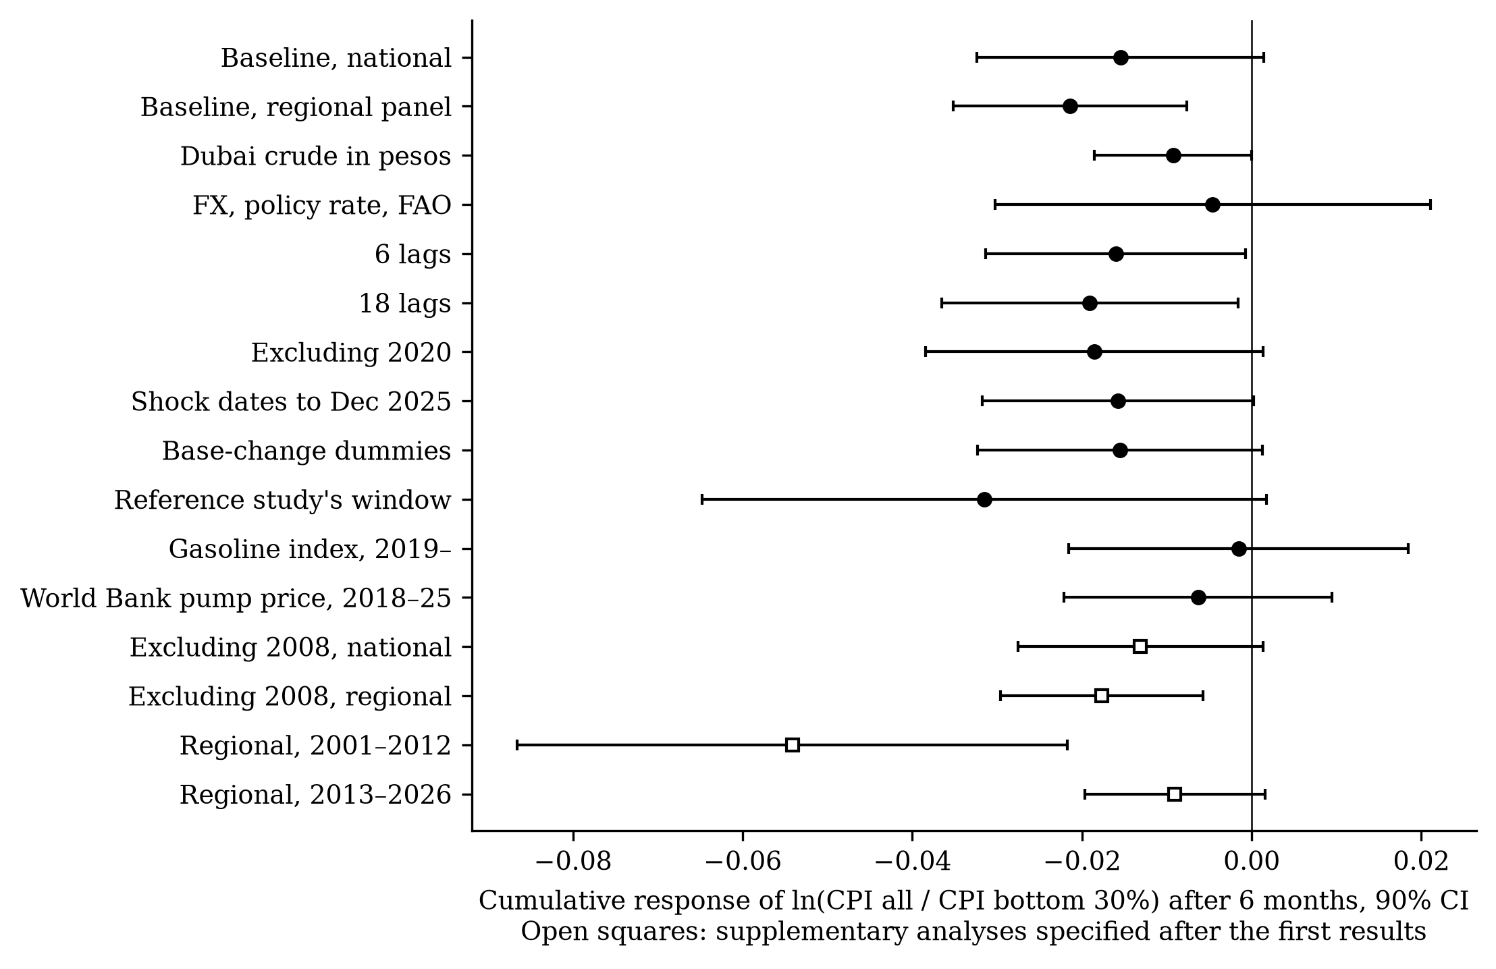
Robustness of the six-month gap

5. The 2026 shock (Objective 3)

5.0 Context: year-on-year inflation, late 2025–2026
date | inflation_all_yoy | inflation_b30_yoy | fuel_yoy
2025-10-01 | 1.66 | −0.39 | 1.09
2025-11-01 | 1.50 | −0.23 | 3.07
2025-12-01 | 1.80 | 1.08 | −0.49
2026-01-01 | 2.02 | 1.61 | −5.40
2026-02-01 | 2.42 | 2.53 | −4.37
2026-03-01 | 4.07 | 4.23 | 35.85
2026-04-01 | 7.23 | 8.46 | 76.35
2026-05-01 | 6.76 | 8.39 | 53.01
2026-06-01 | 6.44 | 8.01 | 38.75
2026-07-01 | 6.19 | 8.17 | 35.09
2026-08-01 | 6.15 | 8.22 | 41.40

5.1 E1 out-of-sample test (model estimated to Dec 2025)
date | beta | lo | hi | actual | series | fuel_cum
2026-01-01 | −0.108 | −0.137 | −0.080 | 0.766 | cpi_all | −2.733
2026-02-01 | −0.141 | −0.184 | −0.099 | 0.919 | cpi_all | −1.564
2026-03-01 | 1.250 | 0.938 | 1.563 | 2.281 | cpi_all | 30.228
2026-04-01 | 3.001 | 2.154 | 3.847 | 4.879 | cpi_all | 53.743
2026-05-01 | 1.821 | 1.062 | 2.579 | 4.365 | cpi_all | 36.034
2026-06-01 | 0.795 | 0.270 | 1.321 | 4.144 | cpi_all | 28.154
2026-07-01 | 1.920 | 1.345 | 2.495 | 4.217 | cpi_all | 27.597
2026-08-01 | 2.553 | 1.941 | 3.165 | 4.806 | cpi_all | 32.497
2026-01-01 | −0.102 | −0.145 | −0.058 | 1.060 | cpi_b30 | −2.733
2026-02-01 | −0.137 | −0.202 | −0.072 | 1.660 | cpi_b30 | −1.564
2026-03-01 | 1.224 | 0.762 | 1.685 | 2.999 | cpi_b30 | 30.228
2026-04-01 | 2.852 | 1.550 | 4.155 | 6.125 | cpi_b30 | 53.743
2026-05-01 | 1.220 | −0.110 | 2.551 | 5.982 | cpi_b30 | 36.034
2026-06-01 | 0.390 | −0.482 | 1.263 | 5.551 | cpi_b30 | 28.154
2026-07-01 | 2.436 | 1.692 | 3.180 | 5.623 | cpi_b30 | 27.597
2026-08-01 | 3.128 | 2.158 | 4.097 | 5.982 | cpi_b30 | 32.497
2026-01-01 | 0.005 | −0.019 | 0.029 | −0.294 | ratio_all_over_b30 | −2.733
2026-02-01 | 0.010 | −0.020 | 0.041 | −0.742 | ratio_all_over_b30 | −1.564
2026-03-01 | −0.084 | −0.339 | 0.172 | −0.717 | ratio_all_over_b30 | 30.228
2026-04-01 | −0.158 | −0.820 | 0.504 | −1.246 | ratio_all_over_b30 | 53.743
2026-05-01 | 0.238 | −0.402 | 0.878 | −1.617 | ratio_all_over_b30 | 36.034
2026-06-01 | 0.134 | −0.300 | 0.568 | −1.407 | ratio_all_over_b30 | 28.154
2026-07-01 | −0.670 | −1.099 | −0.241 | −1.405 | ratio_all_over_b30 | 27.597
2026-08-01 | −0.647 | −1.217 | −0.077 | −1.176 | ratio_all_over_b30 | 32.497

5.2 E2–E3 regional fuel-driven rise and peso cost
region | poverty_2018 | fuel_change_pct | fuel_peak_pct | fuel_driven_all | fuel_driven_b30 | fuel_driven_b30_lo | fuel_driven_b30_hi | actual_all | actual_b30 | poverty_line_family5_monthly_dec2025 | extra_cost_php_month | new_geo_ext
NCR | 2.20 | 34.48 | 57.37 | 2.89 | 3.68 | 2.66 | 4.70 | 3.30 | 3.47 | 16894.55 | 633.48 | False
CAR | 12.00 | 30.69 | 53.53 | 2.57 | 3.30 | 2.41 | 4.18 | 5.44 | 6.36 | 14019.53 | 469.77 | False
R01 | 9.90 | 36.32 | 58.23 | 2.91 | 3.68 | 2.69 | 4.68 | 3.83 | 3.82 | 15228.67 | 571.06 | False
R02 | 16.30 | 34.05 | 55.75 | 2.72 | 3.47 | 2.53 | 4.42 | 4.63 | 4.64 | 14245.06 | 503.43 | False
R03 | 7.00 | 33.87 | 57.16 | 2.74 | 3.50 | 2.56 | 4.45 | 5.19 | 6.00 | 16972.80 | 604.79 | False
R04A | 7.10 | 34.63 | 58.33 | 2.76 | 3.52 | 2.57 | 4.48 | 4.86 | 4.96 | 16615.42 | 596.03 | False
R04B | 15.10 | 30.87 | 47.71 | 2.47 | 3.13 | 2.26 | 4.00 | 4.97 | 6.44 | 13367.69 | 424.56 | False
R05 | 27.00 | 33.90 | 50.91 | 2.61 | 3.30 | 2.37 | 4.22 | 5.52 | 6.21 | 15001.27 | 502.69 | False
R06 | 14.20 | 31.59 | 51.36 | 2.52 | 3.20 | 2.31 | 4.08 | 6.11 | 7.48 | 14705.23 | 477.94 | True
R07 | 16.10 | 25.88 | 46.58 | 2.05 | 2.65 | 1.94 | 3.36 | 5.45 | 5.90 | 15607.76 | 418.92 | True
R08 | 30.70 | 27.39 | 47.66 | 2.22 | 2.85 | 2.07 | 3.62 | 5.88 | 6.80 | 14206.73 | 410.01 | False
R09 | 32.70 | 29.38 | 49.95 | 2.39 | 3.07 | 2.23 | 3.91 | 5.37 | 7.07 | 14678.19 | 456.87 | False
R10 | 23.10 | 31.72 | 48.89 | 2.50 | 3.17 | 2.28 | 4.06 | 4.59 | 5.30 | 14717.48 | 473.94 | False
R11 | 19.10 | 29.33 | 46.93 | 2.33 | 2.97 | 2.14 | 3.79 | 6.27 | 8.52 | 13831.51 | 416.51 | False
R12 | 27.30 | 29.62 | 47.08 | 2.36 | 3.00 | 2.16 | 3.84 | 5.62 | 6.10 | 12816.81 | 390.13 | True
R13 | 30.50 | 31.13 | 49.98 | 2.44 | 3.11 | 2.25 | 3.96 | 6.19 | 7.10 | 12963.62 | 408.87 | False
BARMM | 60.40 | 33.48 | 52.62 | 2.60 | 3.30 | 2.38 | 4.21 | 7.67 | 7.88 | 13242.96 | 444.02 | True
PH | 16.70 | 32.50 | 53.74 | 2.55 | 3.13 | 2.16 | 4.10 | 4.81 | 5.98 | 14714.11 | 467.46 | False

5.3 E4 mechanism: household fuels, fares and cereals (2013–2026)
item | coicop | basket | h | beta | se | weight | contribution
e045 | 04.5 | all | 6 | 0.2492 | 0.0344 | 6.7427 | 0.0168
e045 | 04.5 | all | 12 | 0.4240 | 0.0383 | 6.7427 | 0.0286
e045 | 04.5 | b30 | 6 | 0.1904 | 0.0395 | 10.1108 | 0.0193
e045 | 04.5 | b30 | 12 | 0.2940 | 0.0503 | 10.1108 | 0.0297
e0452 | 04.5.2 | all | 6 | 0.5324 | 0.1707 | 1.2732 | 0.0068
e0452 | 04.5.2 | all | 12 | 0.7297 | 0.1524 | 1.2732 | 0.0093
e0452 | 04.5.2 | b30 | 6 | 0.5147 | 0.1655 | 1.3312 | 0.0069
e0452 | 04.5.2 | b30 | 12 | 0.7217 | 0.1476 | 1.3312 | 0.0096
e0453 | 04.5.3 | all | 6 | 1.0952 | 0.1063 | 0.0432 | 0.0005
e0453 | 04.5.3 | all | 12 | 1.1520 | 0.1140 | 0.0432 | 0.0005
e0453 | 04.5.3 | b30 | 6 | 1.0836 | 0.0941 | 0.2699 | 0.0029
e0453 | 04.5.3 | b30 | 12 | 1.1109 | 0.1072 | 0.2699 | 0.0030
e0454 | 04.5.4 | all | 6 | 0.0289 | 0.0205 | 0.8716 | 0.0003
e0454 | 04.5.4 | all | 12 | 0.0128 | 0.0256 | 0.8716 | 0.0001
e0454 | 04.5.4 | b30 | 6 | 0.0225 | 0.0229 | 4.0231 | 0.0009
e0454 | 04.5.4 | b30 | 12 | 0.0382 | 0.0237 | 4.0231 | 0.0015
t073 | 07.3 | all | 6 | 0.0534 | 0.0815 | 4.5385 | 0.0024
t073 | 07.3 | all | 12 | 0.0715 | 0.0789 | 4.5385 | 0.0032
t073 | 07.3 | b30 | 6 | 0.0129 | 0.0897 | 3.7170 | 0.0005
t073 | 07.3 | b30 | 12 | 0.0096 | 0.1015 | 3.7170 | 0.0004
f0111 | 01.1.1 | all | 6 | 0.0767 | 0.0802 | 12.3226 | 0.0095
f0111 | 01.1.1 | all | 12 | 0.0193 | 0.0844 | 12.3226 | 0.0024
f0111 | 01.1.1 | b30 | 6 | 0.0646 | 0.0956 | 23.6434 | 0.0153
f0111 | 01.1.1 | b30 | 12 | 0.0124 | 0.1012 | 23.6434 | 0.0029

5.4 E5 decomposition of the Dec 2025–Aug 2026 rise
coicop | item | contribution_pp_all | contribution_pp_b30 | pct_change_all | pct_change_b30 | weight_all | weight_b30 | gap_pp
0 | ALL ITEMS | 4.923 | 6.164 | 4.923 | 6.164 | 100.000 | 100.000 | 1.241
01.1 | FOOD | 0.910 | 2.698 | 2.522 | 5.312 | 34.783 | 51.380 | 1.788
01.1.1 | Cereals and cereal products (ND) | 1.261 | 2.933 | 12.047 | 15.121 | 12.323 | 23.643 | 1.672
01.1.1.1 | Cereals (ND) | 1.160 | 2.787 | 15.676 | 18.261 | 9.352 | 19.616 | 1.628
01.1.3 | Fish and other seafood (ND) | 0.148 | 0.284 | 2.302 | 3.062 | 5.657 | 8.496 | 0.137
01.2 | NON-ALCOHOLIC BEVERAGES | 0.073 | 0.092 | 2.520 | 2.609 | 2.962 | 3.550 | 0.019
02.1 | ALCOHOLIC BEVERAGES | 0.037 | 0.035 | 3.654 | 3.651 | 0.881 | 0.810 | −0.002
02.3 | TOBACCO | 0.144 | 0.247 | 6.900 | 8.204 | 1.278 | 1.804 | 0.104
02.4 | OTHER VEGETABLE-BASED TOBACCO PRODUCTS | 0.000 | 0.001 | 4.484 | 6.717 | 0.003 | 0.013 | 0.001
03.1 | CLOTHING | 0.050 | 0.045 | 2.457 | 2.362 | 2.154 | 2.058 | −0.004
03.2 | FOOTWEAR | 0.021 | 0.011 | 2.301 | 2.488 | 0.982 | 0.474 | −0.010
04.1 | ACTUAL RENTALS FOR HOUSING | 0.355 | 0.125 | 2.953 | 3.309 | 12.815 | 4.014 | −0.230
04.3 | MAINTENANCE, REPAIR AND SECURITY OF THE DWELLING | 0.033 | 0.020 | 5.213 | 4.598 | 0.656 | 0.458 | −0.013
04.4 | WATER SUPPLY AND MISCELLANEOUS SERVICES RELATING TO THE DWELLING | 0.073 | 0.038 | 6.067 | 4.334 | 1.165 | 0.933 | −0.035
04.5 | ELECTRICITY, GAS AND OTHER FUELS | 1.027 | 1.154 | 15.591 | 11.619 | 6.743 | 10.111 | 0.127
04.5.2 | Gas (ND) | 0.413 | 0.399 | 29.887 | 28.407 | 1.273 | 1.331 | −0.014
04.5.3 | Liquid fuels (ND) | 0.020 | 0.104 | 38.258 | 32.211 | 0.043 | 0.270 | 0.084
04.5.4 | Solid fuels (ND) | 0.055 | 0.193 | 5.702 | 4.403 | 0.872 | 4.023 | 0.138
05.1 | FURNITURE, FURNISHINGS, AND LOOSE CARPETS | 0.005 | 0.001 | 2.018 | 2.564 | 0.267 | 0.059 | −0.003
05.2 | HOUSEHOLD TEXTILES | 0.002 | 0.001 | 1.753 | 1.593 | 0.098 | 0.104 | −0.000
05.3 | HOUSEHOLD APPLIANCES | 0.009 | 0.005 | 1.659 | 2.207 | 0.598 | 0.247 | −0.004
05.4 | GLASSWARE, TABLEWARE AND HOUSEHOLD UTENSILS | 0.001 | 0.001 | 2.951 | 2.717 | 0.026 | 0.052 | 0.001
05.5 | TOOLS AND EQUIPMENT FOR HOUSE AND GARDEN | 0.000 | 0.001 | 2.371 | 6.146 | 0.022 | 0.009 | 0.000
05.6 | GOODS AND SERVICES FOR ROUTINE HOUSEHOLD MAINTENANCE | 0.097 | 0.044 | 4.378 | 2.470 | 2.208 | 1.879 | −0.052
06.1 | MEDICINES AND HEALTH PRODUCTS | 0.079 | 0.051 | 4.476 | 4.396 | 1.828 | 1.209 | −0.028
06.2 | OUTPATIENT CARE SERVICES | 0.025 | 0.005 | 5.069 | 5.004 | 0.462 | 0.101 | −0.020
06.3 | INPATIENT CARE SERVICES | 0.020 | 0.013 | 3.633 | 12.665 | 0.574 | 0.108 | −0.007
06.4 | OTHER HEALTH SERVICES | 0.001 | 0.000 | 3.553 | 1.074 | 0.022 | 0.019 | −0.001
07.1 | PURCHASE OF VEHICLES | 0.016 | 0.012 | 1.043 | 2.044 | 1.681 | 0.674 | −0.003
07.2 | OPERATION OF PERSONAL TRANSPORT EQUIPMENT | 0.875 | 0.499 | 33.279 | 31.322 | 2.808 | 1.731 | −0.375
07.2.2 | Fuels and lubricants for personal transport equipment (ND) | 0.864 | 0.495 | 38.399 | 33.663 | 2.390 | 1.593 | −0.370
07.3 | PASSENGER TRANSPORT SERVICES | 0.234 | 0.379 | 4.732 | 9.079 | 4.539 | 3.717 | 0.145
07.3.2 | Passenger transport by road (S) | 0.211 | 0.335 | 4.520 | 8.554 | 4.291 | 3.496 | 0.124
07.4 | TRANSPORT SERVICES OF GOODS | 0.000 | 0.000 | 0.189 | 0.096 | 0.004 | 0.001 | −0.000
08.1 | INFORMATION AND COMMUNICATION EQUIPMENT | 0.009 | 0.001 | 0.958 | 1.158 | 1.120 | 0.067 | −0.008
08.3 | INFORMATION AND COMMUNICATION SERVICES | 0.014 | 0.007 | 0.771 | 0.959 | 2.291 | 0.978 | −0.007
09.1 | RECREATIONAL DURABLES | 0.001 |  | 7.890 |  | 0.009
09.2 | OTHER RECREATIONAL GOODS | 0.004 | 0.001 | 2.920 | 2.445 | 0.152 | 0.049 | −0.003
09.3 | GARDEN PRODUCTS AND PETS | 0.004 | 0.001 | 3.569 | 6.255 | 0.124 | 0.024 | −0.003
09.4 | RECREATIONAL SERVICES | 0.020 | 0.015 | 20.000 | 23.693 | 0.139 | 0.088 | −0.006
09.5 | CULTURAL GOODS | 0.000 | 0.000 | 1.007 | 0.864 | 0.006 | 0.000 | −0.000
09.6 | CULTURAL SERVICES | 0.001 | 0.000 | 0.961 | 0.635 | 0.075 | 0.056 | −0.000
09.7 | NEWSPAPERS, BOOKS AND STATIONERY | 0.013 | 0.020 | 3.191 | 3.669 | 0.401 | 0.527 | 0.007
09.8 | PACKAGE HOLIDAYS (S) | −0.001 | 0.000 | −1.650 | 1.891 | 0.055 | 0.000 | 0.001
10.1 | EARLY CHILDHOOD AND PRIMARY EDUCATION | 0.010 | 0.004 | 1.797 | 5.116 | 0.574 | 0.083 | −0.006
10.2 | SECONDARY EDUCATION (S) | 0.006 | 0.003 | 1.135 | 2.752 | 0.578 | 0.130 | −0.003
10.4 | TERTIARY EDUCATION (S) | 0.015 | 0.004 | 1.993 | 2.506 | 0.790 | 0.153 | −0.011
10.5 | EDUCATION NOT DEFINED BY LEVEL (S) | 0.001 |  | 4.236 |  | 0.016
11.1 | FOOD AND BEVERAGE SERVING SERVICES | 0.597 | 0.529 | 6.170 | 6.858 | 9.468 | 7.480 | −0.068
11.2 | ACCOMMODATION SERVICES | 0.004 | 0.000 | 3.423 | 5.839 | 0.150 | 0.004 | −0.004
12.2 | FINANCIAL SERVICES | 0.000 | 0.000 | 0.000 | 0.000 | 0.034 | 0.000 | 0.000
13.1 | PERSONAL CARE | 0.126 | 0.135 | 3.344 | 3.132 | 3.914 | 4.433 | 0.008
13.2 | OTHER PERSONAL EFFECTS | 0.009 | 0.007 | 2.087 | 2.241 | 0.510 | 0.345 | −0.002
13.9 | OTHER SERVICES | 0.000 | 0.000 | 1.540 | 0.859 | 0.035 | 0.066 | −0.000
E1 columns: beta = fuel-driven change (100 × log points since Dec 2025); lo/hi = indicative range combining the per-horizon 90% bounds; actual = observed change. E2 columns: fuel_driven_* = fuel-driven rise by Aug 2026; extra_cost_php_month = fuel-driven cost for a poverty-line family of five. E5: weight and percentage change of each item in each basket and its contribution (pp) to the basket’s rise; gap_pp = bottom 30% minus all income.
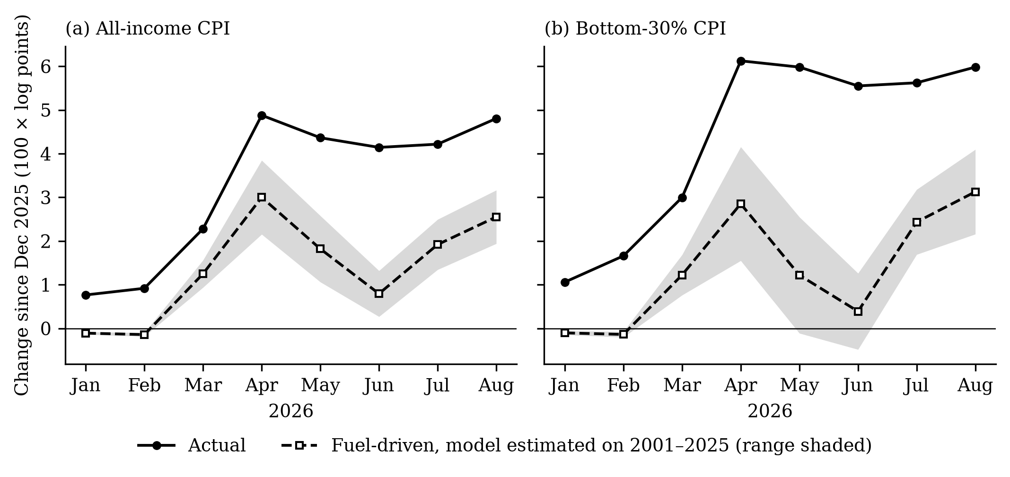
2026 actual vs fuel-driven
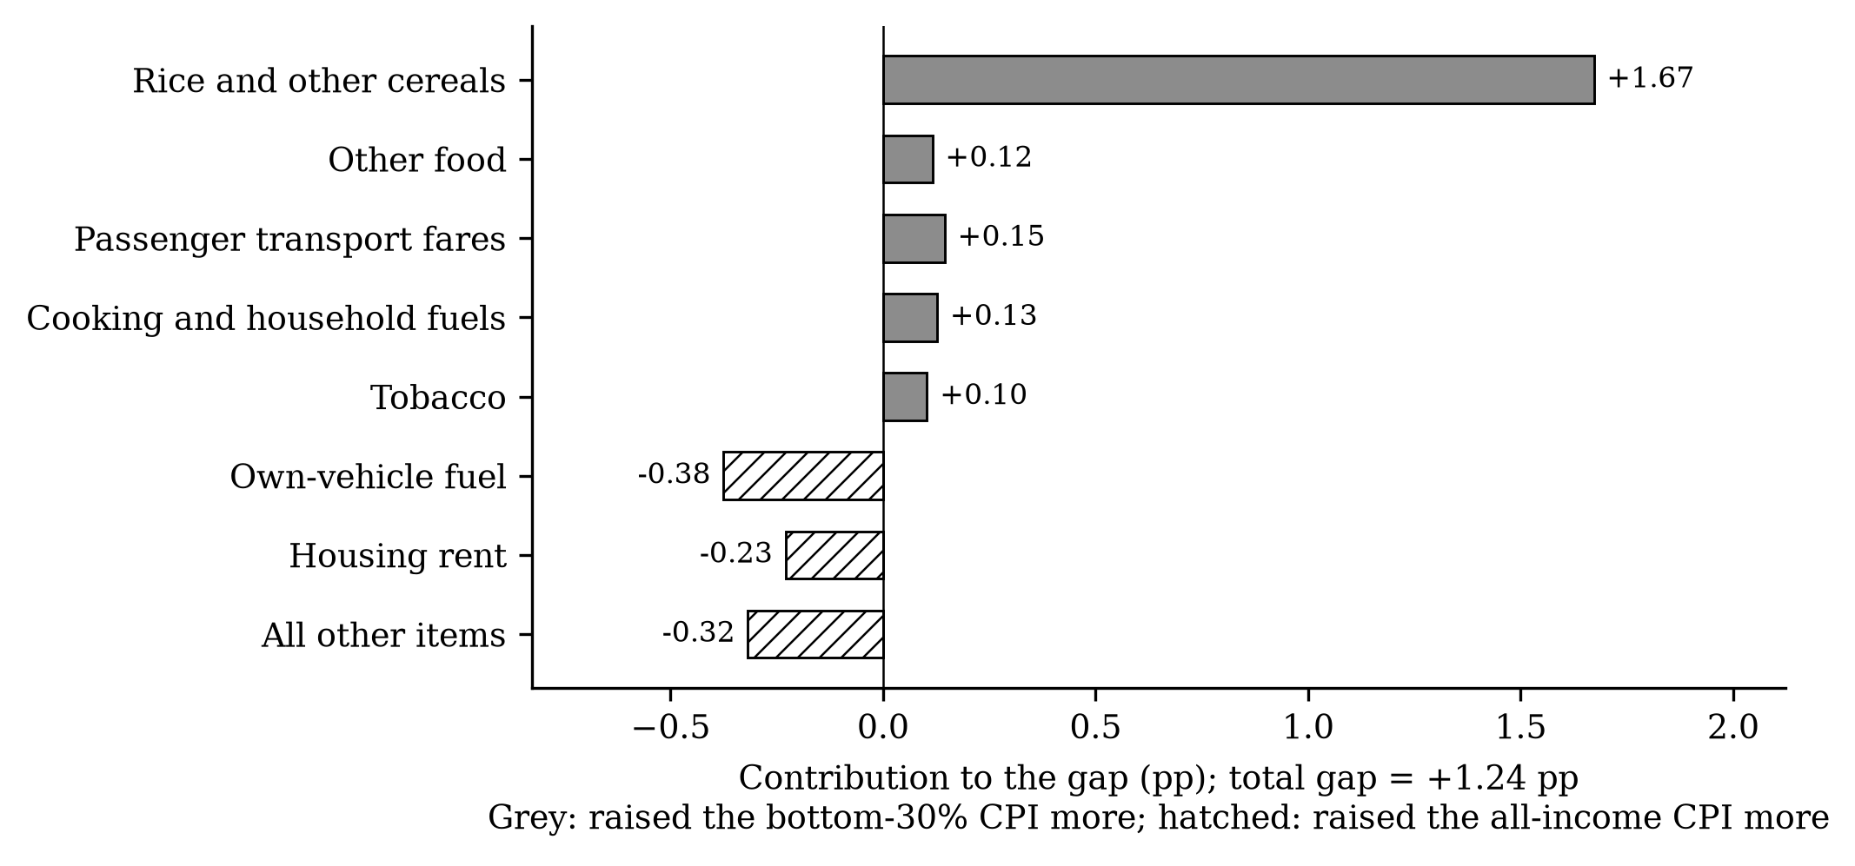
Decomposition of the 2026 gap

6. Output files
File | Contents
output/tables/context_2026.csv | Year-on-year inflation (both groups) and fuel, Oct 2025–Aug 2026
output/tables/desc_adf.csv | Objective 1 unit-root tests
output/tables/desc_annual.csv | Objective 1 annual inflation and fuel change
output/tables/desc_crosscorr.csv | Objective 1 cross-correlations
output/tables/desc_episodes.csv | Objective 1 fuel-shock episodes
output/tables/desc_regional.csv | Objective 1 regional summary
output/tables/desc_summary.csv | Objective 1 summary statistics by period
output/tables/desc_yoy_national.csv | Monthly year-on-year series used in the trend figure
output/tables/e1_national_2026.csv | E1 fuel-driven vs actual change, national, Jan–Aug 2026
output/tables/e2_regional_2026.csv | E2–E3 regional fuel-driven rise, actual rise, poverty line and peso cost
output/tables/e4_mechanism.csv | E4 responses and weights of household fuels, fares and cereals, both baskets
output/tables/e5_decomposition_2026.csv | E5 item contributions to the Dec 2025–Aug 2026 rise, both baskets
output/tables/estimates.csv | All local projection estimates (RQ1–RQ4, RQ3b, robustness): spec, outcome, shock, cumulative flag, h, term, beta, se, 90% bounds, nobs, units, R²
output/tables/region_groups.csv | Poverty, food share and group dummies for the 17 regions
output/tables/replication_eu_ph.csv | Replication gate estimates (EU) and indicative Philippine estimate
output/tables/replication_gate.csv | Pass/fail of the pre-registered gate criteria
output/tables/rq3_gap_decomposition.csv | RQ3 division responses at h = 12 with basket weights and implied gap contributions
output/tables/paper_numbers.json | Every number inserted into the manuscript and working paper

