Who Pays for Oil Shocks? Fuel Price Pass-Through to the Inflation of Poor Households across Philippine Regions, 2001–2026
  - Working Paper
[Author name], Master of Arts in Economics (Applied Economics), Graduate School of Applied Economics, University of Southeastern Philippines, Davao City
October 2026
Abstract
This working paper asks whether poor Filipino households pay more than others when fuel prices rise, and whether the answer depends on where they live. It uses the Philippine Statistics Authority’s monthly consumer price index (CPI) for all income households and for the bottom 30% income households, for the country and 17 regions, from 2001 to August 2026, together with the CPI sub-index for retail motor fuels. The paper pursues three objectives. Objective 1 describes the trends: since 2001, bottom-30% prices have risen 13.3 log points more than all-income prices, the poor’s inflation exceeded the average in 6 of 9 fuel-shock episodes, and in August 2026 it stood at 8.2% against 6.2%. Objective 2 estimates the local projection model of Kpodar and Liu (2022), validated by reproducing their EU benchmark: a 1% rise in fuel prices raises the price level by 0.044 pp within the month and 0.102 pp after a year, and the poor’s prices rise 0.0214 pp more after six months in the regional panel — the opposite of the cross-country finding — with the gap concentrated in 2001–2012. Objective 3 draws policy implications from the 2026 shock: a model estimated on data to 2025 explains about half of the 2026 price surge; the fuel-driven extra cost for a poverty-line family of five is about PHP 467 a month; and rice accounted for most of the poor’s excess inflation. Excise relief on LPG is distribution-neutral, cuts in gasoline and diesel taxes would mainly help the better-off, and transfers sized to the poor’s own price index, together with attention to rice and fares, are the better-targeted response.
Table of Contents

Keywords: oil price shock; inflation inequality; fuel price pass-through; local projections; bottom 30% CPI; regional inflation; Philippines
JEL classification: E31, Q41, I32, D31, R12

Chapter 1. Introduction

1.1 Background of the study
The Philippines imports almost all of the petroleum it consumes, so world oil prices reach Filipino households quickly through the pump price of gasoline and diesel, the price of LPG for cooking, transport fares and the cost of moving food. The country has lived through several oil price surges since 2000: the run-up of 2004–2006, the spike of 2008 that coincided with the global rice price crisis, the post-pandemic surge of 2021–2022, and, in 2026, the oil shock caused by the conflict in the Middle East.
The 2026 shock was among the sharpest. The CPI sub-index for retail motor fuels was 36% higher in March 2026 than a year earlier and 76% higher in April. Headline inflation rose from 2.4% in February to 4.1% in March and 7.2% in April, above the Bangko Sentral ng Pilipinas (BSP) target of 2–4%, and was still 6.2% in August. Inflation measured by PSA’s CPI for the bottom 30% income households was higher: 8.5% in April and 8.2% in August.
The government responded on several fronts. Republic Act 12316, approved on 25 March 2026, allows the President to suspend or reduce excise taxes on petroleum products for up to three months whenever Dubai crude averages USD 80 per barrel or more (Republic of the Philippines 2026). Excise taxes on LPG and kerosene were suspended from April 2026 and again from late September, while those on gasoline and diesel were kept, on the grounds that suspending them would not be progressive. Fuel subsidies were released to public utility vehicle drivers, a one-peso increase in the jeepney minimum fare took effect at the end of September, and the BSP raised its policy rate three times between March and August 2026, from 4.25% to 5.00%.

1.2 Rationale
Each of these responses rests on an assumption about who bears the cost of a fuel price shock. The best cross-country evidence answers that question in a way that would favour broad measures: Kpodar and Liu (2022), using retail fuel prices for 122 countries and quintile-specific price indices reconstructed from household surveys, find that fuel price increases are progressive — the richest households’ prices rise more, because they spend more on transport.
There are three reasons to doubt that this holds in the Philippines. First, poor Filipino households spend more than half of their budget on food and a large share on cooking fuels and public transport, so the indirect effects of fuel on food and fares may outweigh the direct effect on motor fuel. Second, the cross-country method applies the same component prices to all income groups and lets only the weights differ; if the poor buy cheaper varieties whose prices respond differently, that method cannot see it. The Philippines is one of the few countries whose statistical agency publishes an official CPI for poor households, monthly and by region, which makes a direct test possible. Third, the Philippines is an archipelago with large regional differences in poverty, diets and transport costs. A national or cross-country estimate cannot show whether households in Mindanao or the island regions bear more of the shock.
The 2026 shock gives the question practical urgency. Relief was designed in weeks; whether it reached the people who needed it depends on facts this study can establish.

1.3 Objectives of the study
The general objective is to determine how fuel price shocks affect the prices faced by poor households relative to all households in the Philippines, nationally and across regions, from 2001 to 2026, and what this implies for policy.
The specific objectives follow the three-objective structure of descriptive, estimation and policy analysis:
- Objective 1 (descriptive statistics and trend analysis). To describe the levels, trends, volatility and co-movement of retail fuel prices, all-income inflation and bottom-30% inflation in the Philippines and its regions from 2001 to 2026, including the behaviour of the gap between the two groups during fuel-shock episodes.
- Objective 2 (model estimation). To estimate, using the local projection model of Kpodar and Liu (2022), (a) the size and persistence of the pass-through of retail fuel prices to the price level (RQ1); (b) whether the pass-through is larger for the bottom 30% than for all households (RQ2); (c) the CPI components through which it travels (RQ3); and (d) whether the distributional effect differs across regions grouped by poverty, food dependence and location (RQ4).
- Objective 3 (policy implications). To assess, using the estimated model and the 2026 shock, (a) how much of the 2026 price surge the historical relationships explain, nationally and by region; (b) the peso cost of the shock for a poverty-line family; (c) which goods drove the poor’s excess inflation; and (d) how well the policy instruments used in 2026 — excise relief, fuel subsidies, fare regulation, monetary policy and transfers — are targeted to the poor.
Hypotheses. For Objective 2: H1, fuel prices pass through positively and persistently to the price level, peaking within six months (as in developing economies); H2a, the effect is progressive (all-income prices rise more), as in the cross-country literature; H2b, the alternative, the effect is regressive (bottom-30% prices rise more) because of food and fares; H3, transport and food carry most of the pass-through, and food matters more for the poor; H4, the gap is wider in high-poverty, high-food-share, Mindanao and island regions.

1.4 Significance of the study
The study is relevant to several groups.
- Fiscal authorities (Department of Finance, Bureau of Internal Revenue). RA 12316 gives the President a recurring decision on fuel excise relief until 2028. The study shows which fuels’ relief reaches the poor and how much it is worth to them.
- Social protection agencies (Department of Social Welfare and Development). The study translates a fuel shock into a monthly peso amount for a poverty-line family, by region, which can be used to size and time emergency transfers.
- Transport and agriculture agencies (Department of Transportation, LTFRB, Department of Agriculture). The study shows that fares and rice, not motor fuel, are the main channels through which the poor feel oil shocks.
- The BSP. The study measures the size and persistence of second-round effects using retail rather than crude oil prices, and shows how they differ between income groups.
- The Philippine Statistics Authority. The study demonstrates the value of the bottom-30% CPI and its regional detail for policy analysis.
- Researchers. The study provides a within-country test of a cross-country finding, a validated open-source implementation of the local projection model, and a fully reproducible data pipeline.

1.5 Scope and limitations
The study covers the Philippines and its 17 regions under the geographic code used in PSA’s backcasts, monthly, from January 2001 to August 2026 (descriptive statistics) and with shock dates from January 2001 (estimation; the bottom-30% CPI begins in January 2000 and twelve lags are needed). It uses published price indices, not household survey microdata.
The main limitations are the following. (1) The fuel price measure is the CPI sub-index for fuels and lubricants for personal transport, because the retail price database of the reference study is not public; the sub-index tracks pump prices closely but is not a pump price. (2) The comparison is between the bottom 30% and all households, not between the poorest and the richest. (3) Retail fuel prices may respond to domestic conditions; the study uses crude oil prices as a check but not an identified oil supply shock. (4) The bottom-30% series before 2018 are PSA backcasts. (5) The 2026 analysis covers eight months, and the rice-price channel cannot be separated from trade policy. (6) Price indices measure the cost of a fixed basket and ignore substitution and income effects. These are discussed in Chapter 5.

1.6 Definition of terms
- Pass-through. The change in a price index, in percentage points, per 1% change in the fuel price.
- Bottom-30% CPI. PSA’s consumer price index for households in the lowest 30% of the income distribution.
- Gap. D = ln(CPI all income / CPI bottom 30%). A fall in D means the poor’s prices rose more.
- Progressive / regressive. A shock is progressive if it raises prices more for the better-off, regressive if it raises them more for the poor.
- Cumulative response. The effect of a fuel shock on the price level after h months, the sum of the monthly effects.
- Local projection. A method that estimates the effect of a shock at each future horizon with a separate regression (Chapter 3).

Chapter 2. Review of Related Literature

2.1 How oil prices reach consumer prices
An increase in oil prices raises consumer prices through three channels (Blanchard and Galí 2010; Choi et al. 2018; Kpodar and Liu 2022). The direct channel works through the fuels households buy: gasoline and diesel for vehicles, LPG and kerosene for cooking, and electricity where it is generated from oil. The indirect channel works through costs: transport fares, food (through fuel for farm machinery, fertilizer and freight) and other goods whose production uses energy. The second-round channel works through wages and expectations, when higher prices lead workers and firms to raise wages and prices further. The size of each channel depends on the energy intensity of the economy, the share of fuel taxes in pump prices, the regulation of fuel prices and fares, exchange rate movements and the credibility of monetary policy (Gelos and Ustyugova 2017; Kpodar and Imam 2021).

2.2 Empirical evidence on pass-through
The early literature used crude oil prices and found that pass-through to inflation in advanced economies fell sharply after the 1980s (Blanchard and Galí 2010). Cross-country studies find larger and more persistent effects in developing economies (Choi et al. 2018; Gelos and Ustyugova 2017). Crude oil prices, however, are a poor measure of what consumers pay: retail prices include taxes, margins and, in many developing countries, regulated adjustments. Kpodar and Abdallah (2017) built a monthly database of retail fuel prices for 162 countries and showed that pass-through estimated with retail prices is larger and more persistent. Kpodar and Liu (2022) extend it to 190 countries and to CPI components, finding that a 1 pp increase in gasoline prices raises inflation by about 0.04 pp at peak in advanced economies and 0.02 pp in developing economies, with more persistence in the latter, and that using crude oil prices understates pass-through mainly because fuel taxes are ignored.
Methodologically, these studies use local projections (Jordà 2005), which estimate impulse responses horizon by horizon without imposing the dynamic structure of a vector autoregression, often with the correction of Teulings and Zubanov (2014). Local projections and VARs estimate the same population impulse responses (Plagborg-Møller and Wolf 2021), and local projection inference is robust when lags of the variables are included (Montiel Olea and Plagborg-Møller 2021).

2.3 Who bears the cost of fuel price changes
A large literature simulates the distributional effect of fuel price changes and subsidy reforms with input–output or general equilibrium models. It generally finds that fuel subsidies are captured by richer households and that fuel price increases are neutral or progressive, although the absolute burden on the poor can be large (Coady et al. 2015; Siddig et al. 2014; Soile and Mu 2015). Carbon pricing tends to be progressive in poorer countries (Dorband et al. 2019). A related literature documents that inflation differs across households, usually against the poor (Easterly and Fischer 2001; Kaplan and Schulhofer-Wohl 2017; Jaravel 2021). Kpodar and Liu (2022) is the first to estimate the distributional effect of fuel prices econometrically, using quintile CPIs reconstructed from survey expenditure shares; they find the effect progressive, more persistently so in developing economies.

2.4 Philippine studies
Allon-Pineda et al. (2026) estimate the second-round and asymmetric effects of oil and food price shocks on Philippine inflation with local projections. Valera et al. (2025) document the changing effects of energy and rice prices, and of remittances, on overall inflation. Neither distinguishes income groups or regions. In the Asian Economic Journal, Armas (2021) studies the bank lending channel of monetary policy in the Philippines, Kurita and Kurosaki (2011) analyse regional growth, poverty and inequality in Thailand and the Philippines, and Pagaduan (2022) studies subnational output measurement.

2.5 Asian evidence on shocks, poverty and regions
The Asian Economic Journal has a long line of work on who bears the cost of shocks and policies: the targeting of rice subsidies in Indonesia (Satriawan and Shrestha 2018), food price instability in Asia (Timmer and Dawe 2007), and the evolution of poverty and inequality (Warr et al. 2018; Wihardja and Pradana 2024). Subnational studies show that regions differ in their exposure to and recovery from shocks (Kataoka 2022). Work on price transmission in the region has focused on the exchange rate and inflation targeting (Taguchi and Sohn 2014).

2.6 Synthesis and research gap
The literature establishes that fuel prices pass through to inflation, that retail prices capture this better than crude prices, and, from cross-country data, that the effect is progressive. It leaves three gaps that this study addresses: no within-country test using official income-group price indices; no evidence on regional differences in the distributional effect; and no evidence for the 2026 shock.

2.7 Conceptual framework
Figure 1 summarises the framework. A rise in world oil prices, converted at the exchange rate, raises retail fuel prices, whose level also depends on taxes and margins. The shock reaches consumer prices through the direct, indirect and second-round channels. How much it raises the all-income and bottom-30% indices depends on the two groups’ basket weights and on the price changes they face within each category, which in turn may depend on the region. The gap between the two indices is the distributional effect. Policy can intervene at several points: excise relief and subsidies at the retail fuel price, fare regulation in the indirect channel, monetary policy in the second round, and transfers, which offset the burden without changing prices.
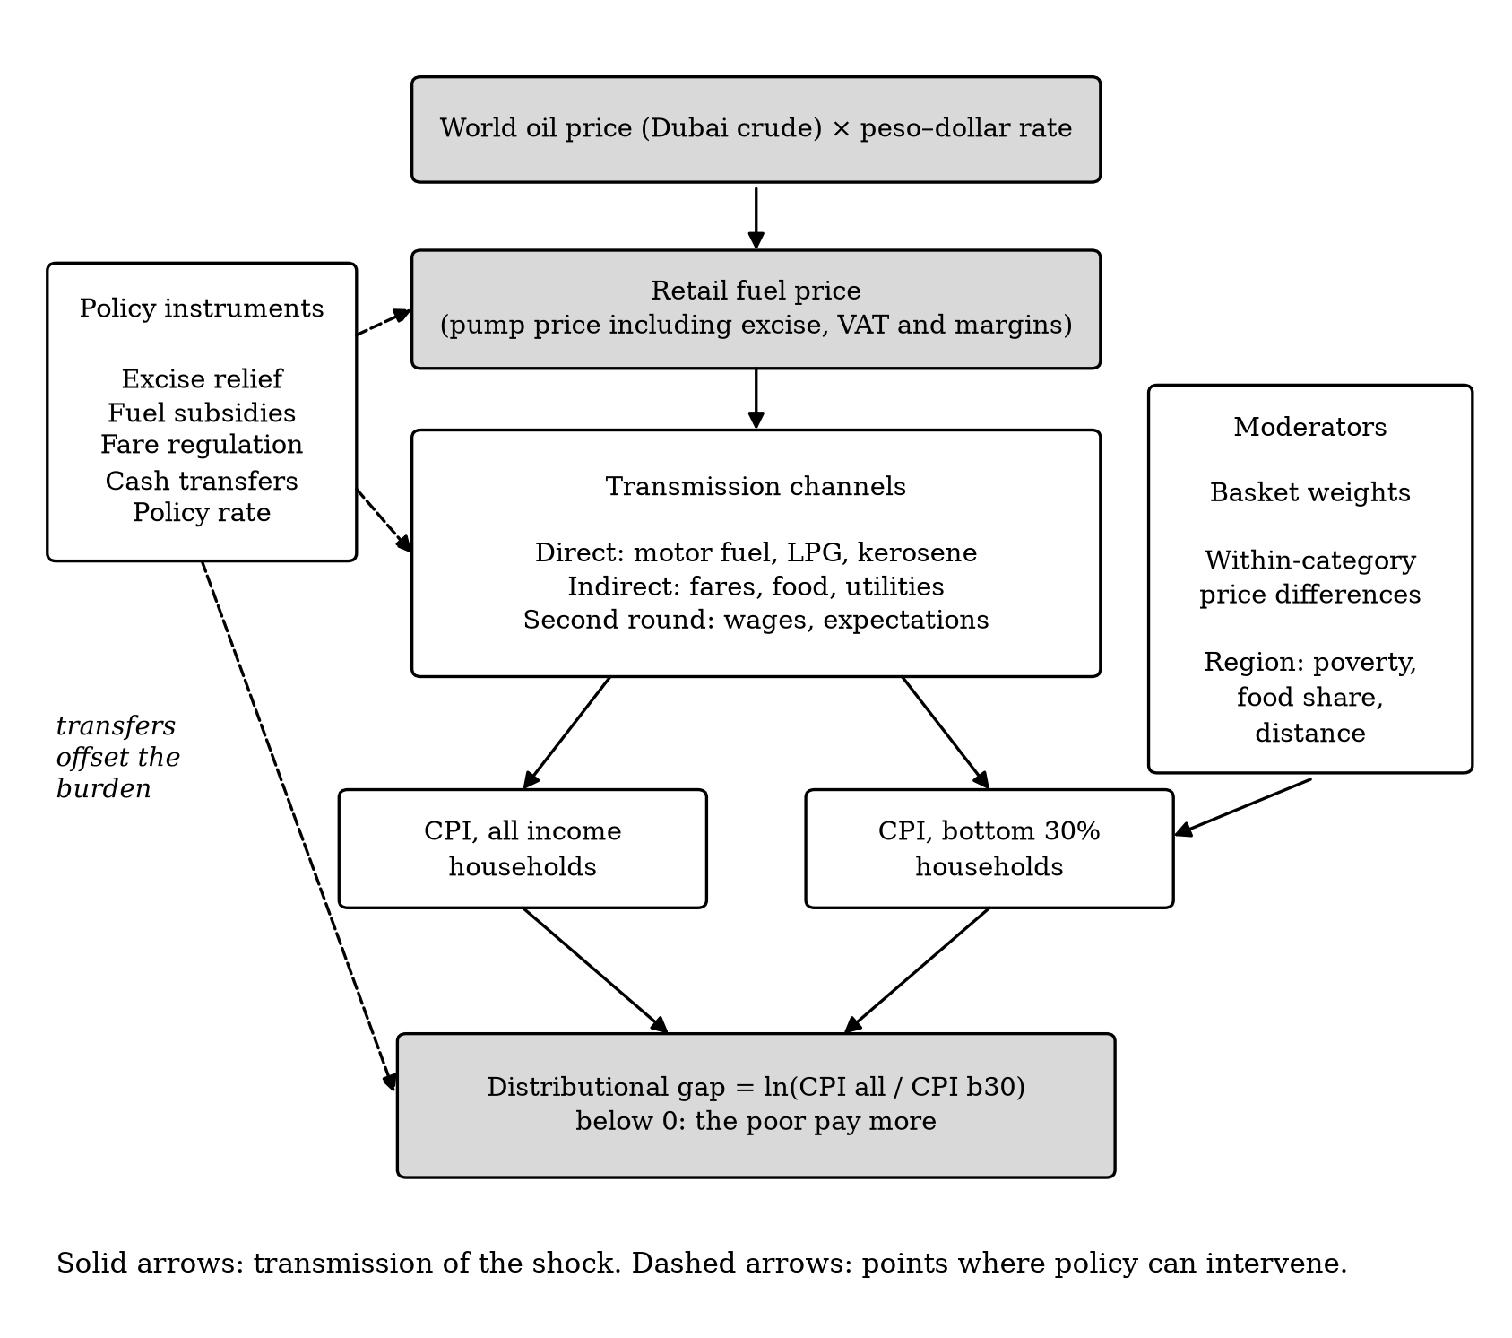
Figure 1. Conceptual framework of the study.

Chapter 3. Digression: The Local Projection Model and How to Implement It
This chapter explains the model used for Objectives 2 and 3 and shows, step by step, how to estimate it. It is written so that a reader with a background in regression can reproduce every estimate in the paper.

3.1 The question an impulse response answers
Suppose the fuel price rises by 1% this month. By how much will the consumer price index be higher next month, in three months, in a year, compared with what would have happened otherwise? The sequence of answers, one per horizon, is the impulse response function. It cannot be read from a single regression of inflation on fuel prices, because the effect unfolds over time and because fuel prices and inflation also respond to their own past.
The traditional tool is the vector autoregression (VAR): estimate a system of equations for fuel prices and inflation with their lags, then simulate the system forward after a shock. The impulse response then depends on the whole dynamic structure being right; a misspecified lag structure distorts every horizon.

3.2 The local projection idea
Jordà (2005) proposed estimating the response at each horizon h directly, with its own regression: regress inflation h months ahead on today’s fuel price change and on enough lags to absorb the predictable dynamics. The coefficient on today’s fuel price change is the response at horizon h. Repeating this for h = 0, 1, …, 12 traces out the impulse response. Each regression is ordinary least squares, the specification is the same at every horizon, and no forward simulation is needed. The cost is some loss of precision at long horizons, and serially correlated errors (because the outcomes of neighbouring months overlap), which the standard errors must allow for.

3.3 The specification term by term
The model of Kpodar and Liu (2022), which we use, is
$$Δlny_{t+h}=α_{h}+\sum_{q=1}^{12}{γ_{1q}} Δlny_{t−q}+\sum_{q=1}^{12}{γ_{2q}} ΔlnF_{t−q}+β_{h} ΔlnF_{t}+\sum_{l=1}^{h−1}{γ_{3l}} ΔlnF_{t+l}+δ_{h} t+ε_{t+h}$$
- Left-hand side. Δln y_{t+h} is the change in the log price index in month t + h, multiplied by 100 (approximately the monthly inflation rate in percent). The model is written in changes because the levels of prices are non-stationary (Section 5.1.6).
- Lags of the outcome, Δln y_{t−1}, …, Δln y_{t−12}, absorb the persistence of inflation and, because the data are not seasonally adjusted, its seasonal pattern: the coefficient on the lag that falls in the same calendar month a year earlier picks up seasonality.
- Lags of the fuel price, Δln F_{t−1}, …, Δln F_{t−12}, remove the part of today’s inflation that is a delayed effect of past fuel shocks.
- The shock, Δln F_t, today’s percentage change in the fuel index. Its coefficient β_h is the quantity of interest: the change in inflation in month t + h per 1% change in fuel prices in month t.
- The Teulings–Zubanov terms, the fuel price changes in months t + 1, …, t + h − 1. Fuel prices are persistent: a shock today is often followed by further increases. Without these terms, β_h would mix the effect of today’s shock with the effect of the later shocks it predicts. Including them isolates the effect of a one-time shock (Teulings and Zubanov 2014). Following the reference study’s tables, there are none at h = 0 and h = 1.
- A linear trend t and a constant α_h. In the regional panel the constant is replaced by region fixed effects.

3.4 From monthly effects to the price level
β_h is an effect on inflation in one month. Policy questions are usually about the price level: how much higher are prices after a year? The answer is the cumulative response, β_0 + β_1 + … + β_h. To obtain it with a correct standard error, we re-estimate the model with the cumulative change Σ_{j=0}^{h} Δln y_{t+j} = ln y_{t+h} − ln y_{t−1} on the left-hand side.
Worked example. With the estimates of Chapter 5, the cumulative response of the all-income CPI after twelve months is 0.102. A 10% increase in fuel prices therefore raises the price level by 10 × 0.102 ≈ 1.0% after a year. For the distributional gap D = ln(CPI all/CPI b30), a cumulative response of −0.0214 after six months means that a 10% fuel increase lowers D by 0.2 log points: the poor’s price level ends up 0.2% higher, relative to the average household’s, than before the shock.

3.5 Standard errors
Because the outcome at horizon h overlaps with the outcomes of nearby months, the regression errors are serially correlated. For the national time series we use Newey–West standard errors with h + 1 lags (Newey and West 1987). In the regional panel, all regions are hit by common national shocks in the same month, so errors are correlated across regions as well as over time; Driscoll–Kraay standard errors allow for both (Driscoll and Kraay 1998). Confidence bands are 90%, as in the reference study.

3.6 The panel version and group differences
For 17 regions r, the model is estimated jointly with region fixed effects u_r, using each region’s own fuel index and outcome. To test whether a group of regions G (for example, Mindanao) responds differently, we add the interaction Δln F_{r,t} × G_r. Its coefficient θ_h is the additional response in group G; the coefficient on Δln F_{r,t} is then the response outside G. Because G_r does not change over time, its own effect is absorbed by the fixed effects.

3.7 Checking the implementation
Two checks were made before any Philippine estimate was produced. First, a simulation test: data are generated from a model whose impulse response is known exactly, and the estimator must recover it. Second, a replication gate: our code must reproduce the reference study’s published results on comparable data, against criteria written down in advance. Both are described in Chapter 4 and their results in Chapter 5.

3.8 Step-by-step implementation
The full code is in the replication package (ospd/lp.py for the estimator, scripts/ for the pipeline). The steps are:
Step 1. Arrange the data. One row per region and month, sorted by region and then date, with a complete monthly calendar (missing months as blank rows, so that “lag 1” is always the previous calendar month). Compute 100 × Δln of each price index and of the fuel index, and an integer month counter t for the trend.
Step 2. Build the regressors for horizon h. Within each region, shift the outcome forward by h months to obtain y_{t+h}; shift the outcome and the fuel change backward by 1 to 12 months to obtain the lags; shift the fuel change forward by 1 to h − 1 months to obtain the Teulings–Zubanov terms.
Step 3. Restrict the sample to shock dates in the estimation window after building the lags, so that earlier data still supply the lags of the first observations, and drop rows with any missing value.
Step 4. Estimate by OLS (with region fixed effects in the panel) and keep the coefficient on Δln F_t and its standard error.
Step 5. Repeat for h = 0, …, 12, and again with the cumulative outcome.
Step 6. Plot β_h against h with the 90% band β_h ± 1.645 × s.e.
A minimal version of steps 2–4 for one horizon of the national model, written in Python with pandas and statsmodels, is:
import statsmodels.api as sm
def one_horizon(df, h, p=12):
X = df[["d_fuel", "t"]].copy()
for q in range(1, p + 1):
X[f"y_l{q}"] = df["d_cpi_all"].shift(q) # lags of the outcome
X[f"f_l{q}"] = df["d_fuel"].shift(q) # lags of the shock
for lead in range(1, h): # Teulings-Zubanov terms
X[f"f_f{lead}"] = df["d_fuel"].shift(-lead)
y = df["d_cpi_all"].shift(-h) # outcome h months ahead
data = X.assign(y=y)[df.date >= "2001-01-01"].dropna()
res = sm.OLS(data["y"], sm.add_constant(data.drop(columns="y"))).fit(
cov_type="HAC", cov_kwds={"maxlags": h + 1}) # Newey-West
return res.params["d_fuel"], res.bse["d_fuel"]
The function local_projection in ospd/lp.py does the same for all horizons, for panels (with linearmodels.PanelOLS and Driscoll–Kraay errors), with interactions, controls and cumulative outcomes. For example, the regional estimate of RQ2 is obtained with
from ospd.lp import local_projection
res = local_projection(regional_panel, y="d_ratio", x="d_fuel", time="t", unit="region",
horizons=12, p=12, se="driscoll_kraay", cumulative=True,
sample=regional_panel.date >= "2001-01-01")
which returns one row per horizon with the coefficient, its standard error, the 90% band, the number of observations and the R². The whole study — downloads, cleaning, validation, estimation, figures, tables and this document — is reproduced with the single command ./run_all.sh.

3.9 Common pitfalls
- Calendar gaps. If a month is missing and rows are simply stacked, “lag 1” silently becomes a two-month lag. Always reindex to a complete monthly calendar.
- Sample restriction before lagging. Restricting the sample first throws away the data needed for the lags of the first observations.
- Splices and base changes. Joining series with different bases can create artificial jumps; check the months where series are joined (Section 4.2.3).
- Seasonality. With non-seasonally-adjusted data, twelve lags are needed; fewer lags leave seasonality in the errors.
- Reading per-horizon coefficients as level effects. β_h is an effect on monthly inflation, not on the price level; report cumulative responses for level questions.
- Multiple testing. Testing many groups or horizons makes some “significant” results likely by chance; report how many tests were run and correct for them.

Chapter 4. Methodology

4.1 Research design
The study is quantitative and uses secondary, publicly available monthly data. It combines descriptive time-series analysis (Objective 1), econometric estimation with local projections on national time series and a regional panel (Objective 2), and counterfactual and accounting analysis of the 2026 episode (Objective 3). All specifications for Objective 2 were written in a decision log before any Philippine estimate was produced; analyses added afterwards are labelled as supplementary.

4.2 Data

4.2.1 Sources and variables
Table 1 lists the data. All price data come from PSA OpenSTAT (Philippine Statistics Authority 2026) and were downloaded through its public application programming interface on 4 October 2026.
Table 1. Data sources and variables
Variable | Definition and source | Coverage | Use
CPI, all income households | All items and 13 COICOP divisions, 2018 = 100; PSA | Jan 1994–Aug 2026; national and 17 regions | Objectives 1–3
CPI, bottom 30% income households | All items (from 2000) and commodity groups (from 2012), 2018 = 100; PSA | Jan 2000–Aug 2026; national and 17 regions | Objectives 1–3
Fuel price index (shock) | CPI sub-index 07.2.2, fuels and lubricants for personal transport equipment; PSA | Jan 1994–Aug 2026; national and 17 regions | Objectives 1–3
Gasoline index | CPI sub-index 07.2.2.2; PSA | Jan 2018–Aug 2026 | Robustness
Pump price, Manila RON 91 | World Bank Global Fuel Prices Database (World Bank 2025) | Jan 2017–Mar 2025 | Validation, robustness
Dubai and Brent crude prices | World Bank Pink Sheet (World Bank 2026) | Monthly, to Sep 2026 | Robustness
Peso–dollar rate; policy rate | BSP; BIS policy rate database | Monthly | Controls
FAO Food Price Index | FAO | Monthly | Control
CPI weights, both baskets | PSA, 2018 basket | National and regional | Decompositions, region groups
Poverty incidence and thresholds | PSA official poverty statistics | 2018, 2021, 2023 | Region groups, peso costs
EU harmonised CPI; EU pump prices with and without taxes | Eurostat; European Commission Weekly Oil Bulletin (European Commission 2026) | 2000–2019 | Validation

4.2.2 Data collection procedure
Data were collected by scripts rather than by hand, so that every file can be downloaded again and every step repeated. PSA tables were downloaded through the OpenSTAT API, one geography at a time, for the national and regional rows of 19 tables covering both baskets and all base years; files were saved unchanged and compressed. World Bank, BSP, BIS, FAO, Eurostat and European Commission files were downloaded from their official URLs. Each raw file is recorded in a source log with its URL, download date, base year and coverage. Facts about the 2026 policy response were collected from the text of RA 12316 and from official and news sources, each marked as verified or secondary.

4.2.3 Data processing
The raw tables were reshaped into one long table (series × region × commodity × month), with region names harmonised to standard codes. Three processing decisions matter for the results.
Base years. All series are on PSA’s 2018 = 100 base. The bottom-30% all-items index is built by joining PSA’s own backcasts for 2000–2011 and 2012–2017 to the current series from 2018. The joins were checked: month-on-month changes in the 2018-base backcast correlate perfectly with those of the 2012-base series over 2012–2017, and the changes at the joins are consistent with the older series (the January 2018 jump reflects the TRAIN law excise increase). Dummies for the two join months are used as a robustness check.
Geography. The bottom-30% backcasts exist only under the old geographic code (17 regions, with Negros in Regions VI and VII). The panel therefore uses the old code. For January–August 2026, published only under the new code that separates the Negros Island Region, each region’s new-code monthly changes are chained onto its old-code level; the four regions whose boundaries changed are flagged and dropped in a robustness check.
The fuel price shock. The reference study’s retail price database is not public. The CPI sub-index 07.2.2 measures the retail prices of motor fuels; its monthly changes correlate at 0.87 with the World Bank’s Manila pump price over 2016–2025 and at 0.99 with PSA’s gasoline-only index.

4.3 Methods by objective

4.3.1 Objective 1: descriptive statistics and trend analysis
Monthly changes (100 × Δln) of the fuel index, both CPIs and the gap are summarised by mean, annualised mean, standard deviation, minimum and maximum, for the full period and for 2001–2012, 2013–2019, 2020–2025 and January–August 2026. Annual inflation is the average of the twelve monthly year-on-year rates. Fuel-shock episodes are runs of at least three consecutive months in which the fuel index was 15% or more above its level a year earlier; for each, we report the peak fuel increase and average inflation for both groups. Cross-correlations between the fuel change in month t and the price changes in month t + k, k = 0, …, 12, describe the timing of co-movement. For each region we report average inflation for both groups over 2001–2025, the cumulative change in the gap, fuel price volatility, poverty and food share. Augmented Dickey–Fuller tests (constant and trend in levels, constant in differences; lag length by AIC) establish the order of integration of the series.

4.3.2 Objective 2: estimation of pass-through and distributional effects
The local projection model of Chapter 3 is estimated with p = 12 lags, horizons h = 0, …, 12 and shock dates from January 2001 to August 2026:
- RQ1: national, outcome Δln CPI all income and Δln CPI bottom 30%; Newey–West errors.
- RQ2: national, outcome ΔD = Δln(CPI all/CPI b30). A positive cumulative response supports H2a (progressive), a negative one H2b (regressive). The pre-specified judgement is based on the cumulative response at six and twelve months.
- RQ3: national, outcome each of the 13 COICOP divisions of the all-income CPI; and, from 2013, the matching bottom-30% divisions. A decomposition multiplies each division’s cumulative response by the difference in its weight between the two baskets, which shows what the gap would be if both groups faced the same price change within each division.
- RQ4: regional panel of ΔD on each region’s own fuel index, with region fixed effects and Driscoll–Kraay errors; then, one at a time, the interaction with dummies for high poverty (2018 poverty incidence above the median of the 17 regions), high food share (food share of the regional basket above the median), Mindanao (IX, X, XI, XII, XIII and BARMM) and island regions (MIMAROPA, VI, VII and VIII).
- Robustness: crude oil (Dubai, in pesos) as the shock; controls for the exchange rate, policy rate and world food prices; 6 and 18 lags; excluding 2020; shock dates only to December 2025; dummies for the base-change months; asymmetry between increases and decreases; the reference study’s window (to June 2019); the gasoline index and the World Bank pump price as shocks; and, in the panel, leaving out one region at a time, dropping the re-mapped 2026 observations and using the national instead of the regional fuel index. Supplementary analyses split the sample at 2012/2013 and exclude 2008.

4.3.3 Objective 3: policy implications
- Out-of-sample test of the 2026 shock. The cumulative responses are re-estimated on data ending in December 2025 and applied to the observed 2026 fuel path: the fuel-driven change in the price level between December 2025 and month m is Σ_s β^{cum}_{m−s} Δln F_s, summed over the 2026 months up to m. This is compared with the actual change.
- Regional burden and peso cost. The pooled regional responses are applied to each region’s fuel path. The fuel-driven rise in the bottom-30% CPI is converted to pesos for a family of five living at the official poverty line (the 2023 regional per-capita poverty threshold × 5 / 12, carried to December 2025 with the regional bottom-30% CPI).
- Mechanism. National responses (2013–2026) of the bottom-30% and all-income sub-indices for electricity, gas and other fuels, LPG, kerosene, solid fuels, passenger transport services and cereals, with their weights in each basket.
- Decomposition of the 2026 gap. The actual December 2025–August 2026 change in each index is split into item contributions using the fixed 2018 weights (descriptive, no model).
- Assessment of instruments. The results are used to assess the targeting of the 2026 policy instruments.

4.4 Validation
Simulation. Panels and time series are generated from y_t = 0.4 y_{t−1} + 0.04 x_t + 0.02 x_{t−1} + 0.01 x_{t−2} + e_t, whose impulse response is known. The estimator recovers it within 0.006 at every horizon with Newey–West, clustered and Driscoll–Kraay errors, recovers the cumulative response, and detects a known group difference.
Replication gate. Before any Philippine estimate, the estimator had to reproduce three results of Kpodar and Liu (2022) on EU data (harmonised CPIs and Weekly Oil Bulletin pump prices, 2005–June 2019), under criteria written in advance: an impact response to after-tax gasoline prices between 0.035 and 0.075 (reference 0.055), near zero from the second month; a larger response to after-tax than to before-tax prices and to crude oil; and the advanced-economy shape with the EU fuels index.

4.5 Software and reproducibility
The analysis is written in Python 3.11 with pandas, statsmodels, linearmodels, matplotlib and pandoc. Every number in this paper is inserted by script from the output tables, and the command ./run_all.sh regenerates the data, estimates, figures and this document from the raw files.

4.6 Ethical considerations
The study uses published aggregate statistics; no individual or household data were collected. AI tools were used in data processing, coding and drafting; [the author to complete a disclosure statement and confirm review of and responsibility for all content].

Chapter 5. Results and Discussion

5.1 Objective 1: descriptive statistics and trend analysis

5.1.1 Summary statistics
Table 2 summarises the monthly changes. Over January 2001–August 2026, all-income prices rose at an annualised average of 3.77% and bottom-30% prices at 4.33%; the gap therefore fell by 0.56 log points a year on average. Bottom-30% inflation is also more volatile (standard deviation 0.565 against 0.386 pp a month). The fuel index is far more volatile still (standard deviation 4.367 pp, with monthly changes between −18.10% and +31.79%).
The difference between the groups was largest in 2001–2012 (annualised 4.22% against 5.07%), narrowed in 2013–2019 (2.68% against 2.86%) and 2020–2025 (3.75% against 4.06%), and widened again in 2026 (7.21% against 8.97% annualised over January–August).
Table 2. Summary statistics of monthly changes (100 × Δln), national
Period | Variable | N | Mean (monthly, pp) | Annualised mean | SD | Min | Max
2001–2026 (full) | Fuel index (07.2.2) | 308 | 0.449 | 5.39 | 4.367 | −18.10 | 31.79
2001–2026 (full) | CPI, all income | 308 | 0.314 | 3.77 | 0.386 | −0.59 | 2.60
2001–2026 (full) | CPI, bottom 30% | 308 | 0.361 | 4.33 | 0.565 | −0.88 | 3.89
2001–2026 (full) | Gap: ln(CPI all/CPI b30) | 308 | −0.047 | −0.56 | 0.303 | −2.27 | 0.71
2001–2012 | Fuel index (07.2.2) | 144 | 0.604 | 7.25 | 2.862 | −12.49 | 8.66
2001–2012 | CPI, all income | 144 | 0.352 | 4.22 | 0.350 | −0.44 | 1.61
2001–2012 | CPI, bottom 30% | 144 | 0.422 | 5.07 | 0.617 | −0.88 | 3.89
2001–2012 | Gap: ln(CPI all/CPI b30) | 144 | −0.071 | −0.85 | 0.379 | −2.27 | 0.71
2013–2019 | Fuel index (07.2.2) | 84 | −0.028 | −0.34 | 3.716 | −12.59 | 6.48
2013–2019 | CPI, all income | 84 | 0.224 | 2.68 | 0.279 | −0.59 | 0.98
2013–2019 | CPI, bottom 30% | 84 | 0.238 | 2.86 | 0.354 | −0.78 | 1.57
2013–2019 | Gap: ln(CPI all/CPI b30) | 84 | −0.015 | −0.18 | 0.171 | −0.58 | 0.30
2020–2025 | Fuel index (07.2.2) | 72 | 0.293 | 3.52 | 4.699 | −18.10 | 12.00
2020–2025 | CPI, all income | 72 | 0.313 | 3.75 | 0.432 | −0.39 | 1.66
2020–2025 | CPI, bottom 30% | 72 | 0.338 | 4.06 | 0.546 | −0.85 | 1.97
2020–2025 | Gap: ln(CPI all/CPI b30) | 72 | −0.026 | −0.31 | 0.245 | −0.76 | 0.55
2026 (Jan–Aug) | Fuel index (07.2.2) | 8 | 4.062 | 48.75 | 16.215 | −17.71 | 31.79
2026 (Jan–Aug) | CPI, all income | 8 | 0.601 | 7.21 | 0.999 | −0.51 | 2.60
2026 (Jan–Aug) | CPI, bottom 30% | 8 | 0.748 | 8.97 | 1.129 | −0.43 | 3.13
2026 (Jan–Aug) | Gap: ln(CPI all/CPI b30) | 8 | −0.147 | −1.76 | 0.300 | −0.53 | 0.23

5.1.2 Trends in inflation and fuel prices
Figure 2 and Table 3 show the annual pattern. Bottom-30% inflation exceeded all-income inflation in 18 of the 25 years from 2001 to 2025. The largest gap was in 2008, when the oil price spike coincided with the global rice crisis: bottom-30% inflation averaged 13.9% against 8.2% (5.7 pp). The gap was reversed in some years with falling food prices, most recently 2025 (−1.4 pp), when cereal prices fell by 10–15% year on year in both baskets (PSA CPI 01.1.1).
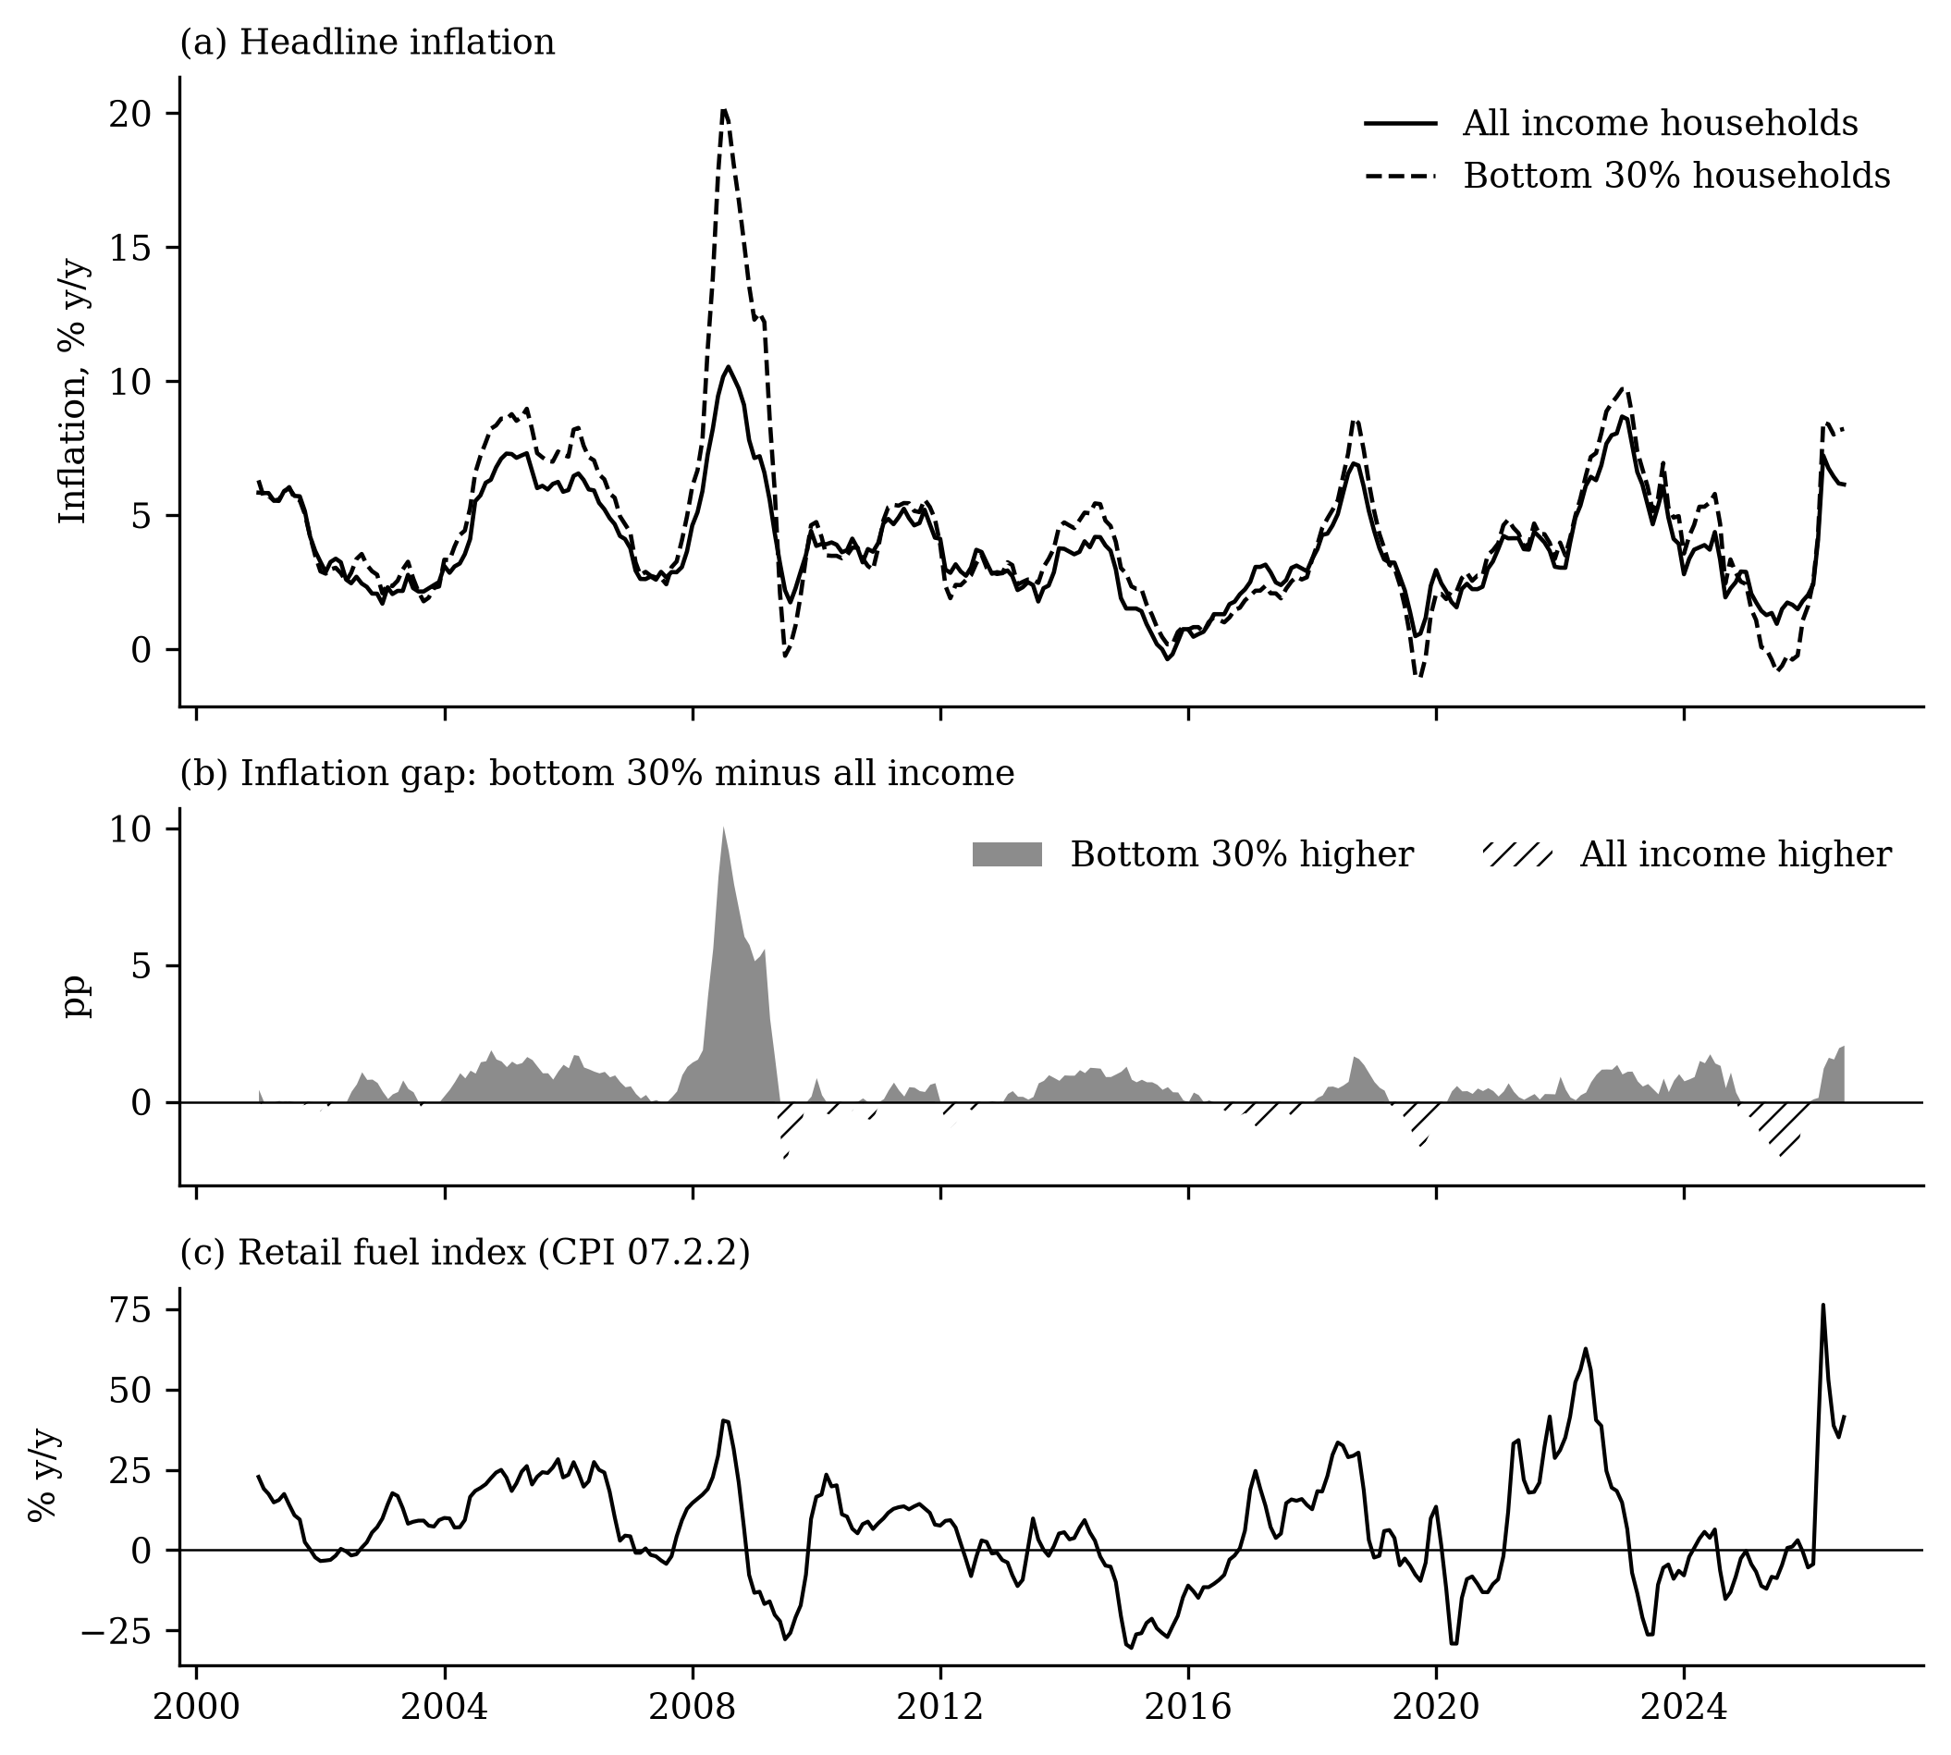
Figure 2. Inflation of all income and bottom-30% households, the gap between them, and the retail fuel index, January 2001–August 2026 (year-on-year).
Table 3. Annual inflation by group and fuel price change, 2001–2026
Year | Inflation, all income (%) | Inflation, bottom 30% (%) | Gap, b30 − all (pp) | Fuel index (% y/y)
2001 | 5.41 | 5.39 | −0.02 | 11.8
2002 | 2.73 | 2.98 | +0.25 | 0.1
2003 | 2.25 | 2.40 | +0.15 | 10.9
2004 | 4.80 | 5.93 | +1.13 | 15.8
2005 | 6.61 | 7.91 | +1.30 | 23.4
2006 | 5.48 | 6.62 | +1.14 | 19.0
2007 | 2.94 | 3.26 | +0.32 | 1.4
2008 | 8.17 | 13.91 | +5.74 | 20.9
2009 | 4.26 | 5.38 | +1.12 | −15.9
2010 | 3.79 | 3.61 | −0.17 | 12.9
2011 | 4.72 | 5.13 | +0.41 | 11.9
2012 | 3.17 | 2.82 | −0.36 | 2.1
2013 | 2.58 | 3.05 | +0.46 | −1.4
2014 | 3.60 | 4.68 | +1.08 | −0.4
2015 | 0.68 | 1.32 | +0.64 | −24.3
2016 | 1.25 | 1.11 | −0.14 | −7.3
2017 | 2.85 | 2.30 | −0.55 | 14.0
2018 | 5.23 | 5.99 | +0.76 | 23.2
2019 | 2.41 | 1.91 | −0.50 | −1.0
2020 | 2.39 | 2.59 | +0.20 | −11.2
2021 | 3.93 | 4.22 | +0.29 | 20.8
2022 | 5.81 | 6.56 | +0.75 | 39.7
2023 | 6.01 | 6.77 | +0.76 | −9.1
2024 | 3.22 | 4.18 | +0.97 | −3.0
2025 | 1.66 | 0.29 | −1.37 | −4.3
2026* | 5.16 | 6.20 | +1.04 | 33.8
Notes: Average of monthly year-on-year rates. *2026: January–August.

5.1.3 Fuel-shock episodes
Table 4 lists the 9 episodes in which the fuel index stayed at least 15% above its level a year earlier for three months or more. In 6 of them the poor’s inflation exceeded the average. The gap was largest in 2008 and second largest in 2026; the long 2021–2022 episode, with the largest fuel increase before 2026, produced a modest gap.
Table 4. Fuel-shock episodes
Episode | Months | Peak fuel rise (% y/y) | Inflation, all (%) | Inflation, b30 (%) | Gap, b30 − all (pp)
2001-01 to 2001-03 | 3 | 22.8 | 5.83 | 5.90 | +0.07
2004-06 to 2006-09 | 28 | 28.3 | 6.21 | 7.53 | +1.32
2008-02 to 2008-10 | 9 | 40.3 | 8.50 | 14.68 | +6.17
2010-01 to 2010-05 | 5 | 23.5 | 3.92 | 3.88 | −0.04
2017-01 to 2017-03 | 3 | 24.6 | 2.88 | 2.12 | −0.76
2017-09 to 2017-11 | 3 | 15.9 | 3.06 | 2.61 | −0.44
2018-02 to 2018-11 | 10 | 33.5 | 5.42 | 6.22 | +0.81
2021-04 to 2022-12 | 21 | 62.7 | 4.99 | 5.52 | +0.53
2026-03 to 2026-08 | 6 | 76.3 | 6.14 | 7.58 | +1.44

5.1.4 Timing of co-movement
Table 5 shows the correlations between this month’s fuel price change and price changes in the same and following months. The correlation with all-income inflation is 0.54 in the same month and 0.30 a month later, then falls to around zero before rising again to 0.17 after six months — a first sign of fast direct effects and slower indirect effects. The correlation with the gap is negative in the same month (−0.11) and at most lags in the first year: fuel price increases tend to be followed by faster price increases for the poor. These correlations do not control for other influences; Objective 2 does.
Table 5. Cross-correlations of the fuel price change with later price changes
Lag k (months) | Corr(Δfuel_t, Δln CPI all_t+k) | Corr(Δfuel_t, Δln CPI b30_t+k) | Corr(Δfuel_t, ΔGap_t+k)
0 | 0.536 | 0.428 | −0.114
1 | 0.295 | 0.271 | −0.129
2 | −0.028 | 0.012 | −0.057
3 | −0.058 | −0.023 | −0.030
4 | 0.060 | 0.036 | 0.010
5 | 0.168 | 0.092 | 0.042
6 | 0.166 | 0.139 | −0.048
7 | 0.128 | 0.127 | −0.075
8 | 0.069 | 0.093 | −0.085
9 | 0.024 | 0.026 | −0.019
10 | 0.061 | 0.066 | −0.046
11 | 0.015 | 0.009 | 0.002
12 | −0.016 | −0.025 | 0.026

5.1.5 Regional patterns
Table 6 and Figure 3 compare the regions. In every region, bottom-30% prices rose more than all-income prices over 2001–2025; the cumulative gap ranges from −4.2 log points in MIMAROPA to −16.0 in VII Central Visayas (−13.3 nationally). The gap is, perhaps surprisingly, smaller in poorer and more food-dependent regions (the correlation of the cumulative gap with poverty incidence is 0.20, and with the food share 0.31). The likely reason is composition: where most households are poor, the all-income basket is itself close to the poor’s basket, so the two indices move together. This pattern is important for interpreting the regional estimates in Section 5.2.4. In August 2026, bottom-30% inflation ranged widely across regions, and was highest in Mindanao and the Visayas.
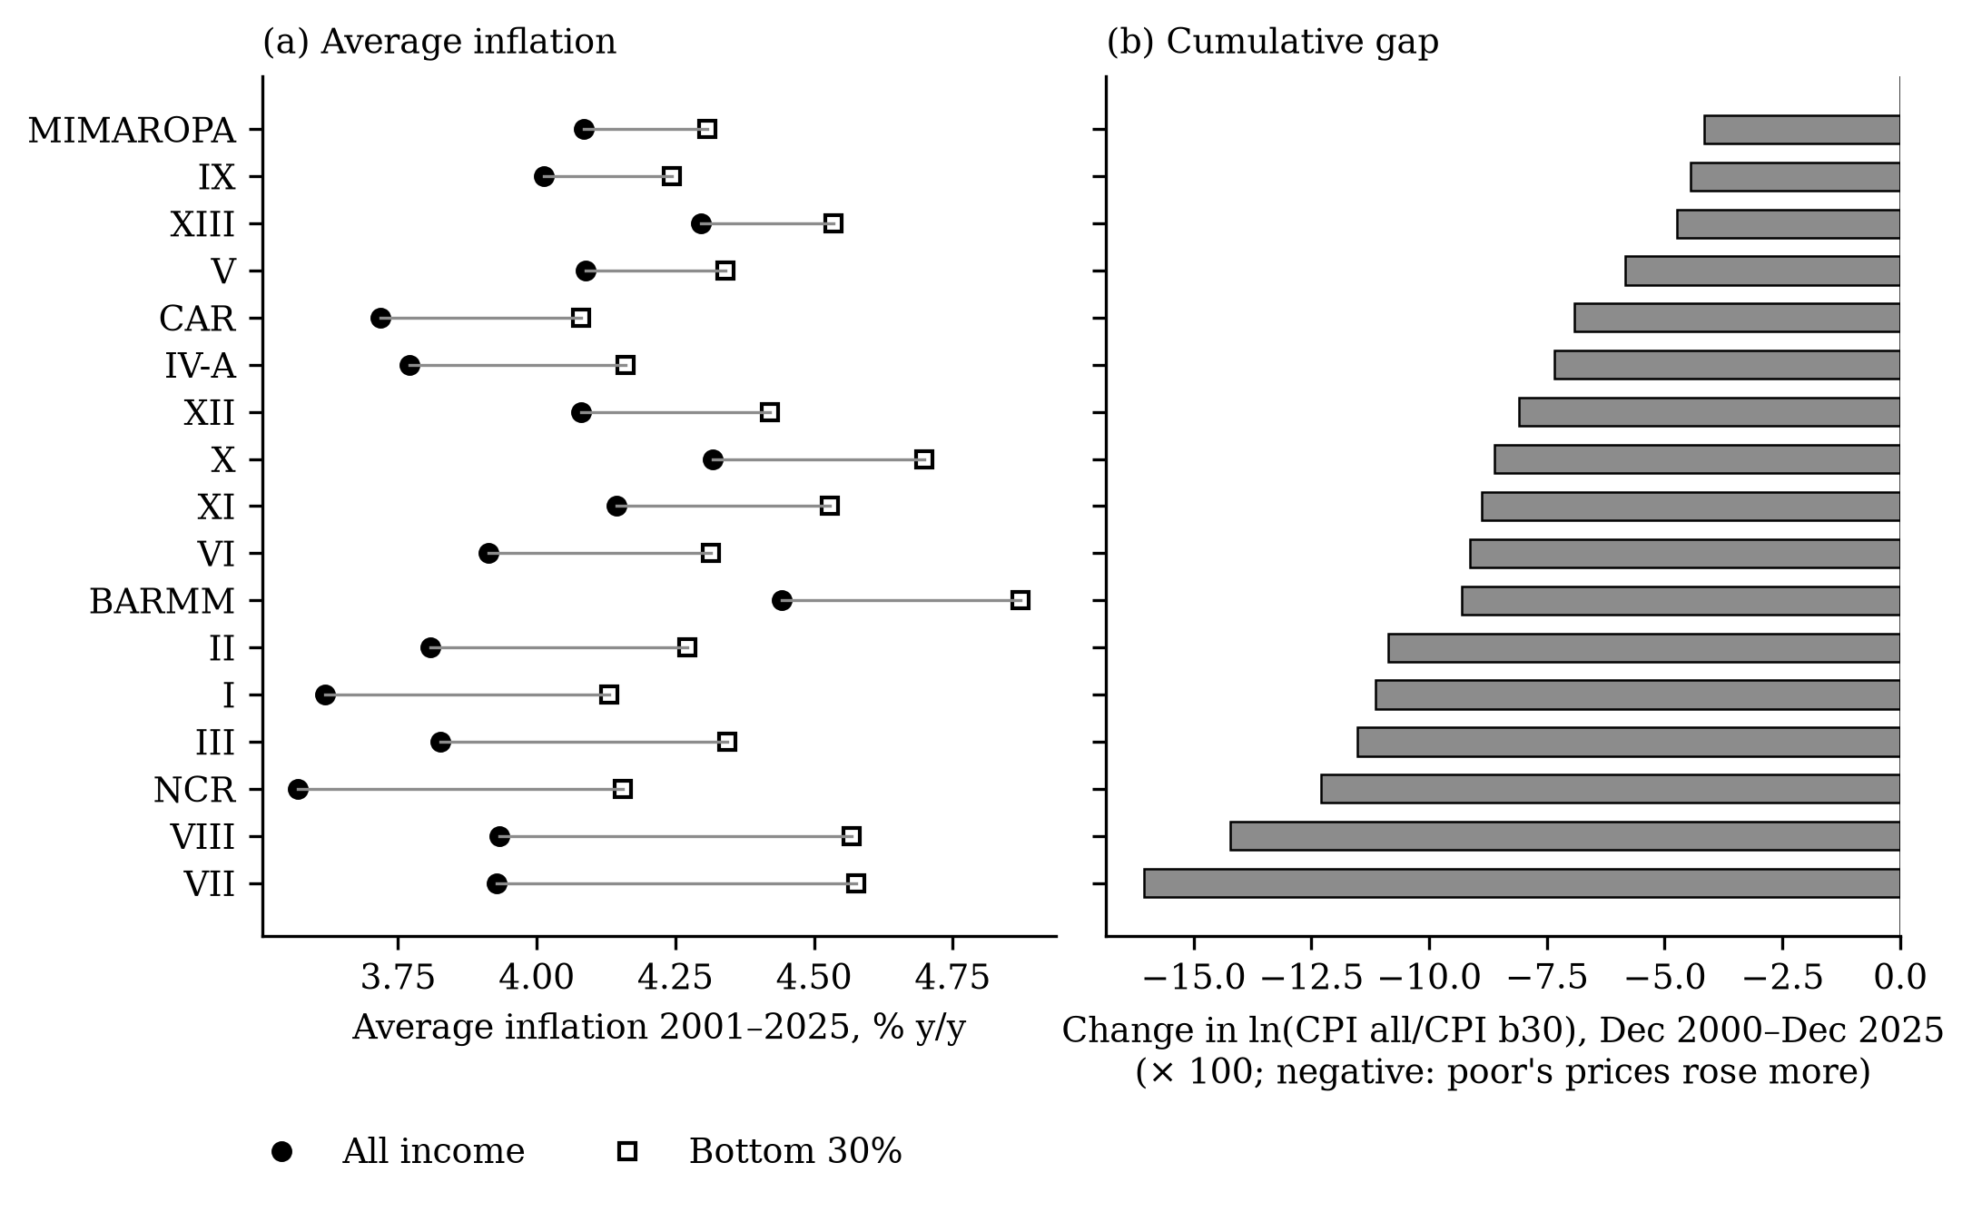
Figure 3. Average inflation by group, 2001–2025, and cumulative change in the gap, by region.
Table 6. Regional summary
Region | Poverty 2018 (%) | Food share 2018 (%) | Inflation all, 2001–2025 (%) | Inflation b30, 2001–2025 (%) | Cumulative gap 2001–2025 (×100) | Fuel volatility (SD, pp/month) | Inflation b30, Aug 2026 (% y/y)
National Capital Region | 2.2 | 29.5 | 3.57 | 4.15 | −12.3 | 4.96 | 4.3
Cordillera (CAR) | 12.0 | 35.8 | 3.72 | 4.08 | −6.9 | 4.41 | 8.3
I Ilocos | 9.9 | 38.4 | 3.62 | 4.13 | −11.1 | 4.47 | 4.7
II Cagayan Valley | 16.3 | 43.9 | 3.81 | 4.27 | −10.9 | 4.46 | 7.1
III Central Luzon | 7.0 | 36.5 | 3.83 | 4.34 | −11.5 | 4.51 | 6.9
IV-A CALABARZON | 7.1 | 33.0 | 3.77 | 4.16 | −7.3 | 4.65 | 6.0
MIMAROPA | 15.1 | 46.4 | 4.08 | 4.31 | −4.2 | 3.83 | 6.8
V Bicol | 27.0 | 45.6 | 4.09 | 4.34 | −5.8 | 4.24 | 9.3
VI Western Visayas | 14.2 | 42.6 | 3.91 | 4.31 | −9.1 | 4.39 | 10.4
VII Central Visayas | 16.1 | 37.9 | 3.93 | 4.58 | −16.0 | 4.24 | 9.7
VIII Eastern Visayas | 30.7 | 47.4 | 3.93 | 4.57 | −14.2 | 4.15 | 9.9
IX Zamboanga Peninsula | 32.7 | 49.6 | 4.01 | 4.24 | −4.4 | 4.31 | 10.0
X Northern Mindanao | 23.1 | 43.1 | 4.32 | 4.70 | −8.6 | 4.30 | 7.2
XI Davao | 19.1 | 43.0 | 4.14 | 4.53 | −8.9 | 4.27 | 12.1
XII SOCCSKSARGEN | 27.3 | 45.7 | 4.08 | 4.42 | −8.1 | 4.02 | 8.6
XIII Caraga | 30.5 | 46.7 | 4.30 | 4.54 | −4.7 | 4.12 | 10.4
BARMM | 60.4 | 59.4 | 4.44 | 4.87 | −9.3 | 3.92 | 9.0
Philippines | 16.7 | 37.7 | 3.84 | 4.41 | −13.3 | 4.37 | 8.2

5.1.6 Stationarity
Table 7 reports unit-root tests. The log levels of the fuel index, both CPIs and their ratio are non-stationary (the smallest p-value is 0.48), while their monthly changes are stationary (p-values of 0.000 or less). This supports estimating the model in changes and reporting level effects as cumulative responses.
Table 7. Augmented Dickey–Fuller tests, January 2001–August 2026
Series | Form | ADF statistic | p-value | Lags | N
ln fuel index | level | −2.22 | 0.480 | 2 | 305
ln fuel index | first difference | −13.47 | 0.000 | 1 | 305
ln CPI all | level | −1.62 | 0.786 | 1 | 306
ln CPI all | first difference | −12.12 | 0.000 | 0 | 306
ln CPI b30 | level | −1.91 | 0.649 | 1 | 306
ln CPI b30 | first difference | −9.59 | 0.000 | 0 | 306
ln(CPI all/CPI b30) | level | −1.66 | 0.770 | 4 | 303
ln(CPI all/CPI b30) | first difference | −9.08 | 0.000 | 3 | 303
Discussion. The descriptive evidence already points against the cross-country finding: the poor’s prices have risen faster than the average over 25 years and in most fuel-shock episodes. But many things change prices at the same time as fuel — rice prices, the exchange rate, policy — and the correlations are modest. Whether fuel shocks themselves raise the poor’s prices more is the question for Objective 2.

5.2 Objective 2: estimates of pass-through and distributional effects

5.2.1 Validation
All three pre-registered tests passed (Table 8). On EU data, our estimate of the impact response of inflation to after-tax pump prices is 0.057, against 0.055 in the reference study; the responses to before-tax prices (0.024) and Brent crude (0.014) are close to the reference values (0.020 and 0.015) and smaller, as required; and responses fade to zero from the second month. The estimator therefore reproduces the published results, and the Philippine analysis proceeded.
Table 8. Validation against Kpodar and Liu (2022): per-horizon responses
Test | Shock | h = 0 | h = 1 | h = 2 | h = 3 | h = 4 | h = 5 | h = 6 | Reference value at h = 0
G1 | Pump price after tax, EU 2005–2019 | 0.057*** | 0.026*** | −0.002 | −0.000 | 0.003 | 0.000 | 0.006*** | 0.055
G2 | Pump price before tax (+ tax control) | 0.024*** | 0.012*** | −0.001 | 0.003 | 0.002** | 0.000 | 0.005*** | 0.020
G2 | Brent crude in euro | 0.014*** | 0.015*** | 0.001 | 0.000 | 0.003*** | 0.001 | −0.000 | 0.015
G3 | HICP fuels and lubricants, EU 2000–2019 | 0.065*** | 0.026*** | −0.001 | −0.003 | 0.005*** | 0.002 | 0.004* | 0.044 (advanced) / 0.018 (developing)
Indicative | Philippines, fuel index 2000–2019 | 0.063*** | 0.033*** | −0.009 | 0.011* | 0.000 | 0.005 | 0.009* | 0.044 (advanced) / 0.018 (developing)
Notes: Per-horizon responses of monthly inflation to a 1% fuel price change. G1–G3: EU countries, country fixed effects, clustered standard errors. Indicative row: Philippines, national, Newey–West. *, **, ***: 10%, 5%, 1%.

5.2.2 RQ1: pass-through to the price level
A 1% rise in the retail fuel index raises the all-income price level by 0.044 pp within the month (s.e. 0.006), 0.087 pp after six months and 0.102 pp (s.e. 0.017) after a year (Table 9, Figure 4). The bottom-30% price level responds by 0.044 on impact, 0.095 after six months and 0.102 after a year. H1 is supported, with one qualification: the cumulative effect is still rising at twelve months rather than peaking within six.
Compared with the reference study, the Philippine impact response (0.044) equals the advanced-economy estimate (0.044) and is more than twice the developing-economy estimate (0.018); the cumulative six-month response (0.087) is close to the developing-economy sum (0.091). Motor fuel accounts for 2.39% of the all-income basket, so the direct effect explains about 54% of the impact response; for the bottom 30%, with a fuel weight of 1.59%, only about 36%. The rest is indirect. With Dubai crude in pesos as the shock, the twelve-month response is 0.041, about 40% of the retail estimate, confirming that crude prices understate pass-through.
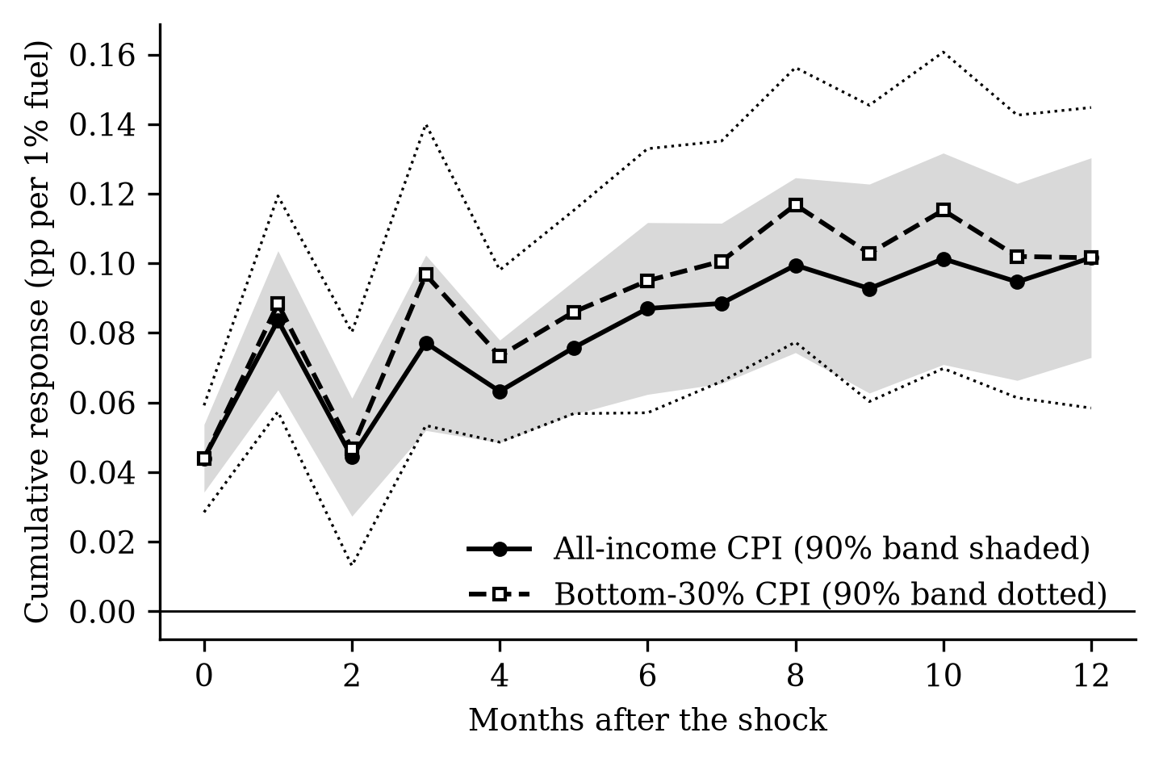
Figure 4. Cumulative pass-through of a 1% fuel price increase to the price level (90% bands).
Table 9. Cumulative responses to a 1% fuel price increase
Horizon (months) | CPI, all income | CPI, bottom 30% | Gap ln(CPI all/CPI b30), national | Gap, 17-region panel
0 | 0.044*** (0.006) | 0.044*** (0.009) | −0.0000 (0.0040) | −0.0006 (0.0032)
3 | 0.077*** (0.015) | 0.097*** (0.026) | −0.0185* (0.0110) | −0.0149** (0.0075)
6 | 0.087*** (0.015) | 0.095*** (0.023) | −0.0155 (0.0103) | −0.0214** (0.0084)
9 | 0.093*** (0.018) | 0.103*** (0.026) | −0.0137 (0.0101) | −0.0187** (0.0086)
12 | 0.102*** (0.017) | 0.102*** (0.026) | −0.0097 (0.0113) | −0.0173** (0.0085)
Notes: Cumulative response (pp) of 100 × ln of each index. Gap = ln(CPI all/CPI b30); negative: bottom-30% prices rise more. National: Newey–West; panel: region fixed effects, Driscoll–Kraay. Standard errors in parentheses. *, **, ***: 10%, 5%, 1%.

5.2.3 RQ2: do the poor pay more?
The cumulative response of the gap is negative at every horizon after the impact month (Table 9, Figure 5): nationally −0.0185 after three months, −0.0155 (s.e. 0.0103) after six and −0.0097 after twelve, significant at the 10% level at horizons 3, 4, 7, 8. In the regional panel, which uses each region’s own fuel prices, it is −0.0214 (s.e. 0.0084) after six months and −0.0173 (s.e. 0.0085) after twelve, both significant; dropping any one region leaves the six-month estimate between −0.0227 and −0.0203. H2a (progressive) is rejected; H2b (regressive) is supported in the panel and in sign nationally. In magnitude, a 10% fuel increase raises the bottom-30% price level about 0.2 pp more than the all-income level after six months, against a total increase of about 0.9 pp.
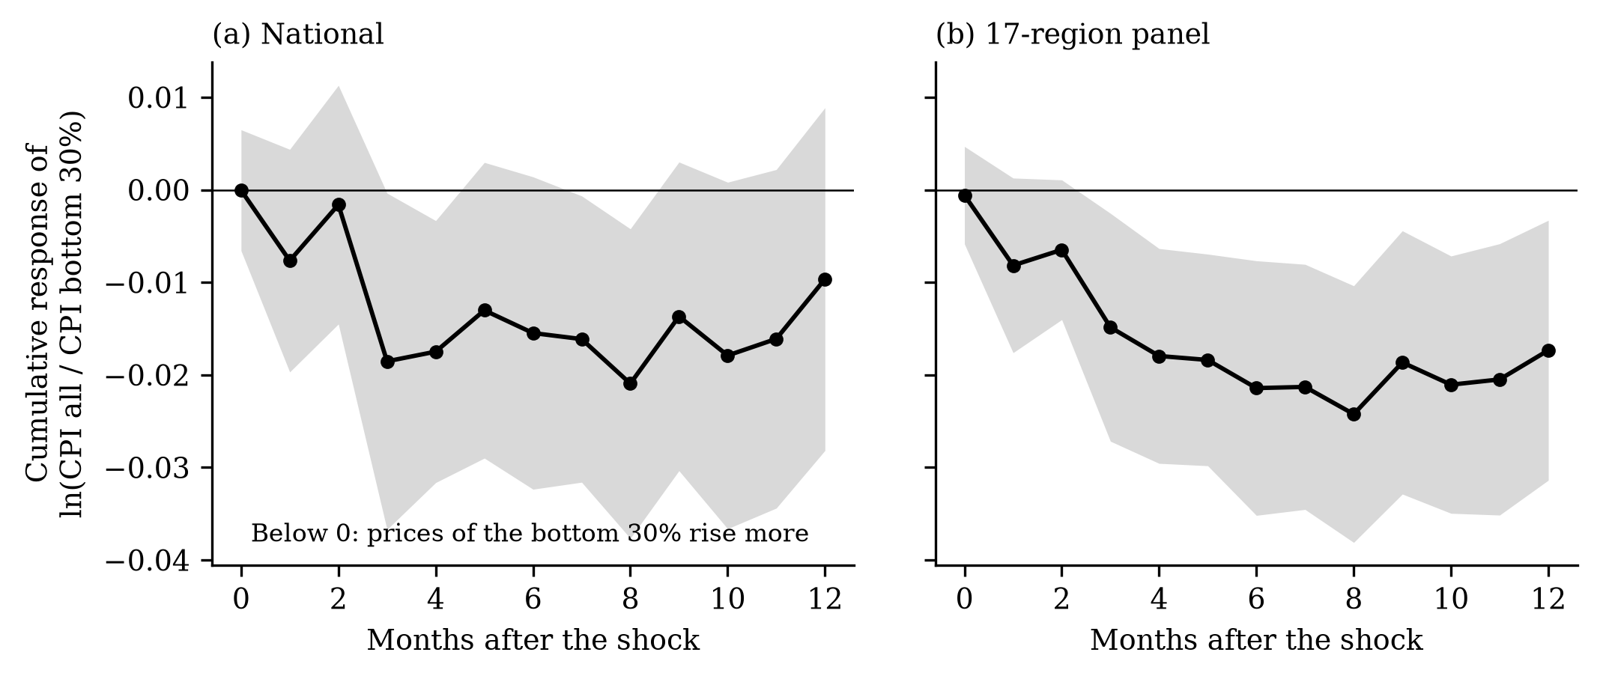
Figure 5. Cumulative response of the gap ln(CPI all/CPI bottom 30%) to a 1% fuel price increase: (a) national, (b) 17-region panel (90% bands).

5.2.4 RQ3: channels
Ten of the thirteen CPI divisions respond significantly (Table 10, Figure 6). The largest cumulative responses after a year are in transport (0.370), housing, water, electricity and gas (0.158), food (0.072) and restaurants (0.063). H3 is partly supported: transport carries the largest pass-through, food a significant but smaller one.
The weights alone cannot explain the regressive gap. The bottom-30% basket gives food 54.9% against 37.7%, but transport 6.1% against 9.0%. If both groups faced the same price change within each division, the gap after a year would be progressive (+0.0101), the cross-country result. Since the estimated gap is regressive, the poor must face larger price increases within divisions. The bottom-30% component indices (from 2013) confirm this: the poor’s housing and utilities index rises 0.182 per 1% fuel increase against 0.142, their food index 0.067 against 0.055, while their transport index rises less (0.196 against 0.300) because it consists mainly of fares.
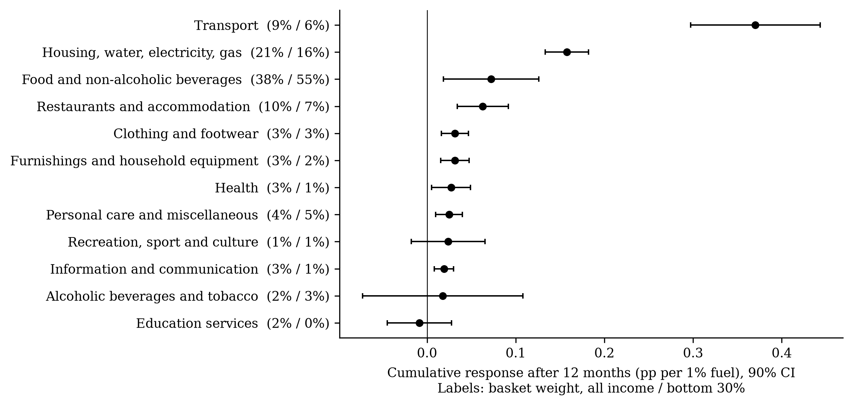
Figure 6. Cumulative pass-through after 12 months by CPI division (90% CI).
Table 10. Pass-through by CPI division, all income households
COICOP division | Weight, all income (%) | Weight, bottom 30% (%) | Cumulative response, h = 12
07 Transport | 9.0 | 6.1 | 0.370*** (0.044)
12 Financial services | 0.0 | 0.0 | 0.358** (0.158)
04 Housing, water, electricity, gas | 21.4 | 15.5 | 0.158*** (0.015)
01 Food and non-alcoholic beverages | 37.7 | 54.9 | 0.072** (0.033)
11 Restaurants and accommodation | 9.6 | 7.5 | 0.063*** (0.018)
03 Clothing and footwear | 3.1 | 2.5 | 0.032*** (0.009)
05 Furnishings and household equipment | 3.2 | 2.4 | 0.031*** (0.010)
06 Health | 2.9 | 1.4 | 0.027** (0.013)
13 Personal care and miscellaneous | 4.5 | 4.8 | 0.025*** (0.009)
09 Recreation, sport and culture | 1.0 | 0.7 | 0.024 (0.025)
08 Information and communication | 3.4 | 1.0 | 0.019*** (0.007)
02 Alcoholic beverages and tobacco | 2.2 | 2.6 | 0.018 (0.055)
10 Education services | 2.0 | 0.4 | −0.009 (0.022)

5.2.5 RQ4: regional differences
After a year, the gap is 0.0166 pp larger (per 1% fuel increase) in Mindanao (s.e. 0.0092), 0.0123 pp in the island regions (s.e. 0.0086) and 0.0095 pp in high-poverty regions (s.e. 0.0078), and 0.0100 pp smaller in regions with a high food share (s.e. 0.0052) (Table 11, Figure 7). The Mindanao and food-share interactions are significant at 10%, but none survives a correction for testing four groups. H4 is therefore not established. The food-share result runs against the hypothesis but matches the descriptive pattern of Section 5.1.5: where most households are poor and food-dependent, the all-income basket resembles the poor’s, and the gap between the two indices is mechanically smaller.
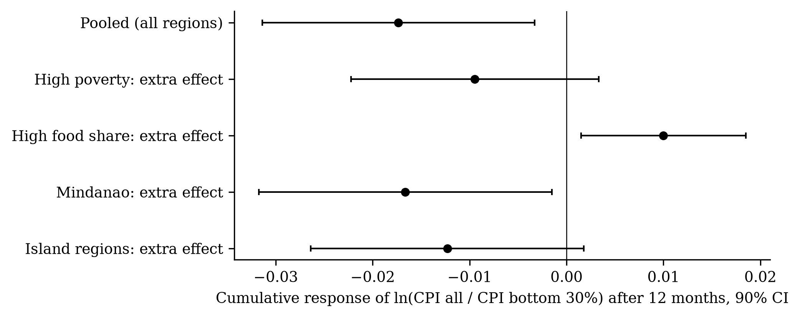
Figure 7. Additional distributional effect in groups of regions after 12 months (90% CI).
Table 11. Regional heterogeneity in the gap
Group G | Base effect, h = 6 | Extra effect θ, h = 6 | Base effect, h = 12 | Extra effect θ, h = 12
High poverty (2018 incidence above median) | −0.0271** (0.0108) | 0.0128 (0.0119) | −0.0131 (0.0100) | −0.0095 (0.0078)
High food share of the regional basket (above median) | −0.0240*** (0.0085) | 0.0060 (0.0044) | −0.0216** (0.0094) | 0.0100* (0.0052)
Mindanao | −0.0263** (0.0108) | 0.0146 (0.0151) | −0.0118 (0.0096) | −0.0166* (0.0092)
Island regions (MIMAROPA, VI, VII, VIII) | −0.0201*** (0.0078) | −0.0061 (0.0096) | −0.0147* (0.0079) | −0.0123 (0.0086)

5.2.6 Robustness and stability
The negative six-month gap holds in all pre-specified robustness checks (Table 12, Figure 8). It shrinks toward zero with macro controls (−0.0046), and with the two fuel series available only from 2018–2019 (−0.0016 and −0.0063). The supplementary split shows why: in the regional panel the six-month gap is −0.0541 (s.e. 0.0197) over 2001–2012 and −0.0091 (s.e. 0.0064) over 2013–2026; excluding 2008 leaves −0.0177 (s.e. 0.0073). The regressive effect was strongest in the 2000s and has weakened since.
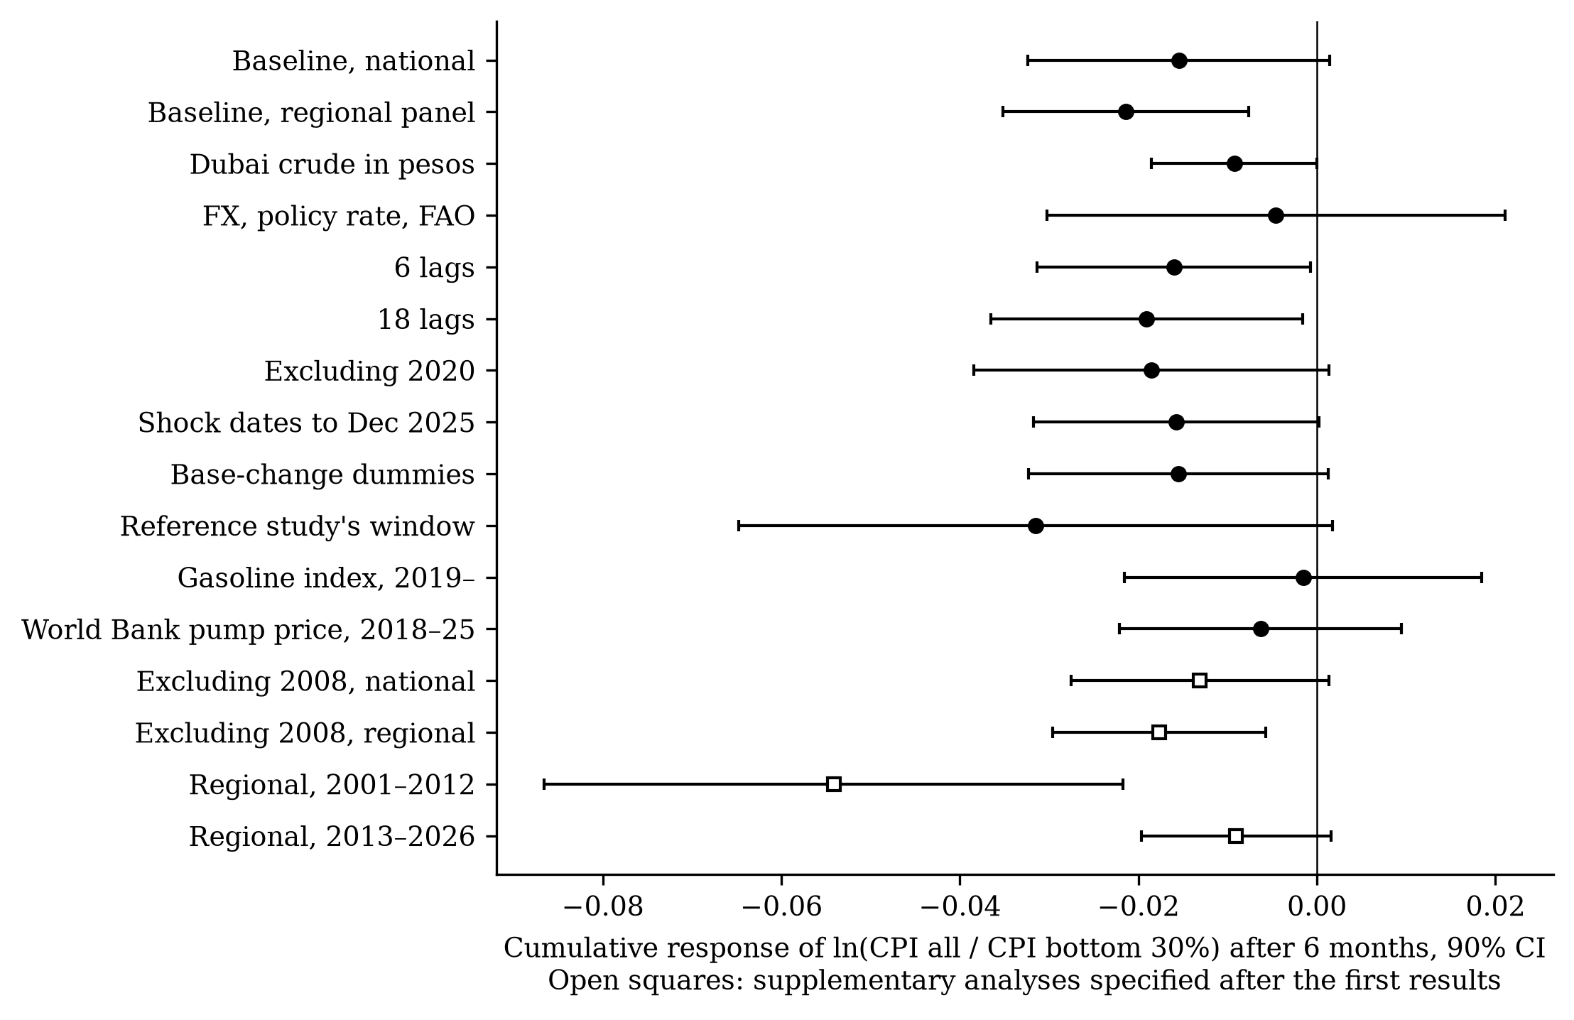
Figure 8. Robustness of the six-month distributional effect (90% CI). Open squares: supplementary analyses.
Table 12. Robustness of the distributional gap
Specification | Gap, h = 6 | Gap, h = 12 | CPI all, h = 12
Baseline, national | −0.0155 (0.0103) | −0.0097 (0.0113) | 0.102*** (0.017)
Baseline, 17-region panel | −0.0214** (0.0084) | −0.0173** (0.0085) | —
(a) Shock: Dubai crude in pesos | −0.0093 (0.0056) | −0.0075 (0.0063) | 0.041*** (0.009)
(b) + PHP/USD, policy rate, FAO food index | −0.0046 (0.0156) | 0.0086 (0.0160) | 0.072*** (0.020)
(c) 6 lags | −0.0160* (0.0093) | −0.0157 (0.0121) | 0.107*** (0.020)
(c) 18 lags | −0.0191* (0.0106) | −0.0109 (0.0115) | 0.109*** (0.018)
(d) Excluding 2020 | −0.0186 (0.0121) | −0.0142 (0.0129) | 0.111*** (0.017)
(d) Shock dates to Dec 2025 only | −0.0158 (0.0097) | −0.0097 (0.0113) | 0.102*** (0.017)
(e) Base-change dummies (Jan 2012, Jan 2018) | −0.0155 (0.0102) | −0.0100 (0.0114) | 0.102*** (0.018)
(g) Reference study’s window (to Jun 2019) | −0.0315 (0.0202) | −0.0215 (0.0191) | 0.093*** (0.016)
(h) Shock: gasoline index, 2019–2026 | −0.0016 (0.0122) | −0.0051 (0.0125) | 0.096*** (0.027)
(i) Shock: World Bank pump price, 2018–2025 | −0.0063 (0.0096) | −0.0005 (0.0054) | 0.072*** (0.019)
(k) Panel, drop re-mapped 2026 observations | −0.0215*** (0.0083) | −0.0173** (0.0085) | —
(l) Panel, national instead of regional shock | −0.0225** (0.0095) | −0.0188** (0.0095) | —
Supplementary: national, excluding 2008 | −0.0131 (0.0088) | −0.0079 (0.0115) | —
Supplementary: panel, excluding 2008 | −0.0177** (0.0073) | −0.0135 (0.0092) | —
Supplementary: panel, 2001–2012 | −0.0541*** (0.0197) | −0.0369** (0.0147) | —
Supplementary: panel, 2013–2026 | −0.0091 (0.0064) | −0.0063 (0.0075) | —
Discussion of Objective 2. Fuel price shocks pass through to Philippine prices as much as in the average developing economy but as fast as in advanced economies. Their distributional effect is the opposite of the cross-country finding: not progressive but, if anything, regressive. The explanation lies not in what the poor buy but in the prices they pay within the same categories, a difference that the reconstructed indices of the cross-country literature cannot capture by construction.

5.3 Objective 3: policy implications of the 2026 shock

5.3.1 How much of the 2026 surge did fuel explain?
The fuel index rose 53.7 log points between December 2025 and April 2026 and was still 32.5 points higher in August. A model estimated only on data up to December 2025 attributes 2.55 log points (range 1.94–3.17) of the 4.81-point rise in the all-income CPI by August to fuel, about 53%, and 3.13 (2.16–4.10) of the 5.98-point rise in the bottom-30% CPI, about 52% (Figure 9). It also predicts that the poor would pay more: −0.65 pp of the −1.18 pp actual gap. The historical relationships thus held in 2026, but explain only half of what happened. Prices did not fall when fuel prices eased in May and June, as the model predicted, consistent with downward price rigidity and with other shocks, including a 5.1% depreciation of the peso between February and August.
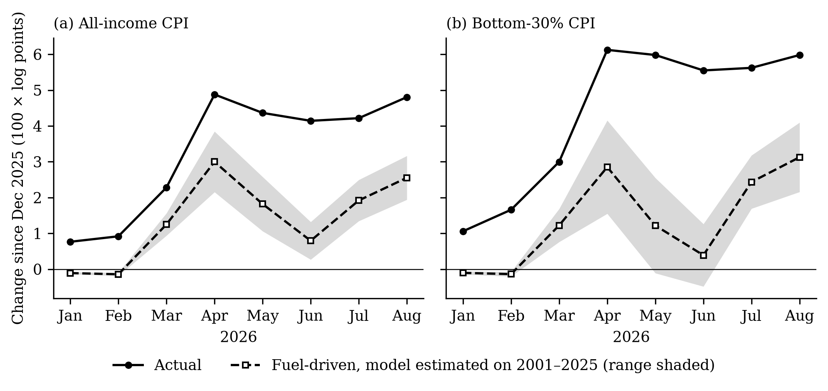
Figure 9. Actual price changes in 2026 against the fuel-driven changes predicted by a model estimated on 2001–2025 data.

5.3.2 Regional burden and peso cost
For a family of five at the poverty line, the fuel-driven increase in the cost of its basket by August 2026 was about PHP 467 a month nationally, from PHP 390 in XII SOCCSKSARGEN to PHP 633 in the National Capital Region (Table 13). The total price-driven increase was about PHP 907 a month. Fuel-driven increases were similar across regions because pump prices moved together, but actual bottom-30% inflation was much higher in XI Davao, BARMM, VI Western Visayas, XIII Caraga and IX Zamboanga Peninsula than in the National Capital Region, and fuel explains about 72% of the rise in NCR, CAR and Regions I to IV-A but only 44% in Mindanao.
Table 13. The 2026 shock by region, December 2025 to August 2026
Region | Poverty 2018 (%) | Fuel price rise, Dec 2025–Aug 2026 (%) | Fuel-driven rise, bottom-30% CPI | Actual rise, bottom-30% CPI | Fuel-driven extra cost, poverty-line family of five (PHP/month)
National Capital Region | 2.2 | 34.5 | 3.68 [2.66, 4.70] | 3.47 | 633
Cordillera (CAR) | 12.0 | 30.7 | 3.30 [2.41, 4.18] | 6.36 | 470
I Ilocos | 9.9 | 36.3 | 3.68 [2.69, 4.68] | 3.82 | 571
II Cagayan Valley | 16.3 | 34.1 | 3.47 [2.53, 4.42] | 4.64 | 503
III Central Luzon | 7.0 | 33.9 | 3.50 [2.56, 4.45] | 6.00 | 605
IV-A CALABARZON | 7.1 | 34.6 | 3.52 [2.57, 4.48] | 4.96 | 596
MIMAROPA | 15.1 | 30.9 | 3.13 [2.26, 4.00] | 6.44 | 425
V Bicol | 27.0 | 33.9 | 3.30 [2.37, 4.22] | 6.21 | 503
VI Western Visayas† | 14.2 | 31.6 | 3.20 [2.31, 4.08] | 7.48 | 478
VII Central Visayas† | 16.1 | 25.9 | 2.65 [1.94, 3.36] | 5.90 | 419
VIII Eastern Visayas | 30.7 | 27.4 | 2.85 [2.07, 3.62] | 6.80 | 410
IX Zamboanga Peninsula | 32.7 | 29.4 | 3.07 [2.23, 3.91] | 7.07 | 457
X Northern Mindanao | 23.1 | 31.7 | 3.17 [2.28, 4.06] | 5.30 | 474
XI Davao | 19.1 | 29.3 | 2.97 [2.14, 3.79] | 8.52 | 417
XII SOCCSKSARGEN† | 27.3 | 29.6 | 3.00 [2.16, 3.84] | 6.10 | 390
XIII Caraga | 30.5 | 31.1 | 3.11 [2.25, 3.96] | 7.10 | 409
BARMM† | 60.4 | 33.5 | 3.30 [2.38, 4.21] | 7.88 | 444
Philippines | 16.7 | 32.5 | 3.13 [2.16, 4.10] | 5.98 | 467
Notes: 100 × log points. Fuel-driven rise: pooled responses estimated to December 2025 applied to each region’s fuel path; indicative range in brackets. †: boundaries changed in 2024.

5.3.3 Which goods drove the poor’s excess inflation?
Between December 2025 and August 2026, the bottom-30% CPI rose 6.16% and the all-income CPI 4.92%, a gap of +1.24 pp (Figure 10). Rice and other cereals contributed +1.67 pp: cereal prices rose 18.3% in the poor’s basket and 15.7% in the average, and cereals weigh 19.6% against 9.4%. Passenger fares added +0.15 pp (the poor’s fares rose 9.1%, against 4.7%), and household fuels +0.13 pp. Private vehicle fuel (−0.38 pp) and rents (−0.23 pp) worked the other way. Historically, cereal prices barely respond to pump prices (0.012–0.019 after a year), so the 2026 rice increase probably reflects the conflict’s effect on fertilizer and freight costs and changes in rice import policy (USDA Foreign Agricultural Service 2026) more than the direct pass-through of fuel; the data cannot separate these causes.
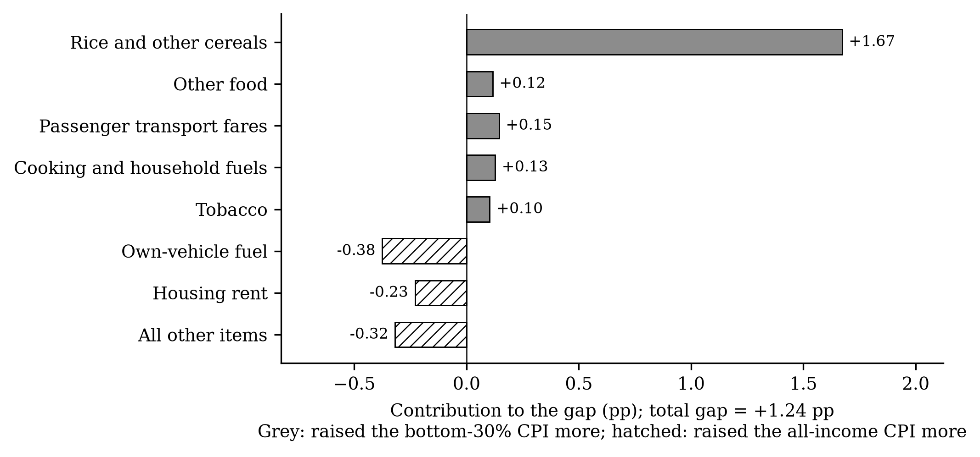
Figure 10. Item contributions to the difference between bottom-30% and all-income price changes, December 2025–August 2026.
Table 14 shows the household fuels and fares behind these results. LPG prices respond equally in both baskets (0.730 and 0.722), and LPG has the same weight in both (1.27% and 1.33%). Kerosene responds strongly but weighs only 0.27% even for the poor. Solid fuels — charcoal and wood — weigh 4.02% for the poor against 0.87% for the average, but do not respond to oil prices. The poor’s fares have historically responded little (0.010 against 0.071).
Table 14. Household fuels, fares and cereals: weights and responses, 2013–2026
Item | Weight, all (%) | Weight, b30 (%) | Response, all-income index | Response, bottom-30% index
04.5 Electricity, gas and other fuels | 6.74 | 10.11 | 0.424*** (0.038) | 0.294*** (0.050)
04.5.2 Gas (LPG) | 1.27 | 1.33 | 0.730*** (0.152) | 0.722*** (0.148)
04.5.3 Liquid fuels (kerosene) | 0.04 | 0.27 | 1.152*** (0.114) | 1.111*** (0.107)
04.5.4 Solid fuels (charcoal, wood) | 0.87 | 4.02 | 0.013 (0.026) | 0.038 (0.024)
07.3 Passenger transport services (fares) | 4.54 | 3.72 | 0.071 (0.079) | 0.010 (0.101)
01.1.1 Cereals and cereal products | 12.32 | 23.64 | 0.019 (0.084) | 0.012 (0.101)

5.3.4 Assessment of the 2026 policy instruments
Table 15 brings the evidence together.
Table 15. Assessment of policy instruments against the evidence
Instrument (2026) | Evidence from this study | Assessment
Excise relief on gasoline and diesel (not used) | Motor fuel weighs 2.39% of the all-income basket and 1.59% of the poor’s; private vehicle fuel lowered the poor’s relative inflation by 0.38 pp in 2026 | Benefits mainly better-off households; not targeted. The decision not to use it is consistent with the evidence.
Excise suspension on LPG and kerosene (April–July and from September 2026) | LPG responds equally in both baskets and has the same weight; kerosene responds strongly but weighs 0.27% for the poor; relief of about PHP 37 per 11-kg tank ≈ 8% of the fuel-driven monthly cost of a poverty-line family | Distribution-neutral (LPG) or well targeted but small (kerosene); limited protection for the poor.
Fuel subsidies for public utility vehicle drivers | The poor’s fares historically responded little to fuel (0.010); in 2026 their fares rose 9.1% against 4.7% | Protects the poor indirectly by delaying fare increases; worth continuing while fares are held, and monitoring local fares.
Policy rate increases (to 5.00%) | Pass-through builds for at least 12 months; crude-based estimates understate it by more than half | Appropriate against second-round effects, but does not address the distribution of the burden.
Targeted cash transfers | Fuel-driven cost PHP 467 a month and total price-driven cost PHP 907 a month for a poverty-line family of five by August 2026; regional range PHP 390–633 | Best targeted; can be sized and regionally allocated with the bottom-30% CPI.
Rice price and supply measures | Rice and cereals contributed +1.67 pp of the +1.24 pp gap in 2026 | The largest channel of the poor’s excess inflation in 2026; should be part of the oil-shock response.

5.4 Synthesis
The three objectives give a consistent picture. The descriptive record (Objective 1) shows that the poor’s prices have risen faster than average over 25 years and during most fuel-shock episodes. The model (Objective 2) shows that fuel shocks themselves contribute to this — the opposite of the cross-country finding — through larger price increases within the categories the poor buy, especially in the 2000s. The 2026 episode (Objective 3) shows that the historical model still predicts about half of the price surge and the direction of the gap, but that the poor’s excess inflation in 2026 came mostly through rice, a channel that pump-price-focused relief does not reach.
The results qualify the policy conclusion usually drawn from the cross-country evidence. In the Philippines, fuel subsidies and excise relief are still poorly targeted — that conclusion stands — but not because fuel shocks spare the poor. They do not; the poor are reached through food and fares, which fuel tax relief does not touch.
Limitations. Retail fuel prices may respond to domestic conditions; crude-price results have the same sign, but an identified oil supply shock (Kilian 2009; Baumeister and Hamilton 2019; Känzig 2021) would strengthen the causal interpretation. The bottom 30% are compared with all households, which understates differences. The pre-2018 bottom-30% series are backcasts. The distributional effect is concentrated in 2001–2012 and is sensitive to some controls. The 2026 analysis is short and its decomposition descriptive. The regional tests do not survive a multiple-testing correction. Price indices ignore substitution and income effects.

Chapter 6. Summary, Conclusions and Recommendations

6.1 Summary of findings
Objective 1. From 2001 to 2025, bottom-30% prices rose faster than all-income prices on average (4.41% against 3.84% a year) and in 18 of 25 years, accumulating to a 13.3-log-point difference nationally and a difference in every region. The poor’s inflation exceeded the average in 6 of 9 fuel-shock episodes, most in 2008 and 2026. In August 2026 it was 8.2% against 6.2%.
Objective 2. A 1% fuel price increase raises the price level by 0.044 pp within the month and 0.102 pp within a year; crude prices capture about 40% of this. The effect is not progressive: in the regional panel, the poor’s prices rise 0.0214 pp more after six months, through larger increases within food, utilities and other categories, while the expenditure weights alone would predict the opposite. The effect was strongest in 2001–2012. Regional differences are suggestive but not statistically established.
Objective 3. The historical model explains about half of the 2026 price surge and predicts that the poor would pay more. The fuel-driven cost for a poverty-line family of five reached about PHP 467 a month by August 2026 (total price-driven cost about PHP 907). Rice and cereals accounted for most of the poor’s excess inflation. LPG excise relief is distribution-neutral; gasoline and diesel tax relief would mainly help the better-off.

6.2 Conclusions
- Fuel price shocks pass through quickly, broadly and persistently to Philippine consumer prices; analyses based on crude oil prices understate them.
- The cross-country finding that fuel shocks are progressive does not hold in the Philippines. The burden is at best neutral and often falls harder on poor households.
- The reason is not the poor’s spending pattern, which by itself would make the shock progressive, but the price changes they face within categories — their food, their household fuels and, in 2026, their fares.
- The 2026 shock confirmed the historical relationships but added a large rice-price channel that fuel-focused relief does not reach.
- Instruments that work through fuel taxes are poorly targeted to the poor; transfers sized with the bottom-30% CPI, fare policy and rice policy are better targeted.

6.3 Recommendations
For policy.
- Department of Finance: reserve excise relief under RA 12316 for products whose budget share is clearly higher for the poor (kerosene) and avoid broad relief on gasoline and diesel; redirect the revenue to targeted transfers.
- Department of Social Welfare and Development: use existing registries of poor households to release emergency transfers when a fuel shock occurs, sized with the bottom-30% CPI (on 2026 evidence, PHP 467–907 a month for a poverty-line family of five) and allocated by regional bottom-30% inflation rather than regional pump prices; keep them for at least a year, because prices do not fall back when fuel eases.
- Department of Transportation and LTFRB: treat fuel subsidies for public transport operators as protection for poor commuters, tie them to fare restraint, and monitor local fares (such as tricycle fares) that are not set nationally.
- Department of Agriculture: include rice in the oil-shock response, through monitoring of fertilizer and freight costs and timely use of import and buffer-stock policy.
- BSP: use retail fuel prices, not crude prices, to gauge second-round effects, and recognise that they build over at least a year.
- PSA: continue and publicise the bottom-30% CPI and its regional and commodity detail, and publish technical notes on its backcasts.
For research.
- Use an identified oil supply shock as an instrument for retail fuel prices.
- Compare the poorest and the richest households directly, with FIES-based indices for the top of the distribution.
- Study the fertilizer–rice channel of oil shocks with longer horizons.
- Extend the 2026 analysis as data for later months become available, including the September 2026 fare increase and the second excise suspension.
- Examine income effects — on drivers, farmers and fisherfolk — alongside price effects.

References
Allon-Pineda, Joan Christine S., Jan Christopher G. Ocampo, and Eduard Renzo D. Santos. 2026. “Second-Round Effects and Asymmetry in Oil and Food Price Shocks to Inflation.” Latin American Journal of Central Banking 7 (3): 100180. https://doi.org/10.1016/j.latcb.2025.100180.
Armas, Jean Christine A. 2021. “Is the Bank Lending Channel of Monetary Policy Evident in the Philippines? A Dynamic Panel Data Approach.” Asian Economic Journal 35 (3): 246–69. https://doi.org/10.1111/asej.12249.
Baumeister, Christiane, and James D. Hamilton. 2019. “Structural Interpretation of Vector Autoregressions with Incomplete Identification: Revisiting the Role of Oil Supply and Demand Shocks.” American Economic Review 109 (5): 1873–910. https://doi.org/10.1257/aer.20151569.
Blanchard, Olivier J., and Jordi Galí. 2010. “The Macroeconomic Effects of Oil Price Shocks: Why Are the 2000s so Different from the 1970s?” In International Dimensions of Monetary Policy, edited by Jordi Galí and Mark J. Gertler. University of Chicago Press.
Choi, Sangyup, Davide Furceri, Prakash Loungani, Saurabh Mishra, and Marcos Poplawski-Ribeiro. 2018. “Oil Prices and Inflation Dynamics: Evidence from Advanced and Developing Economies.” Journal of International Money and Finance 82: 71–96. https://doi.org/10.1016/j.jimonfin.2017.12.004.
Coady, David, Valentina Flamini, and Louis Sears. 2015. The Unequal Benefits of Fuel Subsidies Revisited: Evidence for Developing Countries. IMF Working Paper 15/250. International Monetary Fund. https://doi.org/10.5089/9781513501390.001.
Dorband, Ira Irina, Michael Jakob, Matthias Kalkuhl, and Jan Christoph Steckel. 2019. “Poverty and Distributional Effects of Carbon Pricing in Low- and Middle-Income Countries – a Global Comparative Analysis.” World Development 115: 246–57. https://doi.org/10.1016/j.worlddev.2018.11.015.
Driscoll, John C., and Aart C. Kraay. 1998. “Consistent Covariance Matrix Estimation with Spatially Dependent Panel Data.” Review of Economics and Statistics 80 (4): 549–60. https://doi.org/10.1162/003465398557825.
Easterly, William, and Stanley Fischer. 2001. “Inflation and the Poor.” Journal of Money, Credit and Banking 33 (2): 160–78. https://doi.org/10.2307/2673879.
European Commission. 2026. Weekly Oil Bulletin: Price History Since 2005. Https://energy.ec.europa.eu/data-and-analysis/weekly-oil-bulletin_en.
Gelos, Gaston, and Yulia Ustyugova. 2017. “Inflation Responses to Commodity Price Shocks – How and Why Do Countries Differ?” Journal of International Money and Finance 72: 28–47. https://doi.org/10.1016/j.jimonfin.2016.10.001.
Jaravel, Xavier. 2021. “Inflation Inequality: Measurement, Causes, and Policy Implications.” Annual Review of Economics 13: 599–629. https://doi.org/10.1146/annurev-economics-091520-082042.
Jordà, Òscar. 2005. “Estimation and Inference of Impulse Responses by Local Projections.” American Economic Review 95 (1): 161–82. https://doi.org/10.1257/0002828053828518.
Känzig, Diego R. 2021. “The Macroeconomic Effects of Oil Supply News: Evidence from OPEC Announcements.” American Economic Review 111 (4): 1092–125. https://doi.org/10.1257/aer.20190964.
Kaplan, Greg, and Sam Schulhofer-Wohl. 2017. “Inflation at the Household Level.” Journal of Monetary Economics 91: 19–38. https://doi.org/10.1016/j.jmoneco.2017.08.002.
Kataoka, Mitsuhiko. 2022. “Cyclical Shocks and Spatial Association of Indonesia’s District-Level Per Capita Income.” Asian Economic Journal 36 (3): 261–87. https://doi.org/10.1111/asej.12277.
Kilian, Lutz. 2009. “Not All Oil Price Shocks Are Alike: Disentangling Demand and Supply Shocks in the Crude Oil Market.” American Economic Review 99 (3): 1053–69. https://doi.org/10.1257/aer.99.3.1053.
Kpodar, Kangni, and Chadi Abdallah. 2017. “Dynamic Fuel Price Pass-Through: Evidence from a New Global Retail Fuel Price Database.” Energy Economics 66: 303–12. https://doi.org/10.1016/j.eneco.2017.06.017.
Kpodar, Kangni, and Patrick A. Imam. 2021. “To Pass (or Not to Pass) Through International Fuel Price Changes to Domestic Fuel Prices in Developing Countries: What Are the Drivers?” Energy Policy 149: 111999. https://doi.org/10.1016/j.enpol.2020.111999.
Kpodar, Kangni, and Boya Liu. 2022. “The Distributional Implications of the Impact of Fuel Price Increases on Inflation.” Energy Economics 108: 105909. https://doi.org/10.1016/j.eneco.2022.105909.
Kurita, Kyosuke, and Takashi Kurosaki. 2011. “Dynamics of Growth, Poverty and Inequality: A Panel Analysis of Regional Data from Thailand and the Philippines.” Asian Economic Journal 25 (1): 3–33. https://doi.org/10.1111/j.1467-8381.2011.02046.x.
Montiel Olea, José Luis, and Mikkel Plagborg-Møller. 2021. “Local Projection Inference Is Simpler and More Robust Than You Think.” Econometrica 89 (4): 1789–823. https://doi.org/10.3982/ECTA18756.
Newey, Whitney K., and Kenneth D. West. 1987. “A Simple, Positive Semi-Definite, Heteroskedasticity and Autocorrelation Consistent Covariance Matrix.” Econometrica 55 (3): 703–8. https://doi.org/10.2307/1913610.
Pagaduan, James Agustin. 2022. “Do Higher-Quality Nighttime Lights and Net Primary Productivity Predict Subnational GDP in Developing Countries? Evidence from the Philippines.” Asian Economic Journal 36 (3): 288–317. https://doi.org/10.1111/asej.12278.
Philippine Statistics Authority. 2026. OpenSTAT: Consumer Price Index for All Income Households and for the Bottom 30% Income Households (2018=100), and Official Poverty Statistics. Https://openstat.psa.gov.ph.
Plagborg-Møller, Mikkel, and Christian K. Wolf. 2021. “Local Projections and VARs Estimate the Same Impulse Responses.” Econometrica 89 (2): 955–80. https://doi.org/10.3982/ECTA17813.
Republic of the Philippines. 2026. Republic Act No. 12316: An Act Authorizing the President to Suspend or Reduce Excise Tax on Petroleum Products, Amending for the Purpose Section 148 of the National Internal Revenue Code of 1997, as Amended. Https://lawphil.net/statutes/repacts/ra2026/ra_12316_2026.html.
Satriawan, Elan, and Ranjan Shrestha. 2018. “Mistargeting and Regressive Take up of the Indonesian Rice Subsidy Program.” Asian Economic Journal 32 (4): 387–415. https://doi.org/10.1111/asej.12164.
Siddig, Khalid, Angel Aguiar, Harald Grethe, Peter Minor, and Terrie Walmsley. 2014. “Impacts of Removing Fuel Import Subsidies in Nigeria on Poverty.” Energy Policy 69: 165–78. https://doi.org/10.1016/j.enpol.2014.02.006.
Soile, Ismail, and Xiaoyi Mu. 2015. “Who Benefit Most from Fuel Subsidies? Evidence from Nigeria.” Energy Policy 87: 314–24. https://doi.org/10.1016/j.enpol.2015.09.018.
Taguchi, Hiroyuki, and Wook Sohn. 2014. “Inflation Targeting and the Pass-Through Rate in East Asian Economies.” Asian Economic Journal 28 (2): 139–59. https://doi.org/10.1111/asej.12029.
Teulings, Coen N., and Nikolay Zubanov. 2014. “Is Economic Recovery a Myth? Robust Estimation of Impulse Responses.” Journal of Applied Econometrics 29 (3): 497–514. https://doi.org/10.1002/jae.2333.
Timmer, C. Peter, and David Dawe. 2007. “Managing Food Price Instability in Asia: A Macro Food Security Perspective.” Asian Economic Journal 21 (1): 1–18. https://doi.org/10.1111/j.1467-8381.2007.00244.x.
USDA Foreign Agricultural Service. 2026. Philippines: Grain and Feed Annual. Nos. RP2026-0007. GAIN Report RP2026-0007, Manila.
Valera, Harold Glenn, Mark Holmes, and Vic Delloro. 2025. The Changing Effect of Energy and Rice Prices and Remittances on Overall Inflation in Emerging Markets: Evidence from the Philippines. BSP Discussion Paper Nos. 2025-02. Bangko Sentral ng Pilipinas.
Warr, Peter, Sitthiroth Rasphone, and Jayant Menon. 2018. “Two Decades of Declining Poverty but Rising Inequality in Laos.” Asian Economic Journal 32 (2): 165–85. https://doi.org/10.1111/asej.12147.
Wihardja, Maria Monica, and Wisnu Harto Adi Wijoyo Pradana. 2024. “Examining the Drivers of Changes in Mean Earnings and Earnings Inequality in Indonesia.” Asian Economic Journal 38 (2): 232–55. https://doi.org/10.1111/asej.12332.
World Bank. 2025. Global Fuel Prices Database, Version April 2025. Https://datacatalog.worldbank.org/search/dataset/0066829/global-fuel-prices-database.
World Bank. 2026. Commodity Price Data (the Pink Sheet), Monthly Historical Data. Https://www.worldbank.org/en/research/commodity-markets.

Appendix A. Reproducing the study
The replication package contains the raw data with a source log, the code for every step, the decision log recording when each specification was fixed, the output tables, the figures and this document. Running ./run_all.sh in a Python 3.11 environment with the packages in requirements.txt regenerates all of them; ./run_all.sh --download first downloads the PSA tables again. A separate Analysis and Results Report lists every estimate, and the Master Document describes the whole process of data collection, analysis and interpretation.

