Opening the Rice Border: World Price Pass-Through, Domestic Rice Prices and the Poor after the Philippine Rice Tariffication Law
  - Working paper
[Name 1], [Name 2], [Name 3]
October 2026
Table of Contents

Abstract. In March 2019 the Philippines replaced its quantitative restrictions on rice imports with a 35% tariff (Republic Act 11203, the Rice Tariffication Law). We ask whether the law changed how much of a world rice price movement reaches Filipino consumers and farmers. We first reproduce the data and the main impulse response of Antonio et al. (2025) exactly, then estimate local projections on a panel of 17 regions from 1995 to September 2026. Before the law, a 1% rise in the world rice price in pesos raised regional rice consumer prices by 0.16 percentage points within six months; after the law, by 0.46. The increase is significant only at the 10% level and is fragile: it is smaller with data ending in June 2024 and with macroeconomic controls at twelve months. Along the supply chain, pass-through to farmgate palay, wholesale and retail prices was close to zero from 2011 to 2019 and between 0.53 and 0.74 afterwards, so farmers are now more exposed to world prices than consumers. World rice shocks are regressive: the consumer price index (CPI) of the poorest 30% of households responds 2.4 times as strongly as the all-income CPI. The 2024 tariff cut from 35% to 15% did not reach consumers: rice prices fell by about what world prices alone predicted, and the gap between domestic and world prices widened. The 2025 import suspension was followed by a 21.1% rise in the rice CPI between November 2025 and April 2026.
Keywords: rice; tariffication; price transmission; local projections; inflation inequality; Philippines. JEL: F13, Q17, Q18, E31.

Chapter 1. Introduction

1.1 Background
Rice is the Philippine staple. In the 2018 consumer basket rice takes 8.9% of spending for the average household and 17.9% for the poorest 30% (the PSA’s official CPI weights). About two million farm households sell palay, the unmilled grain. A change in the price of rice therefore moves the cost of living of the poor, the income of farmers and headline inflation at the same time.
For decades the government kept imported rice out with quantitative restrictions (QR): only the National Food Authority (NFA), or traders holding its permits, could import, and only in the volumes the government allowed. Republic Act (RA) 11203, the Rice Tariffication Law (RTL), approved on 14 February 2019 and in force from March 2019, replaced the quotas with a tariff: 35% on rice from countries of the Association of Southeast Asian Nations (ASEAN), with any private importer free to bring in any amount once the duty is paid. The tariff revenue funds the Rice Competitiveness Enhancement Fund (RCEF) for farmers. The border kept changing afterwards. Executive Order (EO) 62 cut the tariff to 15% from July 2024; EO 93 and EO 102 suspended imports of regular- and well-milled rice from September to December 2025; and from January 2026 EO 105 ties the tariff (15–35%) to world prices. All policy facts are listed with their sources in paper/policy_context.md.

1.2 Rationale
Each of these measures rests on a claim about pass-through, that is, about how much of a change in the cost of imported rice reaches domestic prices. The law’s promise was that open imports would tie domestic prices to cheaper world prices. The 2024 tariff cut assumed that a lower duty would lower retail prices. The 2025 suspension assumed that keeping imports out would raise palay prices. Yet the evidence on pass-through since 2019 is thin and mixed. Simulation studies predicted large falls in retail prices (Balié and Valera 2020; Briones 2019); time-series studies find weak long-run links between world and domestic prices and strong market power downstream (Bathan et al. 2025; Trinidad et al. 2026). The closest study to ours, Antonio et al. (2025), shows that world rice prices are the largest driver of regional rice inflation from 1994 to 2023, but it does not ask whether the law changed that link.

1.3 Objectives
The general objective is to measure whether, and for whom, the RTL changed the transmission of world rice prices to Philippine rice prices.
Objective 1 (descriptive) is to document how rice prices, their volatility, their gap to world prices and their dispersion across regions behaved before and after the law, and how much rice contributed to inflation for all households and for the poorest 30%.
Objective 2 (estimation) is to estimate pass-through and its change with the law. It answers five research questions (RQs). RQ1: how much of a 1% change in the world rice price, in pesos, reaches regional consumer rice prices within 6 and 12 months, and did this change after March 2019? RQ2: did the law change pass-through to farmgate, wholesale and retail prices differently? RQ3: did the gap between domestic and world prices fall after the law, and again after the 2024 tariff cut? RQ4: did the change differ between rice-deficit and rice-surplus regions, and between high- and low-poverty regions? RQ5: do world rice shocks raise the CPI of the poorest 30% more than the all-income CPI?
We test competing hypotheses. H1a (integration): pass-through rose, as the trade-reform literature predicts when quotas become an ad valorem tariff (Baffes and Gardner 2003; Mundlak and Larson 1992). H1b (rigidity): it did not rise, because of market power and downward price rigidity in the domestic chain (Trinidad et al. 2026; Bathan et al. 2025). H2: farmgate pass-through rose more than retail pass-through. H3: the gap fell, but by less than the tariff change implies. H4a: the increase was larger in rice-deficit regions; H4b: no difference. H5: world rice shocks are regressive.
Objective 3 (policy) is to use the estimates to assess the 2024 tariff cut, the 2025 import suspension and the 2026 price-indexed tariff, in pesos for a poverty-line family.

1.4 Significance
For the Department of Agriculture (DA), the National Economic and Development Authority’s successor, the Department of Economy, Planning and Development (DEPDev), and the Tariff Commission, the study says how much a tariff change is likely to move retail and farmgate prices, and how quickly. For the Bangko Sentral ng Pilipinas (BSP), it measures how strongly world rice shocks feed into the CPI. For social protection, it shows how much more these shocks hurt the poorest households.

1.5 Scope and limitations
The study uses monthly official data for 17 regions from 1994 to September 2026. It measures price responses; it does not measure quantities, profits or welfare directly. The law is a single national event, so the comparison is between periods, not between treated and untreated places, and other things changed after 2019 (the pandemic, the 2023 world price spike, the 2024 tariff cut). We address this with robustness checks, a placebo law date and an out-of-sample test, but the “after the law” period mixes the law with everything that followed. Finally, the replication of the reference paper passed on data and on the main response but failed on one pre-registered criterion about region groups (Section 4.4); results by region group are therefore labelled as not validated.

1.6 Definition of terms
Log change and inflation. We measure every change as 100 times the change in the natural logarithm, which is close to the percentage change for small changes: $π_{t}=100 [lnP_{t}−lnP_{t−1}]$. If the rice CPI goes from 100 to 101, $π_{t}≈1.0$.
World rice price shock. $f_{t}=100 Δln(P_{t}^{W}E_{t})$, where $P_{t}^{W}$ is the World Bank’s Thai 5% broken rice price in US dollars per tonne and $E_{t}$ is pesos per dollar. If the dollar price rises 3% and the peso is unchanged, $f_{t}≈3$.
Pass-through. How many percentage points domestic prices rise for each 1% rise in the world price. The cumulative pass-through after $h$ months is $B_{h}=\sum_{j=0}^{h}{β_{j}}$. A value of $B_{6}=0.4$ means that a 10% world price rise raises the domestic price by about 4% within six months.
Change in pass-through. $θ_{h}=B_{h}^{\text{after}}−B_{h}^{\text{before}}$.
Inflation gap. $D_{t}=100 ln(P_{t}^{A}/P_{t}^{B30})$, where $A$ is the all-income CPI and $B30$ the bottom-30% CPI; its monthly change is $ΔD_{t}=π_{t}^{A}−π_{t}^{B30}$. If $ΔD$ is negative, prices rose faster for the poor: the shock is regressive.
Border gap. $G_{t}=100 ln(P_{t}^{\text{dom}}/(P_{t}^{W}E_{t}/1000))$, the domestic price per kilogram relative to the world price per kilogram, both in pesos.
Official statistics and our constructions. The CPIs (all income and bottom 30%), their weights, and the retail, wholesale and farmgate prices are the Philippine Statistics Authority’s (PSA). The shock, the gaps, the spliced series, the region groups (taken from Antonio et al.) and all estimates are ours.

Chapter 2. Review of Related Literature

2.1 How world prices reach domestic markets
The law of one price says that, with free trade, the domestic price of an imported good equals the world price times the exchange rate, plus the tariff and transport costs. Mundlak and Larson (1992) estimate that domestic agricultural prices move almost one-for-one with world prices on average, while Baffes and Gardner (2003) show that transmission depends on policy: it is weak under quotas and state trading and rises after reforms. A quota cuts the link, because the domestic price is set by domestic supply and the quota, while the quota rent absorbs world price changes. A tariff restores the link, scaled by the share of imported cost in the final price. Dawe (2008) and Dawe and Timmer (2012) explain why Asian governments, including the Philippines, long chose stable domestic rice prices over integration with a thin and volatile world market.

2.2 Empirical pass-through and its timing
Studies of food price transmission to developing countries find partial and slow transmission (Ceballos et al. 2017; Dawe et al. 2015). Furceri et al. (2016) use local projections to show that global food price shocks raise domestic headline inflation for several months, more in poorer countries. Kpodar and Liu (2022) use the same method, with a correction for later shocks, to show that fuel price increases raise the inflation of poor households more. Price responses along a chain are often asymmetric: increases pass through faster than decreases (Meyer and Cramon-Taubadel 2004).

2.3 Rice tariffication in the Philippines
Before the law was passed, simulations predicted that removing quotas would lower retail rice prices by 10–17% and farm prices by more (Balié and Valera 2020; Briones 2019), with net gains for poor consumers and losses for many farmers (Balié et al. 2021; Briones 2021). Clarete (2022) stresses that market structure decides whether the gains reach consumers. After the law, Bathan et al. (2025) find, with autoregressive distributed lag models on 2012–2024 data, that farmgate prices drive wholesale and retail prices asymmetrically and that the law had only short-run effects. Bathan (2026) finds similar vertical responses after tariffication. Trinidad, Ravago and Balisacan (2026) find limited transmission from international to domestic prices and argue that competition policy must accompany tariff cuts.

2.4 Regional evidence and the reference study
Valera, Balié and Magrini (2022) show that rice prices are a major source of regional inflation. Antonio et al. (2025) estimate a panel vector autoregression (VAR) for 17 regions from 1994 to 2023: a world rice shock raises regional rice inflation, peaks after one month and fades within about five months; the effect is larger in rice-deficit regions. Their data are public, so we use their paper as the reference to replicate.

2.5 Synthesis and gap
The literature agrees that world prices matter and that the domestic chain is not perfectly competitive. It does not tell us whether the switch from quotas to tariffs changed pass-through to consumers, farmers and the poor, and how the later policy reversals (tariff cut, suspension, indexed tariff) fit that picture. That is the gap this study fills.

2.6 Conceptual framework
Figure 1 summarises the framework. The world price and the exchange rate set the import parity price, $(1+τ)E_{t}P_{t}^{W}$. The border regime decides how much of a change in that price reaches the wholesale, retail and farmgate markets: under a quota very little, under a tariff more. Retail rice prices feed the CPI, with a weight twice as large for the poor. Dashed arrows show the policy levers studied in Objective 3.
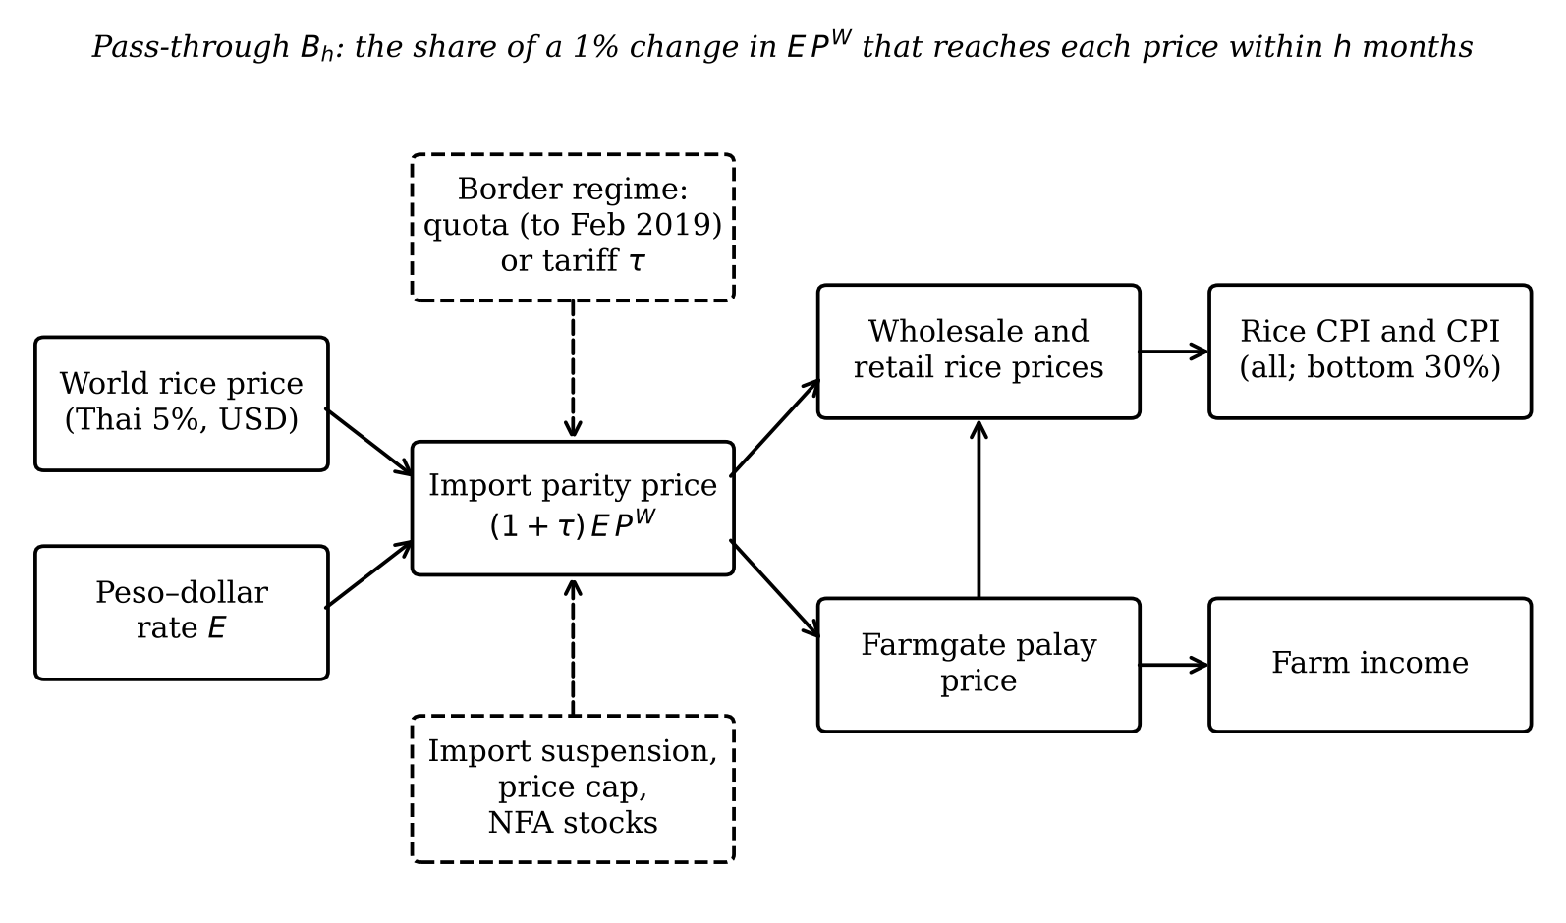
Conceptual framework. Solid arrows show how a world price change travels to domestic prices; dashed boxes and arrows show the policy levers (border regime, import suspension, price cap, NFA stocks).
The general theory gives the estimating equation. If importers price at import parity plus a marketing margin $m$, $P^{\text{dom}}=(1+τ)EP^{W}+m$, then a 1% change in $EP^{W}$ changes the domestic price by $∂lnP^{\text{dom}}/∂ln(EP^{W})=(1+τ)EP^{W}/P^{\text{dom}}$, the share of the import cost in the final price. Under a binding quota this elasticity is close to zero. The farmgate price is the milled price minus milling and marketing costs, so in percentage terms it moves more than the retail price (Gardner 1975), which is H2. Finally, by cost-of-living index theory, group $g$’s inflation is πg=k​wkgπk, so the effect of a rice shock on the gap is roughly $B_{h}^{\text{rice}}(w_{\text{rice}}^{A}−w_{\text{rice}}^{B30})$, which is negative because the poor’s rice weight is larger (H5). Deaton (1989) and Ivanic and Martin (2008) show that the welfare effect then depends on whether a household is a net buyer or a net seller of rice.

Chapter 3. Digression: the model and how to implement it
This chapter is a tutorial. Someone new to the method should be able to reproduce the study from it.

3.1 The question an impulse response answers
We want the path of domestic rice prices in the months after a world price change, holding everything else as it would otherwise have been. That path is an impulse response: the response of $y$ at $t+h$ to a one-unit shock at $t$, for $h=0,1,2,…$

3.2 The local projection idea
A VAR estimates one model of how all variables evolve together and then iterates it forward to get the responses. A local projection (Jordà 2005) skips the iteration: for each horizon $h$ it runs a separate regression of the outcome $h$ months ahead on today’s shock. If the VAR is right both give the same answer (Plagborg-Møller and Wolf 2021); if it is wrong, the local projection is more robust, and its standard errors are simple (Montiel Olea and Plagborg-Møller 2021).

3.3 The specification term by term
For each $h=0,…,12$ we estimate by ordinary least squares
$$\sum_{j=0}^{h}{π_{r,t+j}}=α_{r}+B_{h}f_{t}+θ_{h}(f_{t}×{\text{post}}_{t})+\sum_{q=1}^{12}{γ_{q}}π_{r,t−q}+\sum_{q=1}^{12}{λ_{q}}f_{t−q}+\sum_{l=1}^{h−1}{ρ_{l}}f_{t+l}+δ {\text{post}}_{t}+κt+ε_{r,t+h}. (1)$$
The left side is the cumulative rice inflation from $t$ to $t+h$ in region $r$, so $B_{h}$ is directly the cumulative pass-through. $α_{r}$ are region fixed effects: they let each region have its own average inflation. The twelve past values of rice inflation and of the shock account for earlier movements and for seasonal patterns, such as the lean months before the harvest. The Teulings–Zubanov leads $f_{t+1},…,f_{t+h−1}$ make sure $B_{h}$ is not confused with the effect of later shocks (Teulings and Zubanov 2014). ${\text{post}}_{t}$ equals 1 from March 2019; $θ_{h}$ is the change in pass-through after the law, and $B_{h}+θ_{h}$ is the post-law pass-through. The trend $κt$ absorbs slow drifts.

3.4 From monthly effects to the level
Because the left side is a running sum, $B_{6}=0.4$ means that a 1% world price rise raises the level of the rice CPI by 0.4% after six months. The monthly effect at horizon $h$ is $B_{h}−B_{h−1}$.

3.5 Standard errors
Standard errors measure how uncertain an estimate is. Because all regions face the same world price in the same month, their errors are correlated across regions and over time. Driscoll–Kraay standard errors (Driscoll and Kraay 1998) allow for correlation over time and across regions; for single national series we use Newey–West standard errors (Newey and West 1987), which allow for correlation over time. Bands in the figures are 90% intervals.

3.6 The panel and group differences
To ask whether a group $G$ of regions (for example rice-deficit regions) changed differently, we add $f_{t}×G_{r}$, $f_{t}×{\text{post}}_{t}×G_{r}$ and the corresponding dummies. The coefficient on the triple product is the extra change in group $G$.

3.7 Checking the implementation
Before any real estimate we checked the code in two ways. First, simulation tests (tests/test_lp.py, tests/test_pvar.py) generate data with a known response and confirm that the estimators recover it. Second, the replication gate (Section 4.4) reproduces a published result on the same public data.

3.8 Step-by-step implementation
The whole study runs from one command, ./run_all.sh. The steps are: download the raw files unchanged (scripts/01_download_*.py); clean them into long tables (02_clean_*.py); build the regional and national panels (03_build_panel.py); run the replication gate (04_replicate.py); estimate (05_estimate.py); run the episode analysis (07_episode_2024.py) and the descriptive statistics (09_descriptive.py); draw the figures (06_figures.py); and render the documents (08_paper.py, 10_analysis_report.py, 11_master_document.py). The core call is:
from rtl.lp import local_projection
res = local_projection(panel, y="dl_rice", x="f", time="t", unit="region",
horizons=12, p=12, interact=("post",), exog=("post",),
cumulative=True, se="driscoll_kraay")

3.9 Common pitfalls
Do not mix outcomes in levels and shocks in changes. Do not drop the leads: without them $B_{h}$ partly measures later shocks. Do not use standard errors clustered only by region when the shock is common to all regions: robustness check (o) shows they are several times too small. Do not read a single significant horizon as a result; decide in advance which horizons count (here $h=6$ and $h=12$).

Chapter 4. Methodology

4.1 Design
The design compares pass-through before and after a national policy change, within a panel of regions, with the reference study replicated first and every specification fixed in advance. The pre-registered plan, the decisions log (D1–D12) and the replication gate are in CLAUDE.md and were committed to the repository before the corresponding estimates were run.

4.2 Data
Table 1 lists the variables. All are official and public; each raw file is logged in data/raw/source_log.md with its URL, date pulled, base year and coverage.
Table 1. Variables and sources.
Variable | Symbol | Source | Coverage | Use
Rice CPI, all income, by region (item 01.1.1.12, 2018 = 100) | $P_{rt}^{R}$ | PSA OpenSTAT | 1994M1–2026M9 | RQ1, RQ4, Objective 3
All-items CPI, all income and bottom 30% | $P_{t}^{A},P_{t}^{B30}$ | PSA OpenSTAT | 2000M1–2026M9 | RQ5
CPI weights 2018 (all income; bottom 30%) | $w_{k}^{g}$ | PSA OpenSTAT | 2018 | RQ5, Objective 3
Retail, wholesale prices of regular-milled rice; farmgate palay | $P^{\text{ret}},P^{\text{whs}},P^{\text{farm}}$ | PSA price surveys | 2010M1–2026M9 | RQ2, RQ3
Thai 5% and Viet 5% rice; urea; Dubai crude | $P_{t}^{W}$ | World Bank Pink Sheet | 1990M1–2026M9 | Shock, robustness
Peso–dollar rate, monthly average | $E_{t}$ | BSP | 1990M1–2026M9 | Shock
Oceanic Niño Index | ONI | NOAA | 1990M1–2026M8 | Replication, robustness
Three construction choices matter. Geography: we use PSA’s old 17-region code, which has the long history, and extend it to 2026 with the growth of the new code; four regions whose boundaries changed (Western and Central Visayas, SOCCSKSARGEN, BARMM) are flagged for those months (D5). Splicing: national retail prices join three PSA survey series on growth rates; the 2012-based and 2018-based series agree closely (correlation of monthly changes 0.99), the 1990-based series less so (D12). Validation: the rice CPI and the separate retail price survey move together (correlation of monthly changes 0.98); the bottom-30% and all-income rice CPIs correlate at 0.995; the Thai and Vietnamese world prices correlate at only 0.43, which is why the Vietnamese price is a robustness check.

4.3 Methods by objective
Objective 1 uses summary statistics by sub-period, annual inflation by income group, the contribution of rice to headline inflation (rice weight times rice inflation), episodes of world price spikes (at least three months with a 12-month rise of 15% or more), cross-correlations between the shock and rice inflation, the dispersion of rice prices across regions, and unit-root tests.
Objective 2 uses equation (1) for RQ1 (panel, 1995–2026), the same equation on national farmgate, wholesale and retail prices for RQ2 (2011–2026, Newey–West), an interrupted time-series regression of the border gap $G_{t}$ on dummies for the law, the 15% tariff and the suspension with month dummies for RQ3, triple interactions for RQ4, and national local projections of the all-items CPIs and of $ΔD_{t}$ for RQ5 (2001–2026). The decisive horizons are $h=6$ and $h=12$; for RQ4 we use a Bonferroni correction across the two group tests, so each is judged at 5%. The robustness menu has fifteen checks, lettered (a) to (o), listed in Table 6.
Objective 3 applies the post-law pass-through, estimated only on data that end in June 2024, to the July 2024 tariff cut, which lowers the peso cost of imports by $100ln(1.15/1.35)$ = −16.0 log points. The predicted change in the rice CPI from June 2024 to month $m$ is t​Bm−t(ft+τt); we compare it with the actual change, by region, and convert the tariff part into pesos for a poverty-line family of five, using the PSA’s 2023 poverty threshold (PHP 13,873 a month) and the bottom-30% rice weight. The 2025 suspension is analysed descriptively (exploratory).

4.4 Validation: the replication gate
We fixed the pass criteria before downloading any data (Table 2). The data replication is exact: our regional rice CPI means and standard deviations for 1994M1–2023M3 equal those in Antonio et al.’s Table 1 in all 17 regions (largest deviation 0.000), and their “fuel price” turns out to be CPI item 07.2.2, transport fuels (the other candidate deviates by 6.3 points). Our panel VAR replica reproduces their main response: a one-standard-deviation world price shock raises rice inflation by 0.256 points after one month (95% band 0.215 to 0.303), the peak, and the response is gone by month six (0.002). The gate failed on the third criterion: the peak response in rice-deficit regions is 1.26 times that in surplus regions, below the pre-registered range of 1.3 to 3.0, and the peak in high-poverty regions is not below that in low-poverty regions. No coding error was found, and two lags give the same ratio (1.27). An exploratory look shows that the paper’s wording fits the impact response better than the peak (impact ratio 1.69; low- versus high-poverty impact 0.236 versus 0.102), but we did not change the criterion. We proceeded with estimation (decision D11) because the data and the core estimator are validated; region-group results (RQ4) are labelled as not validated.
Table 2. Replication gate against Antonio et al. (2024), pre-registered 14 October 2026.
Criterion | Target | Result | Pass
G1 rice CPI means within 0.5 of Table 1 | >= 15 of 17 | 17 of 17 (median |dev| 0.000) | yes
G1 rice CPI SDs within 0.5 of Table 1 | >= 15 of 17 | 17 of 17 (median |dev| 0.000) | yes
G1b fuel CPI means within 0.5 (better candidate) | >= 15 of 17 | cpi_fuel_tr: 17 of 17 (median |dev| 0.000; other cpi_fuel_hh: 6.338) | yes
G2(i) THAI->RPI 95% band above zero at h=1 | lo > 0 | irf 0.256 [0.215, 0.303] | yes
G2(ii) THAI->RPI peaks at h=1 or 2 | h in {1,2} | peak at h=1 (0.256) | yes
G2(iii) THAI->RPI below 25% of peak by h=6 | < 0.25 x peak | h=6: 0.002 (0.01 of peak) | yes
G2(iv) FPI->RPI positive at h=0 | > 0 | 0.143 [0.143, 0.143] | yes
G2(v) FPI->RPI below 25% of impact by h=3 | < 0.25 x h0 | h=3: -0.006 (-0.04 of impact) | yes
G3 peak ratio insufficient/sufficient | in [1.3, 3.0] | 1.26 (0.296 / 0.235) | no
G3 peak high poverty < low poverty | high < low | high 0.260 vs low 0.255 | no
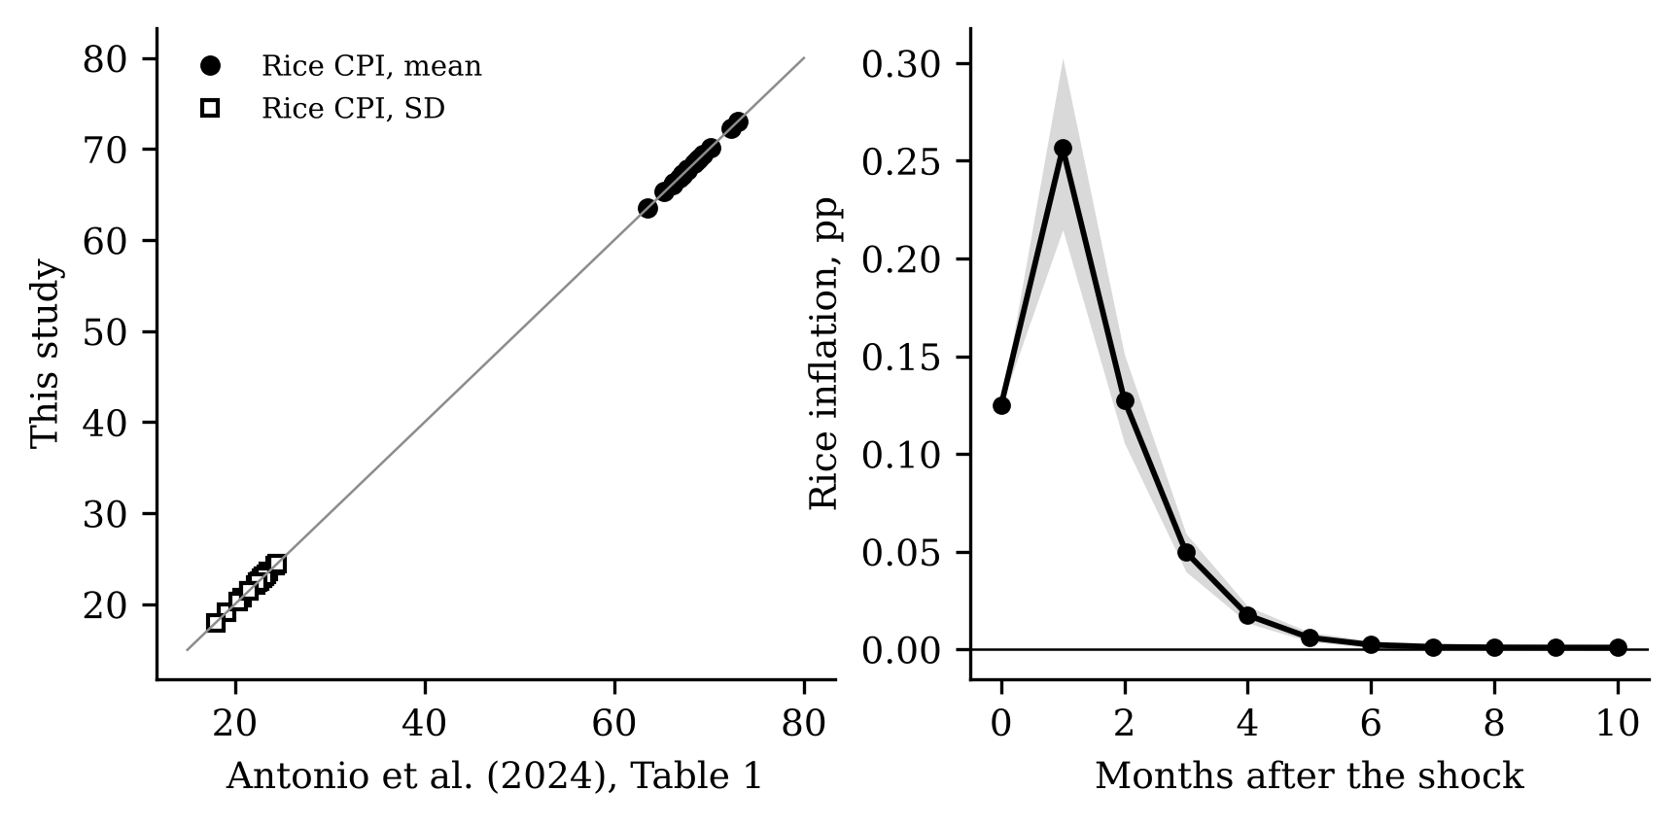
Replication. Left: regional means (circles) and standard deviations (squares) of the rice CPI, 1994M1–2023M3, in Antonio et al. (2024, Table 1) and in this study; the line is equality. Right: response of regional rice inflation (percentage points) to a one-standard-deviation world rice price shock in the panel VAR replica, with the 95% Monte Carlo band (grey).

4.5 Software and reproducibility
Python 3 with pandas, statsmodels and linearmodels; figures in matplotlib; documents rendered from templates with Jinja2 and pandoc. Raw files are kept unchanged; every output and every number in this paper is regenerated by ./run_all.sh.

4.6 Ethics
The study uses only published aggregate statistics; no human subjects are involved.

Chapter 5. Results and Discussion

5.1 Objective 1: rice prices before and after the law
Figure 2 shows the rice CPI and the world rice price in pesos since 1995. Until 2008 the two move together loosely; the 2008 world price spike passes into domestic prices with a lag and a smaller amplitude. Between 2012 and 2018, under quotas, the domestic price stays well above the world price and barely reacts to it. After 2019 the two move together much more closely, including the 2023 spike and the 2025 fall, until the domestic surge of early 2026 at a time of stable world prices.
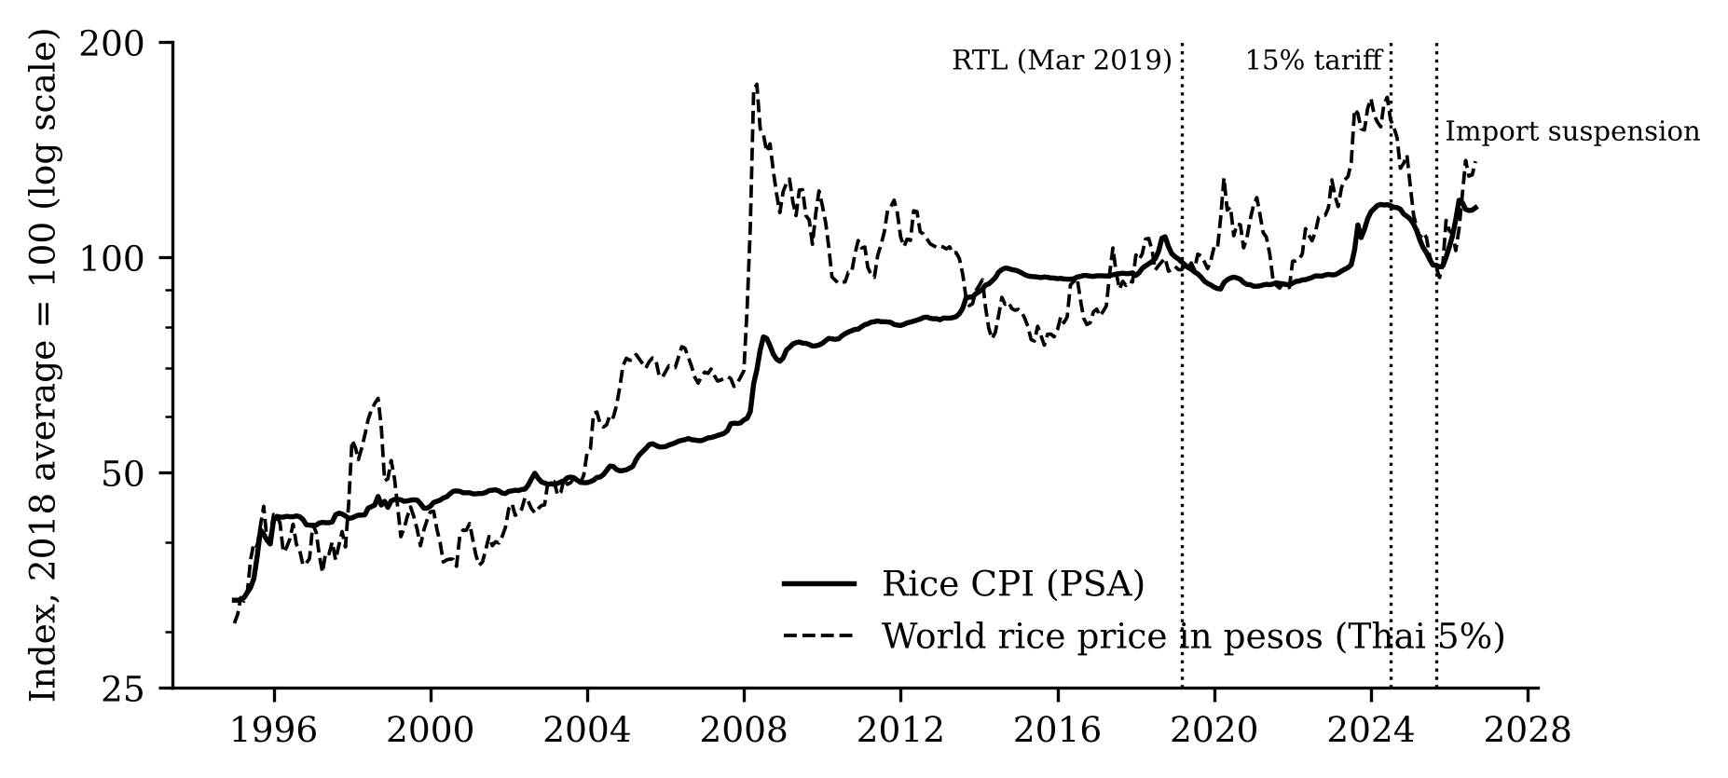
Rice consumer price index (PSA) and the world rice price (Thai 5%) in pesos, monthly, index 2018 average = 100, log scale. Dotted lines mark the Rice Tariffication Law (March 2019), the 15% tariff (July 2024) and the import suspension (September 2025).
Table 3 summarises rice inflation by period. Under quotas (2009 to February 2019) monthly rice inflation was calm, with a standard deviation of 0.82 points. It rose to 1.52 under the 35% tariff and to 2.33 after July 2024: an open border imports world volatility. In the law’s first year (2019) the rice CPI fell by −10.1% (December to December), and by −11.8% for the bottom 30%. In 2023, when world prices spiked, it rose by 17.9%, contributing about 1.6 percentage points to headline inflation for all households and 3.5 for the bottom 30% (Table 4).
Table 3. Rice CPI inflation and world rice price changes by period (national; annualised means of monthly log changes, and standard deviations of monthly changes).
Period | Rice CPI, % a year | Rice CPI, SD monthly | World rice (PHP), % a year | World, SD monthly | Months
1995M1-2007M9 | 4.6 | 1.36 | 6.8 | 4.76 | 153
2007M10-2008M12 (world crisis) | 16.1 | 3.31 | 42.7 | 15.24 | 15
2009M1-2019M2 (quotas) | 3.2 | 0.82 | −1.8 | 4.37 | 122
2019M3-2024M6 (35% tariff) | 3.3 | 1.52 | 10.4 | 5.09 | 64
2024M7-2026M9 (15% tariff, suspension, indexed tariff) | −0.4 | 2.33 | −9.2 | 6.29 | 27

Table 4. Annual inflation (December to December, log points) and the approximate contribution of rice to headline inflation (2018 rice weight × rice inflation). 2026 is September 2025 to September 2026.
Year | Rice, all | Rice, bottom 30% | Headline, all | Headline, bottom 30% | World rice (PHP) | Rice contribution, all | Rice contribution, bottom 30%
2012 | 2.1 | nan | 2.8 | 2.8 | −11.1 | 0.18 | nan
2013 | 8.1 | 6.8 | 3.7 | 4.5 | −14.0 | 0.71 | 1.22
2014 | 7.6 | 7.0 | 1.9 | 3.0 | −6.3 | 0.67 | 1.25
2015 | −2.6 | −2.4 | 0.7 | 0.8 | −8.6 | −0.23 | −0.42
2016 | 0.5 | 0.5 | 2.2 | 1.8 | 8.0 | 0.05 | 0.09
2017 | 1.1 | 0.6 | 2.9 | 2.6 | 9.6 | 0.10 | 0.11
2018 | 6.2 | 7.0 | 5.0 | 6.0 | 4.1 | 0.55 | 1.24
2019 | −10.1 | −11.8 | 2.3 | 1.3 | 2.8 | −0.90 | −2.10
2020 | 0.1 | −0.2 | 3.2 | 3.6 | 13.1 | 0.01 | −0.03
2021 | −0.1 | −0.2 | 3.0 | 3.3 | −21.8 | −0.01 | −0.04
2022 | 3.4 | 3.8 | 7.7 | 9.0 | 25.8 | 0.30 | 0.68
2023 | 17.9 | 19.4 | 3.9 | 4.8 | 32.0 | 1.59 | 3.46
2024 | 0.8 | 0.7 | 2.9 | 2.5 | −15.0 | 0.07 | 0.12
2025 | −13.1 | −15.1 | 1.8 | 1.1 | −21.1 | −1.17 | −2.69
2026 | 18.5 | 21.2 | 6.9 | 8.6 | 34.3 | 1.64 | 3.78
Regional rice prices also converged. The coefficient of variation of retail regular-milled rice prices across regions fell from 6.7% in 2015–2017 to 4.1% in 2021–2024, a sign of better-integrated regional markets, before rising to 5.6% in 2026 (Figure 3). The border gap (Figure 4) fell from an average of 46 log points under quotas (2010 to February 2019) to 35 under the 35% tariff, and rose again to 46 after the tariff cut. We identify 11 world price episodes since 1995 (Annex Table A1). Before the law, world price shocks were followed by rice inflation with a correlation of at most 0.28; after the law, by up to 0.35 at a lag of 4 months. Rice CPI levels are not stationary (augmented Dickey–Fuller p = 0.26); monthly changes are, which is why we model changes.
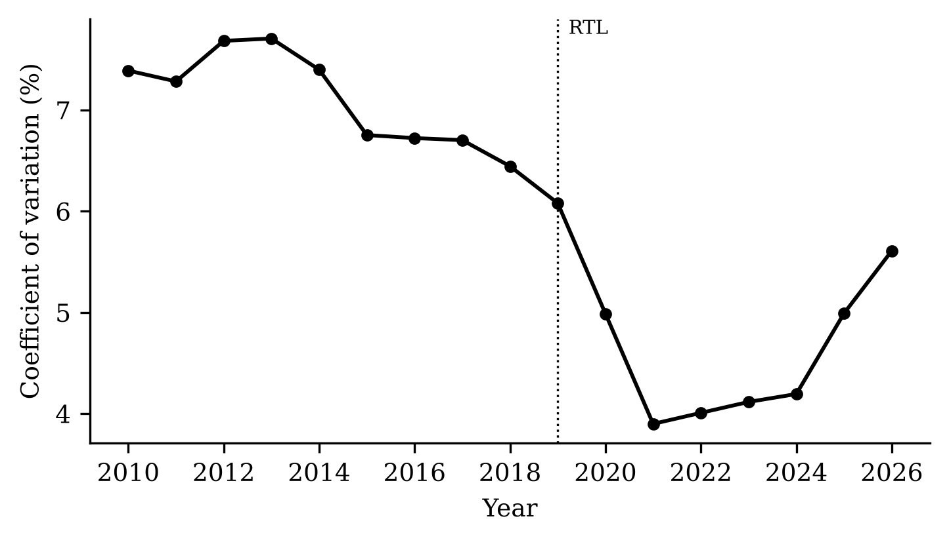
Coefficient of variation (%) of the annual average retail price of regular-milled rice across the 17 regions. The dotted line marks the Rice Tariffication Law.
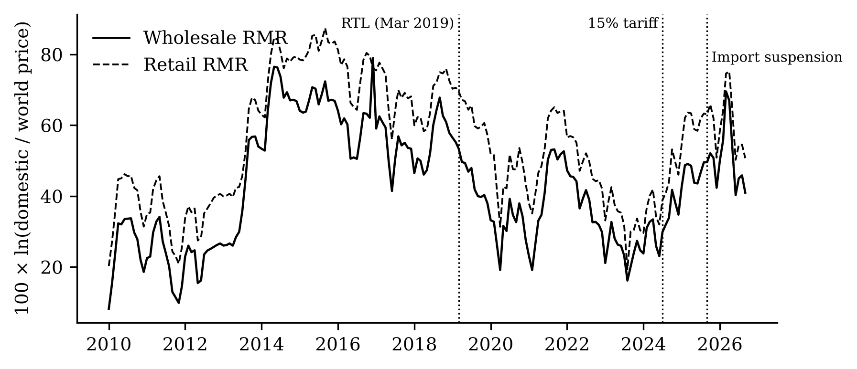
Border gap: 100 × ln of the domestic price of regular-milled rice (wholesale, solid; retail, dashed) over the world price (Thai 5%) in pesos per kilogram, monthly 2010–2026.

5.2 Objective 2: pass-through and the law
RQ1: consumer rice prices. Over the whole period, a 1% rise in the world price raises regional rice CPIs by 0.23 percentage points within six months and 0.24 within twelve. Table 5 and Figure 5 split this by regime. Before the law, pass-through at six months was 0.16 (0.05); after it, 0.46 (0.14), about 2.9 times larger. The change θ₆ = 0.30 (0.16) is significant at the 10% level only (p = 0.06); at twelve months it is 0.20 (0.21, p = 0.34), not significant. The national rice CPI gives the same picture (0.16 before, 0.44 after). So the evidence supports H1a at six months, weakly, and cannot reject H1b at twelve.
Table 5. Cumulative pass-through of a 1% world rice price change (pesos) to regional rice CPIs, percentage points; Driscoll–Kraay standard errors in parentheses; *, **, *** significant at 10%, 5%, 1%. 17 regions, 1995M1–2026M9.
Months (h) | Before the law | After the law | Change θ | Observations
0 | 0.04 (0.02) | 0.07** (0.03) | 0.03 (0.04) | 6460
3 | 0.15** (0.06) | 0.30*** (0.10) | 0.14 (0.13) | 6409
6 | 0.16*** (0.05) | 0.46*** (0.14) | 0.30* (0.16) | 6358
9 | 0.17*** (0.05) | 0.48*** (0.15) | 0.31* (0.17) | 6307
12 | 0.20*** (0.07) | 0.40** (0.18) | 0.20 (0.21) | 6256
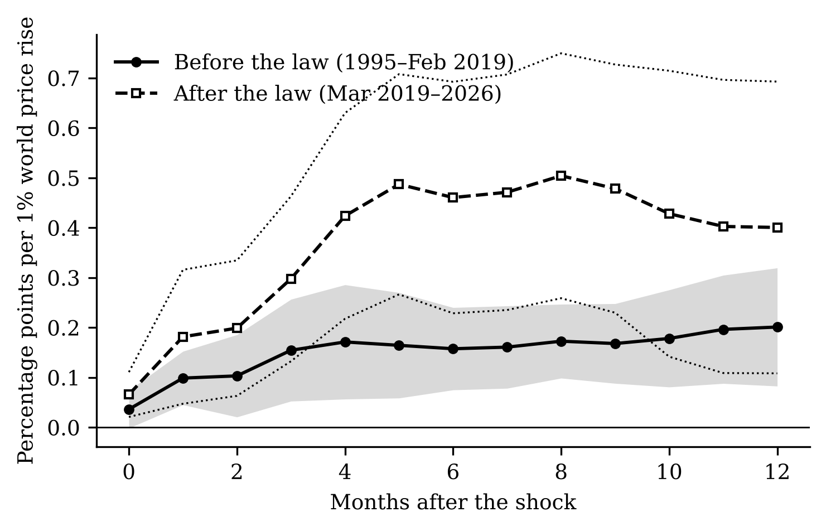
Cumulative response of regional rice CPIs to a 1% rise in the world rice price in pesos, before the law (solid, grey 90% band) and after it (dashed, dotted 90% band), percentage points.
The robustness checks (Table 6, Figure 6) show where the result is solid and where it is fragile. The change at six months ranges from 0.13 to 0.44 across the checks and keeps its 90% band above zero in 12 of 15 checks with standard errors; at twelve months it ranges from 0.06 to 0.40 and its band excludes zero in 2. It is larger without the 2007–08 crisis (0.37), without 2020 (0.39), and in a window of seven years on each side of the law (0.44, significant at 5%, and 0.40 at twelve months). It weakens with the Vietnamese price (0.33, imprecise) and, importantly, with data ending in June 2024: then the change at six months is only 0.13 (0.18). With macroeconomic controls the change at twelve months falls to 0.06. Leaving out any one region changes $θ_{6}$ only within 0.29 to 0.32. A placebo law date in March 2016, within the quota period, gives 0.07 (0.10), not significant. Standard errors clustered only by region are several times smaller and overstate precision, as Section 3.9 warned.
Table 6. Robustness of the change in pass-through after the law, θ, at 6 and 12 months (percentage points per 1%); standard errors in parentheses; for (l) the range across the 17 leave-one-out estimates.
Check | Change θ, h = 6 | Change θ, h = 12
Baseline | 0.30* (0.16) | 0.20 (0.21)
(a) Real shock | 0.31* (0.17) | 0.21 (0.22)
(b) Viet 5% | 0.33 (0.22) | 0.29 (0.26)
(c) USD price + FX control | 0.25 (0.18) | 0.19 (0.26)
(d) Macro controls | 0.28** (0.14) | 0.06 (0.16)
(e) 6 lags | 0.31* (0.16) | 0.19 (0.22)
(e) 18 lags | 0.28* (0.17) | 0.23 (0.22)
(f) Without 2007–08 crisis | 0.37** (0.15) | 0.29 (0.20)
(g) Without 2020 | 0.39** (0.18) | 0.33 (0.22)
(h) Ending June 2024 | 0.13 (0.18) | 0.20 (0.19)
(i) 2012–2026 window | 0.44** (0.20) | 0.40* (0.24)
(j) Asymmetry | 0.33** (0.15) | 0.24 (0.20)
(k) Drop chained 2026 | 0.31* (0.16) | 0.20 (0.21)
(o) Clustered SE | 0.30*** (0.03) | 0.20*** (0.03)
(l) Leave one region out (range) | 0.29 to 0.32 | 0.19 to 0.21
(m) Separate pre/post models | 0.25* (0.13) | 0.08 (0.10)
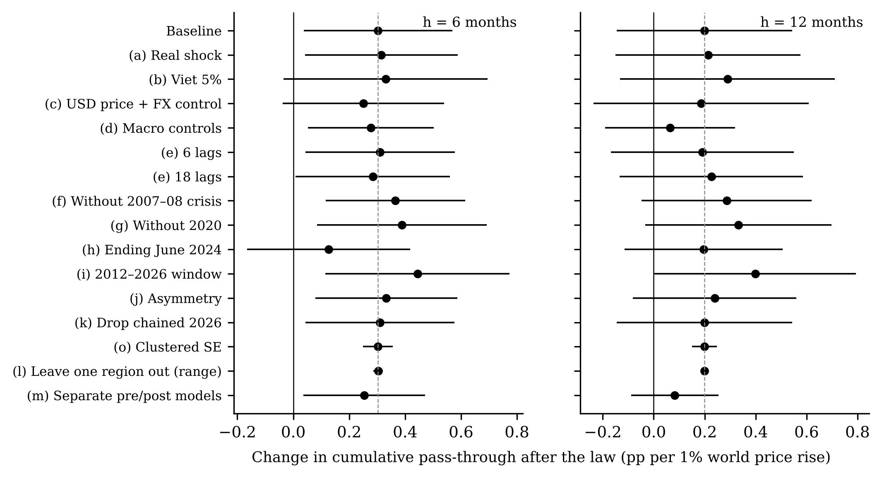
Change in cumulative pass-through after the law at 6 months (left) and 12 months (right) across the robustness checks: point estimates with 90% intervals; for (l) the range across leave-one-region-out estimates. The dashed line is the baseline.
RQ2: along the chain. The clearest result of the study is in Table 7 and Figure 7. From 2011 to February 2019, pass-through to farmgate, wholesale and retail prices was statistically zero at every stage. After the law, six-month pass-through is 0.74 for farmgate palay, 0.61 for wholesale rice and 0.53 for retail rice; all changes are significant at six months. At twelve months the changes are smaller and less precise. Farmgate pass-through is the largest, which supports H2: as the framework predicts, the price farmers receive now moves more, in percent, than the price consumers pay. The regional farmgate panel gives a similar post-law value (0.77). In this window the pre-law consumer pass-through is near zero rather than the 0.16 of the long sample, because the 1995–2008 years, when world and domestic prices moved together, are excluded.
Table 7. Cumulative pass-through to national farmgate, wholesale and retail rice prices and the rice CPI, before and after the law, 2011M1–2026M9; Newey–West standard errors in parentheses.
Price | Before, h=6 | After, h=6 | Change, h=6 | Before, h=12 | After, h=12 | Change, h=12
Farmgate palay | 0.00 (0.22) | 0.74*** (0.25) | 0.74** (0.35) | 0.03 (0.29) | 0.59*** (0.20) | 0.56 (0.39)
Wholesale RMR | −0.16 (0.19) | 0.61*** (0.16) | 0.77*** (0.26) | −0.11 (0.29) | 0.50*** (0.17) | 0.61 (0.39)
Retail RMR | −0.03 (0.13) | 0.53*** (0.13) | 0.56*** (0.19) | −0.04 (0.20) | 0.45*** (0.17) | 0.49* (0.29)
Rice CPI | −0.03 (0.11) | 0.45*** (0.12) | 0.48*** (0.17) | −0.05 (0.16) | 0.40*** (0.14) | 0.44* (0.24)
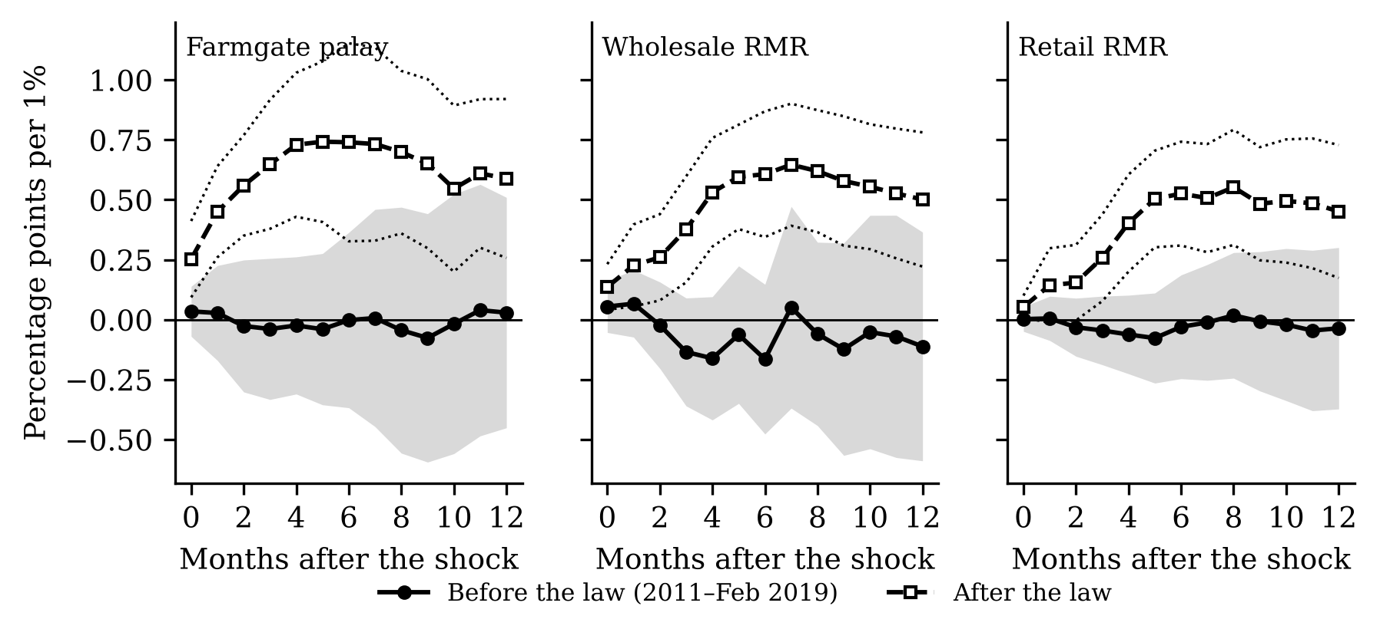
Cumulative response of national farmgate palay, wholesale and retail regular-milled rice prices to a 1% world rice price rise, before (solid) and after (dashed) the law, with 90% bands.
RQ3: the border gap. Table 8 shows that the wholesale–world gap fell by −11.2 log points after the law (p = 0.089), and rose by 10.6 after the 2024 tariff cut (p = 0.020). Holding the world price constant (columns 2 and 4), the gap moves −0.8 points for each 1% rise in the world price, so domestic prices absorb only a small part of world movements in levels; the law dummy is then no longer negative, and the tariff cut is associated with a gap 15.2 points wider. H3 is rejected for the 2024 cut: lowering the duty by 20 points did not narrow the gap.
Table 8. Interrupted time-series regressions of the border gap (100 × ln domestic/world price), 2010M1–2026M9, with month dummies; Newey–West (12 lags) standard errors in parentheses. Columns (2) and (4) add the log world price.
 | Wholesale (1) | Wholesale (2) | Retail (1) | Retail (2)
Law in force (from Mar 2019) | −11.2* (6.6) | 5.5 (5.4) | −11.4 (7.2) | 7.4 (5.1)
15% tariff (from Jul 2024) | 10.6** (4.5) | 15.2*** (4.5) | 9.4** (4.8) | 14.6*** (3.6)
Import suspension (Sep–Dec 2025) | 2.0 (4.3) | −13.8*** (4.2) | 2.3 (4.0) | −15.4*** (3.5)
World price (log × 100) |  | −0.83*** (0.18) |  | −0.93*** (0.17)
RQ4: regions (not validated). Table 9 and Figure 8 show no significant difference at the decisive twelve-month horizon: the extra change in rice-deficit regions is −0.05 (0.07) and in high-poverty regions 0.06 (0.05). At six months the high-poverty term is 0.09 (p = 0.03), below the Bonferroni threshold, but this horizon was not the decisive one. We cannot reject H4b. Because the reference paper’s group ordering did not replicate (Section 4.4), we put little weight on these group results.
Table 9. Extra change in pass-through after the law in rice-deficit and high-poverty regions (θ on shock × post × group), percentage points per 1%; Driscoll–Kraay standard errors; Bonferroni threshold 5% for each test.
Group | θ post×G, h=6 | p | θ post×G, h=12 | p
Rice-deficit regions | −0.06 (0.05) | 0.163 | −0.05 (0.07) | 0.479
High-poverty regions | 0.09** (0.04) | 0.027 | 0.06 (0.05) | 0.295
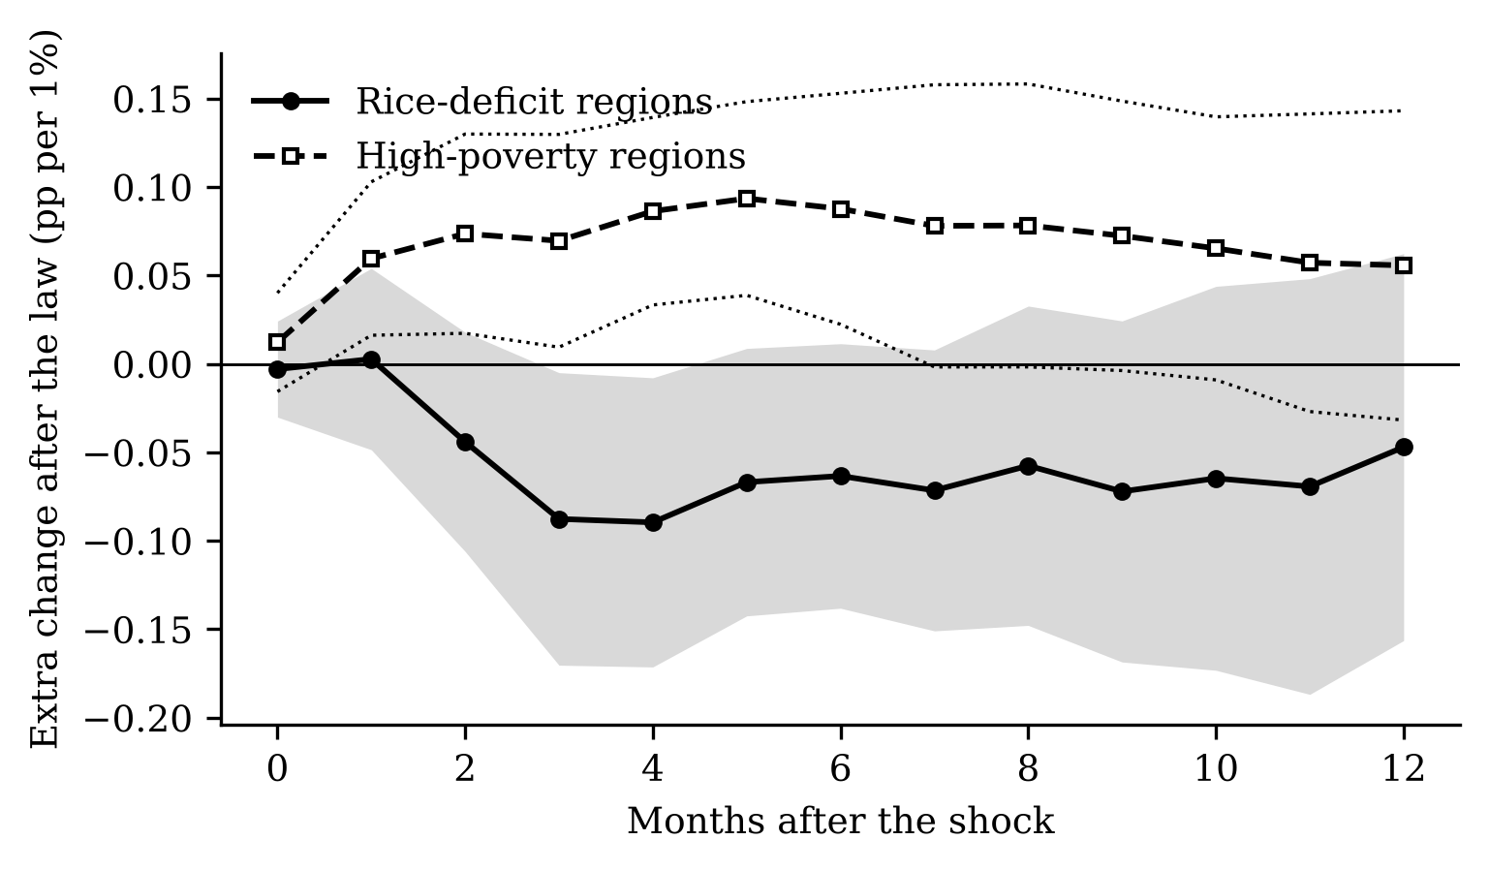
Extra change in cumulative pass-through after the law in rice-deficit regions (solid, grey band) and high-poverty regions (dashed, dotted band), percentage points per 1%, 90% bands.
RQ5: the poor. A 1% world rice price rise raises the all-items CPI of all households by 0.045 percentage points within six months and that of the bottom 30% by 0.110, 2.4 times as much (Table 10, Figure 9). The inflation gap falls by −0.060 (0.010): world rice shocks are regressive, supporting H5. The difference in rice weights alone (17.9% against 8.9%) predicts a gap of −0.022, about 36% of the estimate; the rest presumably comes from other foods whose prices follow rice, which also weigh more for the poor. The law did not change the regressive pattern (θ₆ = 0.018, standard error 0.021).
Table 10. Cumulative response of national all-items CPIs, their gap and the national rice CPI to a 1% world rice price rise, percentage points, 2001M1–2026M9; Newey–West standard errors.
Outcome | h = 0 | h = 6 | h = 12
All-items CPI, all income | 0.013*** (0.004) | 0.045*** (0.009) | 0.043*** (0.012)
All-items CPI, bottom 30% | 0.028*** (0.007) | 0.110*** (0.018) | 0.100*** (0.026)
Gap ΔD (all income − bottom 30%) | −0.014*** (0.004) | −0.060*** (0.010) | −0.052*** (0.016)
Rice CPI (national) | 0.056** (0.023) | 0.240*** (0.050) | 0.239*** (0.075)
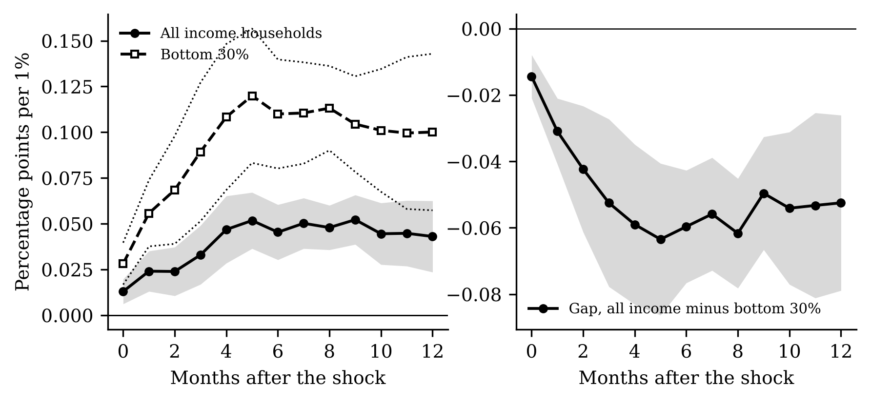
Left: cumulative response of the all-items CPI for all income households (solid) and for the bottom 30% (dashed). Right: response of the inflation gap, all income minus bottom 30% (negative = regressive). Percentage points per 1% world rice price rise, 90% bands.

5.3 Objective 3: what the estimates imply for policy
The 2024 tariff cut. Using only data up to June 2024, the post-law model predicts that the rice CPI should have fallen by −21.3 log points between June 2024 and June 2025: −15.0 from falling world prices and −6.3 from the tariff cut. The actual fall was −15.4, 103% of the world-price part alone and 73% of the total (Figure 10). After six months the actual fall (−3.7) was only 36% of the predicted (−10.3). In other words, consumers received the fall in world prices but not the tariff cut, the pattern Trinidad, Ravago and Balisacan (2026) describe. In 2 of 17 regions the fall exceeded the prediction (Annex Table A2); the largest fall was in Cagayan Valley (−23.6) and the smallest in CAR (−7.7) (Figure 11).
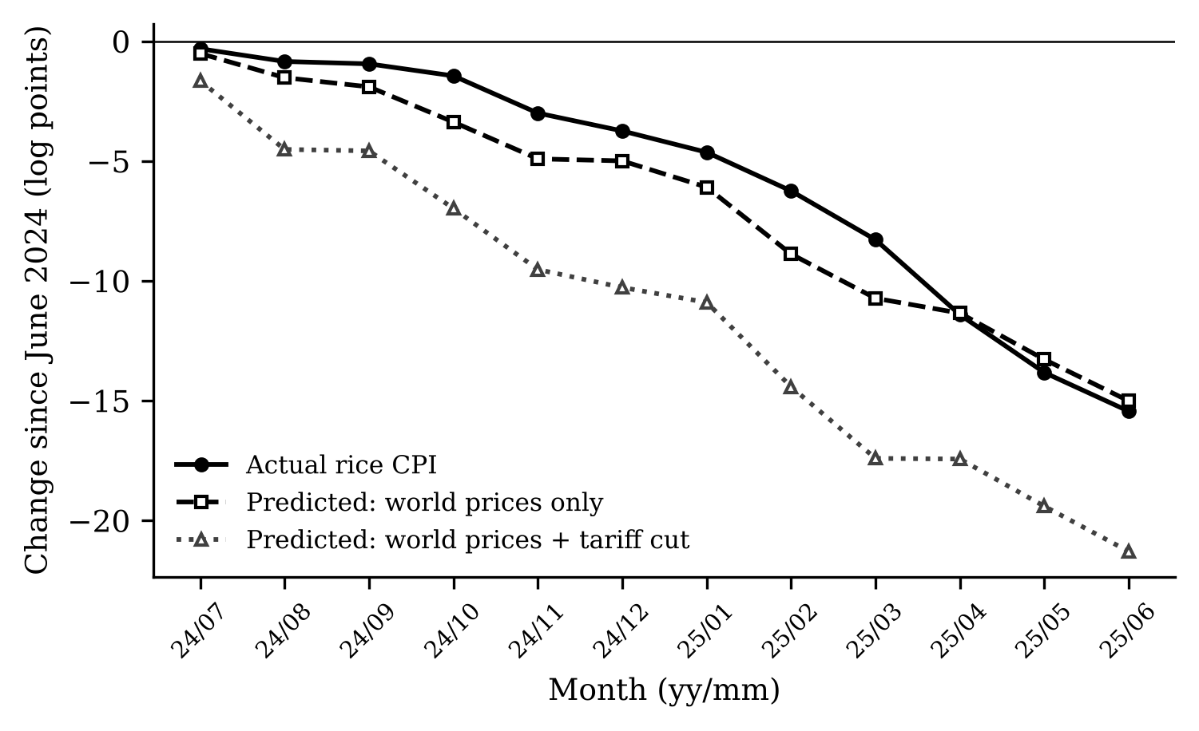
Change in the national rice CPI since June 2024 (log points): actual (solid), predicted from world prices only (dashed), and predicted from world prices plus the July 2024 tariff cut (dotted). Predictions use post-law pass-through estimated on data ending June 2024.
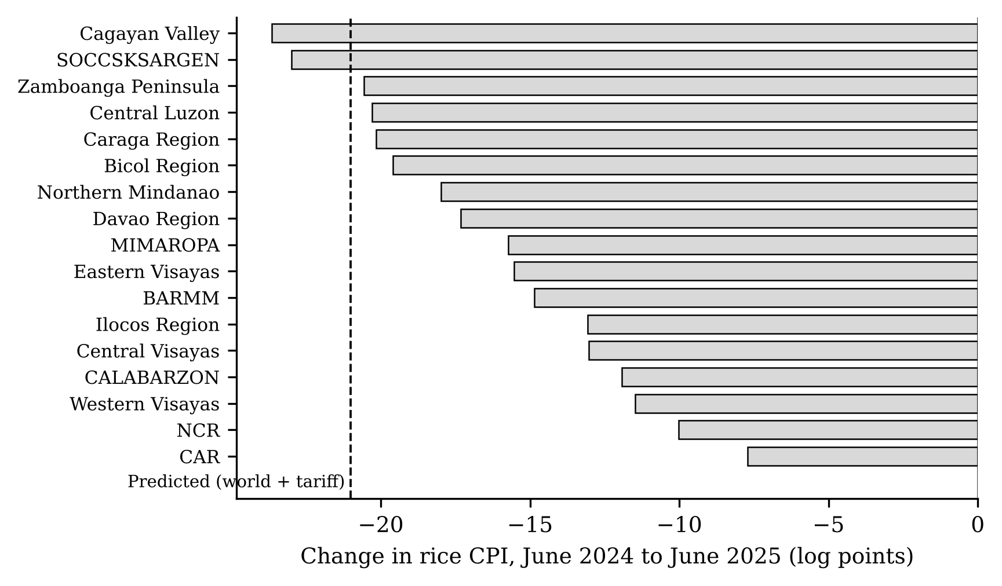
Change in regional rice CPIs from June 2024 to June 2025 (log points). The dashed line is the predicted change from world prices and the tariff cut.
In pesos: a poverty-line family of five (PHP 13,873 a month in 2023) spends about PHP 2,479 a month on rice if its budget shares are those of the bottom-30% CPI. A full pass-through of the tariff wedge would save it about PHP 367 a month; the model predicts PHP 151 after a year; the actual fall in the bottom-30% rice CPI, mostly due to world prices, was worth about PHP 398.
The 2025 import suspension (exploratory). Farmgate palay prices fell −8.9% in September 2025, the first month of the suspension and the start of the main harvest, then rose. Between November 2025 and April 2026 the rice CPI rose 21.1% while the world price in pesos rose 11.4%. From August 2025 to April 2026, world prices alone predict a rise of 4.7% in retail and 7.6% in farmgate prices; the actual rises were 24.2% and 31.1% (Figure 12). The suspension appears to have raised farm prices, as intended, but with a delay and at a large cost to consumers that outlasted the suspension itself. This reading is descriptive: imports resumed in January 2026 at a tariff that may have been 15% or 20% (policy_context.md, P12), and the model was not designed for a closed border.
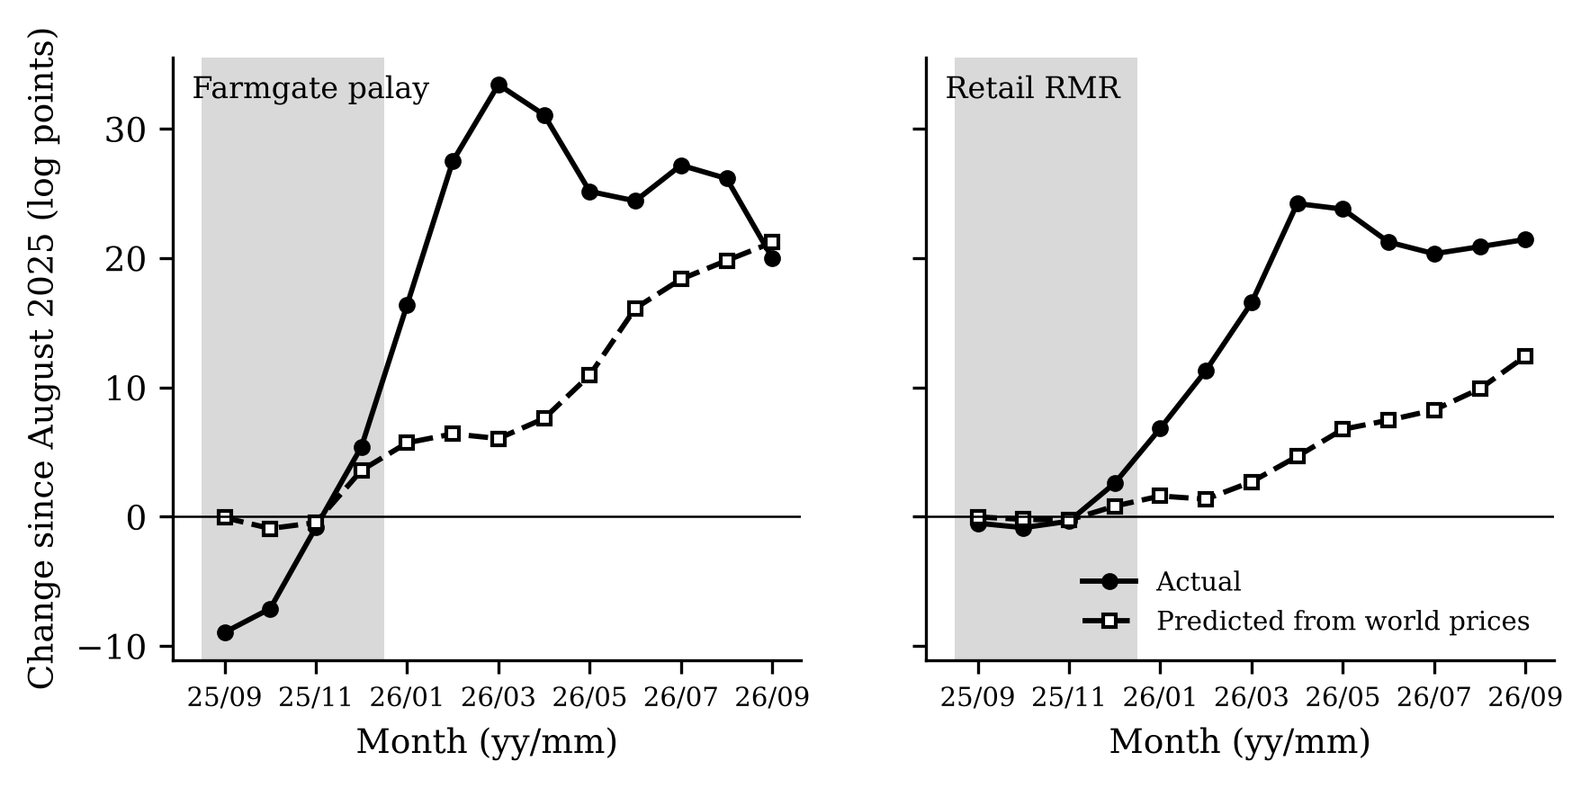
Farmgate palay (left) and retail regular-milled rice (right): change since August 2025 (log points), actual (solid) and predicted from world prices (dashed). Grey shading marks the import suspension, September–December 2025.
The 2026 price-indexed tariff. EO 105 raises the tariff by 5 points for every 5% fall in world prices and lowers it for every 5% rise, within bounds of 15% and 35%. Near a 20% tariff, a 5% world price rise lowers the duty factor by $ln(1.15/1.20)≈−4.3\%$, so the rule offsets about 85% of a world price move in the peso cost of imports while the tariff stays within its bounds. Combined with a post-law pass-through of about 0.40 at twelve months, the rule would leave only a small part of world price moves in consumer prices, but only between the bounds, and only if tariff changes pass through, which the 2024 episode questions. Our data cover only nine months of the rule, so we do not estimate it.

Chapter 6. Summary, Conclusions and Recommendations

6.1 Summary
Objective 1. Since the law, domestic rice prices track world prices more closely, regional prices have converged, and monthly rice inflation has become more volatile. The domestic–world gap narrowed under the 35% tariff and widened again after 2024.
Objective 2. Pass-through to consumer rice prices roughly doubled to tripled after the law at six months (0.16 to 0.46), but the change is significant only at 10% and is fragile. Along the chain, pass-through went from about zero to about 0.53–0.74, largest for farmers. World rice shocks raise the poor’s CPI 2.4 times as much as the average.
Objective 3. The 2024 tariff cut did not reach consumers within a year; the 2025 suspension was followed by a sharp rise in both farmgate and retail prices.

6.2 Conclusions
The law did open the border to world price movements, most clearly for farmers, and it coincided with a large one-off fall in rice prices in 2019. But openness works in both directions: the poor now feel world price spikes more, and later cuts in the tariff were absorbed in the chain rather than passed on.

6.3 Recommendations
To the Tariff Commission and DEPDev: judge tariff changes by their pass-through. Our estimates suggest that at most part of a tariff cut reaches retail prices within a year; the indexed tariff of EO 105 should be evaluated after a full year of data. To the Philippine Competition Commission and the DA: the widening gap after the 2024 cut points to margins in importing, milling and wholesaling; monitor them. To the DA and the Department of Social Welfare and Development: because world rice shocks raise the poor’s CPI 2.4 times as much as the average (RQ5), support during world price spikes is best targeted at poor households; border measures change prices for all buyers. To the DA: in the 2025–26 episode farm prices rose mostly after the suspension ended (5.4% above August 2025 by December, 31.1% by April 2026), while retail prices rose by 24.2% (E4, exploratory); suspensions should be weighed against that consumer cost, and alternatives such as the RCEF productivity programmes, which this study does not evaluate, deserve evaluation.

6.4 Further research
Household-level data from the Family Income and Expenditure Survey would show net buyers and net sellers directly; import volumes and margins by stage would show where the tariff cut was absorbed; and a longer post-2026 sample will allow the indexed tariff to be evaluated.

References
Antonio, Ronald Jeremy, Harold Glenn Valera, Ashok K. Mishra, Valerien Pede, and Takashi Yamano. 2025. “Rice Price Inflation Dynamics in the Philippines.” Australian Journal of Agricultural and Resource Economics 69 (2): 440–52. https://doi.org/10.1111/1467-8489.70012.
Baffes, John, and Bruce Gardner. 2003. “The Transmission of World Commodity Prices to Domestic Markets Under Policy Reforms in Developing Countries.” Journal of Policy Reform 6 (3): 159–80. https://doi.org/10.1080/0951274032000175770.
Balié, Jean, Nicholas Minot, and Harold Glenn Valera. 2021. “Distributional Impacts of the Rice Tariffication Policy in the Philippines.” Economic Analysis and Policy 69: 289–306. https://doi.org/10.1016/j.eap.2020.12.005.
Balié, Jean, and Harold Glenn Valera. 2020. “Domestic and International Impacts of the Rice Trade Policy Reform in the Philippines.” Food Policy 92: 101876. https://doi.org/10.1016/j.foodpol.2020.101876.
Bathan, Bates M. 2026. “Vertical Price Transmission in the Philippine Rice Supply Chain: Responses to Shocks in the Post-Tariffication Period.” The Philippine Agricultural Scientist 109 (1): 35–46. https://doi.org/10.62550/gk22125025.
Bathan, Bates M., Apichart Daloonpate, and Itthipong Mahathanseth. 2025. “The Dynamics of Price Transmission in the Philippine Rice Supply Chain.” Journal of the International Society for Southeast Asian Agricultural Sciences 31 (1): 63–82. http://issaasphil.org/wp-content/uploads/2025/06/5.-Bathan-et-al.-2025-The-dynamics-of-price-transmission-FINAL.pdf.
Briones, Roehlano M. 2019. Welfare Impacts of Rice Tariffication. PIDS Discussion Paper Nos. 2019-16. Philippine Institute for Development Studies. https://doi.org/10.62986/dp2019.16.
Briones, Roehlano M. 2021. Does Rice Tariffication in the Philippines Worsen Income Poverty and Inequality? PIDS Policy Notes Nos. 2021-02. Philippine Institute for Development Studies. https://doi.org/10.62986/pn2021.02.
Ceballos, Francisco, Manuel A. Hernandez, Nicholas Minot, and Miguel Robles. 2017. “Grain Price and Volatility Transmission from International to Domestic Markets in Developing Countries.” World Development 94: 305–20. https://doi.org/10.1016/j.worlddev.2017.01.015.
Clarete, Ramon L. 2022. “Tariffication and Market Structure: The Case of the Philippine Rice Industry.” In Pro-Poor Development Policies: Lessons from the Philippines and East Asia. ISEAS–Yusof Ishak Institute. https://doi.org/10.1355/9789815011067-030.
Dawe, David. 2008. “Can Indonesia Trust the World Rice Market?” Bulletin of Indonesian Economic Studies 44 (1): 115–32. https://doi.org/10.1080/00074910802008053.
Dawe, David, Cristian Morales-Opazo, Jean Balié, and Guillaume Pierre. 2015. “How Much Have Domestic Food Prices Increased in the New Era of Higher Food Prices?” Global Food Security 5: 1–10. https://doi.org/10.1016/j.gfs.2015.01.001.
Dawe, David, and C. Peter Timmer. 2012. “Why Stable Food Prices Are a Good Thing: Lessons from Stabilizing Rice Prices in Asia.” Global Food Security 1 (2): 127–33. https://doi.org/10.1016/j.gfs.2012.09.001.
Deaton, Angus. 1989. “Rice Prices and Income Distribution in Thailand: A Non-Parametric Analysis.” The Economic Journal 99 (395): 1–37. https://doi.org/10.2307/2234068.
Driscoll, John C., and Aart C. Kraay. 1998. “Consistent Covariance Matrix Estimation with Spatially Dependent Panel Data.” Review of Economics and Statistics 80 (4): 549–60. https://doi.org/10.1162/003465398557825.
Furceri, Davide, Prakash Loungani, John Simon, and Susan M. Wachter. 2016. “Global Food Prices and Domestic Inflation: Some Cross-Country Evidence.” Oxford Economic Papers 68 (3): 665–87. https://doi.org/10.1093/oep/gpw016.
Gardner, Bruce L. 1975. “The Farm-Retail Price Spread in a Competitive Food Industry.” American Journal of Agricultural Economics 57 (3): 399–409. https://doi.org/10.2307/1238402.
Ivanic, Maros, and Will Martin. 2008. “Implications of Higher Global Food Prices for Poverty in Low-Income Countries.” Agricultural Economics 39 (s1): 405–16. https://doi.org/10.1111/j.1574-0862.2008.00347.x.
Jordà, Òscar. 2005. “Estimation and Inference of Impulse Responses by Local Projections.” American Economic Review 95 (1): 161–82. https://doi.org/10.1257/0002828053828518.
Kpodar, Kangni, and Boya Liu. 2022. “The Distributional Implications of the Impact of Fuel Price Increases on Inflation.” Energy Economics 108: 105909. https://doi.org/10.1016/j.eneco.2022.105909.
Meyer, Jochen, and Stephan von Cramon-Taubadel. 2004. “Asymmetric Price Transmission: A Survey.” Journal of Agricultural Economics 55 (3): 581–611. https://doi.org/10.1111/j.1477-9552.2004.tb00116.x.
Montiel Olea, José Luis, and Mikkel Plagborg-Møller. 2021. “Local Projection Inference Is Simpler and More Robust Than You Think.” Econometrica 89 (4): 1789–823. https://doi.org/10.3982/ECTA18756.
Mundlak, Yair, and Donald F. Larson. 1992. “On the Transmission of World Agricultural Prices.” The World Bank Economic Review 6 (3): 399–422. https://doi.org/10.1093/wber/6.3.399.
Newey, Whitney K., and Kenneth D. West. 1987. “A Simple, Positive Semi-Definite, Heteroskedasticity and Autocorrelation Consistent Covariance Matrix.” Econometrica 55 (3): 703–8. https://doi.org/10.2307/1913610.
Plagborg-Møller, Mikkel, and Christian K. Wolf. 2021. “Local Projections and VARs Estimate the Same Impulse Responses.” Econometrica 89 (2): 955–80. https://doi.org/10.3982/ECTA17813.
Teulings, Coen N., and Nikolay Zubanov. 2014. “Is Economic Recovery a Myth? Robust Estimation of Impulse Responses.” Journal of Applied Econometrics 29 (3): 497–514. https://doi.org/10.1002/jae.2333.
Trinidad, Emmanuel G., Majah-Leah V. Ravago, and Arsenio M. Balisacan. 2026. “Tariff Cuts Without Consumer Gains? A Competition Policy Perspective on Philippine Price Trends.” The Philippine Review of Economics 63 (1): 5–42. https://doi.org/10.37907/2erp6202j.
Valera, Harold Glenn, Jean Balié, and Emiliano Magrini. 2022. “Is Rice Price a Major Source of Inflation in the Philippines? A Panel Data Analysis.” Applied Economics Letters 29 (16): 1528–32. https://doi.org/10.1080/13504851.2021.1946470.

