Can Machine Learning Beat Simple Benchmarks in Forecasting Philippine Inflation? Evidence from a Pre-Registered Pseudo Out-of-Sample Evaluation, 2005–2026
Lian Cataytay
Submitted to the Journal of Asian Economics. Draft of 16 October 2026
Abstract
Do machine-learning (ML) models that use many predictors forecast Philippine inflation better than simple benchmarks? We replicate the data-rich design of Medeiros et al. (2021) on official monthly data from the Philippine Statistics Authority, 1994–2026. We compare ridge, LASSO, adaptive LASSO, random forest and gradient boosting forecasts, their combination and a factor model with random-walk and autoregressive (AR) benchmarks over 260 out-of-sample months, using 86 predictors that include detailed food and energy prices, all 18 regional indices and world commodity prices. The design was pre-registered, and the code first had to reproduce the reference paper’s main result on US data, which it did. Every model beats the random walk by a wide margin, but none beats the AR. At the four pre-specified test cases, the best ML forecast, the equal-weight combination, has a root mean squared error between 0.98 and 1.03 times the AR’s. No difference is statistically significant, and the AR is never excluded from the 90% model confidence set. Only with an expanding estimation window do two ML forecasts become significantly more accurate one month ahead, and not after a correction for multiple testing. The gains are not larger in high-inflation months. Food and regional prices carry most of the random forest’s one-month-ahead predictive content. Yet no model, linear or nonlinear, anticipated the large inflation episodes of 2008, 2018, 2022–23 or 2026 a year ahead. For the Philippines, simple benchmarks remain very hard to beat; adding predictors and nonlinearity does little to change that.
Keywords: inflation forecasting; machine learning; random forest; LASSO; forecast evaluation; Philippines
JEL codes: C53, C55, E31, E37

1 Introduction
Inflation forecasts sit at the centre of monetary policy. The Bangko Sentral ng Pilipinas (BSP) has targeted inflation since 2002, and under a forward-looking regime the policy rate responds to where inflation is expected to be one to two years ahead, not where it is today. A better forecast therefore means better-timed policy. The Philippine case is also a hard one. Food is 34.8% of the consumer basket and rice alone is 8.9% (Philippine Statistics Authority, 2018 weights). Rice and oil are largely imported, and typhoons hit farm output every year. As a result, Philippine inflation swings much more than inflation in advanced economies. Since 2005 it has left the 2–4% target band in 56% of months (Figure 1), and the most recent episode, an oil-price shock in early 2026, pushed it to 7.2% in September 2026. These features are common across emerging Asia: rice is the staple, food takes a large share of household budgets, and most economies import their oil. The Philippine evidence is therefore a useful test case for other Asian central banks that are weighing whether to add ML tools to their forecasting toolkits.
Machine-learning (ML) methods promise better forecasts when there are many possible predictors. They do this in two ways: they shrink or select among predictors so that noise does not swamp the signal, and some of them (tree-based methods) also capture nonlinear relationships. The most influential evidence is Medeiros et al. (2021). Using about 120 US macroeconomic series, they find that a random forest (RF) forecasts US consumer price inflation more accurately than the standard benchmarks at every horizon, and that the gains are largest when uncertainty is high. Similar comparisons for Brazil (Garcia, Medeiros, and Vasconcelos 2017; Araujo and Gaglianone 2023) and for a broad set of US variables (Goulet Coulombe et al. 2022) support the view that ML helps. But the classic finding of inflation forecasting points the other way: simple univariate benchmarks are very hard to beat (Atkeson and Ohanian 2001; Stock and Watson 2007; Faust and Wright 2013).
This paper asks which of these two findings holds for the Philippines. We replicate the design of Medeiros et al. (2021) on official monthly data from the Philippine Statistics Authority (PSA), 1994–2026, and compare five ML models, their combination and a factor model with three benchmarks over 260 out-of-sample months (January 2005 to August 2026). We ask three research questions. RQ1: are the ML models more accurate than the benchmarks? RQ2: which predictors carry the gains? RQ3: are the gains larger in high-inflation periods?
The paper makes three contributions. First, to our knowledge it is the first systematic evaluation of data-rich ML inflation forecasts for the Philippines, using the full detail of the PSA consumer price index (CPI): 13 food and energy classes, the remaining divisions and groups, and all 18 regional indices. Second, the design was pre-registered. The research questions, models, hyperparameters, evaluation sample, tests and robustness checks were written down and committed to a public version-control history before any Philippine forecast was computed. A replication of the reference paper’s main finding on US data served as a gate that had to pass before we could proceed. This guards against the “garden of forking paths” that is common in horse races between many models. Third, we show where the gains come from: which groups of predictors matter and in which inflation regimes.
The answer is clear and goes against the US evidence. All models beat the random walk by a wide margin; the AR’s error is 17% smaller one month ahead. But no ML model is more accurate than the AR benchmark. The best of them, the equal-weight ML combination, has a relative RMSE of 0.98 one month ahead and 1.03 for inflation over the next year, and none of the Diebold–Mariano tests rejects equal accuracy. The random forest, the winner in the US, has relative RMSEs of 0.99 to 1.04 at these cases. The same code reproduces the random forest’s advantage on US data, so the difference lies in the data, not the implementation. Food and regional prices carry most of the random forest’s short-horizon signal, but that signal is already contained in past headline inflation. The ML gains do not grow in high-inflation periods. We read these results as support for the long-standing view that simple benchmarks are hard to beat (Atkeson and Ohanian 2001; Stock and Watson 2007), in a setting where supply shocks dominate inflation and are hard to predict.
The rest of the paper is organised as follows. Section 2 describes the data, Section 3 the models and the evaluation, and Section 4 the replication gate. Section 5 presents the results by research question, Section 6 the robustness checks, and Section 7 discusses the findings and concludes.

2 Data
Target. The target is monthly headline inflation, defined as the log change of the all-items CPI for all income households (2018 = 100):
$$π_{t}=100×ln\left(\frac{P_{t}}{P_{t−1}}\right). \left(1\right)$$
For example, if the CPI rises from 120.0 to 120.6, then $π_{t}=100ln\left(120.6/120.0\right)≈0.50$, a monthly rate of about half a percent. Inflation over the next $k$ months is the sum $π_{t+1}+…+π_{t+k}$. For $k=12$ this is, to a close approximation, the year-on-year rate that the BSP targets. We use the official series, which is not seasonally adjusted. All models therefore include month dummies and twelve lags of inflation, so that regular patterns such as higher prices every December do not show up as forecast errors.
The PSA publishes the 2018-based CPI from January 2018 and its own backcasts of the same indices on the same base for January 1994 to December 2017. We join the two without any rescaling. The January 2018 change in headline inflation at the join is ordinary: it lies 0.11 standard deviations from the average January change. Our computed year-on-year inflation matches the PSA’s published rates for every month from 2019 to September 2026 to within 0.05 percentage points.
Predictors. The predictor set contains 86 monthly series that are complete from February 1994 to July 2026. Table 1 lists them by group. They are the 13 COICOP divisions and their groups in the national CPI, the food classes (cereals, meat, fish, dairy, oils, fruit, vegetables, sugar and other food) and rice, the energy classes (electricity, gas, solid fuels and motor fuels), core inflation, and headline inflation in each of the 18 regions. They also include world prices: Brent and Dubai crude oil, the International Monetary Fund (IMF) all-commodities and food indices, wheat, maize, and Dubai crude in pesos. Finally, they include the peso–dollar exchange rate, the BSP policy rate and the US federal funds rate. Prices and the exchange rate enter as log changes (as in Equation 1), and interest rates as first differences. Series that start after 1994 are dropped, so that every model sees the same information. This removes 16 small CPI groups and US CPI, whose October 2025 value was never published.
Table 1. Predictors by group
Group | Series | Content | Source
Food | 13 | Food and non-alcoholic beverages; Food; Non-alcoholic beverages; Cereals and cereal products (ND); Meat and other parts of slaughtered land animals (ND); Fish and other seafood (ND); Milk, other dairy products and eggs (ND); Oils and fats (ND); … | PSA
Other domestic prices | 38 | Alcoholic beverages and tobacco; Alcoholic beverages; Tobacco; Non-food; Clothing and footwear; Clothing; Footwear; Housing, water, electricity, gas, and other fuels; … | PSA
Energy and utilities | 7 | Water supply and miscellaneous services relating to the dwelling; Electricity, gas and other fuels; Operation of personal transport equipment; Electricity (ND); Gas (ND); Solid fuels (ND); Fuels and lubricants for personal transport equipment (ND) | PSA
Regional inflation | 18 | Bangsamoro Autonomous Region in Muslim Mindanao (BARMM); Cordillera Administrative Region (CAR); MIMAROPA Region; National Capital Region (NCR); Negros Island Region (NIR); Region I (Ilocos Region); Region II (Cagayan Valley); Region III (Central Luzon); … | PSA
World prices | 7 | Brent crude, USD; Dubai crude, USD; IMF all-commodities index; IMF food price index; Wheat, USD/mt; Maize, USD/mt; Dubai crude in pesos | FRED
Money and exchange rate | 3 | US federal funds rate (change); Peso per US dollar; BSP policy rate (change) | BIS, FRED
Notes: All series are monthly, Feb 1994 to July 2026. Prices and the exchange rate enter as 100 × log change, interest rates as first differences. The full list is in output/tables/predictor_groups.csv.

3 Forecasting models and evaluation

3.1 Direct forecasts in a rolling window
We forecast inflation $h=1,…,12$ months ahead with direct forecasts. For each horizon we fit a separate model that maps information available at month $t$ into inflation at month $t+h$:
$$π_{t+h}=f_{h}\left(z_{t}\right)+ε_{t+h}, \left(2\right)$$
and the forecast made at origin $T$ is ${\hat{π}}_{T+h|T}={\hat{f}}_{h}\left(z_{T}\right)$. The information vector $z_{t}$ contains twelve lags of inflation, the current value and three lags of every predictor (as in Medeiros et al. (2021)), the first four principal components of the predictors and their three lags, and eleven month dummies, 383 features in all. The principal components are recomputed in every window from data up to the origin only.
Each model is re-estimated at every origin on the most recent 120 months, a rolling window. The window lets the models adapt to change, such as the start of inflation targeting in 2002 or the 2018 rebasing, while keeping enough months for estimation. The first origin is December 2004, so the first forecast target is January 2005. Because the forecasts at each origin use only data available at that origin, they are pseudo out-of-sample forecasts: they mimic what a forecaster could have done in real time, apart from data revisions, which are rare for the Philippine CPI.

3.2 Models
There are three benchmarks. The random walk (RW) forecasts that inflation in month $t+h$ equals this month’s inflation, ${\hat{π}}_{T+h|T}=π_{T}$, as in Medeiros et al. (2021). The 12-month-mean random walk (RW-AO) of Atkeson and Ohanian (2001) forecasts the average of the last twelve months. The autoregressive (AR) model regresses $π_{t+h}$ on a constant, month dummies and $p$ lags of inflation, with $p≤12$ chosen by the Bayesian information criterion (BIC). We treat the AR as the main benchmark because it is the stronger of the two for a seasonal monthly series.
The factor model adds to the AR the first $k≤4$ principal components of the predictors (the diffusion index model of Stock and Watson 2002), with $p$ and $k$ chosen by BIC.
Five ML models use all the features. Ridge regression (Hoerl and Kennard 1970) shrinks all coefficients toward zero by penalising their squared size, with the penalty chosen by leave-one-out cross-validation. The LASSO (Tibshirani 1996) penalises the absolute size of the coefficients, which sets many of them exactly to zero and so selects predictors. Its penalty is chosen by BIC. The adaptive LASSO (Zou 2006) reweights the LASSO penalty using a first-stage ridge estimate, so that strong predictors are penalised less. The random forest (Breiman 2001) averages 500 regression trees, each grown on a bootstrap sample with a random third of the features considered at each split. Trees split the data into regions and predict the regional average, so they capture nonlinear effects and interactions without having to specify them. Gradient boosting (LightGBM, Ke et al. 2017) grows small trees one after another, each one fitting the errors left by the previous ones. Finally, the ML combination is the equal-weight average of the five ML forecasts (Timmermann 2006). All hyperparameters were fixed in advance (Appendix A) and never tuned on the evaluation sample.

3.3 Evaluation
Accuracy is measured by the root mean squared error (RMSE), the square root of the average squared forecast error. We report it relative to a benchmark:
$${\text{Relative RMSE}}_{m}=\frac{{\text{RMSE}}_{m}}{{\text{RMSE}}_{\text{AR}}}. \left(3\right)$$
A value of 0.90 means that model $m$’s typical error is 10% smaller than the AR’s. To judge whether a difference could be due to chance, we use the Diebold–Mariano (DM) test (Diebold and Mariano 1995) with the small-sample correction of Harvey, Leybourne, and Newbold (1997). The test asks whether the average difference in squared errors is zero, allowing for the overlap of multi-step errors. We report one-sided p-values for “model $m$ is more accurate than the benchmark”. Because we test seven challengers at four cases, we also report p-values with a Holm correction for multiple testing. In addition, we compute the 90% model confidence set (MCS) of Hansen, Lunde, and Nason (2011), the set of models that cannot be statistically distinguished from the best one.
RQ1 is judged on four pre-specified decisive cases: one month ahead ($h=1$), twelve months ahead ($h=12$), and inflation accumulated over the next three and the next twelve months. A model beats a benchmark when its relative RMSE is below one and the DM p-value is below 0.05. For RQ2 we measure each predictor group’s contribution with grouped permutation importance in the RF: the rise in the training error when all of a group’s features are shuffled together. We report it as a share of the total, averaged over origins, for $h=1$ and $h=12$, together with the share of origins in which the LASSO selects at least one feature from the group. For RQ3 we split the target months into high-inflation months, where year-on-year inflation exceeds 4% (the top of the target band), and all others. We also plot cumulative squared forecast-error differences over time (cf. Giacomini and Rossi 2010).

4 Validation: the replication gate
Before any Philippine forecast was computed, we tested the code on the reference paper’s own setting. Using FRED-MD (McCracken and Ng 2016), US CPI inflation, a rolling 360-month window, four lags of every series plus four principal components, and out-of-sample months 2001–2015, we pre-registered three criteria: (G1) the RF beats the RW at $h=1,3,6,12$; (G2) its RMSE averaged across these horizons is below the AR’s; and (G3) it has the lowest average RMSE among RW, AR, ridge, LASSO and RF. The criteria are qualitative because the paper’s tables were not accessible when the gate was written. All three criteria hold. The RF’s RMSE relative to the RW is 0.89, 0.71, 0.72, 0.69 at h = 1, 3, 6 and 12; its RMSE averaged over horizons is 0.950 times the AR’s; and it has the lowest average RMSE of the five models, although LASSO is close and is better than RF one month ahead. The random forest’s advantage on US data is therefore reproduced by our code (Figure 6, Table A2).

5 Results

5.1 RQ1: Do machine-learning models beat the benchmarks?
Table 2 and Figure 2 give the main result. First, the random walk is a poor benchmark for monthly Philippine inflation. Its RMSE is 1.20 times the AR’s one month ahead and 2.20 times for inflation over the next twelve months. It is excluded from the 90% model confidence set in every decisive case. Every other model beats it, and so would pass the criterion of Medeiros et al. (2021), who report results relative to the random walk.
Second, against the AR benchmark, no model wins. At $h=1$ the relative RMSEs range from 0.98 (ML combination) and 0.99 (random forest) to 1.05 (ridge). The lowest one-sided Diebold–Mariano p-value across all seven challengers and four decisive cases is 0.32, far from any conventional threshold; after the Holm correction, the smallest is 1.00. Twelve months ahead the picture is the same: the ratios lie between 1.00 and 1.07. For inflation accumulated over the next three months, the combination and the random forest are about 2% more accurate than the AR (0.98 and 0.99), but for inflation over the next year they are worse (1.03 and 1.04). The model confidence set confirms that these differences are noise. The 90% set contains the AR in every case, together with almost every challenger. The models excluded are: Random walk and Random walk (12-month mean) one month ahead; Random walk and Gradient boosting twelve months ahead; Random walk for 3-month accumulated inflation; Random walk for 12-month accumulated inflation.
Third, the methods that use the predictors most aggressively do worst. Ridge regression, which keeps every feature, and gradient boosting are up to 40% and 11% less accurate than the AR at some horizons (Table A3). At long horizons the LASSO usually selects few or no features (Section 5.2), so its forecast stays close to the window mean and is about as accurate as the AR. The factor model is almost identical to the AR (relative RMSEs between 0.99 and 1.02 across all horizons). The AR itself almost always chooses a single lag (the median at every horizon), so the strongest forecast is little more than a recent mean plus seasonal dummies.
Table 2. RMSE relative to the AR benchmark, January 2005–August 2026
Model | h = 1 | h = 12 | 3-month acc. | 12-month acc.
Random walk | 1.20 | 1.29 | 1.50 | 2.20
Random walk (12-month mean) | 1.08 | 1.08 | 1.09 | 1.30
AR | 1.00 | 1.00 | 1.00 | 1.00
Factor (AR + PCs) | 0.99 | 1.00 | 0.99 | 1.00
Ridge | 1.05 | 1.02 | 1.05 | 1.15
LASSO | 1.01 | 1.01 | 0.99 | 1.01
Adaptive LASSO | 1.01 | 1.01 | 0.99 | 1.01
Random forest | 0.99 | 1.01 | 0.99 | 1.04
Gradient boosting | 1.00 | 1.07 | 1.02 | 1.11
ML combination | 0.98 | 1.01 | 0.98 | 1.03
AR RMSE (log points) | 0.382 | 0.410 | 0.866 | 2.073
In 90% MCS | AR, Factor (AR + PCs), Ridge, LASSO, Adaptive LASSO, Random forest, Gradient boosting, ML combination | Random walk (12-month mean), AR, Factor (AR + PCs), Ridge, LASSO, Adaptive LASSO, Random forest, ML combination | Random walk (12-month mean), AR, Factor (AR + PCs), Ridge, LASSO, Adaptive LASSO, Random forest, Gradient boosting, ML combination | Random walk (12-month mean), AR, Factor (AR + PCs), Ridge, LASSO, Adaptive LASSO, Random forest, Gradient boosting, ML combination
Notes: Stars mark one-sided Diebold–Mariano tests (HLN correction) that the model is more accurate than the AR: * 10%, ** 5%, *** 1%. ‘acc.’ = inflation accumulated over the next 3 or 12 months. The last row lists the models in the 90% model confidence set.

5.2 RQ2: Which predictors matter?
Figure 4 shows which predictor groups the random forest relies on. One month ahead, food prices carry 26% of the grouped permutation importance, regional inflation 23% and the other domestic CPI components 23%. World prices (9%), energy and utilities (5%) and money and the exchange rate (4%) matter much less. The LASSO tells the same story: it selects at least one food feature at 71% of origins and one regional feature at 72%, against 33% for world prices. Twelve months ahead, the random forest shifts toward the slow-moving domestic components (50%), and the LASSO selects far fewer features: the share of origins with any food feature falls to 14%, and with any other domestic feature to 30%.
H2 is therefore supported at short horizons, with one qualification. Food is the most important group one month ahead, but energy is not; the oil and fuel series matter less than regional and other domestic prices. And because the models that use these predictors do not beat the AR, the importance measures describe where the models find signal in the training data, not where they gain accuracy out of sample. The food and regional series co-move closely with headline inflation, so they largely repeat information that past inflation already contains. These importance measures are computed on the training windows and are descriptive.

5.3 RQ3: When do the gains arise?
Since 2005, year-on-year inflation has been above 4% in 39% of months. Table 3 compares relative RMSEs in these months and in the rest. H3 predicts that the ML gains concentrate in the high-inflation months. They do not. One month ahead, the combination’s relative RMSE is 0.98 in high-inflation months and 0.99 in other months, and the random forest’s is 0.99 and 0.99. For inflation over the next year, the random forest is about as accurate as the AR in high-inflation periods (1.00) and worse in calm ones (1.07). That is a small relative advantage in turbulent times, but only because the AR is also bad then.
Figure 3 tracks the comparison over time. A rising line means the model is gaining on the AR. One month ahead, the random forest and the combination gain a little on the AR before 2008 and again in 2010–12, hold that small lead until 2020, lose it in the 2021–23 surge, and then swing sharply in the 2026 oil shock. No model saw the March–April 2026 jump coming (monthly inflation of 1.36% and 2.60%). But the AR then carried the April jump forward, forecasting 1.48% for May, when prices in fact fell (-0.51%). The ML models, which average over many predictors, gave a damped 0.62%. Twelve months ahead, the ML models lose ground in the 2022–23 surge and do not recover it. Figure 7 shows why accuracy is so hard to come by at this horizon. Both the AR and the ML combination forecast year-ahead inflation close to its recent average, mostly between about 3% and 5%, and neither anticipates the 2008, 2018, 2022–23 or 2026 episodes.
Table 3. RMSE relative to the AR in high-inflation and other months
Model | h = 1, high | h = 1, other | h = 12, high | h = 12, other | 3-month acc., high | 3-month acc., other | 12-month acc., high | 12-month acc., other
Random walk | 1.20 | 1.21 | 1.25 | 1.34 | 1.51 | 1.49 | 2.01 | 2.38
Factor (AR + PCs) | 0.99 | 1.00 | 1.00 | 1.00 | 0.99 | 1.00 | 1.00 | 1.00
Ridge | 1.02 | 1.12 | 1.01 | 1.05 | 1.08 | 0.99 | 1.16 | 1.13
LASSO | 1.01 | 1.02 | 1.02 | 0.99 | 1.00 | 0.98 | 1.02 | 1.01
Adaptive LASSO | 1.00 | 1.02 | 1.01 | 1.00 | 1.00 | 0.98 | 1.02 | 1.00
Random forest | 0.99 | 0.99 | 1.01 | 0.99 | 1.02 | 0.94 | 1.00 | 1.07
Gradient boosting | 0.99 | 1.03 | 1.07 | 1.08 | 1.04 | 0.97 | 1.04 | 1.18
ML combination | 0.98 | 0.99 | 1.02 | 0.99 | 1.01 | 0.94 | 1.02 | 1.04
Months | 102 | 158 | 92 | 158 | 101 | 158 | 92 | 158
Notes: High-inflation months are target months in which year-on-year headline inflation exceeds 4%, the top of the BSP target band.

6 Robustness
Figure 5 and Table A4 report the four decisive cases under each pre-registered robustness check. The checks are: an expanding window; a 96-month window; a 180-month window; targets up to December 2019 only; only world prices and money as predictors; a dummy for the January 2018 join; core inflation as the target. Across these seven checks, the lowest relative RMSE among the challengers ranges from 0.94 to 0.98, and 2 of the 196 Diebold–Mariano tests against the AR reject at 5%. Taken together, the checks leave the conclusion largely unchanged, with one qualification. With rolling windows, the best model in each check is at most about 3% more accurate than the AR, the same small and insignificant margin as in the main specification. A shorter (96-month) or longer (180-month) window does not help the data-rich models: more data per window does not turn the small gains into significant ones. Leaving out the pandemic and the 2022–23 surge (targets up to December 2019) does not change the picture either, so the null result is not an artefact of recent shocks. Using only world prices and money as predictors makes gradient boosting and the random forest worse at the one-year horizon (1.20 and 1.07), which confirms that the world-price block on its own adds noise. The January 2018 join dummy changes nothing.
The qualification is the expanding window, which uses every month since 1994 at each origin and so gives the models the most data. One month ahead, the ML combination and gradient boosting are then about 5% more accurate than the AR (relative RMSEs of 0.95 and 0.94; one-sided DM p = 0.032 and 0.025). These are the only two of the 196 robustness tests that reject at 5%, and neither survives the Holm correction (p = 0.874 and 0.702). At the other three decisive cases the expanding-window ratios lie close to one. In this check, gradient boosting and the combination have the lowest one-month RMSEs of any model in any headline-inflation specification evaluated on the full sample (0.362 and 0.364, against 0.382 for the main AR). So more training data helps the flexible models a little at the shortest horizon, which supports the small-sample explanation in Section 7, but the gain is small and statistically fragile.
A second partial exception is core inflation, which excludes the most volatile food and energy items. With core inflation as the target, the random forest and the ML combination have relative RMSEs of 0.95 and 0.95 one month ahead, and the combination reaches 0.94 for inflation over the next three months (one-sided DM p = 0.061). This is significant only at the 10% level, and not after the Holm correction (p = 1.000). We read it as weak evidence that the ML models find some signal once the hardest-to-predict supply shocks are removed from the target. That fits the explanation in Section 7: the obstacle is the unpredictability of food and energy shocks, not a lack of model flexibility.

7 Discussion and conclusion
We asked whether the data-rich ML methods that beat the benchmarks for the United States also help forecast Philippine inflation. On 260 months of pseudo out-of-sample forecasts, with a pre-registered design and code that reproduces the US result, the answer is no. All the models comfortably beat the random walk. None beats a simple autoregression with month dummies, and the differences among the better models are small and statistically insignificant. This is the outcome predicted by H1b, not H1a.
Why does the US result not carry over? We see three reasons, which the design lets us partly separate. First, the benchmark matters. Relative to the random walk used by Medeiros et al. (2021), all our models look good (ratios of 0.78 and lower at $h=12$), which shows how much of the reported ML gain can come from a weak benchmark when inflation is noisy month to month. Second, the sample is short. A 120-month window gives about 120 observations for 383 features. With so few observations per feature, the flexible models fit noise (ridge and boosting) or shrink to the mean (LASSO). The 360-month windows available for the United States are not possible for an inflation-targeting regime that began in 2002. The expanding-window check supports this reading: with all the data since 1994, the ML combination gains about 5% on the AR one month ahead, the only marginally significant gain we find (Section 6). Third, and most importantly, Philippine inflation episodes are driven by supply shocks to rice, other food and oil that are themselves unpredictable a month or a year ahead. The predictors that carry signal are other prices that move at the same time as headline inflation, so they add little to its own history.
For forecasting practice, the results suggest that the effort should go into better information on the shocks themselves, not into more flexible models of the same monthly price data. Examples are crop and import data for rice, futures prices for oil, and scheduled changes in administered prices and excise taxes. For the BSP’s communication, they suggest stating openly that year-ahead inflation forecasts carry wide uncertainty, which simple and complex models share. The ML combination does have one useful property: it reacts less to a single extreme month than the AR does, as in May 2026. This may make it a useful second opinion during a shock, which future work could evaluate with density forecasts.
Several extensions follow naturally. They include real-time vintages, density and quantile (‘inflation at risk’) forecasts, and forecasting the components separately and combining them bottom-up. Another is a comparison with the BSP’s own published forecasts.
Limitations. We use final-vintage data. The CPI is rarely revised, but the 2018 rebasing changed the index history, and the external series can be revised. The evaluation sample is long for an emerging economy (260 months) but contains only a handful of inflation episodes, so the regime comparisons in RQ3 rest on few independent events. We fixed the hyperparameters in advance instead of tuning them. This protects against overfitting the evaluation sample, but it may understate what a carefully tuned model could achieve. Finally, we do not compare with the BSP’s own published forecasts, which are made on a quarterly schedule with information we do not observe. The replication gate is qualitative. It checks that our code reproduces the reference paper’s rankings and its random-forest advantage on US data, not its exact numbers, which we could not access when the gate was written.

Declarations
Funding. None. Competing interests. None. Data and code availability. All data are public (PSA OpenSTAT, FRED, BIS). The raw downloads, the code that rebuilds every number, table and figure from them, and the dated pre-registration are in the replication package (run_all.sh). Pre-registration. The design (research questions, models, hyperparameters, evaluation sample, tests, robustness checks and the replication gate) was committed before any estimate. Deviations are listed in Appendix B.

References
Araujo, Gustavo Silva, and Wagner Piazza Gaglianone. 2023. “Machine Learning Methods for Inflation Forecasting in Brazil: New Contenders Versus Classical Models.” Latin American Journal of Central Banking 4 (2): 100087. https://doi.org/10.1016/j.latcb.2023.100087.
Atkeson, Andrew, and Lee E. Ohanian. 2001. “Are Phillips Curves Useful for Forecasting Inflation?” Federal Reserve Bank of Minneapolis Quarterly Review 25 (1). https://doi.org/10.21034/qr.2511.
Breiman, Leo. 2001. “Random Forests.” Machine Learning 45 (1): 5–32. https://doi.org/10.1023/a:1010933404324.
Diebold, Francis X., and Roberto S. Mariano. 1995. “Comparing Predictive Accuracy.” Journal of Business & Economic Statistics 13 (3): 253–63. https://doi.org/10.1080/07350015.1995.10524599.
Faust, Jon, and Jonathan H. Wright. 2013. “Forecasting Inflation.” In Handbook of Economic Forecasting, 2A:2–56. Elsevier. https://doi.org/10.1016/b978-0-444-53683-9.00001-3.
Garcia, Márcio G. P., Marcelo C. Medeiros, and Gabriel F. R. Vasconcelos. 2017. “Real-Time Inflation Forecasting with High-Dimensional Models: The Case of Brazil.” International Journal of Forecasting 33 (3): 679–93. https://doi.org/10.1016/j.ijforecast.2017.02.002.
Giacomini, Raffaella, and Barbara Rossi. 2010. “Forecast Comparisons in Unstable Environments.” Journal of Applied Econometrics 25 (4): 595–620. https://doi.org/10.1002/jae.1177.
Goulet Coulombe, Philippe, Maxime Leroux, Dalibor Stevanovic, and Stéphane Surprenant. 2022. “How Is Machine Learning Useful for Macroeconomic Forecasting?” Journal of Applied Econometrics 37 (5): 920–64. https://doi.org/10.1002/jae.2910.
Hansen, Peter R., Asger Lunde, and James M. Nason. 2011. “The Model Confidence Set.” Econometrica 79 (2): 453–97. https://doi.org/10.3982/ecta5771.
Harvey, David, Stephen Leybourne, and Paul Newbold. 1997. “Testing the Equality of Prediction Mean Squared Errors.” International Journal of Forecasting 13 (2): 281–91. https://doi.org/10.1016/s0169-2070(96)00719-4.
Hoerl, Arthur E., and Robert W. Kennard. 1970. “Ridge Regression: Biased Estimation for Nonorthogonal Problems.” Technometrics 12 (1): 55–67. https://doi.org/10.1080/00401706.1970.10488634.
Ke, Guolin, Qi Meng, Thomas Finley, Taifeng Wang, Wei Chen, Weidong Ma, Qiwei Ye, and Tie-Yan Liu. 2017. “LightGBM: A Highly Efficient Gradient Boosting Decision Tree.” In Advances in Neural Information Processing Systems 30.
McCracken, Michael W., and Serena Ng. 2016. “FRED-MD: A Monthly Database for Macroeconomic Research.” Journal of Business & Economic Statistics 34 (4): 574–89. https://doi.org/10.1080/07350015.2015.1086655.
Medeiros, Marcelo C., Gabriel F. R. Vasconcelos, Álvaro Veiga, and Eduardo Zilberman. 2021. “Forecasting Inflation in a Data-Rich Environment: The Benefits of Machine Learning Methods.” Journal of Business & Economic Statistics 39 (1): 98–119. https://doi.org/10.1080/07350015.2019.1637745.
Stock, James H., and Mark W. Watson. 2002. “Macroeconomic Forecasting Using Diffusion Indexes.” Journal of Business & Economic Statistics 20 (2): 147–62. https://doi.org/10.1198/073500102317351921.
———. 2007. “Why Has U.S. Inflation Become Harder to Forecast?” Journal of Money, Credit and Banking 39: 3–33. https://doi.org/10.1111/j.1538-4616.2007.00014.x.
Tibshirani, Robert. 1996. “Regression Shrinkage and Selection via the Lasso.” Journal of the Royal Statistical Society: Series B (Methodological) 58 (1): 267–88. https://doi.org/10.1111/j.2517-6161.1996.tb02080.x.
Timmermann, Allan. 2006. “Forecast Combinations.” In Handbook of Economic Forecasting, 1:135–96. Elsevier. https://doi.org/10.1016/s1574-0706(05)01004-9.
Zou, Hui. 2006. “The Adaptive Lasso and Its Oracle Properties.” Journal of the American Statistical Association 101 (476): 1418–29. https://doi.org/10.1198/016214506000000735.

Appendix A. Hyperparameters and implementation
Table A1. Model settings (fixed before estimation)
Model | Settings
AR, factor | OLS; p ≤ 12 lags and k ≤ 4 principal components by BIC; month dummies
Ridge | Standardized features; penalty from 60 values in [0.01, 10^5] by leave-one-out CV
LASSO | Standardized features; 100-value path; BIC with df < n/2
Adaptive LASSO | As LASSO with weights 1/(
Random forest | 500 trees; a third of features per split; minimum leaf 5
Gradient boosting | LightGBM; 500 rounds; learning rate 0.02; 15 leaves; minimum leaf 10; 80% row and column subsampling
All | Rolling 120-month window; direct forecasts; seed 20261015

Appendix B. Decisions log and deviations from the pre-registration
The full decisions log (D1–D13) is in the replication package (CLAUDE.md), with dates and labels. Three changes were made after the plan was written but before any estimate: world food and grain prices come from the IMF series on FRED because the FAO file was out of date (D9); food and energy classes were added so that H2 could be tested (D10); and US CPI was dropped because of a missing month (D11). One correction was made after the first run stopped with an error at its first origin, before any forecast was saved (D13). The out-of-sample period is defined by origin (December 2004 to July 2026), and the first few origins use every month available, at least 108, rather than exactly 120. The Holm correction covers seven challengers at four cases (28 tests per benchmark); the plan said eight challengers by miscounting. Everything in Section 5.3 after the regime table, including the discussion of the 2026 episode, is exploratory.

Appendix C. Full results
Table A2. Replication gate on FRED-MD: RMSE relative to the random walk, 2001–2015
Model | h = 1 | h = 3 | h = 6 | h = 12
AR | 0.913 | 0.766 | 0.760 | 0.729
Ridge | 0.908 | 0.807 | 0.830 | 0.731
LASSO | 0.867 | 0.730 | 0.750 | 0.699
Random forest | 0.894 | 0.714 | 0.719 | 0.688
Notes: US CPI inflation; rolling 360-month window; 180 target months per horizon.
Table A3. RMSE relative to the AR at every horizon h = 1, …, 12 (main specification)
Model / h | 1 | 2 | 3 | 4 | 5 | 6 | 7 | 8 | 9 | 10 | 11 | 12
Random walk | 1.20 | 1.36 | 1.37 | 1.41 | 1.33 | 1.30 | 1.28 | 1.36 | 1.40 | 1.36 | 1.40 | 1.29
Random walk (12-month mean) | 1.08 | 1.08 | 1.06 | 1.05 | 1.07 | 1.07 | 1.08 | 1.09 | 1.09 | 1.09 | 1.09 | 1.08
AR | 1.00 | 1.00 | 1.00 | 1.00 | 1.00 | 1.00 | 1.00 | 1.00 | 1.00 | 1.00 | 1.00 | 1.00
Factor (AR + PCs) | 0.99 | 1.01 | 1.00 | 1.00 | 1.02 | 1.00 | 1.00 | 1.01 | 1.00 | 1.01 | 1.01 | 1.00
Ridge | 1.05 | 1.08 | 1.16 | 1.22 | 1.08 | 1.08 | 1.18 | 1.34 | 1.40 | 1.13 | 1.08 | 1.02
LASSO | 1.01 | 1.02 | 1.01 | 1.00 | 1.01 | 1.01 | 1.01 | 1.01 | 1.02 | 1.01 | 1.02 | 1.01
Adaptive LASSO | 1.01 | 1.02 | 1.01 | 0.99 | 1.02 | 1.01 | 1.00 | 1.01 | 1.02 | 1.01 | 1.02 | 1.01
Random forest | 0.99 | 1.02 | 1.01 | 1.00 | 1.01 | 1.02 | 1.04 | 1.05 | 1.03 | 1.02 | 1.01 | 1.01
Gradient boosting | 1.00 | 1.05 | 1.04 | 1.03 | 1.06 | 1.07 | 1.10 | 1.11 | 1.10 | 1.08 | 1.08 | 1.07
ML combination | 0.98 | 1.02 | 1.02 | 1.01 | 1.01 | 1.01 | 1.03 | 1.04 | 1.03 | 1.01 | 1.01 | 1.01

Table A4. Robustness: RMSE relative to the AR at the decisive cases
Specification | Model | h = 1 | h = 12 | 3-month acc. | 12-month acc.
Main | Factor (AR + PCs) | 0.99 | 1.00 | 0.99 | 1.00
Main | LASSO | 1.01 | 1.01 | 0.99 | 1.01
Main | Random forest | 0.99 | 1.01 | 0.99 | 1.04
Main | ML combination | 0.98 | 1.01 | 0.98 | 1.03
An expanding window | Factor (AR + PCs) | 0.98 | 1.00 | 1.00 | 1.00*
An expanding window | LASSO | 1.02 | 0.98 | 1.01 | 1.00
An expanding window | Random forest | 0.95* | 0.98 | 0.96 | 0.98
An expanding window | ML combination | 0.95** | 0.98 | 0.96 | 0.98
A 96-month window | Factor (AR + PCs) | 1.00 | 1.01 | 1.00 | 1.03
A 96-month window | LASSO | 1.01 | 1.00 | 1.00 | 0.99
A 96-month window | Random forest | 1.00 | 1.01 | 0.98 | 1.01
A 96-month window | ML combination | 0.99 | 1.01 | 0.98 | 1.00
A 180-month window | Factor (AR + PCs) | 1.01 | 1.00 | 1.01 | 1.00
A 180-month window | LASSO | 1.00 | 1.00 | 1.01 | 1.01
A 180-month window | Random forest | 0.99 | 0.99 | 0.99 | 1.03
A 180-month window | ML combination | 0.97 | 1.00 | 0.99 | 1.01
Targets up to december 2019 only | Factor (AR + PCs) | 0.97 | 1.00 | 0.98 | 1.01
Targets up to december 2019 only | LASSO | 1.03 | 0.99 | 1.03 | 1.03
Targets up to december 2019 only | Random forest | 0.98 | 0.98 | 1.00 | 1.09
Targets up to december 2019 only | ML combination | 0.98 | 0.98 | 1.00 | 1.07
Only world prices and money as predictors | Factor (AR + PCs) | 0.98 | 1.00 | 0.99 | 1.01
Only world prices and money as predictors | LASSO | 1.01 | 1.01 | 1.00 | 1.02
Only world prices and money as predictors | Random forest | 0.99 | 1.05 | 1.01 | 1.07
Only world prices and money as predictors | ML combination | 0.97 | 1.04 | 1.00 | 1.05
A dummy for the january 2018 join | Factor (AR + PCs) | 0.99 | 1.00 | 0.99 | 1.00
A dummy for the january 2018 join | LASSO | 1.01 | 1.01 | 0.99 | 1.01
A dummy for the january 2018 join | Random forest | 1.00 | 1.01 | 0.99 | 1.03
A dummy for the january 2018 join | ML combination | 0.99 | 1.01 | 0.98 | 1.03
Core inflation as the target | Factor (AR + PCs) | 0.99 | 1.04 | 0.98 | 1.00
Core inflation as the target | LASSO | 1.01 | 1.00 | 1.02 | 1.00
Core inflation as the target | Random forest | 0.95 | 1.01 | 0.94 | 1.00
Core inflation as the target | ML combination | 0.95 | 0.99 | 0.94* | 0.98
Notes: Stars as in Table 2. Each check changes one element of the main specification.

Figures
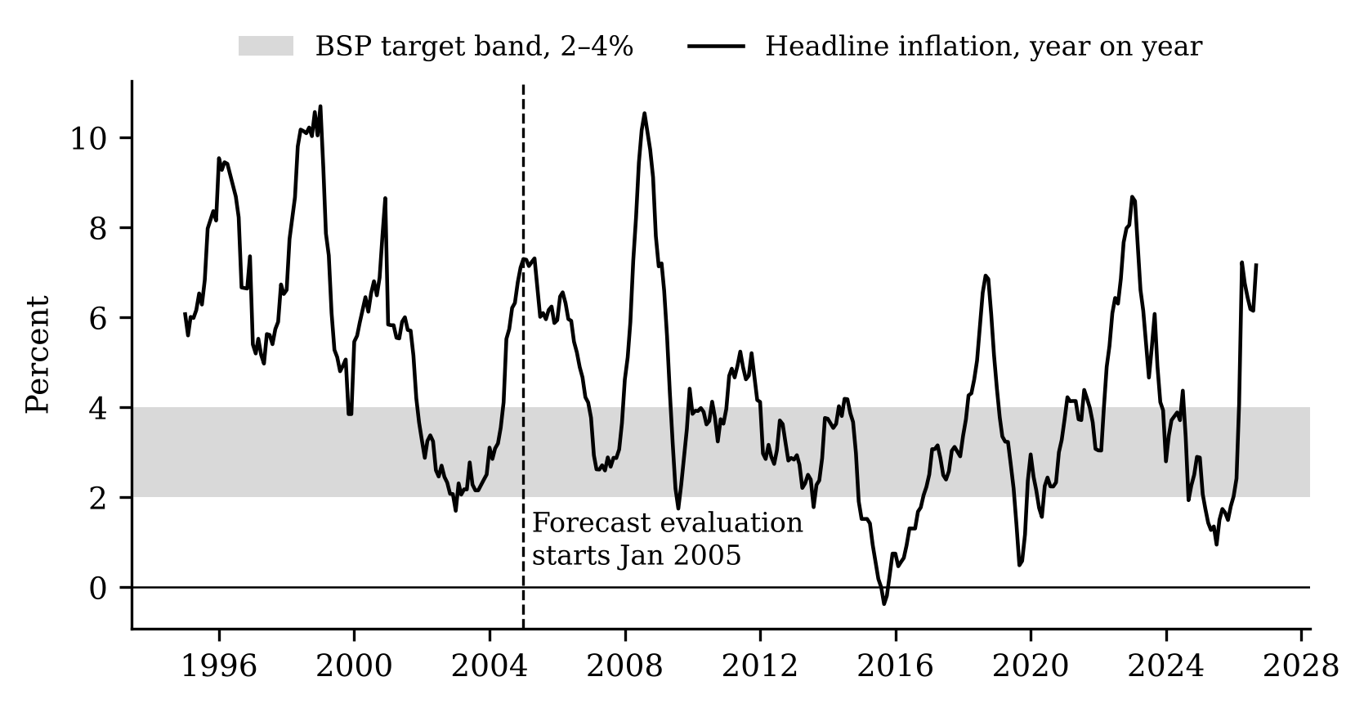
Figure 1. Headline inflation in the Philippines, year on year, January 1995 to September 2026. The grey band is the BSP target range of 2–4%. The dashed line marks the first month of the forecast evaluation. Source: PSA CPI (2018 = 100), our calculation.
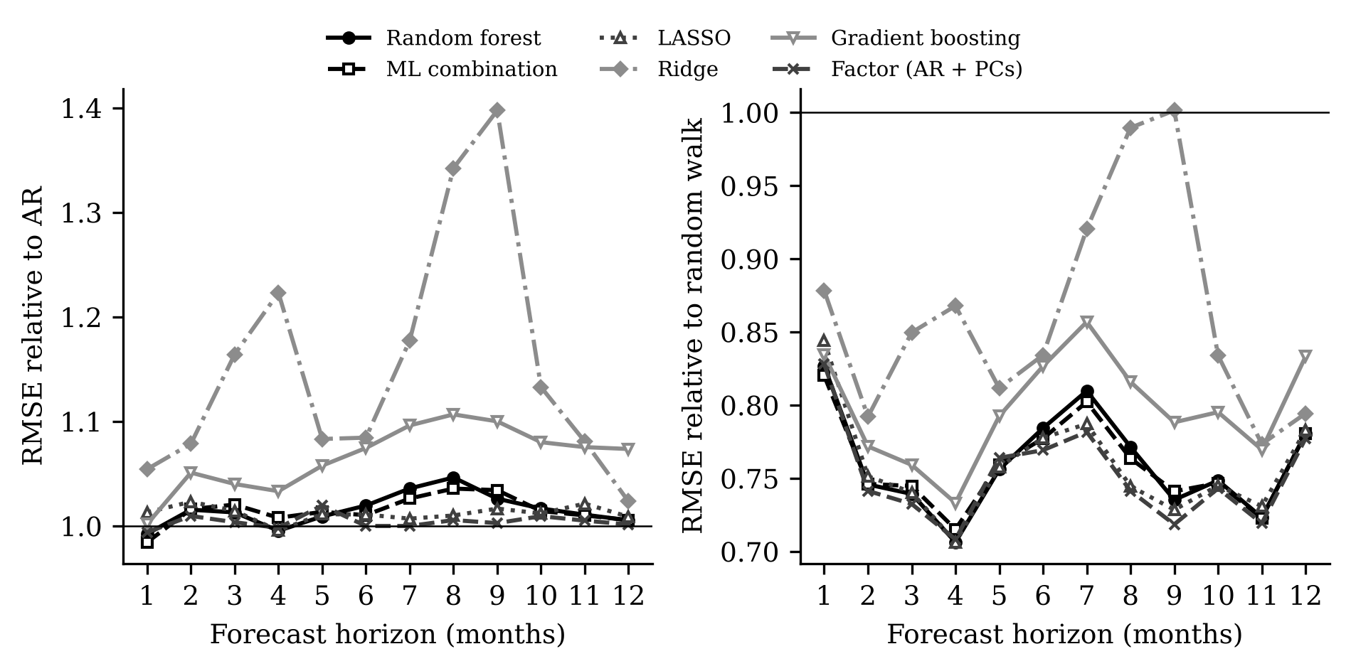
Figure 2. RMSE of each model relative to the AR benchmark (left) and to the random walk (right), by forecast horizon, January 2005 to August 2026. Values below the horizontal line at 1 mean the model is more accurate than the benchmark.
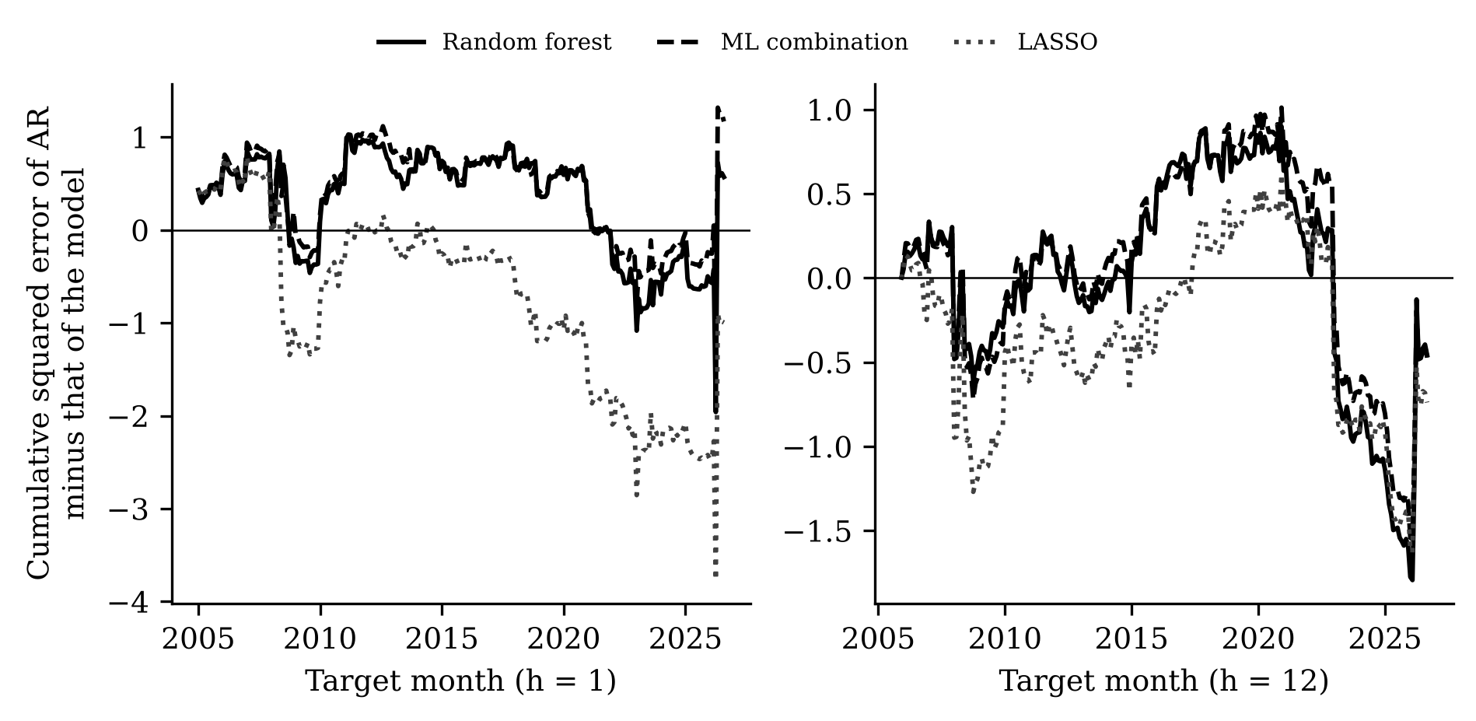
Figure 3. Cumulative squared forecast-error difference between the AR benchmark and each model, by target month, for one-month-ahead (left) and twelve-month-ahead (right) forecasts. A rising line means the model is doing better than the AR over that period; a falling line means it is doing worse.
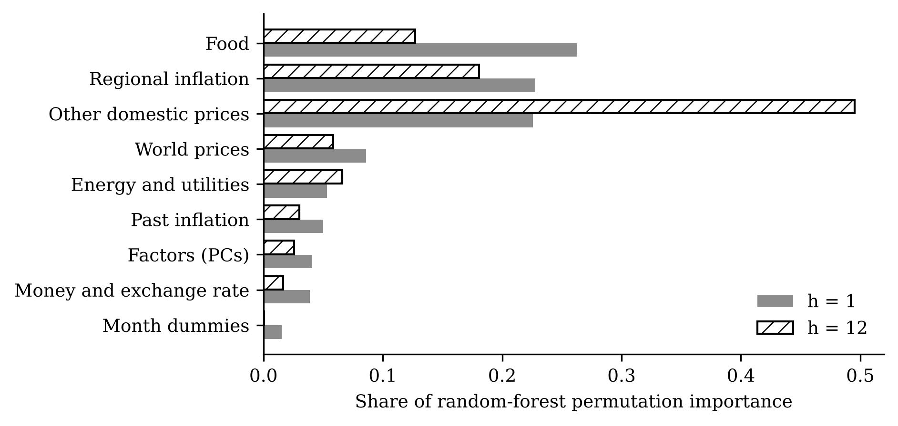
Figure 4. Share of the random forest’s grouped permutation importance by predictor group, averaged over all forecast origins, for one-month-ahead (grey) and twelve-month-ahead (hatched) forecasts.
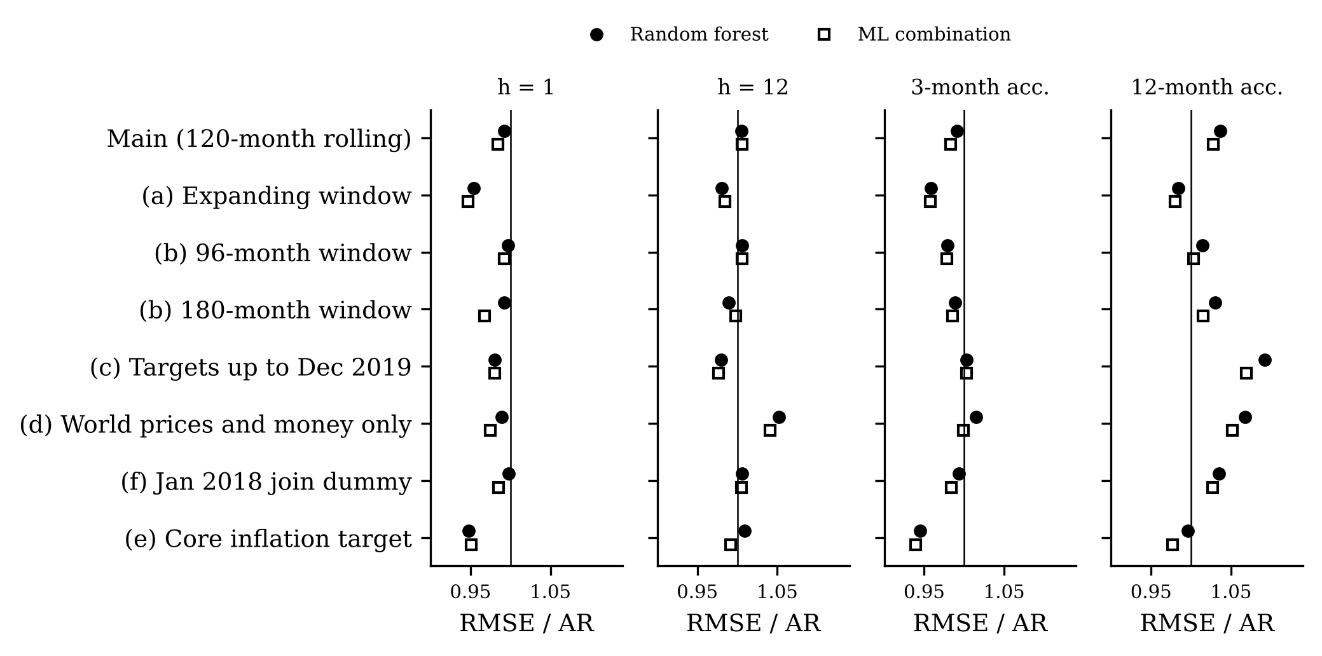
Figure 5. RMSE relative to the AR at the four decisive cases, for the random forest (filled circles) and the ML combination (open squares), in the main specification and each robustness check. Values left of the vertical line mean the model is more accurate than the AR.
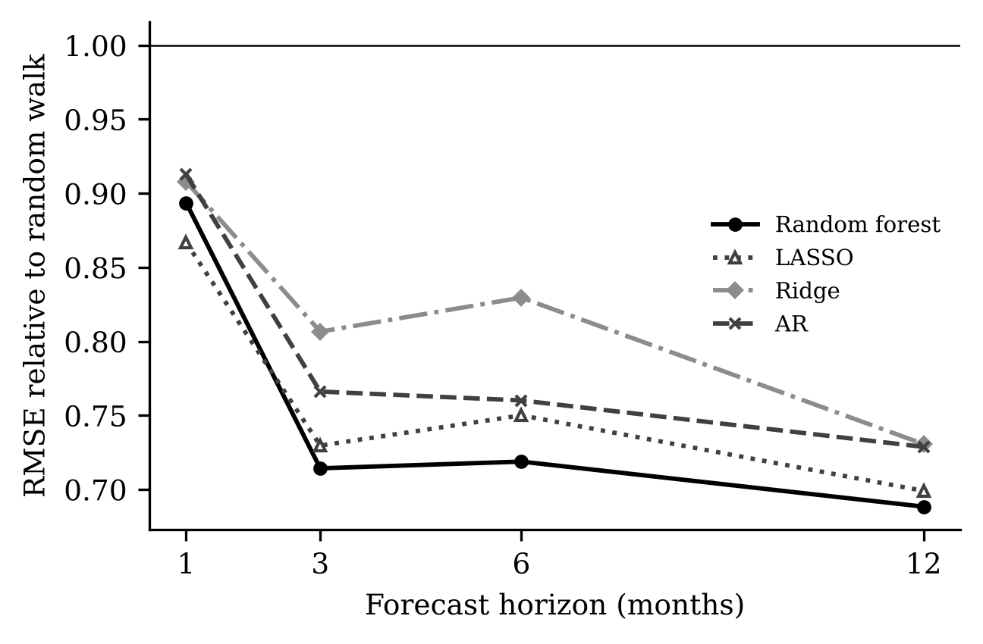
Figure 6. Replication gate on US data (FRED-MD): RMSE relative to the random walk for the random forest, LASSO, ridge and AR, 2001–2015.
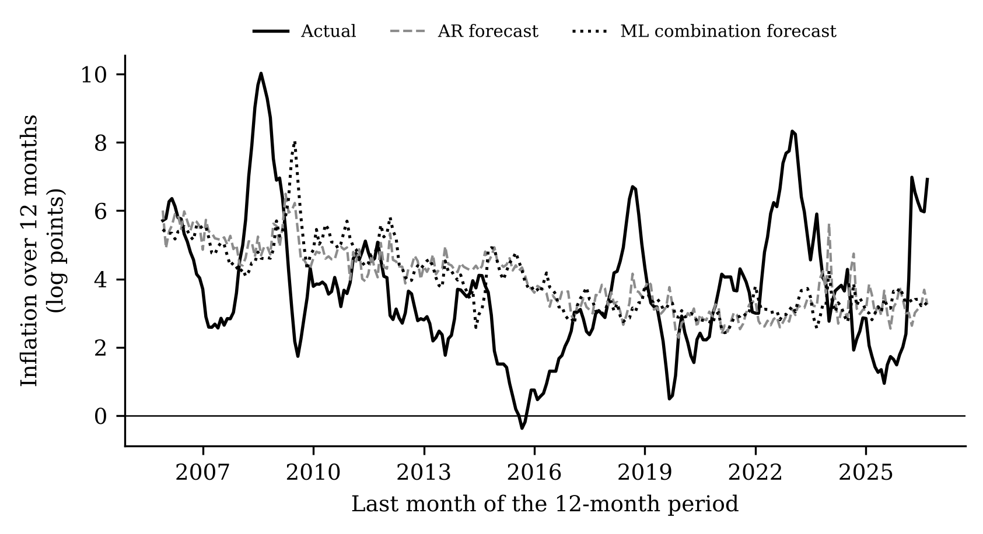
Figure 7. Inflation over the next twelve months: actual values and the forecasts of the AR and the ML combination made twelve months earlier, in log points (approximately percent).

University of Southeastern Philippines, Davao City, Philippines. E-mail: lrcataytay00745@usep.edu.ph.

