Good policy or good luck? Philippine economic performance across presidential administrations
[Author name], [Affiliation], [email]
Draft, 16 October 2026
Abstract. Does the Philippine economy grow faster under some presidents than under others, and how much of the difference is luck? We replicate the design of Blinder and Watson (2016) on Philippine data. We first reproduce their US results on the paper’s own data vintage (a 1.80-point growth gap between parties; ours is 1.80). We then measure each administration’s premium, its average growth minus the 1981–2026 average, from quarterly data on 181 quarters. We split the premium into the part explained by shocks no Philippine president controls (oil prices, demand from the United States, El Niño and world financial conditions) and the rest. Three findings stand out. First, the spread of administration premiums is no larger than chance would produce (randomization p = 0.44); only the Aquino III premium (+2.22 points) survives a correction for multiple testing. Second, measured against Indonesia, Malaysia and Thailand, the differences grow rather than shrink: the Philippines lagged its neighbours before 1992 and has outgrown them since 2011. Third, luck explains about half of the spread of premiums (0.48), as in the United States, but this share is fragile: it falls to 0.12 without the 1984–85 debt crisis. The current administration’s premium (+0.56) is small and statistically indistinguishable from zero, and its strong first year was largely predictable from the rebound under way when it took office.
Keywords: presidents; economic growth; luck; Philippines; replication. JEL codes: E32, E60, O53.

1. Introduction
Every Philippine administration claims credit for growth, and every opposition blames the president for slowdowns. Both claims assume that presidents move the growth rate. Yet the largest swings in Philippine growth since 1981 came with events that no president chose: the oil shocks, the 1997–98 Asian financial crisis, the 2008–09 world recession and the 2020 pandemic. A president who governs in calm years looks good; one who governs through a world recession looks bad, whatever either did.
This paper asks two questions. Did the Philippine economy grow faster under some presidents than others? And how much of the difference is luck, meaning shocks from outside that no Philippine president controls? We follow Blinder and Watson (2016), who asked the same questions for the United States. They found that the US economy grew 1.8 percentage points a year faster under Democratic than under Republican presidents, and that oil prices, productivity, wars and growth abroad explain about half of that gap. Their design transfers to the Philippines with one change. The Philippines has no stable two-party system: the nine presidents since 1961 came from seven parties, and no party held the presidency twice in a row. We therefore compare administrations one by one.
The paper makes three contributions. It provides the first estimate, to our knowledge, of how much of the differences in growth between Philippine administrations is luck, using the method of Blinder and Watson (2016) after reproducing their US results to two decimals. It puts six decades of administrations on a common footing, per person and relative to regional peers. And it gives an evidence-based reading of the current administration’s record at the same point in the term as its predecessors. Earlier accounts of Philippine growth by period, such as Balisacan and Hill (2003) and Clarete et al. (2018), are narrative; the political-cycle literature (Alesina et al. 1997) concerns advanced democracies with stable parties.
All specification choices were written down and time-stamped before the first Philippine estimate (Section 2.6). The study measures; it does not rank people. Every claim about an administration is tied to a number and its uncertainty, and the luck-adjusted figure is always shown next to the raw one.

2. Data and methods

2.1 Data
The main measure is quarterly real GDP growth. Real GDP is the value of everything the economy produces, at constant prices, so that inflation does not count as growth. We use the Philippine Statistics Authority’s (PSA) series at constant 2018 prices, 1981Q1–2026Q2, which is not seasonally adjusted. We remove the seasonal pattern with the US Census Bureau’s X-13ARIMA-SEATS program (U.S. Census Bureau 2017). Our adjusted growth correlates 0.978 with PSA’s own adjusted series over the years PSA publishes it (2000–2026).
Growth is measured as in Blinder and Watson (2016), at a compounded annual rate:
$$y_{t}=100\left[{\left(\frac{GDP_{t}}{GDP_{t−1}}\right)}^{4}−1\right]. (1)$$
For example, if real GDP rises by 1% in a quarter, $y_{t}=100({1.01}^{4}−1)≈4.06$% a year. Over 1981Q2–2026Q2, growth averaged 4.02% a year.
For the long view we use PSA’s annual real GDP (1946–2025) and World Bank data on GDP per person, inflation, unemployment and population, and on GDP growth in Indonesia, Malaysia and Thailand (and Vietnam from 1985), 1961–2025. Presidents’ term dates come from the official record as compiled on Wikipedia (the Official Gazette could not be reached from our computing environment). Every raw file, with its source and date, is listed in the replication package.

2.2 Charging quarters to administrations
A new president cannot change the economy on inauguration day. Following Blinder and Watson (2016), who charge the first quarter of each term to the previous president, we charge each quarter to the president who held office for most of the previous quarter. For the 30 June inaugurations of 1992–2022 this means a new president is charged from the October quarter. Corazon Aquino, who took office on 25 February 1986, is charged from 1986Q3, and Gloria Macapagal Arroyo, who took office on 20 January 2001, from 2001Q2. Years are charged to the president who holds most of their quarters. Lags of zero, two and four quarters are robustness checks. The quarterly data cover only the last five years of Ferdinand E. Marcos (1981Q2–1986Q2), which we label “Marcos Sr. (1981–86)”. His whole presidency (1966–1985) enters the annual analysis. The Marcos Jr. administration enters with the 15 quarters observed so far (2022Q4–2026Q2).

2.3 The administration premium
An administration’s premium is its average growth minus the average over the whole sample:
$$P_{a}={\overset{‾}{y}}_{a}−\overset{‾}{y}. (2)$$
If growth averaged 4.0% over the sample and 5.0% under one administration, its premium is +1.0 point. Standard errors, which measure how uncertain each premium is, allow for correlation over time [Newey–West with six lags; Newey and West (1987)]. Because there are only eight administrations in the quarterly sample, we also use a test that does not rely on large-sample theory. The circular-shift test slides the calendar of administrations along the growth series by every possible number of quarters, keeping each administration’s length and the order of terms, and asks how often an arbitrary alignment gives a larger spread of administration averages than the real one. Its p-value is that share. It is the analogue of the random relabelling of terms in Blinder and Watson (2016). When we test the eight premiums one by one, we also report p-values corrected for multiple testing (Holm).
Two standardized versions put decades on a common footing. Growth per person subtracts population growth. Growth relative to peers subtracts the average growth of Indonesia, Malaysia and Thailand in the same year; it removes shocks that hit the whole region at once.

2.4 How much is luck?
We estimate the Philippine version of equation (1) in Blinder and Watson (2016):
yt=a​αaAa,t+k​j=06γkj ek,t−j+ut, (3)
where $A_{a,t}$ equals 1 in the quarters charged to administration $a$, and $e_{k,t}$ is shock $k$, entered with its current value and six lags, because shocks take time to work. The fitted shock component ct=k​j​γkjek,t−j is the growth the shocks alone predict. The explained premium of administration $a$ is the average of ${\hat{c}}_{t}$ in its quarters minus the sample average of ${\hat{c}}_{t}$; the unexplained premium is the rest. The unexplained premium is the most that policy could have contributed. It is an upper bound, not a measure of policy, because it also contains any luck we fail to measure.
We use four shocks, fixed before estimation. Oil is the net oil price increase of Hamilton (2003), the percentage by which the oil price exceeds its highest value of the previous three years (zero otherwise), computed from the US producer price index for crude petroleum, exactly as in the reference paper. US demand is US real GDP growth. The United States was the largest market for Philippine exports over most of the sample. El Niño is the positive part of the Oceanic Niño Index of the US National Oceanic and Atmospheric Administration; El Niño years bring drought to Philippine farms. Financial conditions is the excess bond premium of Gilchrist and Zakrajšek (2012), a measure of stress in world credit markets. As in the reference paper, the US-demand and financial series are first purged of any feedback from Philippine growth: we keep only the part that cannot be predicted from their own past and from current and past Philippine growth. Domestic fiscal policy, the central bank’s policy rate, coups and the 2020 lockdown are not treated as luck. The joint model is estimated over 1983Q4-2026Q2 (171 quarters), the period over which every shock and its lags exist.
A single summary is the share of the spread of premiums explained by luck,
S=1−a​naUa2a​naPa2, (4)
where $U_{a}$ is the unexplained premium and $n_{a}$ the number of quarters. If luck explained every premium exactly, $S=1$; if it explained none, $S=0$.

2.5 Inheritance and the same point in the term
Growth in a president’s first year may simply continue, or rebound from, what was under way before. For each administration that starts inside the sample we forecast growth over its first four quarters with data up to the quarter before it took office, using two models estimated on the full sample, as in Table 5 of Blinder and Watson (2016). The first is an autoregression, which predicts growth from its own recent past. The second, the bounce-back model, adds an indicator of recession quarters and its interaction with growth, so that growth can rebound faster after a slump. The current term is incomplete, so we also compare every administration over its first 15 quarters, raw and after removing the fitted shock component.

2.6 Validation and pre-specification
Before touching Philippine data, we re-estimated the reference paper on US data at its own data vintage (Table 1). The pass criteria were written down first. The first run failed one criterion: both party averages were 0.13 points too low, because we had used log growth instead of the compounded rate of equation (1). With that correction, which we then applied to every growth rate, the replication matches: Democratic mean 4.35 against 4.35, Republican 2.54 against 2.54, gap 1.80 against 1.80 (standard error 0.64 against 0.64, randomization p = 0.011 against 0.01). The oil shock explains 0.48 of the gap, against 0.50 in the paper, and its term-by-term effects correlate 0.996 with the published ones (Figure 6). The full Philippine estimation plan, including every hypothesis test rule and robustness check, was then committed to the project’s public repository before the first Philippine estimate. All results below are from that plan unless labelled otherwise. The estimation code was also checked on simulated data with known answers.

3. Results

3.1 Do administrations differ?
Figure 1 shows quarterly growth with the administrations marked, and Table 2 the premiums. The largest negative premium belongs to the last five years of Marcos Sr. (-4.22 points, s.e. 2.26), the years of the 1983–85 debt crisis. The largest positive premium belongs to Aquino III (+2.22, s.e. 0.72, p = 0.002); it is the only premium that survives the Holm correction (p = 0.02). The other premiums are within about one point of zero, with standard errors of the same size. The Marcos Jr. premium so far is +0.56 (s.e. 0.90, p = 0.53).
Taken together, the differences are no larger than chance alone would produce. In the circular-shift test, 0.44 of all alignments of the calendar give a spread at least as large as the real one (0.28 for growth per person). The first hypothesis, that differences are large and detectable as in the United States (H1a), is therefore not supported. Per person, the premiums of recent administrations are larger because population growth has slowed; the Marcos Jr. per-person premium is +1.99 (s.e. 0.88, p = 0.02, Holm p = 0.17).
The annual data tell the same story over six decades (Table 3): the shift-test p-value is 1.00. Marcos Sr.’s twenty-year average contains both the growth of the 1970s and the crash of 1984–85, and comes close to the long-run mean (-0.46 points).
Measured against regional peers, the picture changes (Figure 3). We expected the peer comparison to remove much of the difference between administrations, because the big swings of 1997–98, 2009 and 2020 were regional (H1b). The opposite happens: the spread of peer-relative premiums is 2.4 times the spread of raw premiums, so H1b is not supported. Relative to its neighbours, the Philippines grew much more slowly under Marcos Sr. (-1.73 points) and C. Aquino (-3.26), and faster under Aquino III (+2.90), Duterte (+2.16) and Marcos Jr. (+2.37). Much of this pattern comes from the peers themselves: they grew 7.0% a year on average before 1997 and 3.8% since, while the Philippines grew 4.0% before 1997 and 5.1% in 2011–2025. A peer-relative premium therefore mixes the Philippines’ record with its neighbours’. Even so, the shift test cannot reject equal premiums on this measure either (p = 0.77).

3.2 How much is luck?
Table 4 and Figure 2 split each premium into its explained and unexplained parts. Jointly the shocks matter (p < 0.001 for the test that all their coefficients are zero), but not equally. World financial conditions are the clearest: tighter credit markets abroad predict slower Philippine growth (p = 0.005). Oil prices matter at the 10% level (p = 0.09). US demand (p = 0.53) and El Niño (p = 0.84) add little, and the US-demand coefficients even sum to a negative number (-1.01).
Luck explains a share S = 0.48 of the spread of premiums, which by our pre-set rule supports H2a (about half), the same order as in the United States. This number should be read with care. Much of it comes from the 11 crisis quarters of Marcos Sr. in the joint sample, where the model attributes -2.67 points to US demand: the United States was booming in 1984 while the Philippines collapsed. That is an accident of timing, not a plausible channel. Without 1984–85, S falls to 0.12; with a broader measure of foreign demand (the United States, Japan and the euro area, from 1997) it is 0.11; with other timing conventions it ranges from 0.33 to 0.40 (Table 7). We therefore do not claim that luck explains half of the differences. We claim only that the measured shocks explain a modest and uncertain share.
For individual administrations, luck explains about half of the Aquino III premium (+1.04 of +2.14 points, s.e. 0.78), mainly through oil prices (+0.54) and US demand (+0.32). For Marcos Jr., the premium on the joint sample is +0.49 points, of which +0.33 (s.e. 0.24) is explained, mostly by easier world financial conditions (+0.40, partly offset by oil, -0.13), leaving +0.16 unexplained. For Duterte the figures are +0.63, +0.45 and +0.17.

3.3 Is early growth inherited?
Table 5 and Figure 4 compare first-year growth with what the two models predicted at the start of each term. The bounce-back model predicted strong first years for both administrations that took over after a collapse. For C. Aquino it predicted 4.64%, against 4.51% actual. For Marcos Jr. it predicted 4.88%, against 5.75% actual (the sample mean is 3.70%). By our pre-set rule, the third hypothesis is supported for C. Aquino and supported for Marcos Jr.: a large part of their strong first years was already under way. Duterte’s first year (7.14% against a forecast of 4.81%) and Ramos’s (2.34% against 1.05%) beat the forecasts.

3.4 The current administration in context
Table 6 and Figure 5 compare administrations over their first 15 quarters. Marcos Jr. averaged 4.59% a year (4.26% after removing the fitted luck component). This is within the range of C. Aquino (5.17%), Ramos (4.54%), Arroyo (5.09%) and Aquino III (6.02%; 4.29% luck-adjusted). Duterte’s first 15 quarters (1.24%) end with the pandemic collapse of 2020Q2. No difference from Marcos Jr. exceeds 1.4 standard errors.
The annual scorecard (Table 8) adds other measures. In 2023–2025, GDP growth averaged 5.08% (z = +0.28), growth per person 4.36% (+0.68), growth relative to peers 1.14 points (+0.69), inflation 3.62% (-0.58) and unemployment 2.21% (-1.90), the lowest administration average on this series, which starts in 1991. A z-score expresses each measure in “typical swings” from its long-run average: z = (administration mean − long-run mean) / standard deviation of the annual values.

3.5 Robustness
Table 7 repeats the main statistics under every check that was specified in advance. The conclusion that differences are within chance holds throughout (the shift-test p never falls below 0.26). The Aquino III premium stays between 1.83 and 2.77 points, and the Marcos Jr. premium between 0.18 and 0.83. The luck share is the fragile result, as discussed in Section 3.2.

4. Discussion
Findings. Philippine growth has differed across administrations by less than headline debates suggest. With one exception, the differences are within what chance would produce, and the one robust exception (Aquino III) owes about half of its premium to favourable oil prices and financial conditions. The sharpest contrast is with the neighbours: the Philippines fell far behind Indonesia, Malaysia and Thailand in the 1980s and has grown faster than them since 2011. Unlike in the United States, we cannot say with confidence that luck explains about half of the differences; the share depends on a few crisis quarters. The current administration’s growth so far is close to the long-run average, its strong start was largely predictable, and its record is indistinguishable from its predecessors’ at the same point in the term.
What this means for reading growth claims (Objective 3). A quarter or a year of fast growth says little about a president. A fair reading of any administration’s record should show three numbers together: the raw average, the average after removing world shocks, and the comparison with the same point in earlier terms, each with its uncertainty. Our tables provide these for every administration since 1981 and can be updated each quarter.
Limitations. There are only eight administrations in the quarterly sample, so every estimate is imprecise. The unexplained premium is not a measure of policy: it contains unmeasured luck, such as typhoons (for which we found no long official quarterly series), remittance flows and domestic political shocks, and it cannot separate the president from Congress, the independent central bank (since 1993) or past decisions. Quarterly data begin in 1981, so the earlier administrations enter only the annual analysis, and the national accounts of the Marcos years are themselves debated. The Marcos Jr. term is incomplete.
Conclusion. Measured carefully, the growth record of Philippine presidents is mostly a story of shared fortunes and wide uncertainty, not of large and reliable differences between administrations.

Declarations
Funding: none (personal research). Conflicts of interest: none. Data and code availability: all data are public; the replication package (raw files, code and a one-command rebuild) is available at [repository URL to be inserted]. Use of AI tools: [author to complete; the code, analysis and draft were prepared with the assistance of Claude Code (Anthropic), and all results were checked by the author.]

References
Alesina, Alberto, Nouriel Roubini, and Gerald D. Cohen. 1997. Political Cycles and the Macroeconomy. MIT Press. https://doi.org/10.7551/mitpress/5437.001.0001.
Balisacan, Arsenio M., and Hal Hill, eds. 2003. The Philippine Economy: Development, Policies, and Challenges. Oxford University Press. https://doi.org/10.1093/0195158989.001.0001.
Blinder, Alan S., and Mark W. Watson. 2016. “Presidents and the US Economy: An Econometric Exploration.” American Economic Review 106 (4): 1015–45. https://doi.org/10.1257/aer.20140913.
Clarete, Ramon L., Emmanuel F. Esguerra, and Hal Hill, eds. 2018. The Philippine Economy: No Longer the East Asian Exception? ISEAS–Yusof Ishak Institute. https://doi.org/10.1355/9789814786621.
Gilchrist, Simon, and Egon Zakrajšek. 2012. “Credit Spreads and Business Cycle Fluctuations.” American Economic Review 102 (4): 1692–720. https://doi.org/10.1257/aer.102.4.1692.
Hamilton, James D. 2003. “What Is an Oil Shock?” Journal of Econometrics 113 (2): 363–98. https://doi.org/10.1016/S0304-4076(02)00207-5.
Newey, Whitney K., and Kenneth D. West. 1987. “A Simple, Positive Semi-Definite, Heteroskedasticity and Autocorrelation Consistent Covariance Matrix.” Econometrica 55 (3): 703–8. https://doi.org/10.2307/1913610.
U.S. Census Bureau. 2017. X-13ARIMA-SEATS Reference Manual, Version 1.1. U.S. Census Bureau.

Tables
Table 1. Replication of Blinder and Watson (2016) on US data, 1949Q2–2013Q1
Criterion | Statistic | Paper | This study | Pass range | Pass
G1 | D mean growth | 4.35 | 4.346 | [4.25, 4.45] | yes
G1 | R mean growth | 2.54 | 2.543 | [2.44, 2.64] | yes
G1 | D-R gap | 1.8 | 1.803 | [1.7, 1.9] | yes
G2 | Newey-West (6) s.e. of gap | 0.64 | 0.637 | [0.54, 0.74] | yes
G2 | randomization p-value (16 blocks) | 0.01 | 0.011 | [0.0, 0.03] | yes
G3 | oil-explained gap, adopted reading: lags 0-6 | 0.5 | 0.481 | [0.4, 0.6] | yes
G4 | corr. of term oil effects with Table 7 | >=0.90 | 0.996 | [0.9, 1.0] | yes
G4 | terms with the same sign (of 16) | >=14 | 16.0 | [14, 16] | yes
Note. Pass ranges were fixed before the gate was run. Growth is quarterly real GDP growth at a compounded annual rate, ALFRED vintage of 1 July 2014.
Table 2. Administration premiums in quarterly real GDP growth, 1981Q2–2026Q2
Administration | Quarters charged | n | Mean growth | Premium (s.e.) | Holm p | Per-person premium (s.e.)
Marcos Sr. (1981–86) | 1981Q2–1986Q2 | 21 | -0.20 | -4.22* (2.26) | 0.44 | -5.03** (2.30)
C. Aquino | 1986Q3–1992Q3 | 25 | 3.25 | -0.77 (1.38) | 1.00 | -1.35 (1.37)
Ramos | 1992Q4–1998Q3 | 24 | 3.78 | -0.24 (0.93) | 1.00 | -0.60 (0.98)
Estrada | 1998Q4–2001Q1 | 10 | 3.48 | -0.54 (0.83) | 1.00 | -1.03 (0.86)
Arroyo | 2001Q2–2010Q3 | 38 | 5.09 | +1.07 (0.70) | 0.76 | +1.13 (0.76)
Aquino III | 2010Q4–2016Q3 | 24 | 6.24 | +2.22*** (0.72) | 0.02 | +2.43*** (0.79)
Duterte | 2016Q4–2022Q3 | 24 | 4.72 | +0.70 (1.84) | 1.00 | +1.54 (1.87)
Marcos Jr. | 2022Q4–2026Q2 | 15 | 4.59 | +0.56 (0.90) | 1.00 | +1.99** (0.88)
Note. Growth at a compounded annual rate, percent; premium = administration mean minus the sample mean (4.02%). Newey–West standard errors (6 lags) in parentheses. * p < 0.10, ** p < 0.05, *** p < 0.01 (unadjusted). Holm p corrects for the eight tests. Circular-shift test of no differences: p = 0.44 (raw), 0.28 (per person).
Table 3. Annual premiums, raw and relative to regional peers, 1962–2025
Administration | Years | Premium, PSA growth | Premium relative to IDN–MYS–THA | Relative to IDN–MYS–THA–VNM
Macapagal | 4 | +0.86 | +1.25
Marcos Sr. | 20 | -0.46 | -1.73 | -8.25
C. Aquino | 7 | -0.84 | -3.26 | -2.82
Ramos | 6 | -0.63 | +0.40 | -0.71
Estrada | 2 | -0.37 | +0.14 | -0.21
Arroyo | 10 | +0.55 | +1.23 | +0.64
Aquino III | 6 | +1.87 | +2.90 | +2.33
Duterte | 6 | -0.55 | +2.16 | +1.26
Marcos Jr. | 3 | +0.92 | +2.37 | +1.57
Note. Percentage points. Years charged to the administration in office for most of the year after a one-quarter lag. Dispersion of premiums: 0.82 (raw), 1.99 (relative). Shift-test p: 1.00 (raw), 0.77 (relative). Vietnam data start in 1985, so the last column covers only 1985 for Marcos Sr.
Table 4. How much of each premium is luck? Joint shock model, 1983Q4-2026Q2
Administration | n | Premium | Explained (s.e.) | Unexplained | Oil | US demand | El Niño | Financial
Marcos Sr. (1983–86) | 11 | -6.97 | -2.03 (1.63) | -4.95 | +0.59 | -2.67 | +0.04 | +0.00
C. Aquino | 25 | -0.85 | -0.22 (0.48) | -0.62 | -0.06 | +0.32 | -0.13 | -0.36
Ramos | 24 | -0.32 | +0.29 (0.24) | -0.61 | +0.28 | -0.45 | -0.10 | +0.56
Estrada | 10 | -0.61 | -1.90 (1.17) | +1.29 | +0.32 | -1.03 | -0.05 | -1.15
Arroyo | 38 | +1.00 | -0.02 (0.62) | +1.02 | -0.76 | +0.90 | +0.18 | -0.35
Aquino III | 24 | +2.14 | +1.04 (0.78) | +1.10 | +0.54 | +0.32 | -0.01 | +0.19
Duterte | 24 | +0.63 | +0.45 (0.29) | +0.17 | +0.11 | +0.01 | -0.07 | +0.40
Marcos Jr. | 15 | +0.49 | +0.33 (0.24) | +0.16 | -0.13 | +0.03 | +0.04 | +0.40
Note. Percentage points. Explained = the administration’s average of the fitted shock component minus its sample average; the last four columns split it by shock. Each shock enters with lags 0–6. Share of the dispersion of premiums explained, S = 0.48. Wald tests that a shock’s lags are all zero: oil p = 0.09, US demand p = 0.53, El Niño p = 0.84, financial conditions p = 0.005.
Table 5. Was first-year growth inherited?
Administration | Forecast made in | Actual first-year growth | AR forecast | Bounce-back forecast | Inherited (H3 rule)
C. Aquino | 1986Q2 | 4.51 | 4.31 | 4.64 | yes
Ramos | 1992Q3 | 2.34 | 3.01 | 1.05 | no
Estrada | 1998Q3 | 3.53 | 3.01 | 2.40 | no
Arroyo | 2001Q1 | 3.78 | 3.34 | 2.91 | no
Aquino III | 2010Q3 | 3.16 | 4.24 | 5.02 | no
Duterte | 2016Q3 | 7.14 | 4.24 | 4.81 | no
Marcos Jr. | 2022Q3 | 5.75 | 4.20 | 4.88 | yes
Note. Growth over the first four charged quarters, 100·ln(GDP_s+3 / GDP_s−1), percent. Sample mean 3.70%. ‘Inherited’ if the bounce-back forecast exceeds the mean by at least half of the actual excess.
Table 6. The same point in the term: the first 15 quarters
Administration | First 15 quarters | Raw mean | Marcos Jr. minus this (s.e.) | Luck-adjusted mean | Marcos Jr. minus this (s.e.)
C. Aquino | 1986Q3–1990Q1 | 5.17 | -0.58 (1.48) | 5.14 | -0.88 (2.16)
Ramos | 1992Q4–1996Q2 | 4.54 | +0.05 (0.90) | 3.64 | +0.62 (1.38)
Arroyo | 2001Q2–2004Q4 | 5.09 | -0.50 (0.96) | 4.60 | -0.35 (1.41)
Aquino III | 2010Q4–2014Q2 | 6.02 | -1.43 (1.01) | 4.29 | -0.04 (1.42)
Duterte | 2016Q4–2020Q2 | 1.24 | +3.35 (4.79) | 1.21 | +3.05 (4.54)
Marcos Jr. | 2022Q4–2026Q2 | 4.59 |  | 4.26
Note. Percent, annual rate. Luck-adjusted growth removes the fitted shock component of the joint model. Estrada (10 quarters) and Marcos Sr. (first quarters outside the sample) are not compared. Newey–West standard errors; the luck-adjusted ones ignore the estimation error of the shock component.
Table 7. Robustness
Specification | Shift-test p | Luck share S | Aquino III premium | Marcos Jr. premium
Main | 0.44 | 0.48 | +2.22 | +0.56
Timing lag 0 | 0.27 | 0.33 | +2.15 | +0.79
Timing lag 2 | 0.34 | 0.40 | +2.32 | +0.35
Timing lag 4 | 0.26 | 0.39 | +2.77 | +0.83
Excluding 2020Q2-2021Q1 | 0.42 | 0.47 | +2.15 | +0.50
Excluding 1984Q1-1985Q4 | 0.86 | 0.12 | +1.83 | +0.18
Log growth | 0.43 | 0.43 | +2.35 | +0.77
Lags 1-6 | 0.44 | 0.51 | +2.22 | +0.56
Foreign demand US-JP-EA (from 1997) | 0.44 | 0.11 | +2.22 | +0.56
Note. All checks were specified before estimation. Premiums are raw quarterly premiums (percentage points).
Table 8. Scorecard, annual averages 1962–2025 (z-score in parentheses)
Administration | GDP growth | Growth per person | Relative to peers | Inflation | Unemployment (1991–)
Macapagal | 5.02 (+0.26) | 1.92 (-0.04) | 0.02 (+0.37) | 5.54 (-0.34)
Marcos Sr. | 3.70 (-0.14) | 1.16 (-0.26) | -2.97 (-0.51) | 14.32 (+0.74)
C. Aquino | 3.32 (-0.26) | 0.81 (-0.36) | -4.50 (-0.95) | 10.20 (+0.23) | 3.79 (+0.79)
Ramos | 3.53 (-0.19) | 1.24 (-0.24) | -0.84 (+0.12) | 7.71 (-0.07) | 3.70 (+0.64)
Estrada | 3.79 (-0.11) | 1.33 (-0.21) | -1.09 (+0.04) | 4.96 (-0.41) | 3.76 (+0.74)
Arroyo | 4.71 (+0.17) | 2.85 (+0.24) | -0.00 (+0.36) | 4.64 (-0.45) | 3.69 (+0.62)
Aquino III | 6.03 (+0.57) | 4.43 (+0.70) | 1.67 (+0.85) | 2.64 (-0.70) | 3.33 (+0.00)
Duterte | 3.61 (-0.17) | 2.74 (+0.20) | 0.93 (+0.63) | 3.78 (-0.56) | 2.61 (-1.23)
Marcos Jr. | 5.08 (+0.28) | 4.36 (+0.68) | 1.14 (+0.69) | 3.62 (-0.58) | 2.21 (-1.90)
Note. Percent; z = (administration mean − 1962–2025 mean) / standard deviation of the annual values. For inflation and unemployment a negative z means a lower rate than usual. No composite index is formed and administrations are not ranked. Unemployment is the ILO modelled estimate (1991–).

Figures
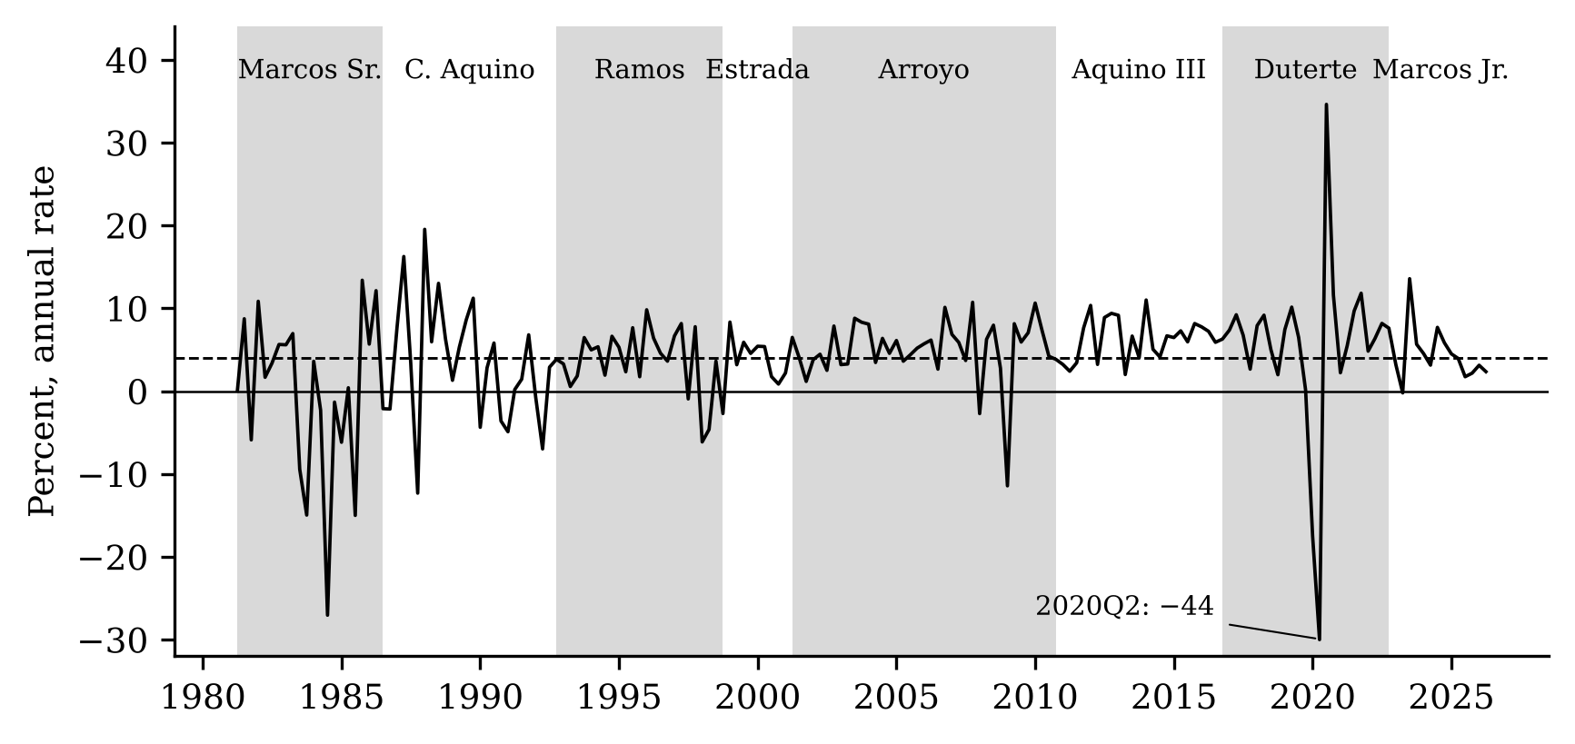
Figure 1. Quarterly real GDP growth, 1981Q2–2026Q2, at a compounded annual rate (percent). Shading marks alternating administrations, with quarters charged after a one-quarter lag. The dashed line is the sample mean. The 2020Q2 value is cut at −30 for readability.
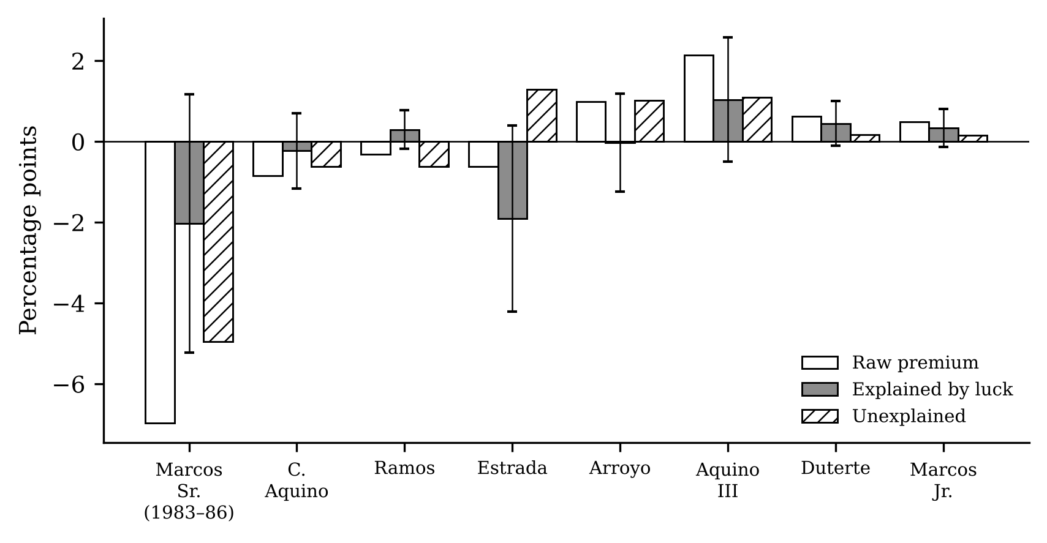
Figure 2. Each administration’s premium (average growth minus the sample mean, percentage points), the part explained by the four luck shocks (with a 95% confidence interval) and the unexplained rest, joint model 1983Q4-2026Q2.
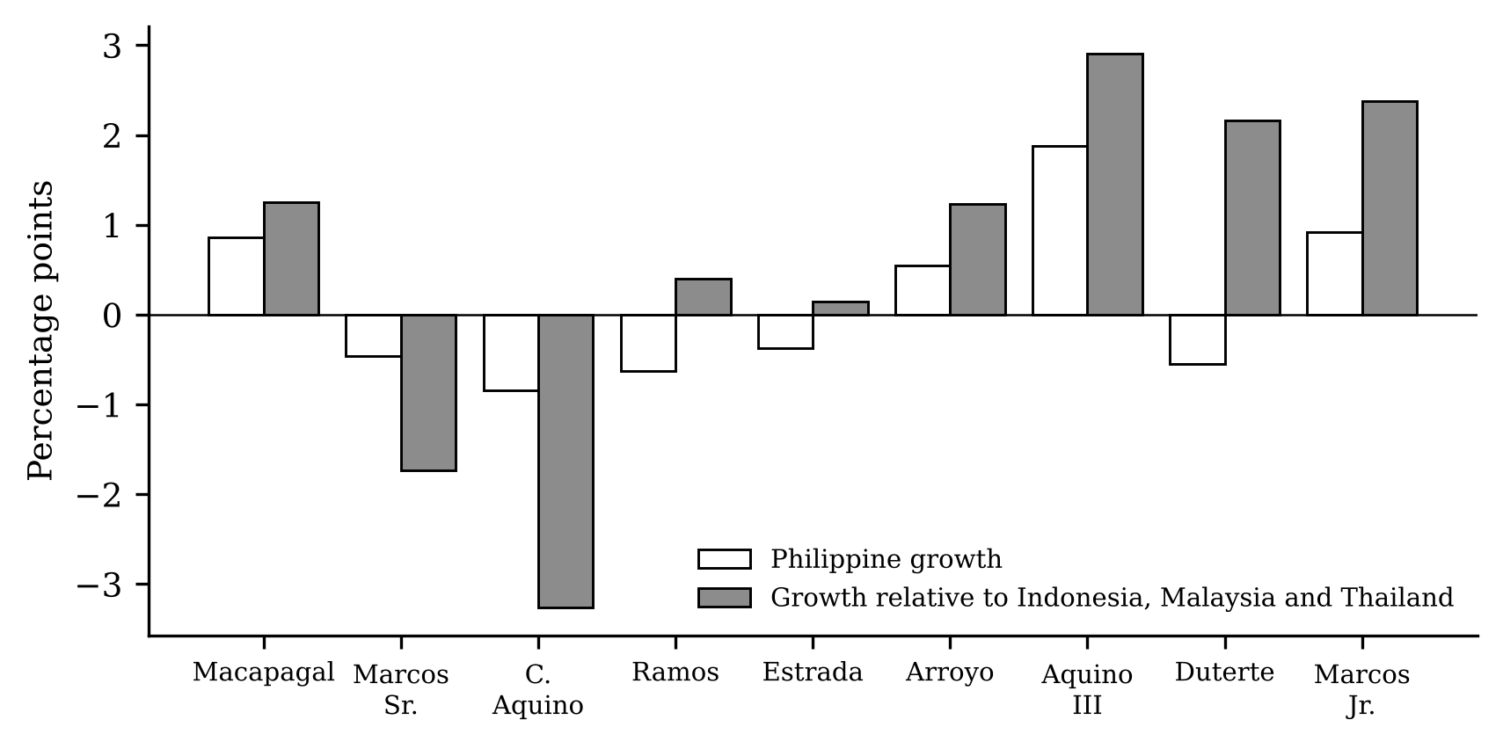
Figure 3. Annual premiums, 1962–2025: Philippine growth (white) and Philippine growth minus the average of Indonesia, Malaysia and Thailand (grey), percentage points.
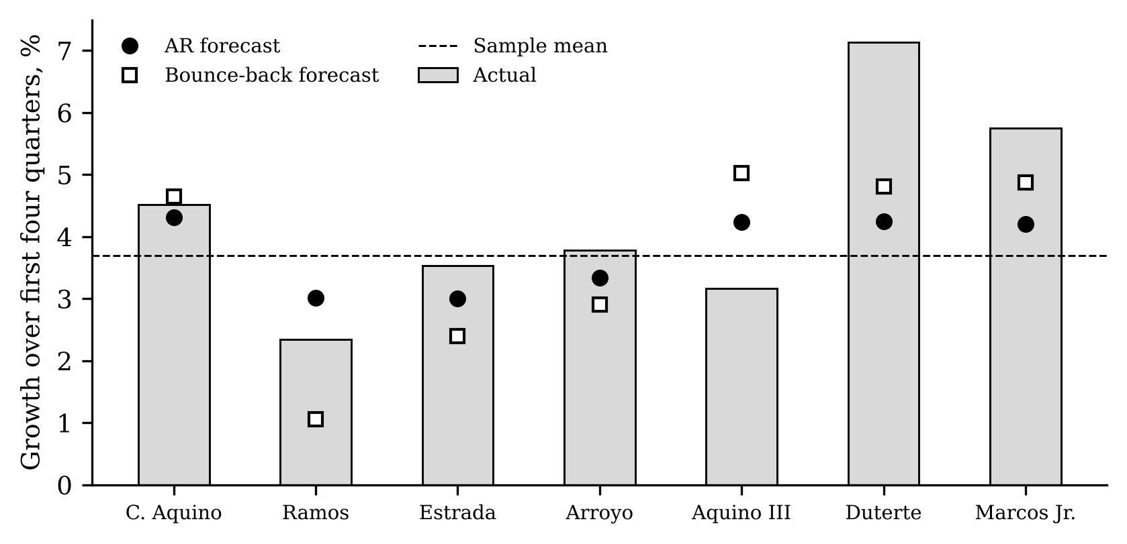
Figure 4. Growth over each administration’s first four quarters (bars) against forecasts made in the quarter before it took office: an autoregression (circles) and a bounce-back model (squares). The dashed line is the sample mean.
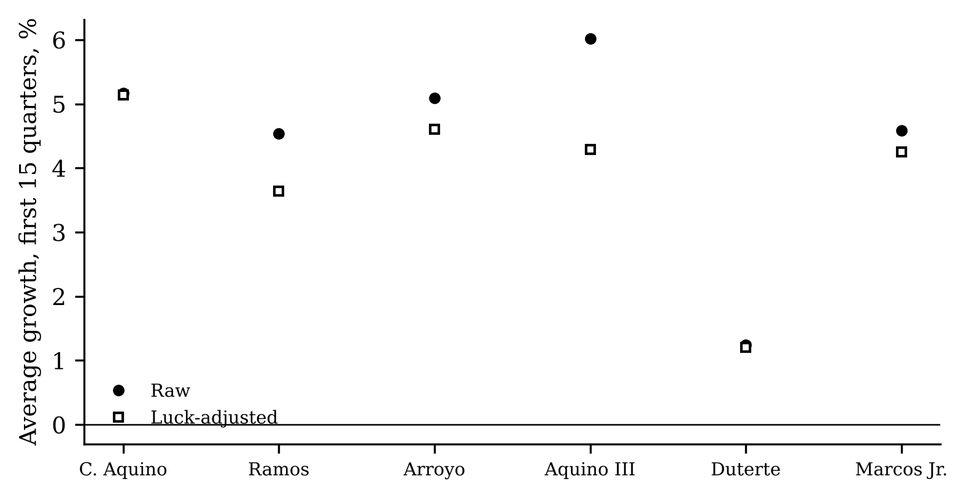
Figure 5. Average growth over each administration’s first 15 quarters, raw (filled circles) and after removing the fitted luck component (open squares), percent at an annual rate.
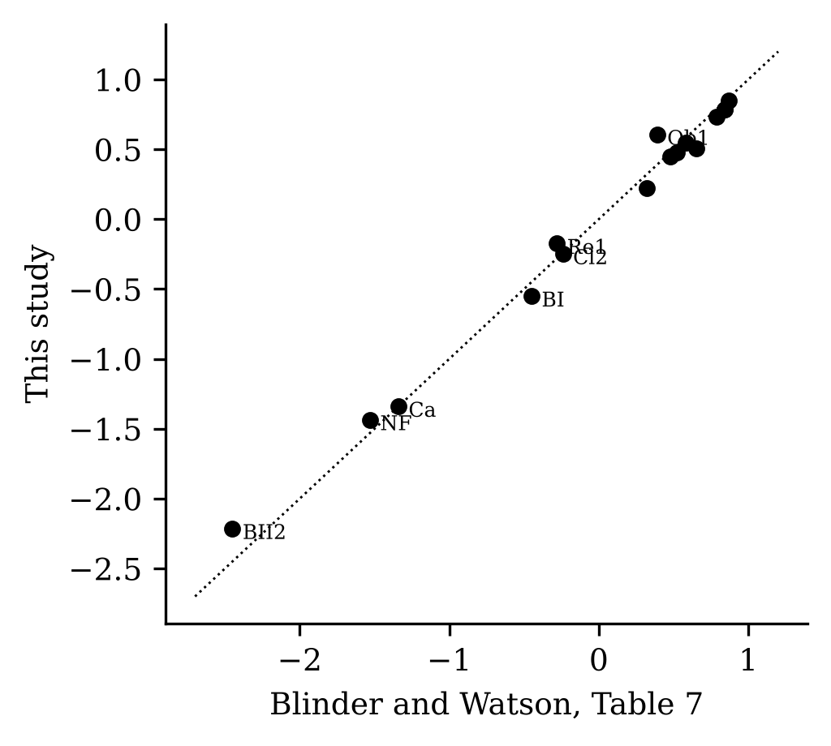
Figure 6. Replication: the effect of oil shocks on average growth in each US presidential term, from Table 7 of Blinder and Watson (horizontal axis) and from this study (vertical axis). The dotted line is the 45-degree line.

