MASTER DOCUMENT
Critical Review of Agbola and Acupan (2010): An Empirical Analysis of International Labour Migration in the Philippines
Agbola, F. W., & Acupan, A. B. (2010). Economic Systems, 34(4), 386–396. https://doi.org/10.1016/j.ecosys.2010.03.002
Prepared by: Lian Cataytay · October 22, 2026

How to read this document
Each part pairs highlighted excerpts from the article (screenshots, page numbers in the captions) with a concise technical review. Colours carry meaning:
Key fact / result from the paper | Strength of the study | Critical note (weakness) | Reviewer suggestion

The article at a glance
Item | Summary
Question | How do economic, demographic and political factors affect emigration from the Philippines?
Setting | Philippines; 8.2 million Filipinos abroad; US$14.4 billion remittances (2007)
Data | Annual national time series, 1975–2005 (T = 31); CFO, NSCB, IMF IFS, BSP
Method | Unit root and cointegration tests → unrestricted error correction model (ECM) by OLS
Main result | Unemployment ↑ emigration; adult literacy, political instability, population density ↓ emigration
Verdict | Careful time-series steps, but small sample, weak proxies and no pull factors
Table 1. Overview of the study and of this review.

1. Research Problem / Gap
Guiding question
What issue or knowledge gap does the study address?

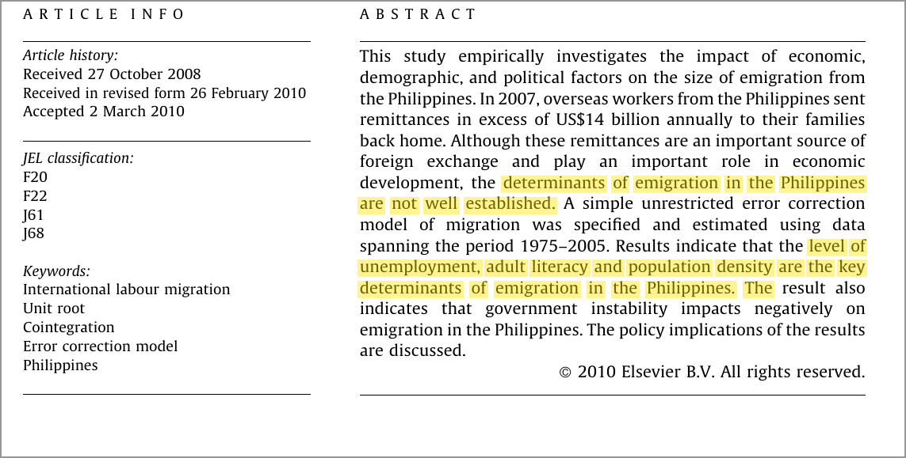
Excerpt 1.1. Abstract: the gap and the headline result (p. 386).
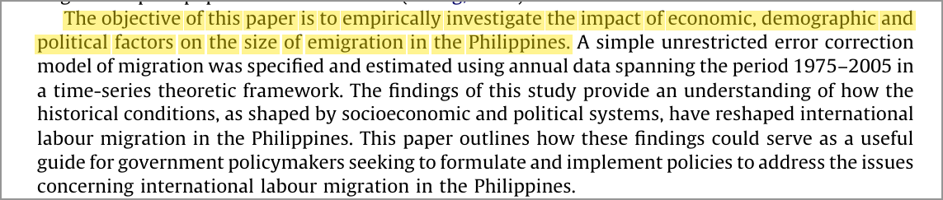
Excerpt 1.2. Objective of the study (p. 387).
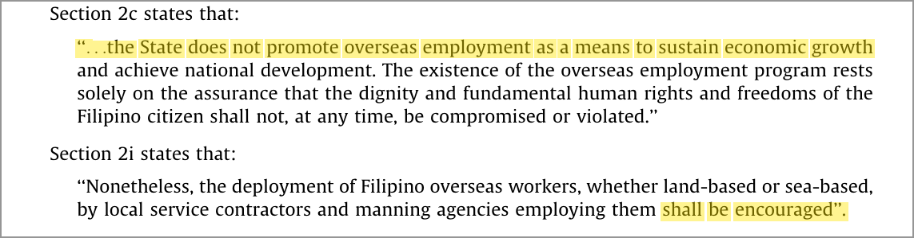
Excerpt 1.3. The policy ambiguity in Republic Act No. 8042 (p. 388).

Review
• Issue. Labour export began in the 1970s as a stop-gap for unemployment and a balance-of-payments crisis, then became structural: 8.2 million Filipinos abroad and US$14.4 billion in remittances (2007).
• Gap. The determinants of emigration “are not well established” (p. 386); there is no country-specific, long-run time-series evidence on domestic drivers.
• Policy tension. RA 8042 §2c says the State “does not promote” overseas work, while §2i says deployment “shall be encouraged”. A de facto labour-export policy lacks an evidence base.
• Research question. How do economic, demographic and political factors affect the size of emigration?
Strength
Clear, policy-relevant question for one of the world’s largest labour exporters.

Critical note
The gap is asserted, not demonstrated: there is no systematic review of earlier Philippine migration studies.

2. Theoretical Framework / Theory
Guiding question
What theory or conceptual framework guides the study?

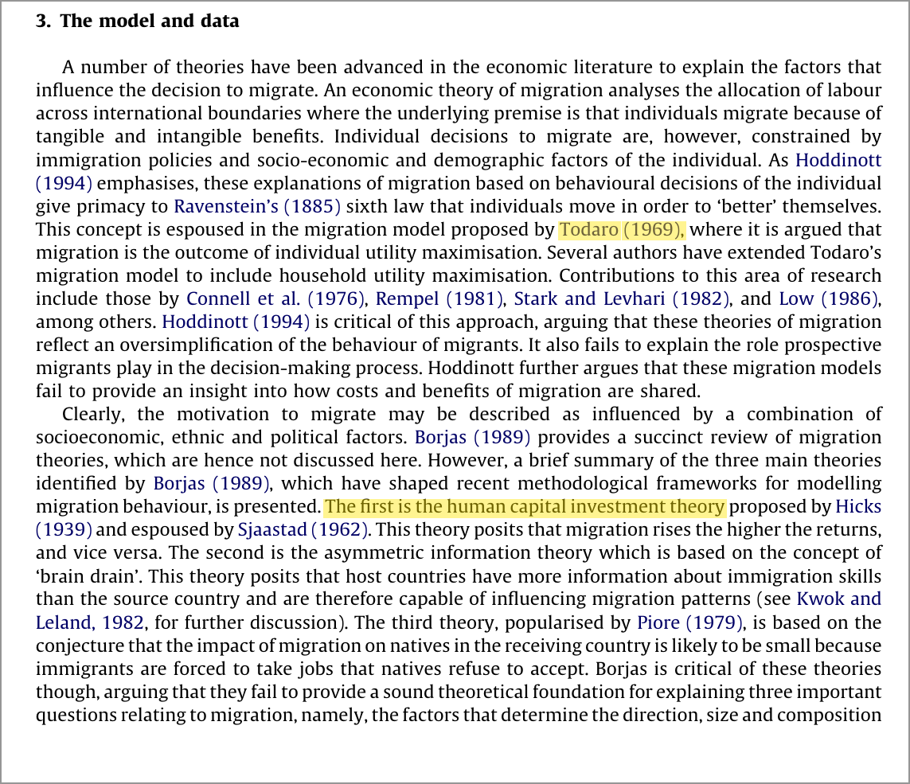
Excerpt 2.1. Migration theories reviewed by the authors (p. 389).
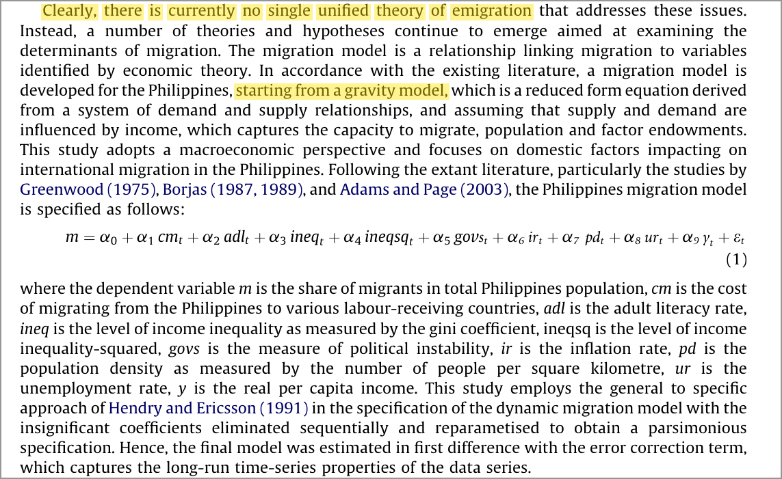
Excerpt 2.2. No unified theory; the gravity-based model, equation (1) (p. 390).

Review
• Expected-utility models (Ravenstein, 1885; Todaro, 1969): people migrate when the expected gain abroad exceeds the cost.
• Human capital theory (Hicks, 1939; Sjaastad, 1962): migration is an investment, so education should raise emigration.
• Roy effect / self-selection (Borjas, 1987): skill-return differentials decide who leaves; tested with the Gini coefficient and its square.
• Gravity model (Greenwood, 1975; Adams & Page, 2003): a reduced-form demand–supply relation in income, population and migration cost.
• Operational model, equation (1): m = f(cm, adl, ineq, ineq², govs, ir, pd, ur, y), a macro push-factor equation for the migration share.
All theory citations are as cited in Agbola and Acupan (2010).
Strength
Grounded in established migration theory; each hypothesis gives a testable expected sign.

Critical note
Eclectic, not structural: the theories mainly justify coefficient signs.
The gravity model is bilateral by nature, yet no destination-side (pull) variables enter the model.

3. Data
Guiding question
What data were used, and where were they obtained?

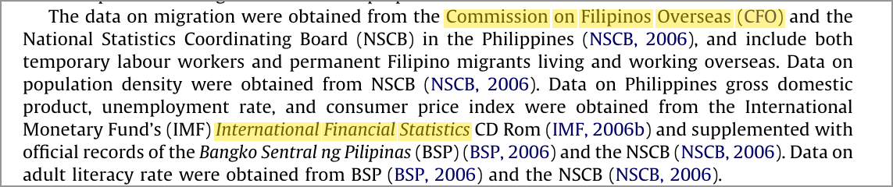
Excerpt 3.1. Data sources (p. 390).
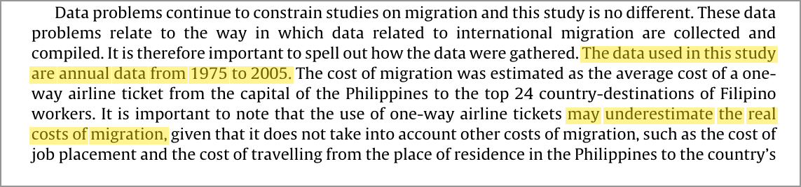
Excerpt 3.2. Sample period and the airfare proxy for migration cost (p. 391).
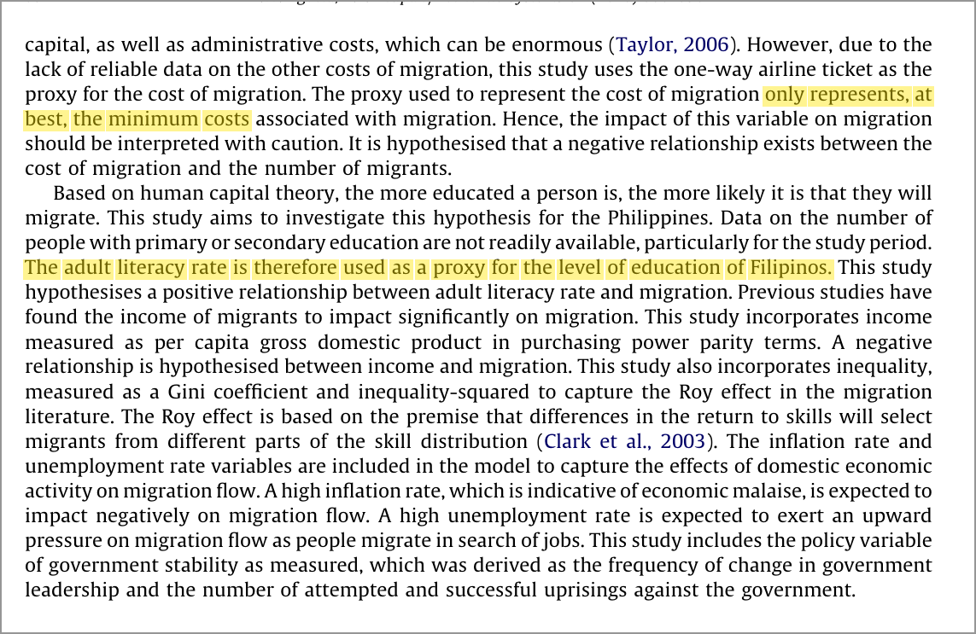
Excerpt 3.3. Proxies and expected signs (p. 392).

Review
Variable | Measure / proxy | Source
Migration share (m) | (Temporary + permanent migrants) ÷ population | CFO; NSCB
Cost of migration | One-way airfare, Manila → top 24 destinations (proxy) | Authors’ estimate
Adult literacy | Adult literacy rate (proxy for education) | BSP; NSCB
Income inequality, ineq² | Gini coefficient and its square | Not stated
Political instability | Leadership changes, coups and uprisings | Gastil (1987) approach
Inflation; unemployment; income | CPI inflation; unemployment rate; real GDP per capita (PPP) | IMF IFS; BSP; NSCB
Population density | People per km² | NSCB
Table 2. Variables, measures and sources (adapted from Agbola & Acupan, 2010, pp. 390–392).
• Sample. Annual national aggregates, 1975–2005: T = 31, all secondary data.
Critical note
• Undisclosed data handling: the Gini source is not stated; the Philippine Gini is published only every few years, so the annual values were presumably interpolated.
• Aggregation: m pools temporary and permanent migrants, who respond to different incentives.
• Weak proxies: airfare is a lower bound on migration cost; near-universal adult literacy has little variation.

4. Methodology
Guiding question
What research methods and analytical approaches were employed?

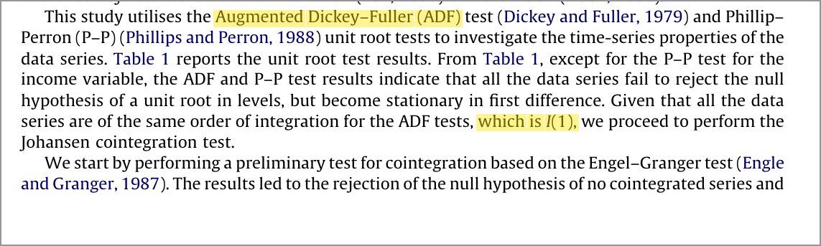
Excerpt 4.1. Unit root tests and the move to cointegration (p. 390).
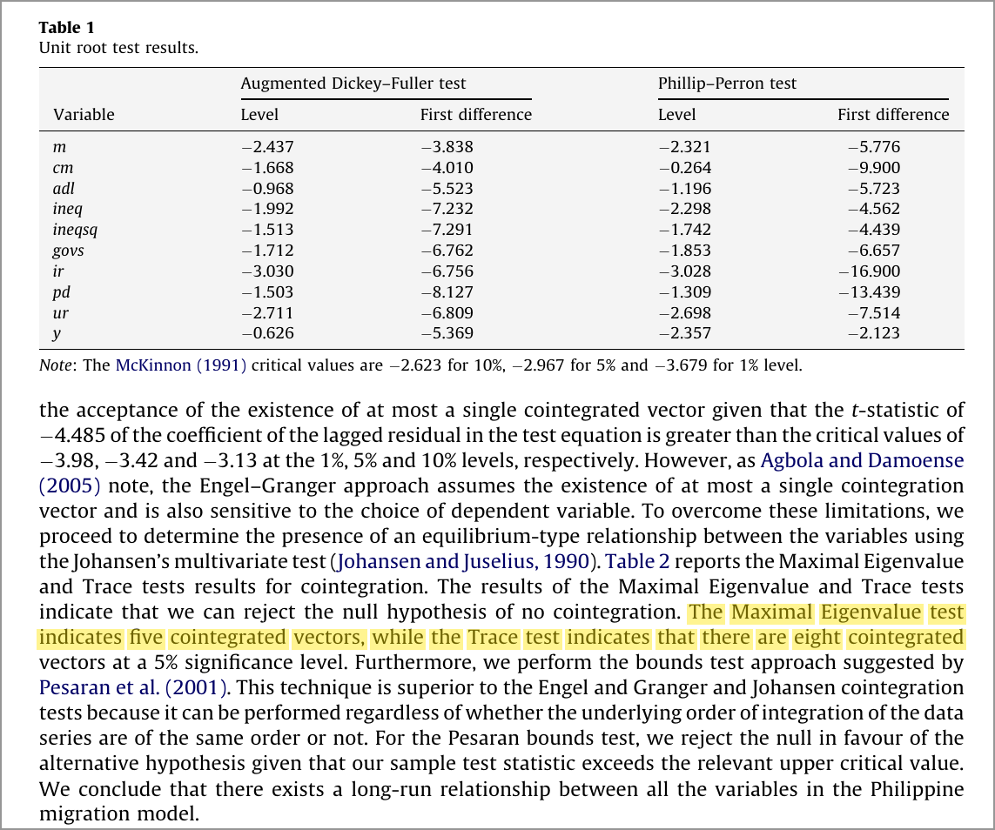
Excerpt 4.2. Table 1 (unit roots) and the cointegration evidence (p. 391).

Review
A quantitative, single-country time-series econometric design in five steps:
• Step 1 – Unit roots: ADF and Phillips–Perron tests; the series are treated as I(1).
• Step 2 – Cointegration: Engle–Granger (t = −4.485), Johansen (λmax: 5 vectors; trace: 8) and the Pesaran bounds test all confirm a long-run relationship.
• Step 3 – Specification: Hendry general-to-specific reduction to a parsimonious model.
• Step 4 – Estimation: unrestricted ECM by OLS (EViews 6.0).
• Step 5 – Diagnostics: Breusch–Godfrey, RESET, Jarque–Bera, ARCH and CUSUM/CUSUMSQ, all passed.
Strength
Textbook sequence with three cointegration tests and a full set of diagnostics.

Critical note
• One ECT despite 5–8 cointegrating vectors: the long-run structure is collapsed for parsimony.
• Order of integration unclear: income (y) fails the P–P test even in first differences (−2.123 vs. the 10% critical value of −2.623).
• Low power: T = 31 for 10 estimated terms, and there are no structural-break tests (1986 EDSA, 1997 Asian financial crisis).

5. Key Findings
Guiding question
What are the main results and conclusions of the study?

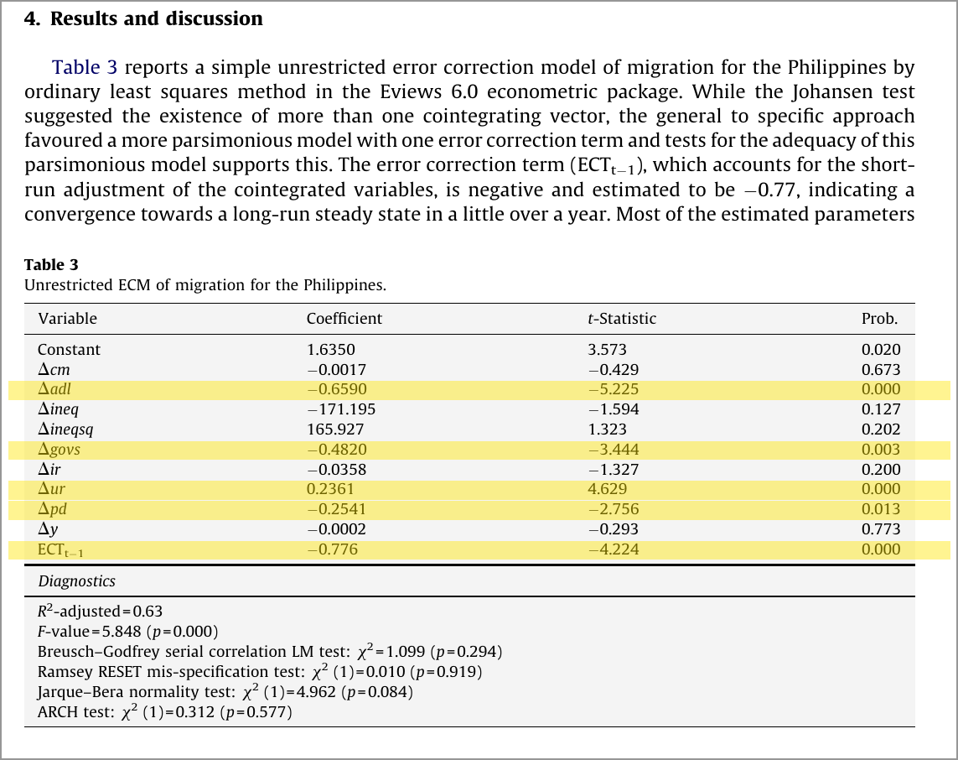
Excerpt 5.1. Table 3, unrestricted ECM; the significant rows are highlighted (p. 392).

Review
Explanatory variable | Coefficient | t-statistic | Result (5%)
Unemployment | +0.236 | 4.629 | Significant ↑
Adult literacy | −0.659 | −5.225 | Significant ↓
Political instability | −0.482 | −3.444 | Significant ↓
Population density | −0.254 | −2.756 | Significant ↓
Inequality; inequality² | −171.195; +165.927 | −1.594; 1.323 | Not significant
Inflation; cost of migration; income | −0.036; −0.002; −0.0002 | −1.327; −0.429; −0.293 | Not significant
Error correction term (ECT) | −0.776 | −4.224 | Significant
Table 3. ECM results. Adjusted R² = 0.63; F = 5.848 (p = 0.000). Adapted from Agbola and Acupan (2010, p. 392).
• Fit and adjustment: the model explains 63% of the variation in the migration share; ECT = −0.776 means about 78% of any deviation from equilibrium is corrected within a year.
• Unemployment ↑ → emigration ↑: emigration acts as a safety valve for surplus labour.
• Adult literacy ↑ → emigration ↓: this contradicts human capital theory; the authors point to the low-skilled profile of migrants.
• Political instability ↑ → emigration ↓: emigration fell in turbulent years (1983, 1986, 2001, 2005).
• Population density ↑ → emigration ↓: contrary to expectation; the authors suggest, tentatively, that domestic demand creates local jobs.
• Not significant: income, inflation, migration cost and inequality, so the Roy effect is rejected.
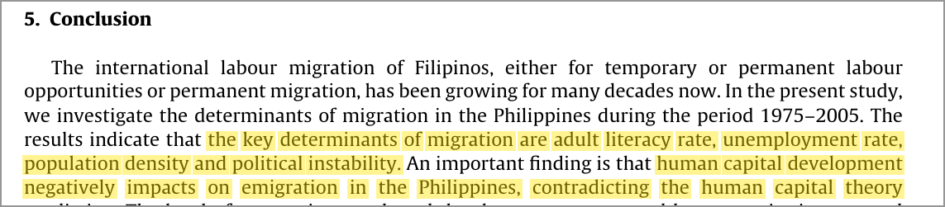
Excerpt 5.2. Conclusion: the key determinants (p. 394).
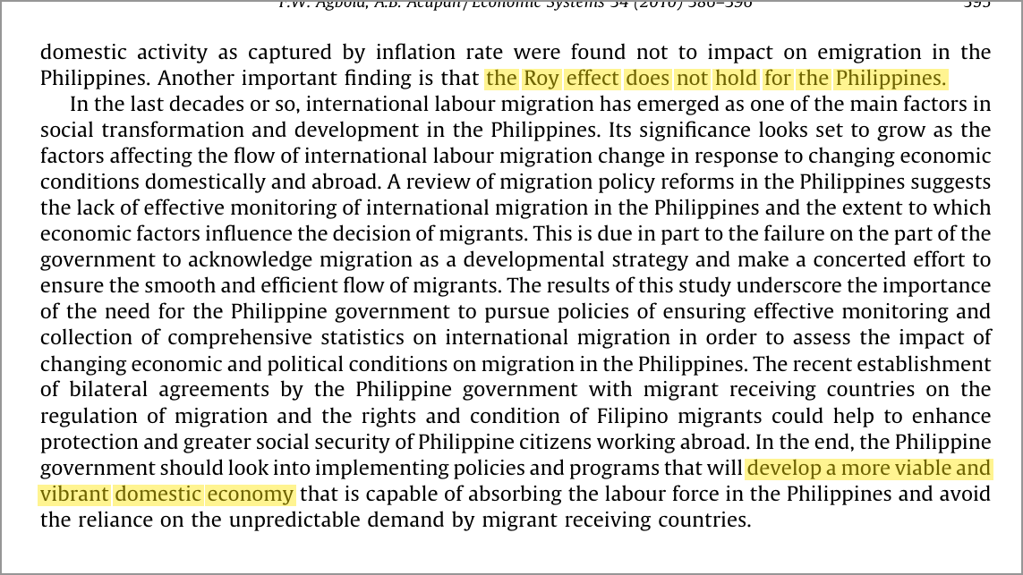
Excerpt 5.3. Conclusion: the Roy effect and the policy implications (p. 395).
• Policy conclusion: better migration statistics, bilateral agreements to protect overseas workers, and a domestic economy able to absorb labour.
Critical note
• The low-skill explanation conflicts with the paper’s own source: Alburo and Abella (2002, as cited in Agbola & Acupan, 2010) found professional outflows exceeding domestic additions.
• The insignificant results may partly reflect low statistical power, not true zero effects.

6. Areas for Further Research
Guiding question
What limitations were identified, and what future research opportunities are suggested?

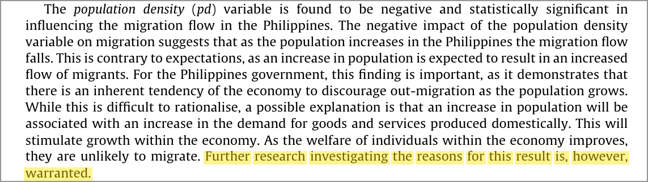
Excerpt 6.1. The authors call for further research on population density (p. 393).
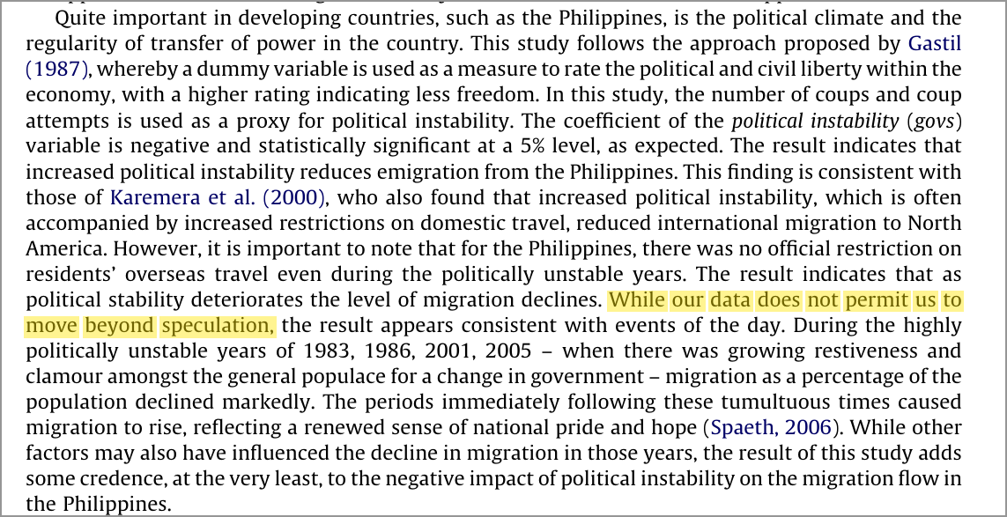
Excerpt 6.2. The authors acknowledge the limits of the political-instability evidence (p. 394).

Limitations identified by the authors
• Migration statistics are hard to collect and compile (p. 391).
• Airfare captures only the minimum cost of migration, so its coefficient should be read with caution (p. 392).
• The population-density result is unexplained: “further research … is warranted” (p. 393).
• The data “does not permit us to move beyond speculation” on political instability (p. 394).

Future research opportunities
• Suggested by the authors: explain the density effect; build systematic monitoring of migration statistics.
Reviewer suggestions
1. Disaggregate the migration share: temporary vs. permanent, and by skill or occupation.
2. Add pull factors: a bilateral panel gravity model with destination wages and labour demand (e.g., Gulf oil revenues).
3. Extend past 2005 and test structural breaks (1997, 2008, COVID-19) with Zivot–Andrews or Bai–Perron tests.
4. Use household micro-data to test human-capital selection directly.

Key Insights
Five takeaways
1. Push factors at home matter: unemployment is the clearest driver of Filipino emigration.
2. Education keeps people home at the macro level, against human capital theory, but the explanation is contested.
3. Instability and density reduce emigration, and both mechanisms remain speculative.
4. Long-run equilibrium: about 78% of shocks to the migration share fade within a year.
5. Read with care: T = 31, weak proxies and missing pull factors limit the conclusions.

Bottom line. Agbola and Acupan (2010) offer useful early evidence that domestic push factors shape Filipino emigration. Without destination-side pull factors and richer data, however, they are not the whole story.

Reference
Agbola, F. W., & Acupan, A. B. (2010). An empirical analysis of international labour migration in the Philippines. Economic Systems, 34(4), 386–396. https://doi.org/10.1016/j.ecosys.2010.03.002

Footnote Text.

