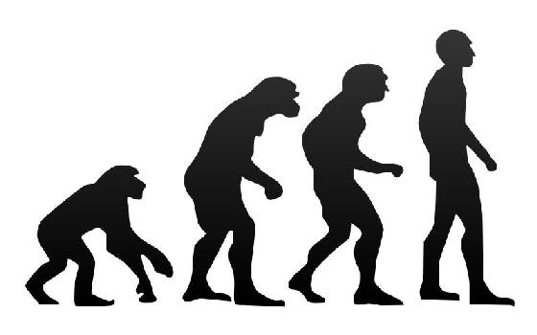

aUTHOR: el khadir bACHIR

Evolutionary Algorithms Project Report

June 2, 2014