HW1 Report

HW1-1 Simulate a Function:

1-1-1 The first function is sin(x), x is in range [-pi, pi]

The three models are summarized as following:

model0
Sequential(
(0): Linear(in_features=1, out_features=5)
(1): Linear(in_features=5, out_features=10)
(2): Linear(in_features=10, out_features=10)
(3): Linear(in_features=10, out_features=10)
(4): Linear(in_features=10, out_features=10)
(5): Linear(in_features=10, out_features=10)
(6): ReLU()
(7): Linear(in_features=10, out_features=5)
(8): Linear(in_features=5, out_features=1)
)

model1
Sequential(
(0): Linear(in_features=1, out_features=10)
(1): Linear(in_features=10, out_features=18)
(2): Linear(in_features=18, out_features=15)
(3): Linear(in_features=15, out_features=4)
(4): ReLU()
(5): Linear(in_features=4, out_features=1)
)

model2
Sequential(
(0): Linear(in_features=1, out_features=190)
(1): ReLU()
(2): Linear(in_features=190, out_features=1)
)

model0 paramters 571
model1 paramters 572
model2 paramters 571

Loss for the first function sin(x):

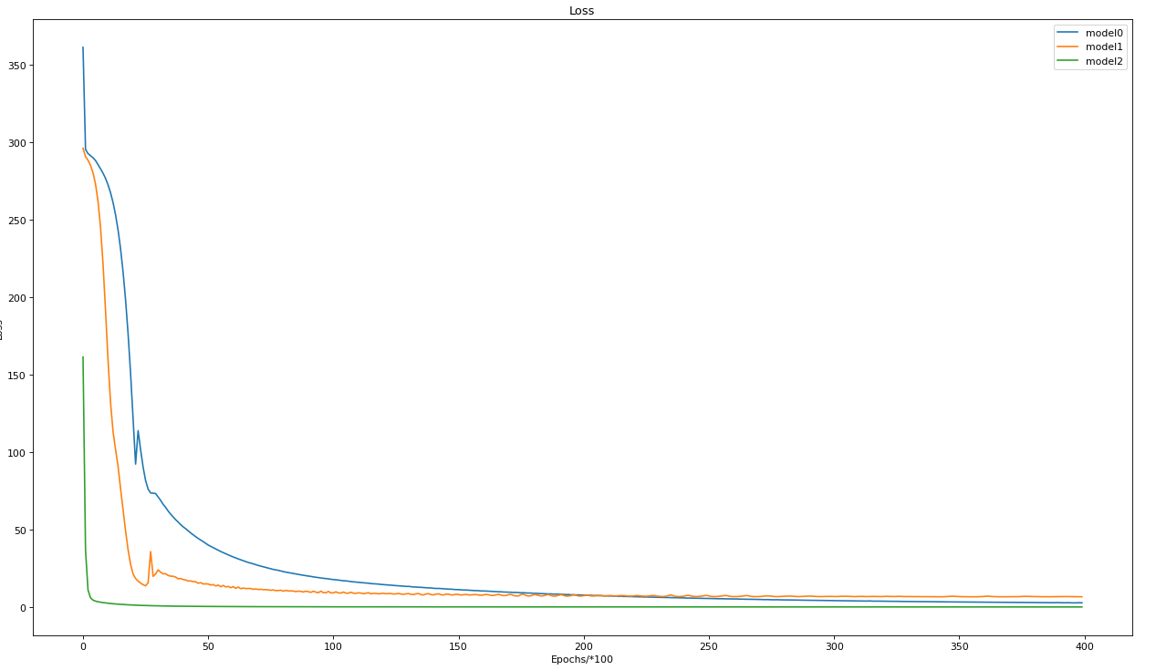
Model 2 is shallow network which converges very fast. Mode0 and model 1 are deeper than model 2 and converge slower than model 2. For a simple function sin(x), shallow network performs even better than a deep network. The possible reason is shallow is easy to train. A deep network is harder to train comparing a shallow network.
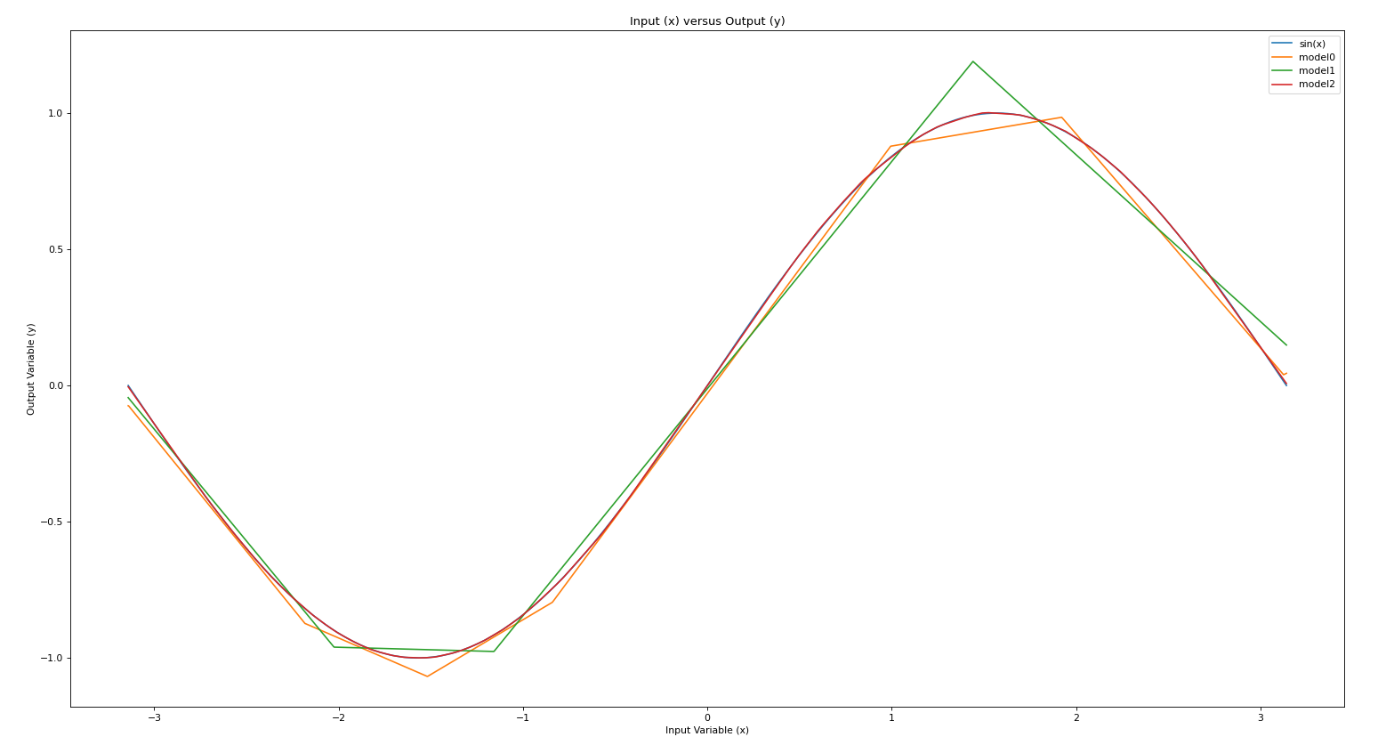
1-1-2 The Second function is sin(x)/x, x is in range [-0.1pi, 3*pi]

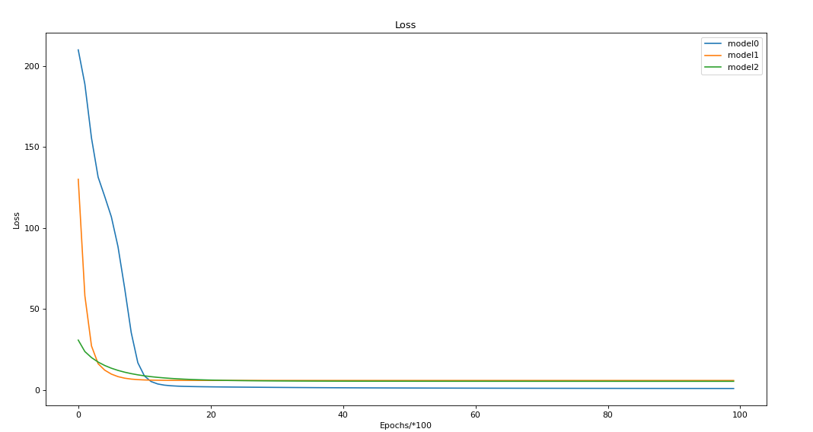

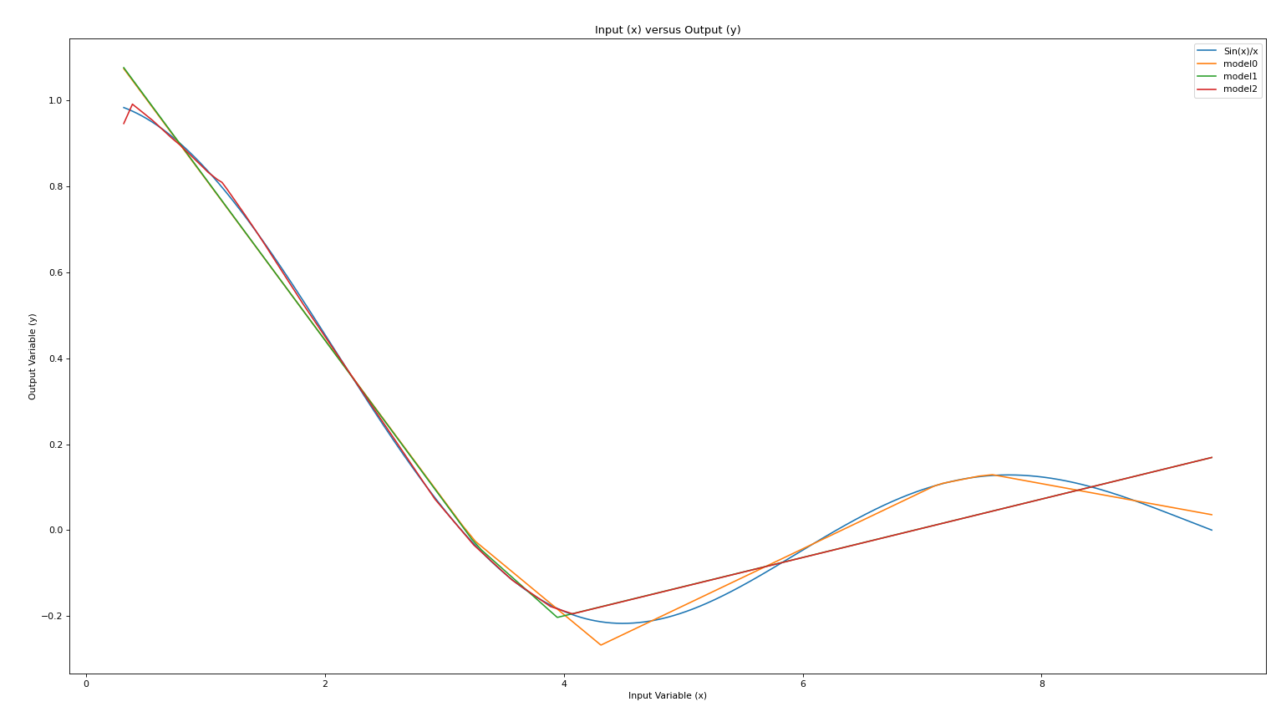
For a more complex function sin(x)/x, deep neural network performs better than shallow network. E.g., model 0 performs better than model 1; Model 1 performs better than model 2. Shallow neural network converges faster than deep neural network.

HW1-1 Train on Actual Tasks:

The first dataset used is MNIST. The second dataset is CIFAR-10. Model0 has 2 conv layers and two dense layers. Model1 has 4 conv layers and 1 dense layer. Model2 has 6 conv layers and 1 dense layer. The three models are summarized as following:

model0(
(conv1): Conv2d(1, 10, kernel_size=(5, 5), stride=(1, 1))
(conv2): Conv2d(10, 20, kernel_size=(5, 5), stride=(1, 1))
(fc1): Linear(in_features=320, out_features=50, bias=True)
(fc2): Linear(in_features=50, out_features=10, bias=True)
)
model1(
(conv1): Conv2d(1, 10, kernel_size=(3, 3), stride=(1, 1))
(conv2): Conv2d(10, 20, kernel_size=(3, 3), stride=(1, 1))
(conv3): Conv2d(20, 40, kernel_size=(3, 3), stride=(1, 1))
(conv4): Conv2d(40, 80, kernel_size=(3, 3), stride=(1, 1))
(fc1): Linear(in_features=80, out_features=10, bias=True)
)
model2(
(conv1): Conv2d(1, 16, kernel_size=(3, 3), stride=(1, 1))
(conv2): Conv2d(16, 32, kernel_size=(3, 3), stride=(1, 1))
(conv3): Conv2d(32, 64, kernel_size=(3, 3), stride=(1, 1))
(conv4): Conv2d(64, 128, kernel_size=(3, 3), stride=(1, 1))
(conv5): Conv2d(128, 256, kernel_size=(3, 3), stride=(1, 1))
(conv6): Conv2d(256, 512, kernel_size=(3, 3), stride=(1, 1))
(fc1): Linear(in_features=2048, out_features=10, bias=True)
)

Performances on MNIST dataset:
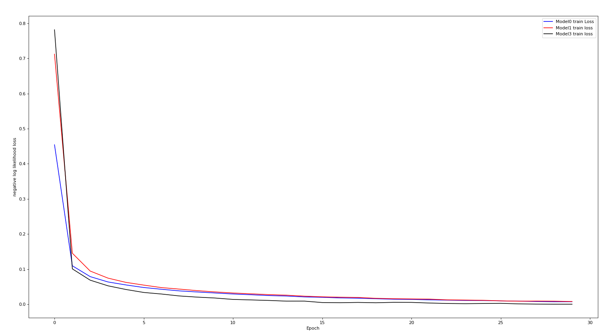
Model2 is deeper than model1 and model1 is deeper than model0. From the loss, the performance of model2 is the best. We can roughly drawn a conclusion: deeper neural network can achieve lower loss.

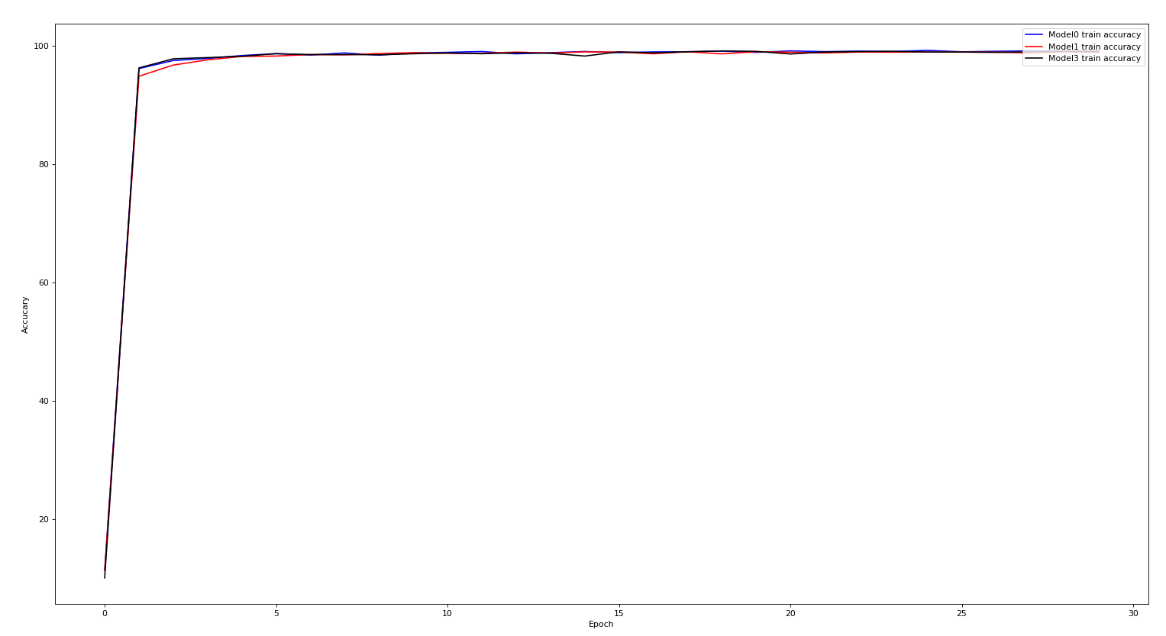
The three models have similar performance on MNIST from the accuracy. The all can achieve very high accuracy with a similar speed.

Performances on CIFAR-10 dataset:
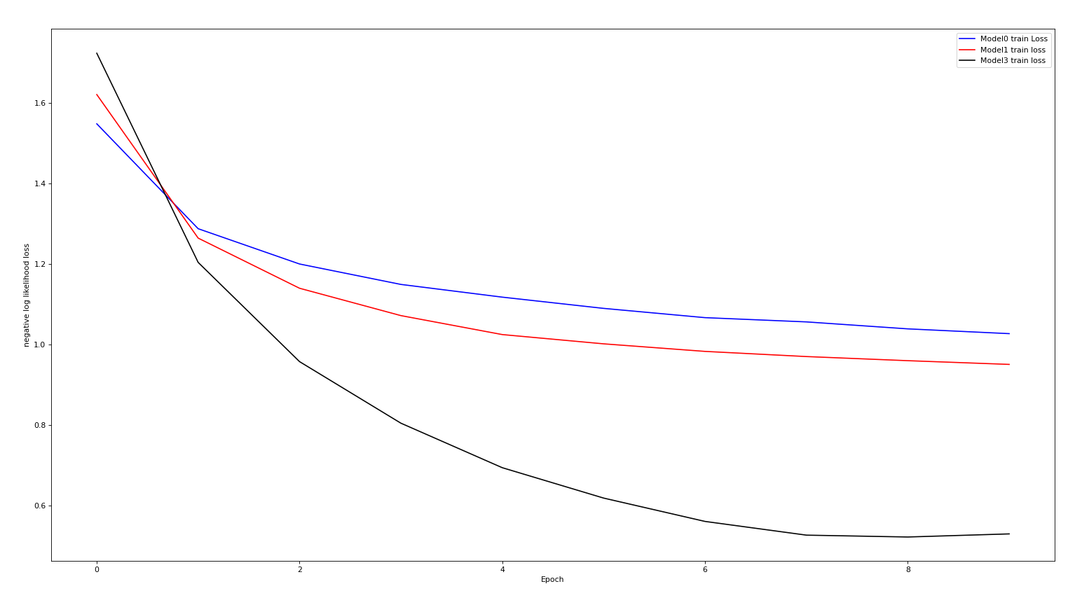
The conclusion from the CIFAR-10 dataset is that the performance of the three models are the best when the model is the deepest. The loss of model2 is smaller than the loss of model1; The loss of model1 is smaller than the loss of model0.

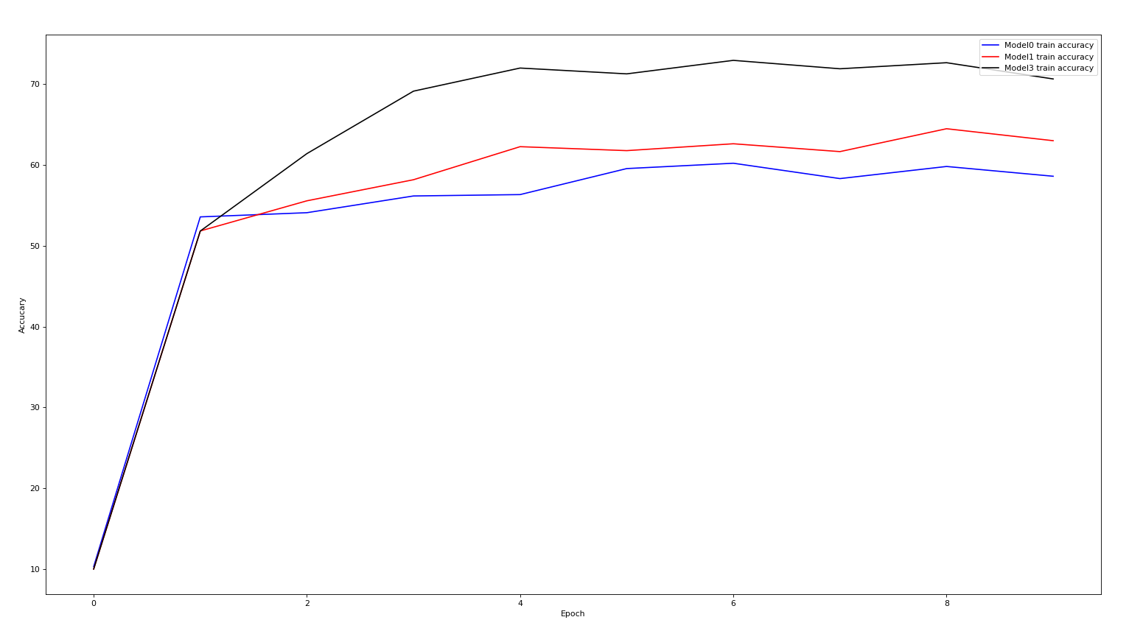
The accuracy from the CIFAR-10 dataset is the highest when the model is the deepest. The accuracy of model2 is larger than the loss of model1; The loss of model1 is larger than the loss of model0.

HW1.2 Optimization
1.2 (1) Record Weights. I tried two models . The first model is for function simulation. The second model is for MNIST dataset.
The first model is
model0
Sequential(
(0): Linear(in_features=1, out_features=5)
(1): Linear(in_features=5, out_features=10)
(2): Linear(in_features=10, out_features=10)
(3): Linear(in_features=10, out_features=10)
(4): Linear(in_features=10, out_features=10)
(5): Linear(in_features=10, out_features=10)
(6): ReLU()
(7): Linear(in_features=10, out_features=5)
(8): Linear(in_features=5, out_features=1)
)

The function to simulate is sin(x)/x

The second model is
model0(
(conv1): Conv2d(1, 10, kernel_size=(5, 5), stride=(1, 1))
(conv2): Conv2d(10, 20, kernel_size=(5, 5), stride=(1, 1))
(fc1): Linear(in_features=320, out_features=50, bias=True)
(fc2): Linear(in_features=50, out_features=10, bias=True)
)
It is for MNIST dataset. The optimizer is SGD with the learning rate 0.01.

I used the PCA from sklearn to reduce the parameter dimensions.
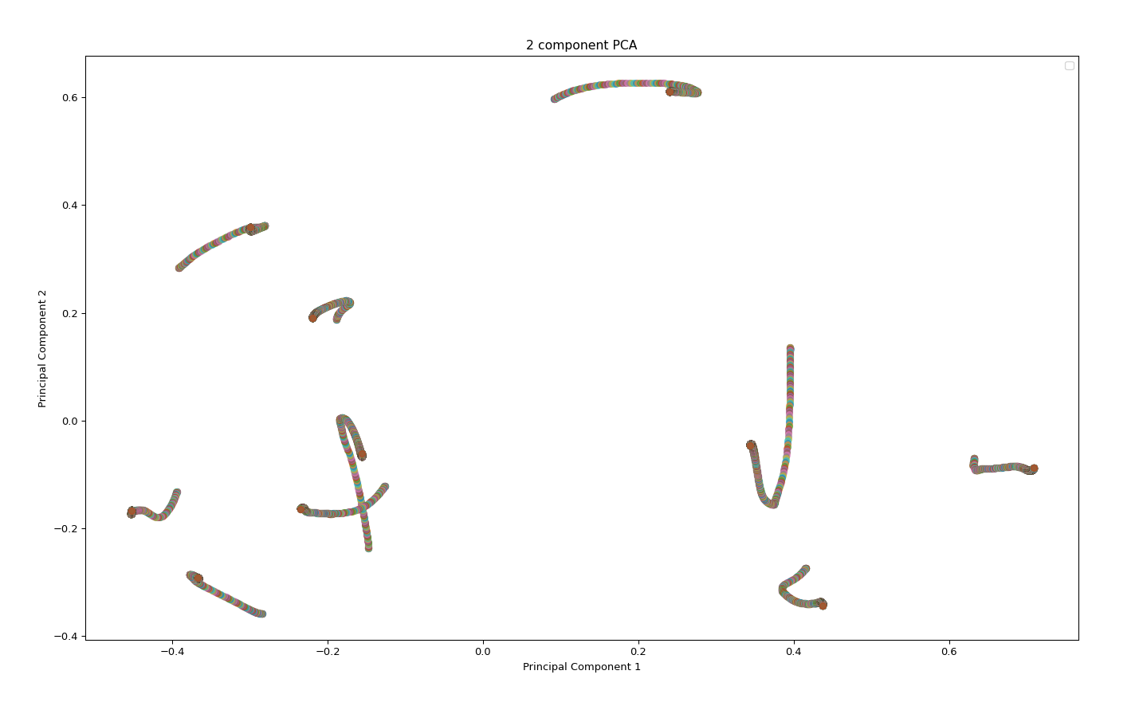

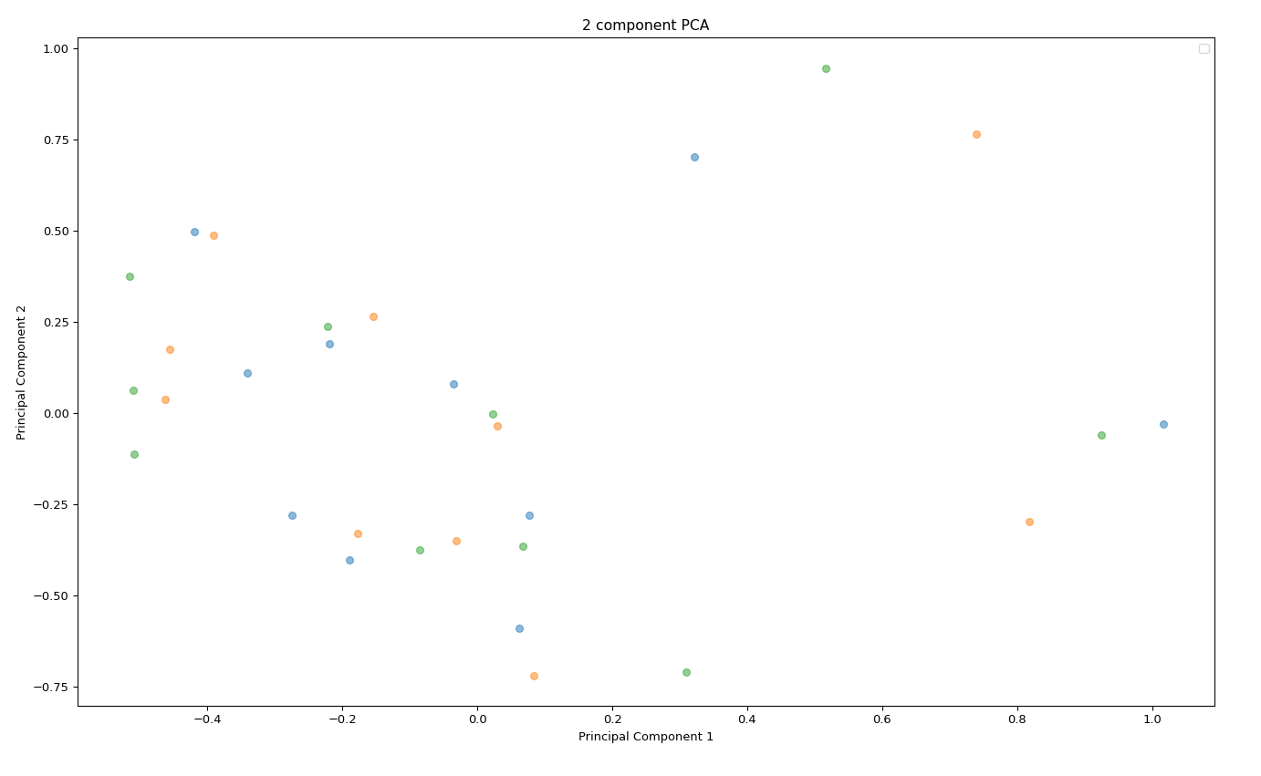

1.2 (2) gradient norm

Sin(x)/x
The gradient norm and the loss are very large at the beginning. They both reduce to very small values when the loss curve become flat. When the loss are stable, the gradient also stabilized.
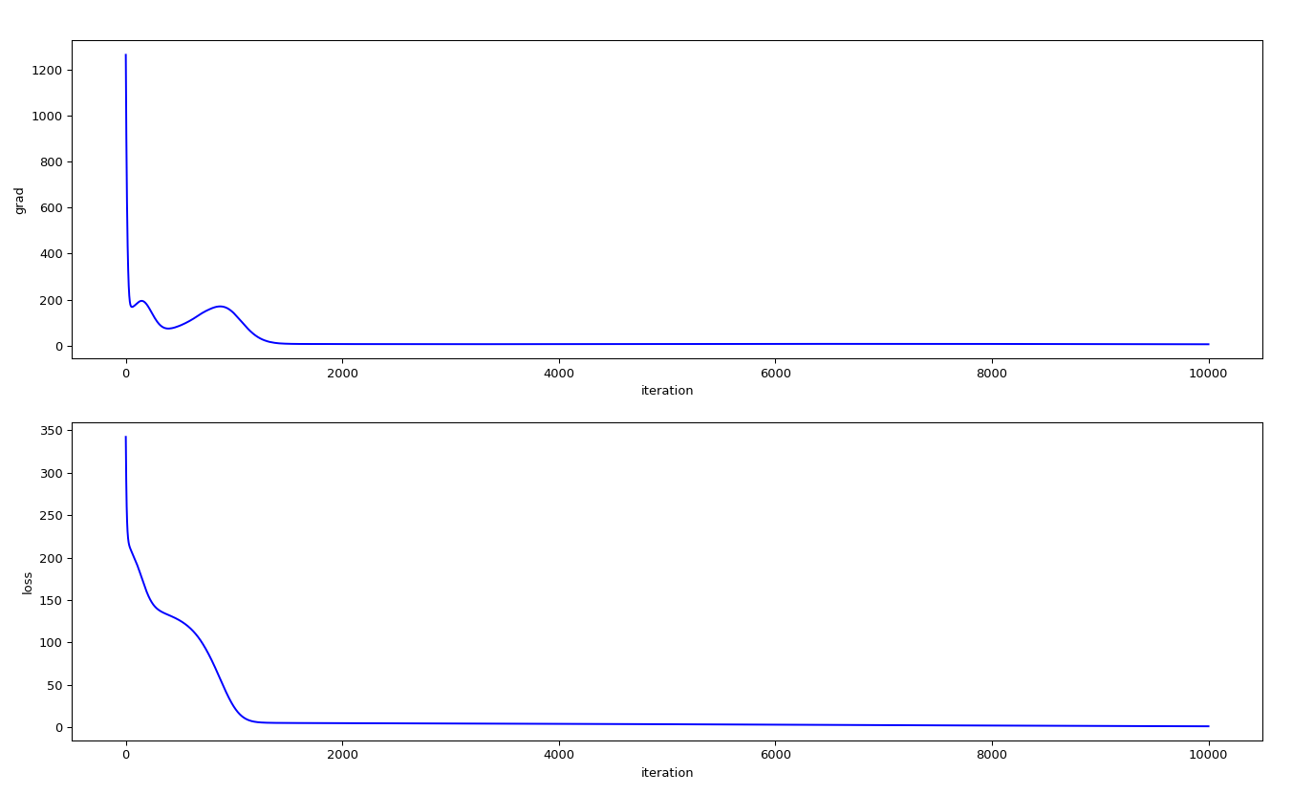

MNIST dataset. The gradient norm and the loss are large at the beginning. They both reduce to very small values when the loss curve become flat. When the loss are stable, the gradient also stabilized.

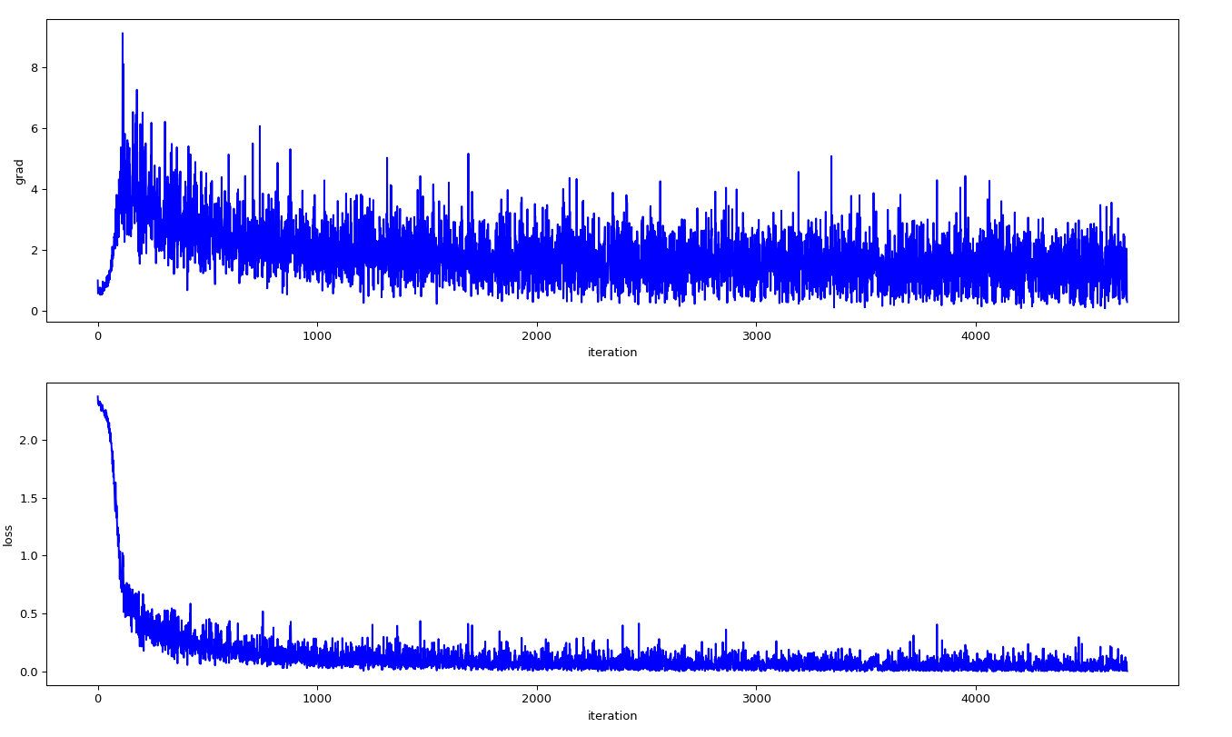

1.2 (3) minimum ratio
First train a model with MSE loss function.
Then get the gradient norm
Then use autograd_lib.backward_hessian to compute the hess values
Then get the egenvalues of the hess matrix

HW1.3 Generalization

(1) Train with random Label

Experimental setting: I use MNIST dataset with the learning rate = 0.1. The optimizer is SGD and the momentum is 0.5.
Comments: Randomly shuffle the training set label before training. Keep the testing set label as is. We can see from the result that the training loss is reducing as the epoch increasing. This means the network can fit random labels. While the testing loss is increasing. Because the testing label is not consistent with the training label.

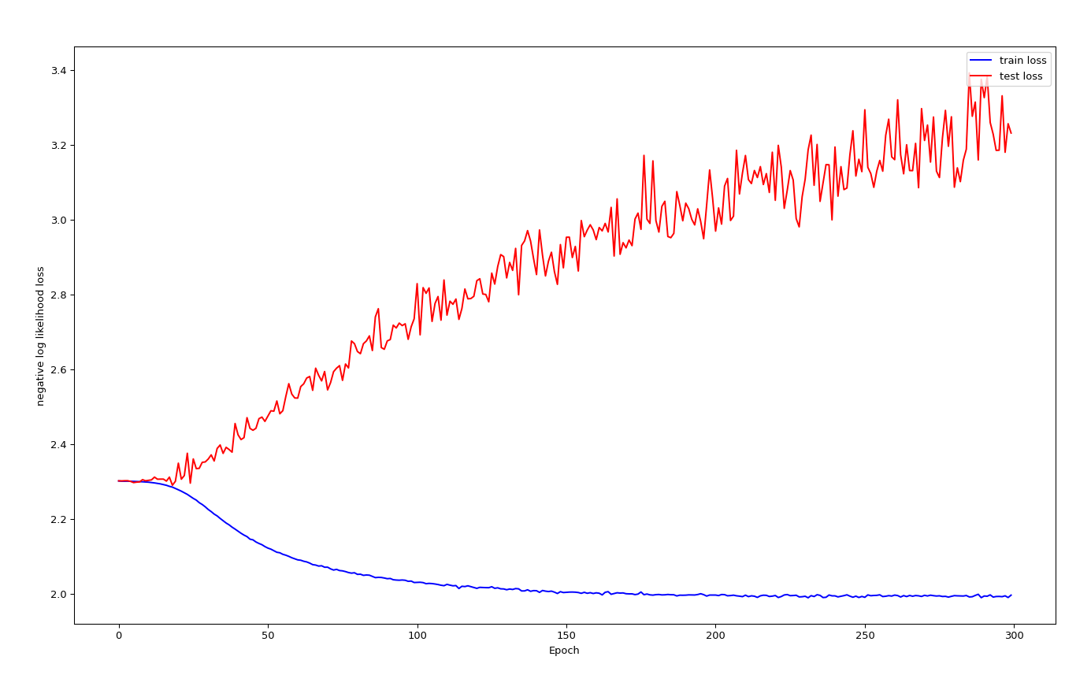

(2) Number of parameters v.s. Generalization
I choose MNIST dataset with the learning rate 0.01 and the optimizer SGD. All the 10 models have the same structures but with different sizes.
model0(
(conv1): Conv2d(1, 10, kernel_size=(5, 5), stride=(1, 1))
(conv2): Conv2d(10, 20, kernel_size=(5, 5), stride=(1, 1))
(fc1): Linear(in_features=320, out_features=50, bias=True)
(fc2): Linear(in_features=50, out_features=10, bias=True)
)

Comments on the results: with more parameters, the loss tends to decrease, while the accuracy increase. Which means the performance improves with bigger networks.

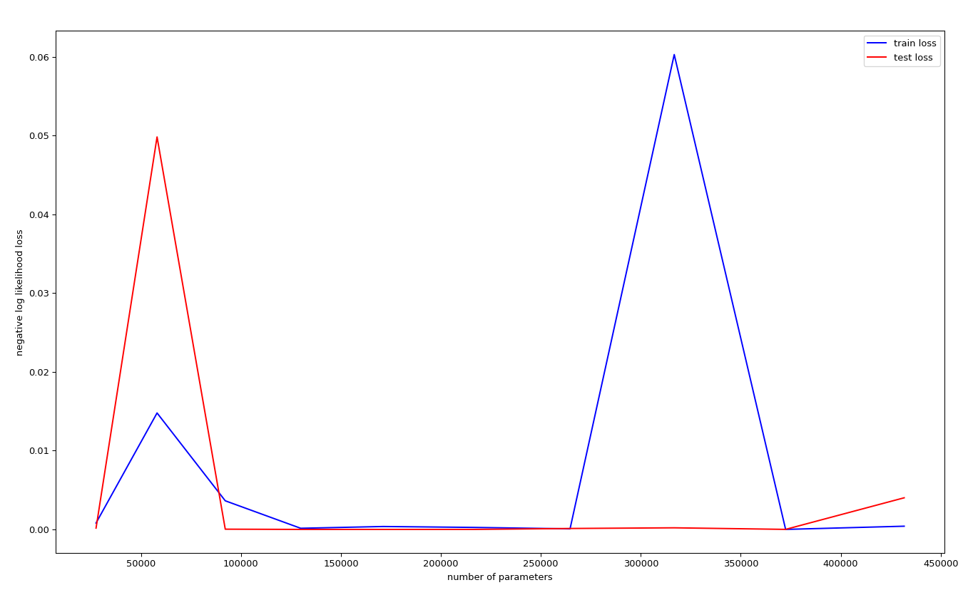

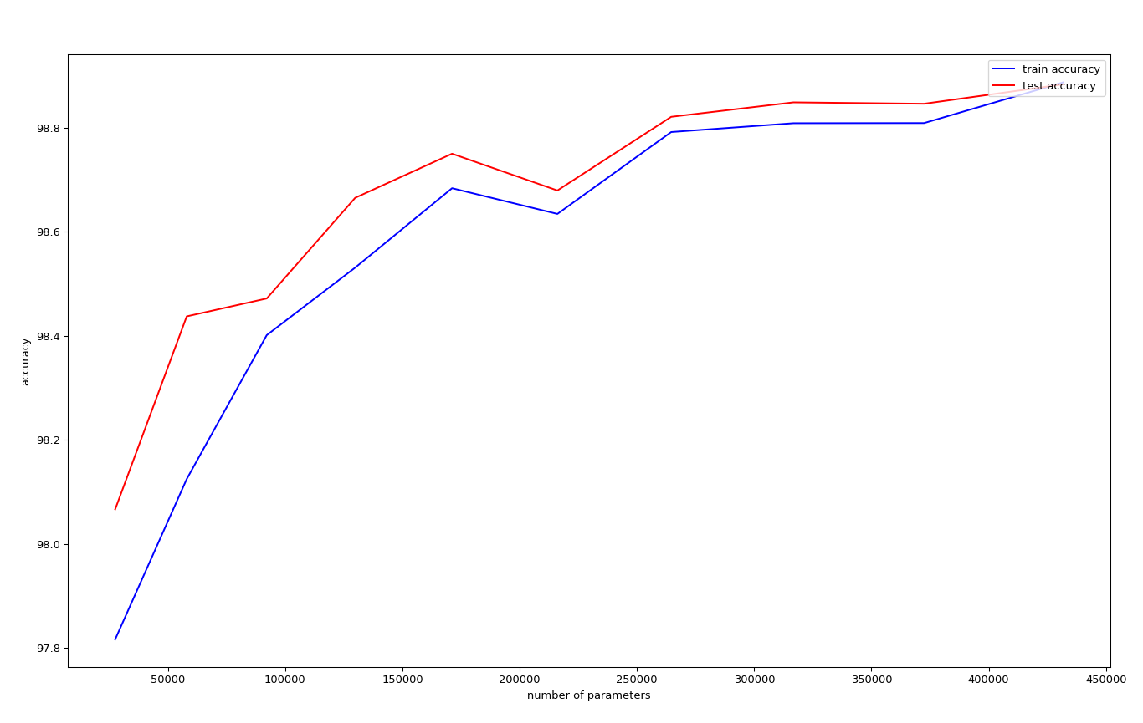
(3.1) Flatness v.s. Generalization – part1 interpolation
With MNIST dataset, three models has the same structures. Batch sizes for model0 and model1 are 64 and 1024 respectively. The approach is train the first models individually and save their weights. Interpolate the weights of the two trained models with a ratio alpha to make the weights for the third model.

Comments: the performance is bad when alpha is close to 0.5 and 2 where the accuracy are low and the losses are high. The performance is good when the ratio close to 0 or 1 where the accuracy are high and the losses are low.

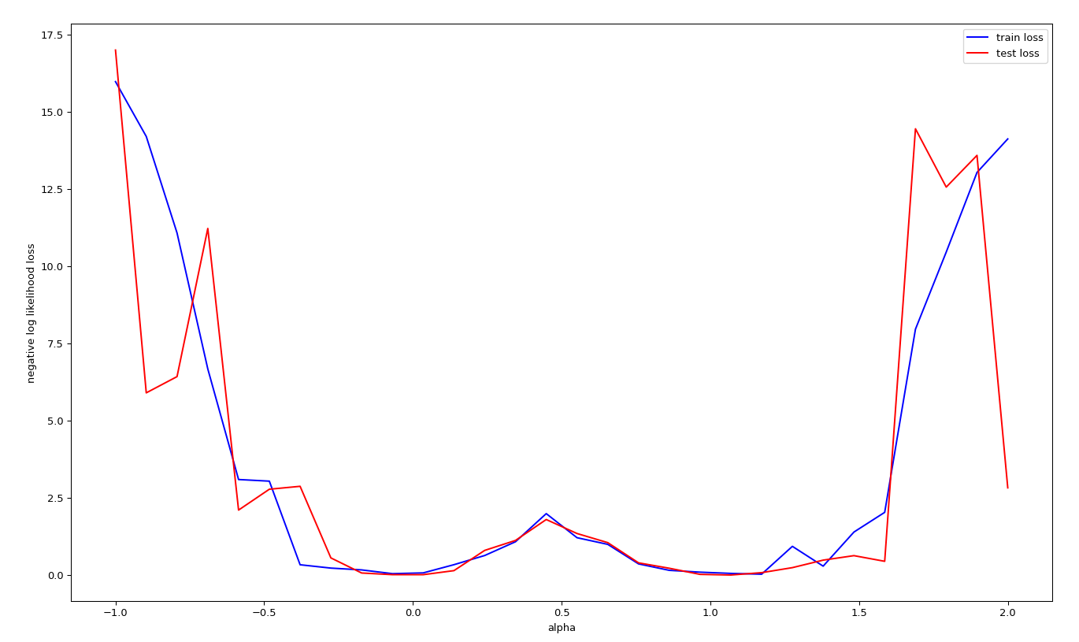

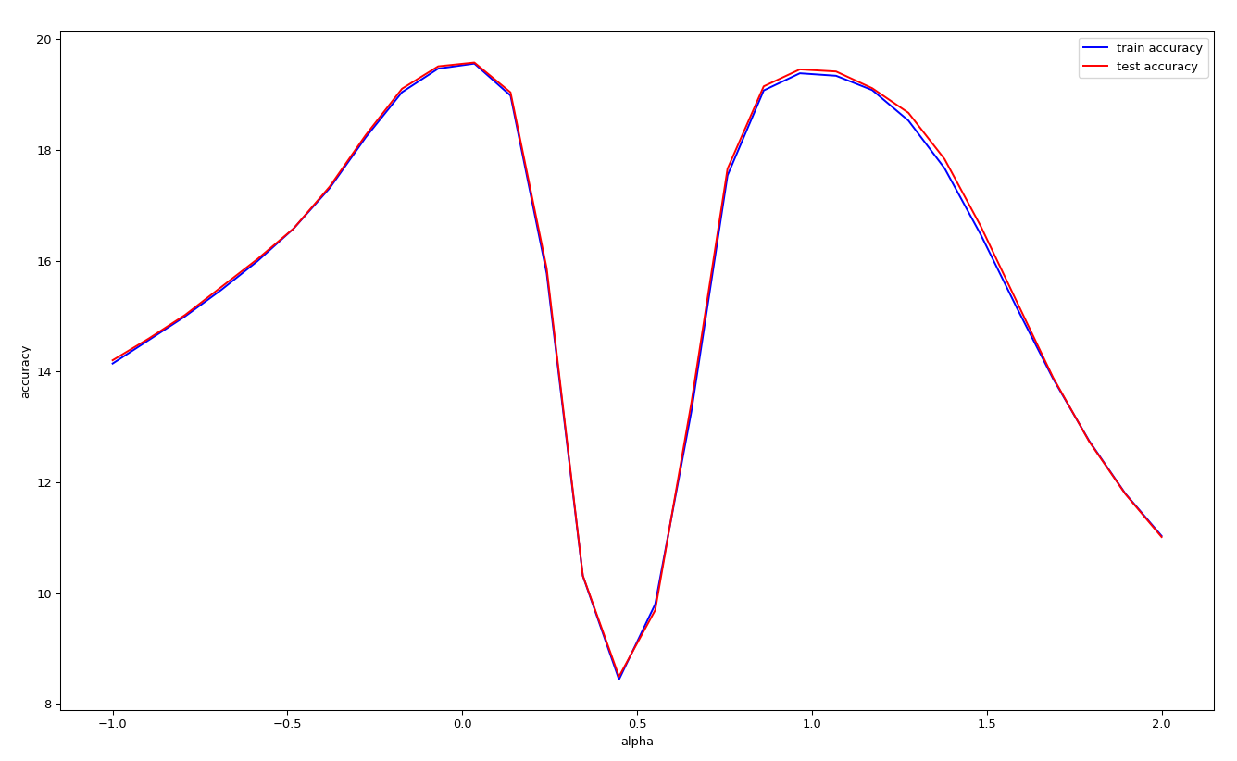

(3.2) Flatness v.s. Generalization – part2 sensitivity

I use MNIST dataset for five models that has the same structures.
model0(
(conv1): Conv2d(1, 10, kernel_size=(5, 5), stride=(1, 1))
(conv2): Conv2d(10, 20, kernel_size=(5, 5), stride=(1, 1))
(fc1): Linear(in_features=320, out_features=50, bias=True)
(fc2): Linear(in_features=50, out_features=10, bias=True)
) . Each model takes a input with different batch size as its input. Calculate the sensitivity and record it.

Comments: sensitivity is decrease as the number of batch size increases.

