HW3 Report

1 DCGAN

The authors of DCGAN made several changes in the DCGAN model. (1) All convolutional net is used in the generator. (2) eliminating fully connected layers on top of convolutional features. (3) Third is Batch Normalization. (4) The ReLU activation (Nair & Hinton, 2010) is used in the generator with the exception of the output layer which uses the Tanh function. The following figure is the specific architecture of the generator from reference [1].

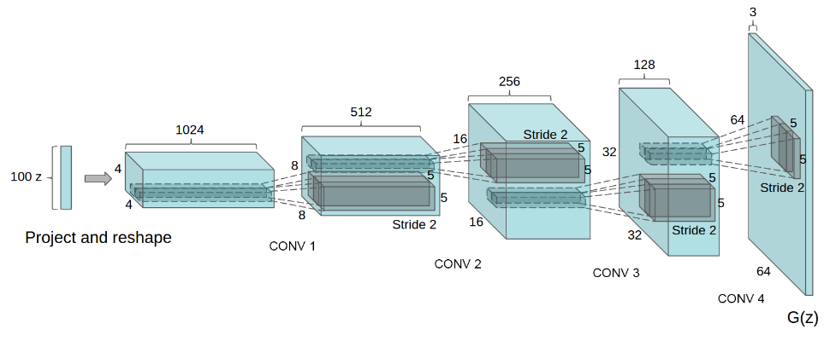

Result: These pictures in the following figure is the results generated by the DCGAN model after training for 100 epochs. Some pictures have some strange shape.

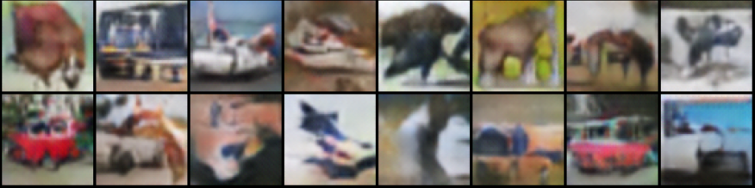

2 WGAN

WGAN model mainly solved the problem of instability during the training process by introducing Wasserstein distance to measure the loss. The authors also revised the GAN architecture. Some of the changes are summarized in table I.

Table I Comparison between DCGAN and WGAN
 | DCGAN | WGAN
Discriminator | With batchNorm | Without batchNorm
Discriminator last layer activation | sigmoid | linear
Discriminator model output | probability | score
Discriminator weight clipping | N/A | [-0.01,0.01]
Optimizer | Adam | RMSProp
Learning rate | 0.0002 | 0.0005
Loss | cross-entropy | Wasserstein loss

Result: These pictures in the following figure is the results generated by the WGAN model after training for 100 epochs. Some pictures have some strange shape.

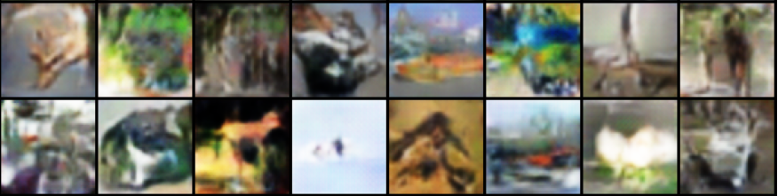

3 Evaluation:

Fréchet Inception Distance” (FID) was introduced in [3] to evaluate GANs. A well-known approach to measure the performance of GANs is the “Inception Score” which correlates with human judgment. Generated samples are fed into an inception model that was trained on ImageNet. Images with meaningful objects are supposed to have low label (output) entropy. The entropy across images should be high, that is, the variance over the images should be large. The authors in [1] improve the measurement of the Inception score to FID score. The proposed measurement can evaluate the generated images from the aspects of Gaussian noise, Gaussian blur, implanted black rectangles, swirled images, salt and pepper noise, etc..

I use the repo in [4] to calculate the FID score. DCGAN FID score is 100.01768534449116
WGAN FID score is 78.14961571052828.
If two images are the same, the FID score should be 0. The FID scores are calculated between real images and fake images from each GAN model. From the FID scores of DCGAN and WGAN. We can conclude that the image quality generated by WGAN is better than the images generated by DCGAN.

During the training process. DCGAN is not stable. The losses exploded sometimes. However, WGAN is stable since the losses can converge during training. The following figure shows the losses of the WGAN which converge easily.

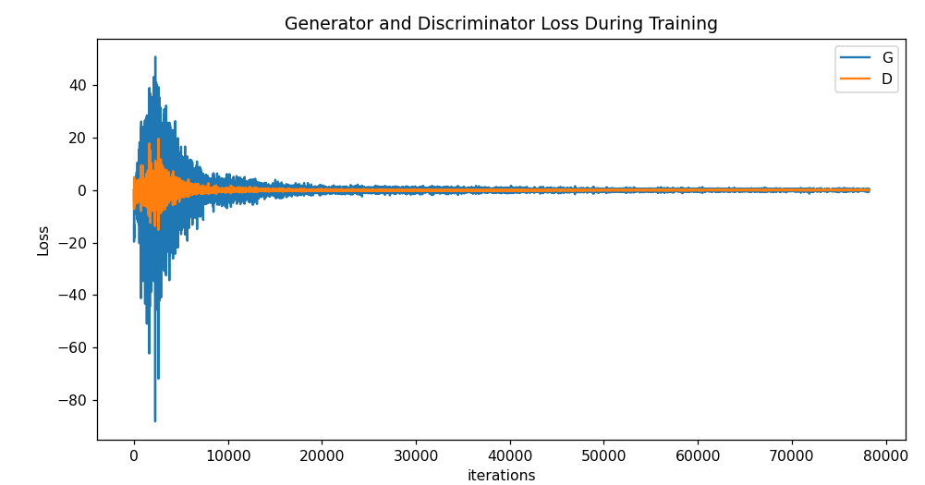

[1] Radford, Alec, Luke Metz, and Soumith Chintala. "Unsupervised representation learning with deep convolutional generative adversarial networks." arXiv preprint arXiv:1511.06434 (2015).

[2] Arjovsky, Martin, Soumith Chintala, and Léon Bottou. "Wasserstein generative adversarial networks." In International conference on machine learning, pp. 214-223. PMLR, 2017.

[3] Heusel, Martin, Hubert Ramsauer, Thomas Unterthiner, Bernhard Nessler, and Sepp Hochreiter. "Gans trained by a two time-scale update rule converge to a local nash equilibrium." Advances in neural information processing systems 30 (2017).

[4] https://github.com/mseitzer/pytorch-fid

