planes

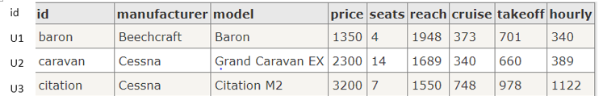

flights

id, plane, Departure airport, Departure time, arrival airport, arrival time.

U001 u1 YYD 8:30 YPZ 9:00

U002 u1 YPZ 9:40 YDL 11:15

U003 u1 YDL 12:00 YYD 13:25

U004 u3 YYD 9:00 ZST 9:30

U005 u3 ZST 10:00 YYD 10:30

U006 u2 YYD 12:00 YPZ 12:30

U007 u2 YPZ 13:00 YDL 14:45

U008 u2 YDL 15:15 ZST 16:05

U009 u2 ZST 16:45 YYD 17:35